
DecOps with Docker
Mooc.fi

Interacting with the container via volumes and ports

EXERCISE 1.14: Environment

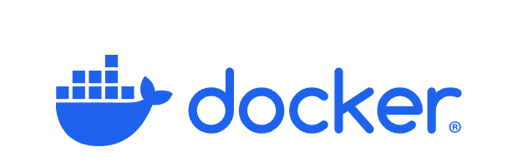

Student: Andreas Zelios

Part 1.9
text.log file of my working directory:

The changes I made to Docker files where:
- Added ENV REACT_APP_BACKEND_URL=http://localhost:8080 to the frontend Dockerfile
- Added ENV REQUEST_ORIGIN=http://localhost:5000 to the backend Dockerfile
As described in the README files.
I then rebuilt the two Docker files and run them, as previously with, docker run --rm -d -p 5000:5000 frontend-example and docker run --rm -d -p 8080:8080 go-project ./server.
The results are the following:
