
DecOps with Docker
Mooc.fi

Interacting with the container via volumes and ports

EXERCISE 1.12: Hello, frontend!

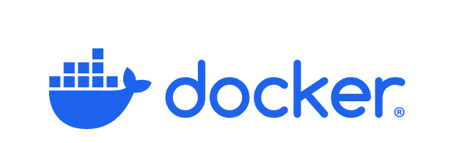

Student: Andreas Zelios

Part 1.9
text.log file of my working directory:

I installed curl to be able to download setup script and also gnupg that is needed by that setup script. Then I copy the sources and run npm install -f, npm install -g serve as instructed by the README.
To serve the app as the README states, I use:
CMD ["serve", "-s", "-l", "5000", "build"].
To build and run the image I use:
docker build . -t frontend-example
docker run --rm -p 5000:5000 frontend-example

The results are the following:
