
DecOps with Docker
Mooc.fi

Migrating to Docker Compose

EXERCISE 2.4



Student: Andreas Zelios

Part 1.9
text.log file of my working directory:

The only addition to the previous yml file is the new service redis and the new env variable REDIS_HOST=redis in our backend service:
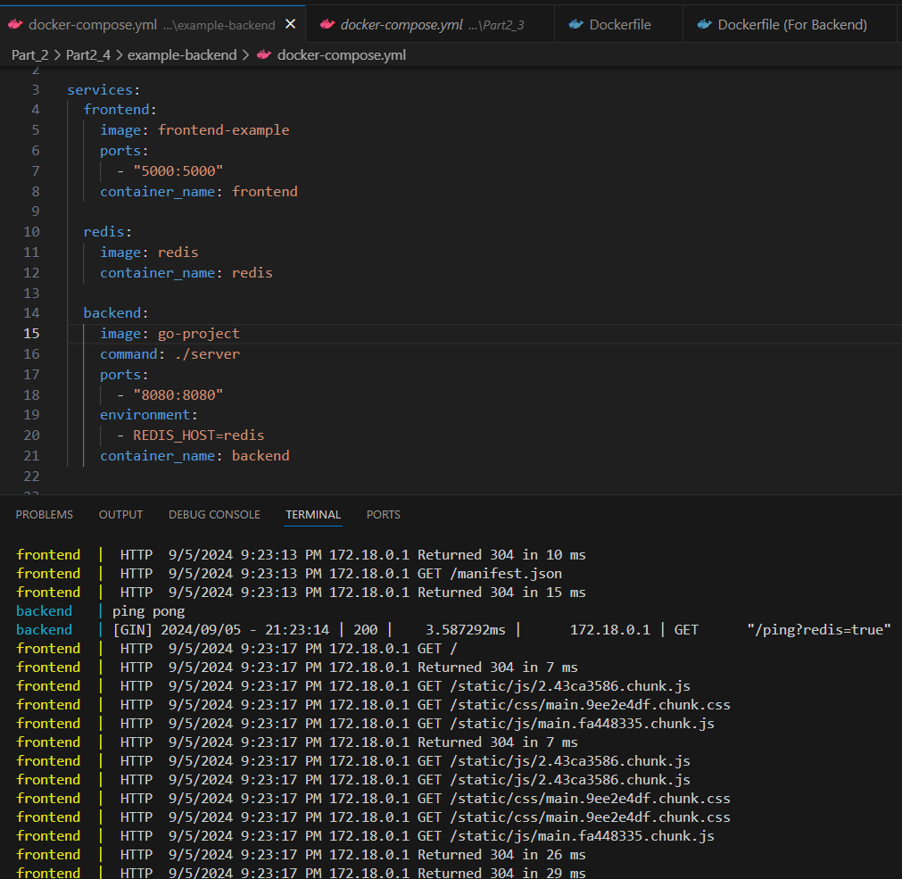
We can see the response in our frontend, showing everything is working
