
DecOps with Docker
Mooc.fi

Migrating to Docker Compose

EXERCISE 2.1



Student: Andreas Zelios

Part 1.9
text.log file of my working directory:

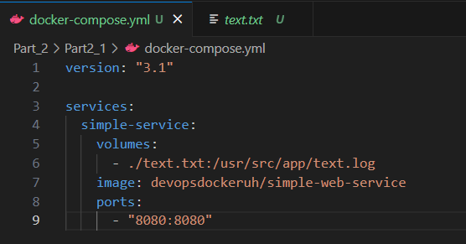
My docker-compose.yml file looks like this:

ds
Indicate available port
Image in docker hub
Specify the dir of the file that is written in our conteiner
Name of image

The output comes to the docker-compose.yml directory in text.txt as specified in volumes. We can see the file contents here:
