
DecOps with Docker
Mooc.fi

Migrating to Docker Compose

EXERCISE 2.2



Student: Andreas Zelios

Part 1.9
text.log file of my working directory:

Seeing the docker-compose.yml and the response of docker compose up:
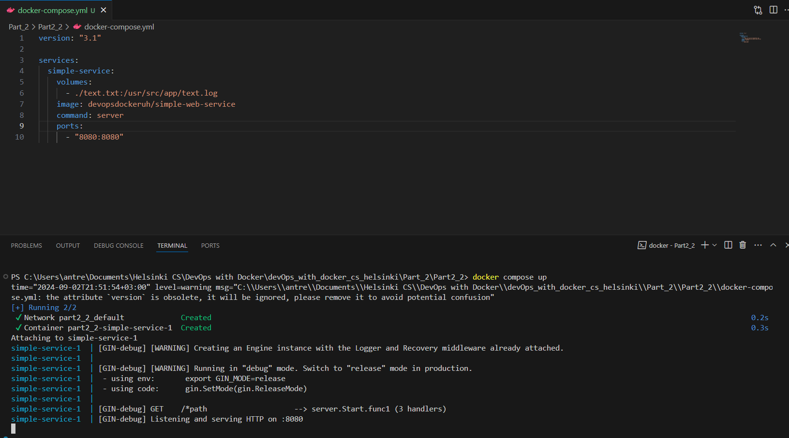
We can see the service is indeed running on port 8080
Run the command server to start a web service in port 8080. We have declared that port as available

