
DecOps with Docker
Mooc.fi

Interacting with the container via volumes and ports

EXERCISE 1.15: Cloud deployment



Student: Andreas Zelios

Part 1.9
text.log file of my working directory:

I decided to run devopsdockeruh/coursepage to the cloud using https://render.com.
The steps I followed were:
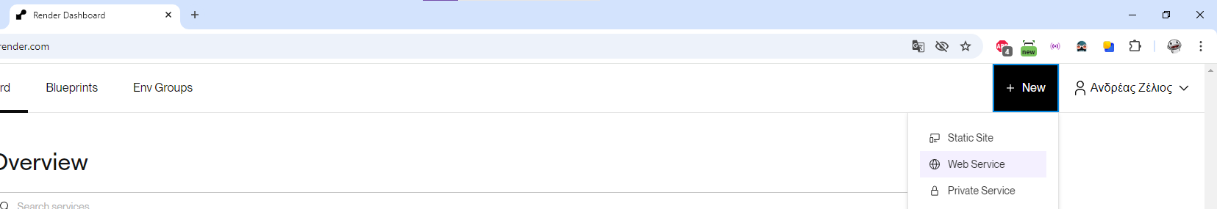
- Oper render.com and navigate to +New > Web Service

- Choose existing image and type the image in the dockerhub
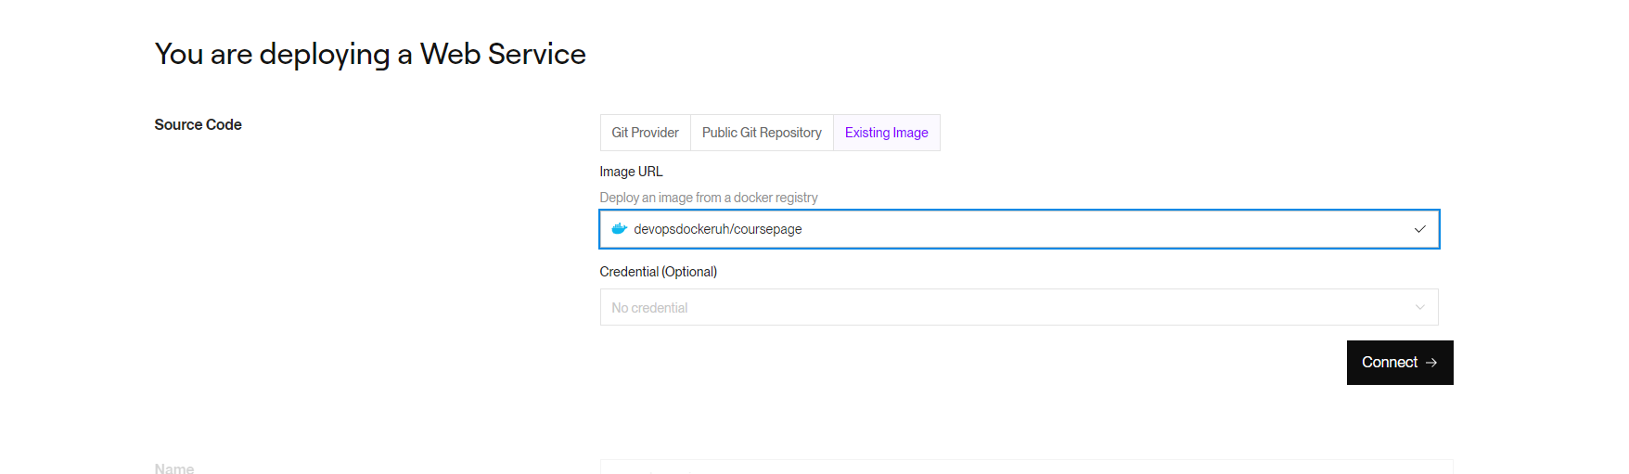
- Choose Free Plan and Deploy Web Service
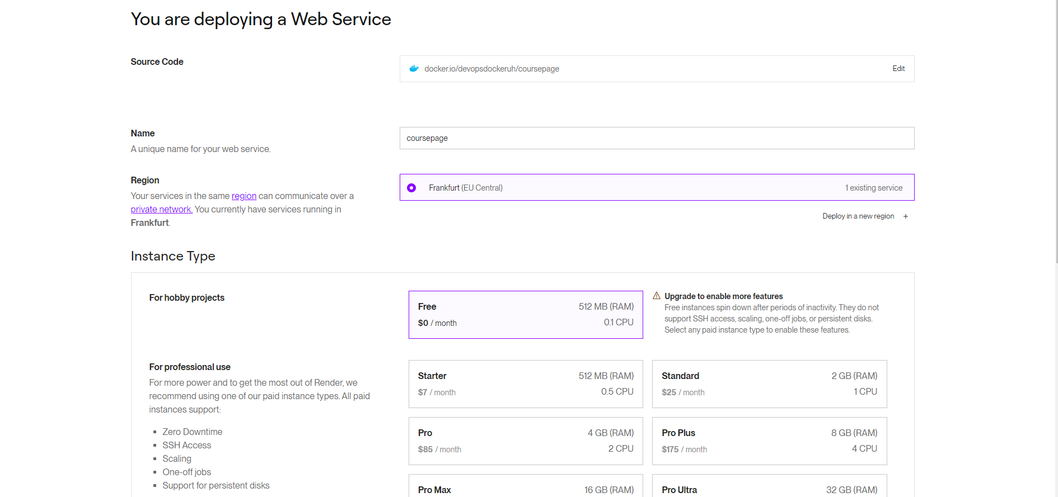
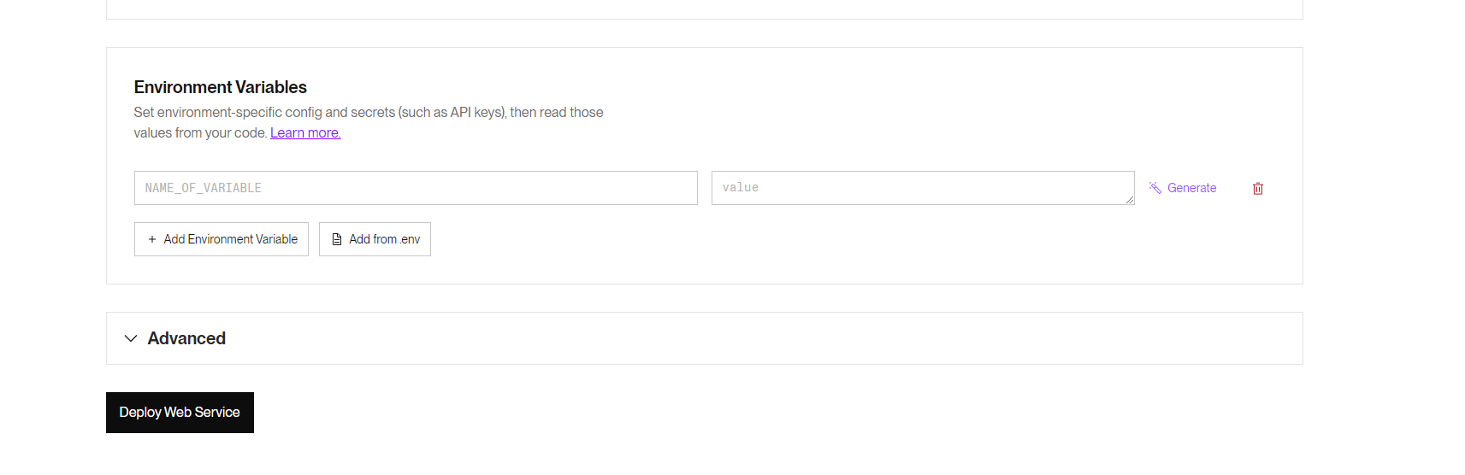

We can now see that it is deployed and can be accessed with https://sortinghelsinki.onrender.com
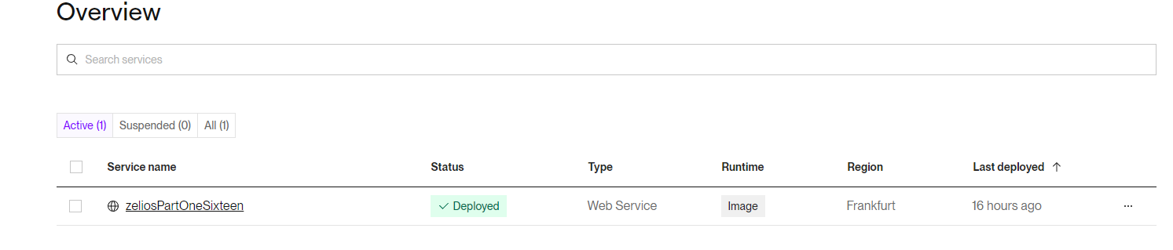
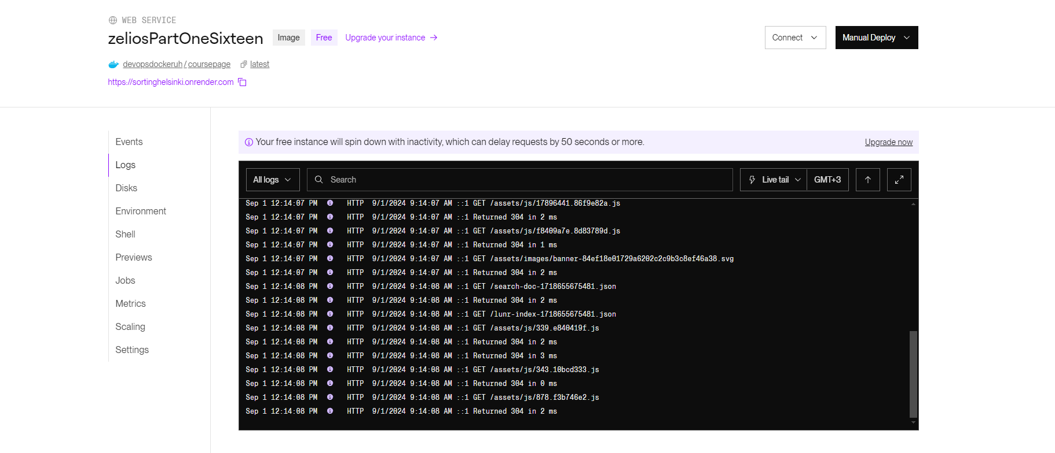
**Please note that free tier spin down after periods of inactivity, so if you try to access the website it might appear to be down**

