
DecOps with Docker
Mooc.fi

Interacting with the container via volumes and ports

EXERCISE 1.13: Hello, backend!

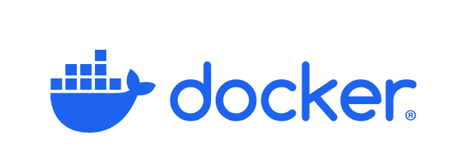

Student: Andreas Zelios

Part 1.9
text.log file of my working directory:

I run apt-get update && apt-get -y install wget tar to download wget in order to run wget https://go.dev/dl/go1.16.15.linux-amd64.tar.gz in order download go.
Next I run tar -C . -xzf go1.16.15.linux-amd64.tar.gz to extract the file in the current directory and set the environmental variable with ENV PATH="$PATH:/usr/src/app/go/bin".
Next I copy the backend project in my container with COPY . . and run go build as specified in README file to generate a binary named "server".
Finally I specify type docker build . -t go-project && docker run --rm -d -p 8080:8080 go-project ./server. This way I build the image and then run it specifying ./server as the README file states.
The result is the following:
