
DecOps with Docker
Mooc.fi

Migrating to Docker Compose

EXERCISE 2.3



Student: Andreas Zelios

Part 1.9
text.log file of my working directory:

As we can see in the docker-compose.yml, we create two services using the images previously built in Part 1, frontend and backend, the only difference is that we use command in backend to run the command server in our container:
As discussed in the lecture, we could define our env variables in the yml file, but we choose to keep it inside the image as we have already accomplish that in the previous part:
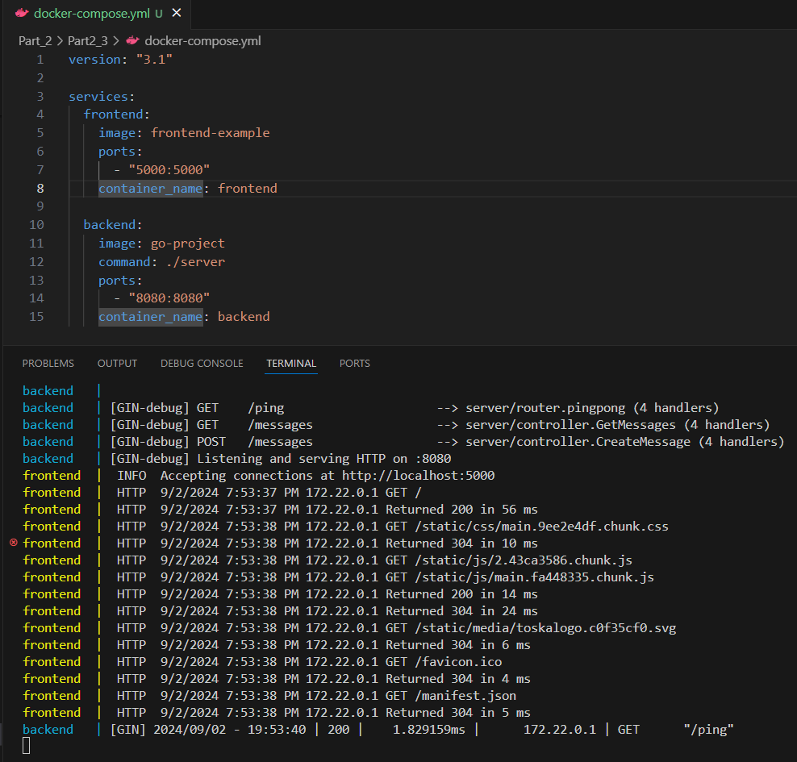

Seeing the logs we can verify that both services are running, typing localhost:5000 in the browser and clicking the test button also verifies this, as shown in the image bellow:
