Chocolate Sales BI Dashboard — End‑to‑End Analytics Project (Python & Streamlit)

Business Intelligence Report — 2024 Dataset

Prepared by: Andreas Koufopoulos
Business Intelligence & Data Analytics March 2026

Executive Summary

This report presents an end-to-end Business Intelligence solution developed using Python, Excel, and Streamlit, designed to analyze chocolate sales across multiple countries, products, and salespersons. The project transforms a raw Excel dataset into a fully interactive BI dashboard with dynamic filters, KPI indicators, drill-down capabilities, and automated PDF reporting.
The objective of this project is to provide business stakeholders with a clear, data-driven understanding of revenue performance, product profitability, and sales team effectiveness. The dashboard enables fast decision-making through intuitive visualizations, while the automated PDF generator produces professional reports suitable for management review.
This work demonstrates strong technical skills in Python-based analytics, data modeling, dashboard development, and BI storytelling — essential capabilities for modern Business Intelligence and Data Analyst roles.

Project Overview

The Chocolate Sales BI Dashboard was developed as a complete analytics pipeline, starting from raw Excel data and ending with a polished, interactive dashboard and exportable business report. The project focuses on analyzing sales performance for chocolate products across multiple regions and sales channels.

- Project Goals

- Transform raw transactional data into actionable insights

- Build a fully interactive dashboard using Python and Streamlit

- Provide clear KPI metrics for revenue, boxes shipped, and profitability

- Enable drill‑down analysis by country, product, and salesperson

- Automate the creation of a professional PDF report

- Deliver a clean, enterprise‑grade user interface

- Business Value

The dashboard supports decision‑makers by highlighting:

- High‑performing markets

- Top‑selling products

- Salesperson performance gaps

- Monthly revenue trends

- Profitability patterns

This project demonstrates the ability to deliver BI solutions that combine technical depth with business understanding.

Tools & Technologies

This project was developed using a modern analytics stack centered around Python.

- Programming & Development

- Python 3.x

- Visual Studio Code

- Python Libraries

- pandas — data cleaning, transformation, grouping

- plotly.express — interactive charts

- streamlit — dashboard UI and layout

- reportlab — automated PDF report generation

- openpyxl — Excel file handling

- io.BytesIO — in‑memory file creation

- Data Source

- Excel file: Data.xlsx

- Sheet: Data_Raw

- Year analyzed: 2024

These tools were selected to demonstrate a code‑driven BI workflow rather than a drag‑and‑drop approach.

Dataset Description

The dataset contains transactional sales records for chocolate products across multiple countries. Each row represents a sales transaction with associated product, salesperson, and profitability information.

- Key Columns

- Date

- Country

- Product

- Sales Person

- Amount (Revenue)

- Boxes Shipped

- Profitability Category (High / Medium / Low)

- Data Quality Issues Identified

- Inconsistent date formats

- Missing profitability values

- Profitability stored as text instead of numeric

- Unsorted month values

- Need for Year and Month extraction

- Data Preparation

- Converted dates to datetime

- Extracted Year and Month fields

- Applied ordered month categories (Jan–Dec)

- Mapped profitability to numeric scale (High=3, Medium=2, Low=1)

- Cleaned and filtered data based on user selections

This preparation ensured a clean, analysis‑ready dataset for the dashboard.

ETL Pipeline (Python)

The ETL pipeline was implemented entirely in Python using pandas and custom logic inside the Streamlit application.

- Extract

- Loaded Excel data using pandas.read_excel()

- Read the Data_Raw sheet

- Converted date fields to proper datetime format

- Transform

- Created Year and Month columns

- Applied month ordering for correct visualization

- Mapped profitability categories to numeric values

- Grouped data for KPIs, charts, and drill‑downs

- Applied filters for year, country, and product search

- Load

- Loaded transformed data into the Streamlit dashboard

- Generated grouped datasets for:

  - Monthly sales

  - Country performance

  - Top products

  - Salesperson leaderboard

- Passed filtered data to the PDF generator

This ETL pipeline ensures consistent, accurate, and dynamic analytics

Dashboard Architecture

The dashboard is structured into four main analytical sections, each designed to support different business questions.

- Executive Summary

- Total Revenue

- Total Boxes

- Average Sale Value

- Active Products

- Average Profitability

- YoY or MoM Growth

- Overview

- Monthly Sales Trend (with 3‑month rolling average)

- Sales by Country

- Products & Profitability

- Top 10 Products by Revenue

- Profitability vs Revenue Scatter Plot

- Sales Performance

- Salesperson Leaderboard

- Boxes Shipped by Salesperson

- Drill‑down Country View

- Top products in selected country

- Salesperson performance in selected country

- PDF Export Engine

- Automated PDF report using ReportLab

- Includes summary tables and insights

- Professional layout with corporate blue theme

This architecture ensures clarity, usability, and analytical depth.

Dashboard Features & Screenshots

Executive Summary KPIs
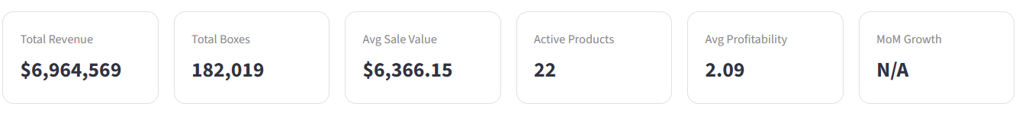
A clean KPI section summarizing revenue, boxes shipped, average sale value, product count, profitability, and growth metrics.

Monthly Sales Trend
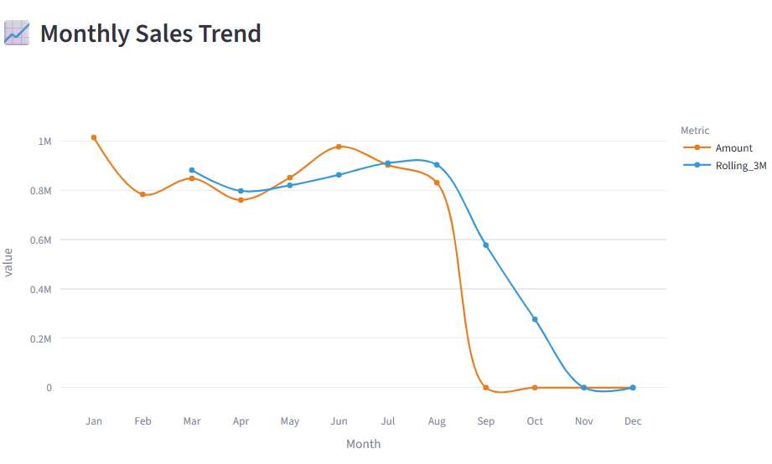
Line chart showing monthly revenue with a 3‑month rolling average.

Sales by Country
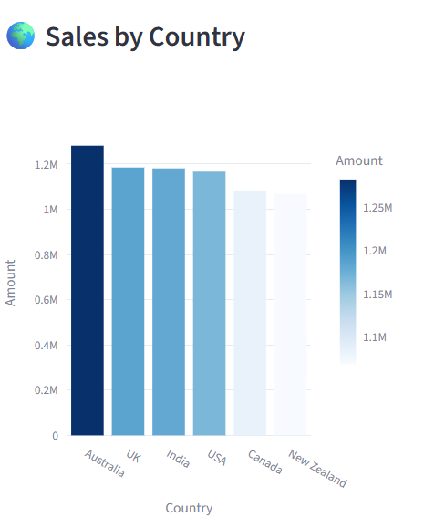
Bar chart highlighting revenue distribution across countries.

Top Products
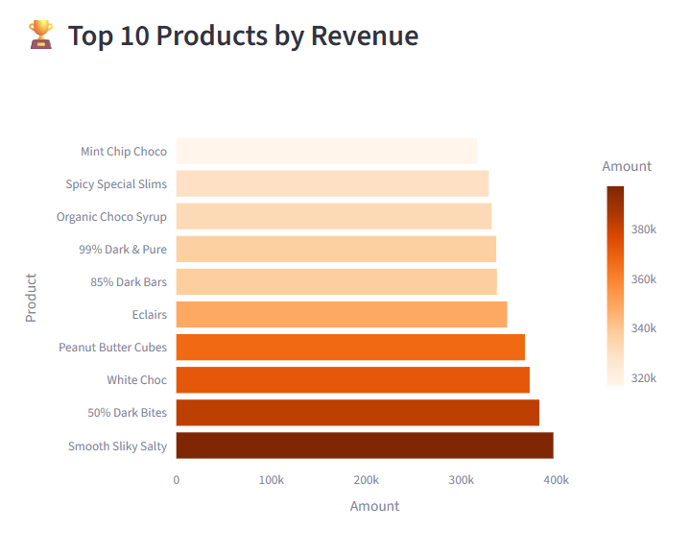
Horizontal bar chart showing the top 10 products by revenue.

Drill‑down Country View
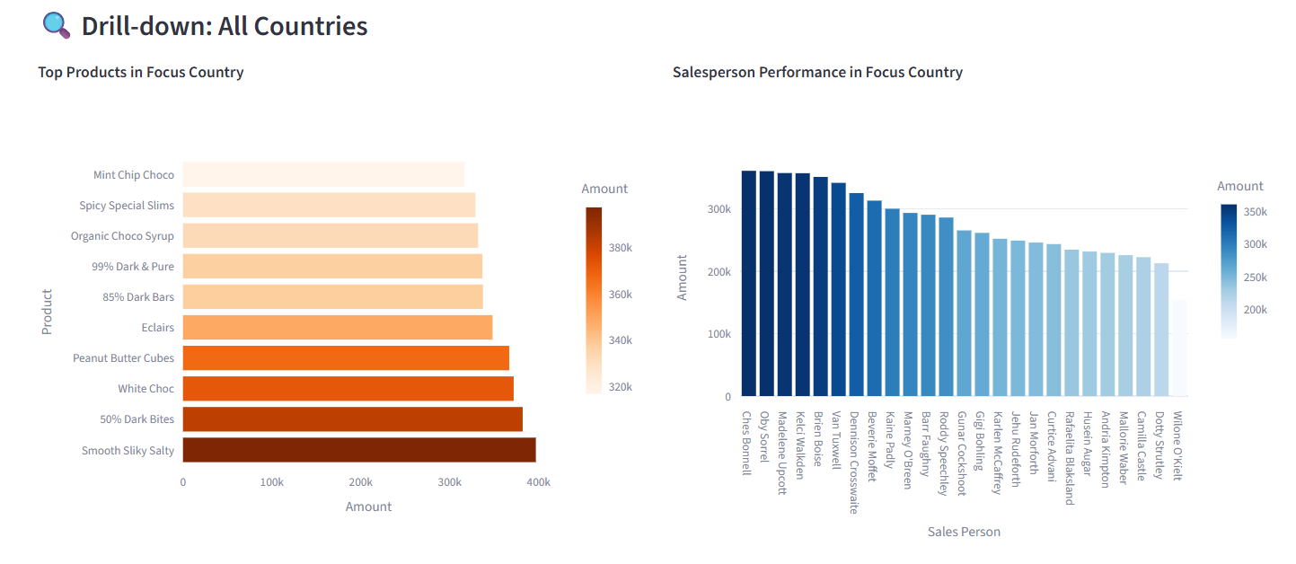
Country‑specific product and salesperson performance.

Business Insights

Based on the analysis of the 2024 dataset, the following insights were identified:

- Strongest market: Countries with the highest revenue contribution show consistent performance and strong demand.

- Weakest market: Lower‑performing regions may require targeted marketing or pricing adjustments.

- Product concentration: The top 10 products contribute a significant share of total revenue, indicating a concentrated product portfolio.

- Salesperson performance: Performance varies widely, revealing opportunities for training, incentives, or territory adjustments.

- Seasonality: Monthly trends show fluctuations that can guide inventory planning and promotional campaigns.

- Profitability: Mapping profitability categories to numeric values highlights products that generate revenue but may require margin optimization.

These insights support strategic decision‑making across sales, marketing, and operations.

Conclusion

The Chocolate Sales BI Dashboard successfully delivers a complete end‑to‑end analytics solution using Python, Excel, and Streamlit. Through a structured ETL pipeline, interactive visualizations, and automated PDF reporting, the project demonstrates the ability to transform raw data into meaningful business insights.

The dashboard provides stakeholders with a clear understanding of revenue performance, product profitability, and salesperson effectiveness. Its modular architecture allows for easy expansion, such as adding forecasting models, integrating SQL databases, or deploying the dashboard to the cloud.

This project highlights strong capabilities in data analysis, BI development, dashboard design, and business storytelling — essential skills for modern Business Intelligence and Data Analyst roles.

Appendix

Data Dictionary

- Date: Transaction date

- Country: Market where the sale occurred

- Product: Chocolate product sold

- Sales Person: Responsible salesperson

- Amount: Revenue generated

- Boxes: Units shipped

- Profitability Category: High / Medium / Low margin classification

Python Code Snippets

- Data loading

- Month ordering

- Profitability mapping

- PDF generation function

- Groupby logic for KPIs

