# Abbreviations

|  |  |
| --- | --- |
| **Abbreviations** | **Meaning** |
| AUC | area under the curve |
| CABG | coronary artery bypass grafting |
| CTO | chronic total occlusion |
| EF | ejection fraction |
| FDG PET/CT | 18F-fluorodeoxyglucose positron emission tomography/computed tomography |
| HEC | hyperinsulinemic euglycemic clamp |
| IQR | inter-quartile range (25th to 75th percentile) |
| LAD | left anterior descendent artery |
| LCx | left circumflex artery |
| MGU | myocardial glucose uptake |
| PCI | percutaneous coronary intervention |
| RCA | right coronary artery |
| ROC | receiver operator curve |
| SD | standard deviation |

# Figures

## Figure 1 - Patient flow diagram

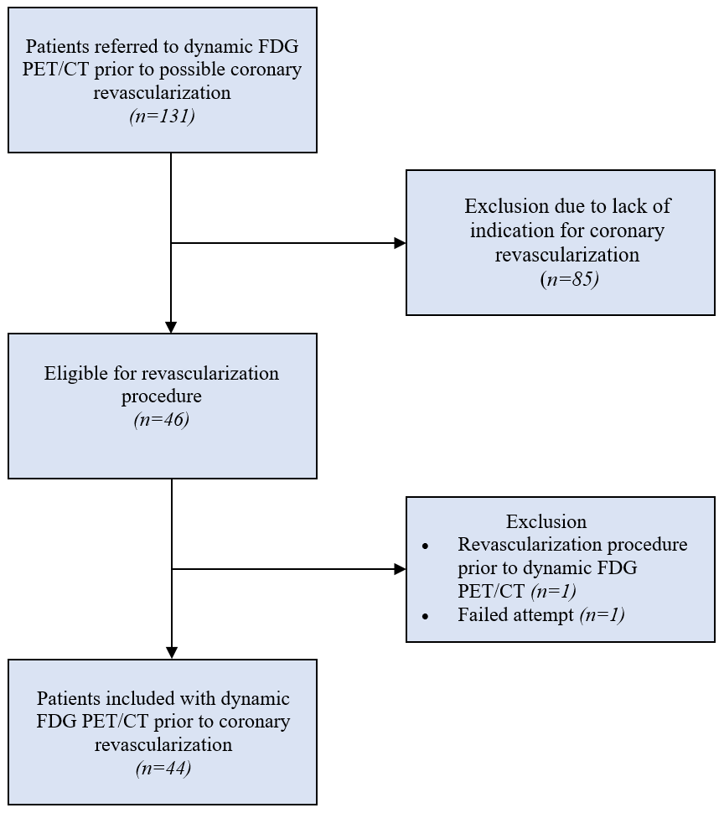

**Abbreviations:** FDG PET/CT, 18F-fluorodeoxyglucose positron emission tomography/computed tomography.   
**Notes:** Flow diagram showing the inclusion of patients from the 131 who were referred to the Department of Nuclear Medicine & PET-Centre to undergo cardiac viability PET/CT.

## Figure 2 - Example of a dynamic cardiac PET scan



**Notes:** Insert footnotes.

## Figure 3 - ROC curves of pre-intervention dynamic (MGU), static (hibernation), and perfusion PET measures for predicting LVEF-improvement of 5% or above

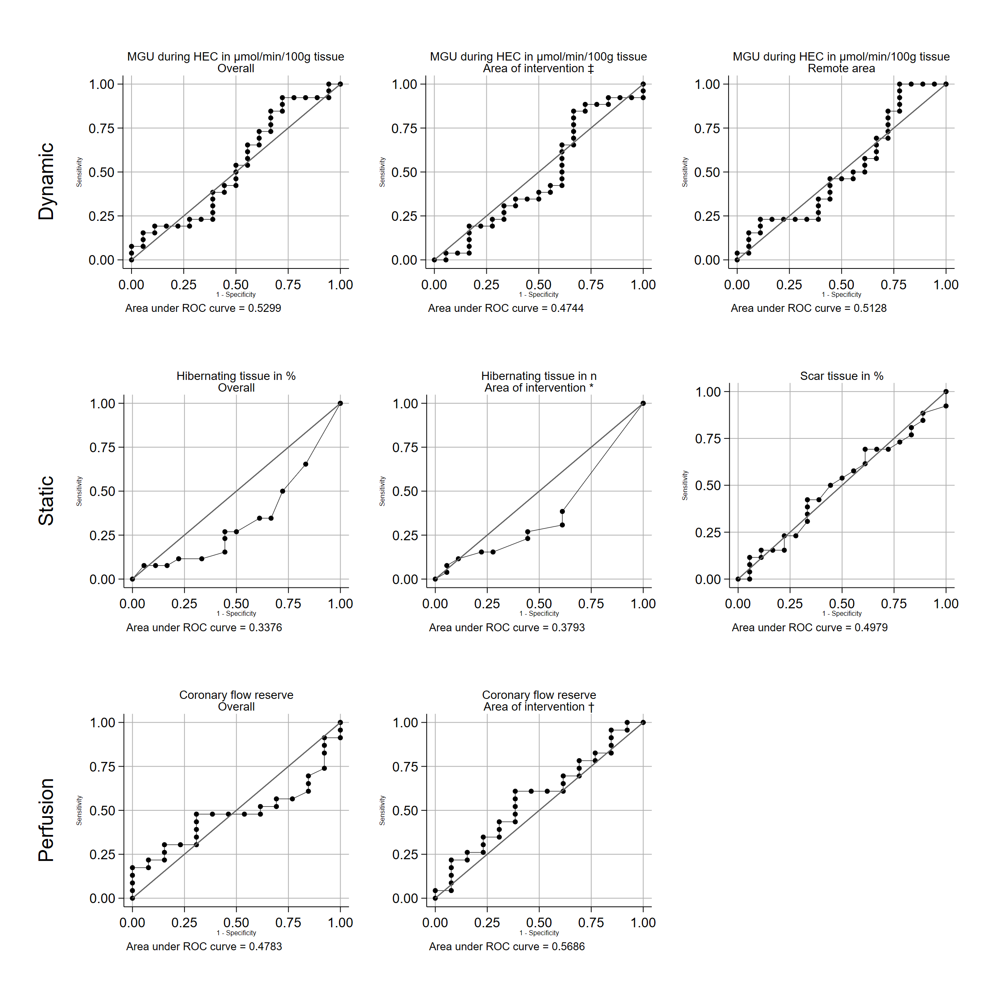

**Abbreviations:** EF, ejection fraction; HEC, hyperinsulinemic euglycemic clamp; MGU, myocardial glucose uptake; ROC, receiver operator curve.   
**Notes:** * † ‡ See table 1 footnotes.

## Figure 4 - Hibernating tissue and survival

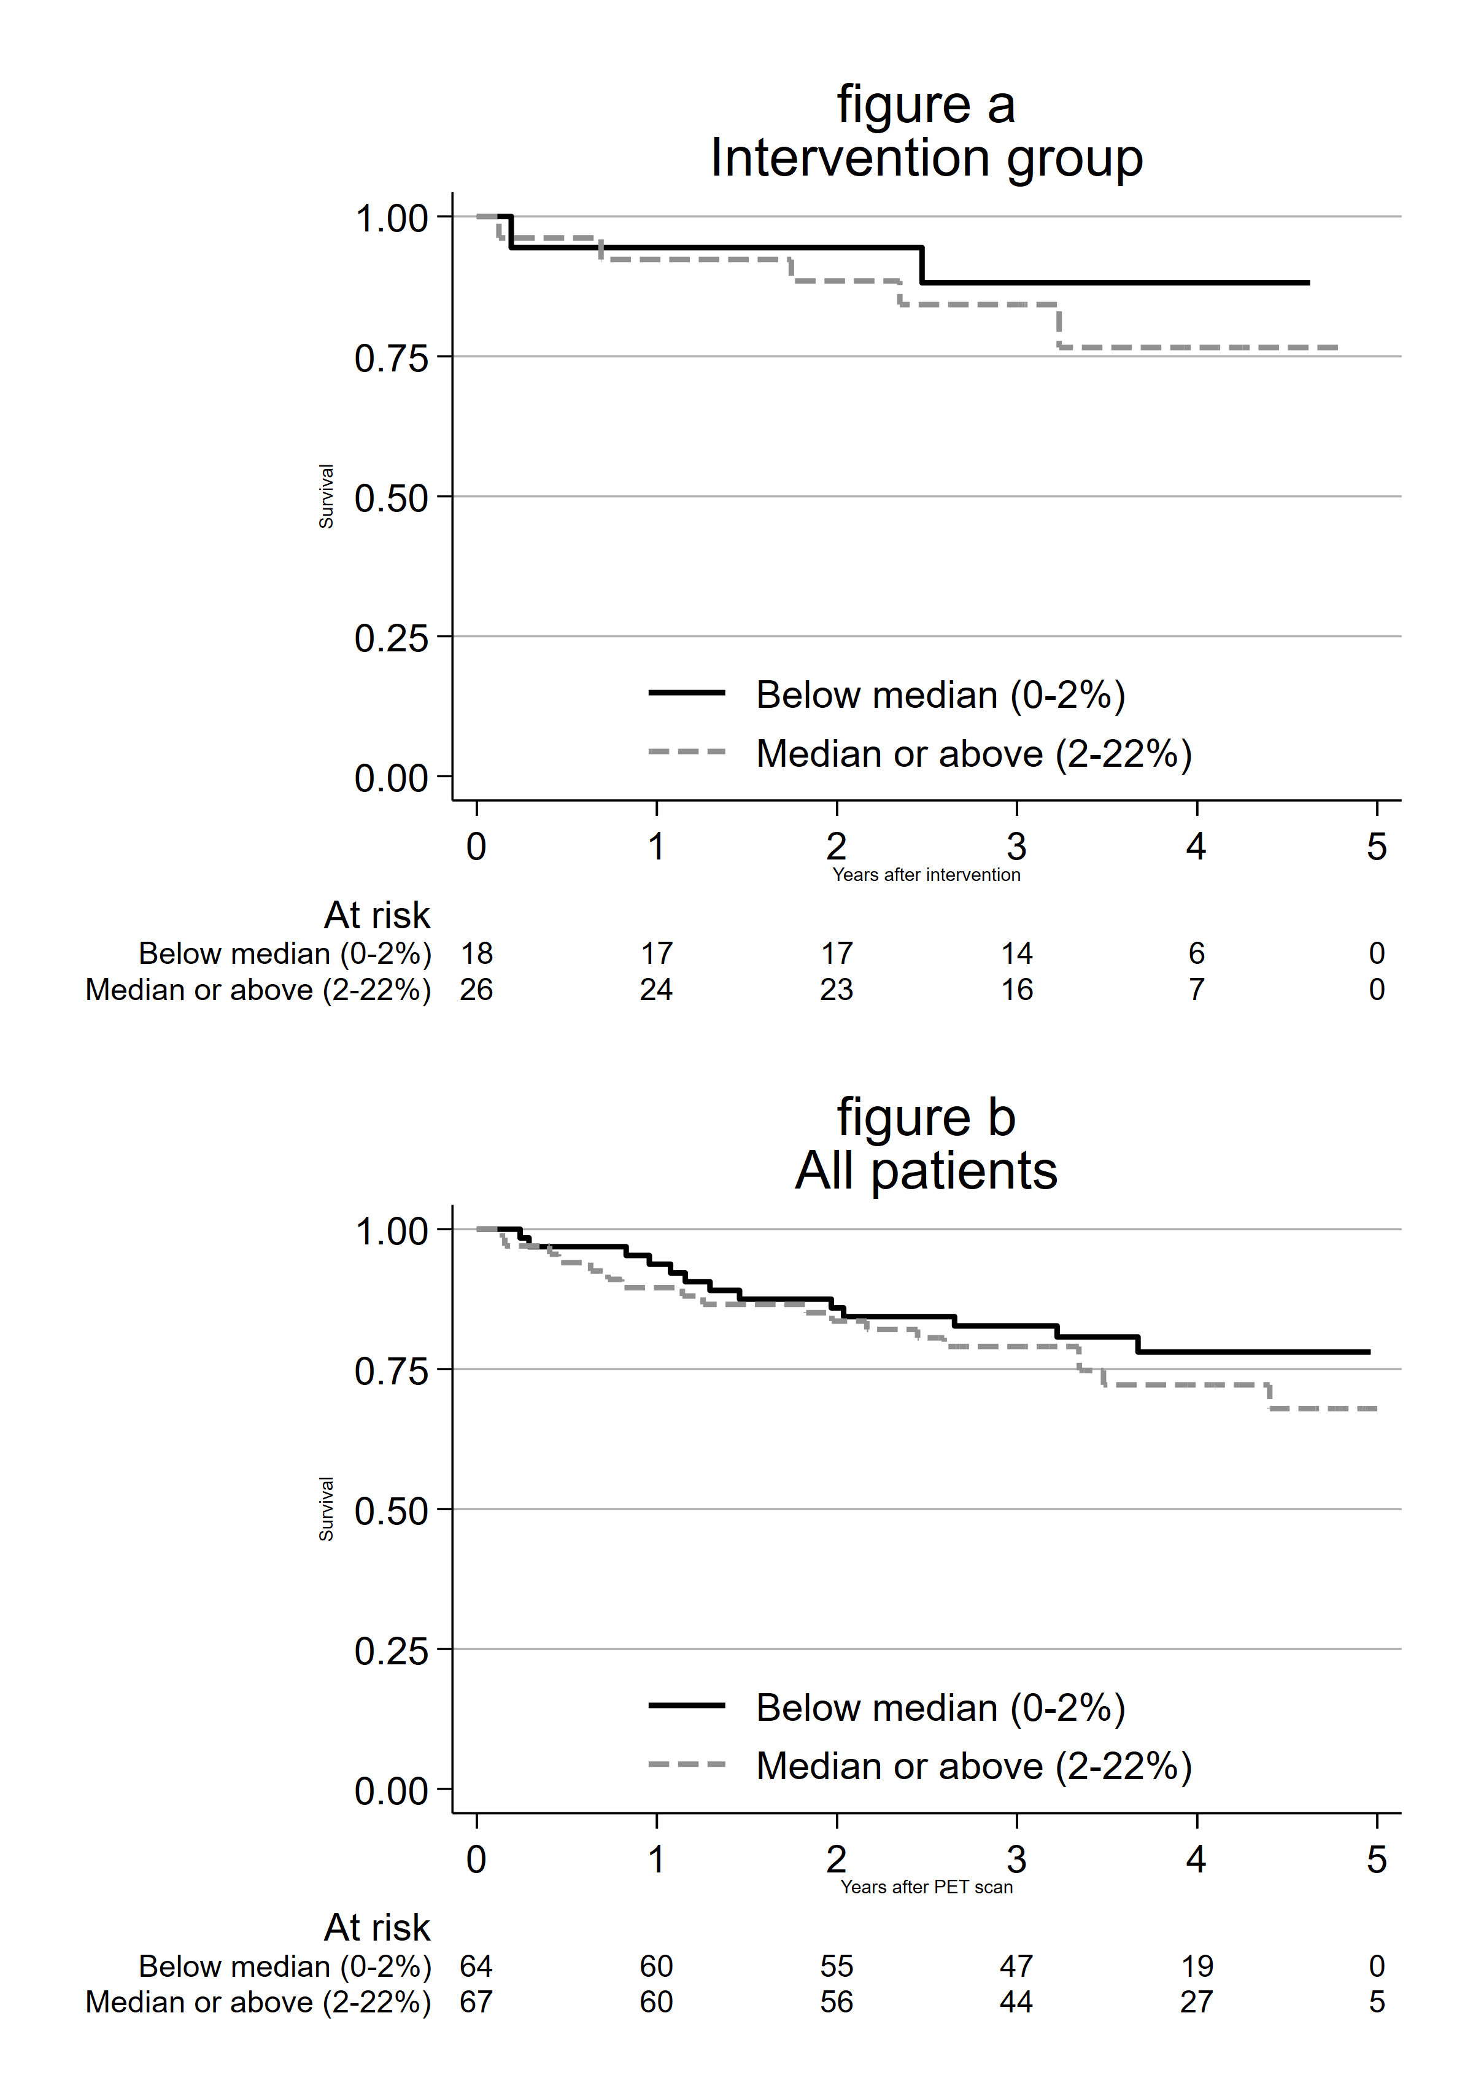

**Notes:** Kaplan-Meier survival curves by hibernation % (above versus below median) for the included patients who underwent intervention (a) and for all patients (b). Follow-up started at date of intervention (a) and date of PET scan (b), respectively. Number of patients at risk are shown below each figure.

# Tables

## Table 1 - Baseline patient characteristics

|  |  |
| --- | --- |
|  | **Total** |
| Patients, N | 44 |
| Patient characteristics |  |
| Age in years, mean (SD) | 64.9 (8.9) |
| Sex, n (%) |  |
| - Male | 39 (88.6) |
| - Female | 5 (11.4) |
| Diabetes status, n (%) |  |
| - Diabetes | 13 (29.5) |
| - No diabetes | 31 (70.5) |
| BMI in kg/m2, median (IQR) | 26.7 (24.5-30.3) |
| P-glucose during HEC in mM, median (IQR) | 5.1 (4.8-5.3) |
| Glucose infusion rate during HEC in mg/kg/min, median (IQR) | 3.7 (2.6-4.8) |
| Cardiac status |  |
| Ejection-fraction on echocardiography in %, mean (SD) |  |
| - Before intervention | 30.8 (9.8) |
| - After intervention | 36.4 (10.9) |
| Types of intervention, n (%) |  |
| - PCI without CTO | 21 (47.7) |
| - PCI with CTO | 16 (36.4) |
| - CABG | 7 (15.9) |
| Area of intervention, n (%) |  |
| - LAD | 9 (20.5) |
| - LCx | 8 (18.2) |
| - RCA | 7 (15.9) |
| - Multiple areas | 20 (45.5) |
| PET measurements |  |
| Scar tissue in %, median (IQR) | 14.0 (6.5-20.5) |
| Hibernating tissue, median (IQR) |  |
| - Overall in % | 2.0 (0.0-8.0) |
| - Area of intervention in n hibernating segments * | 0.0 (0.0-2.0) |
| Coronary flow reserve, median (IQR) |  |
| - Overall | 1.7 (1.3-2.1) |
| - Area of intervention † | 1.6 (1.2-2.1) |
| Myocardial glucose uptake during in µmol/min/100g tissue, median (IQR) |  |
| - Overall | 27.4 (17.7-36.7) |
| - Remote area | 33.8 (21.6-40.8) |
| - Area of intervention ‡ | 27.9 (18.8-35.8) |

**Abbreviations:** CABG, coronary artery bypass grafting; CTO, chronic total occlusion; HEC, hyperinsulinemic euglycemic clamp; IQR, inter-quartile range (25th to 75th percentile); LAD, left anterior descendent artery; LCx, left circumflex artery; PCI, percutaneous coronary intervention; RCA, right coronary artery; SD, standard deviation.   
**Notes:** Values are shown as mean (SD), n (%) or median (IQR range 25th to 75th percentile). * Number of segments in area of intervention (up to 17) with at least 10% hibernating tissue divided by the number of coronary arteries intervened upon. Example: 3 hibernating segments in LAD + 1 in RCA / 2 arteries = 2. † Average coronary flow reserve across the area(s) of intervention. ‡ Average myocardial glucose uptake across area(s) of intervention.

## Table 2 - Patient characteristics stratified by LVEF-improvement after revascularizatiion intervention

|  |  |  |  |
| --- | --- | --- | --- |
|  | **EF not improved** | **EF improved 5% or more** | **P-value** |
| Patients, N | 18 | 26 |  |
| Patient characteristics |  |  |  |
| Age in years, mean (SD) | 61.8 (7.3) | 67.1 (9.4) | 0.05 |
| Sex, n (%) |  |  |  |
| - Male | 16 (88.9) | 23 (88.5) | >0.99 |
| - Female | 2 (11.1) | 3 (11.5) |  |
| Diabetes status, n (%) |  |  |  |
| - Diabetes | 6 (33.3) | 7 (26.9) | 0.74 |
| - No diabetes | 12 (66.7) | 19 (73.1) |  |
| BMI in kg/m2, median (IQR) | 26.6 (23.5-32.3) | 26.7 (25.4-29.5) | >0.99 |
| P-glucose during HEC in mM, median (IQR) | 5.0 (4.8-5.2) | 5.2 (4.9-5.3) | 0.38 |
| Glucose infusion rate during HEC in mg/kg/min, median (IQR) | 3.4 (2.0-4.4) | 3.8 (2.8-4.9) | 0.21 |
| Cardiac status |  |  |  |
| Ejection-fraction on echocardiography in %, mean (SD) |  |  |  |
| - Before intervention | 31.9 (10.2) | 30.0 (9.7) | 0.52 |
| - After intervention | 31.1 (10.9) | 40.0 (9.5) | 0.006 |
| Types of intervention, n (%) |  |  |  |
| - PCI without CTO | 9 (50.0) | 12 (46.2) | >0.99 |
| - PCI with CTO | 6 (33.3) | 10 (38.5) |  |
| - CABG | 3 (16.7) | 4 (15.4) |  |
| Area of intervention, n (%) |  |  |  |
| - LAD | 4 (22.2) | 5 (19.2) | 0.21 |
| - LCx | 5 (27.8) | 3 (11.5) |  |
| - RCA | 4 (22.2) | 3 (11.5) |  |
| - Multiple areas | 5 (27.8) | 15 (57.7) |  |
| PET measurements |  |  |  |
| Scar tissue in %, median (IQR) | 13.5 (7.0-21.0) | 14.5 (6.0-20.0) | 0.99 |
| Hibernating tissue, median (IQR) |  |  |  |
| - Overall in % | 4.5 (1.0-9.0) | 1.5 (0.0-6.0) | 0.07 |
| - Area of intervention in n hibernating segments * | 1.0 (0.0-2.3) | 0.0 (0.0-1.5) | 0.15 |
| Coronary flow reserve, median (IQR) |  |  |  |
| - Overall | 1.7 (1.4-2.0) | 1.6 (1.2-2.2) | 0.84 |
| - Area of intervention † | 1.5 (1.1-1.8) | 1.6 (1.2-2.2) | 0.52 |
| Myocardial glucose uptake during in µmol/min/100g tissue, median (IQR) |  |  |  |
| - Overall | 28.0 (16.6-37.3) | 27.4 (18.8-33.7) | 0.75 |
| - Remote area | 34.5 (20.8-41.1) | 32.8 (21.8-38.3) | 0.90 |
| - Area of intervention ‡ | 32.6 (14.2-36.2) | 27.4 (19.2-35.5) | 0.79 |

**Abbreviations:** CABG, coronary artery bypass grafting; CTO, chronic total occlusion; HEC, hyperinsulinemic euglycemic clamp; IQR, inter-quartile range (25th to 75th percentile); LAD, left anterior descendent artery; LCx, left circumflex artery; PCI, percutaneous coronary intervention; RCA, right coronary artery; SD, standard deviation.   
**Notes:** P-values for differences were calculated using Fisher's exact test (sex, diabetes, type of intervention, and area of intervention), Student's t-test (age and ejection-fraction), and Wilcoxon rank-sum test (remaining variables). * † ‡ See table 1 footnotes.