# Results of various analyses not presented in the paper

## Patient characteristics stratified for diabetes status

|  |  |  |
| --- | --- | --- |
|  | **Diabetes** | **No diabetes** |
| Patients, N | 13 | 31 |
| Patient characteristics |  |  |
| Age in years, mean (SD) | 65.3 (10.0) | 64.7 (8.6) |
| Sex, n (%) |  |  |
| - Male | 10 (76.9) | 29 (93.5) |
| - Female | 3 (23.1) | 2 (6.5) |
| BMI in kg/m2, median (IQR) | 28.1 (25.4-30.5) | 26.7 (24.1-30.1) |
| P-glucose during HEC in mM, median (IQR) | 5.3 (5.2-6.3) | 5.1 (4.8-5.2) |
| Glucose infusion rate during HEC in mg/kg/min, median (IQR) | 2.8 (2.1-4.5) | 3.8 (2.7-5.0) |
| Cardiac status |  |  |
| Ejection-fraction on echocardiography in %, mean (SD) |  |  |
| - Before intervention | 28.8 (5.8) | 31.6 (11.1) |
| - After intervention | 34.2 (8.1) | 37.3 (11.9) |
| Types of intervention, n (%) |  |  |
| - PCI without CTO | 3 (23.1) | 18 (58.1) |
| - PCI with CTO | 6 (46.2) | 10 (32.3) |
| - CABG | 4 (30.8) | 3 (9.7) |
| Area of intervention, n (%) |  |  |
| - LAD | 2 (15.4) | 7 (22.6) |
| - LCx | 2 (15.4) | 6 (19.4) |
| - RCA | 1 (7.7) | 6 (19.4) |
| - Multiple areas | 8 (61.5) | 12 (38.7) |
| PET measurements |  |  |
| Scar tissue in %, median (IQR) | 11.0 (7.0-18.0) | 15.0 (6.0-22.0) |
| Hibernating tissue, median (IQR) |  |  |
| - Overall in % | 4.0 (1.0-9.0) | 2.0 (0.0-8.0) |
| - Area of intervention in n hibernating segments * | 1.0 (0.0-2.0) | 0.0 (0.0-2.0) |
| Coronary flow reserve, median (IQR) |  |  |
| - Overall | 1.6 (1.3-2.2) | 1.7 (1.3-2.0) |
| - Area of intervention † | 1.3 (1.1-1.8) | 1.7 (1.2-2.1) |
| Myocardial glucose uptake during in µmol/min/100g tissue, median (IQR) |  |  |
| - Overall | 25.6 (12.4-32.8) | 29.4 (20.3-37.3) |
| - Remote area | 29.2 (15.0-37.6) | 34.4 (24.7-41.1) |
| - Area of intervention ‡ | 27.3 (13.8-35.3) | 28.1 (21.1-36.2) |

**Abbreviations:** CABG, coronary artery bypass grafting; CTO, chronic total occlusion; HEC, hyperinsulinemic euglycemic clamp; IQR, inter-quartile range (25th to 75th percentile); LAD, left anterior descendent artery; LCx, left circumflex artery; PCI, percutaneous coronary intervention; RCA, right coronary artery; SD, standard deviation.   
**Notes:** Prespecified analysis. Not presented in paper as it did not add any new insights. * † ‡ See table 1 footnotes in manuscript.

## ROC AUC sensitivity analysis stratified by patient characteristics

|  |  |  |  |  |  |  |  |  |  |
| --- | --- | --- | --- | --- | --- | --- | --- | --- | --- |
|  | **N EF improved_P/N total** | **Hibernating tissue in %_pOverall** | **Hibernating tissue in n_pArea of intervention \*** | **Scar tissue in %** | **Coronary flow reserve_pOverall** | **Coronary flow reserve_pArea of intervention †** | **MGU during HEC in µmol/min/100g tissue_pOverall** | **MGU during HEC in µmol/min/100g tissue_pRemote area** | **MGU during HEC in µmol/min/100g tissue_pArea of intervention ‡** |
| Overall | 26/44 | 0.34_p(0.17-0.50) | 0.38_p(0.22-0.54) | 0.50_p(0.32-0.68) | 0.48_p(0.29-0.67) | 0.57_p(0.37-0.77) | 0.53_p(0.35-0.71) | 0.51_p(0.33-0.70) | 0.47_p(0.29-0.66) |
| Patient characteristics |  |  |  |  |  |  |  |  |  |
| Sex |  |  |  |  |  |  |  |  |  |
| - Men | 23/39 | 0.35_p(0.17-0.52) | 0.41_p(0.24-0.58) | 0.49_p(0.30-0.68) | 0.46_p(0.26-0.66) | 0.50_p(0.29-0.71) | 0.52_p(0.32-0.72) | 0.50_p(0.30-0.71) | 0.48_p(0.27-0.68) |
| - Women | 3/5 | 0.25_p(0.00-0.77) | 0.25_p(0.00-0.77) | 0.50_p(0.00-1.00) | 0.75_p(0.06-1.00) | 1.00_p(1.00-1.00) | 0.50_p(0.00-1.00) | 0.67_p(0.01-1.00) | 0.33_p(0.00-0.99) |
| Diabetes |  |  |  |  |  |  |  |  |  |
| - Yes | 7/13 | 0.31_p(0.00-0.64) | 0.32_p(0.00-0.65) | 0.79_p(0.51-1.00) | 0.33_p(0.00-0.71) | 0.42_p(0.00-0.88) | 0.76_p(0.43-1.00) | 0.76_p(0.43-1.00) | 0.62_p(0.26-0.97) |
| - No | 19/31 | 0.36_p(0.15-0.56) | 0.42_p(0.22-0.61) | 0.37_p(0.17-0.57) | 0.54_p(0.31-0.77) | 0.63_p(0.39-0.87) | 0.43_p(0.22-0.65) | 0.36_p(0.16-0.56) | 0.38_p(0.17-0.60) |
| Cardiac status |  |  |  |  |  |  |  |  |  |
| Pre-intervention EF |  |  |  |  |  |  |  |  |  |
| - Below median | 11/16 | 0.48_p(0.15-0.82) | 0.55_p(0.23-0.87) | 0.42_p(0.01-0.83) | 0.69_p(0.35-1.00) | 0.93_p(0.76-1.00) | 0.64_p(0.32-0.96) | 0.62_p(0.31-0.93) | 0.49_p(0.15-0.84) |
| - Above median | 15/28 | 0.29_p(0.09-0.49) | 0.33_p(0.13-0.52) | 0.47_p(0.24-0.69) | 0.44_p(0.19-0.68) | 0.48_p(0.23-0.73) | 0.46_p(0.23-0.70) | 0.44_p(0.21-0.68) | 0.43_p(0.20-0.66) |
| Area of intervention, n (%) |  |  |  |  |  |  |  |  |  |
| - LAD | 5/9 | 0.58_p(0.15-1.00) | 0.50_p(0.07-0.93) | 0.25_p(0.00-0.68) | 0.58_p(0.00-1.00) | 0.50_p(0.00-1.00) | 0.55_p(0.08-1.00) | 0.40_p(0.00-0.89) | 0.45_p(0.00-0.92) |
| - LCx | 3/8 | 0.13_p(0.00-0.44) | 0.20_p(0.00-0.44) | 0.53_p(0.00-1.00) | 0.67_p(0.01-1.00) | 0.93_p(0.75-1.00) | 0.47_p(0.00-1.00) | 0.40_p(0.00-1.00) | 0.40_p(0.00-1.00) |
| - RCA | 3/7 | 0.12_p(0.00-0.41) | 0.37_p(0.00-0.79) | 0.25_p(0.00-0.66) | 0.78_p(0.29-1.00) | 0.56_p(0.00-1.00) | 0.83_p(0.46-1.00) | 0.75_p(0.33-1.00) | 0.67_p(0.17-1.00) |
| - Multiple areas | 15/20 | 0.36_p(0.00-0.73) | 0.39_p(0.08-0.70) | 0.56_p(0.31-0.81) | 0.21_p(0.00-0.43) | 0.29_p(0.05-0.53) | 0.47_p(0.10-0.83) | 0.53_p(0.13-0.93) | 0.48_p(0.10-0.86) |

**Abbreviations:** EF, ejection fraction; LAD, left anterior descendent artery; LCx, left circumflex artery; RCA, right coronary artery.   
**Notes:** Sensitivity analysis to check if AUC varied by patient characteristics. The analysis was prespecified in statistical analysis plan. The analysis is mentioned but not not presented in paper as the analysis did not add any new insights. * † ‡ See table 1 footnotes in manuscript.

## ROC curves for predicting LVEF-improvement of 10% or above

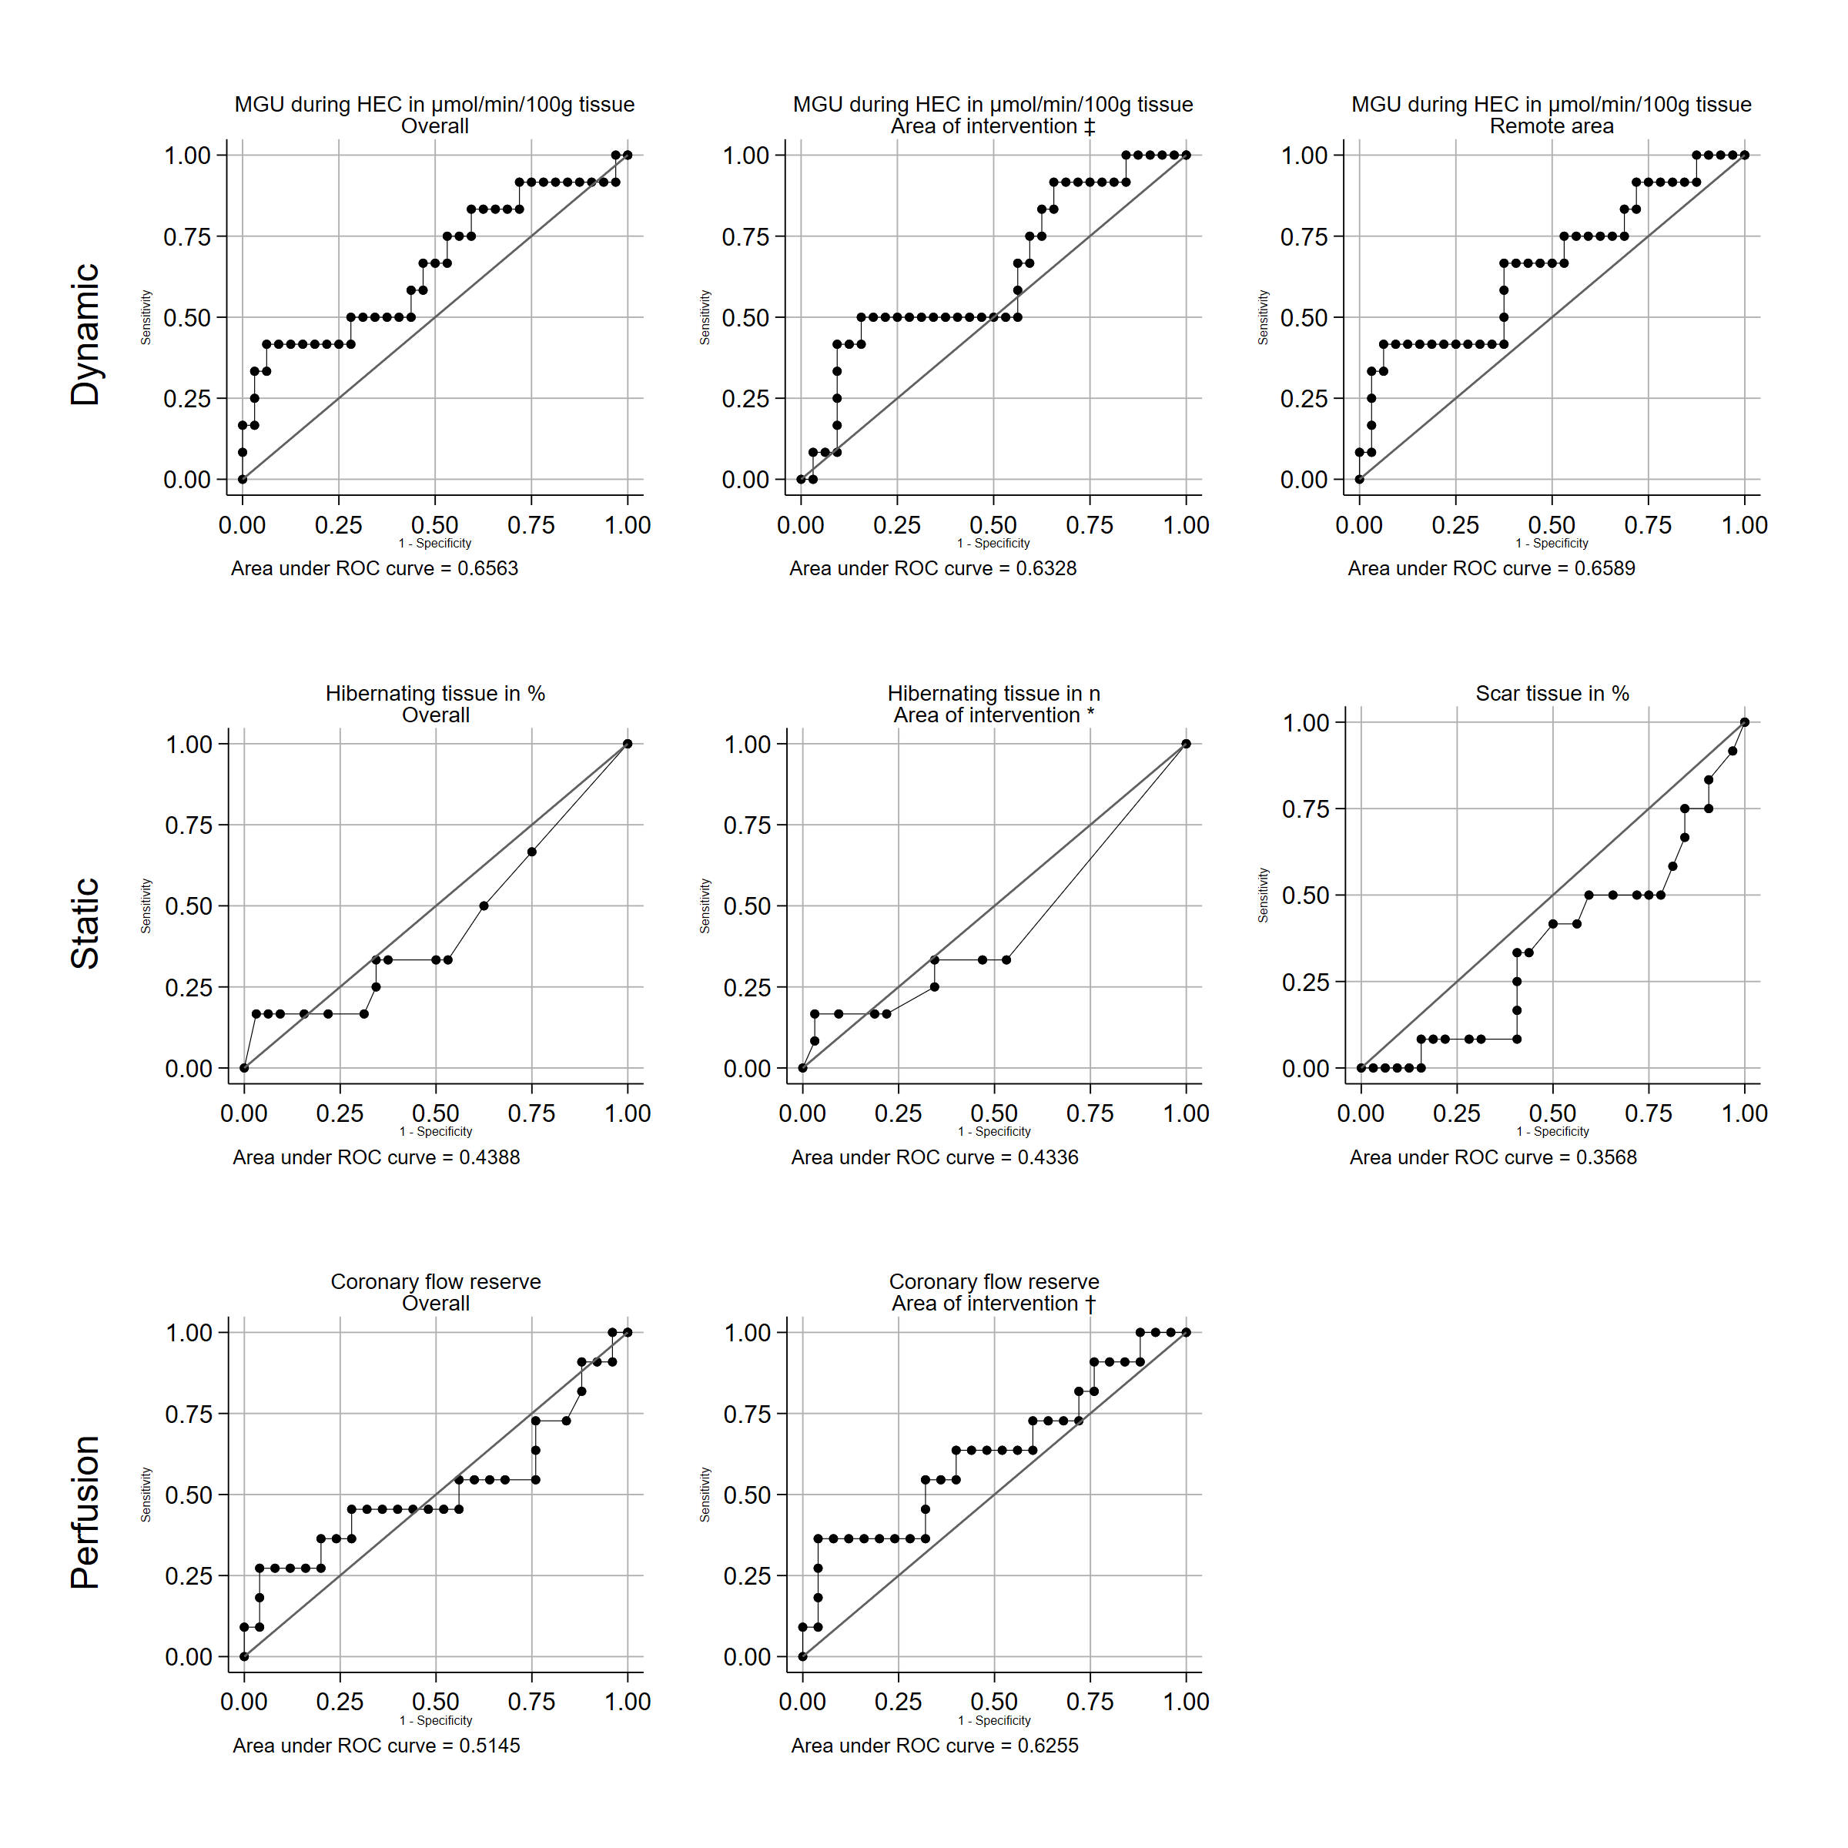

**Abbreviations:** EF, ejection fraction; HEC, hyperinsulinemic euglycemic clamp; MGU, myocardial glucose uptake; ROC, receiver operator curve.   
**Notes:** Secondary outcome, described but not presented in paper. * † ‡ See table 1 footnotes in manuscript.