resultater.gruppe

── Attaching core tidyverse packages ──────────────────────── tidyverse 2.0.0 ──  
✔ dplyr 1.1.2 ✔ readr 2.1.4  
✔ forcats 1.0.0 ✔ stringr 1.5.0  
✔ ggplot2 3.4.3 ✔ tibble 3.2.1  
✔ lubridate 1.9.2 ✔ tidyr 1.3.0  
✔ purrr 1.0.2   
── Conflicts ────────────────────────────────────────── tidyverse_conflicts() ──  
✖ dplyr::filter() masks stats::filter()  
✖ dplyr::lag() masks stats::lag()  
ℹ Use the conflicted package (<http://conflicted.r-lib.org/>) to force all conflicts to become errors  
Loading required package: Matrix  
  
  
Attaching package: 'Matrix'  
  
  
The following objects are masked from 'package:tidyr':  
  
 expand, pack, unpack  
  
  
Loading required package: lpSolve

Warning: package 'lpSolve' was built under R version 4.3.3

Attaching package: 'cowplot'  
  
The following object is masked from 'package:lubridate':  
  
 stamp

Warning: package 'psych' was built under R version 4.3.3

Attaching package: 'psych'  
  
The following objects are masked from 'package:ggplot2':  
  
 %+%, alpha

Adding missing grouping variables: `sex`

# A tibble: 168 × 7  
# Groups: id, period, sex, test [84]  
 sex id period test change timepoint values  
 <chr> <fct> <chr> <chr> <dbl> <fct> <dbl>  
 1 f 1 1 max 116. post 1913.  
 2 f 1 1 max 116. pre 1797   
 3 f 1 2 max 58.5 post 1996.  
 4 f 1 2 max 58.5 pre 1937.  
 5 f 2 1 max 124. post 2059.  
 6 f 2 1 max 124. pre 1934.  
 7 f 2 2 max 196. post 2174.  
 8 f 2 2 max 196. pre 1978.  
 9 m 3 1 max 253. post 4206.  
10 m 3 1 max 253. pre 3953.  
# ℹ 158 more rows

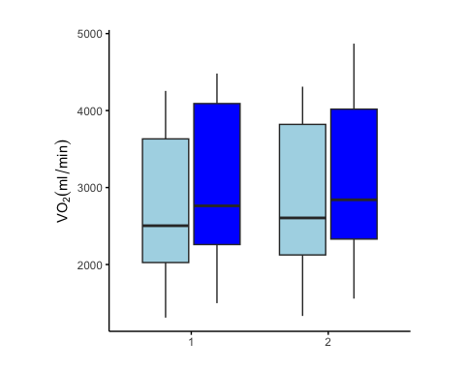

Adding missing grouping variables: `sex`

# A tibble: 168 × 7  
# Groups: id, period, sex, test [84]  
 sex id period test change timepoint values  
 <chr> <fct> <chr> <chr> <dbl> <fct> <dbl>  
 1 f 1 1 max -0.833 post 152.  
 2 f 1 1 max -0.833 pre 153.  
 3 f 1 2 max -2 post 160   
 4 f 1 2 max -2 pre 162   
 5 f 2 1 max 25.5 post 190.  
 6 f 2 1 max 25.5 pre 165.  
 7 f 2 2 max 21.2 post 201.  
 8 f 2 2 max 21.2 pre 180.  
 9 m 3 1 max 9.50 post 352.  
10 m 3 1 max 9.50 pre 343.  
# ℹ 158 more rows

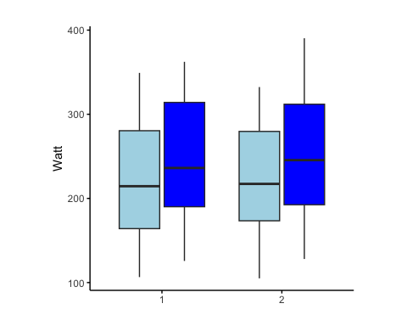

Adding missing grouping variables: `sex`

# A tibble: 168 × 7  
# Groups: id, period, sex, test [84]  
 sex id period test change timepoint values  
 <chr> <fct> <chr> <chr> <dbl> <fct> <dbl>  
 1 f 1 1 per 11.7 post 101.   
 2 f 1 1 per 11.7 pre 89.5  
 3 f 1 2 per 1.46 post 101.   
 4 f 1 2 per 1.46 pre 99.4  
 5 f 2 1 per 17.1 post 120.   
 6 f 2 1 per 17.1 pre 103.   
 7 f 2 2 per 16.3 post 127.   
 8 f 2 2 per 16.3 pre 110.   
 9 m 3 1 per -6.58 post 229.   
10 m 3 1 per -6.58 pre 236.   
# ℹ 158 more rows



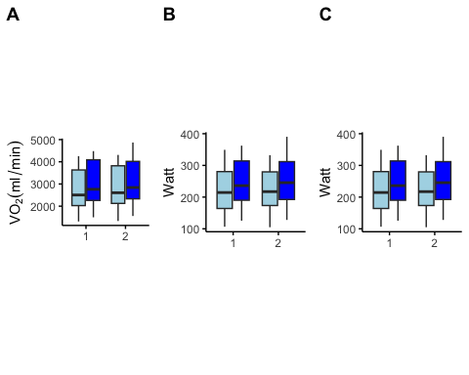

# A tibble: 1 × 5  
 mean_diff mean sd_diff te cv  
 <dbl> <dbl> <dbl> <dbl> <dbl>  
1 -3.49 2834. 85.3 60.3 2.13

# A tibble: 1 × 5  
 mean_diff mean sd_diff te cv  
 <dbl> <dbl> <dbl> <dbl> <dbl>  
1 -2.07 225. 9.88 6.99 3.11

# A tibble: 1 × 5  
 mean_diff mean sd_diff te cv  
 <dbl> <dbl> <dbl> <dbl> <dbl>  
1 -0.41 140. 8.55 6.05 4.32

# A tibble: 3 × 3  
 variables te cv  
 <chr> <dbl> <dbl>  
1 vo2max 60.3 2.13  
2 wmax 6.99 3.11  
3 w15min 6.05 4.32

| variables | te | cv |
| --- | --- | --- |
| vo2max | 60.32 | 2.13 |
| wmax | 6.99 | 3.11 |
| w15min | 6.05 | 4.32 |

## create a plot that visualize if the mean diff is inside one TE

# A tibble: 84 × 14  
 id test vo2.change_1 vo2.change_2 watt.change_1 watt.change_2  
 <fct> <chr> <dbl> <dbl> <dbl> <dbl>  
 1 1 per 114. 147. 11.7 1.46  
 2 1 max 116. 58.5 -0.833 -2   
 3 2 per 109. 61.5 17.1 16.3   
 4 2 max 124. 196. 25.5 21.2   
 5 3 per 461. 279. -6.58 41.5   
 6 3 max 253. 258. 9.50 34.0   
 7 5 per 88.1 199. 7.96 18.0   
 8 5 max 211. 399. 25.3 31.8   
 9 7 per 200. 301. 18.3 21.6   
10 7 max 188. 226. 19.2 23   
# ℹ 74 more rows  
# ℹ 8 more variables: vo2.per.change_1 <dbl>, vo2.per.change_2 <dbl>,  
# watt.per.change_1 <dbl>, watt.per.change_2 <dbl>, diff.change.vo2 <dbl>,  
# diff.change.watt <dbl>, diff.pchange.vo2 <dbl>, diff.pchange.watt <dbl>

# A tibble: 42 × 13  
 id vo2.change_1 vo2.change_2 watt.change_1 watt.change_2 vo2.per.change_1  
 <fct> <dbl> <dbl> <dbl> <dbl> <dbl>  
 1 1 116. 58.5 -0.833 -2 6.45  
 2 2 124. 196. 25.5 21.2 6.42  
 3 3 253. 258. 9.50 34.0 6.39  
 4 5 211. 399. 25.3 31.8 7.20  
 5 7 188. 226. 19.2 23 14.3   
 6 8 135. 262. 20.3 20 6.24  
 7 9 379. 347. 26.8 39.3 9.45  
 8 10 167. -0.667 19 23.3 11.5   
 9 14 358. 208. 34.2 29.0 10.1   
10 15 44.7 352. 33.5 39 1.84  
# ℹ 32 more rows  
# ℹ 7 more variables: vo2.per.change_2 <dbl>, watt.per.change_1 <dbl>,  
# watt.per.change_2 <dbl>, diff.change.vo2 <dbl>, diff.change.watt <dbl>,  
# diff.pchange.vo2 <dbl>, diff.pchange.watt <dbl>

# A tibble: 42 × 7  
 id change.w15.1 `change.w15.2 ` diff.change.w15 p.change.w15.1  
 <fct> <dbl> <dbl> <dbl> <dbl>  
 1 1 11.7 1.46 -10.3 13.1   
 2 2 17.1 16.3 -0.815 16.6   
 3 3 -6.58 41.5 48.1 -2.79  
 4 5 7.96 18.0 10.0 5.40  
 5 7 18.3 21.6 3.30 32.3   
 6 8 9.32 12.1 2.76 11.1   
 7 9 15.5 24.1 8.65 7.37  
 8 10 17.6 18.2 0.621 28.1   
 9 14 22.7 10.3 -12.4 13.1   
10 15 3.19 22.1 18.9 2.83  
# ℹ 32 more rows  
# ℹ 2 more variables: p.change.w15.2 <dbl>, p.diff.change.w15 <dbl>

Joining with `by = join_by(id)`

# A tibble: 3 × 2  
 variables change.diff   
 <chr> <chr>   
1 vo2max 21.57 ± 183.18  
2 wmax 6.17 ± 15.79   
3 w15min 5.93 ± 14.7

# A tibble: 3 × 2  
 variables per.change.diff  
 <chr> <chr>   
1 vo2max 0.52 ± 6.5   
2 wmax 2.01 ± 6.92   
3 w15min 2.68 ± 10.21

Joining with `by = join_by(variables)`

# A tibble: 3 × 3  
 variables change.diff per.change.diff  
 <chr> <chr> <chr>   
1 vo2max 21.57 ± 183.18 0.52 ± 6.5   
2 wmax 6.17 ± 15.79 2.01 ± 6.92   
3 w15min 5.93 ± 14.7 2.68 ± 10.21

Joining with `by = join_by(variables)`

| variables | change.diff | per.change.diff | te | cv |
| --- | --- | --- | --- | --- |
| vo2max | 21.57 ± 183.18 | 0.52 ± 6.5 | 60.32 | 2.13 |
| wmax | 6.17 ± 15.79 | 2.01 ± 6.92 | 6.99 | 3.11 |
| w15min | 5.93 ± 14.7 | 2.68 ± 10.21 | 6.05 | 4.32 |

Adding missing grouping variables: `sex`

# A tibble: 84 × 7  
# Groups: id, period, sex, test [84]  
 sex id period test post pre change  
 <chr> <fct> <chr> <chr> <dbl> <dbl> <dbl>  
 1 f 1 1 max 152. 153. -0.833  
 2 f 1 2 max 160 162 -2   
 3 f 2 1 max 190. 165. 25.5   
 4 f 2 2 max 201. 180. 21.2   
 5 m 3 1 max 352. 343. 9.50   
 6 m 3 2 max 351. 317. 34.0   
 7 f 5 1 max 260. 235 25.3   
 8 f 5 2 max 262. 230. 31.8   
 9 f 7 1 max 126. 106. 19.2   
10 f 7 2 max 128 105 23   
# ℹ 74 more rows

Linear mixed model fit by REML ['lmerMod']  
Formula: change ~ period + (1 | id)  
 Data: lmm_wmax.g  
  
REML criterion at convergence: 668.2  
  
Scaled residuals:   
 Min 1Q Median 3Q Max   
-2.05278 -0.57060 -0.04089 0.51426 2.53417   
  
Random effects:  
 Groups Name Variance Std.Dev.  
 id (Intercept) 74.92 8.655   
 Residual 124.63 11.164   
Number of obs: 84, groups: id, 42  
  
Fixed effects:  
 Estimate Std. Error t value  
(Intercept) 23.915 2.180 10.972  
period2 6.167 2.436 2.531  
  
Correlation of Fixed Effects:  
 (Intr)  
period2 -0.559

Computing profile confidence intervals ...

# A tibble: 1 × 3  
 mean.diff.watt sd.diff.watt group  
 <dbl> <dbl> <chr>  
1 6.17 15.8 wmax

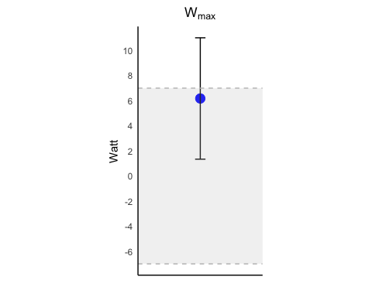

Adding missing grouping variables: `sex`

# A tibble: 84 × 7  
# Groups: id, period, sex, test [84]  
 sex id period test post pre change  
 <chr> <fct> <chr> <chr> <dbl> <dbl> <dbl>  
 1 f 1 1 max 1913. 1797 116.   
 2 f 1 2 max 1996. 1937. 58.5  
 3 f 2 1 max 2059. 1934. 124.   
 4 f 2 2 max 2174. 1978. 196.   
 5 m 3 1 max 4206. 3953. 253.   
 6 m 3 2 max 4462. 4204. 258.   
 7 f 5 1 max 3147. 2936. 211.   
 8 f 5 2 max 3243. 2845. 399.   
 9 f 7 1 max 1498 1310. 188.   
10 f 7 2 max 1557. 1332. 226.   
# ℹ 74 more rows

Linear mixed model fit by REML ['lmerMod']  
Formula: change ~ period + (1 | id)  
 Data: lmm_vo2.g  
  
REML criterion at convergence: 1054.7  
  
Scaled residuals:   
 Min 1Q Median 3Q Max   
-2.1451 -0.5224 -0.1197 0.5630 2.7312   
  
Random effects:  
 Groups Name Variance Std.Dev.  
 id (Intercept) 4264 65.3   
 Residual 16777 129.5   
Number of obs: 84, groups: id, 42  
  
Fixed effects:  
 Estimate Std. Error t value  
(Intercept) 255.28 22.38 11.405  
period2 21.57 28.27 0.763  
  
Correlation of Fixed Effects:  
 (Intr)  
period2 -0.631

Computing profile confidence intervals ...

# A tibble: 1 × 3  
 mean.diff.vo2 sd.diff.vo2 group  
 <dbl> <dbl> <chr>  
1 21.6 183. vo2

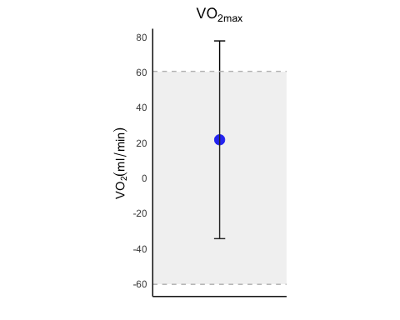

# A tibble: 84 × 6  
 id period test post pre change  
 <fct> <chr> <chr> <dbl> <dbl> <dbl>  
 1 1 1 per 101. 89.5 11.7   
 2 1 2 per 101. 99.4 1.46  
 3 2 1 per 120. 103. 17.1   
 4 2 2 per 127. 110. 16.3   
 5 3 1 per 229. 236. -6.58  
 6 3 2 per 244. 202. 41.5   
 7 5 1 per 155. 147. 7.96  
 8 5 2 per 163. 145. 18.0   
 9 7 1 per 74.9 56.6 18.3   
10 7 2 per 78.4 56.9 21.6   
# ℹ 74 more rows

Linear mixed model fit by REML ['lmerMod']  
Formula: change ~ period + (1 | id)  
 Data: lmm_w15.g  
  
REML criterion at convergence: 650.8  
  
Scaled residuals:   
 Min 1Q Median 3Q Max   
-2.1008 -0.4990 -0.0315 0.3548 2.9094   
  
Random effects:  
 Groups Name Variance Std.Dev.  
 id (Intercept) 49.49 7.035   
 Residual 108.08 10.396   
Number of obs: 84, groups: id, 42  
  
Fixed effects:  
 Estimate Std. Error t value  
(Intercept) 15.954 1.937 8.237  
period2 5.926 2.269 2.612  
  
Correlation of Fixed Effects:  
 (Intr)  
period2 -0.586

Computing profile confidence intervals ...

# A tibble: 1 × 3  
 mean.diff.watt sd.diff.watt group  
 <dbl> <dbl> <chr>  
1 5.93 14.7 w15

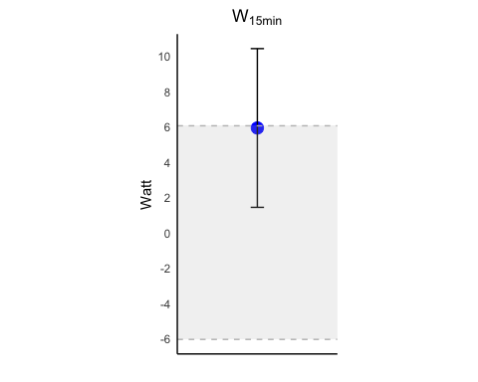

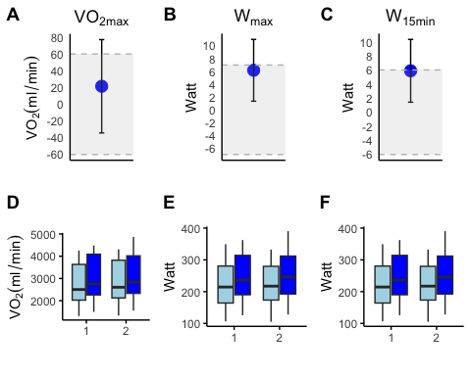

# A tibble: 84 × 7  
 id period test post pre change change.per  
 <fct> <chr> <chr> <dbl> <dbl> <dbl> <dbl>  
 1 1 1 max 1913. 1797 116. 6.45  
 2 1 2 max 1996. 1937. 58.5 3.02  
 3 2 1 max 2059. 1934. 124. 6.42  
 4 2 2 max 2174. 1978. 196. 9.89  
 5 3 1 max 4206. 3953. 253. 6.39  
 6 3 2 max 4462. 4204. 258. 6.14  
 7 5 1 max 3147. 2936. 211. 7.20  
 8 5 2 max 3243. 2845. 399. 14.0   
 9 7 1 max 1498 1310. 188. 14.3   
10 7 2 max 1557. 1332. 226. 16.9   
# ℹ 74 more rows

Linear mixed model fit by REML ['lmerMod']  
Formula: change.per ~ period + (1 | id)  
 Data: lmm_vo2.percent  
  
REML criterion at convergence: 493.7  
  
Scaled residuals:   
 Min 1Q Median 3Q Max   
-2.34983 -0.56189 0.00092 0.71148 2.97840   
  
Random effects:  
 Groups Name Variance Std.Dev.  
 id (Intercept) 0.9122 0.9551   
 Residual 21.1203 4.5957   
Number of obs: 84, groups: id, 42  
  
Fixed effects:  
 Estimate Std. Error t value  
(Intercept) 9.3643 0.7243 12.93  
period2 0.5215 1.0029 0.52  
  
Correlation of Fixed Effects:  
 (Intr)  
period2 -0.692

Computing profile confidence intervals ...

# A tibble: 1 × 2  
 mean.diff.vo2.per group  
 <dbl> <chr>  
1 0.522 vo2

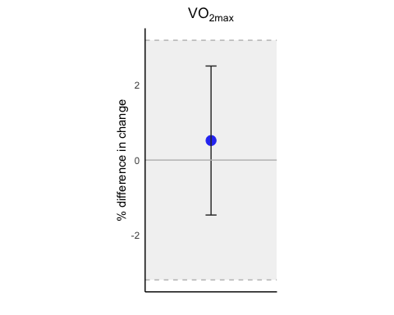

# A tibble: 84 × 7  
 id period test post pre change change.per  
 <fct> <chr> <chr> <dbl> <dbl> <dbl> <dbl>  
 1 1 1 max 152. 153. -0.833 -0.544  
 2 1 2 max 160 162 -2 -1.23   
 3 2 1 max 190. 165. 25.5 15.5   
 4 2 2 max 201. 180. 21.2 11.7   
 5 3 1 max 352. 343. 9.50 2.77   
 6 3 2 max 351. 317. 34.0 10.7   
 7 5 1 max 260. 235 25.3 10.8   
 8 5 2 max 262. 230. 31.8 13.9   
 9 7 1 max 126. 106. 19.2 18.0   
10 7 2 max 128 105 23 21.9   
# ℹ 74 more rows

Linear mixed model fit by REML ['lmerMod']  
Formula: change.per ~ period + (1 | id)  
 Data: lmm_wmax.percent  
  
REML criterion at convergence: 526.1  
  
Scaled residuals:   
 Min 1Q Median 3Q Max   
-1.99853 -0.59910 0.02819 0.57576 1.77805   
  
Random effects:  
 Groups Name Variance Std.Dev.  
 id (Intercept) 10.34 3.216   
 Residual 23.93 4.892   
Number of obs: 84, groups: id, 42  
  
Fixed effects:  
 Estimate Std. Error t value  
(Intercept) 11.3611 0.9033 12.577  
period2 2.0094 1.0674 1.883  
  
Correlation of Fixed Effects:  
 (Intr)  
period2 -0.591

Computing profile confidence intervals ...

# A tibble: 1 × 2  
 mean.diff.wmax.per group  
 <dbl> <chr>  
1 2.01 wmax

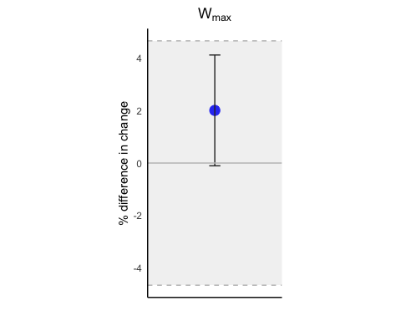

# A tibble: 84 × 7  
 id period test post pre change change.per  
 <fct> <chr> <chr> <dbl> <dbl> <dbl> <dbl>  
 1 1 1 per 101. 89.5 11.7 13.1   
 2 1 2 per 101. 99.4 1.46 1.47  
 3 2 1 per 120. 103. 17.1 16.6   
 4 2 2 per 127. 110. 16.3 14.7   
 5 3 1 per 229. 236. -6.58 -2.79  
 6 3 2 per 244. 202. 41.5 20.5   
 7 5 1 per 155. 147. 7.96 5.40  
 8 5 2 per 163. 145. 18.0 12.3   
 9 7 1 per 74.9 56.6 18.3 32.3   
10 7 2 per 78.4 56.9 21.6 37.9   
# ℹ 74 more rows

Linear mixed model fit by REML ['lmerMod']  
Formula: change.per ~ period + (1 | id)  
 Data: lmm_w15.percent  
  
REML criterion at convergence: 589.2  
  
Scaled residuals:   
 Min 1Q Median 3Q Max   
-1.8894 -0.5151 -0.1120 0.5227 2.0888   
  
Random effects:  
 Groups Name Variance Std.Dev.  
 id (Intercept) 21.69 4.657   
 Residual 52.15 7.222   
Number of obs: 84, groups: id, 42  
  
Fixed effects:  
 Estimate Std. Error t value  
(Intercept) 13.016 1.326 9.817  
period2 2.684 1.576 1.703  
  
Correlation of Fixed Effects:  
 (Intr)  
period2 -0.594

Computing profile confidence intervals ...

# A tibble: 1 × 2  
 mean.diff.w15.per group  
 <dbl> <chr>  
1 2.68 w15

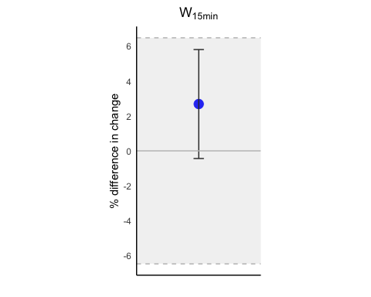

## a adataframe with CI, TE, CV and change

variables LowerCI UpperCI  
1 vo2max -1.4653031 2.508316  
2 wmax -0.1057828 4.124672  
3 w15min -0.4389876 5.806637

Joining with `by = join_by(variables)`

# A tibble: 3 × 7  
 variables change.diff per.change.diff LowerCI UpperCI cv consistency.range  
 <chr> <chr> <chr> <dbl> <dbl> <dbl> <dbl>  
1 vo2max 21.57 ± 183… 0.52 ± 6.5 -1.47 2.51 2.13 3.20  
2 wmax 6.17 ± 15.79 2.01 ± 6.92 -0.106 4.12 3.11 4.66  
3 w15min 5.93 ± 14.7 2.68 ± 10.21 -0.439 5.81 4.32 6.48

| variables | change.diff | per.change.diff | LowerCI | UpperCI | cv | consistency.range |
| --- | --- | --- | --- | --- | --- | --- |
| vo2max | 21.57 ± 183.18 | 0.52 ± 6.5 | -1.4653031 | 2.508316 | 2.13 | 3.195 |
| wmax | 6.17 ± 15.79 | 2.01 ± 6.92 | -0.1057828 | 4.124672 | 3.11 | 4.665 |
| w15min | 5.93 ± 14.7 | 2.68 ± 10.21 | -0.4389876 | 5.806637 | 4.32 | 6.480 |

