Chess Database

# 1. Introduction

This document is a summary of the chess database.

## 2. Statistics

The database contains 2600 games. The following sections describe the games in more detail.

# 2.1 General results

The following table shows the results of games.

|  |  |  |  |
| --- | --- | --- | --- |
|  | White wins | Draws | Black wins |
| Total | 704 | 1600 | 296 |
| Percentage | 27.08% | 61.54% | 11.38% |

## 2.1.1 Result table for Stockfish

The following table shows the results of games where Stockfish either won or lost, depending on Stockfish color

def create_document_result_table_with_stockfish(self, list_of_games, list_of_drawed_games):

|  |  |  |  |  |
| --- | --- | --- | --- | --- |
|  | Wins | Draws | Losses | Winning Percentage |
| Starts as white | 698 | 601 | 2 | 53.65% |
| Starts as black | 294 | 999 | 6 | 22.63% |
| Total | 992 | 1600 | 8 | 38.15% |

## 2.2 Move count distributions

The following graphs shows the distribution of the amount moves in the given set of games.

### 2.2.1 All games

The following graph shows the distribution of the amount moves in all games.

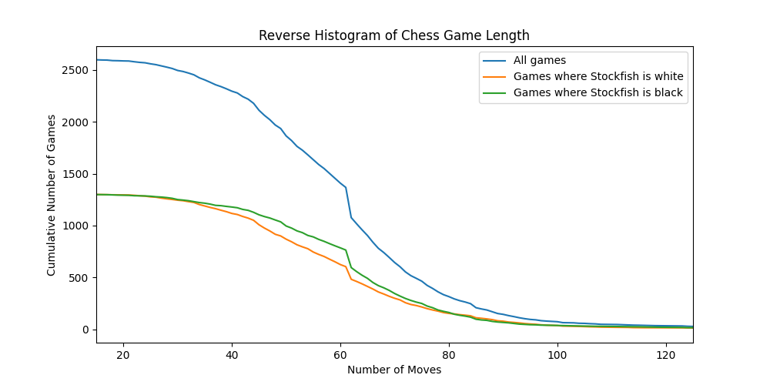

Mean and standard deviation table for all games

|  |  |  |
| --- | --- | --- |
|  | Mean | Standard Deviation |
| Number of moves | 60.33 | 19.58 |

### 2.2.2 Either stockfish won or draws

The following graph shows the distribution of the amount moves in games where Stockfish won.

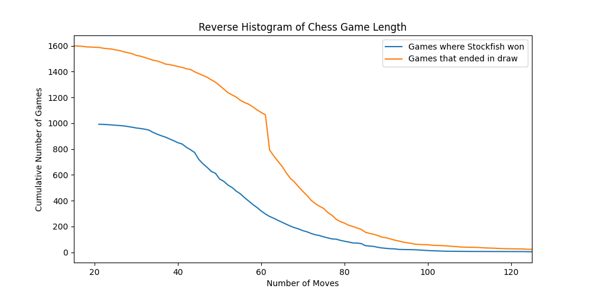

Mean and standard deviation table for games where Stockfish won or drew

|  |  |  |
| --- | --- | --- |
|  | Mean | Standard Deviation |
| Number of moves | 55.08 | 16.66 |

A noteworthy observation is that we get a spike in the distribution of moves when Stockfish draws.

### 2.2.3 Stockfish loses

The following graph shows the distribution of the amount moves in games where Stockfish lost.

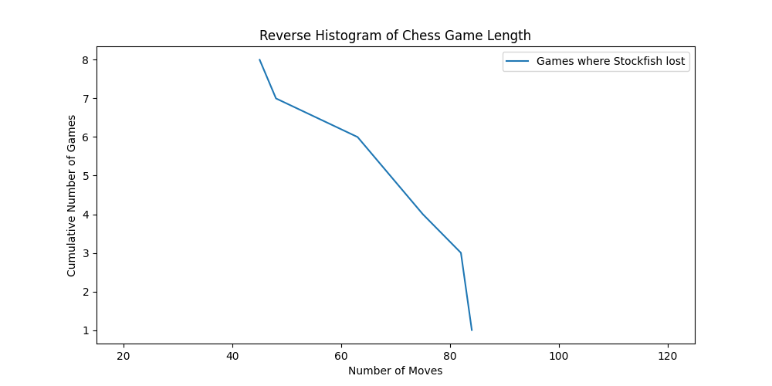

Mean and standard deviation table for games where Stockfish lost

|  |  |  |
| --- | --- | --- |
|  | Mean | Standard Deviation |
| Number of moves | 68.62 | 14.48 |

## 2.3 Plycount distribution

The following graph shows the distribution of plycount in the database.

The x-axis shows the plycount, and the y-axis shows the number of games with that plycount.

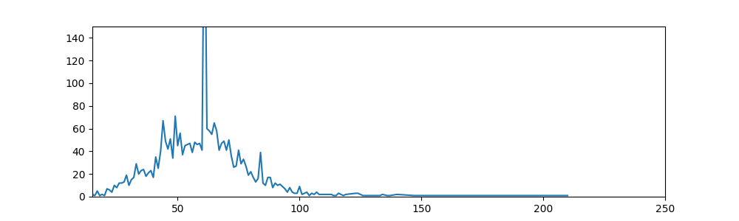

# 3. Conclusion

This document is a summary of the chess database.