Working groups
Atlantic
OC3 database (.xls) needs cleaning up, correct mistakes, find duplicates -- while creating the LiPD files
version databases
data managers for consistency between working groups
excel is the worst -- almost 200k rows
suggestion to use Google drive for group editing

group proj. for best practices for compilation/database: Nature Scientific Data
How do you choose the age model? and how do you keep it consistent?
How does the section change with an d18O-only age model vs. radiocarbon, etc?
Ensemble age model...can we use all the avail age models to estimate the uncertainty? CSIBOX to figure out which age model is the best. https://www.cs.colorado.edu/~lizb/

2+ papers
EX: How do you choose the best age model? How do you bring a group together, build a database, what are the standards?

PIs divide themselves based on their interests, invite others to join the individual/specific papers.

EX: What does the d13c look like in the Atlantic (a la Curry and Oppo, 2005)?
N-S transects (E vs. W)
E-W transects through Eq, high lats, etc.
see what's there
Hol vs. LGM
LGM vs. H1, etc

what is mean ocean d13c change?

smaller papers: science questions addressed for regions, model-data comparison?
motivating questions for the Atlantic:
when, what depth did the d13c changes occur after the deglaciation
imply about ocn circulation
how much did AMOC change during HS1
are d13C consistent with ........

relative timing of changes in N vs S component water

Next iteration: ask for funding specifically to deal with the database? or future questions/model-data comparisons

Earth Science Informatics
ESSD vs. SD: the novelty of the database and science vs. getting the data out (not results-based)
https://www.nature.com/sdata/policies/editorial-and-publishing-policies
http://www.earth-system-science-data.net/about/aims_and_scope.html

Data quality managemtn: 1) enter data, 2) someone else check the data, 3) manager makes sure all the things are there...then create LiPD files. double or triple check, then manager makes LiPD file, and upload.

GROUP SWITCH
similar discussions about a Data-only paper
need to publish the regional syntheses first
experts know best which age models are the best for their region

Timelines
- 1.5 years to do everything
- we need regional deadlines for when data/papers need to be submitted
- need to solicit unpublished data from everyone
From now
- Global: 1 year
- Regional: 6 months

plan A: best age models
plan B: whatever we have, future publications note that the new age models are an improvement on the original OC3 age models

DOI?? figshare gives DOI, so does pangaea

regions can set up their own criteria for that compilation, but the global dataset has everything

already planning to do model simulations with UVic only early part of deglaciation
iLOVECLIM -- isotope implementation (Didier)
iTRACE -- d13C and 14C
FAMOUS -- d13C soon ish
cGENIE
MIROC offline with transient forcing
HADCM3?
multimodel comparison to this OC3 dataset

Could just start with looking at an LGM time slice and a 6 ka time slice, rather than transient
equilibrium spin-up vs. transient spin-up (like 26-21 ka or 23-21 ka)
sensitivity spread across models

Is there anything we need to consider to ensure model-data comparison?
depends on the hypotheses/questions to consider
the data papers might inspire modelers to investigate certain questions

What did HS look like in the ocean?
Northern forcing vs southern? changes starting where and how they relate to eachother?
where is carbon stored
is circ weak/strong?
is NCW shoaling?
what about E-W changes?
what happens to the preformed d13c value if you shift the location of deep water formation south during the LGM cause of expanded sea ice? Nordic sea deep water production?
arctic benthic d13C?
seasonal shifts in deep water formation, model-resolvable
polynyas
models running deglaciation are going to have 1 degree spatial resolution at best

Forward-looking/synthesis
Ivanovic
r.ivanovic@leeds.ac.uk
PMIP feeds into CMIP
investigate underpinning mechanisms
coordinate transient simulations 21-0 ka
can we simulate rapid deglacial changes with realistic forcings
what are robust features across models or is there something specific to individual models
modelling or modeling
Core simulation (21-0 ka)
Focused simulations -- sensitivity runs (diff ice sheet configurations, temp resolution), particular event (HS1)

provide guideance, not rules

boundary conditions, greenhouse gasses, age models -- timing of things matter
Bereiter et al., 2015 composite CO2 curve, is this one on the updated timescale? (Marcott was only off by ~100 years)...might not capture the coincident timing of CO2 and CH4 cause it's a composite. they should have done composites of all the greenhouse gasses.
some people smooth the record
Frankenice for the LGM

probs more EMICs will run isotopes and carbon

isotopes included in some models
Coordinated carbon-cycle modelling
PMIP4
http://www.pmip2017.se, 25-29 sept. stockholm

Mix
Pacific
flagging data for "quality control" -- kinda need a comprimise between documentation and providing "expert opinion" for non-experts
can we have a comment on each data point? it would be another variable (column) of comments (analytical vs. interpretation)
links to original core descriptions
SEM and other images of archive and sensor

Repschläger
database questions
assignment of tasks
- pull together database in an organized and tiered way
authorships
- regional papers vs global compilation and manuscript
open questions
- we can quality control data and make LiPD files and do science without having to upload to LinkedEarth
science questions
- Atl only: Curry and Oppo, redux
- Global and possible regional: EOF/PCA of the global and probs the regions too

Regional data quality leaders
- in charge of finding specialists to help with data quality/checking
Pacific -- Alan, Liz, Gema
South Atlantic -- Steve, Stefan, Dave, Gema
North Atlantic -- Claire, Janne, Steve
Indian -- Carlye, Juan?

Must meet in a year
- AGU (NOLA), or alternatively Ocean Sciences-- 6 mo. benchmark
Abstract submissions will open 12 July 2017 and close 6 September 2017.

- Goldschmidt in Boston, call for session proposal in Fall 2017 for OC3
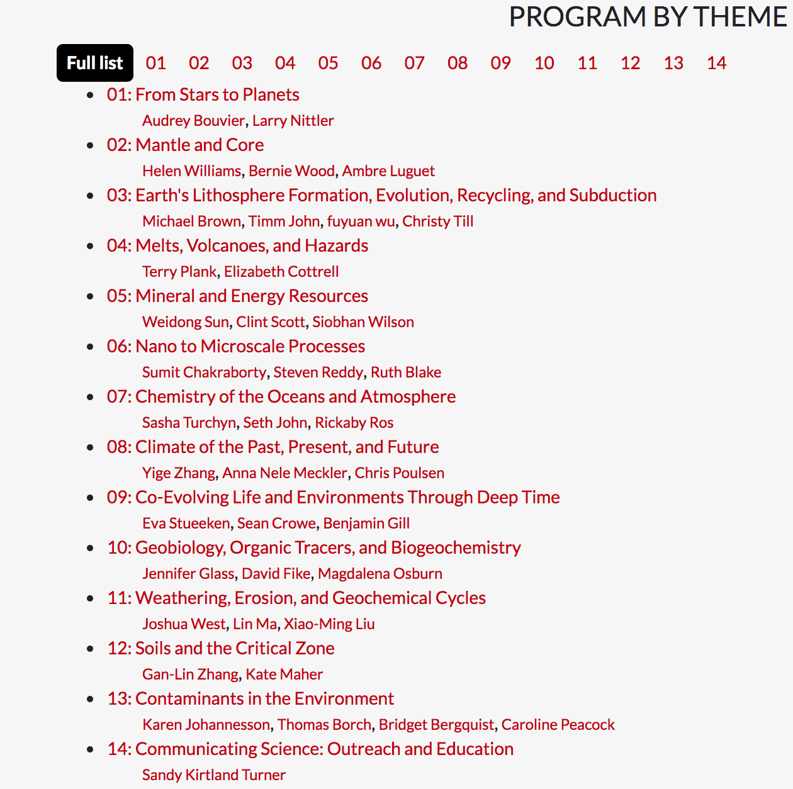

Joint OC3/PMIP steering group meeting
PMIP groups
- Last Millennium
- 6 ka
- LGM
- Transient 21-0 ka
- LIG
- Pliocene
- DEEP MIP
- Ice sheet uncert
- compare
- paleovar-enso
- benchmarking
- isotopes
- past2future
- assimilation

