2024-04-19

Speedtracker Instructions

Introduction
This document functions both as a basic instruction manual and a loose technical specification for Speedtracker, a module within IFDIFF that enables developers to check the library for long-term performance degradations.

Basic Functionality
Speedtracker maintains a set of snapshots, previous states of the project, as well as benchmarks, which contain performance tests and metrics to collect about them. When invoked, Speedtracker will save the current state of the project, then successively load each snapshot, run all benchmarks on it, collect the results, and finally restore the saved state of the project. The interface between snapshots and benchmarks is just the working directory: Loading a snapshot restores the working directory to a previous state and running a benchmark on this snapshot simply means running some code snippet in the context of this working directory. „Project state“ refers to the working directory contents at a given time.

Snapshots
Snapshots are Git commits. A snapshot is a commit saved under an alias. Loading a snapshot means checking out its commit. Instead of saving a commit to a snapshot, you can also directly pass a commit SHA or any Git commit specifier like HEAD, HEAD~2, refs, etc. Finally, the special snapshots current and worktree will test the current state of the project, including uncommitted changes.

Benchmarks
For benchmarking, the general task is to solve a switched IVP using IFDIFF and check 1. how long it took and 2. whether the result changed compared to the previous snapshot.
A benchmark is a function that
- is located in the speedtracker/benchmarks folder (not a subfolder)
- takes no arguments
- returns a sol object augmented with switching point data
Example:

function sol = canonicalExampleBenchmark()
%CANONICALEXAMPLEBENCHMARK simple benchmark using the same RHS and settings as the Readme example
options = odeset('AbsTol', 1e-8, 'RelTol', 1e-6);
datahandle = prepareDatahandleForIntegration( ...
'benchmark_canonicalExampleRHS', 'solver', 'ode45', ...
'options', options);
sol = solveODE(datahandle, [0 20], [1; 0], 5.437);
end

The RHS and any other helper functions should also be located in the speedtracker/benchmarks folder so that they are not lost or changed when an old snapshot is checked out.

Occupied Resources
When checking out snapshots, Speedtracker stores its reference to the project's previous state in a tagged blob with the tag refs/speedtracker/snapshot-manager. Snapshots are stored in the snapshot file at speedtracker/snapshots.txt. To publish snapshots, simply commit and push the snapshot file.
If either of these resources are occupied, the behavior of Speedtracker is undefined.

Tutorial
- You will need IFDIFF to be in a Git repository with a few commits. If you cloned it from GitHub, this is already given. Make sure you do not have any uncommitted changes.
- To perform performance testing, we need a benchmark first. A benchmark can be any function that takes no arguments. speedtracker/docs/examples/canonicalExampleBenchmark is a simple example: it solves the canonical example ODE using IFDIFF and returns the resulting sol object. It also has a copy of the right-hand side, named benchmark_canonicalExampleRHS, alongside it. There is another benchmark and RHS, expBenchmark, in the same folder. Copy the four files from speedtracker/docs/examples into speedtracker/benchmarks and delete all other files there (you can restore them later with Git).
- We are already ready for the first testing run: Get the hashes of two commits in the history. As an example, you can use 46957385aa2106443b0fc36ef766587516823cc2 and c723087e245934273c0cee36b79d2356807bc295, the last two commits at the time of writing. In the MATLAB Command Window, enter the command
speedtracker run 46957385aa2106443b0fc36ef766587516823cc2 c723087e245934273c0cee36b79d2356807bc295
After a few seconds, MATLAB should produce a table of results resembling the following:
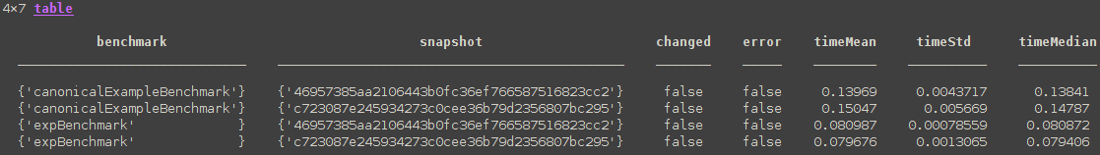
For each pair benchmark and snapshot (the commits), the table shows whether the result changed compared to the first snapshot, and whether any errors occurred. As we can see here, everything went smoothly and the times taken barely changed.
- We may want to use some development milestone as a baseline, in which case it is quite tedious to have to remember the commit SHA. Let us save our commit 46957385aa2106443b0fc36ef766587516823cc2 with the command
speedtracker create-snapshot mymilestone 46957385aa2106443b0fc36ef766587516823cc2
- Now, we can run this snapshot with the command
speedtracker run mymilestone c723087e245934273c0cee36b79d2356807bc295.
Use the command speedtracker delete-snapshot mymilestone to delete it again. Use speedtracker help to get information on all the available commands. The System Functions Reference in this document has more detailed information.
- Now let us introduce an error. In solveODE.m, add the line throw(MException("oh:no", "Oh no!")) directly below the function head, causing the function to always error. Do not commit anything. Now, run speedtracker run HEAD worktree to compare the current commit to the working tree with your uncommitted change. We have now seen every type of snapshot: saved snapshots created with create-snapshot, Git commit specifiers (SHAs, HEAD, or refs) and the special strings current and worktree, which test the current state of the repo including uncommitted changes. You should receive an output like this:
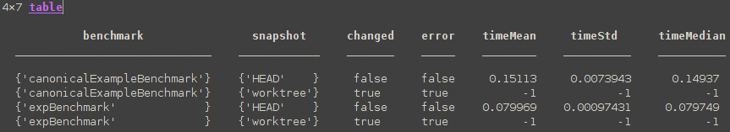
- As expected, our sabotaged solveODE crashed. But the information "error=true" is not very helpful to debug. Let us run again with raw output using the command
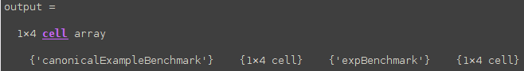
output = speedtracker('run', 'snapshots', {'HEAD', 'worktree'}, 'outputtype', 'raw')Now, Speedtracker should return an association list with the results for each benchmark:
- Run benchmark = output{2} to get the results for canonicalExampleBenchmark:
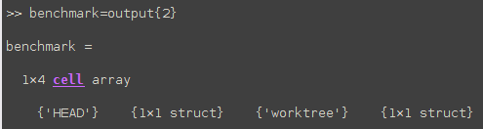
- Run snapshot = benchmark{4} to get the results for worktree:
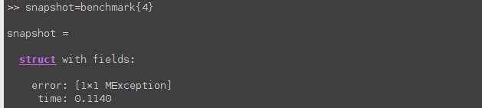
- And finally we can inspect the error:
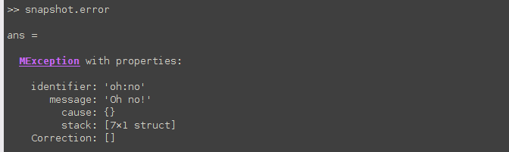
Make sure to fox the error in solveODE again!
- Now let us take a brief look at configuration. Say we want to run benchmarks with fewer iterations because it is taking too long. The option Niterations helps: Run the command speedtracker('run', 'HEAD', 'worktree', 'NIterations', 10) and see if the results have higher timeStd values.
- To set this configuration option persistently, change it in speedtracker/Configuration.m.

System Functions Reference
The only entry point into Speedtracker code is the function speedtracker, found in speedtracker.m in the project root directory. The function is called with the expression
speedtracker(command, varargin)
where command identifies the function and varargin can be either positional or named arguments, depending on the command. Some command parameters are not described in detail here, as they override configuration options, which are described in more detail in the next section.

Name | f001-create-snapshot
Description | Create a new snapshot from a given commit
Inputs/how to perform | speedtracker('create-snapshot', id, [hash])  where id is a string starting with a letter and containing letters, digits, dashes, and underscores, and  hash is the hash of the commit to tag. If it is not given, the commit HEAD points to is tagged.
Preconditions | No snapshot with the given ID exists; the given commit exists; no commit whose SHA equals the given ID exists
Output | A message that the snapshot was created
Postconditions | A snapshot with the given name and commit exists
Exceptions | E1: The provided ID is already taken  E2: the hash does not point to a commit  E3: the provided ID is the name of an automatic snapshot

Name | f002-delete-snapshot
Description | Delete a snapshot
Inputs/how to perform | speedtracker('delete-snapshot', id)  where id is a valid snapshot ID (see f001-create-snapshot)
Preconditions | A snapshot with the given ID exists
Output | A message that the snapshot was deleted
Postconditions | The snapshot is deleted
Exceptions | No snapshot with the given ID exists

Name | f003-list-snapshots
Description | List snapshots
Inputs/how to perform | speedtracker('list-snapshots')
Preconditions | None
Output | A list of all snapshots' IDs.
Postconditions | Nothing changed
Exceptions | None

Name | f004-show-snapshot
Description | Show details of a snapshot
Inputs/how to perform | speedtracker('show-snapshot', id)  where id is a valid snapshot ID (see f001-create-snapshot)
Preconditions | A snapshot named id exists
Output | Information about the snapshot: name, tag name, author, commit date, commit message
Postconditions | Nothing changed
Exceptions | No snapshot with the given ID exists

Name | f005-run-benchmarks
Description | Run a set of benchmarks on a set of snapshots
Inputs/how to perform | speedtracker('run', [snapshot1, snapshot2], [options])  where options is a list of name-value pairs (e.g. speedtracker('run', 'Snapshots', snapshotList, 'OutputType', 'OneTable'))  where the following properties can be passed:  Snapshots: a cellstring of snapshots (IDs of saved snapshots, commit identifiers, or current or worktree). If not supplied, all saved snapshots are run in order of when their commit was created. If snapshot1, snapshot2 are passed, these two snapshots are run. A snapshot can be either the ID of a snapshot created with f001-create-snapshot or a raw commit SHA.  Benchmarks: a string array of benchmark names. To identify a benchmark, pass its function name relative to the benchmarks directory speedtracker/benchmarks. Default: all functions in the benchmark directory that satisfy the criteria mentioned in the "Benchmarks" section are used  The following configuration properties can be overridden as well:  OutputType: override the configuration option for the format in which benchmark results are returned  YEndTol: override the configuration option for the tolerance for final values  Niterations: how many times benchmarks should be run
Preconditions | All mentioned snapshots and benchmarks exist;  the Git repository is currently on a branch (not detached HEAD state);  there are no changes in the Git index(this is because Speedtracker saves the state of the repository including changed files to a temporary commit. Which files were staged and which were not would be difficult to reconstruct)
Output | The results of the benchmarks. The exact structure is determined by the OutputType option.
Postconditions | Nothing changed
Exceptions | E1: There are staged changes  E2: The repository is in detached HEAD mode  E3: There is already a saved state  E4: One or more benchmarks are not found or faulty
Notes | Rule R1: the working directory is left in the same state it was before

Name | f006-restore-state
Description | Restore a saved project state
Inputs/how to perform | speedtracker('restore-state')
Preconditions | A saved project state exists due to an error in f005-run-benchmarks
Output | A message that the state was restored
Postconditions | The project's state is what it was before the problematic f005-run-benchmarks call
Exceptions | E1: There is no saved state to restore from
Notes | Should not normally be necessary since f005-run-benchmarks guarantees that the previous state will be restored. This is mostly a utility for development.

Name | f007-help
Description | Show help for various topics
Inputs/how to perform | speedtracker('help', [<command>])
Preconditions | None
Output | If <command> is not provided: A message describing general usage and how to get further help  If <command> is given: a description of how to use that command
Postconditions | Nothing changed
Exceptions | E1: the command is not known

Name | f008-list-benchmarks
Description | List available benchmarks
Inputs/how to perform | speedtracker('list-benchmarks')
Preconditions | None
OutputA list of all snapshots' IDs. | A list of all benchmarks' IDs.
Postconditions | Nothing changed
Exceptions | None

Configuration Reference
The following configuration properties all have a default value and can be overridden by a direct option to the relevant command(s). The default values can be edited in the class Configuration in the speedtracker directory.

Key | OutputType
Affected Commands | f005-run-benchmarks
Values | 'Raw' | 'OneTable'
Effect | Determines what type of data are output from f005-run-benchmarks.  Raw: return each benchmark’s output as a nested association list, with the values being structs containing return values and times.  OneTable: return one table with the results of all benchmarks’ in sequence. (default)

Key | YEndTol
Affected Commands | f005-run-benchmarks
Values | 1x1 double
Effect | When displaying results in tables, there is one column with a flag that is set whenever a benchmarking run's final y value and switching points are different from the value of the first snapshot. This parameter sets the relative tolerance within which y values are considered equal.

Key | NIterations
Affected Commands | f005-run-benchmarks
Values | 1x1 double
Effect | How many times to run each benchmark. The output table will contain the mean and standard deviation (with the the outer quarters of the distribution removed first) and the median of the times.

Key | HideErrors
Affected Commands | all
Values | 1xn char
Effect | When true, expected exceptions are only printed in the form of a one-line explanation and only unexpected exceptions are logged fully. When false, all exceptions are logged with stack trace.

Appendix A: Restoring Project State
It may happen that a bug in the code or other unforeseen circumstance causes the repository to get stuck in an old snapshot. This may even be one where Speedtracker does not yet exist. It far from guaranteed that f006-restore-state will work without issues.
Restoring manually is simple, however.
Speedtracker saves project state during f005-run-benchmarks as follows:

1. [if necessary] Save all changed files in a temporary commit
2. Write the current branch and latest commit (before the temporary commit) to a file
3. Store this file in Git's object database as a blob with git hash-object
4. Save the file's hash under the ref refs/speedtracker/snapshot-manager

To restore state after testing, Speedtracker proceeds as follows:

1. Read the current branch and latest commit from the file previously stored in Git's object database and delete the reference to it. The file itself will be cleaned up by Git's garbage collection eventually. Uses git show-ref to get the blob's hash and git cat-file to get the file's contents.
2. Check out the current branch
3. Reset to the previous state with git reset –mixed <latest commit>

If something goes wrong and state is not restored, attempt the following:

1. Resolve whatever problem caused the failure
2. Attempt to run f006-restore-state
3. If 2. did not work, manually check out the previous branch, then run f006-restore-state
4. If 2. and 3. did not work, manually go through the steps with which Speedtracker restores state.

