Speedtracker Structure

Introduction
Speedtracker has reached a level of complexity that requires design decisions that are not immediately obvious. Furthermore, being portable to different libraries, not just IFDIFF, has become a goal. The abstractions introduced to aid in this goal may also seem abstruse to a new programmer. As such, I have decided to make a document explaining various aspects of the design and giving guidelines for modifying the code in the future.

Basic Program Flow
The entry point into Speedtracker is ./speedtracker.m. All Speedtracker code except for it is located in the ./speedtracker folder. The function speedtracker:
- copies this folder to a temporary directory and modifies the MATLAB search path to include it
- Prepares program-global configuration
- determines which system function (SF) the user has called and passes the arguments on to the SF, which then does the real work
- returns the results of the SF to the user, or logs errors if they occurred.
System functions are represented by the interface ./speedtracker/commands/UserCommand. Each implementing class has methods for its help message, processing arguments into a structure, and executing the system function. CreateSnapshotCommand is a good example to see how these work.

Error Handling
As mentioned in the README, all errors that are mentioned in the instructions are part of the public API. If one of these errors occurs, the responsible UserCommand's execute() method must throw an exception with the identifier UserCommand.ERROR_EXPECTED_EXCEPTION and a human-friendly description of what went wrong.
If an error is not expected, such as a bug in the code or generally unforeseeable errors, it may be thrown as-is. speedtracker.m will print a full stack trace to give you a start on debugging.

Code Structure and Dependency Injection
The module that loads snapshots is hidden behind the interface ./speedtracker/snapshotting/SnapshotLoader.m. The module that runs benchmarks is hidden behind the interface ./speedtracker/benchmarking/BenchmarkRunner.m. The main benchmark-running functionality is located in the class ./speedtracker/SpeedtrackerRunner.m, which only has access to these interfaces, not their implementations. This makes it easy to port Speedtracker to other MATLAB libraries than IFDIFF. It is also a start towards replacing Git with some other tool for managing snapshots. The following diagram shows this structure.
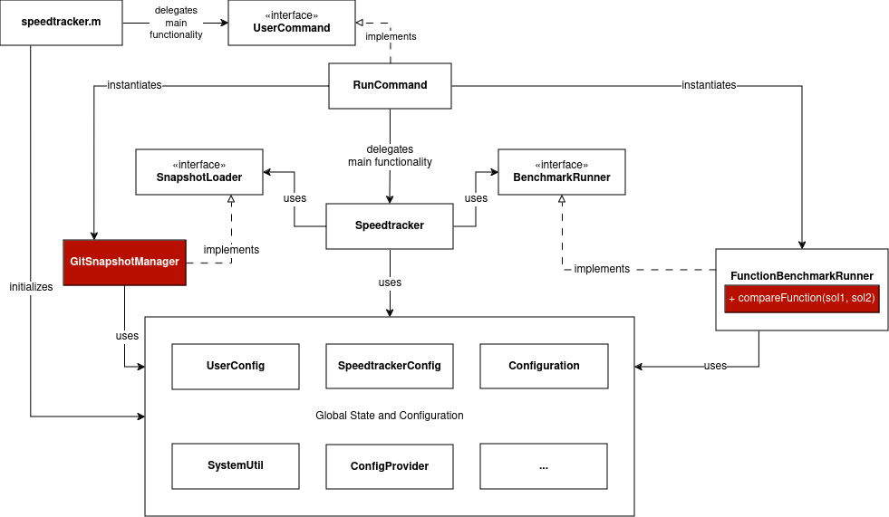
FunctionBenchmarkRunner only captures two metrics: 1. whether a test run's result changed compared to the previous snapshot, 2. how long the test took. The only IFDIFF-specific code it requires is the compareFunction that compares whether the results are the same. In this case, the "results" are the sol objects returned from solveODE, but they can be effortlessly replaced with the benchmark results of whatever other library you want to test – just use a different compareFunction that fits this other library's benchmark results (passed into the constructor of FunctionBenchmarkRunner).
One important thing to notice is that RunCommand is responsible for instantiating GitSnapshotManager and FunctionBenchmarkRunner, and is not separated from them by the interfaces. The UserCommands cannot be disentangled from the specific implementation classes because the options which the user can pass to commands depend on these implementation classes. You can rely on SpeedtrackerRunner and the code in the "Global State and Configuration" box to stay the same if you try to write a new BenchmarkRunner implementation, but the user commands will need to be changed.

Configuration
There are three configuration classes:
- SpeedtrackerConfig: Global, immutable constants, like the location of the root directory of Speedtracker. These will probably never change.
- UserConfig: Global, user-settable configuration parameters. They can be overridden by command-line options. For example, OutputType governs the format in which the results of benchmarking are returned. These properties should be independent of any specific benchmark implementation.
UserConfig gets its default values from Configuration.m. This is also where the the user can change these default values.
Logging
Logging is not very clearly defined at present. There is a Logger interface with four levels and a simple implementation class. speedtracker.m passes UserCommand's execute() method an instance of this implementation class, and the command in turn passes it on to objects that it uses. Objects like GitSnapshotManager each have a logger field, hopefully making it easier to introduce more fine-grained logging one day.
SystemUtil, which handles OS commands (e.g. Git) has its own logger for debug purposes. Set the DEBUG flag to 1 in speedtracker.m to have all these commands logged.

