Program Governance Framework

Overview
This document outlines the governance structure, escalation paths, and communication framework for the AI Delivery Program (Athena). The framework ensures effective oversight, decision-making, and stakeholder alignment across all program activities.

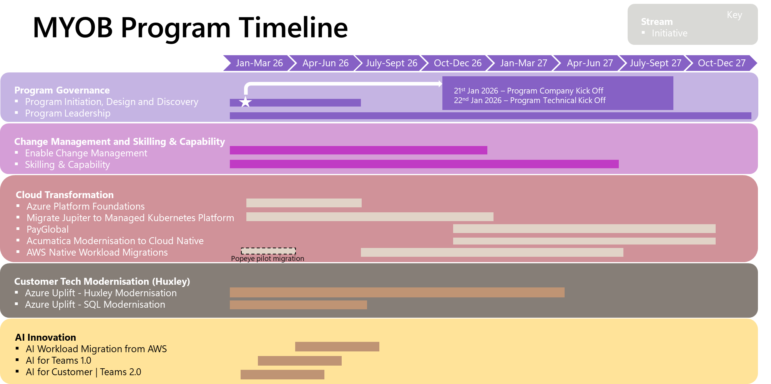

1. Governance Structure

1.1 Partnership Governance Layer
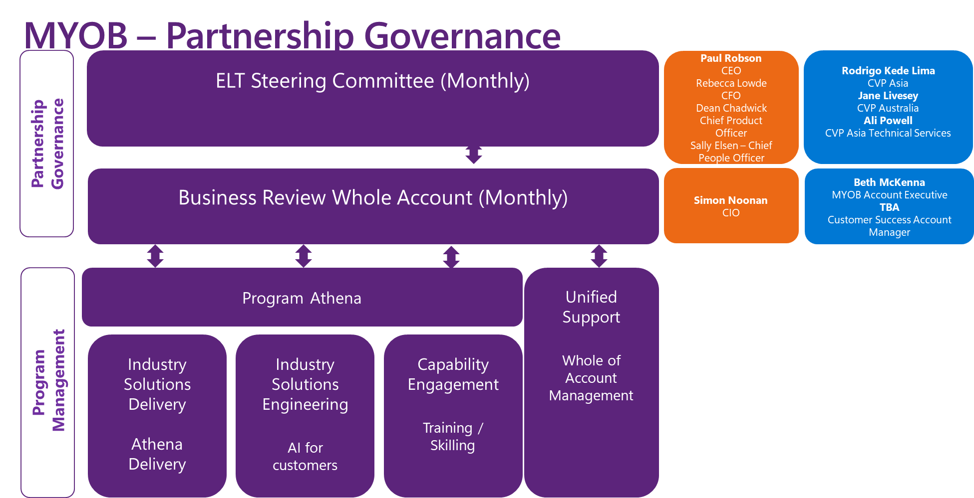

ELT Steering Committee (Monthly)
Purpose: Executive-level oversight and strategic direction
Frequency: Monthly
Participants:
- Executive Leadership Team (ELT) members
- Program Sponsors
- Key Business Unit Leaders
Responsibilities:
- Strategic alignment and investment decisions
- Remove organizational barriers
- Approve major program changes
- Review program ROI and business outcomes
- Set organisational priorities

Business Review Whole Account (Monthly)
Purpose: Comprehensive account-level review and coordination
Frequency: Monthly
Participants:
- Account Leadership
- Program Directors
- Business Stakeholders
- Delivery Leads
Responsibilities:
- Review program health and performance metrics
- Account-wide resource allocation
- Cross-program dependencies management
- Risk and issue escalation from program level
- Budget and financial oversight

1.2 Program Management Layer
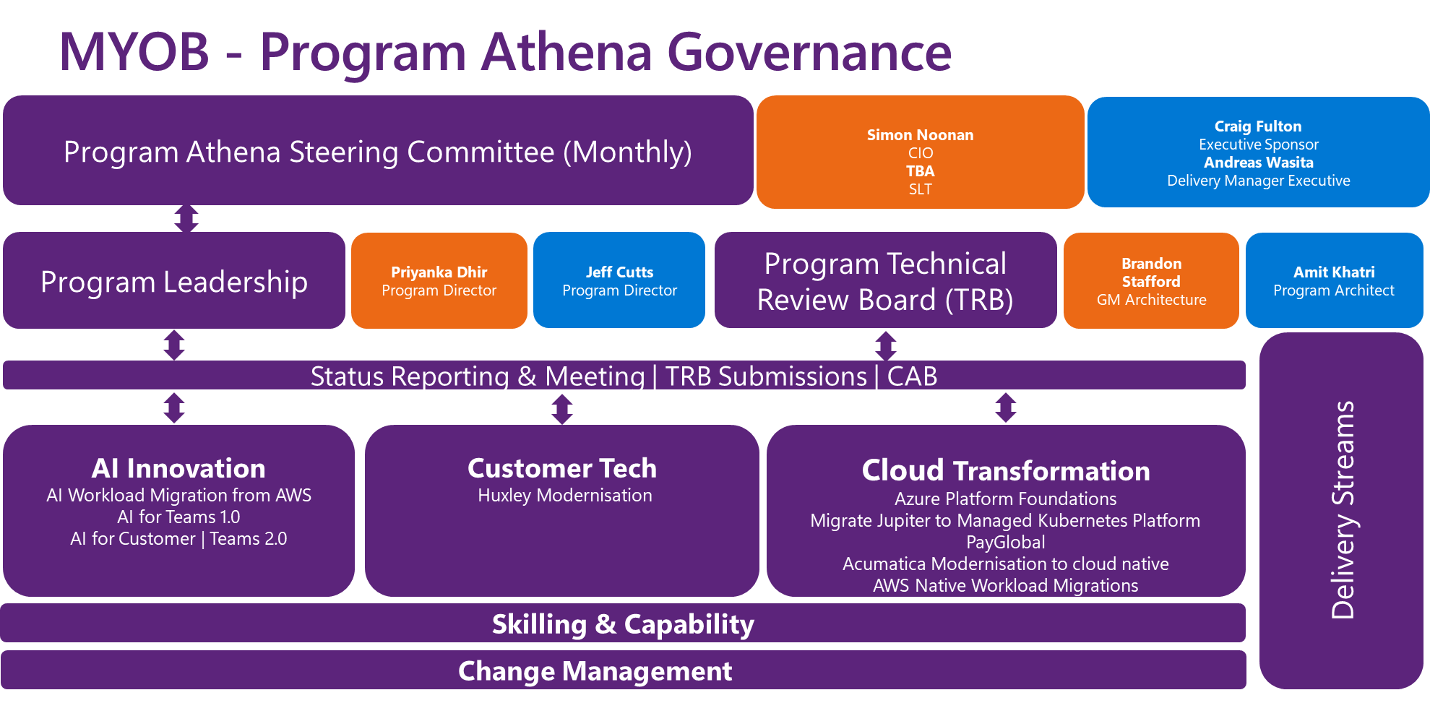

Program Athena
Central coordination hub for all AI delivery initiatives.

Industry Solutions Delivery / Athena Delivery
Purpose: End-to-end delivery of industry-specific AI solutions
Key Activities:
- Project execution and delivery management
- Sprint planning and tracking
- Quality assurance and release management
- Customer acceptance and deployment
- Leadership: Delivery Manager / Project Manager
- Reporting: Weekly to Program Athena, Monthly to Business Review

Industry Solutions Engineering / AI for Customers
Purpose: Technical excellence and solution engineering
Key Activities:
- Solution architecture and design
- AI model development and engineering
- Technical innovation and R&D
- Platform and infrastructure setup
- Customer technical enablement
Leadership: Chief Architect / Engineering Lead
Reporting: Weekly to Program Athena, Monthly to Business Review

Capability Engagement / Training / Skilling
Purpose: Build and maintain AI capabilities across the organization
Key Activities:
- Training program delivery
- Skill assessment and gap analysis
- Workshop facilitation (Business Envisioning, Solution Envisioning)
- Knowledge transfer and documentation
- Community of practice management
Leadership: Capability Lead / Training Manager
Reporting: Weekly to Program Athena, Monthly to Business Review

Unified Support / Whole of Account Management
Purpose: Integrated support across the entire account
Key Activities:
- Cross-program coordination
- Stakeholder relationship management
- Unified communication strategy
- Issue resolution and escalation management
- Benefits realisation tracking
Leadership: Account Manager / Program Director
Reporting: Weekly internal, Monthly to Business Review and ELT

2. Escalation Path

2.1 Escalation Levels

Level 1: Team / Workstream Level
Timeframe: Immediate to 24 hours
Scope: Day-to-day issues, technical blockers, resource conflicts
Owner: Team Lead / Scrum Master
Resolution: Within team or with direct manager
Examples:
- Technical implementation challenges
- Sprint-level resource needs
- Minor scope clarifications

Level 2: Program Management Level
Timeframe: 24-72 hours
Scope: Cross-team dependencies, significant risks, budget variances
Owner: Program Manager / Delivery Lead
Escalate To: Program Athena Leadership
Resolution: Program Steering or leadership decision
Examples:
- Cross-workstream dependencies blocking progress
- Risks with medium-high impact
- Resource reallocation between teams
- Budget overruns within 10-15% threshold

Level 3: Business Review / Account Level
Timeframe: 1 week (or next scheduled Business Review)
Scope: Account-wide impacts, major program changes, cross-account resources
Owner: Program Director / Account Manager
Escalate To: Business Review Forum
Resolution: Account leadership decision, may escalate to ELT
Examples:
- Major scope changes affecting multiple programs
- Significant budget increases (>15%)
- Resource conflicts across accounts
- High-severity risks requiring organizational intervention
- Customer escalations at executive level

Level 4: ELT Steering Committee Level
Timeframe: Up to 1 month (or emergency session)
Scope: Strategic changes, major investments, organizational barriers
Owner: Executive Sponsor
Escalate To: ELT Steering Committee
Resolution: Executive decision, organizational policy change
Examples:
- Program cancellation or major pivot
- Investment decisions >$X threshold
- Organizational structure changes
- Strategic partnership decisions
- Legal or compliance issues

2.2 Escalation Triggers

Risk-Based Escalation
| Risk Level | Impact | Escalation Level | Response Time |
|------------|--------|------------------|---------------|
| Low | Minimal impact on timeline/budget (<5%) | Level 1 | 24 hours |
| Medium | Moderate impact (5-15%), workarounds available | Level 2 | 72 hours |
| High | Major impact (>15%), critical path affected | Level 3 | 1 week |
| Critical | Program success at risk, strategic impact | Level 4 | Immediate |

Issue-Based Escalation
Technical Issues: Start at Level 1, escalate if unresolved in 2 days
Resource Issues: Start at Level 2, escalate if cross-account impact
Budget Issues: Level 2 for <15%, Level 3 for >15%
Scope Changes: Level 2 for minor, Level 3 for major, Level 4 for strategic
Stakeholder Conflicts: Start at appropriate level based on seniority

3. Communication Framework

3.1 Communication Cadence

Daily Communications
Stand-ups: Team-level (15 minutes)
Slack/Teams Updates: Asynchronous progress updates
Blocker Resolution: Ad-hoc as needed

Weekly Communications
Program Sync: All workstream leads + Program Manager (1 hour)
Agenda: Progress, risks, dependencies, upcoming milestones
Technical Review: Engineering team (1 hour)
Stakeholder Updates: Written status report to key stakeholders
Sprint Reviews: Team-level demos and retrospectives

Bi-Weekly Communications
- Capability Review: Training and skilling progress
- Account Coordination: Unified Support sync with account teams

Monthly Communications
Business Review Meeting: (2 hours)
Full program performance review
Financial status and forecasting
Milestone achievement and upcoming deliverables
Risk and issue register review
Resource planning for next period
ELT Steering Committee: (1.5 hours)
Strategic alignment review
Business value realization
Major decisions and approvals
Executive-level escalations
Monthly Newsletter: Broader stakeholder communication

Quarterly Communications
- Quarterly Business Review (QBR): Comprehensive program assessment
- Benefits Realization Report: ROI and value delivery
- Strategic Planning Session: Next quarter planning

3.2 Communication Channels

Synchronous Channels
- Microsoft Teams: Primary collaboration platform
- General Program Channel
- Delivery Workstream Channel
- Engineering Workstream Channel
- Capability Workstream Channel
- Executive Updates Channel (read-only for most)
- Meetings: Teams for all scheduled sessions
- Emergency Hotline: For critical escalations

Asynchronous Channels
- Email: Formal communications, approvals, external stakeholders
- SharePoint/Confluence: Document repository, knowledge base
- JIRA/GitHub: Work tracking, sprint management
- Power BI Dashboard: Real-time program metrics

3.3 Communication Matrix

| Stakeholder Group | Frequency | Channel | Content | Owner |
|-------------------|-----------|---------|---------|-------|
| ELT Steering Committee | Monthly | Formal Meeting + Deck | Strategic metrics, decisions needed, risks | Program Director |
| Business Review Forum | Monthly | Formal Meeting + Report | Performance metrics, financials, milestones | Program Manager |
| Program Athena Team | Weekly | Teams Meeting | Detailed progress, blockers, planning | Workstream Leads |
| Delivery Team | Daily | Stand-up | Sprint progress, daily blockers | Scrum Master |
| Engineering Team | Weekly | Technical Review | Architecture, technical debt, innovation | Tech Lead |
| Capability Team | Bi-weekly | Sync Meeting | Training delivery, capability gaps | Capability Lead |
| Account Management | Weekly | Status Report | Account health, customer sentiment | Account Manager |
| External Stakeholders | Monthly | Email + Dashboard | High-level progress, business value | Program Director |
| End Users | As needed | Training/Workshops | Solution updates, new features | Capability Team |

3.4 Communication Artifacts

Status Reports
Weekly Status Report:
- RAG (Red/Amber/Green) status
- Key accomplishments
- Upcoming milestones
- Top 3 risks/issues
- Ask/needs

Monthly Executive Report:
- Executive summary (1 page)
- Progress against objectives
- Financial summary
- Key metrics and KPIs
- Strategic decisions needed

Dashboards
Program Health Dashboard: Real-time metrics
- Schedule performance index (SPI)
- Cost performance index (CPI)
- Quality metrics
- Resource utilization
- Risk heat map

Value Realisation Dashboard:
- Benefits tracking
- ROI calculations
- Business outcome metrics
- Customer satisfaction scores

Meeting Artifacts
- Meeting Agendas: Distributed 24 hours in advance
- Meeting Minutes: Published within 24 hours
- Action Item Tracker: Updated weekly
- Decision Log: All key decisions documented

4. Governance Best Practices

4.1 Decision-Making Framework
- Decision Rights: Clearly defined at each governance level
- RACI Matrix: Maintained for all major deliverables
- Decision Log: All decisions documented with rationale
- Escalation Criteria: Clear thresholds for escalation

4.2 Risk Management
- Risk Register: Updated weekly, reviewed monthly
- Risk Assessment: Probability x Impact matrix
- Mitigation Plans: Defined for all high/critical risks
- Risk Escalation: Follow defined escalation path

4.3 Change Management
- Change Request Process: Formal process for scope/budget changes
- Impact Assessment: Required for all change requests
- Approval Authority: Based on change magnitude
- Change Log: All changes tracked and communicated

4.4 Quality Assurance
- Quality Gates: Defined at each phase
- Review Process: Peer reviews, code reviews, architecture reviews
- Acceptance Criteria: Clear definition of done
- Audit Trail: All key artifacts version-controlled

5. Key Performance Indicators (KPIs)

Governance Effectiveness KPIs
- Decision Velocity: Average time from issue identification to resolution
- Escalation Rate: Number of escalations per level per month
- Meeting Effectiveness: % of meetings with clear outcomes
- Stakeholder Satisfaction: Quarterly survey scores
- Communication Reach: % of stakeholders receiving timely updates

Program Performance KPIs
- Schedule Performance: On-time milestone delivery rate
- Budget Performance: Actual vs. planned spend variance
- Quality Metrics: Customer satisfaction (NPS)
- Value Delivered: ROI, benefits realized vs. planned
- ACR Milestones: Committed vs Realised

6. Governance Calendar

Monthly Rhythm
- Week 1: Sprint planning, team kick-offs
- Week 2: Mid-sprint check-ins, risk reviews
- Week 3: Sprint reviews, retrospectives, program sync
- Week 4: Business Review, ELT Steering Committee, reporting

Quarterly Rhythm
- Month 1: Quarterly planning, OKR setting
- Month 2: Mid-quarter review, course corrections
- Month 3: QBR, benefits realization review, next quarter planning

7. Roles and Responsibilities

Executive Sponsor (ELT Level)
- Strategic alignment and organizational support
- Remove executive-level barriers
- Final authority on major program decisions
- Advocate for program at executive level

Program Director
- Overall program success and delivery
- Stakeholder management at account level
- Resource allocation across workstreams
- Escalation management to Business Review/ELT

Program Manager
- Day-to-day program execution
- Cross-workstream coordination
- Risk and issue management
- Reporting and communication

Workstream Leads
- Workstream delivery and quality
- Team management and resource planning
- Technical/functional decisions within scope
- Escalation of cross-workstream issues

Customer Success Account Manager (Unified Support)
- Account relationship management
- Customer satisfaction and engagement
- Commercial management
- Account-wide coordination

Appendices

Appendix A: Escalation Template
ESCALATION REQUEST
Date: [Date]
From: [Name, Role]
To: [Escalation Level]
Priority: [Low/Medium/High/Critical]

ISSUE SUMMARY:
[Brief description]

IMPACT:
- Schedule: [Impact on timeline]
- Budget: [Financial impact]
- Scope: [Scope impact]
- Quality: [Quality impact]
- Stakeholders: [Who is affected]

ATTEMPTS TO RESOLVE:
[What has been tried]

DECISION NEEDED:
[Specific ask]

DEADLINE:
[When decision is needed]

Appendix B: Communication Plan Template
[Link to detailed communication plan spreadsheet] – In Progress

Appendix C: RACI Matrix
[Link to RACI matrix for key activities] – In Progress

Appendix D: Contact Directory
[Link to stakeholder contact information] – In Progress

Document Control
- Version: 0.1
- Last Updated: January 29, 2026
- Draft by: Andreas Wasita – Delivery Management Executive
- Review Cycle: Quarterly
- Approval: ELT Steering Committee

Revision History
Version | Date | Author | Change
0.1 | 29/1/2026 | Andreas Wasita | Draft

