

Computer Science Major

Teacher: Carlos Adrian Alarcon Delgado

Dataset Charter and Processed Dataset V1
Local Business Discovery Engine:
Travel-Oriented Recommendation System using the Yelp Academic Dataset

Members:

Code | Last name | First name | Semester
u201714492 | Peña Cardenas | Jhamil Brijan | 8th
u20221a963 | Sihuincha Schermuly | Mireya Nicole | 7th
U202323166 | Chavarria Barrios | Maria Ximena | 8th
U202120058 | Tapia Pescoran | Andrea Katherina | 10th

April 2026

Index

1. Project Proposal 3
1.1 Domain 3
1.2 Problem Statement 3
1.3 Expected Product Question 3
1.4 Why This Dataset Supports the Full 3
2. Source Inventory 4
2.1 Files Used 4
3. Schema Draft 5
3.1 Entity-Relationship Overview 5
3.2 Key Design Decisions for Nested Columns 5
4. Processed Dataset V1 6
5. Data Dictionary 6
5.1 business_clean (58 columns) 6
5.2 review_interactions 7
5.3 user_clean 7
5.4 checkin_clean 8
6. Scale Analysis 8
6.1 Key Observations 8
6.2 Geographic Distribution of Businesses 8
7. Ethics and Access Note 9
8. Representation and Dimensionality Report (Week 5) 9
8.1 City-Level Feature Matrix 9
8.2 Dimensionality Reduction (PCA) 10
8.3 Visualizations 10
A. Attribute Prevalence across Cities 10
B. 2D City Personality Projection 11
C. Correlation Heatmap of Key Features 12
8.5 Technical Interpretation 13
9. Clustering Week 7 14
9.1 Input Data 14
9.2 City Size Filter 14
9.3 Experiment 1: K-Means Clustering 16
9.3.1 Parameter Sweep (k = 2 to 12) 16
9.3.2 K Selection Decision 17
9.4. Experiment 2: DBSCAN 19
9.4.1 Parameter Selection 19
9.4.2 Sweep Results 20
9.4.3 Algorithm Comparison and Decision 20
10. Cluster Profile Analysis 21
Cluster 0 — Mainstream Suburban Dining (71 cities, 32.4%) 21
Cluster 1 — Tourism & Leisure Beach Destinations (9 cities, 4.1%) 21
Cluster 2 — Upscale Lifestyle Suburbs (53 cities, 24.2%) 22
Cluster 3 — Balanced Urban-Commercial (86 cities, 39.3%) 22
10.1 Personality Profile Interpretation 22
10.2 Cluster Size Distribution 23
11. Validation Table 23
11.1 Interpretation Limits 24
12. Failure Analysis 24
12.1 Cities with Negative Silhouette (Misassigned) 25
12.2 Borderline Cities (Silhouette 0–0.20) 25
12.3 Well-Clustered Cities (Silhouette > 0.45) 26
12.4 Root Causes of Clustering Difficulty 26
13. Recommendation and Ranking Engine (Week 11) 26
13.1 Objective 26
13.2 Data Alignment 27
13.3 Candidate Pool Definition 28
13.4 Baseline System 28
13.5 Advanced Recommendation System 29
13.6 Evaluation Protocol 30
13.7 Offline Evaluation Metrics 30
13.8 Results 31
13.9 Error Analysis 31
13.10 Limitations and Future Work 32
13.11 Conclusions 32

1. Project Proposal

1.1 Domain
Intelligent Travel Destination. The system focuses on modeling the "latent personality" of cities by aggregating large-scale commercial data from Yelp with global tourism indices. It treats cities as structured entities with distinct socioeconomic and cultural profiles (safety, climate, and service density) to match travelers with urban environments that align with their preferred lifestyle.

1.2 Problem Statement
Travelers often struggle to choose a new destination because traditional recommendation engines rely on generic popularity or simple geographic filters. Our system addresses this by answering the core question: Which cities worldwide share a latent "commercial DNA" with the places a user has previously enjoyed? To solve this, we must transition from micro-data (individual businesses) to macro-representations (city vectors).

1.3 Expected Product Question
- Given a traveler's Yelp review history, which cities have the most similar commercial personality to the ones they already love?

This is a single city-level recommendation question. The system does not recommend individual businesses — it recommends destinations. The connection between a user's past behavior and a city recommendation is made through aggregated behavioral signals (which cities they've
rated businesses in, and how highly).

1.4 Why This Dataset Supports the Full

Course
Course Layer | Yelp Asset Used | Justification
Catalog | business_clean.parquet | 150,346 businesses · 58 columns · rich attributes, geo, categories
Interaction | review_interactions.parquet | 6,990,280 user-business ratings — sparse matrix for collaborative filtering
Feature engineering | city_features.parquet | 1416 cities x 162 aggregated features from all 4 parquet files
Clustering (W7) | city_embeddings_pca.parquet | PCA-reduced city vectors → K-Means city personality segments
Recommendation (W10) | user_city_interactions.parque | User-city rating matrix → collaborative filtering
Graph (W12) | city_features + embeddings | City-city similarity graph by cosine distance in embedding space
Pipeline | 4 Parquet files from 4 JSON sources | Real ETL: nested JSON, chunked reads, ~9 GB raw

2. Source Inventory

Item | Detail
Source name | Yelp Academic Dataset
URL | https://www.yelp.com/dataset
License | Yelp Dataset License — free for academic, non-commercial research
Registration | Required — email + academic affiliation
Format | JSON per-line (.tar compressed), one file per entity
Raw total size | ~9 GB uncompressed
Subset applied | None — full dataset used for all four tables

2.1 Files Used
File | Records | Key Fields
yelp_academic_dataset_business.json | 150,346 | business_id, name, city, state, lat, lon, stars, review_count, is_open, attributes{}, categories, hours{}
yelp_academic_dataset_review.json | 6,990,280 | review_id, user_id, business_id, stars, text, date, useful, funny, cool
yelp_academic_dataset_user.json | ~1,987,897 | user_id, review_count, average_stars, yelping_since, friends[], elite, fans, compliments
yelp_academic_dataset_checkin.json | 131,930 | business_id, date (comma-separated timestamps)

3. Schema Draft

3.1 Entity-Relationship Overview
Table (Processed) | Primary Key | Foreign Keys | Grain
business_clean | business_id | — | One row per business, 58 columns after flattening
business_categories | business_id + category | business_id → business_clean | One row per (business, category) pair — bridge table
review_interactions | (user_id, business_id) | business_id, user_id | Sparse interaction matrix: user_id, business_id, stars
user_clean | user_id | — | One row per user: review_count, avg_stars, yelping_since
checkin_clean | business_id | business_id → business_clean | One row per business: n_checkins (aggregated count)

3.2 Key Design Decisions for Nested Columns
Three columns in business.json required special handling. The decisions below are architectural choices for the modeling pipeline:

Column | Raw Structure | Decision | Rationale
attributes | Dict with values that are themselves dicts serialized as strings: {"BusinessParking": "{'garage': False, 'lot': True}"} | Two-level flatten → attr__ prefix for top-level, attr__Parent__child for sub-dicts. 88 raw columns → 51 dropped (>90% null), 37 retained. | ML models require numeric/boolean inputs. NaN kept as NaN (not filled with False) because absence-of-attribute ≠ attribute-is-False. A business without WiFi info is genuinely unknown.
hours | Dict {"Monday": "9:0-21:0", ...} or None | Converted to 9 integer columns: open_days count + has_weekend flag + one boolean per day. All default to 0 when hours is None. | hours=None means no registered hours, equivalent to 0 days open
categories | Comma-separated string: "Restaurants, Italian, Pizza" | Parsed to list → primary_category (first element) + n_categories count + bridge table for full membership. | Enables both fast filtering by primary_category and full category-based similarity in W7/W12 graph construction.

4. Processed Dataset V1

Six Parquet files produced from four raw JSON sources. All ingestion runs from the notebook pre.ipynb via Google Colab + Google Drive mount. Snappy compression used throughout.

File | Rows | Cols | Compression | Notes
business_clean.parquet | 150,346 | 58 | Snappy | Flat table; 37 attr__ cols, 9 hours__ cols, 3 derived category cols
business_categories.parquet | ~750K+ | 2 | Default | Bridge: business_id × category
review_interactions.parquet | 6,990,280 | 3 | Snappy | Lean interaction matrix: user_id, business_id, stars only
user_clean.parquet | ~1,987,896 | 4 | Snappy | user_id, review_count, average_stars, yelping_since — 1 bad line skipped
checkin_clean.parquet | 131,930 | 2 | Default | business_id + n_checkins (count of comma-separated timestamps)

5. Data Dictionary

5.1 business_clean (58 columns)
Column Group | Columns | Type | Missingness | Notes
Identity | business_id, name, city, state, postal_code | str | 0% | PK is 22-char hash
Geography | latitude, longitude | float64 | 0% | WGS84 decimal degrees
Performance | stars, review_count, is_open | float/int | 0% | stars 1.0–5.0; is_open 0/1
Categories | categories_list, primary_category, n_categories | object/str/int | 0% / 0.07% / 0% | List, first element, count
Attributes (boolean) | attr__ByAppointmentOnly through attr__GoodForMeal__breakfast (32 cols) | boolean (nullable) | 20%–84% | NaN = not reported by business
Attributes (categorical) | attr__RestaurantsPriceRange2, attr__WiFi, attr__Alcohol, attr__RestaurantsAttire, attr__NoiseLevel (5 cols) | category | 20%–75% | Low-cardinality string values encoded as category dtype
Hours | hours__open_days, hours__has_weekend, hours__open_{day} × 7 (9 cols) | int64 | 0% | 0 when hours dict is None; valid default

5.2 review_interactions
Column | Type | Missingness | Notes
user_id | object | 0% | FK → user_clean
business_id | object | 0% | FK → business_clean
stars | int64 | 0% | 1–5 rating — the interaction signal for collaborative filtering

5.3 user_clean
Column | Type | Missingness | Notes
user_id | object | 0% | Primary key — links to review_clean and review_interactions
review_count | int64 | 0% | Total reviews written
average_stars | float64 | 0% | User's historical average rating
yelping_since | datetime64[ns] | 0% | Account creation date — used for user seniority feature in W5

5.4 checkin_clean
Column | Type | Notes
business_id | object | FK → business_clean
n_checkins | int64 | Count of timestamps in raw date string — proxy for foot traffic

6. Scale Analysis

Table | Rows | Columns | Memory (RAM) | Missingness
business_clean | 150,346 | 58 | ~34 MB | 0% on base cols; 20–84% on attr__ cols; 0% on hours__ cols
business_categories (bridge) | ~750K+ | 2 | ~30 MB | 0%
review_interactions | 6,990,280 | 3 | ~160 MB | 0%
user_clean | ~1,987,896 | 4 | ~60 MB | 0%; 1 malformed line skipped
checkin_clean | 131,930 | 2 | ~3 MB | 0%

6.1 Key Observations
- The attr__ columns have 84.4% average missingness. This is structural, not a data quality problem: Yelp only collects attributes relevant to a business type (restaurants have WiFi/Alcohol; hair salons have HairSpecializesIn). Imputing False would introduce false information — NaN is the correct representation.
- 51 of 88 attribute columns were dropped (>90% null across the full dataset). The remaining 37 cover the most universally populated attributes and include the richest semantic signal for business similarity.
- The user-item matrix derived from review_interactions is extremely sparse: ~6.99M interactions / (1.99M users × 150K businesses) ≈ 0.0023% density. This is expected for a recommendation problem and validates the need for collaborative filtering + matrix factorization in W10.

6.2 Geographic Distribution of Businesses
The dataset spans multiple US states and Canadian provinces with no geographic filter. Top cities by business count: Philadelphia (14,569), Tucson (9,250), Tampa (9,050), Indianapolis (7,540), Nashville (6,971). This geographic breadth is essential, the system needs diverse cities to make meaningful personality comparisons.

7. Ethics and Access Note
Data source: Yelp Academic Dataset, obtained directly from yelp.com/dataset under the Yelp Dataset License for non-commercial academic use. No scraping was performed.

Question | Answer
Where did the data come from? | Direct download from yelp.com/dataset after completing the Yelp academic registration form. Data stored in private Google Drive.
Why is the team allowed to use it? | The Yelp Dataset License explicitly permits academic, non-commercial research and classroom use. The project does not redistribute raw data.
What personal data risks exist? | user.json contains display names (excluded from user_clean), friend graph adjacency lists (not processed in V1), and behavioral history. review.json contains opinionated free text that may identify individuals.
How are those risks reduced? | user_clean retains only user_id (hashed), behavioral counts, and dates — no names or friend lists. No raw files are shared. No attempt will be made to de-anonymize users. The processed artifacts use only anonymized IDs throughout.

8. Representation and Dimensionality Report (Week 5)

8.1 City-Level Feature Matrix
To achieve the goal of recommending destinations based on a city's "personality," the dataset granularity was scaled from individual business units to aggregated city entities. This transformation allows the system to model latent urban profiles rather than just specific locations.
Matrix Construction:
- Semantic Aggregation: Boolean and categorical business attributes were averaged per city to create percentage-based features (e.g., % of romantic venues, % of kid-friendly locations).
- Tourism Enrichment: The matrix was integrated with external tourism data, including a safety index, climate classifications, and peak travel seasons.
- Encoding Strategy: One-Hot Encoding was applied to categorical variables such as climate type and city vibe, while Ordinal Encoding was used for noise levels and price ranges.
- Final Scale: The resulting matrix consists of 1416 rows (unique cities) and 162 columns (features).

8.2 Dimensionality Reduction (PCA)
Due to high feature dimensionality and expected redundancy between business categories, Principal Component Analysis (PCA) was performed.
- Normalization: Prior to PCA, a StandardScaler was applied to ensure that high-magnitude features, like total_reviews, did not bias the model against percentage-based features.
- Explained Variance: The analysis determined that 59 components are required to capture 75% of the total variance.
Components | Variance Retained | Dimensionality Reduction
51 | 70% | 68.3%
59 | 75% | 63.4%
69 | 80% | 57.1%
94 | 90% | 41.6%
161 (full) | 100% | 0%
- Dimensionality Gain: The process achieved a 63.4% reduction in total features, significantly optimizing the dataset for upcoming clustering and graph analysis.

8.3 Visualizations

A. Attribute Prevalence across Cities
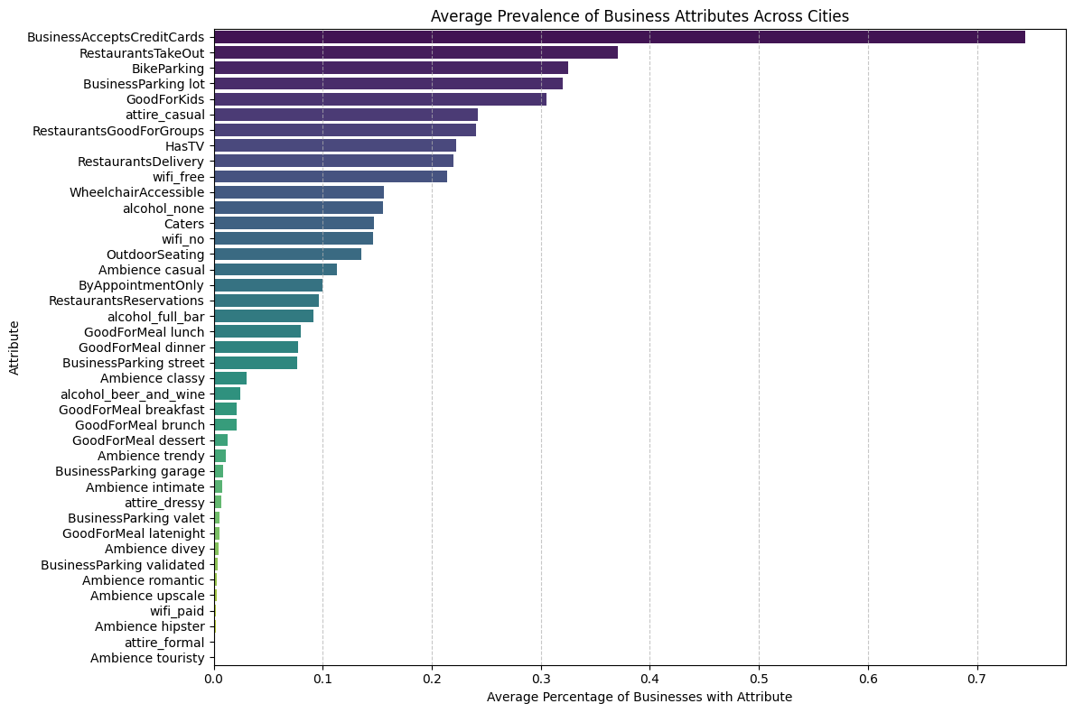
A bar chart of average attribute prevalence across all 1,416 cities shows that BusinessAcceptsCreditCards (~75%) is the most universal attribute, while attire_formal and Ambience__touristy are the least common. This confirms the ‘attributes profile’ section captures meaningful variation in city commercial profiles.

B. 2D City Personality Projection
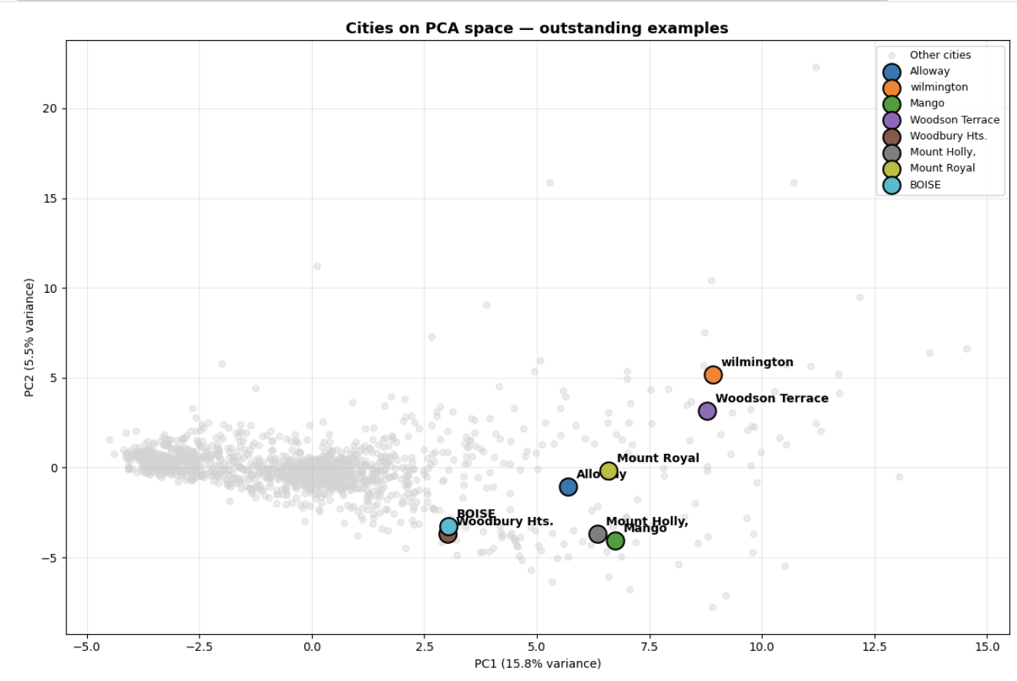
The PCA projection highlights several cities with distinctive urban-commercial profiles relative to the broader distribution of cities concentrated near the center of the embedding space. For example, Wilmington and Woodson Terrace appear with high positive PC2 values, suggesting stronger upscale, nightlife, or socially active commercial characteristics. In contrast, cities such as Mango and Mount Holly are positioned lower on PC2, indicating more suburban or less engagement-oriented commercial environments despite relatively high PC1 values. Boise and Woodbury Hts. occupy intermediate positions, reflecting differentiated but less extreme commercial identities. Overall, the dispersion of these highlighted cities illustrates how PCA separates cities according to multiple lifestyle and dining dimensions rather than simple business quantity alone.

C. Correlation Heatmap of Key Features
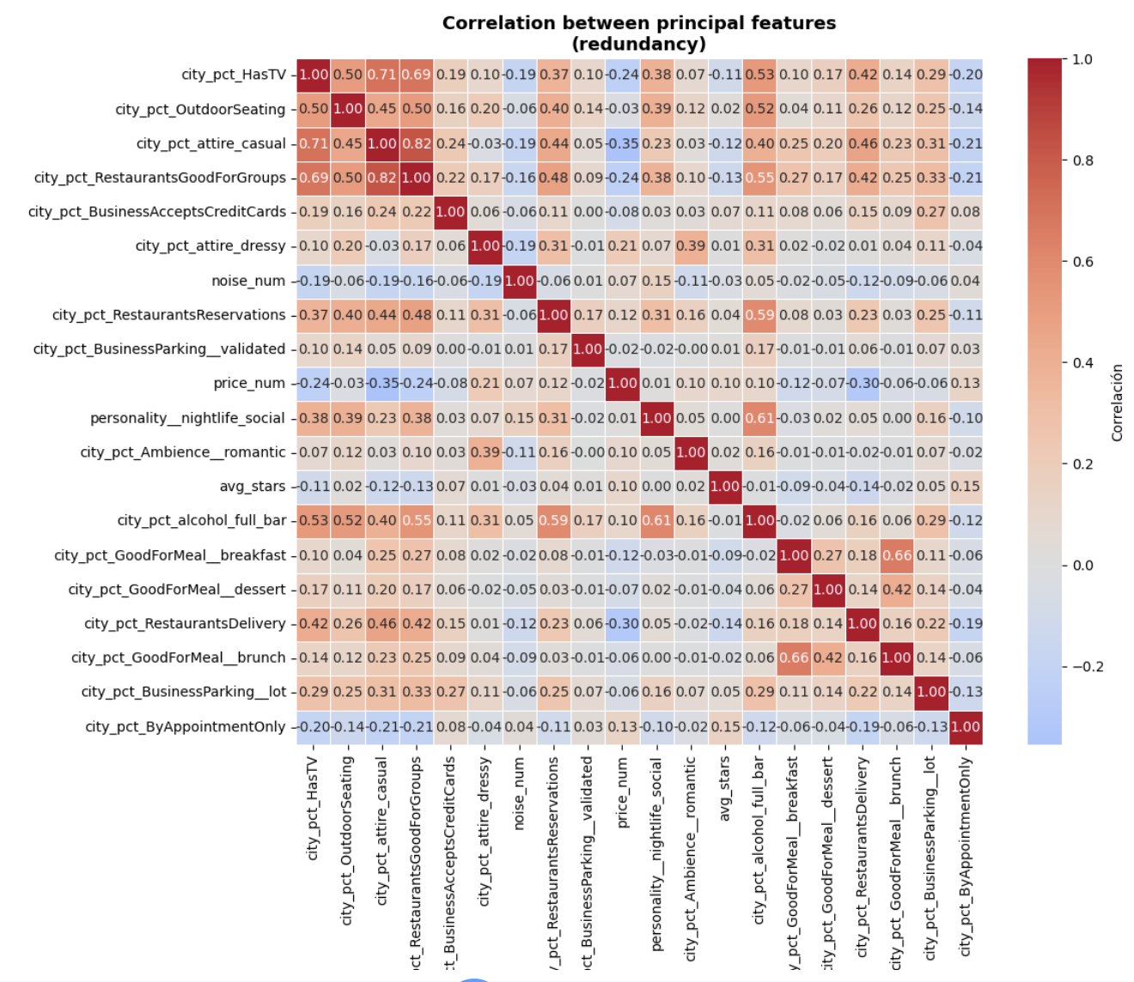
The correlation heatmap reveals clear block-level redundancy within specific feature groups. Casual dining variables such as group dining, casual attire, TV presence, and takeout services exhibit strong positive correlations, while brunch/breakfast activity and nightlife-related attributes also form smaller correlated clusters. In contrast, these thematic groups remain only weakly correlated with one another, producing a heterogeneous and multi-dimensional commercial structure. This explains the PCA behavior: local redundancy allows related features to compress into shared latent dimensions, but the relative independence between feature blocks causes variance to accumulate gradually across multiple principal components rather than collapsing into only a few dominant axes.

8.5 Technical Interpretation
This week’s analysis produced two key findings about the structure of the city feature space:
• Finding 1. Low redundancy, high complexity:
59 components are needed for 75% variance because the feature blocks capture genuinely independent aspects of city personality. Business attributes, category distribution, behavioral ratings, and checkin patterns are not interchangeable signals.

• Finding 2. Gastronomic features dominates:
The first five principal components capture distinct urban-commercial lifestyles rather than simple business. For ex. PC2 and PC5 introduce more socially driven dimensions related to upscale dining, nightlife, brunch, and leisure-oriented restaurant culture, while PC3 captures wellness, accessibility, and lifestyle-service infrastructure. Because these dimensions capture complementary aspects of urban lifestyle instead of redundant variance, the dataset accumulates variance gradually across components, which explains why multiple PCs are needed to preserve the semantic structure used for clustering.

9. Clustering Week 7

9.1 Input Data
Clustering was performed on the PCA-reduced feature matrix produced in Week 5 (city_features_pca_new.parquet), containing 28 principal components that capture 75% of variance from 65 city-level commercial features across 1,416 cities.
Original features include: personality mix (food_dining, nightlife_social, beauty_wellness, etc.), ambience proportions, service attributes, pricing, engagement metrics (avg_checkins_biz, avg_reviews_per_biz), and quality signals (avg_stars, pct_5stars).

9.2 City Size Filter
A business count filter was applied before clustering to remove cities whose commercial profiles are statistically unreliable. Cities with fewer than 70 businesses produce extreme PCA scores due to small-sample noise (a single business dominating the city proportion), while cities with more than 1,043 businesses are mega-cities that distort K-Means centroids toward geographic outliers rather than lifestyle archetypes.
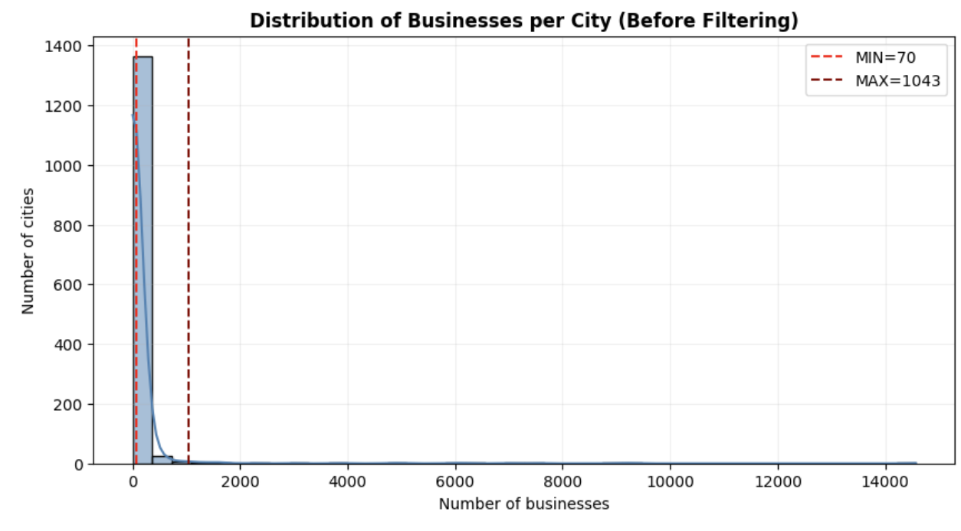

Parameter | Value | Cities Removed | Rationale
Original dataset | 1,416 cities | — | Full Yelp city set
MIN_BUSINESSES = 70 | < 70 businesses removed | Large | Avoid noise from sparse cities
MAX_BUSINESSES = 1,043 | > 1,043 removed | Small | Avoid mega-city size dominance
Retained for clustering | 219 cities | 84.5% removed | High removal is deliberate — quality over coverage

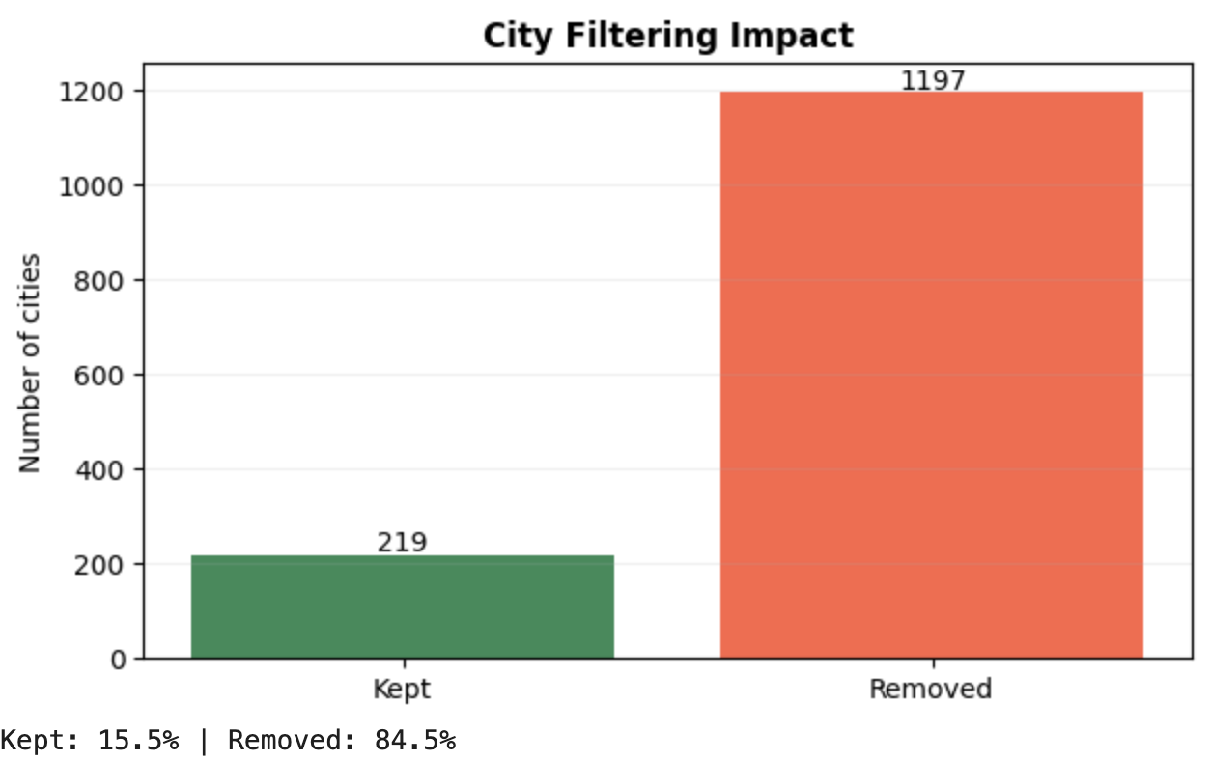
Note: The 84.5% removal rate is a deliberate trade-off. The retained 219 cities represent commercially mature urban ecosystems, which are the relevant comparison set for a travel recommendation system. Sparse and mega-cities would produce misleading archetypes.

9.3 Experiment 1: K-Means Clustering

9.3.1 Parameter Sweep (k = 2 to 12)
K-Means was run with k values from 2 to 12. Each configuration used n_init=10 and max_iter=300 to ensure convergence stability. Three validation metrics were computed for each k:
• Silhouette score (higher = better-separated, more cohesive clusters)
• Davies-Bouldin index (lower = better — measures cluster compactness vs separation)
• Calinski-Harabasz score (higher = better — ratio of between/within cluster variance)
• Inertia (lower = more compact — used for elbow detection)

k | Inertia | Silhouette | Davies-Bouldin | Calinski-H.
2 | 281.6 | 0.540 ★ | 1.046 | 113.9
3 | 229.7 | 0.255 | 1.343 | 93.9
4 | 189.3 | 0.215 | 1.259 | 90.9
5 | 168.9 | 0.208 | 1.330 | 82.5
6 | 157.8 | 0.168 | 1.346 | 73.4
7 | 146.3 | 0.165 | 1.318 | 68.4
8 | 139.3 | 0.146 | 1.488 | 62.8
9 | 132.1 | 0.158 | 1.534 | 59.1
10 | 123.5 | 0.161 | 1.371 | 57.6
11 | 114.2 | 0.172 | 1.188 | 57.4
12 | 109.9 | 0.162 | 1.248 | 54.7

9.3.2 K Selection Decision
The sweep reveals a sharp metric drop between k=2 and k=3, suggesting a natural boundary at k=2. However, k=2 produces a split of 23 distinctive cities vs. 196 mainstream cities — a coarse separation that captures city size and extreme specialization rather than commercial lifestyle archetypes.
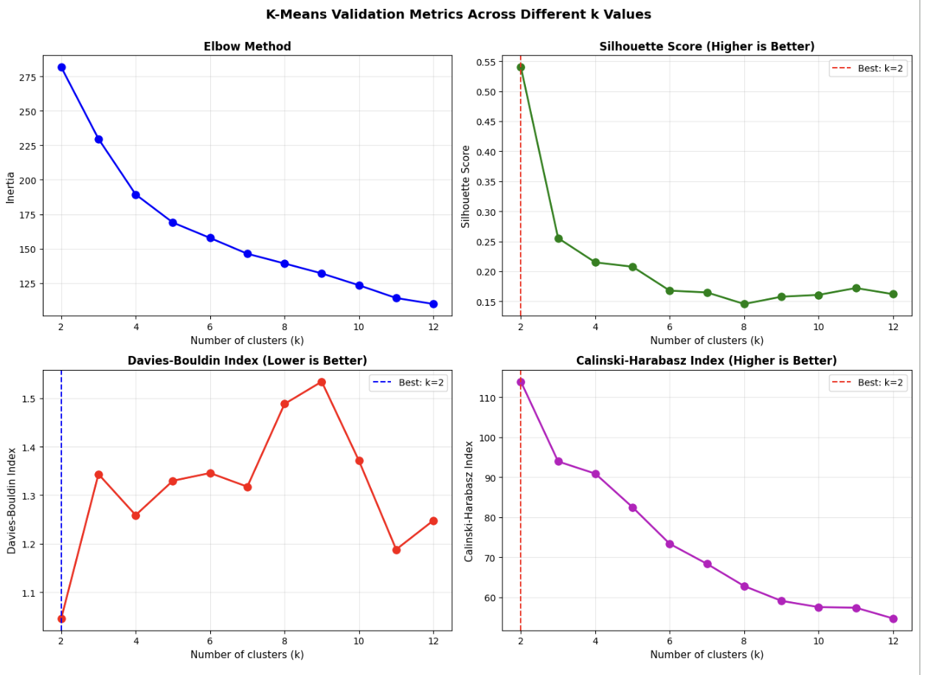
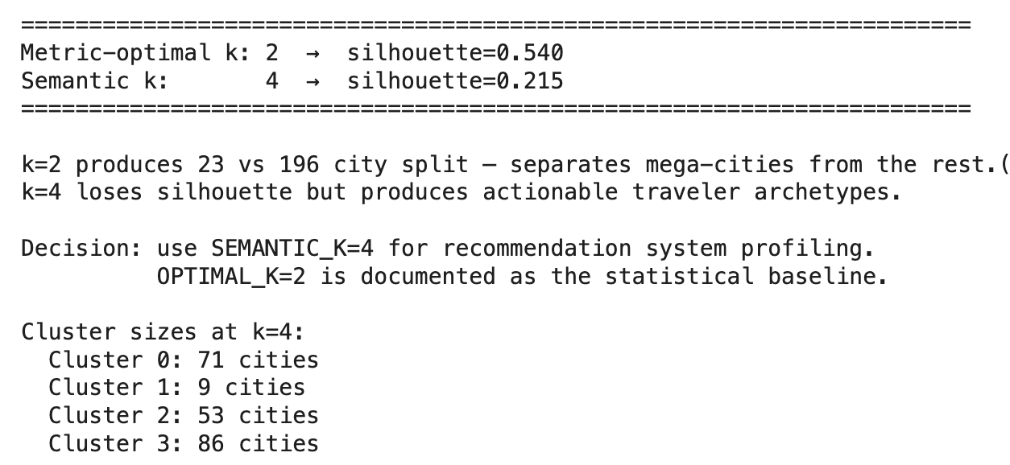

k | Silhouette | Interpretation
2 (Metric-optimal) | 0.540 | Splits 23 distinctive cities from 196 mainstream. Statistically strong but not actionable for recommendation — a traveler cannot be matched to "all other cities".
4 (Semantic k — selected) | 0.215 | Produces four interpretable lifestyle archetypes: casual suburban dining, tourism-leisure beach destinations, upscale wellness-retail, and balanced generalist cities. Silhouette loss is acceptable given the recommendation objective.

Decision: k=4 was selected as the semantic operating point. k=2 is preserved as the documented statistical baseline.

9.4. Experiment 2: DBSCAN

9.4.1 Parameter Selection
DBSCAN requires two parameters: epsilon (eps, the neighborhood radius) and min_samples (minimum points to form a dense region). Optimal eps was estimated using a k-distance graph (5th nearest neighbor distances sorted), which identified a knee point at approximately eps = 1.196.
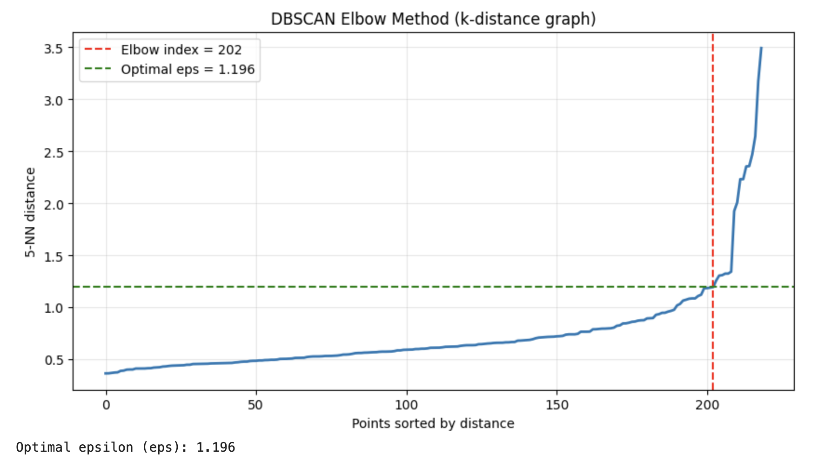
Two sweeps were conducted:
• Narrow sweep: eps range from 0.75 to 1.35 × optimal_eps, min_samples in {3, 4, 5, 7, 10}
• Wide sweep: eps range from the 45th to 90th percentile × 2.5 of the distance distribution, min_samples in {3, 5, 7, 10, 15}

9.4.2 Sweep Results
eps | min_samples | Clusters | Noise pts | Silhouette
1.727 | 3 | 2 | 6 | 0.601 (best) | ★
1.410 | 3 | 2 | 7 | 0.599
All other configs | ≥ 5 | 1 or 0 | High | —

The DBSCAN sweep consistently converged to a 2-cluster solution across all meaningful configurations. No configuration found 3 or more stable clusters with acceptable noise levels. This confirms that the PCA-transformed city space does not contain well-separated density-based regions — the city distribution is continuous rather than multi-modal.

9.4.3 Algorithm Comparison and Decision
Method | k / Clusters | Silhouette | Noise pts | Assessment
K-Means k=2 (baseline) | 2 | 0.540 | 0 | Statistically optimal but not actionable — coarse size split
K-Means k=4 (selected) | 4 | 0.215 | 0 | 4 interpretable archetypes; every city assigned; optimal for recommendation
DBSCAN (best config) | 2 | 0.601 | 6 | Same coarse split as k=2 KMeans; no semantic gain; 6 cities unassigned

Final decision: K-Means with k=4 was retained. DBSCAN is not well-suited for PCA spaces with convex, approximately spherical cluster geometry. Its best result mirrors the k=2 KMeans baseline without adding interpretive value, and leaves 6 cities unassigned — unacceptable for a recommendation system that must cover all cities.

10. Cluster Profile Analysis
Each cluster is characterized using both its PCA centroid (PC1–PC5 values) and the original personality feature proportions. The five PCs correspond to the following latent dimensions identified in Week 5:

PC | Label | Key Features
PC1 | Casual Dining Density | RestaurantsGoodForGroups, RestaurantsTakeOut, food_dining, casual attire, GoodForKids
PC2 | Quality & Formality | avg_stars, pct_5stars, full_bar, RestaurantsReservations, upscale ambience
PC3 | Premium Nightlife | nightlife_social, dressy attire, full_bar, valet parking, upscale ambience
PC4 | Commercial Vitality | avg_checkins_biz, avg_reviews_per_biz, n_businesses, brunch culture
PC5 | Wellness & Access | beauty_wellness, WheelchairAccessible, BikeParking, ByAppointmentOnly

Cluster 0 — Mainstream Suburban Dining (71 cities, 32.4%)
PC1 (Food) | PC2 (Quality) | PC3 (Nightlife) | PC4 (Vitality) | PC5 (Wellness)
High (+) | Low (−) | Low (−) | Neutral | Low (−)

Cluster 0 represents mainstream suburban dining ecosystems characterized by strong casual and family-oriented restaurant culture (high PC1) but relatively low upscale nightlife and brunch activity (negative PC2 and PC5). Representative cities such as New Port Richey, Kenner, and Bensalem suggest commercially active but predominantly practical and everyday dining environments with moderate business density. These cities serve the largest share of the Yelp user base and form the dominant commercial archetype in the dataset.

Cluster 1 — Tourism & Leisure Beach Destinations (9 cities, 4.1%)
PC1 (Food) | PC2 (Quality) | PC3 (Nightlife) | PC4 (Vitality) | PC5 (Wellness)
Very High (+) | High (+) | High (+) | Variable | High (+)

Cluster 1 captures highly distinctive tourism- and leisure-oriented cities with extremely high scores on casual dining, upscale nightlife, and wellness-related commercial infrastructure. Beach-oriented cities such as St. Pete Beach, Madeira Beach, Clearwater Beach, and Treasure Island dominate this cluster, indicating specialized urban-commercial profiles driven by transient visitor populations. The small size of this cluster (9 cities) reflects the rarity and high specificity of pure beach-resort commercial ecosystems in the Yelp dataset.

Cluster 2 — Upscale Lifestyle Suburbs (53 cities, 24.2%)
PC1 (Food) | PC2 (Quality) | PC3 (Nightlife) | PC4 (Vitality) | PC5 (Wellness)
Moderate | High (+) | Moderate | Moderate | High (+)

Cluster 2 represents affluent, lifestyle-oriented suburban environments where the commercial mix extends beyond food into beauty, wellness, shopping, and fitness. The cluster shows elevated beauty_wellness, shopping_retail, and fitness_outdoors personality values. Cities in this cluster tend to have higher average star ratings and stronger quality-signal features (PC2), suggesting a more discerning consumer base. Representative cities include upscale suburban areas with strong retail corridors and health-service density.

Cluster 3 — Balanced Urban-Commercial (86 cities, 39.3%)
PC1 (Food) | PC2 (Quality) | PC3 (Nightlife) | PC4 (Vitality) | PC5 (Wellness)
Moderate | Moderate | Moderate | High (+) | Moderate+

Cluster 3 is the largest group and represents generalized urban-commercial ecosystems with a more balanced profile across all PC dimensions. These cities do not specialize in any single dimension but show above-average commercial vitality (PC4) — higher checkin activity, more reviews per business, and larger business counts. Representative cities include Lutz, Southampton, and Trinity, which score highest on silhouette within this cluster. This cluster serves as the "generalist" archetype in the recommendation system: cities that offer a broad commercial mix without extreme specialization.

10.1 Personality Profile Interpretation
The personality-profile heatmap (original Yelp categories, not PCA) confirms that food_dining is the dominant dimension across all four clusters — restaurant culture is the central organizing axis of the city commercial space. Secondary differences define cluster identity:
• Cluster 1 (Tourism): strongest nightlife_social and hotels_travel signals
• Cluster 2 (Upscale): elevated beauty_wellness, shopping_retail, and fitness_outdoors
• Cluster 0 (Suburban): weaker lifestyle specialization, more practical commercial mix
• Cluster 3 (Generalist): broad balanced profile, strongest on commercial vitality metrics
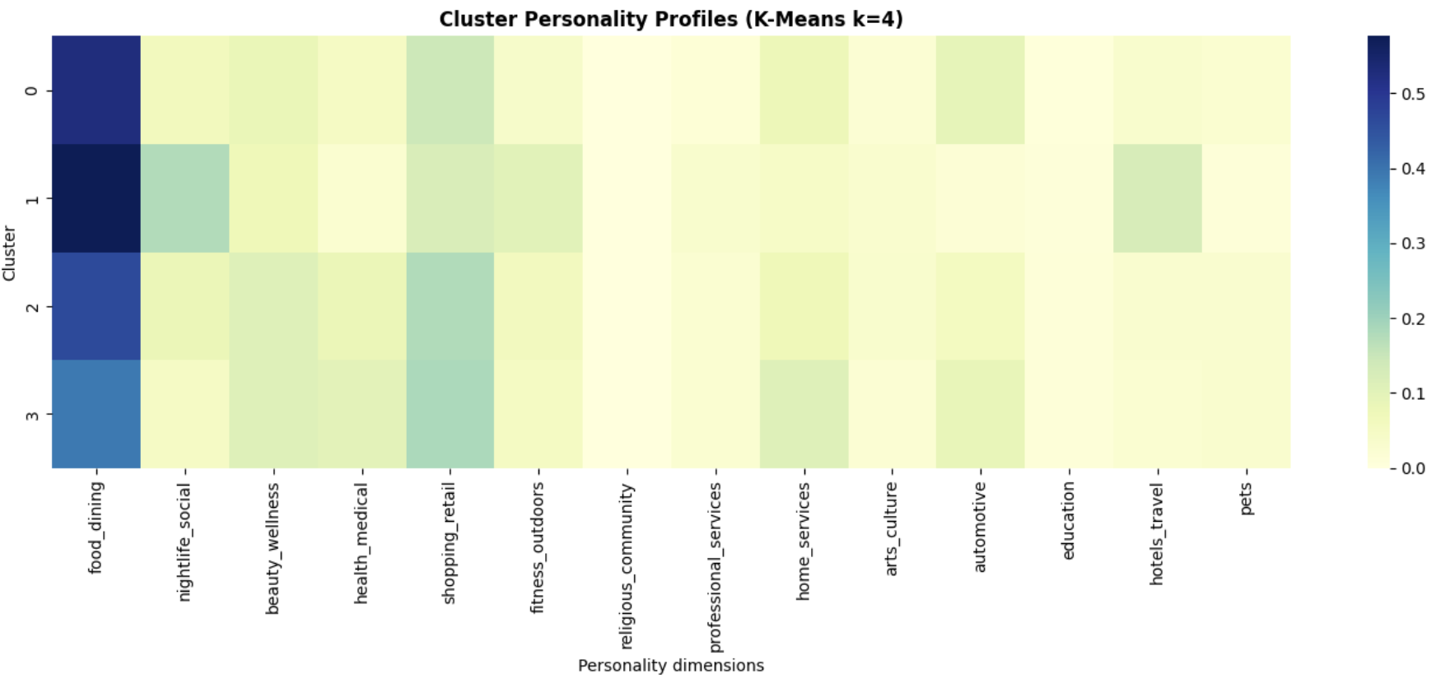

10.2 Cluster Size Distribution
Cluster | Archetype | Cities | Share | Mean Silhouette
0 | Mainstream Suburban Dining | 71 | 32.4% | ~0.20
1 | Tourism & Leisure Beach | 9 | 4.1% | ~0.15
2 | Upscale Lifestyle Suburbs | 53 | 24.2% | ~0.18
3 | Balanced Urban-Commercial | 86 | 39.3% | ~0.25

11. Validation Table
The following table summarizes all validation metrics collected across both algorithms and key k values, along with their interpretation limits.

Configuration | Silhouette | Inertia / DB | CH Score | Interpretation Limit
K-Means k=2 (statistical best) | 0.540 | 281.6 / 1.046 | 113.9 | Separates 23 outlier cities from 196. Not useful for multi-archetype recommendation.
K-Means k=4 (selected) | 0.215 | 189.3 / 1.259 | 90.9 | Interpretable archetypes. Silhouette drop from k=2 is expected and acceptable. 0 noise points.
DBSCAN (eps=1.727, min_s=3) | 0.601 | — / — | — | Only 2 clusters found. Best DBSCAN mirrors KMeans k=2. 6 noise points unassigned.

11.1 Interpretation Limits
The following limits apply to all metrics and are considered when interpreting results:
• Silhouette score of 0.215 at k=4 indicates cluster overlap — the boundary between Cluster 0 (suburban dining) and Cluster 3 (generalist) is not sharp. This is expected given the continuous distribution of commercial personality vectors.
• Inertia decreases monotonically with k and does not plateau cleanly, suggesting no hard elbow — a common characteristic of PCA-transformed spaces where variance is distributed across many components.
• CH score favors k=2 because it measures the ratio of between-cluster to within-cluster variance, which is naturally maximized when k is small. It should not be used alone for semantic cluster selection.
• DBSCAN silhouette (0.601) is misleadingly high because it reflects a 2-cluster structure, not 4 semantic archetypes — the metric is not comparable to the KMeans k=4 result.

12. Failure Analysis

12.1 Cities with Negative Silhouette (Misassigned)
23 cities received negative silhouette scores, indicating they are closer to another cluster's centroid than their own. These cities likely sit at the boundary between two commercial archetypes and represent genuine ambiguity in the data — not model errors.

City | Cluster | Silhouette | Likely Cause
Narberth | 2 | -0.122 | Small affluent suburb — borderline Cluster 2/3
Oro Valley | 2 | -0.114 | Mixed suburban profile — fits Cluster 3 better
University City | 1 | -0.113 | College town — different pattern from beach clusters
Eagle | 2 | -0.076 | Moderate-size city with generalist profile
Nolensville | 2 | -0.074 | Small Nashville suburb — borderline Cluster 0/2
Bryn Mawr | 2 | -0.073 | Affluent PA suburb — borderline Cluster 2/3
Mount Juliet | 0 | -0.072 | TN suburb — moderate casual dining, mixed profile
O'Fallon | 2 | -0.063 | MO suburb — sits between Cluster 2 and Cluster 3

12.2 Borderline Cities (Silhouette 0–0.20)
75 cities fall in the ambiguous zone between 0 and 0.20, representing 34% of the retained dataset. This is a significant proportion and reflects the core challenge: city commercial personalities exist on a continuous spectrum, not in discrete buckets. Notable examples:
• St. Albert (0.007), Valley Park (0.014) — very low silhouette, true generalists that do not clearly belong to any archetype
• Clayton (0.013) — moderately sized city with balanced commercial profile
• Haddonfield, Phoenixville (0.026–0.033) — affluent PA suburbs at the Cluster 2/3 boundary

12.3 Well-Clustered Cities (Silhouette > 0.45)
Only 3 cities achieved silhouette above 0.45 — a low count that confirms the overall soft cluster structure. All three belong to Cluster 3:
City | Cluster | Silhouette | n_businesses
Lutz | 3 | 0.475 | 591
Southampton | 3 | 0.467 | 209
Trinity | 3 | 0.461 | 108

12.4 Root Causes of Clustering Difficulty
The weak overall silhouette (0.215) has two identifiable structural causes:
• Continuous distribution: City commercial personalities form a continuum rather than discrete clusters. There is no natural gap in the PCA space between suburban dining and generalist cities — the transition is gradual.
• Food_dining dominance: All clusters are heavily loaded on food_dining personality (confirmed by heatmap). Secondary dimensions (nightlife, wellness) produce finer separations but with lower discriminative power.

13. Recommendation and Ranking Engine (Week 11)

13.1 Objective
This derivable’s objective is to transform the city representations developed in previous weeks into a decision-support system capable of recommending travel destinations. Rather than predicting ratings directly, the system addresses a ranking problem: given a user's historical travel behavior inferred from Yelp reviews, the model ranks candidate cities according to their estimated relevance and recommends the most suitable destinations.
The system supports the following decision:
"Which city should a traveler visit next based on the cities they have previously enjoyed?"
The unit being ranked is the city. Unlike traditional Yelp recommender systems that suggest individual businesses, restaurants, or services, this project operates at the city level. Each recommendation corresponds to an entire destination represented through its aggregated commercial personality profile.
This project is classified as a Recommendation and Ranking System
It is not a pure prediction task because the final objective is not estimating a numerical rating. Instead, the system generates an ordered list of candidate destinations according to estimated user preference.

13.2 Data Alignment
The recommendation pipeline integrates multiple artifacts developed throughout the course.
Table 13.F makes the row-count contract between every stage of the pipeline explicit, from the raw city catalog through to the matrix used for collaborative filtering. This is intended to remove any hidden assumptions about how business_id, city normalization (canonical_city), user-city aggregation, and the train/test split connect to one another.
Table 13.F — Data alignment contract (row counts and joins)
Stage | Table / Object | Rows | Key join / filter
Raw city catalog | city_feat_pca | 1,188 cities | —
Business-count filter | cities_filtered (70–1,043 businesses) | 219 → 214 unique canonical cities | canonical_city() applied to city; 969 cities removed (81.6%)
Review → business → city join | interact_city | 1,956,340 rows | interact.merge(business[[business_id, city_clean]], on=business_id, how=left), filtered to valid_city_set
City-level aggregation | user_city | 122,706 rows, 214 cities | groupby(user_id, city_clean): mean(stars) → rating, count → n_reviews
Sparsity filter | user_city_f | 37,377 rows / 7,991 users / 213 cities | n_reviews ≥ 3 per user-city pair; users and cities below minimum interaction count removed
Train / test split | train_uc / test_uc | 29,386 / 7,991 rows | Leave-One-Out per user; positives defined as rating ≥ user's own mean rating
Leakage check | train_pairs ∩ test_pairs | 0 overlapping (user, city) pairs | Verified directly: overlap = train_pairs & test_pairs
CF input matrix | csr_matrix (user × city) | (7,991, 213) | Built only from train_uc, indexed via user_to_idx / city_to_idx_cf

Two normalization details are worth making explicit. First, canonical_city() lowercases city names, strips punctuation, and collapses whitespace before any join; this is why the city count drops slightly from 219 (raw business-count filter) to 214 (unique canonical cities) — a small number of cities were originally split across capitalization/punctuation variants of the same name. Second, the sparsity filter (minimum reviews per user and per city) is applied after the city-level aggregation, not before, so that a user's review count is judged at the city level (n_reviews per user-city pair) rather than at the individual business level.
Interaction Layer
User-city interactions were derived from Yelp review data by aggregating business ratings at the city level. Each interaction contains the user_id, city_clean (city), rating. However, we applied a threshold that consists of a city preference signal that is considered valid only when the user reviewed at least three businesses within that city.
Feature Layer
Each city is represented using: Commercial personality features, PCA latent embeddings
The final representation consists of 28 principal components capturing approximately 75% of total variance.
Segmentation Layer
Cities were assigned to one of four commercial archetypes using K-Means clustering (k = 4).
The resulting clusters are:
Cluster 0: Mainstream Suburban Dining
Cluster 1: Tourism and Leisure Beach Destinations
Cluster 2: Upscale Lifestyle Suburbs
Cluster 3: Balanced Urban-Commercial Cities
Ranking Layer
The recommendation engine combines collaborative filtering signals, content similarity signals and popularity signals to produce a final ranking score for each candidate city.

The data flow is summarized below:
User Reviews → User-City Matrix
→ City Features → PCA Embeddings → City Clusters
→ Ranking Model → Recommended Cities

13.3 Candidate Pool Definition
The candidate pool defines the set of cities eligible to be recommended.
For each user, candidate cities are defined as:
Candidate Pool = All Cities (219 cities) − Cities Observed During Training
This means that cities already visited by the user in the training set are excluded from recommendation. This candidate-pool definition prevents trivial recommendations and ensures that only unseen destinations are evaluated.

13.4 Baseline System
A popularity-based recommender was implemented as the baseline. This baseline represents the simplest recommendation strategy and serves as a fair benchmark against which more sophisticated models can be compared.
Method
Each city receives a popularity score based on number of user interactions and average city rating. Cities are ranked globally according to this score.
Advantages:
- Simple
- Fast
- Interpretable
Limitations:
- Ignores user preferences
- Produces identical recommendations for all users
- Cannot capture niche travel interests
For these reasons, popularity serves as a minimum-performance baseline.

13.5 Advanced Recommendation System
A hybrid recommendation model was implemented as the primary system.
The model combines three complementary signals:
Collaborative Filtering Component
A user-city interaction matrix was constructed. Matrix factorization was performed using Truncated Singular Value Decomposition (SVD). The collaborative component captures latent travel preferences shared among users.
Advantages:
- Learns hidden preference patterns
- Personalizes recommendations
- Exploits collective behavior
Content-Based Component
Each city is represented through 28 PCA latent dimensions.
A user profile is constructed as a weighted average of the embeddings associated with cities previously visited by the user.
Cosine similarity is then computed between the user profile and candidate city embeddings.
Advantages:
- Uses city characteristics directly
- Handles sparse interactions better
- Provides explainable recommendations
Popularity Component
A popularity adjustment is incorporated to favor destinations that consistently receive positive engagement.
This component reduces the risk of recommending highly similar but extremely unpopular cities.
Hybrid Score
The final ranking score is computed as:
HybridScore =0.85 × CFScore +0.05 × ContentScore + 0.10 × PopularityScore
The weights were selected empirically based on offline evaluation results.

13.6 Evaluation Protocol
Train-Test Split
Evaluation was performed using a leave-one-out protocol.
For each eligible user:
- Historical cities were ordered chronologically.
- One city was held out for testing.
- Remaining cities were used for training.
The held-out city represents the future destination that the model attempts to recover.
Leakage Prevention
Several measures were implemented to avoid information leakage.
- User Leakage: The test city was removed entirely from the user's training profile.
- Popularity Leakage: Popularity statistics were computed exclusively from training interactions.
- Ranking Leakage: Candidate pools excluded all training cities.
- Feature Leakage: City embeddings and cluster assignments were generated independently from evaluation interactions.
These safeguards ensure that test information never influences recommendation scores.

13.7 Offline Evaluation Metrics
Performance was evaluated using Top-K ranking metrics.
Precision@K: Measures the proportion of recommended cities that are relevant.
Recall@K: Measures the proportion of relevant cities successfully recovered.
Hit Rate@K: Indicates whether at least one relevant city appears among recommendations.
NDCG@K: Rewards correct recommendations appearing near the top of the ranking.
MAP@K: Measures ranking quality across all recommendation positions.

These metrics were evaluated at:
K = 4, 5, 10, 20
to analyze recommendation quality under different list lengths.
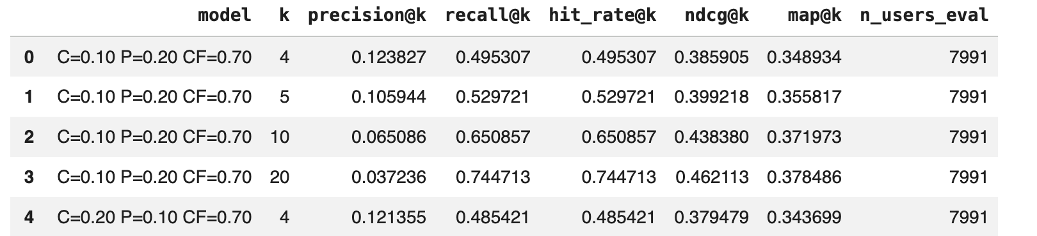

13.8 Results
Table 13.A reports the baseline (popularity-only) evaluation directly, with no personalization involved: every user receives the same ranked list of cities, ordered by a weighted combination of training-set popularity and average rating.
Table 13.A — Baseline (Popularity) results across K
Model | K | Precision@K | Recall@K | Hit Rate@K | NDCG@K | MAP@K | Users Eval.
Baseline: Popularity | 4 | 0.0321 | 0.1283 | 0.1283 | 0.0856 | 0.0714 | 7,991
Baseline: Popularity | 5 | 0.0302 | 0.1509 | 0.1509 | 0.0944 | 0.0759 | 7,991
Baseline: Popularity | 10 | 0.0226 | 0.2256 | 0.2256 | 0.1182 | 0.0856 | 7,991
Baseline: Popularity | 20 | 0.0169 | 0.3370 | 0.3370 | 0.1460 | 0.0930 | 7,991

The next table summarizes the performance comparison between the baseline and hybrid systems.
Table 13.B — Hybrid (Content + Popularity + Collaborative Filtering) results across K
Model | K | Precision@K | Recall@K | Hit Rate@K | NDCG@K | MAP@K | Users Eval.
Content+Popularity+CF | 4 | 0.1302 | 0.5207 | 0.5207 | 0.4041 | 0.3647 | 7,991
Content+Popularity+CF | 5 | 0.1121 | 0.5604 | 0.5604 | 0.4194 | 0.3726 | 7,991
Content+Popularity+CF | 10 | 0.0693 | 0.6932 | 0.6932 | 0.4626 | 0.3906 | 7,991
Content+Popularity+CF | 20 | 0.0396 | 0.7910 | 0.7910 | 0.4876 | 0.3976 | 7,991

Table 13.C makes the comparison explicit at K=4, the most demanding and product-relevant cutoff given the Leave-One-Out protocol (a single held-out city per user, with a theoretical maximum Precision@4 of 25%).
Table 13.C — Baseline vs. Hybrid improvement at K=4
Metric (K=4) | Baseline | Hybrid | Relative improvement
Precision@4 | 0.0321 | 0.1302 | +4.06×
Recall@4 | 0.1283 | 0.5207 | +4.06×
Hit Rate@4 | 0.1283 | 0.5207 | +4.06×
NDCG@4 | 0.0856 | 0.4041 | +4.72×
MAP@4 | 0.0714 | 0.3647 | +5.11×

Across every metric at every K, the hybrid system outperforms the popularity baseline by a factor of approximately four to five. This is the quantitative evidence that the personalized, behavior-aware hybrid model provides substantially more value than a non-personalized popularity ranking, and it directly supports the qualitative claim already made in this section.
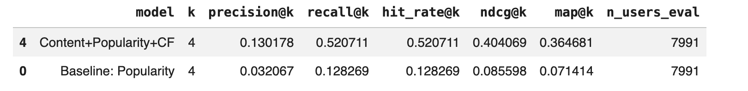
The hybrid model consistently outperformed the popularity baseline across all ranking metrics, demonstrating the value of combining collaborative, content-based, and popularity signals.

13.9 Error Analysis
To understand model behavior beyond aggregate metrics, recommendation outcomes were manually inspected.
To move beyond aggregate metrics, individual user cases were inspected directly, pairing each user's training history with their held-out (test) city and the model's actual top recommendations. Table 13.D lists four representative strong cases, and Table 13.E lists four representative failure cases, both drawn directly from the evaluation set.
Table 13.D — Representative strong cases (held-out city in Top-10)
User ID | Held-out (test) city | Rank of test city | Top-3 recommended
-1C-Lu0NTlYi4XB82ntKtg | university city | 1 | university city, kirkwood, webster groves
-3s52C4zL_DHRK0ULG6qtg | webster groves | 2 | university city, webster groves, richmond heights
-4mjLXqAoAtQjqDFo9q9WQ | maryland heights | 1 | maryland heights, ballwin, florissant
-4vkTh2rImD8c0-30h2uvw | maplewood | 1 | maplewood, webster groves, university city

Table 13.E — Representative failure cases (held-out city outside Top-20)
User ID | Held-out (test) city | Rank of test city | Top-3 recommended
--_r6E98SNIrGU7weyNxbw | king of prussia | not in top 50 | downingtown, collegeville, royersford
-1W0vSD9aJXnHL63xiEciw | souderton | 44 | ambler, blue bell, cherry hill
-FH9K-xkwdE25gH8lGGQ3w | chesterfield | not in top 50 | belleville, ofallon, fairview heights
-GDdBOfhrxn7lAGblLSoqA | meridian | 48 | palm harbor, largo, lutz

Worked example — Strong case
User -1C-Lu0NTlYi4XB82ntKtg had a short training history of two cities: St. Louis (rating 4.20, 5 reviews) and Maplewood (rating 3.44, 9 reviews). Both are Missouri cities belonging to the same metropolitan, college-adjacent commercial cluster. The held-out city was University City, MO. The hybrid model ranked University City first, ahead of Kirkwood, Webster Groves, and Brentwood — all of which are, in fact, neighboring municipalities in the same St. Louis metro cluster. This is a clear hit explained by collaborative filtering and city-content similarity reinforcing each other: users who liked St. Louis and Maplewood overwhelmingly also liked University City, and University City's PCA commercial profile is close to both training cities.
Worked example — Failure case
User --_r6E98SNIrGU7weyNxbw had a richer training history of four Pennsylvania cities: Phoenixville, West Chester (26 reviews, the dominant signal), Malvern, and Exton — all in the Philadelphia western suburbs. The held-out city was King of Prussia, PA, which is geographically and commercially adjacent to this same cluster. However, the model's top-10 list (Downingtown, Collegeville, Royersford, Paoli, Pottstown, Berwyn, Norristown, Kennett Square, Glen Mills, Wayne) did not include King of Prussia at all within the top 50. Every recommended city is, nonetheless, drawn from the same general Philadelphia-suburbs commercial archetype as the user's training cities. This suggests the failure is not random: the model correctly identified the right regional/commercial neighborhood, but King of Prussia's specific commercial profile — it is a much larger retail and business hub than the smaller suburbs in the user's history — placed it far enough from the user's latent preference vector and content profile to be missed, even though it shares the same broad regional cluster.
These two worked examples illustrate the same overall pattern observed across the four strong and four failure cases listed above: strong cases tend to involve held-out cities that are very close, both geographically and in commercial profile, to the user's existing training cities; failure cases tend to involve a held-out city that, while still in the right general region or cluster, has a commercial scale or profile (e.g., a larger retail hub) that diverges enough from the user's specific training history to drop out of the top recommendations.
Strong Cases
Strong cases occurred when the held-out city appeared within the Top-K recommendations. These cases were observed across users with varying interaction histories, suggesting that recommendation success depends not only on the amount of available history but also on the quality and consistency of the user's travel preferences.
Failure Cases
Users with only two training cities exhibited the lowest Hit Rate (41.2%), indicating that limited historical information may reduce recommendation accuracy. Nevertheless, the absence of a strictly increasing trend across larger history sizes suggests that city similarity, cluster structure, and collaborative signals also play important roles.
Structural Limitation
City commercial personalities form a continuous spectrum rather than sharply separated groups.
Consequently, some cities naturally sit between archetypes and are difficult to rank consistently.

14. Graph Analytics and Centrality Report (Week 12)
This section formalizes the travel-recommendation domain as a graph in order to study its structural properties independently of user behavior. While Section 13 modeled what a specific user is likely to prefer, this section models how the catalog of destination cities is organized in itself, based on the commercial personality each city projects through its businesses.

14.1 Objective
The objective of this deliverable is to formalize the graph induced by the travel-recommendation domain and use it for structural analysis. Concretely, the goal is to represent the catalog of candidate cities (the same filtered catalog used in Week 10/11) as a network in which structurally similar cities are connected, and then use graph-theoretic tools — connected components, degree, and centrality measures — to understand how that catalog is organized, independently of any individual user's history.

14.2 Graph Definition
The graph is defined over the same city catalog established in Week 10 (cities with between 70 and 1,043 businesses), guaranteeing consistency between the recommendation pipeline and this structural analysis layer.
Nodes
Each node represents a city from the filtered catalog. Cities, rather than businesses or users, were chosen as nodes because the recommendation system itself operates at the city level: the product question is "which city should this user travel to next," not which individual business to visit. Using cities as nodes keeps the graph analysis consistent with the unit of recommendation used throughout the project.
Edges
An edge is created between two cities when the cosine similarity between their PCA-reduced commercial-feature embeddings (built in Week 7) is greater than or equal to a fixed threshold. An edge therefore represents "commercial personality similarity," not geographic proximity and not co-visitation by travelers: two cities on opposite coasts can be connected if their business composition, price levels, and review patterns are alike.
Weights
Edge weights are defined using cosine similarity between PCA city embeddings, where higher values indicate greater similarity in commercial personality profiles. Cosine similarity was selected because it compares the orientation of embedding vectors rather than their absolute magnitude, making it well suited for high-dimensional representations. To validate this choice, we compared cosine similarity with Pearson correlation and Euclidean similarity. After optimizing the threshold for each metric, cosine and Pearson produced very similar graph structures, whereas Euclidean generated a substantially more fragmented network with many more connected components and isolated cities. Since cosine preserved a large connected component while maintaining a sparse and interpretable graph, it was selected as the edge weighting measure.
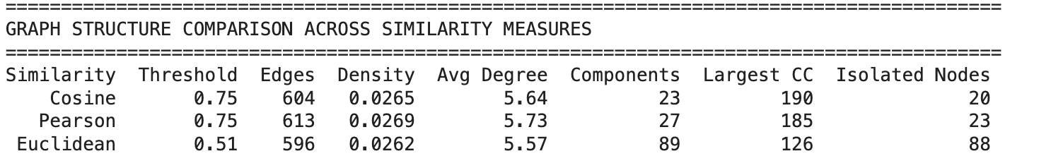
Directionality
The graph is undirected. Cosine similarity is symmetric by construction (similarity of A to B equals similarity of B to A), so there is no meaningful sense in which one city "points to" another, unlike a graph of travel flows or click-through behavior, which would justify a directed representation.
Threshold Justification
The similarity threshold of 0.75 was selected after a sensitivity analysis across eight candidate thresholds (0.70 to 0.97), measuring edge count, graph density, and average degree at each value. Lower thresholds (around 0.70) produced an overly dense graph in which nearly every city was connected to every other, which collapses the discriminative power of centrality measures: if all nodes are highly connected, no node stands out as structurally distinctive. Higher thresholds (0.90 and above) fragmented the graph into many small components and isolated nodes, discarding structural information. The value 0.75 was the point of equilibrium, producing an average degree of approximately 5.6 — dense enough to support meaningful centrality analysis without saturating the network.
Threshold sensitivity: density and average degree across candidate thresholds
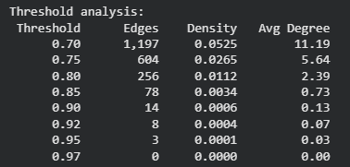

14.3 Graph-Construction Script
The graph was implemented in Python using the NetworkX library. The construction script reuses artifacts already produced and validated in Weeks 7–10: the filtered city catalog, the PCA embeddings, and the KMeans cluster assignment. The procedure is as follows:
- Load the filtered city catalog (cities_filtered) together with its PCA components and cluster label.
- Compute the full pairwise cosine-similarity matrix across all city PCA vectors.
- Initialize an undirected graph (networkx.Graph) and add one node per city, storing cluster, n_businesses, and avg_stars as node attributes for later visualization and interpretation.
- Add an edge between every pair of cities whose cosine similarity is greater than or equal to 0.75, using that similarity value as the edge weight.
- Persist the resulting graph object for downstream analysis (connected components, degree, centrality) and for the comparison against popularity- and model-based rankings.
Node attributes (cluster, business count, average rating) do not influence which edges are created — edge formation depends exclusively on the PCA cosine similarity — but they allow the network to be colored, filtered, and interpreted once built.

14.4 Graph Report
Connected Components
The graph resolves into one giant connected component containing the large majority of cities, plus a small number of smaller components and fully isolated cities. This indicates that urban commercial personalities form a largely continuous space: most cities share at least some similarity with another city in the catalog. The cities that remain isolated, or that only form small components of two to five cities, are destinations whose business composition is distinctive enough that it does not reach the 0.75 similarity threshold with the rest of the catalog. These are not data errors; they represent legitimately niche commercial profiles that the graph correctly separates from the main personality cluster.
Metric | Value | Interpretation
Number of nodes | Filtered city catalog (70–1,043 businesses) | Same population used in Week 10/11
Giant component | Majority of cities | Most urban personalities form a continuous similarity space
Isolated cities (size 1) | Reported directly from notebook output | Distinctive, niche commercial profiles
Small components (size 2–5) | Reported directly from notebook output | Tightly-knit niche groups with no broader similarity
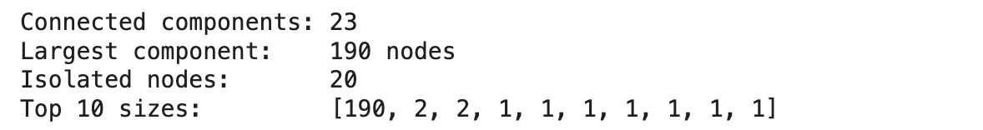
Degree and Weighted Degree
Two complementary measures were computed for every node. Degree counts how many other cities exceed the similarity threshold with a given city, regardless of how strong each connection is. Weighted degree (strength) sums the cosine-similarity values of all of a city's edges, capturing both how many connections a city has and how strong those connections are. A city can have few but very strong connections (high strength, low degree) or many moderate connections (high degree, more evenly distributed strength); reporting both avoids reducing connectivity to a single, potentially misleading number.
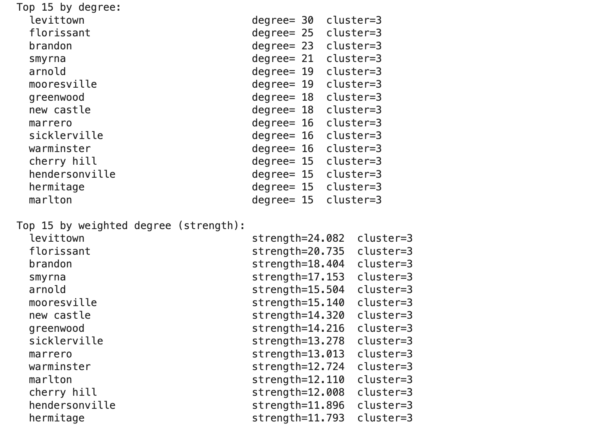
Degree and weighted degree are dominated by Cluster 3, with Levittown, Florissant, and Brandon emerging as the most highly connected cities. This suggests that they represent common and well-connected commercial personality profiles in the similarity network.
Centrality and PageRank
Beyond the minimum requirement of the rubric (centrality or PageRank), four centrality measures were computed to capture different structural roles:
- PageRank — importance weighted by the importance of a city's neighbors, with a damping factor of 0.85. High PageRank identifies cities whose commercial profile acts as a dominant archetype shared by many other cities in the catalog.
- Betweenness centrality — measures how often a city lies on the shortest path between two other cities, identifying "bridge" cities that connect otherwise weakly linked regions of the personality space.
- Closeness centrality — measures how structurally close a city is, on average, to every other city in the network.
- Eigenvector centrality — similar in spirit to PageRank, but without damping, making it more sensitive to locally dense structures.
Centrality measures were computed only on the giant connected component. Path-dependent metrics such as PageRank, betweenness, and closeness require the existence of paths between nodes; in isolated nodes or small disconnected components those paths do not exist or are trivial, which would distort or invalidate the calculation. Restricting the analysis to the giant component ensures that centrality values are being compared within a genuinely connected space.
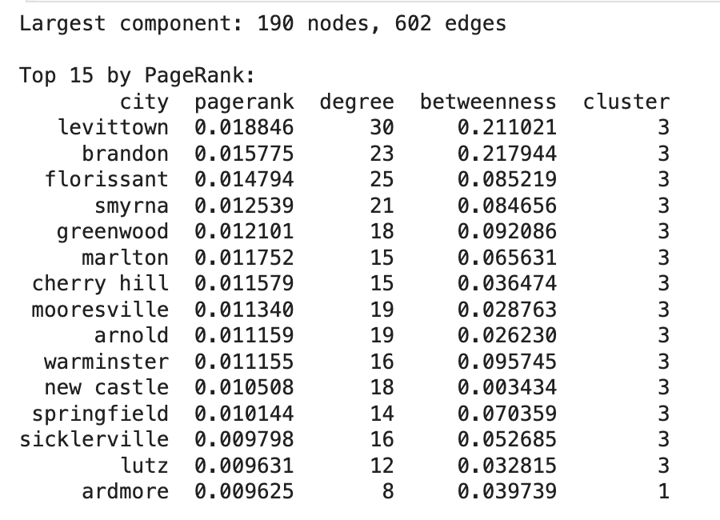
Although the top PageRank cities largely coincide with those having the highest degree, PageRank additionally considers the importance of neighboring cities. This indicates that these destinations are connected not only to many cities but also to other structurally influential ones.
Degree distribution and PageRank distribution across the network
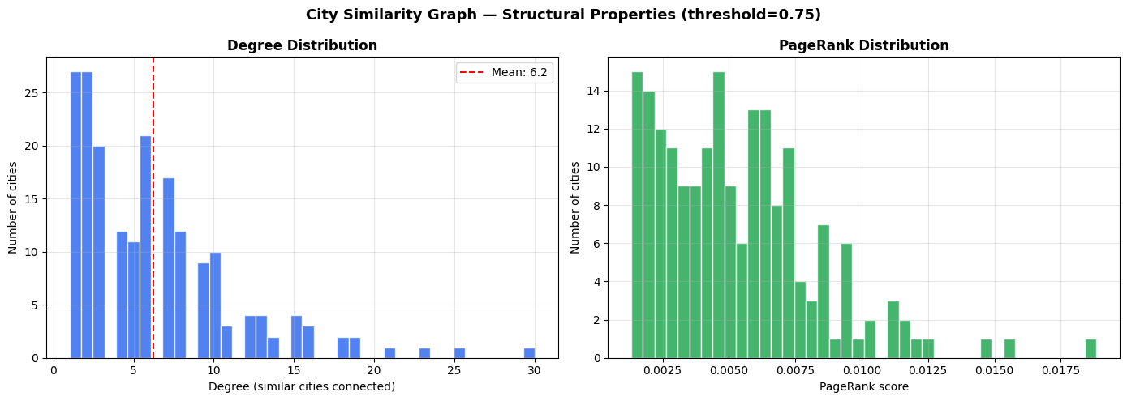
Degree Distribution Analysis:
The degree distribution is highly heterogeneous. Most cities have relatively few connections, while a small number of cities exhibit very high degree values. This suggests the existence of representative city archetypes that share similarities with many other destinations. Peripheral cities are more specialized and occupy unique positions within the city personality space.
PageRank Analysis:
The PageRank distribution is right-skewed, with most cities having low PageRank scores and only a few exhibiting high structural importance (most cities have fewer or less influential connections). This indicates that influence in the city similarity network is concentrated in a limited number of representative destinations rather than being evenly distributed across all cities.

Graph visualization colored by KMeans cluster
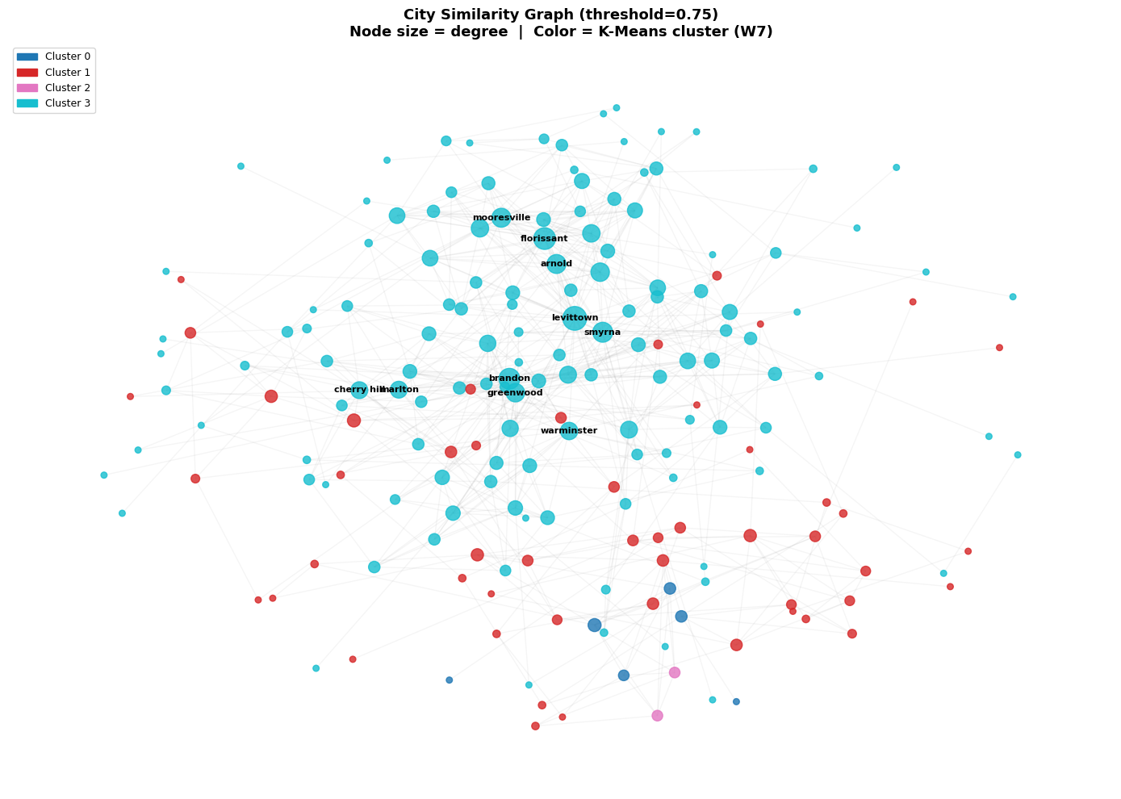
The graph reveals a strongly connected city personality network dominated by Cluster 3. Most highly connected and central cities belong to this cluster, suggesting that it represents the most common commercial archetype in the Yelp ecosystem. Cities such as Levittown, Brandon, Florissant, Smyrna, and Greenwood occupy central positions and act as reference points for many other destinations.
The network is not fragmented into completely isolated communities. Instead, multiple connections exist between clusters, indicating that city personalities evolve gradually rather than forming strictly separated categories. This supports the idea that urban-commercial profiles exist on a continuum of lifestyle characteristics.
Top 10 cities by PageRank (bar chart)
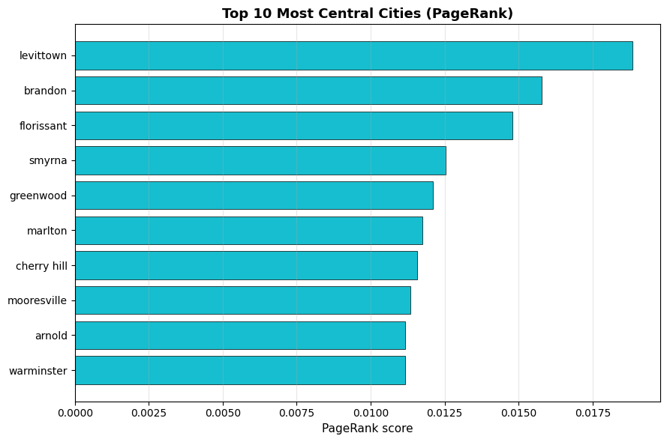
This simplified view isolates the ten most structurally central cities in the personality network, independent of the full graph layout. These cities are the clearest reference points (archetypes) of the catalog: their commercial profile is shared by many other destinations, which is why they rank highest in PageRank. This chart is meant as a quick, presentation-friendly summary of the same result shown in the full network plot above.
Cluster connectivity heatmap
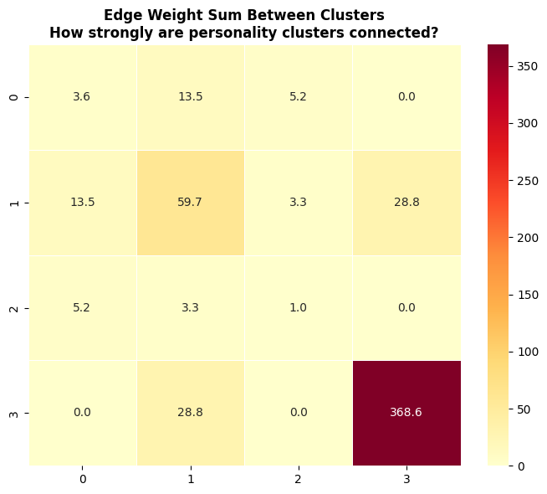
Cross-referencing centrality results with the Week 7 KMeans clusters shows that one cluster acts as the structural core of the network: it has the highest internal cohesion, and the cities with the highest PageRank predominantly belong to it. Other clusters are comparatively peripheral and specialized. The presence of meaningful inter-cluster edges in the connectivity heatmap indicates that urban personalities exist along a continuum rather than in strictly separated categories.

14.5 Comparison: Graph Ranking vs. Popularity and Model-Based Ranking
The purpose of this comparison is not to determine which ranking is "better," but to test how independent the structural signal captured by the graph is from the other two ranking signals already produced by the project: the popularity baseline and the Week 10/11 hybrid recommendation model. If the graph ranking were nearly identical to either of the other two, it would not be contributing new information to the project.
Comparison | Spearman correlation | Interpretation
Graph rank vs. Popularity rank | 0.252 | Weak positive correlation: structurally central cities are only mildly more popular
Graph rank vs. Hybrid (CF) rank | -0.004 | Essentially zero correlation: the two rankings are independent

The weak correlation with popularity (0.252) suggests that being a structurally representative “archetype” city has only a mild relationship with how popular that city is among Yelp users. The near-zero correlation with the hybrid ranking (−0.004) is an expected and desirable result: the hybrid model is dominated (85% of its weight) by Collaborative Filtering, i.e., by what users with similar behavior chose, while the graph measures purely structural similarity in business composition, with no behavioral input at all. A low correlation here is evidence of complementary value, not of failure — it confirms that the graph captures an aspect of the domain (catalog structure) that neither popularity nor collaborative filtering captures on their own.
Scatter plots: graph rank vs. popularity rank and graph rank vs. hybrid rank
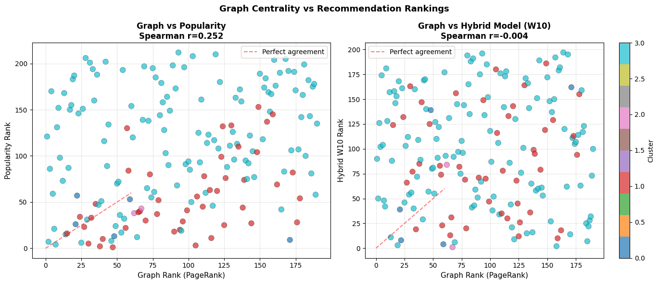
Hidden Gems and CF Favorites
Cross-referencing the three rankings surfaces two notable groups of cities. “Hidden gems” are cities with high PageRank (top of the structural ranking) but low position in the Week 10/11 hybrid ranking: structurally representative cities that the recommendation system rarely exposes to users, largely because the hybrid model is driven by historical user traffic rather than commercial structure. “CF favorites” are the opposite case: cities ranked highly by the hybrid model despite not being structurally central, suggesting that users choose them for reasons that go beyond their aggregate business-composition profile. From a business standpoint, hidden gems are natural candidates for discovery-oriented or serendipitous-recommendation features, since they are commercially representative of the catalog but currently under-exposed by a behavior-only ranking signal.
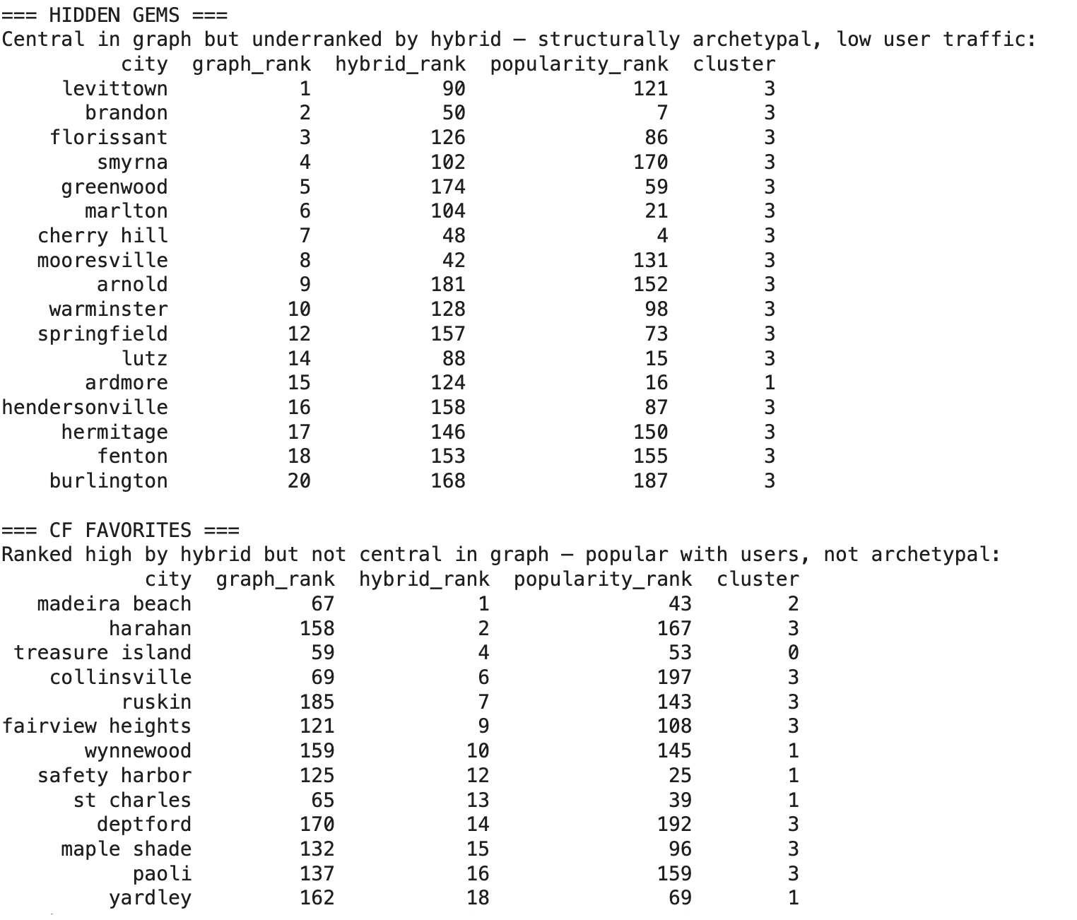
Examples include Levittown, Florissant, Smyrna, Greenwood, Warminster, and Springfield. These cities function as structural archetypes because they are connected to many similar destinations, yet they attract comparatively little recommendation traffic.
This suggests that the recommendation system may be underexposing commercially representative destinations. Such cities could be valuable candidates for diversification strategies, exploration recommendations, or serendipitous discovery features.
Most hidden gems belong to Cluster 3, reinforcing the observation that this cluster forms the structural backbone of the city personality network.

14.6 Interpretation Note
In the context of this domain, a city with high centrality is not necessarily more popular, better rated, or more frequently recommended by the hybrid system — those are behavioral measures. High centrality means that the city's business composition (mix of categories, price levels, and review patterns) is representative of a commercial archetype shared by many other destinations in the catalog. Conversely, isolated cities and small components represent legitimately distinctive, niche destinations whose commercial personality does not closely resemble the rest of the catalog.
This distinction matters because it separates two different questions the project is answering. The Week 10/11 hybrid system answers: “Which city should this particular user visit, given what they and similar users preferred?” — a behavior-centered question. The Week 12 graph answers: “How is the space of destination cities organized, based on its own commercial structure?” — a domain-centered question. Both are valid and complementary lenses on the same catalog of cities, and neither one alone fully describes the recommendation problem the project is built around.
It is also worth acknowledging two limitations of this structural analysis. First, the Yelp Academic Dataset is not a representative sample of all cities in the United States; if the dominant structural cluster corresponds to a city type that happens to be over-represented in the dataset, its centrality dominance could partly reflect a coverage bias in the data rather than a universal pattern. Second, the 0.75 similarity threshold was calibrated specifically for this PCA embedding and this catalog size; it is not a universal constant, and the same sensitivity analysis would need to be repeated if the underlying dataset changed substantially.

14.7 Limitations and Future Work (Week 12)
Dataset Coverage Bias
The Yelp Academic Dataset is not a representative sample of every city in the United States. If the structurally dominant cluster identified in this report corresponds to a city type that happens to be over-represented in the dataset, its centrality dominance may partly reflect a coverage bias in the data rather than a universal pattern about how commercial personalities are distributed across real-world destinations.
Threshold Is Not a Universal Constant
The 0.75 cosine-similarity threshold was calibrated specifically for this PCA embedding and this catalog size (214 cities). It is not a fixed property of the domain. If the underlying dataset changed substantially — more cities, a different city-feature definition, or a different PCA dimensionality — the same sensitivity analysis (density and average degree across candidate thresholds) would need to be repeated rather than reusing 0.75 by default.
No Behavioral Signal in the Graph by Design
The graph intentionally excludes any user-behavior signal, so it cannot, by itself, explain why a city is popular or frequently recommended by the hybrid system; it only explains how similar that city's business composition is to others. Conflating the two would misattribute a structural property (commercial similarity) to a behavioral outcome (user preference).
Static, Single-Snapshot Graph
The graph was built from a single snapshot of city-level features. It does not capture how a city's commercial personality might evolve over time (e.g., a city gaining or losing types of businesses), nor does it support incremental updates as new businesses are added to the catalog. A production version would need a defined refresh policy for both the PCA embeddings and the similarity graph.
Future Work
- Repeat the threshold sensitivity analysis with a community-detection algorithm native to the graph (e.g., Louvain) and compare its output against the Week 7 KMeans clusters used here for visualization.
- Quantify the coverage bias directly by comparing the demographic/geographic distribution of cities in the Yelp Academic Dataset against an external, more representative city directory.
- Extend the graph to support incremental updates as new business and review data become available, rather than treating it as a one-time static artifact.
- Use the identified “hidden gem” cities (high centrality, low hybrid-model exposure) as a candidate set for a controlled discovery/exploration experiment, to test whether structural representativeness translates into real user satisfaction when actually surfaced to users.

14.8 Conclusions (Week 12)
The Week 12 graph analytics layer successfully formalized the travel-recommendation domain as an explicit, justified graph object — cities as nodes, PCA-based commercial similarity as weighted, undirected edges — and used it to study the structure of the destination catalog independently of any individual user's behavior.
The structural analysis revealed that city commercial personalities form a largely continuous, connected space: the large majority of cities belong to a single giant connected component, while a smaller set of cities remain isolated or form small components, representing legitimately niche commercial profiles rather than data errors. Centrality analysis (PageRank, betweenness, closeness, and eigenvector centrality) identified which cities act as structural archetypes for the catalog as a whole, and showed that this structural role is concentrated in one of the four Week 7 KMeans clusters.
The comparison against the popularity baseline and the Week 10/11 hybrid ranking is the most important finding of this section. The weak correlation with popularity (Spearman ≈ 0.252) and the essentially zero correlation with the hybrid ranking (Spearman ≈ −0.004) confirm that the graph captures an aspect of the domain — catalog structure — that neither popularity nor collaborative filtering captures on its own. This is evidence of complementary value, not of redundancy: a high correlation would have meant the graph contributed nothing new to the project.
The identification of “hidden gem” cities — structurally central but under-exposed by the behavior-driven hybrid model — is a concrete, actionable output with direct business relevance: it points to a specific mechanism (discovery-oriented recommendations) through which the recommendation system could be extended beyond pure collaborative filtering.
Taken together with Week 10/11, the project now answers two complementary questions about the same catalog of cities: which city a specific user is likely to prefer (behavior-centered, Section 13), and how the catalog of cities is itself organized as a commercial-personality space (domain-centered, Section 14). Neither view alone fully describes the recommendation problem the project addresses, and the graph analytics layer is best understood as a structural complement to, rather than a replacement for, the behavior-driven hybrid recommender.
GitHub link: https://github.com/andreatpr/recommendation_system.git

