
Travel Recommendation System Based on City Commercial Personality
Final Technical Report
Big Data — Group 5

Members:
Nicole Sihuincha Schermuly
Andrea Katherina Tapia Pescoran
Maria Ximena Chavarria Barrios
Jhamil Brijan Peña Cardenas

Yelp Academic Dataset
July 2026

Table of Contents
Table of Contents 2
1. Problem Statement 4
2. Domain Context 4
3. Dataset Sources and Access Conditions 4
4. Schema and Data Dictionary 5
4.1 Entity-relationship overview 5
4.2 Handling of nested columns 5
4.3 Data dictionary 6
5. Preprocessing and Feature Engineering 7
5.1 From raw JSON to processed tables 7
5.2 The city-level feature matrix 7
5.3 City name normalization and catalog traceability 8
6. Dimensionality and Representation Analysis 8
6.1 PCA on the city feature matrix 8
6.2 Interpreting the leading components 9
7. Clustering Analysis 11
7.1 City size filter 11
7.2 Component sensitivity and input selection 12
7.3 K-Means parameter sweep and selection of k 12
7.4 Cluster profiles 14
7.5 Failure analysis 15
8. Recommendation and Ranking System 16
8.1 Task framing 16
8.2 Data alignment 16
8.3 Baseline system 16
8.4 Hybrid recommendation model 17
8.5 Deployment: recommendation API 17
8.6 Monitoring and operationalization plan 22
9. Graph Analytics 23
9.1 Graph definition 23
9.2 Threshold selection 24
9.3 Robustness across similarity measures 24
9.4 Structural report 25
9.5 Graph ranking versus popularity and model rankings 28
9.6 Case study: positioning recommendations in the graph 30
10. Evaluation Protocol 30
10.1 Protocol design 30
10.2 Metrics 31
10.3 Results 31
10.4 Error analysis 32
11. Pipeline and Reproducibility 32
12. Ethics and Limitations 33
12.1 Data ethics and privacy 33
12.2 Pipeline evolution and internal inconsistencies 34
12.3 Modeling limitations 35
13. Final Conclusions 35

1. Problem Statement
Choosing a travel destination is a decision that most recommendation platforms still resolve through popularity: they suggest the places that everyone visits, regardless of who is asking. This approach fails precisely where it matters most, because two travelers with identical budgets can have completely different expectations of a city. One may value nightlife and dense commercial activity, while the other looks for quiet residential areas with wellness services and family-oriented dining.
This project addresses that gap by asking a single product question: given a traveler's Yelp review history, which cities share the most similar commercial personality with the places that traveler has already enjoyed? The system therefore operates at the city level, not the business level. It does not recommend a specific restaurant; it recommends destinations. The link between past behavior and a new recommendation is built from aggregated behavioral signals, which cities a user has rated businesses in, and how highly.
Solving this question requires a transition from micro-data (millions of individual businesses) to macro-representations (one dense vector per city). Most of the technical work described in this report, feature engineering, dimensionality reduction, clustering, matrix factorization, and graph analysis, exists to make that transition rigorous and defensible.

2. Domain Context
The system belongs to the domain of intelligent travel destination recommendation. Its central modeling assumption is that a city has a latent “commercial personality”: a stable profile that emerges when the attributes of thousands of local businesses are aggregated, such as the proportion of romantic venues, the prevalence of kid-friendly locations, price ranges, noise levels, and engagement patterns. Cities are treated as structured entities with distinct socioeconomic and cultural profiles rather than as points on a map.
The Yelp Academic Dataset supports every layer this project requires. The business table provides a rich catalog (150,346 businesses with attributes, categories, and geolocation); the review table provides an interaction matrix of nearly seven million user-business ratings suitable for collaborative filtering; and the combination of both allows city-level feature engineering, clustering of urban archetypes, a hybrid recommendation engine, and a city-similarity graph. A single data source thus sustains the full pipeline of the project, from raw ETL over roughly 9 GB of nested JSON to the final recommendation API.

3. Dataset Sources and Access Conditions
All data comes from the Yelp Academic Dataset, downloaded directly from yelp.com/dataset after completing Yelp's academic registration form. The dataset is distributed under the Yelp Dataset License, which explicitly permits academic, non-commercial research and classroom use. No scraping was performed at any stage, the raw files are stored in a private drive, and the project does not redistribute the original data.
The raw distribution consists of per-line JSON files, one per entity, totaling approximately 9 GB uncompressed. No geographic or temporal subset was applied: the full dataset feeds all downstream tables.
File | Records | Key fields
yelp_academic_dataset_business.json | 150,346 | business_id, name, city, state, lat/lon, stars, review_count, is_open, attributes{}, categories, hours{}
yelp_academic_dataset_review.json | 6,990,280 | review_id, user_id, business_id, stars, text, date
yelp_academic_dataset_user.json | ~1,987,897 | user_id, review_count, average_stars, yelping_since, friends[], elite
yelp_academic_dataset_checkin.json | 131,930 | business_id, date (comma-separated timestamps)

4. Schema and Data Dictionary

4.1 Entity-relationship overview
The four raw JSON sources were normalized into six processed Parquet tables. The design follows a simple star-like structure: business_clean acts as the central catalog, review_interactions is the sparse fact table connecting users and businesses, and the remaining tables provide dimensions and bridges.
Processed table | Primary key | Foreign keys | Grain
business_clean | business_id | — | One row per business (58 columns after flattening)
business_categories | business_id + category | business_id | One row per (business, category) pair — bridge table
review_interactions | (user_id, business_id) | user_id, business_id | One rating per user-business pair
user_clean | user_id | — | One row per user
checkin_clean | business_id | business_id | One row per business with aggregated check-in count

4.2 Handling of nested columns
Three columns in the raw business file required explicit architectural decisions. The attributes column arrives as a dictionary whose values are themselves dictionaries serialized as strings; we flattened it in two levels using an attr__ prefix, dropping 51 of the 88 resulting columns because they were more than 90% null, and retaining 37. Missing values were deliberately kept as NaN rather than imputed as False, because the absence of an attribute is not the same as the attribute being negative, a business with no WiFi information is genuinely unknown, not WiFi-free. The hours column was converted into nine integer features (days open, a weekend flag, and one boolean per day), defaulting to zero when the dictionary is absent. The categories string was parsed into a list, from which we derived a primary_category, a category count, and a bridge table that later supports category-based similarity in the clustering and graph stages.

4.3 Data dictionary
The table below documents the processed schema of the central catalog, business_clean, by column group. Column-level missingness on the attribute columns ranges from 20% to 84%; as discussed in Section 5, this is structural to how Yelp collects data rather than a quality defect.
Column group | Columns | Type | Missingness | Notes
Identity | business_id, name, city, state, postal_code | str | 0% | PK is a 22-character hash
Geography | latitude, longitude | float64 | 0% | WGS84 decimal degrees
Performance | stars, review_count, is_open | float / int | 0% | stars 1.0-5.0; is_open 0/1
Categories | categories_list, primary_category, n_categories | object / str / int | 0% / 0.07% / 0% | List, first element, count
Attributes (boolean) | attr__ByAppointmentOnly through attr__GoodForMeal__breakfast (32 cols) | boolean (nullable) | 20%-84% | NaN = not reported by the business
Attributes (categorical) | attr__RestaurantsPriceRange2, attr__WiFi, attr__Alcohol, attr__RestaurantsAttire, attr__NoiseLevel (5 cols) | category | 20%-75% | Low-cardinality string values
Hours | hours__open_days, hours__has_weekend, hours__open_{day} x 7 (9 cols) | int64 | 0% | 0 when the hours dict is None

review_interactions (3 columns). user_id and business_id as foreign keys and the 1-5 star rating that serves as the collaborative-filtering signal. With about 6.99M interactions over 1.99M users and 150K businesses, the implied user-item matrix density is roughly 0.0023%, which anticipates the need for matrix factorization later in the pipeline.
user_clean (4 columns). Only user_id, review_count, average_stars, and yelping_since are retained. Display names and friend lists were excluded at ingestion for privacy reasons (see Section 12).
checkin_clean (2 columns). business_id plus n_checkins, the count of raw timestamps, used as a proxy for foot traffic.

5. Preprocessing and Feature Engineering

5.1 From raw JSON to processed tables
Ingestion transformed four nested JSON sources into six Parquet tables with Snappy compression. Beyond the flattening decisions documented in Section 4, the cleaning stage dropped 51 of the 88 raw attribute columns because they exceeded 90% missingness across the full dataset. The 37 retained attribute columns still show between 20% and 84% missing values. We treat this as structural rather than as a data quality defect: Yelp only collects attributes that are relevant to each business type, so a hair salon simply never reports whether it serves alcohol. Imputing False in these cases would inject false information into the model, which is why NaN was preserved throughout.
The interaction table was reduced to the minimum needed for collaborative filtering (user_id, business_id, stars), and the user table retains only anonymized identifiers and behavioral counts. Geographically, the catalog concentrates in a set of US metropolitan areas — Philadelphia (14,569 businesses), Tucson (9,250), Tampa (9,050), Indianapolis (7,540) and Nashville (6,971) lead the count, which gives the system enough diversity of urban environments to make personality comparisons meaningful.

5.2 The city-level feature matrix
The central feature-engineering step scales the data from individual businesses to aggregated city entities. Boolean and categorical business attributes were averaged per city into percentage-based features (for example, the share of romantic venues or of kid-friendly locations), producing a semantic profile of each city's commercial mix. The matrix was then enriched with external tourism descriptors, including a safety index, climate classification, and peak travel seasons. One-hot encoding was applied to categorical variables such as climate type and city vibe, and ordinal encoding to naturally ordered ones such as noise level and price range. The resulting matrix contains 1,416 cities and 74 features and is the input to every downstream stage.

5.3 City name normalization and catalog traceability
During the recommendation stage we detected that the raw city field contains inconsistent spellings of the same place, variants with hyphens, extra spaces, punctuation, or casing differences. A canonicalization function was introduced that lowercases each name, removes punctuation, and collapses whitespace. Applying it reduced the catalog from 1,416 raw name variants to 1,188 canonical cities; rows mapping to the same canonical name were merged by averaging their feature vectors.
This normalization was introduced from the recommendation stage onward, which means the earlier representation and clustering analyses (Sections 6 and 7) operate on the pre-normalization catalog. The implications of that timing are discussed openly in Section 12. The full catalog traceability across the pipeline is:
Pipeline stage | Cities | Note
Raw city name variants | 1,416 | As found in business.json
Canonical names | 1,188 | After normalization (recommendation stage onward)
Business-count filter (70-1,043) | 219 | Rows retained for modeling
Unique canonical cities after merge | 214 | Duplicated canonical names averaged
Cities in the evaluation set | 213 | After minimum-interaction filters

6. Dimensionality and Representation Analysis

6.1 PCA on the city feature matrix
The 61 numeric features of the city matrix were standardized with StandardScaler so that high-magnitude counters such as total reviews could not dominate percentage-based features, and a full Principal Component Analysis was fitted. Variance is broadly distributed rather than concentrated: the first component explains only 15.8% and the second 5.5%, and no single dominant direction emerges. This is expected, because the feature blocks (dining, nightlife, wellness, engagement, quality) capture genuinely different aspects of a city that do not collapse into one axis.
The number of retained components was selected from the cumulative variance curve:
Setting | Components | Variance retained
PCA 70% | 24 | 0.70
PCA 75% (selected) | 28 | 0.75
PCA 80% | 31 | 0.80
PCA 90% | 41 | 0.90

We selected 28 components at 75% retained variance as the working representation. Below that point the representation starts discarding meaningful secondary structure; above it, additional components mostly add noise-like variance while increasing the dimensionality that clustering and similarity computations must handle.

6.2 Interpreting the leading components
The first five components admit a coherent domain reading, which is used throughout the report to interpret clusters and graph structure:
PC | Label | Key loading features
PC1 | Casual Dining Density | groups-friendly, takeout, food_dining, casual attire, kid-friendly
PC2 | Quality & Formality | avg_stars, pct_5stars, full bar, reservations, upscale ambience
PC3 | Premium Nightlife | nightlife_social, dressy attire, valet parking
PC4 | Commercial Vitality | check-ins per business, reviews per business, business count
PC5 | Wellness & Access | beauty_wellness, wheelchair access, bike parking

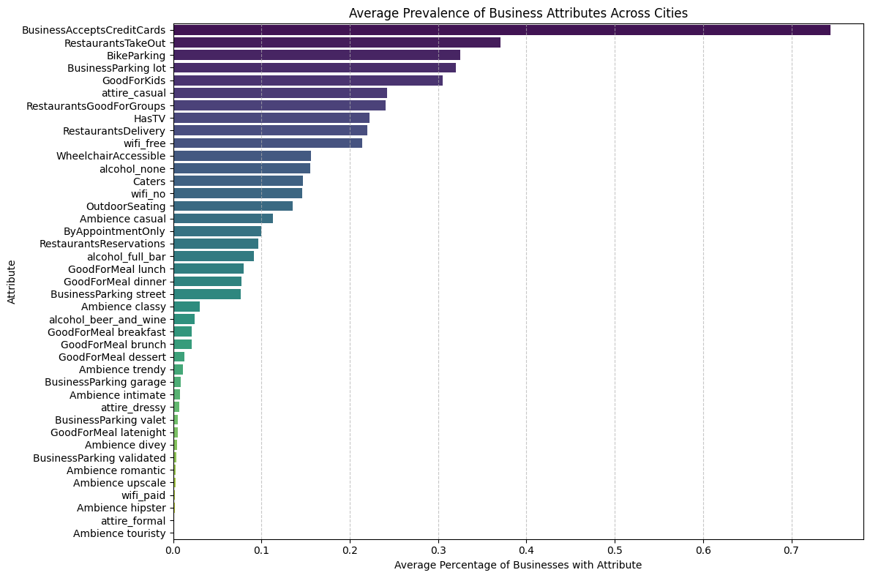
Figure 1. Average attribute prevalence across the 1,416 cities.
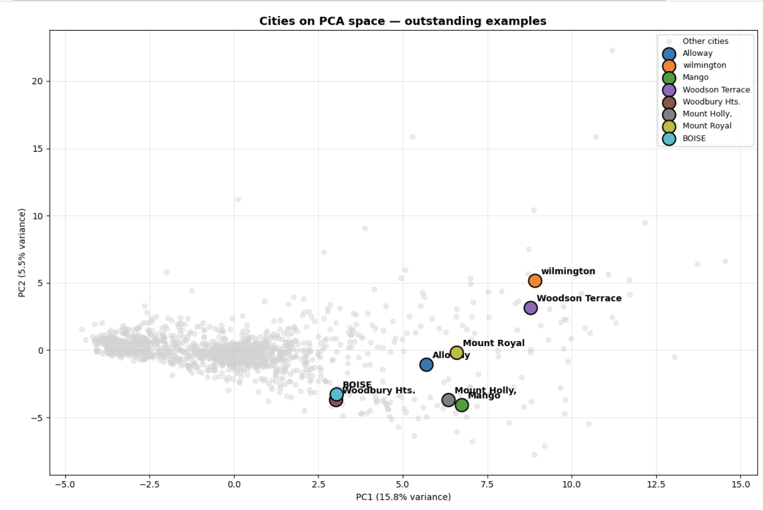
Figure 2. Two-dimensional PCA projection of the city space, colored by average stars.
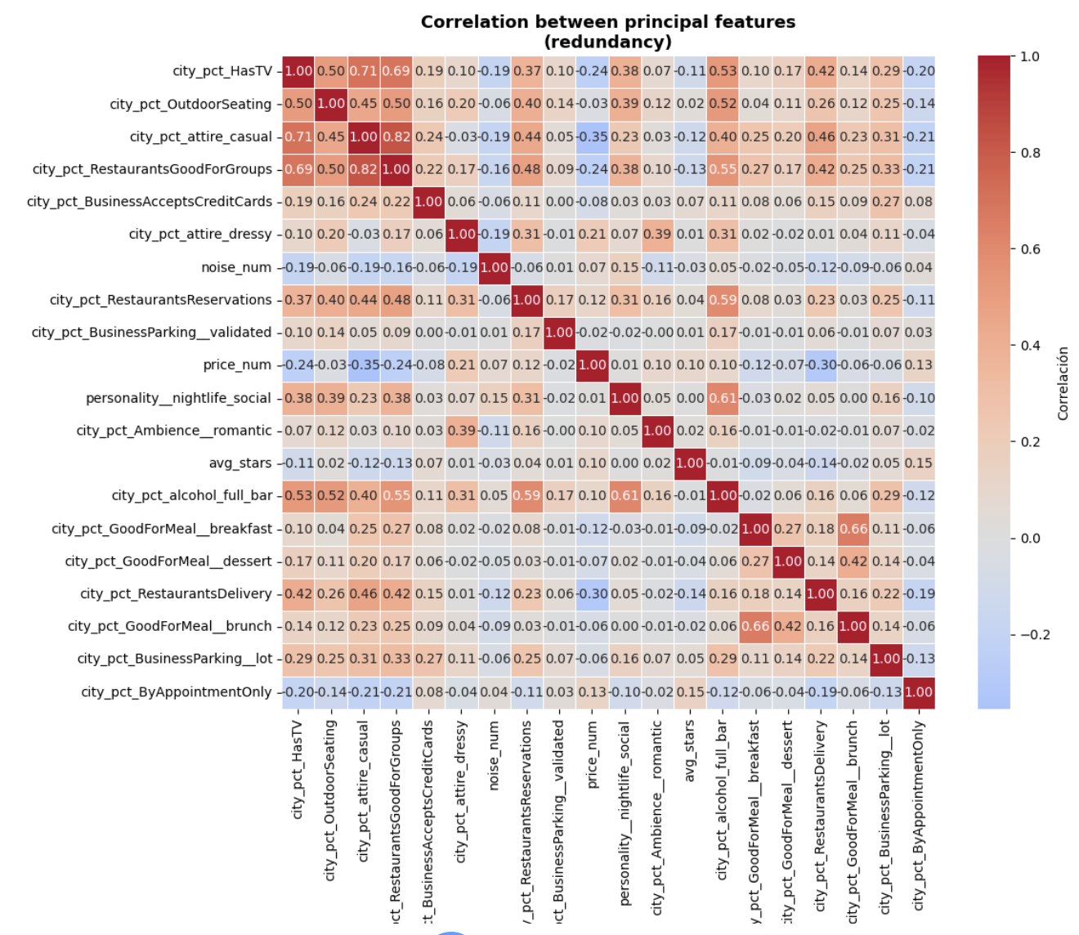
Figure 3. Correlation heatmap of key city-level features.
The two-dimensional projection shows a continuous cloud rather than separated islands, an early signal — confirmed later by clustering, that city personalities form a spectrum rather than discrete types.

7. Clustering Analysis

7.1 City size filter
Before clustering, cities outside the range of 70 to 1,043 businesses were removed. Cities below the minimum produce unstable profiles, because with very few businesses a single venue can dominate the city's percentages and generate extreme PCA scores; cities above the maximum are metropolitan outliers whose sheer size drags K-Means centroids toward geography rather than lifestyle. The filter retains 219 cities, removing 84.5% of the catalog. That removal rate is a deliberate quality-over-coverage trade-off: the retained cities are commercially mature ecosystems, which is the relevant comparison set for a travel recommender.
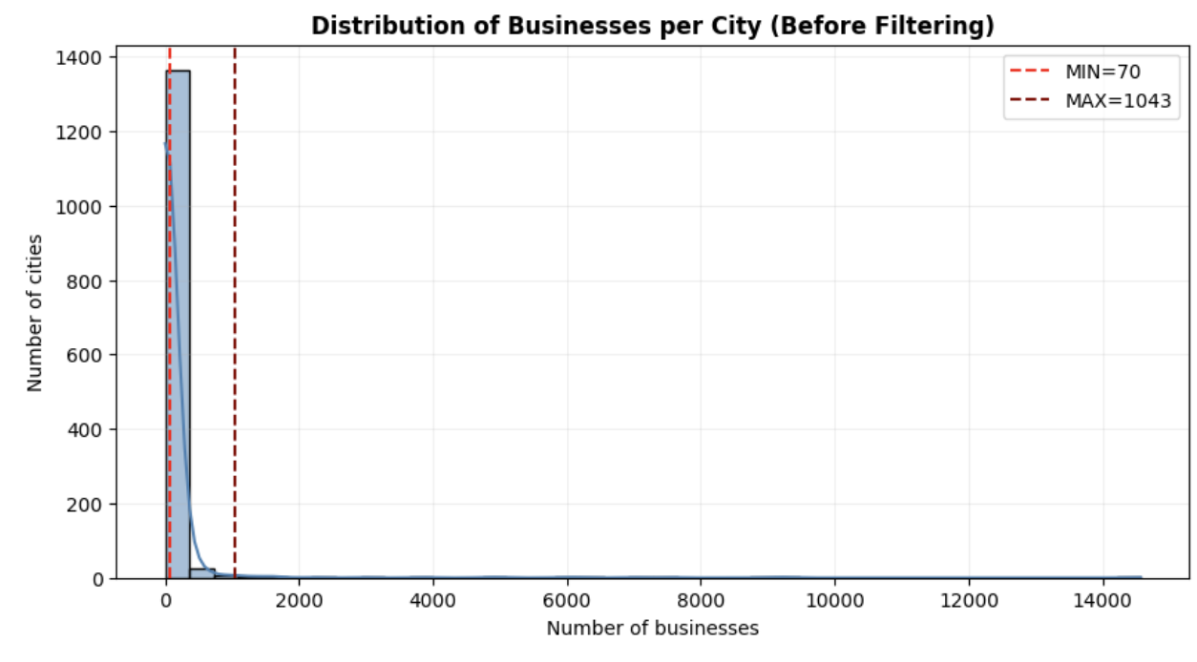
Figure 4. Distribution of businesses per city with the filter bounds (70 and 1,043).
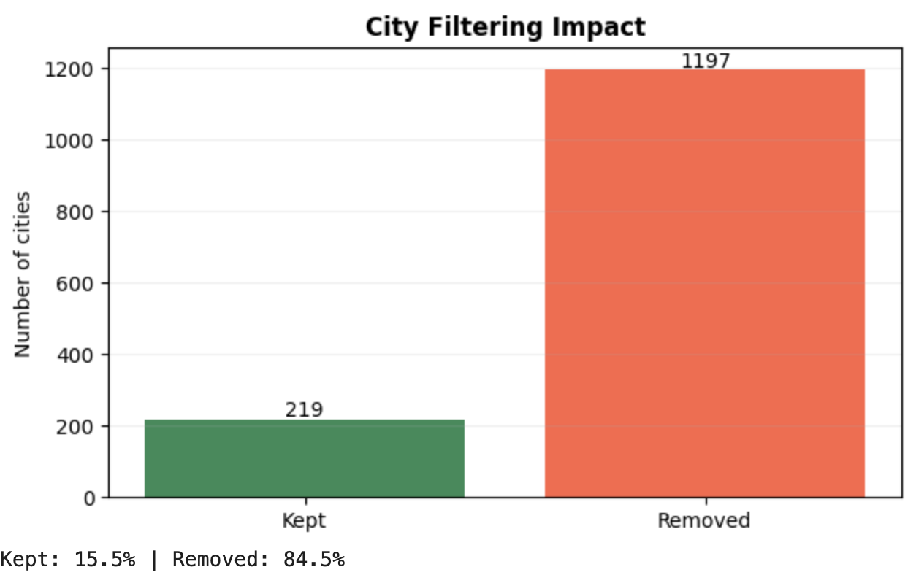
Figure 5. Impact of the city size filter: 15.5% of cities retained.

7.2 Component sensitivity and input selection
Because clustering quality depends on how many principal components enter the distance computation, we ran a sensitivity sweep over 5, 8, 10, 12 and 15 components crossed with k = 4 and k = 5. Silhouette degrades slowly as dimensionality grows, and beyond 10 components the results stabilize (10, 12 and 15 components give identical scores at both k values, indicating the extra components no longer influence the partition). The final clustering therefore uses the first 10 principal components, which preserve the interpretable structure while filtering the noisier tail of the representation.

7.3 K-Means parameter sweep and selection of k
K-Means was evaluated for k from 2 to 12 using silhouette, Davies-Bouldin, Calinski-Harabasz and inertia. Statistically, k=2 wins on every metric (silhouette 0.540, DB 1.046, CH 113.9) — but the resulting split merely separates 23 highly distinctive cities from the remaining 196, which is useless for a recommender that needs multiple destination archetypes. We therefore distinguish between the metric-optimal k and the semantically useful k, and select k=4 (silhouette 0.215) as the working segmentation: the drop in silhouette is the price of obtaining four interpretable archetypes, and no configuration produces noise points.
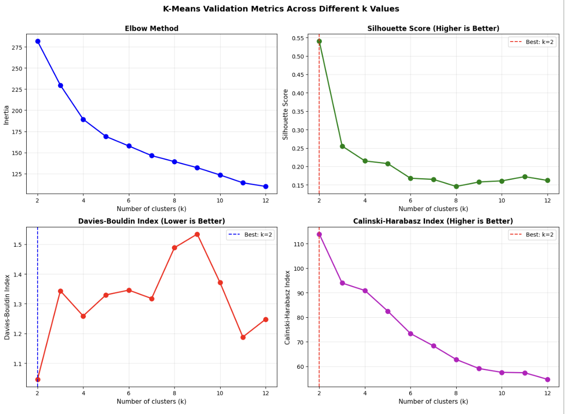
Figure 6. K-Means validation panels across k = 2 to 12 (elbow, silhouette, Davies-Bouldin, Calinski-Harabasz).
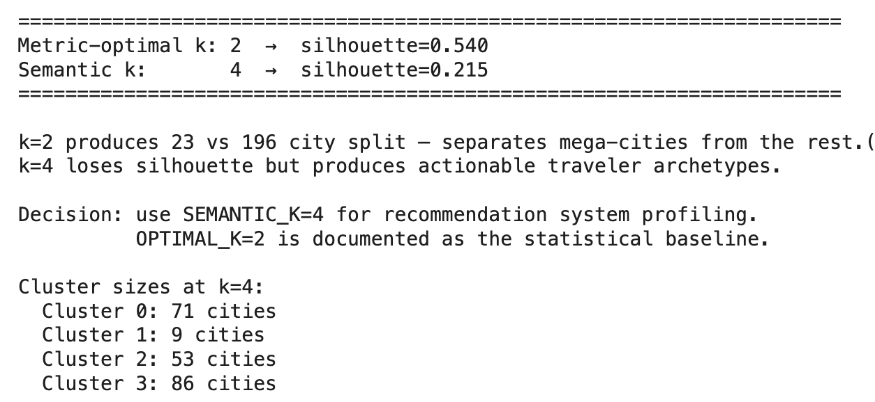
Figure 7. Validation summary used for the selection of k.
DBSCAN was evaluated as a density-based alternative. A k-distance analysis suggested a neighborhood radius near 1.2, and two parameter sweeps (a wide one and a refined one) consistently converged to the same outcome: at best two clusters with silhouette around 0.60, essentially reproducing the k=2 split. No configuration produced three or more meaningful clusters, which indicates the PCA space contains one dominant density region rather than several separable ones. K-Means with k=4 was retained.
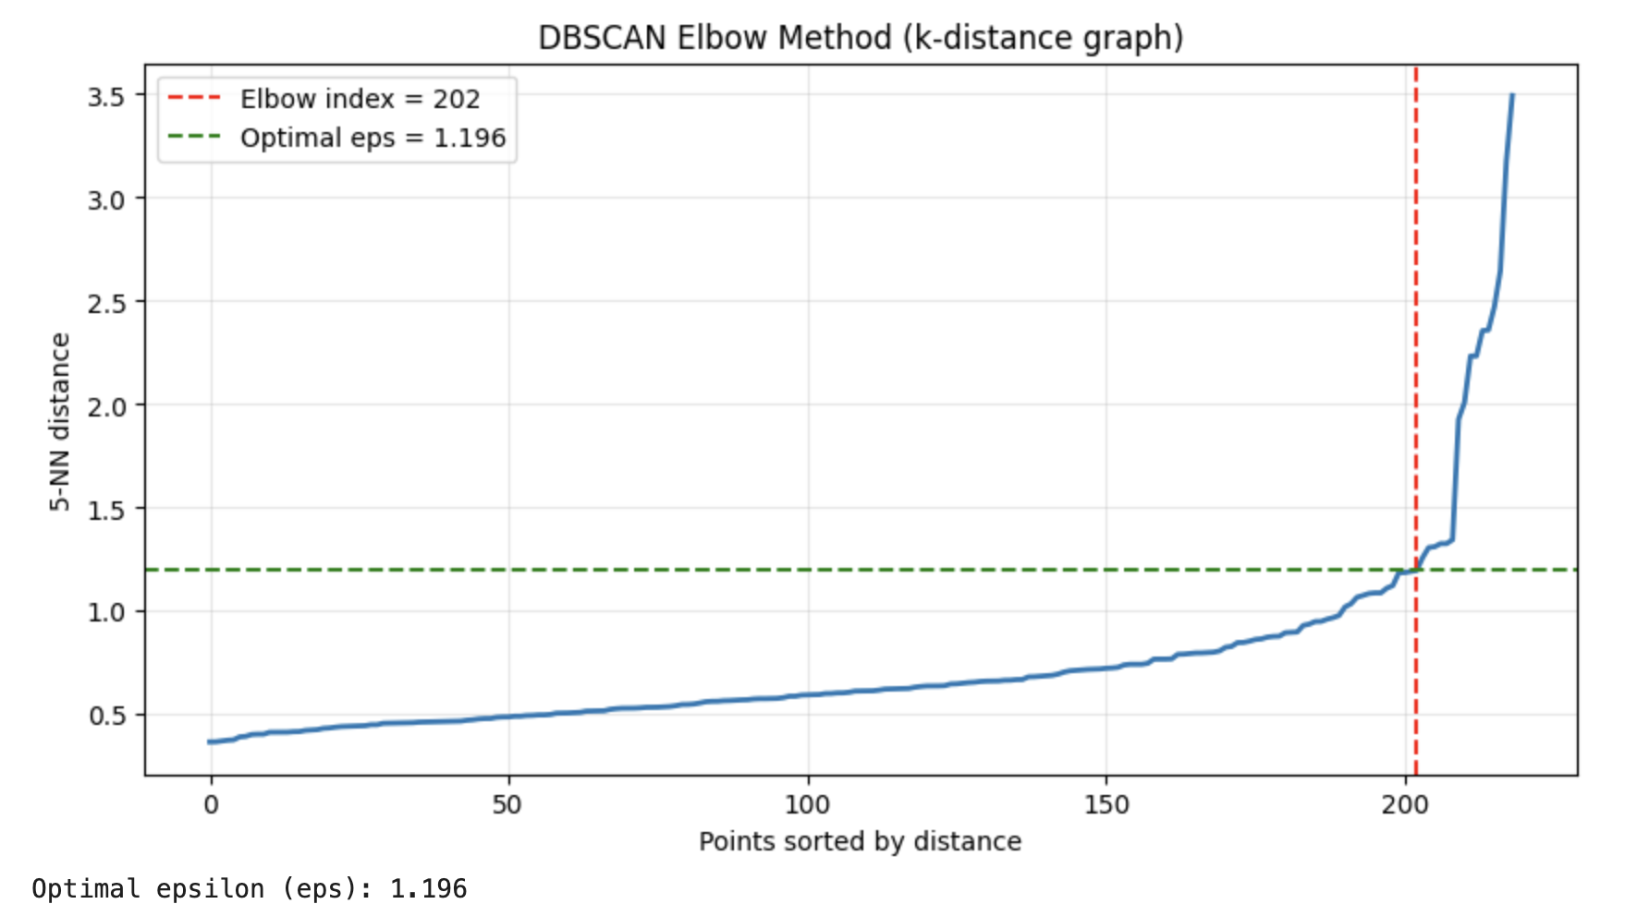
Figure 8. k-distance graph used to estimate the DBSCAN neighborhood radius.
Configuration | Silhouette | Inertia / DB | CH | Interpretation limit
K-Means k=2 (statistical best) | 0.540 | 281.6 / 1.046 | 113.9 | Separates 23 outlier cities from 196; not actionable
K-Means k=4 (selected) | 0.215 | 189.3 / 1.259 | 90.9 | Interpretable archetypes; silhouette drop accepted
DBSCAN (eps=1.727, min_s=3) | 0.601 | — | — | Only 2 clusters; mirrors k=2; not comparable

7.4 Cluster profiles
The four clusters admit consistent readings when profiled with both PCA centroids and the original personality features.
Cluster 0 — Mainstream Suburban Dining (71 cities, 32.4%). Strong casual, family-oriented restaurant culture (high PC1) with low upscale nightlife and wellness signals. Cities such as New Port Richey, Kenner and Bensalem: commercially active but practical, everyday environments. This is the dominant archetype in the dataset.
Cluster 1 — Tourism & Leisure Beach Destinations (9 cities, 4.1%). Extreme values on casual dining, nightlife and wellness simultaneously. St. Pete Beach, Madeira Beach, Clearwater Beach and Treasure Island dominate it; its small size reflects how rare pure beach-resort commercial ecosystems are in the catalog.
Cluster 2 — Upscale Lifestyle Suburbs (53 cities, 24.2%). Affluent suburbs where the commercial mix extends beyond food into beauty, wellness, retail and fitness, with elevated quality signals (PC2) suggesting a more demanding consumer base.
Cluster 3, Balanced Urban-Commercial (86 cities, 39.3%). The generalist archetype: no single specialization, but above-average commercial vitality (PC4). Its best-fitted members (Lutz, Southampton, Trinity) are also the highest-silhouette cities of the whole partition.
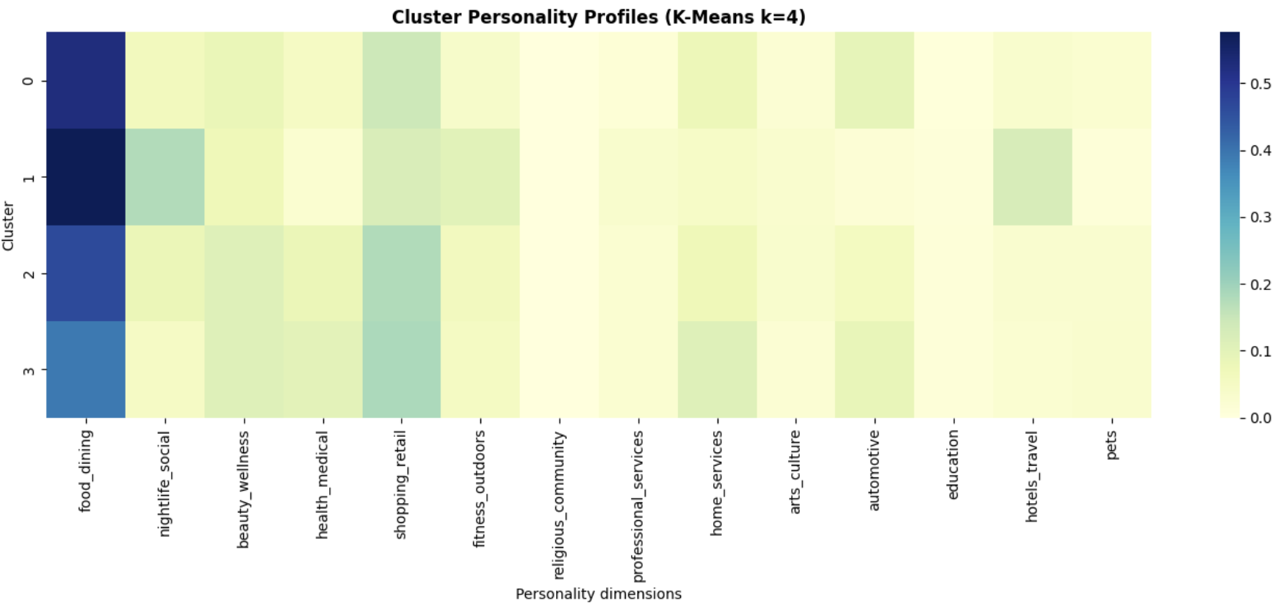
Figure 9. Personality profile heatmap by cluster (original Yelp categories).
The personality heatmap confirms that food_dining is the organizing axis of the whole space every cluster loads on it, and that cluster identity is defined by secondary dimensions: nightlife and hotels for Cluster 1, wellness and retail for Cluster 2, vitality metrics for Cluster 3.

7.5 Failure analysis
A per-city silhouette audit exposes where the segmentation is weakest. Twenty-three cities have negative silhouette, meaning they sit closer to another centroid than to their own; inspection shows these are genuine boundary cases (affluent suburbs between Clusters 2 and 3 such as Narberth or Bryn Mawr, or a college town like University City misplaced among beach destinations) rather than pipeline errors. A further 75 cities (34% of the retained set) fall in the ambiguous 0-0.20 band, and only three cities exceed 0.45. The structural causes are two: city personalities form a continuum with no natural gaps between suburban-dining and generalist profiles, and the shared dominance of food_dining compresses the distances that separate archetypes. These limits are carried into the evaluation and are one reason the recommender does not use clusters as a hard filter (Section 8).
Scope note. This entire clustering analysis was performed on the pre-normalization catalog of 219 cities with raw name variants and 10 principal components. The recommendation and graph stages later re-derive cluster labels on the 214-city canonical catalog with 28 components, which produces a different partition. Section 12 documents this inconsistency and the decision not to retrofit earlier stages.

8. Recommendation and Ranking System

8.1 Task framing
The system transforms the city representations developed in the previous sections into a decision-support tool that answers one question: which city should a traveler visit next, given the cities they have previously enjoyed? This is a ranking problem, not a rating-prediction problem, the output is an ordered list of unseen candidate destinations, and the unit being ranked is the city, represented through its aggregated commercial personality.

8.2 Data alignment
The pipeline integrates artifacts from every previous stage, and each join was verified with an explicit row-count contract so that no hidden assumption connects the stages:
Stage | Table / object | Rows | Key join / filter
Raw city catalog | city_feat_pca | 1,188 canonical cities | —
Business-count filter | cities_filtered | 219 rows / 214 unique canonical | canonical_city() applied; duplicates averaged
Review-business-city join | interact_city | 1,956,340 | merge on business_id, restricted to valid cities
City-level aggregation | user_city | 122,706 (214 cities) | groupby(user, city): mean rating, review count
Sparsity filter | user_city_f | 37,377 / 7,991 users / 213 cities | At least 3 cities per user, at least 5 users per city
Train / test split | train_uc / test_uc | 29,386 / 7,991 | Leave-One-Out per user
Leakage check | train and test pairs | 0 overlapping | verified directly
CF input matrix | sparse user x city | (7,991, 213) | built from training data only

Two details deserve emphasis. The drop from 219 to 214 cities is the direct effect of name canonicalization: a handful of cities had been split across spelling variants, and merging them is what makes user histories join correctly. And the sparsity filter operates at the city level (a preference signal counts only when a user reviewed at least three businesses in that city), which is judged after aggregation, not before.

8.3 Baseline system
A popularity recommender serves as the benchmark: each city receives a score combining the number of distinct training users and its average training rating, and every user receives the same global ranking. It is simple, fast and interpretable, but by construction it ignores individual preferences and cannot capture niche travel interests, which is precisely what makes it a fair minimum bar.

8.4 Hybrid recommendation model
The primary system combines three complementary signals. The collaborative filtering component factorizes the user-city matrix with Truncated SVD using 40 latent factors, a value selected after sweeping 35 to 70 factors and observing that ranking quality plateaus while explained variance keeps climbing, more factors capture variance without improving recommendations. The content-based component builds a user profile as the weighted average of the 28-dimensional PCA embeddings of the cities in the user's history, with weights proportional to rating and interaction frequency, and scores candidates by cosine similarity to that profile. The popularity component, computed within the cluster context, favors destinations with consistently positive engagement and protects the ranking from recommending profile-similar but essentially unvisited cities.
The final score is a weighted combination:
HybridScore = 0.85 x CF + 0.10 x Popularity + 0.05 x Content
These weights were not assumed; nine configurations were evaluated offline, spanning collaborative weights from 0.70 to 0.90, and the configuration (0.85, 0.10, 0.05) maximized both NDCG@4 and MAP@4. The dominance of the collaborative signal is itself a finding: in this domain, what similar users actually preferred carries more predictive power than the abstract personality of a city. Cluster information, in turn, proved most useful as an enrichment signal, an earlier design that used clusters to hard-filter the candidate pool degraded results and was abandoned.
For each user, the candidate pool consists of every city in the catalog except those already present in their training history, so the model is always evaluated on its ability to propose genuinely new destinations.

8.5 Deployment: recommendation API
The final product deploys the trained recommendation system through a FastAPI-based recommendation API, complemented by a Next.js web interface for interactive testing. The API performs inference only and does not retrain the recommendation model at runtime. During application startup, it loads the serialized hybrid model artifacts, including the SVD latent factors, PCA-based city content embeddings, user content profiles, hybrid weight configuration, city cluster assignments, and the auxiliary data required for inference. Additionally, the service reconstructs the set of previously visited cities from the training interaction matrix (w10_train_uc.parquet) and rebuilds the cluster-normalized popularity scores from w10_user_city_f.parquet, ensuring consistency with the recommendation strategy implemented during offline model development.

The deployed API supports two recommendation modes. For known users, recommendations are generated through the hybrid recommender. Given a user identifier, the service excludes cities already present in the user's training history and computes a hybrid score composed of three components: content similarity between the user's content profile and candidate city embeddings, normalized popularity within the corresponding cluster, and collaborative filtering scores obtained from the SVD latent factors. These components are combined using the learned hybrid weights, where collaborative filtering receives the highest contribution by default.
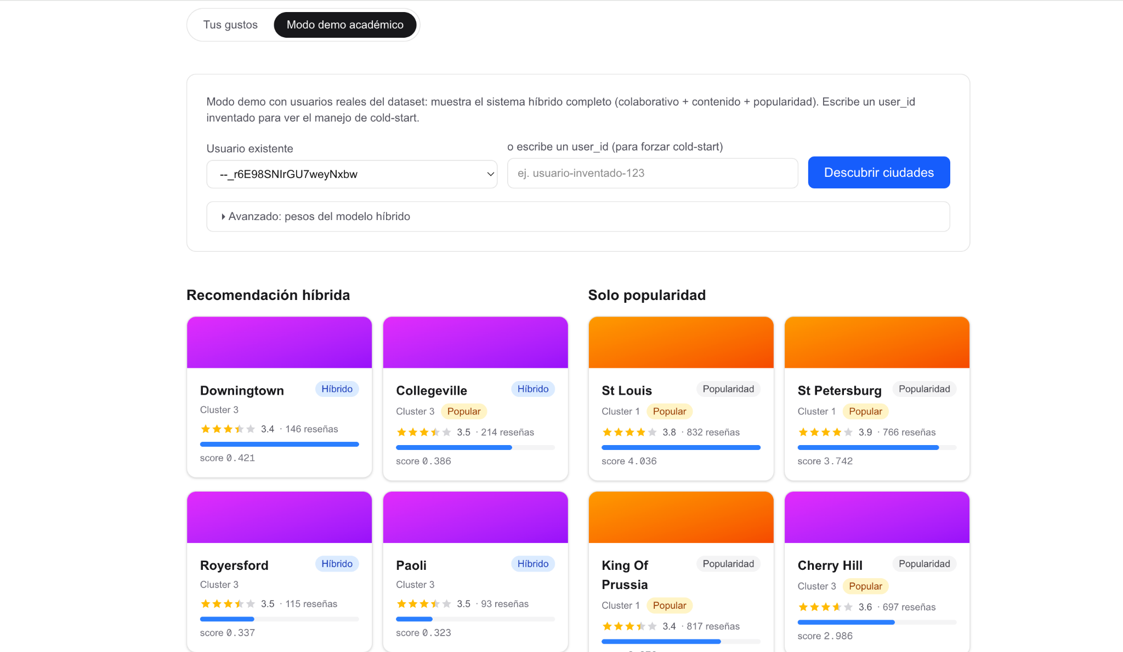
For new users, the system addresses the cold-start problem through a preference-based recommendation mechanism. Instead of relying solely on popularity, the user provides ratings for one or more cities. The API constructs a temporary content profile by computing the weighted average of the rated cities' PCA embeddings, using weights proportional to rating × log(1 + number of reviews). Cosine similarity is then calculated between this temporary profile and every candidate city that has not been rated by the user. The final recommendation score combines content similarity (70%) with cluster-normalized popularity (30%). Since no latent collaborative representation exists for new users, collaborative filtering is intentionally omitted from this recommendation mode.
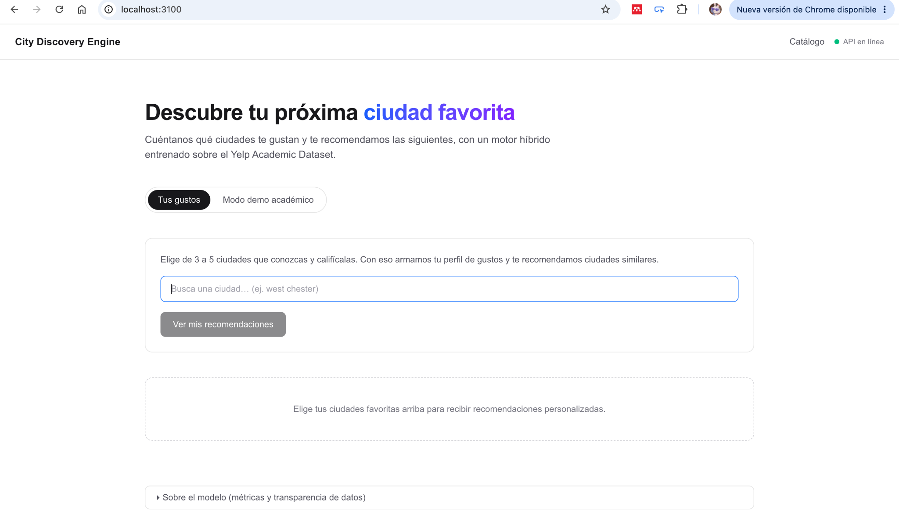
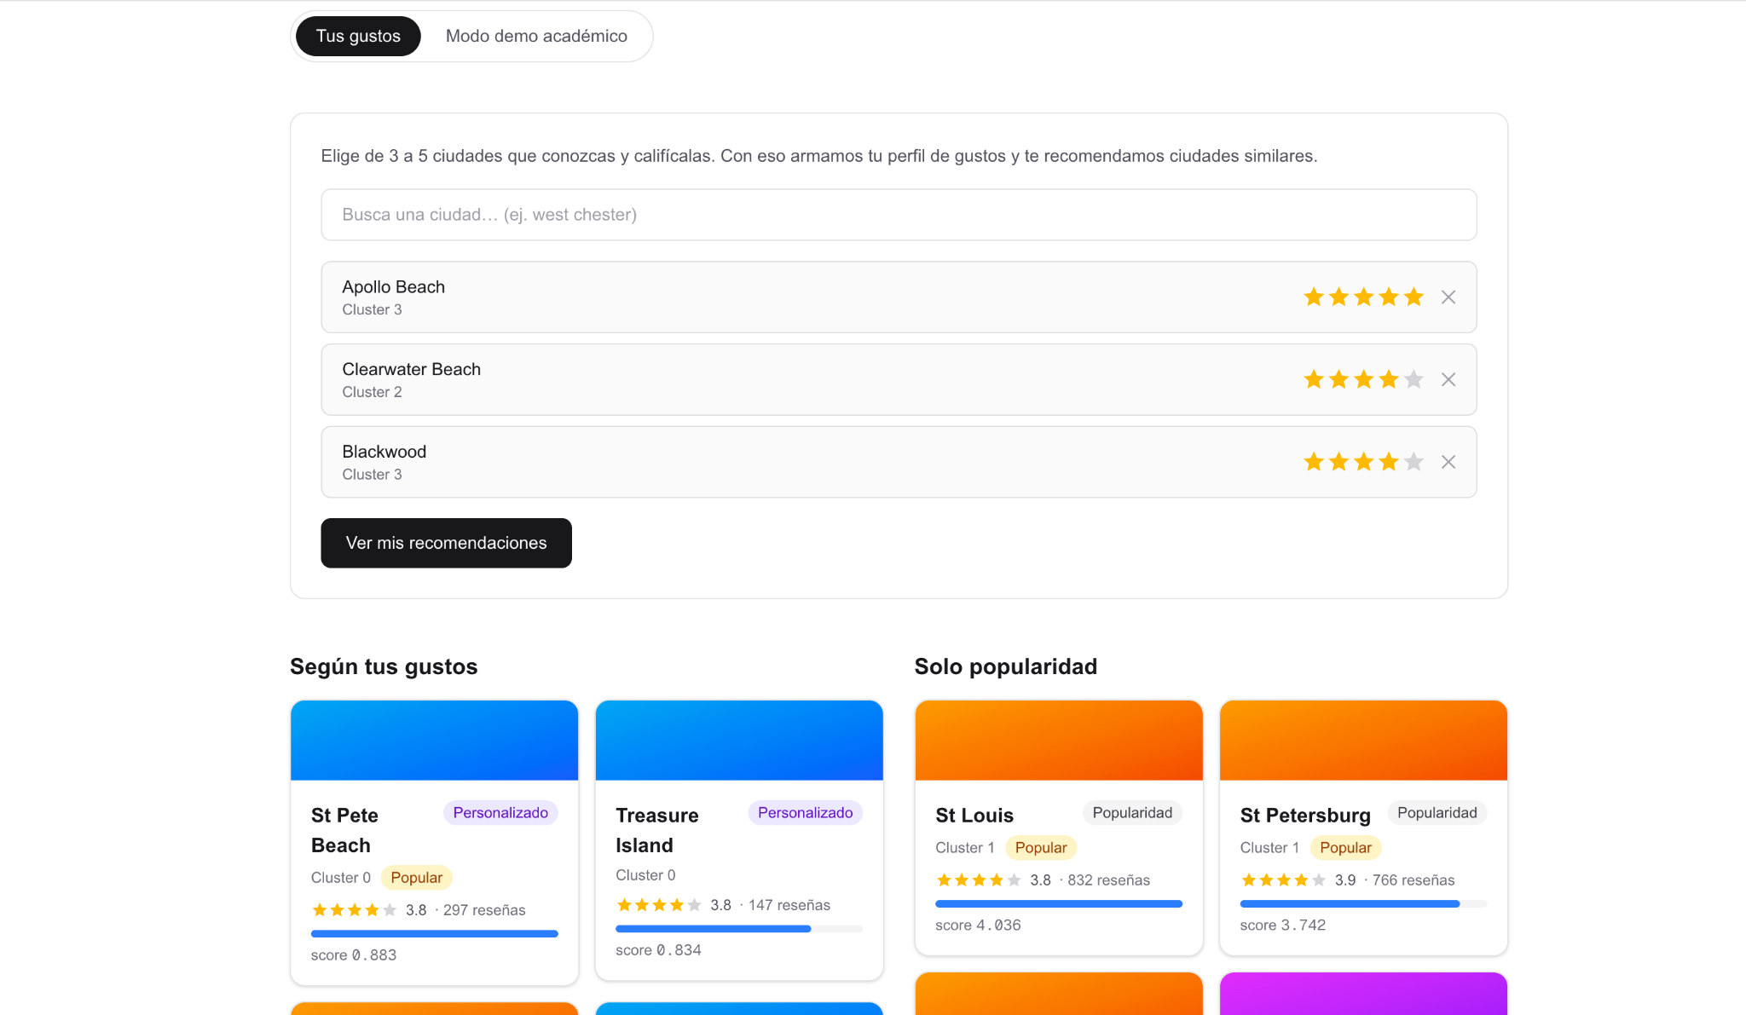
However, just for curiosity, we still added the popularity ranking baseline for unknown users with no preferences, but it is not recommended since it will always give the same results.
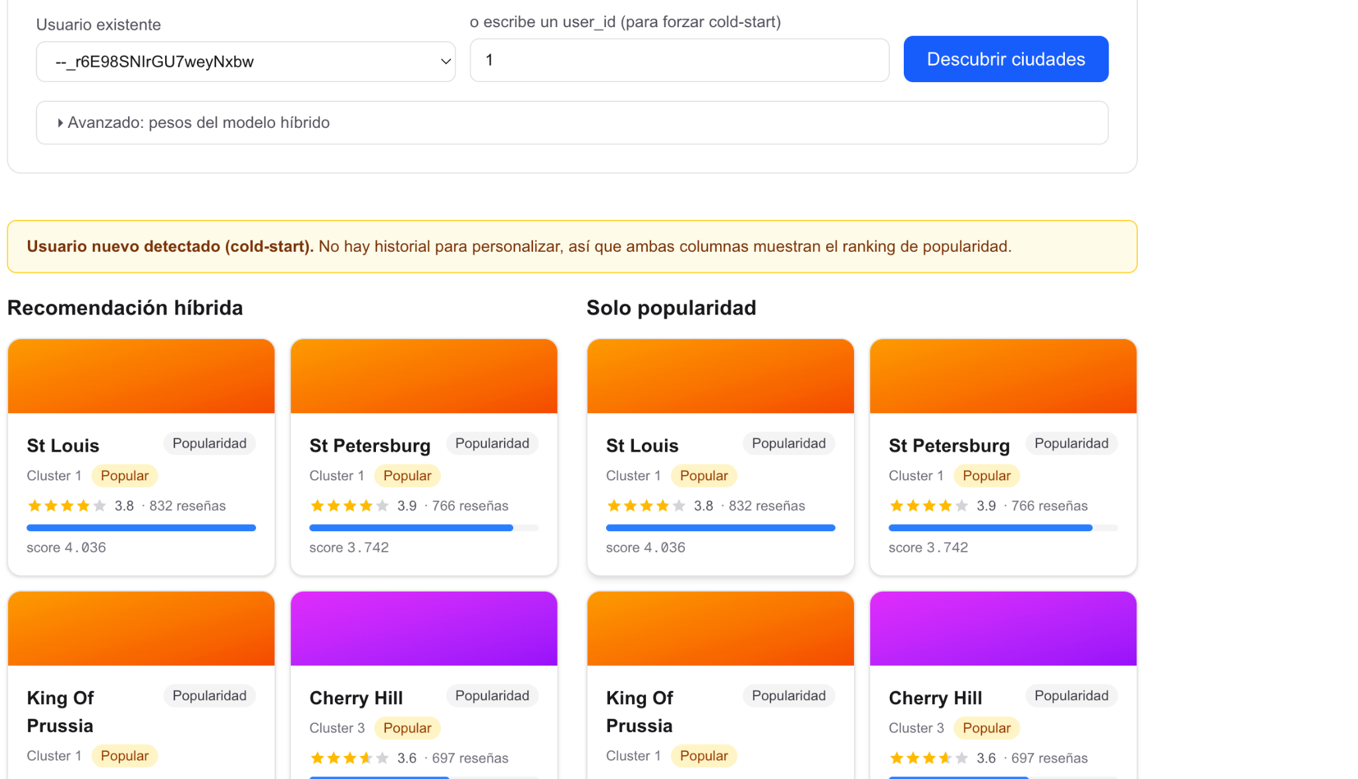
The deployed backend exposes several endpoints to support inference, monitoring, and model transparency. The /health endpoint verifies service availability and successful model loading; /recommendations/{user_id} returns hybrid recommendations for known users and automatically falls back to the popularity baseline for unknown user identifiers; /recommendations/preferences generates personalized recommendations for new users from a list of rated cities; /recommendations/popularity exposes the popularity-based baseline ranking; /cities returns the city catalog with optional cluster filtering; /users/sample provides sample user identifiers for testing; and /model-info reports model dimensions, hybrid configuration, offline evaluation metrics, and data-quality information.
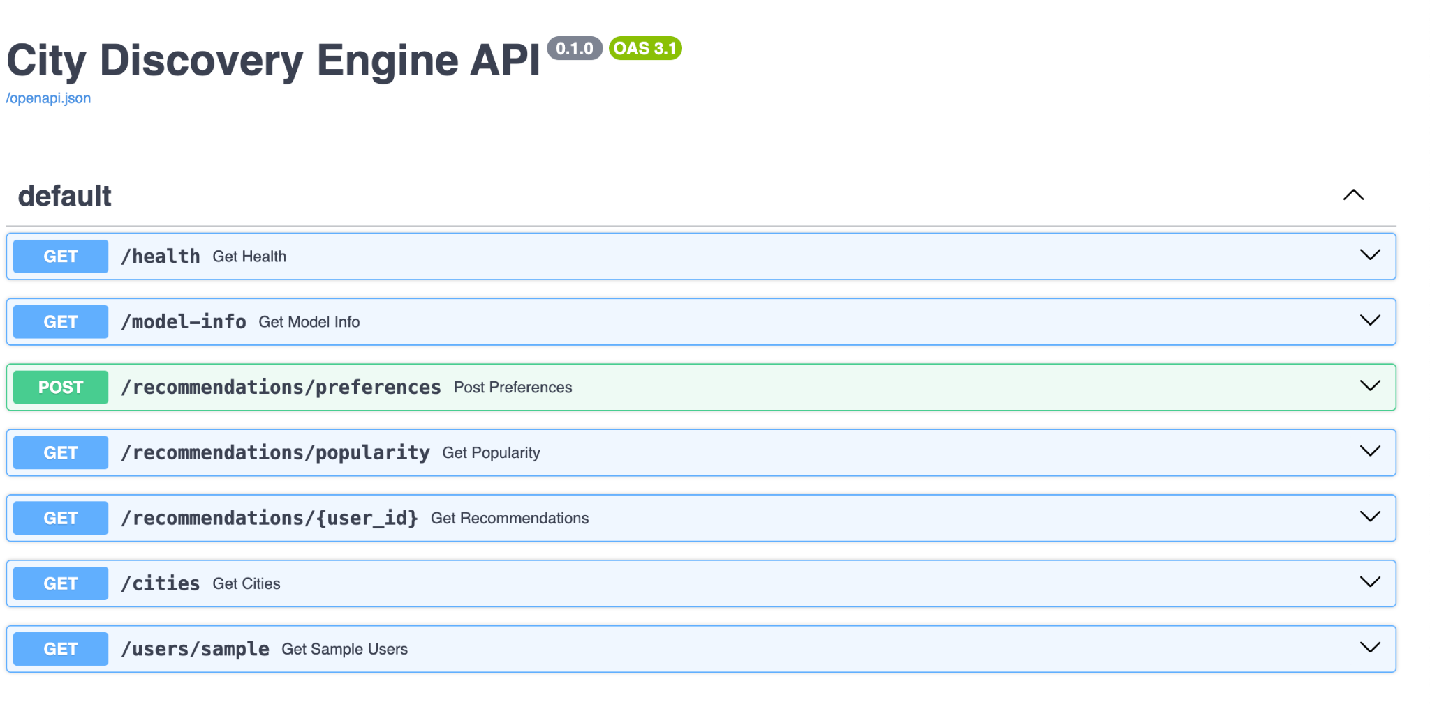
The deployment is fully containerized using Docker. The API image installs the required Python dependencies, copies the FastAPI application, loads the serialized model artifact during startup, and serves inference requests through Uvicorn. A health-check endpoint continuously verifies service availability after deployment. Separating model training from model serving allows the recommendation model to be loaded once and efficiently reused for multiple inference requests while maintaining reproducibility and scalability.

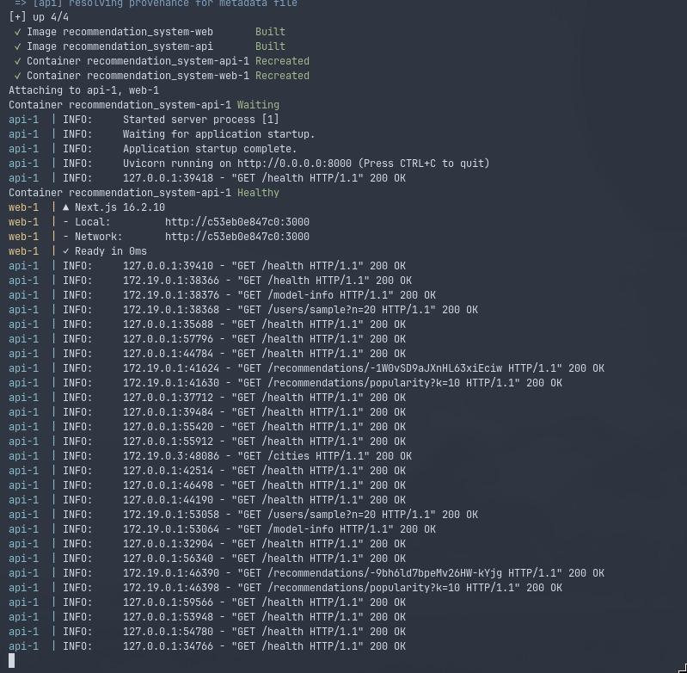

We also implemented an automated API test suite using Pytest to verify endpoint functionality, model loading, hybrid recommendations, cold-start recommendations from user preferences, and the consistency of the deployed recommendation service. The test suite covers health monitoring, recommendation endpoints, city catalog retrieval, model information, and user sampling, helping ensure the correctness and reliability of the deployment.
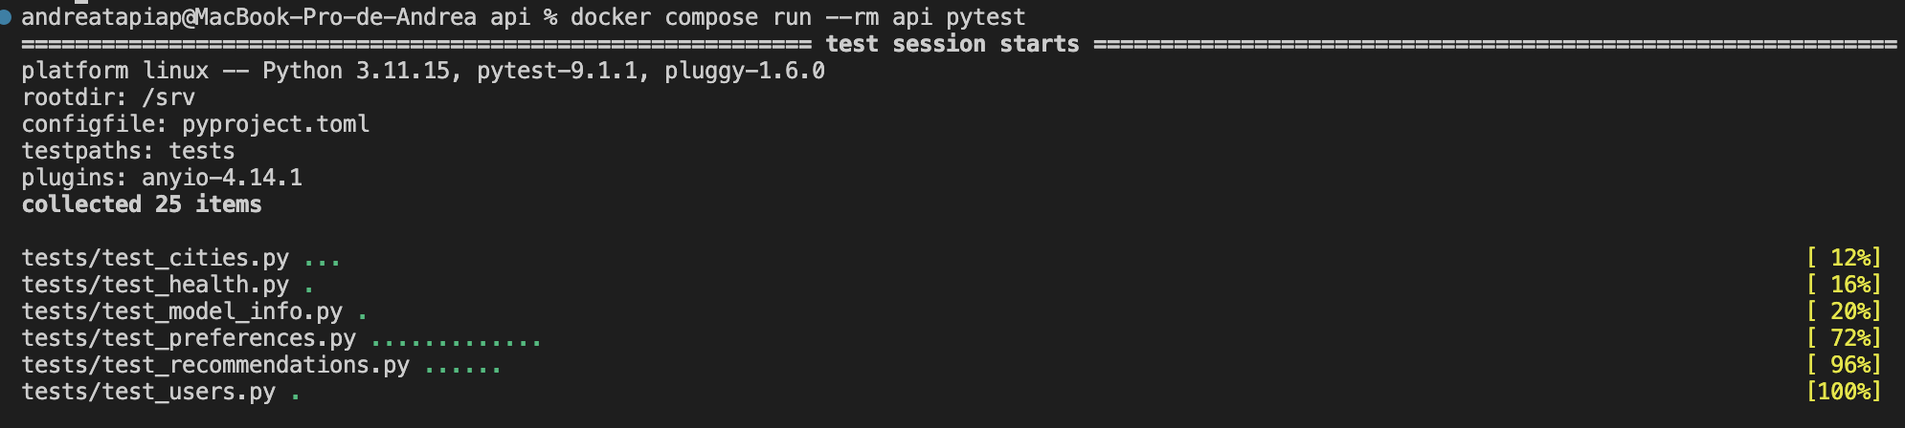

8.6 Monitoring and operationalization plan
After deployment, the recommendation service should be monitored to ensure that the model continues to operate under the assumptions made during offline training.
Serving assumptions
The deployed model assumes that the Yelp city catalog, PCA embeddings, cluster assignments, and SVD latent factors remain fixed until a new offline training cycle is executed. The API performs inference only and does not update model parameters online.
Data and model drift.
The system should periodically monitor changes in:
- distribution of city popularity
- average ratings
- number of reviews
- proportion of unknown users
- frequency of unseen cities
Large deviations from the training distribution may indicate data drift and reduce recommendation quality.
Retraining
If substantial drift is detected or a significant amount of new Yelp data becomes available, the complete offline pipeline should be rerun:
- preprocessing
- feature engineering
- PCA
- clustering
- collaborative filtering
- hybrid evaluation
Only after offline validation should a new model artifact replace the deployed one.
Logging
The API should log:
- endpoint usage
- response times
- inference errors
- cold-start requests
- invalid city names
- model version
These logs facilitate debugging and performance monitoring.
Failure modes
Known situations that may degrade recommendation quality include:
- users with no interaction history
- cities not present in the catalog
- distribution drift caused by new cities or businesses
- outdated popularity estimates
- inconsistencies between training artifacts
The API already handles unknown users through the preference-based cold-start mechanism and validates unknown city names before recommendation generation.

9. Graph Analytics

9.1 Graph definition
To study how the destination catalog is organized independently of any user's behavior, the domain is formalized as a graph. Nodes are the 214 canonical cities of the filtered catalog, the same catalog the recommender serves, which keeps both analyses consistent. Edges connect pairs of cities whose 28-dimensional PCA personality embeddings have cosine similarity of at least 0.75, and each edge is weighted by that similarity. The graph is undirected, because cosine similarity is symmetric: if city A resembles city B, B resembles A to exactly the same degree, so directionality would add no information.
Cities are the natural node entity because the recommender operates at the city level; a business-level graph would answer a different question. Cosine similarity was chosen over alternatives because city embeddings encode proportional commercial profiles, and cosine compares profile shape independently of magnitude.

9.2 Threshold selection
The similarity threshold controls the graph's density, and its value was chosen by systematic evaluation rather than by convention:
Threshold | Edges | Density | Avg. degree | Components | Largest CC | Isolated
0.70 | 1,197 | 0.0525 | 11.19 | 9 | 204 | 6
0.75 | 604 | 0.0265 | 5.64 | 23 | 190 | 20
0.80 | 256 | 0.0112 | 2.39 | 73 | 120 | 52

At 0.70 the graph becomes dense enough that weakly related cities connect, diluting the meaning of an edge; at 0.80 the network shatters into 73 components and loses the giant component that makes structural analysis possible. The value 0.75 preserves a large connected core (190 cities, 88.8% of the network) while keeping the graph sparse enough that each edge represents a genuinely strong similarity.

9.3 Robustness across similarity measures
To verify that the structure is not an artifact of the metric, the same construction was repeated with Pearson correlation and with a Euclidean-based similarity, adjusting each threshold to produce approximately the same number of edges. Pearson at 0.75 yields an almost identical structure (613 edges, 27 components), which is expected since both metrics compare standardized profiles. The Euclidean graph, however, fragments badly at comparable density (596 edges but 89 components and 74 isolated cities), because Euclidean distance is dominated by magnitude differences that cosine deliberately ignores. This comparison supports cosine as the appropriate measure for proportional profiles.
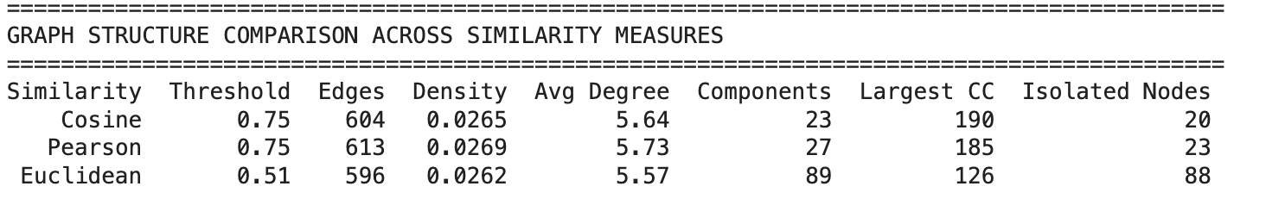
Figure 10. Structural comparison of cosine, Pearson and Euclidean graphs at matched edge counts.
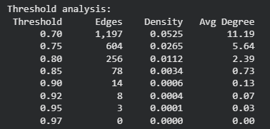
Figure 11. Summary of the constructed similarity graph.

9.4 Structural report
Connected components. The graph resolves into one giant component of 190 cities plus 20 isolated nodes and a few two-city pairs. The dominance of a single giant component confirms what the 2D projection and the clustering silhouettes already suggested: city personalities form a largely continuous space. The isolated cities are not errors, they are destinations whose commercial composition does not reach 0.75 similarity with any other city in the catalog, that is, legitimately distinctive places (the list includes, for example, Montecito, Marana and Tampa Bay).
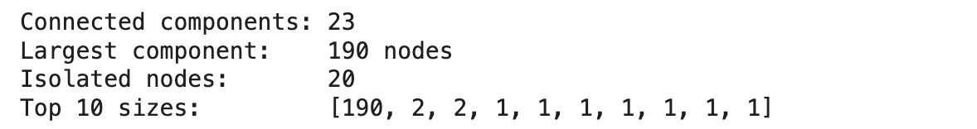
Figure 12. Connected-component summary of the city similarity graph.
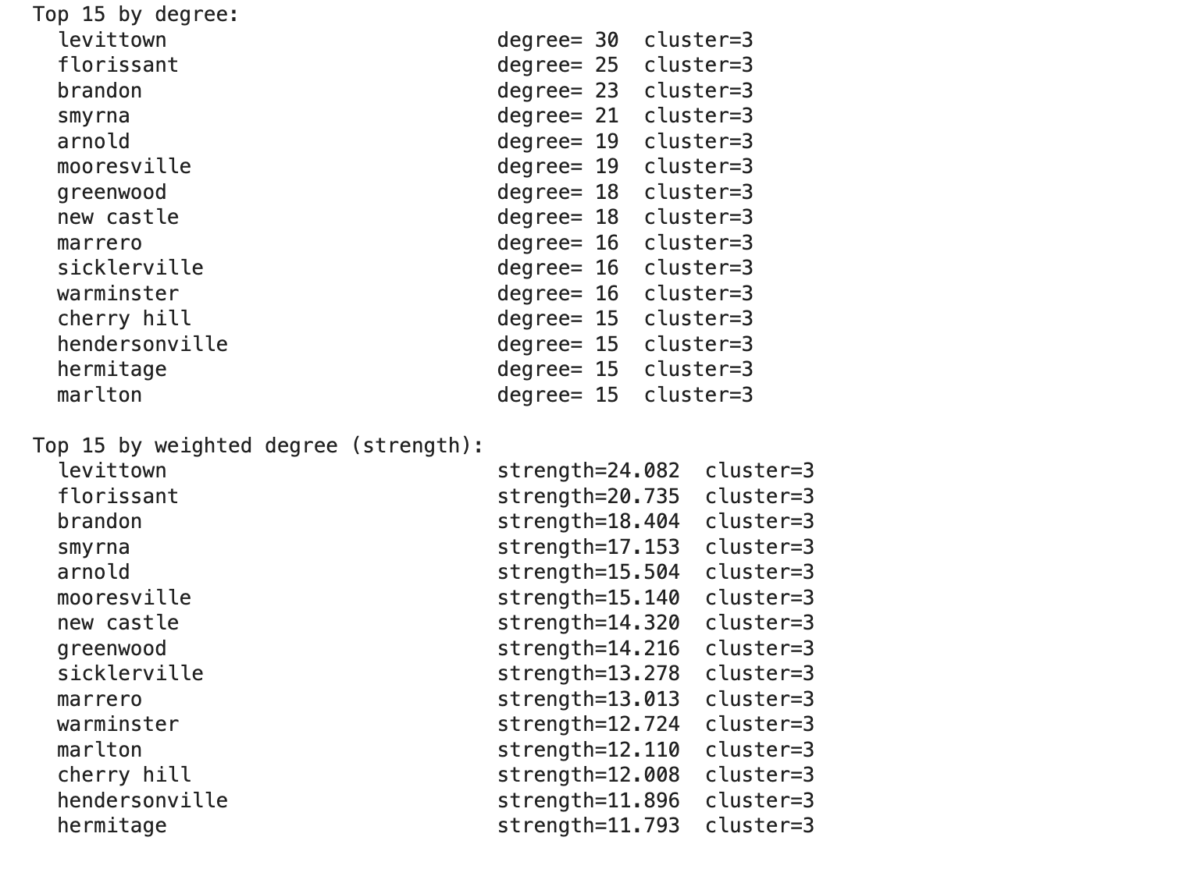
Figure 13. Giant component of the similarity graph, colored by cluster membership.
Degree. Degree is highly heterogeneous: the median city has 5 connections, a quarter of the cities have 2 or fewer, and the maximum reaches 30 (Levittown). Heavy-tailed degree suggests the existence of archetypal cities whose profile is shared by many others.
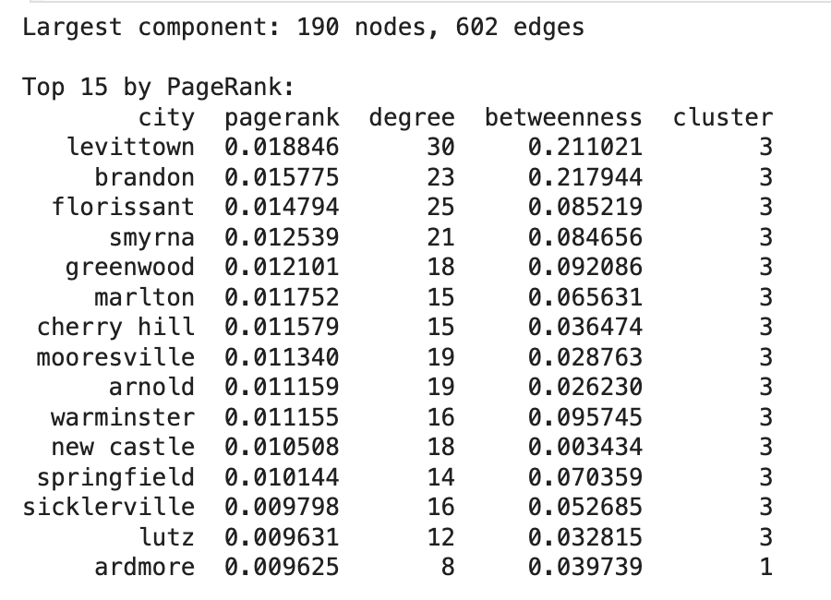
Figure 14. Degree and PageRank distributions over the giant component.
Centrality. PageRank, betweenness and closeness were computed only on the giant component, since shortest-path measures are undefined or trivial across disconnected pieces; restricting the scope guarantees all values are comparable. The top PageRank cities Levittown, Brandon, Florissant, Smyrna are almost all members of the generalist Cluster 3, and they can be read as reference archetypes: their commercial pattern is the one most other destinations resemble. Cities with high betweenness act as bridges between regions of the personality space and often combine traits of several archetypes.
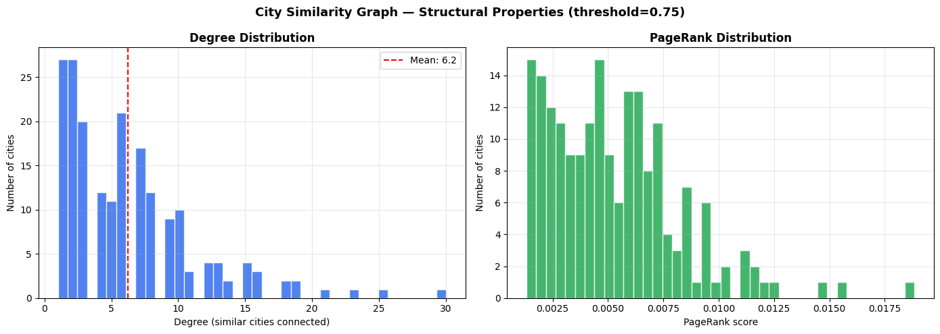
Figure 15. Top cities by PageRank in the giant component.
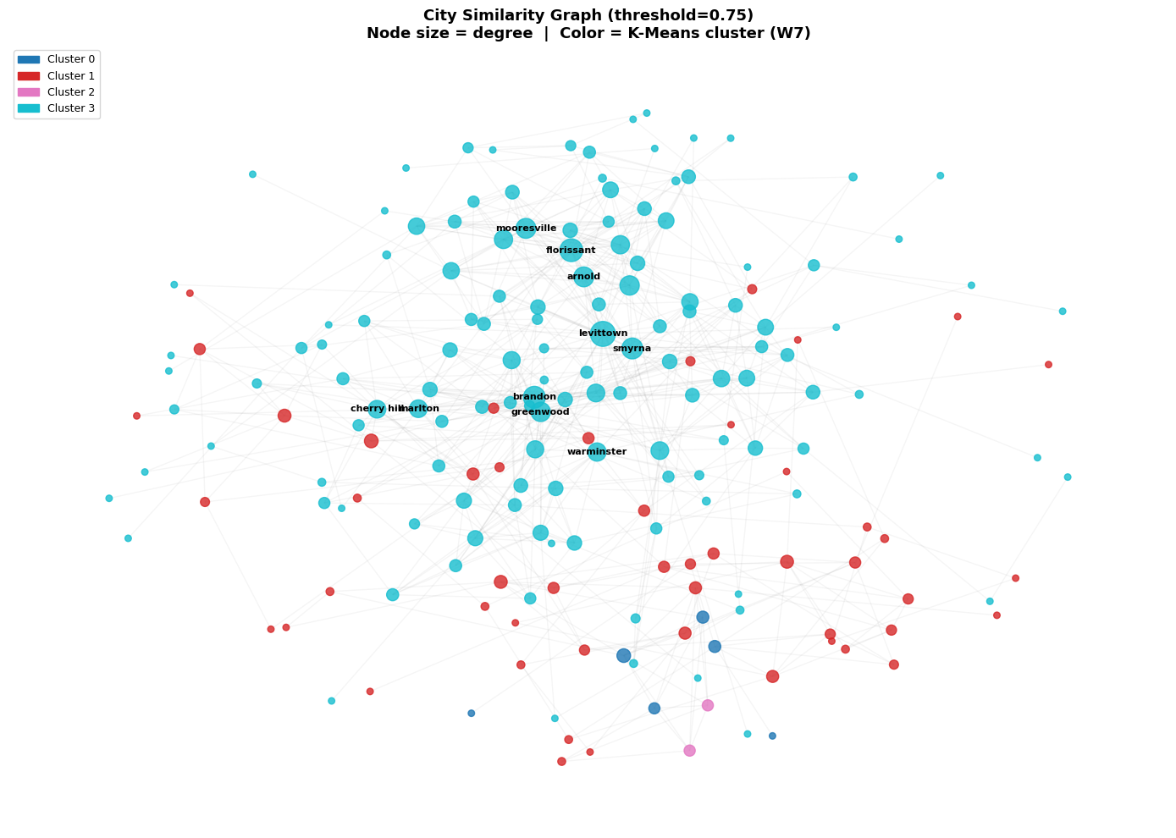
Figure 16. Network view of the giant component with centrality-scaled nodes.
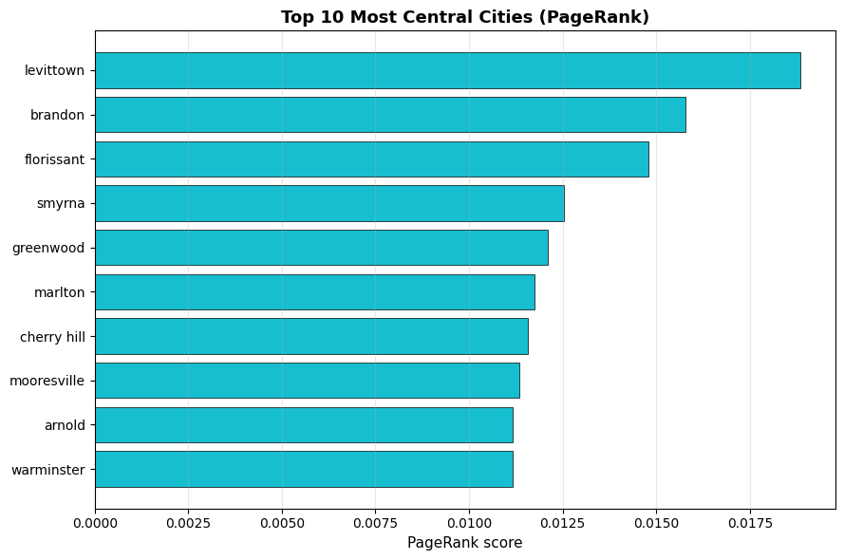
Figure 17. Centrality profile of the leading archetypal cities.
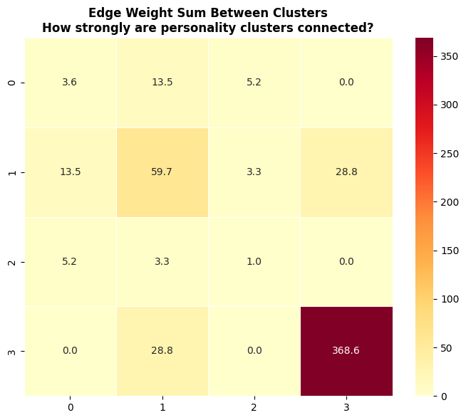
Figure 18. Local neighborhood of the highest-centrality city.

9.5 Graph ranking versus popularity and model rankings
Ranking the giantcomponent cities by PageRank and comparing against the popularity ranking and the hybrid model's ranking yields the central finding of this section:
Comparison | Spearman r | p-value
Graph vs. popularity | 0.252 | 0.0007
Graph vs. hybrid model | -0.004 | 0.95
Popularity vs. hybrid | 0.143 | 0.057

The near-zero correlation between graph centrality and the hybrid ranking is desirable, and it was expected: the graph is built purely from commercial-profile structure, while the hybrid ranking is driven by user behavior. If the two rankings coincided, the graph would contribute nothing new. Instead, the graph surfaces information the model does not encode, most visibly a set of “hidden gems”: cities like Levittown or Brandon that are structurally central (their profile is the most representative in the catalog) yet rank low in both popularity and the behavioral model. The weak but significant correlation with popularity (0.252) indicates that archetypal cities tend to be somewhat visited, without popularity explaining centrality.
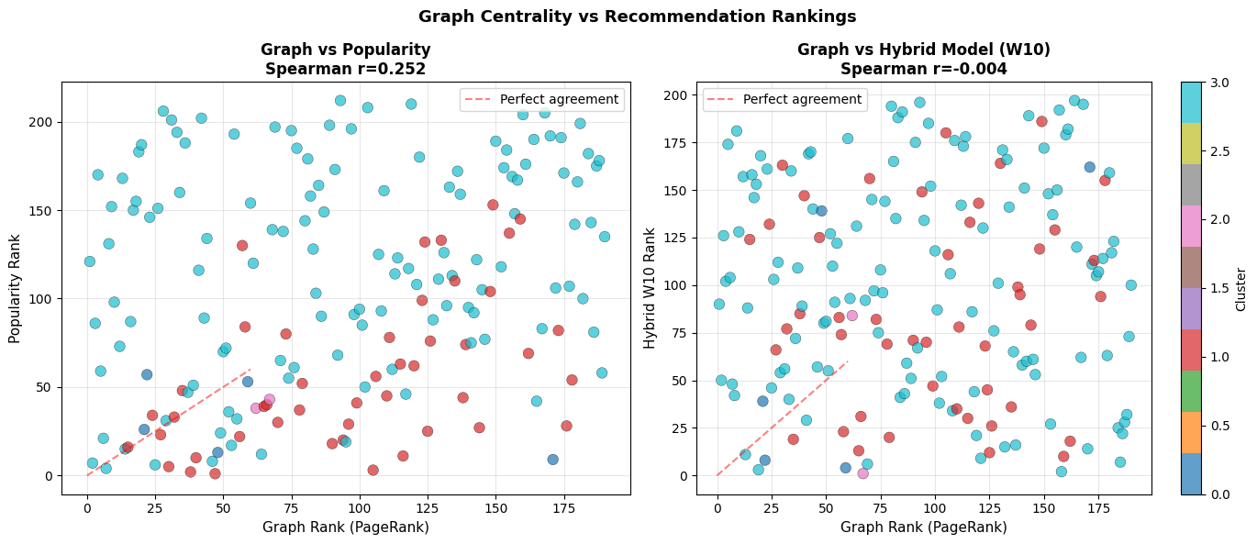
Figure 19. Rank scatter plots: PageRank against popularity and against the hybrid model ranking.
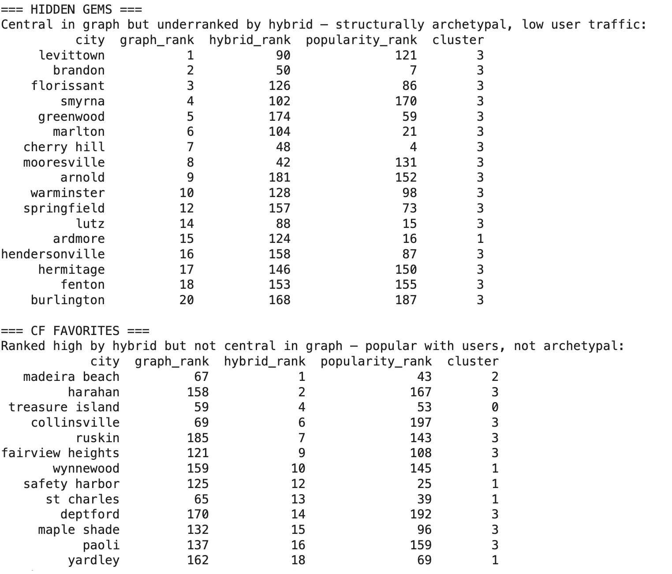
Figure 20. Structurally central cities with low behavioral visibility (hidden gems).

9.6 Case study: positioning recommendations in the graph
To connect both systems, the cities recommended by the hybrid model for a reference user (history: Exton, Malvern, Phoenixville) were located in the graph. The recommended destinations (Downingtown, Paoli, Royersford, Maryland Heights) are not direct neighbors of the user's historical cities, but they are reachable within three to four hops inside the giant component and mostly share the dominant cluster. Together with the near-zero rank correlation, this shows the two systems are complementary: the model finds behaviorally plausible destinations, and the graph explains how those destinations relate structurally to what the user already knows, a property that can power explanation features (“this city is two steps away from ones you loved”) in the final product.

10. Evaluation Protocol

10.1 Protocol design
Evaluation follows a Leave-One-Out protocol over the 7,991 eligible users. For each user, one positively rated city is held out as the test target, positives being defined as cities rated at or above the user's own mean, so that “relevant” is calibrated per user rather than by a global threshold, and the remaining cities form the training history. The held-out city plays the role of the future destination the model should recover.
Leakage was addressed explicitly at four levels: the test city is removed entirely from the user's training profile; popularity statistics are computed exclusively on training interactions; candidate pools exclude all training cities; and city embeddings and cluster assignments are derived independently of the evaluation interactions. The train/test intersection was verified to be empty.

10.2 Metrics
Performance is measured with Top-K ranking metrics at K = 4, 5, 10 and 20: Precision@K (share of recommended cities that are relevant), Recall@K and Hit Rate@K (which coincide here, since each user has a single held-out target), NDCG@K (which rewards placing the target near the top), and MAP@K. K=4 is the most demanding and product-relevant cutoff; note that with one held-out city per user, the theoretical maximum of Precision@4 is 25%.

10.3 Results
Model | K | Precision@K | Recall / Hit Rate@K | NDCG@K | MAP@K
Popularity baseline | 4 | 0.0321 | 0.1283 | 0.0856 | 0.0714
Popularity baseline | 5 | 0.0302 | 0.1509 | 0.0944 | 0.0759
Popularity baseline | 10 | 0.0226 | 0.2256 | 0.1182 | 0.0856
Popularity baseline | 20 | 0.0169 | 0.3370 | 0.1460 | 0.0930
Hybrid (CF+Pop+Content) | 4 | 0.1302 | 0.5207 | 0.4041 | 0.3647
Hybrid (CF+Pop+Content) | 5 | 0.1121 | 0.5604 | 0.4194 | 0.3726
Hybrid (CF+Pop+Content) | 10 | 0.0693 | 0.6932 | 0.4626 | 0.3906
Hybrid (CF+Pop+Content) | 20 | 0.0396 | 0.7910 | 0.4876 | 0.3976

At the product-relevant cutoff K=4, the hybrid system improves the baseline by roughly a factor of four on precision and hit rate (12.8% of users receiving their true next destination within four suggestions rises to 52.1%) and by a factor of five on MAP. The improvement holds at every K and every metric.
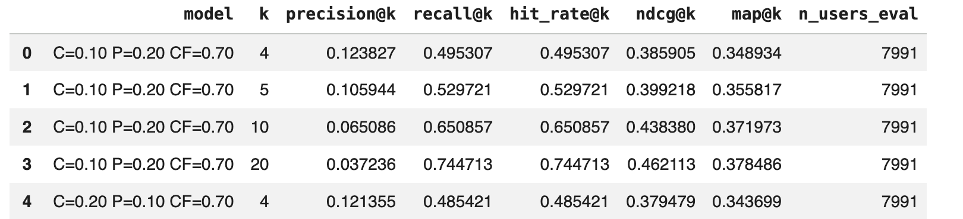
Figure 21. Evaluation output for the popularity baseline across K.
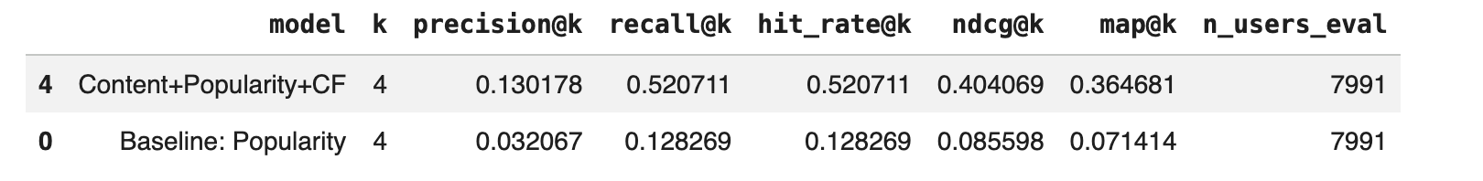
Figure 22. Evaluation output for the hybrid model across K.

10.4 Error analysis
Beyond aggregate numbers, individual outcomes were audited case by case, yielding 5,539 strong cases (target in top-10), 782 intermediate and 1,670 failures (target outside top-20). Two worked examples capture the pattern. In a representative strong case, a user with only St. Louis and Maplewood in their history received University City ranked first — a neighboring municipality in the same metro cluster, where collaborative and content signals reinforce each other. In a representative failure, a user with four western-Philadelphia suburbs in their history had King of Prussia held out; the model's entire top-10 came from the correct regional archetype, but King of Prussia itself,a much larger retail hub than the user's small suburbs, fell outside the top-50. Failures, in other words, tend not to be random: the model finds the right commercial neighborhood but misses targets whose scale diverges from the user's specific history.
History length matters less than expected. Users with only two training cities show the lowest hit rate (41.2%), but no monotonic improvement appears as histories grow, indicating that the consistency of a user's preferences and the position of their cities in the personality space matter as much as data volume. The underlying structural limitation is the same one detected in clustering: commercial personalities form a continuum, and cities sitting between archetypes are inherently harder to rank.

11. Pipeline and Reproducibility
The project is organized as a chain of notebooks, each of which consumes the Parquet artifacts produced by the previous stage and persists its own outputs, so that every stage can be re-executed independently.
Stage | Notebook | Consumes | Produces
Ingestion & cleaning | pre.ipynb | 4 raw JSON files (~9 GB) | business_clean, business_categories, review_interactions, user_clean, checkin_clean (Parquet, Snappy)
Feature engineering & PCA | week5_modified.ipynb | business_clean + bridge tables | city_features_new (1,416 x 74), city_features_pca_new (28 components)
Clustering | week7__3_.ipynb | city_features_pca_new | cluster assignments and validation tables
Recommendation | w10__5_.ipynb | PCA embeddings + review_interactions | popularity table, train/test splits, SVD factors, hybrid_artifacts.pkl
Graph analytics | week12.ipynb | recommendation-stage artifacts | similarity graph, centrality tables, ranking comparisons

Reproducibility rests on three practices. First, every stochastic step, PCA, K-Means, SVD, the leave-one-out sampler, runs with a fixed seed (random_state=42), so results are repeatable. Second, no stage recomputes upstream data: the recommendation notebook reads the persisted PCA parquet, and the graph notebook reads the persisted recommendation artifacts, which guarantees that all stages after the recommendation stage operate on exactly the same 214-city canonical catalog. Third, the row-count contract presented in Section 8.2 (1,416 raw name variants, 1,188 canonical, 219 filtered, 214 merged, 213 evaluated) was verified at each join, including an explicit check that train and test share zero (user, city) pairs.
The environment is standard scientific Python (pandas, scikit-learn, NetworkX, SciPy, Matplotlib), executable both in Google Colab with a Drive mount and locally against a relative data directory; the notebooks retain both path configurations.

12. Ethics and Limitations

12.1 Data ethics and privacy
The Yelp Academic Dataset was obtained directly from Yelp under its dataset license, which explicitly permits non-commercial academic use; no scraping was performed and no raw data is redistributed. The main personal-data risks in the source are display names, the friendship graph, and free-text reviews, any of which could identify individuals. These risks were reduced at ingestion: user_clean retains only a hashed identifier, behavioral counts and an account date; names and friend lists were never processed; review text was never used, only the numeric rating; and no attempt at de-anonymization was or will be made. All downstream artifacts operate exclusively on anonymized identifiers.
A second ethical consideration is representational: Yelp's coverage concentrates on specific US metropolitan areas, so the “catalog of destinations” the system can recommend reflects Yelp's commercial footprint rather than the world's. Recommendations inherit that bias, and any production use should state it.

12.2 Pipeline evolution and internal inconsistencies
We document here, deliberately and in detail, the inconsistencies that accumulated across the project's iterative development, because they affect the comparability of intermediate deliverables.
Late city-name normalization. The canonicalization of city names (Section 5.3) was introduced at the recommendation stage, after the representation and clustering analyses had already been delivered. As a consequence, Sections 6 and 7 operate on the raw catalog of 1,416 name variants (219 after the business-count filter), while Sections 8 to 10 operate on the canonical catalog of 1,188 cities (214 after filtering and merging). The two catalogs differ not only in size but in content: merging spelling variants changes several cities' aggregated feature vectors.
Non-comparable cluster partitions. The clustering stage grouped 219 cities using the first 10 principal components and produced the four archetypes profiled in Section 7.4 (71 / 9 / 53 / 86 cities). The recommendation stage later re-derived cluster labels on the 214-city canonical catalog using all 28 components, obtaining a markedly different partition (151 / 55 / 6 / 2). The two partitions serve different purposes, the first is an interpretive segmentation, the second a contextual signal inside the hybrid score, but they are not the same objects and should not be compared city by city.
Why earlier stages were not retrofitted. We evaluated rerunning the clustering analysis on the corrected canonical catalog. The result was not an improved version of the same segmentation but a qualitatively different one: silhouette scores rose, the four-cluster solution stopped being supportable, and the best alternative (k=3) collapsed into one giant cluster of roughly 204 cities plus marginal groups with no interpretive value for recommendation. Retrofitting would therefore have replaced an interpretable, documented segmentation with an uninformative one, while silently rewriting analyses that had already been examined. We chose instead to preserve each stage as delivered, make the discrepancy explicit, and treat the canonical 214-city catalog as the single source of truth for the final product (the recommender and the graph, which are internally consistent with each other).
Differing component counts. Relatedly, the number of principal components is not uniform across stages: clustering uses 10 components, selected through the sensitivity sweep of Section 7.2, while the content-based recommender and the graph use the full 28-component representation, where discarding variance is unnecessary. Both choices are individually justified, but the difference is one more reason the clustering-stage and recommendation-stage results are not directly comparable.

12.3 Modeling limitations
The remaining limitations are inherent to the data and the design rather than to pipeline evolution. The business-count filter discards 84.5% of cities, so the system only serves commercially mature destinations; sparse cities are invisible to it by construction. The cluster structure is soft (silhouette 0.215, with 34% of cities in the ambiguous band), reflecting a genuine continuum of commercial personalities. Twenty cities remain isolated in the similarity graph and cannot benefit from graph-based explanations. The 0.75 similarity threshold is a property of this embedding and this catalog size, not a universal constant, and would need re-tuning if either changed. The interaction table contains no timestamps, so the leave-one-out protocol holds out a randomly selected positive rather than the chronologically last one, and a true temporal evaluation is not possible with the current data. Finally, evaluation is exclusively offline: the reported metrics estimate the model's ability to recover known preferences, which is a proxy for ,not a measurement of the satisfaction a traveler would report in production.

13. Final Conclusions
This project set out to answer a single product question, which city should a traveler visit next and built the full technical chain that a defensible answer requires: from nine gigabytes of nested JSON to a city-level feature matrix, a compact PCA representation, an interpretable segmentation of urban archetypes, a hybrid recommender, a structural graph of the destination catalog, and a serving API.
Three conclusions stand out. First, popularity is not a recommendation strategy. The baseline recovers the user's true next destination within four suggestions only 12.8% of the time; the hybrid model raises that to 52.1%, with four- to five-fold improvements across every ranking metric. Personalization in this domain is not a refinement ,it is the difference between a directory and a recommender.
Second, behavior outweighs description, but does not replace it. The weight search assigned 85% of the hybrid score to collaborative filtering, confirming that what similar travelers actually preferred is the strongest signal available. Yet the content and popularity components earn their place: they stabilize rankings for sparse users, and the error analysis shows that even the model's failures land inside the correct commercial archetype, evidence that the city-personality representation shapes the ranking meaningfully.
Third, the graph contributes information the model cannot see. The near-zero correlation between PageRank and the hybrid ranking is not a defect but the point: centrality identifies archetypal, structurally representative cities, including hidden gems with little user traffic and provides a vocabulary of explanations (neighborhoods, bridges, hops) that a factorization model cannot articulate. The two systems are complements, one predicting preference and the other explaining structure.
The project also leaves an honest account of its own evolution. The late introduction of name normalization made intermediate deliverables non-comparable, and rather than silently rewriting them we documented the discrepancy, justified the decision not to retrofit, and anchored the final product on a single canonical catalog. Future work follows directly from the limitations: rebuilding the pipeline end-to-end on the canonical catalog from the first stage, incorporating temporal and geographic information into evaluation and features, and extending coverage below the 70-business floor.
Link: https://github.com/andreatpr/recommendation_system

