

Computer Science Major

Teacher: Carlos Adrian Alarcon Delgado

Dataset Charter and Processed Dataset V1
Local Business Discovery Engine:
Travel-Oriented Recommendation System using the Yelp Academic Dataset

Members:

Code | Last name | First name | Semester
u201714492 | Peña Cardenas | Jhamil Brijan | 8th
u20221a963 | Sihuincha Schermuly | Mireya Nicole | 7th
U202323166 | Chavarria Barrios | Maria Ximena | 8th
U202120058 | Tapia Pescoran | Andrea Katherina | 10th

April 2026

Index

1. Project Proposal 3
1.1 Domain 3
1.2 Problem Statement 3
1.3 Expected Product Question 3
1.4 Why This Dataset Supports the Full 3
2. Source Inventory 4
2.1 Files Used 4
3. Schema Draft 5
3.1 Entity-Relationship Overview 5
3.2 Key Design Decisions for Nested Columns 5
4. Processed Dataset V1 6
5. Data Dictionary 6
5.1 business_clean (58 columns) 6
5.2 review_interactions 7
5.3 user_clean 7
5.4 checkin_clean 8
6. Scale Analysis 8
6.1 Key Observations 8
6.2 Geographic Distribution of Businesses 8
7. Ethics and Access Note 9
8. Representation and Dimensionality Report (Week 5) 9
8.1 City-Level Feature Matrix 9
8.2 Dimensionality Reduction (PCA) 10
8.3 Visualizations 10
A. Attribute Prevalence across Cities 10
B. 2D City Personality Projection 11
C. Correlation Heatmap of Key Features 12
8.5 Technical Interpretation 13
9. Clustering Week 7 14
9.1 Input Data 14
9.2 City Size Filter 14
9.3 Experiment 1: K-Means Clustering 16
9.3.1 Parameter Sweep (k = 2 to 12) 16
9.3.2 K Selection Decision 17
9.4. Experiment 2: DBSCAN 19
9.4.1 Parameter Selection 19
9.4.2 Sweep Results 20
9.4.3 Algorithm Comparison and Decision 20
10. Cluster Profile Analysis 21
Cluster 0 — Mainstream Suburban Dining (71 cities, 32.4%) 21
Cluster 1 — Tourism & Leisure Beach Destinations (9 cities, 4.1%) 21
Cluster 2 — Upscale Lifestyle Suburbs (53 cities, 24.2%) 22
Cluster 3 — Balanced Urban-Commercial (86 cities, 39.3%) 22
10.1 Personality Profile Interpretation 22
10.2 Cluster Size Distribution 23
11. Validation Table 23
11.1 Interpretation Limits 24
12. Failure Analysis 24
12.1 Cities with Negative Silhouette (Misassigned) 25
12.2 Borderline Cities (Silhouette 0–0.20) 25
12.3 Well-Clustered Cities (Silhouette > 0.45) 26
12.4 Root Causes of Clustering Difficulty 26
13. Recommendation and Ranking Engine (Week 11) 26
13.1 Objective 26
13.2 Data Alignment 27
14.3 Candidate Pool Definition 28
14.4 Baseline System 28
14.5 Advanced Recommendation System 29
14.6 Evaluation Protocol 30
14.7 Offline Evaluation Metrics 30
14.8 Results 31
14.9 Error Analysis 31
14.10 Limitations and Future Work 32
14.11 Conclusions 32

1. Project Proposal

1.1 Domain
Intelligent Travel Destination. The system focuses on modeling the "latent personality" of cities by aggregating large-scale commercial data from Yelp with global tourism indices. It treats cities as structured entities with distinct socioeconomic and cultural profiles (safety, climate, and service density) to match travelers with urban environments that align with their preferred lifestyle.

1.2 Problem Statement
Travelers often struggle to choose a new destination because traditional recommendation engines rely on generic popularity or simple geographic filters. Our system addresses this by answering the core question: Which cities worldwide share a latent "commercial DNA" with the places a user has previously enjoyed? To solve this, we must transition from micro-data (individual businesses) to macro-representations (city vectors).

1.3 Expected Product Question
- Given a traveler's Yelp review history, which cities have the most similar commercial personality to the ones they already love?

This is a single city-level recommendation question. The system does not recommend individual businesses — it recommends destinations. The connection between a user's past behavior and a city recommendation is made through aggregated behavioral signals (which cities they've
rated businesses in, and how highly).

1.4 Why This Dataset Supports the Full

Course
Course Layer | Yelp Asset Used | Justification
Catalog | business_clean.parquet | 150,346 businesses · 58 columns · rich attributes, geo, categories
Interaction | review_interactions.parquet | 6,990,280 user-business ratings — sparse matrix for collaborative filtering
Feature engineering | city_features.parquet | 1416 cities x 162 aggregated features from all 4 parquet files
Clustering (W7) | city_embeddings_pca.parquet | PCA-reduced city vectors → K-Means city personality segments
Recommendation (W10) | user_city_interactions.parque | User-city rating matrix → collaborative filtering
Graph (W12) | city_features + embeddings | City-city similarity graph by cosine distance in embedding space
Pipeline | 4 Parquet files from 4 JSON sources | Real ETL: nested JSON, chunked reads, ~9 GB raw

2. Source Inventory

Item | Detail
Source name | Yelp Academic Dataset
URL | https://www.yelp.com/dataset
License | Yelp Dataset License — free for academic, non-commercial research
Registration | Required — email + academic affiliation
Format | JSON per-line (.tar compressed), one file per entity
Raw total size | ~9 GB uncompressed
Subset applied | None — full dataset used for all four tables

2.1 Files Used
File | Records | Key Fields
yelp_academic_dataset_business.json | 150,346 | business_id, name, city, state, lat, lon, stars, review_count, is_open, attributes{}, categories, hours{}
yelp_academic_dataset_review.json | 6,990,280 | review_id, user_id, business_id, stars, text, date, useful, funny, cool
yelp_academic_dataset_user.json | ~1,987,897 | user_id, review_count, average_stars, yelping_since, friends[], elite, fans, compliments
yelp_academic_dataset_checkin.json | 131,930 | business_id, date (comma-separated timestamps)

3. Schema Draft

3.1 Entity-Relationship Overview
Table (Processed) | Primary Key | Foreign Keys | Grain
business_clean | business_id | — | One row per business, 58 columns after flattening
business_categories | business_id + category | business_id → business_clean | One row per (business, category) pair — bridge table
review_interactions | (user_id, business_id) | business_id, user_id | Sparse interaction matrix: user_id, business_id, stars
user_clean | user_id | — | One row per user: review_count, avg_stars, yelping_since
checkin_clean | business_id | business_id → business_clean | One row per business: n_checkins (aggregated count)

3.2 Key Design Decisions for Nested Columns
Three columns in business.json required special handling. The decisions below are architectural choices for the modeling pipeline:

Column | Raw Structure | Decision | Rationale
attributes | Dict with values that are themselves dicts serialized as strings: {"BusinessParking": "{'garage': False, 'lot': True}"} | Two-level flatten → attr__ prefix for top-level, attr__Parent__child for sub-dicts. 88 raw columns → 51 dropped (>90% null), 37 retained. | ML models require numeric/boolean inputs. NaN kept as NaN (not filled with False) because absence-of-attribute ≠ attribute-is-False. A business without WiFi info is genuinely unknown.
hours | Dict {"Monday": "9:0-21:0", ...} or None | Converted to 9 integer columns: open_days count + has_weekend flag + one boolean per day. All default to 0 when hours is None. | hours=None means no registered hours, equivalent to 0 days open
categories | Comma-separated string: "Restaurants, Italian, Pizza" | Parsed to list → primary_category (first element) + n_categories count + bridge table for full membership. | Enables both fast filtering by primary_category and full category-based similarity in W7/W12 graph construction.

4. Processed Dataset V1

Six Parquet files produced from four raw JSON sources. All ingestion runs from the notebook pre.ipynb via Google Colab + Google Drive mount. Snappy compression used throughout.

File | Rows | Cols | Compression | Notes
business_clean.parquet | 150,346 | 58 | Snappy | Flat table; 37 attr__ cols, 9 hours__ cols, 3 derived category cols
business_categories.parquet | ~750K+ | 2 | Default | Bridge: business_id × category
review_interactions.parquet | 6,990,280 | 3 | Snappy | Lean interaction matrix: user_id, business_id, stars only
user_clean.parquet | ~1,987,896 | 4 | Snappy | user_id, review_count, average_stars, yelping_since — 1 bad line skipped
checkin_clean.parquet | 131,930 | 2 | Default | business_id + n_checkins (count of comma-separated timestamps)

5. Data Dictionary

5.1 business_clean (58 columns)
Column Group | Columns | Type | Missingness | Notes
Identity | business_id, name, city, state, postal_code | str | 0% | PK is 22-char hash
Geography | latitude, longitude | float64 | 0% | WGS84 decimal degrees
Performance | stars, review_count, is_open | float/int | 0% | stars 1.0–5.0; is_open 0/1
Categories | categories_list, primary_category, n_categories | object/str/int | 0% / 0.07% / 0% | List, first element, count
Attributes (boolean) | attr__ByAppointmentOnly through attr__GoodForMeal__breakfast (32 cols) | boolean (nullable) | 20%–84% | NaN = not reported by business
Attributes (categorical) | attr__RestaurantsPriceRange2, attr__WiFi, attr__Alcohol, attr__RestaurantsAttire, attr__NoiseLevel (5 cols) | category | 20%–75% | Low-cardinality string values encoded as category dtype
Hours | hours__open_days, hours__has_weekend, hours__open_{day} × 7 (9 cols) | int64 | 0% | 0 when hours dict is None; valid default

5.2 review_interactions
Column | Type | Missingness | Notes
user_id | object | 0% | FK → user_clean
business_id | object | 0% | FK → business_clean
stars | int64 | 0% | 1–5 rating — the interaction signal for collaborative filtering

5.3 user_clean
Column | Type | Missingness | Notes
user_id | object | 0% | Primary key — links to review_clean and review_interactions
review_count | int64 | 0% | Total reviews written
average_stars | float64 | 0% | User's historical average rating
yelping_since | datetime64[ns] | 0% | Account creation date — used for user seniority feature in W5

5.4 checkin_clean
Column | Type | Notes
business_id | object | FK → business_clean
n_checkins | int64 | Count of timestamps in raw date string — proxy for foot traffic

6. Scale Analysis

Table | Rows | Columns | Memory (RAM) | Missingness
business_clean | 150,346 | 58 | ~34 MB | 0% on base cols; 20–84% on attr__ cols; 0% on hours__ cols
business_categories (bridge) | ~750K+ | 2 | ~30 MB | 0%
review_interactions | 6,990,280 | 3 | ~160 MB | 0%
user_clean | ~1,987,896 | 4 | ~60 MB | 0%; 1 malformed line skipped
checkin_clean | 131,930 | 2 | ~3 MB | 0%

6.1 Key Observations
- The attr__ columns have 84.4% average missingness. This is structural, not a data quality problem: Yelp only collects attributes relevant to a business type (restaurants have WiFi/Alcohol; hair salons have HairSpecializesIn). Imputing False would introduce false information — NaN is the correct representation.
- 51 of 88 attribute columns were dropped (>90% null across the full dataset). The remaining 37 cover the most universally populated attributes and include the richest semantic signal for business similarity.
- The user-item matrix derived from review_interactions is extremely sparse: ~6.99M interactions / (1.99M users × 150K businesses) ≈ 0.0023% density. This is expected for a recommendation problem and validates the need for collaborative filtering + matrix factorization in W10.

6.2 Geographic Distribution of Businesses
The dataset spans multiple US states and Canadian provinces with no geographic filter. Top cities by business count: Philadelphia (14,569), Tucson (9,250), Tampa (9,050), Indianapolis (7,540), Nashville (6,971). This geographic breadth is essential, the system needs diverse cities to make meaningful personality comparisons.

7. Ethics and Access Note
Data source: Yelp Academic Dataset, obtained directly from yelp.com/dataset under the Yelp Dataset License for non-commercial academic use. No scraping was performed.

Question | Answer
Where did the data come from? | Direct download from yelp.com/dataset after completing the Yelp academic registration form. Data stored in private Google Drive.
Why is the team allowed to use it? | The Yelp Dataset License explicitly permits academic, non-commercial research and classroom use. The project does not redistribute raw data.
What personal data risks exist? | user.json contains display names (excluded from user_clean), friend graph adjacency lists (not processed in V1), and behavioral history. review.json contains opinionated free text that may identify individuals.
How are those risks reduced? | user_clean retains only user_id (hashed), behavioral counts, and dates — no names or friend lists. No raw files are shared. No attempt will be made to de-anonymize users. The processed artifacts use only anonymized IDs throughout.

8. Representation and Dimensionality Report (Week 5)

8.1 City-Level Feature Matrix
To achieve the goal of recommending destinations based on a city's "personality," the dataset granularity was scaled from individual business units to aggregated city entities. This transformation allows the system to model latent urban profiles rather than just specific locations.
Matrix Construction:
- Semantic Aggregation: Boolean and categorical business attributes were averaged per city to create percentage-based features (e.g., % of romantic venues, % of kid-friendly locations).
- Tourism Enrichment: The matrix was integrated with external tourism data, including a safety index, climate classifications, and peak travel seasons.
- Encoding Strategy: One-Hot Encoding was applied to categorical variables such as climate type and city vibe, while Ordinal Encoding was used for noise levels and price ranges.
- Final Scale: The resulting matrix consists of 1416 rows (unique cities) and 162 columns (features).

8.2 Dimensionality Reduction (PCA)
Due to high feature dimensionality and expected redundancy between business categories, Principal Component Analysis (PCA) was performed.
- Normalization: Prior to PCA, a StandardScaler was applied to ensure that high-magnitude features, like total_reviews, did not bias the model against percentage-based features.
- Explained Variance: The analysis determined that 59 components are required to capture 75% of the total variance.
Components | Variance Retained | Dimensionality Reduction
51 | 70% | 68.3%
59 | 75% | 63.4%
69 | 80% | 57.1%
94 | 90% | 41.6%
161 (full) | 100% | 0%
- Dimensionality Gain: The process achieved a 63.4% reduction in total features, significantly optimizing the dataset for upcoming clustering and graph analysis.

8.3 Visualizations

A. Attribute Prevalence across Cities
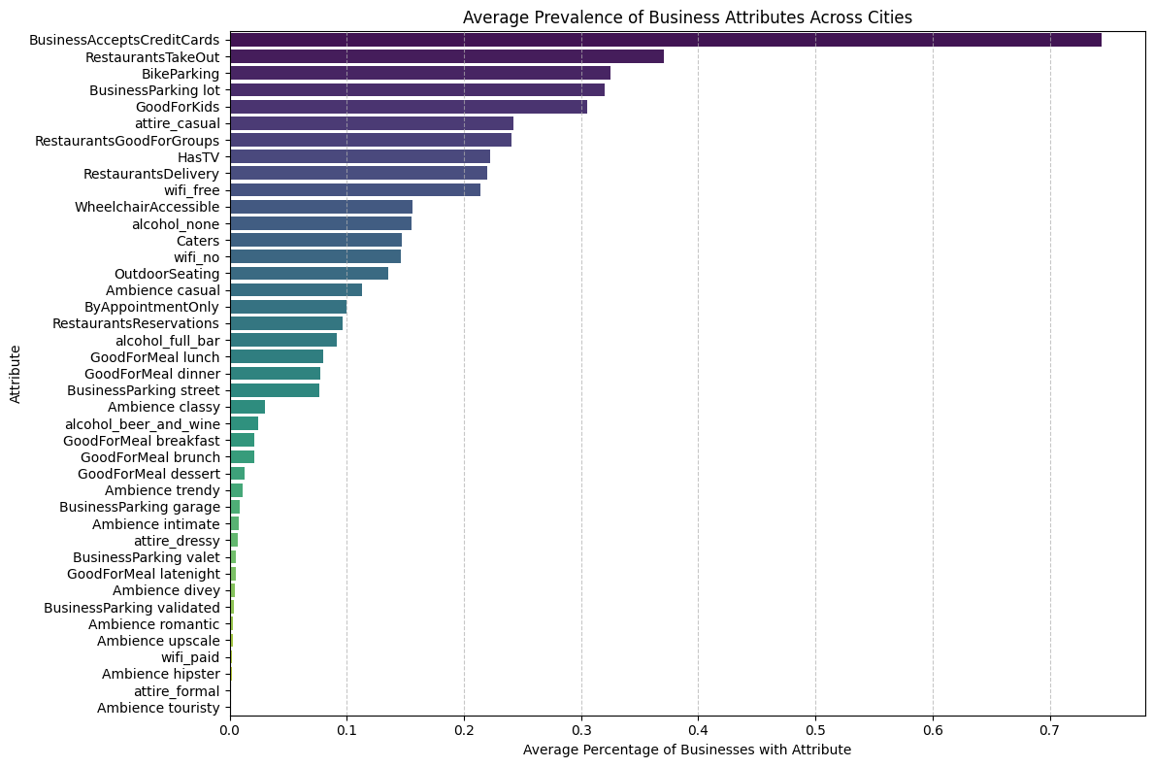
A bar chart of average attribute prevalence across all 1,416 cities shows that BusinessAcceptsCreditCards (~75%) is the most universal attribute, while attire_formal and Ambience__touristy are the least common. This confirms the ‘attributes profile’ section captures meaningful variation in city commercial profiles.

B. 2D City Personality Projection
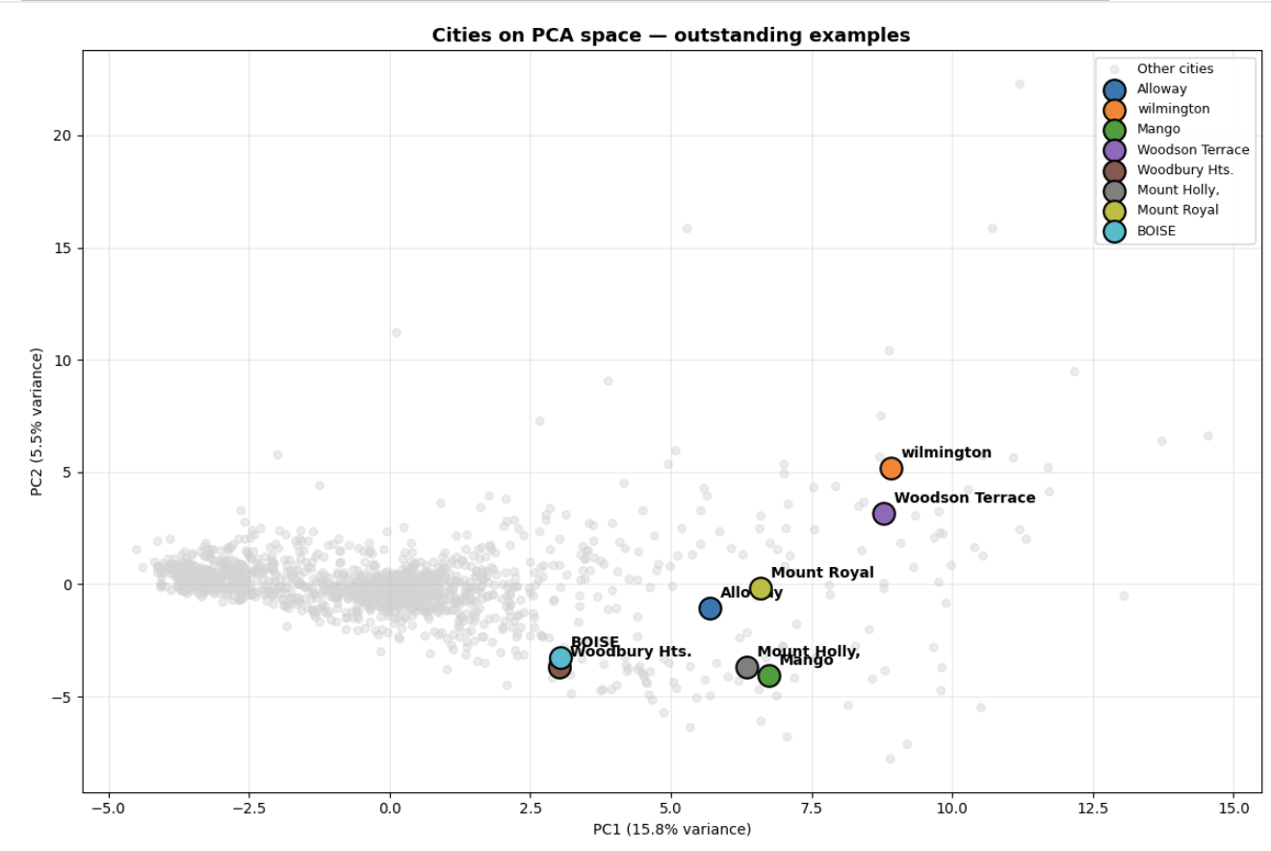
The PCA projection highlights several cities with distinctive urban-commercial profiles relative to the broader distribution of cities concentrated near the center of the embedding space. For example, Wilmington and Woodson Terrace appear with high positive PC2 values, suggesting stronger upscale, nightlife, or socially active commercial characteristics. In contrast, cities such as Mango and Mount Holly are positioned lower on PC2, indicating more suburban or less engagement-oriented commercial environments despite relatively high PC1 values. Boise and Woodbury Hts. occupy intermediate positions, reflecting differentiated but less extreme commercial identities. Overall, the dispersion of these highlighted cities illustrates how PCA separates cities according to multiple lifestyle and dining dimensions rather than simple business quantity alone.

C. Correlation Heatmap of Key Features
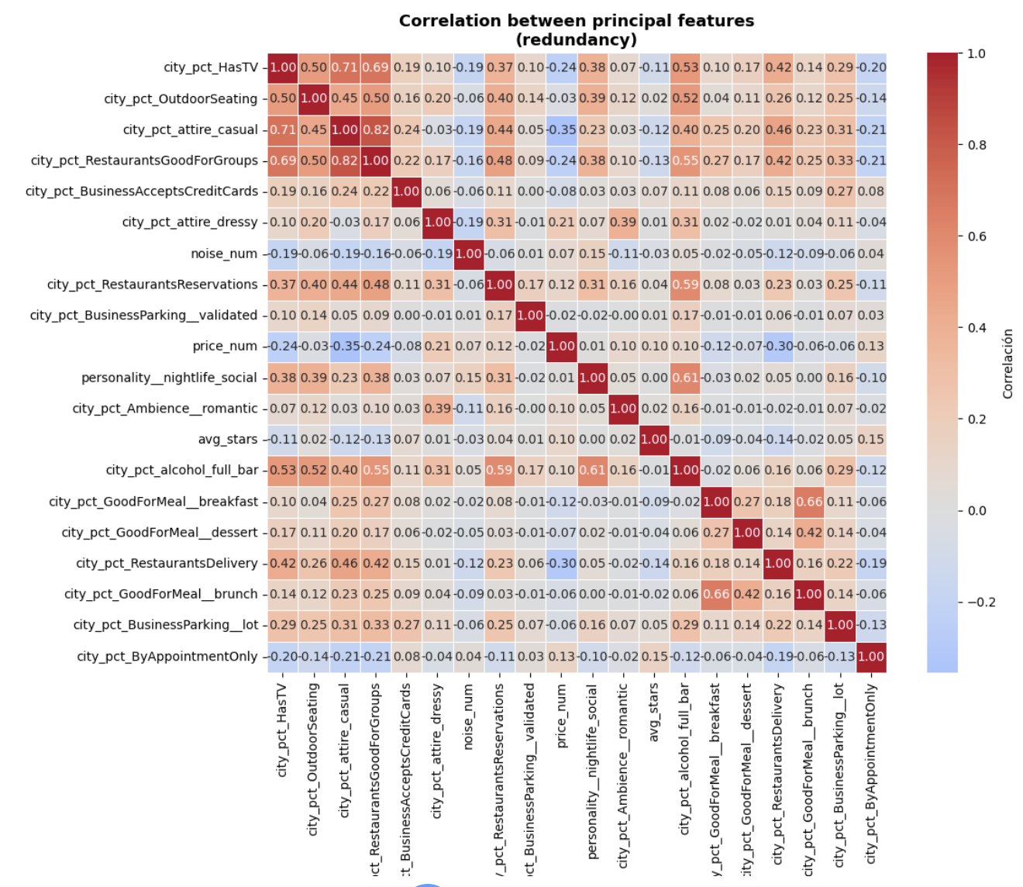
The correlation heatmap reveals clear block-level redundancy within specific feature groups. Casual dining variables such as group dining, casual attire, TV presence, and takeout services exhibit strong positive correlations, while brunch/breakfast activity and nightlife-related attributes also form smaller correlated clusters. In contrast, these thematic groups remain only weakly correlated with one another, producing a heterogeneous and multi-dimensional commercial structure. This explains the PCA behavior: local redundancy allows related features to compress into shared latent dimensions, but the relative independence between feature blocks causes variance to accumulate gradually across multiple principal components rather than collapsing into only a few dominant axes.

8.5 Technical Interpretation
This week’s analysis produced two key findings about the structure of the city feature space:
• Finding 1. Low redundancy, high complexity:
59 components are needed for 75% variance because the feature blocks capture genuinely independent aspects of city personality. Business attributes, category distribution, behavioral ratings, and checkin patterns are not interchangeable signals.

• Finding 2. Gastronomic features dominates:
The first five principal components capture distinct urban-commercial lifestyles rather than simple business. For ex. PC2 and PC5 introduce more socially driven dimensions related to upscale dining, nightlife, brunch, and leisure-oriented restaurant culture, while PC3 captures wellness, accessibility, and lifestyle-service infrastructure. Because these dimensions capture complementary aspects of urban lifestyle instead of redundant variance, the dataset accumulates variance gradually across components, which explains why multiple PCs are needed to preserve the semantic structure used for clustering.

9. Clustering Week 7

9.1 Input Data
Clustering was performed on the PCA-reduced feature matrix produced in Week 5 (city_features_pca_new.parquet), containing 28 principal components that capture 75% of variance from 65 city-level commercial features across 1,416 cities.
Original features include: personality mix (food_dining, nightlife_social, beauty_wellness, etc.), ambience proportions, service attributes, pricing, engagement metrics (avg_checkins_biz, avg_reviews_per_biz), and quality signals (avg_stars, pct_5stars).

9.2 City Size Filter
A business count filter was applied before clustering to remove cities whose commercial profiles are statistically unreliable. Cities with fewer than 70 businesses produce extreme PCA scores due to small-sample noise (a single business dominating the city proportion), while cities with more than 1,043 businesses are mega-cities that distort K-Means centroids toward geographic outliers rather than lifestyle archetypes.
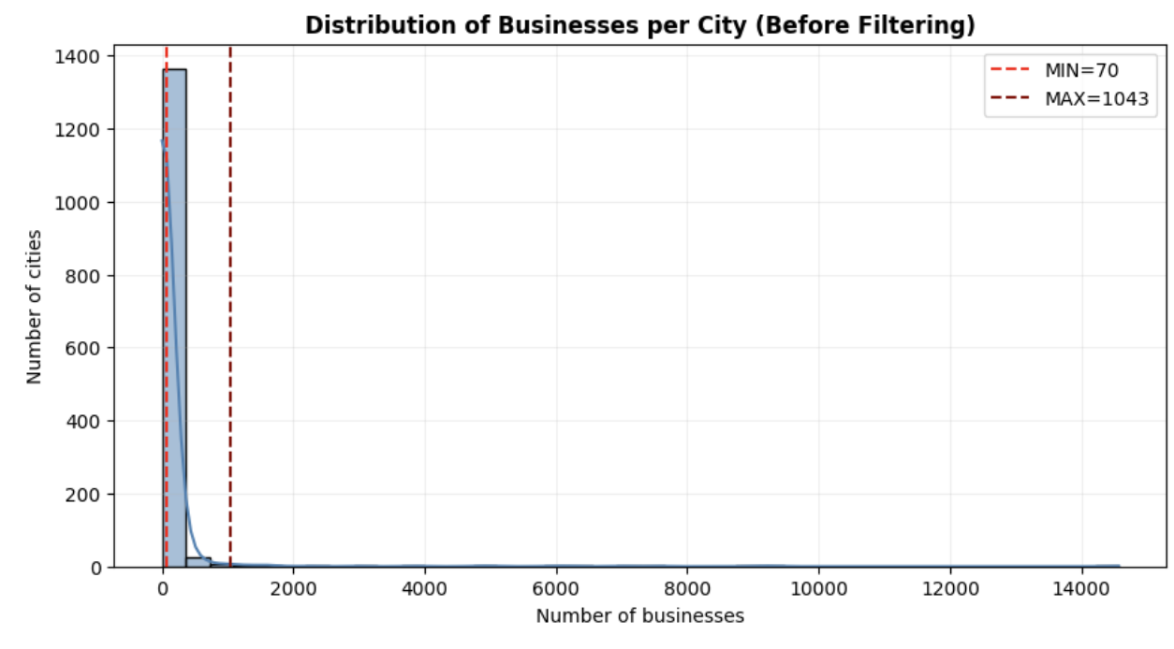

Parameter | Value | Cities Removed | Rationale
Original dataset | 1,416 cities | — | Full Yelp city set
MIN_BUSINESSES = 70 | < 70 businesses removed | Large | Avoid noise from sparse cities
MAX_BUSINESSES = 1,043 | > 1,043 removed | Small | Avoid mega-city size dominance
Retained for clustering | 219 cities | 84.5% removed | High removal is deliberate — quality over coverage

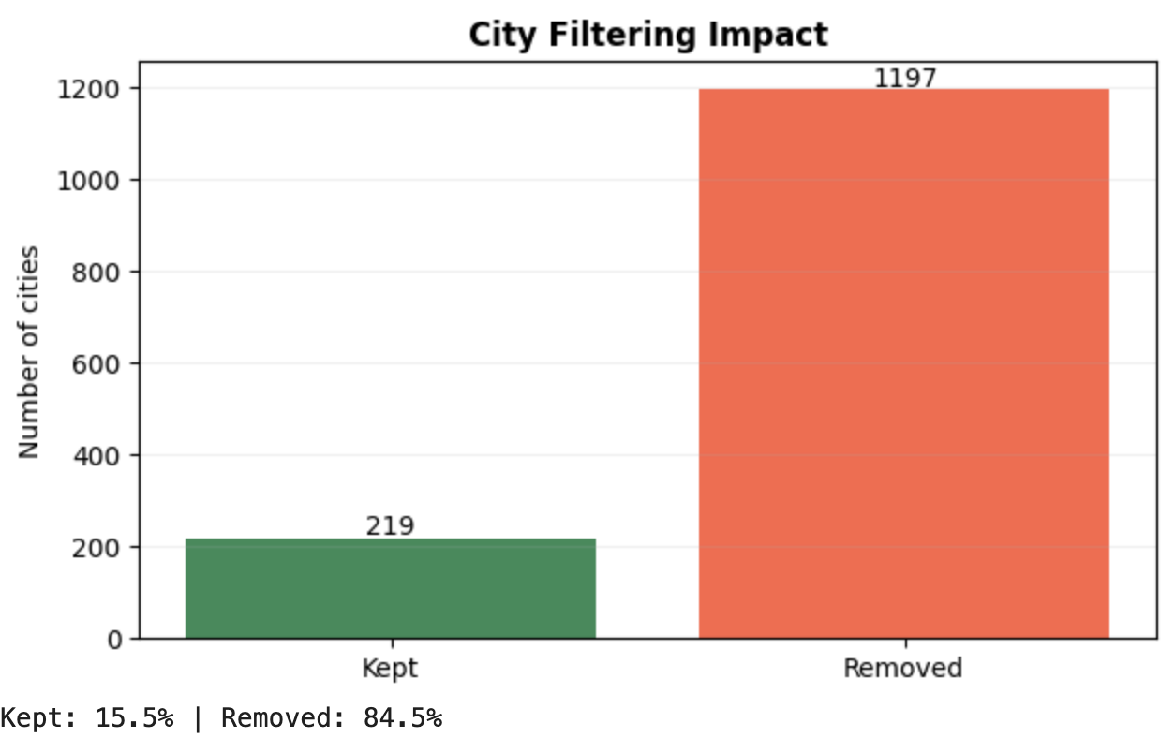
Note: The 84.5% removal rate is a deliberate trade-off. The retained 219 cities represent commercially mature urban ecosystems, which are the relevant comparison set for a travel recommendation system. Sparse and mega-cities would produce misleading archetypes.

9.3 Experiment 1: K-Means Clustering

9.3.1 Parameter Sweep (k = 2 to 12)
K-Means was run with k values from 2 to 12. Each configuration used n_init=10 and max_iter=300 to ensure convergence stability. Three validation metrics were computed for each k:
• Silhouette score (higher = better-separated, more cohesive clusters)
• Davies-Bouldin index (lower = better — measures cluster compactness vs separation)
• Calinski-Harabasz score (higher = better — ratio of between/within cluster variance)
• Inertia (lower = more compact — used for elbow detection)

k | Inertia | Silhouette | Davies-Bouldin | Calinski-H.
2 | 281.6 | 0.540 ★ | 1.046 | 113.9
3 | 229.7 | 0.255 | 1.343 | 93.9
4 | 189.3 | 0.215 | 1.259 | 90.9
5 | 168.9 | 0.208 | 1.330 | 82.5
6 | 157.8 | 0.168 | 1.346 | 73.4
7 | 146.3 | 0.165 | 1.318 | 68.4
8 | 139.3 | 0.146 | 1.488 | 62.8
9 | 132.1 | 0.158 | 1.534 | 59.1
10 | 123.5 | 0.161 | 1.371 | 57.6
11 | 114.2 | 0.172 | 1.188 | 57.4
12 | 109.9 | 0.162 | 1.248 | 54.7

9.3.2 K Selection Decision
The sweep reveals a sharp metric drop between k=2 and k=3, suggesting a natural boundary at k=2. However, k=2 produces a split of 23 distinctive cities vs. 196 mainstream cities — a coarse separation that captures city size and extreme specialization rather than commercial lifestyle archetypes.
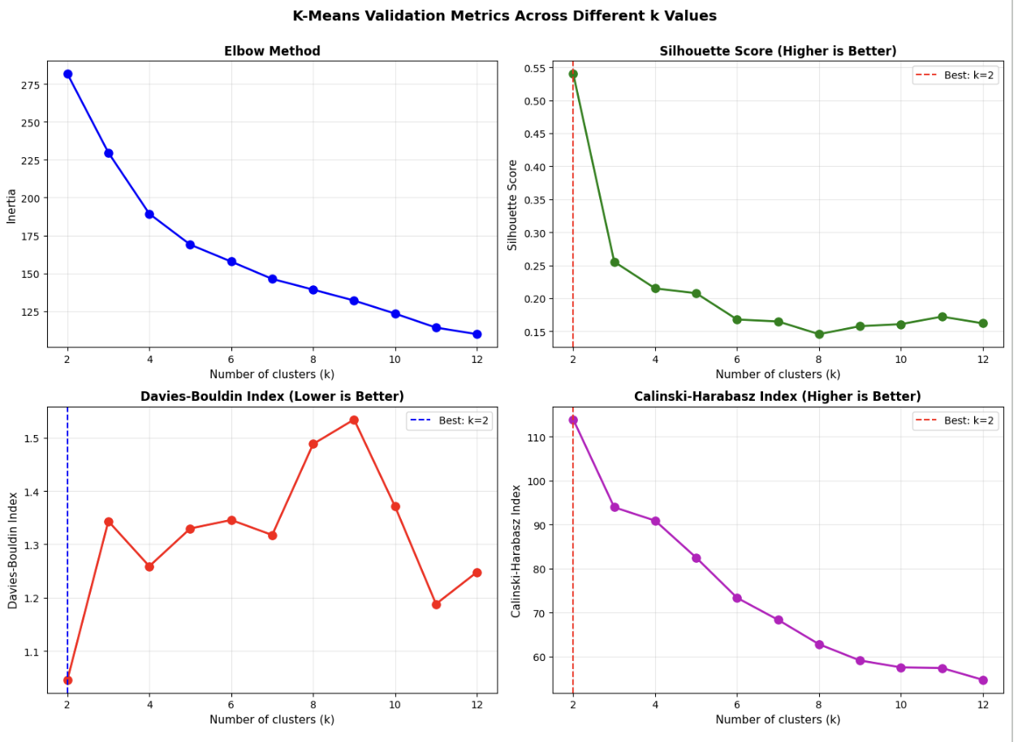
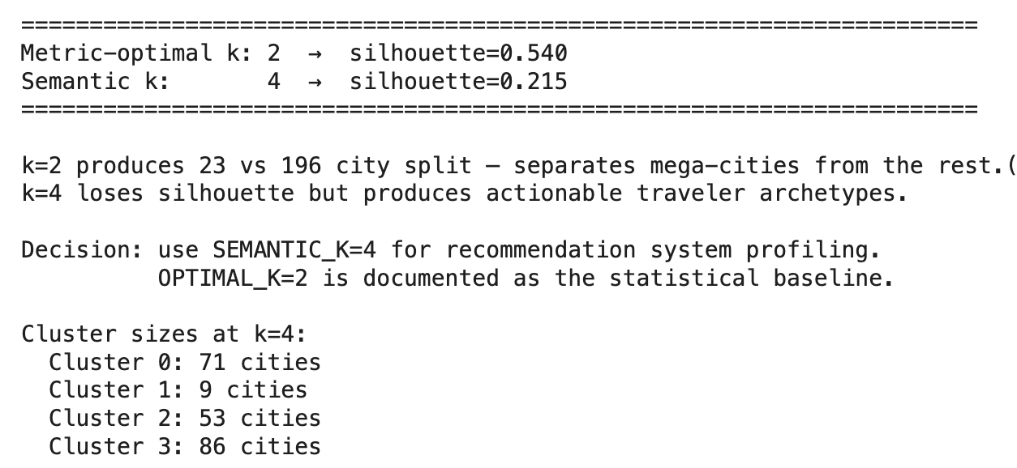

k | Silhouette | Interpretation
2 (Metric-optimal) | 0.540 | Splits 23 distinctive cities from 196 mainstream. Statistically strong but not actionable for recommendation — a traveler cannot be matched to "all other cities".
4 (Semantic k — selected) | 0.215 | Produces four interpretable lifestyle archetypes: casual suburban dining, tourism-leisure beach destinations, upscale wellness-retail, and balanced generalist cities. Silhouette loss is acceptable given the recommendation objective.

Decision: k=4 was selected as the semantic operating point. k=2 is preserved as the documented statistical baseline.

9.4. Experiment 2: DBSCAN

9.4.1 Parameter Selection
DBSCAN requires two parameters: epsilon (eps, the neighborhood radius) and min_samples (minimum points to form a dense region). Optimal eps was estimated using a k-distance graph (5th nearest neighbor distances sorted), which identified a knee point at approximately eps = 1.196.
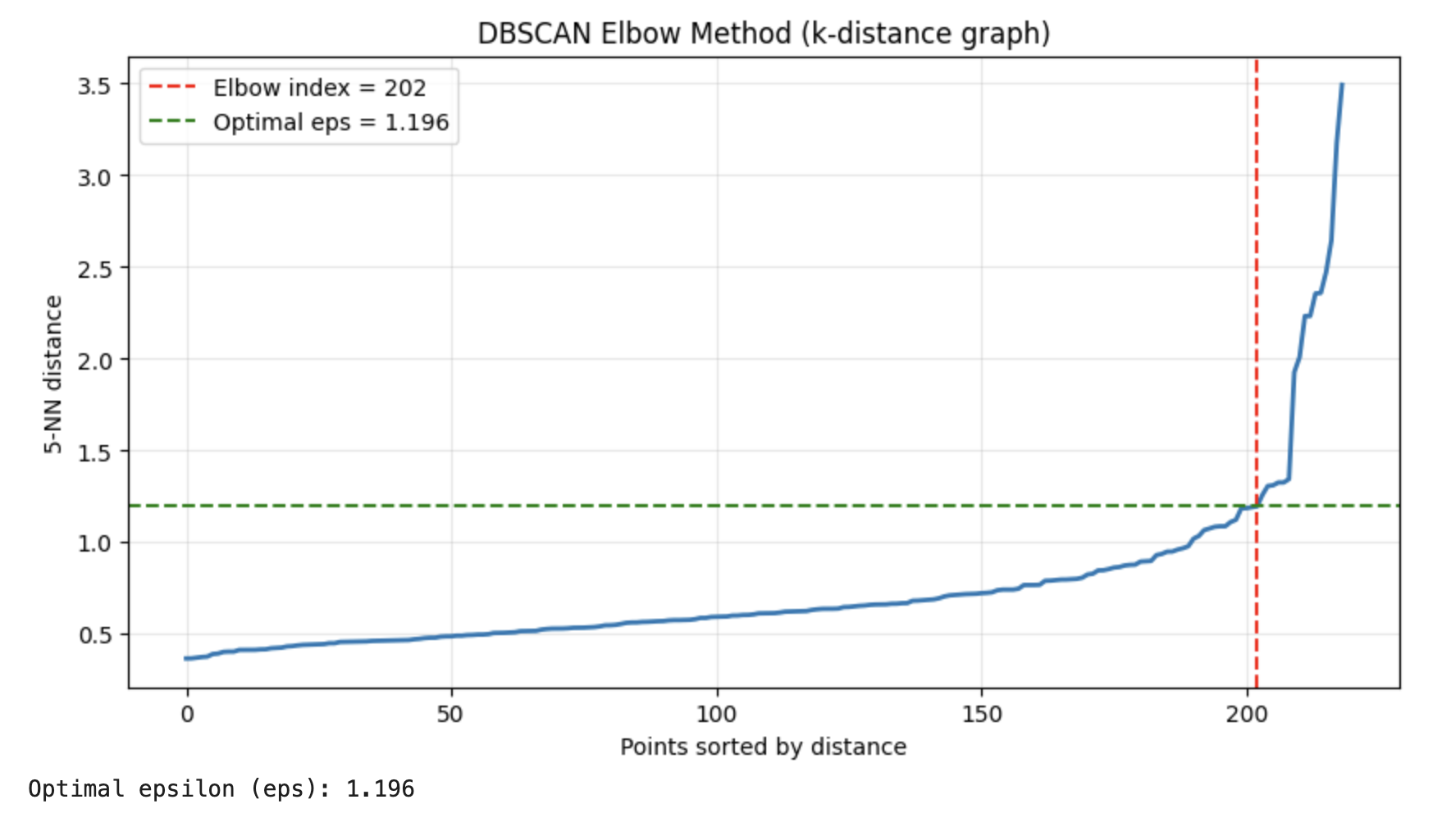
Two sweeps were conducted:
• Narrow sweep: eps range from 0.75 to 1.35 × optimal_eps, min_samples in {3, 4, 5, 7, 10}
• Wide sweep: eps range from the 45th to 90th percentile × 2.5 of the distance distribution, min_samples in {3, 5, 7, 10, 15}

9.4.2 Sweep Results
eps | min_samples | Clusters | Noise pts | Silhouette
1.727 | 3 | 2 | 6 | 0.601 (best) | ★
1.410 | 3 | 2 | 7 | 0.599
All other configs | ≥ 5 | 1 or 0 | High | —

The DBSCAN sweep consistently converged to a 2-cluster solution across all meaningful configurations. No configuration found 3 or more stable clusters with acceptable noise levels. This confirms that the PCA-transformed city space does not contain well-separated density-based regions — the city distribution is continuous rather than multi-modal.

9.4.3 Algorithm Comparison and Decision
Method | k / Clusters | Silhouette | Noise pts | Assessment
K-Means k=2 (baseline) | 2 | 0.540 | 0 | Statistically optimal but not actionable — coarse size split
K-Means k=4 (selected) | 4 | 0.215 | 0 | 4 interpretable archetypes; every city assigned; optimal for recommendation
DBSCAN (best config) | 2 | 0.601 | 6 | Same coarse split as k=2 KMeans; no semantic gain; 6 cities unassigned

Final decision: K-Means with k=4 was retained. DBSCAN is not well-suited for PCA spaces with convex, approximately spherical cluster geometry. Its best result mirrors the k=2 KMeans baseline without adding interpretive value, and leaves 6 cities unassigned — unacceptable for a recommendation system that must cover all cities.

10. Cluster Profile Analysis
Each cluster is characterized using both its PCA centroid (PC1–PC5 values) and the original personality feature proportions. The five PCs correspond to the following latent dimensions identified in Week 5:

PC | Label | Key Features
PC1 | Casual Dining Density | RestaurantsGoodForGroups, RestaurantsTakeOut, food_dining, casual attire, GoodForKids
PC2 | Quality & Formality | avg_stars, pct_5stars, full_bar, RestaurantsReservations, upscale ambience
PC3 | Premium Nightlife | nightlife_social, dressy attire, full_bar, valet parking, upscale ambience
PC4 | Commercial Vitality | avg_checkins_biz, avg_reviews_per_biz, n_businesses, brunch culture
PC5 | Wellness & Access | beauty_wellness, WheelchairAccessible, BikeParking, ByAppointmentOnly

Cluster 0 — Mainstream Suburban Dining (71 cities, 32.4%)
PC1 (Food) | PC2 (Quality) | PC3 (Nightlife) | PC4 (Vitality) | PC5 (Wellness)
High (+) | Low (−) | Low (−) | Neutral | Low (−)

Cluster 0 represents mainstream suburban dining ecosystems characterized by strong casual and family-oriented restaurant culture (high PC1) but relatively low upscale nightlife and brunch activity (negative PC2 and PC5). Representative cities such as New Port Richey, Kenner, and Bensalem suggest commercially active but predominantly practical and everyday dining environments with moderate business density. These cities serve the largest share of the Yelp user base and form the dominant commercial archetype in the dataset.

Cluster 1 — Tourism & Leisure Beach Destinations (9 cities, 4.1%)
PC1 (Food) | PC2 (Quality) | PC3 (Nightlife) | PC4 (Vitality) | PC5 (Wellness)
Very High (+) | High (+) | High (+) | Variable | High (+)

Cluster 1 captures highly distinctive tourism- and leisure-oriented cities with extremely high scores on casual dining, upscale nightlife, and wellness-related commercial infrastructure. Beach-oriented cities such as St. Pete Beach, Madeira Beach, Clearwater Beach, and Treasure Island dominate this cluster, indicating specialized urban-commercial profiles driven by transient visitor populations. The small size of this cluster (9 cities) reflects the rarity and high specificity of pure beach-resort commercial ecosystems in the Yelp dataset.

Cluster 2 — Upscale Lifestyle Suburbs (53 cities, 24.2%)
PC1 (Food) | PC2 (Quality) | PC3 (Nightlife) | PC4 (Vitality) | PC5 (Wellness)
Moderate | High (+) | Moderate | Moderate | High (+)

Cluster 2 represents affluent, lifestyle-oriented suburban environments where the commercial mix extends beyond food into beauty, wellness, shopping, and fitness. The cluster shows elevated beauty_wellness, shopping_retail, and fitness_outdoors personality values. Cities in this cluster tend to have higher average star ratings and stronger quality-signal features (PC2), suggesting a more discerning consumer base. Representative cities include upscale suburban areas with strong retail corridors and health-service density.

Cluster 3 — Balanced Urban-Commercial (86 cities, 39.3%)
PC1 (Food) | PC2 (Quality) | PC3 (Nightlife) | PC4 (Vitality) | PC5 (Wellness)
Moderate | Moderate | Moderate | High (+) | Moderate+

Cluster 3 is the largest group and represents generalized urban-commercial ecosystems with a more balanced profile across all PC dimensions. These cities do not specialize in any single dimension but show above-average commercial vitality (PC4) — higher checkin activity, more reviews per business, and larger business counts. Representative cities include Lutz, Southampton, and Trinity, which score highest on silhouette within this cluster. This cluster serves as the "generalist" archetype in the recommendation system: cities that offer a broad commercial mix without extreme specialization.

10.1 Personality Profile Interpretation
The personality-profile heatmap (original Yelp categories, not PCA) confirms that food_dining is the dominant dimension across all four clusters — restaurant culture is the central organizing axis of the city commercial space. Secondary differences define cluster identity:
• Cluster 1 (Tourism): strongest nightlife_social and hotels_travel signals
• Cluster 2 (Upscale): elevated beauty_wellness, shopping_retail, and fitness_outdoors
• Cluster 0 (Suburban): weaker lifestyle specialization, more practical commercial mix
• Cluster 3 (Generalist): broad balanced profile, strongest on commercial vitality metrics
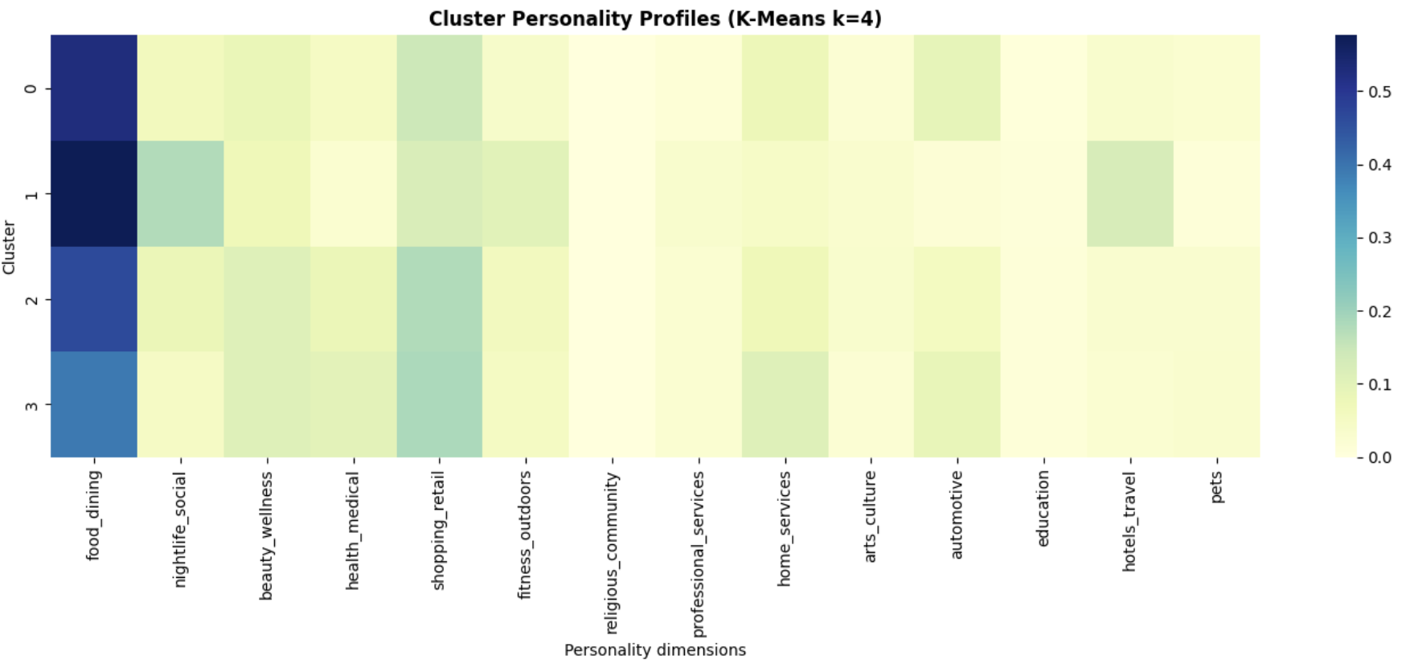

10.2 Cluster Size Distribution
Cluster | Archetype | Cities | Share | Mean Silhouette
0 | Mainstream Suburban Dining | 71 | 32.4% | ~0.20
1 | Tourism & Leisure Beach | 9 | 4.1% | ~0.15
2 | Upscale Lifestyle Suburbs | 53 | 24.2% | ~0.18
3 | Balanced Urban-Commercial | 86 | 39.3% | ~0.25

11. Validation Table
The following table summarizes all validation metrics collected across both algorithms and key k values, along with their interpretation limits.

Configuration | Silhouette | Inertia / DB | CH Score | Interpretation Limit
K-Means k=2 (statistical best) | 0.540 | 281.6 / 1.046 | 113.9 | Separates 23 outlier cities from 196. Not useful for multi-archetype recommendation.
K-Means k=4 (selected) | 0.215 | 189.3 / 1.259 | 90.9 | Interpretable archetypes. Silhouette drop from k=2 is expected and acceptable. 0 noise points.
DBSCAN (eps=1.727, min_s=3) | 0.601 | — / — | — | Only 2 clusters found. Best DBSCAN mirrors KMeans k=2. 6 noise points unassigned.

11.1 Interpretation Limits
The following limits apply to all metrics and are considered when interpreting results:
• Silhouette score of 0.215 at k=4 indicates cluster overlap — the boundary between Cluster 0 (suburban dining) and Cluster 3 (generalist) is not sharp. This is expected given the continuous distribution of commercial personality vectors.
• Inertia decreases monotonically with k and does not plateau cleanly, suggesting no hard elbow — a common characteristic of PCA-transformed spaces where variance is distributed across many components.
• CH score favors k=2 because it measures the ratio of between-cluster to within-cluster variance, which is naturally maximized when k is small. It should not be used alone for semantic cluster selection.
• DBSCAN silhouette (0.601) is misleadingly high because it reflects a 2-cluster structure, not 4 semantic archetypes — the metric is not comparable to the KMeans k=4 result.

12. Failure Analysis

12.1 Cities with Negative Silhouette (Misassigned)
23 cities received negative silhouette scores, indicating they are closer to another cluster's centroid than their own. These cities likely sit at the boundary between two commercial archetypes and represent genuine ambiguity in the data — not model errors.

City | Cluster | Silhouette | Likely Cause
Narberth | 2 | -0.122 | Small affluent suburb — borderline Cluster 2/3
Oro Valley | 2 | -0.114 | Mixed suburban profile — fits Cluster 3 better
University City | 1 | -0.113 | College town — different pattern from beach clusters
Eagle | 2 | -0.076 | Moderate-size city with generalist profile
Nolensville | 2 | -0.074 | Small Nashville suburb — borderline Cluster 0/2
Bryn Mawr | 2 | -0.073 | Affluent PA suburb — borderline Cluster 2/3
Mount Juliet | 0 | -0.072 | TN suburb — moderate casual dining, mixed profile
O'Fallon | 2 | -0.063 | MO suburb — sits between Cluster 2 and Cluster 3

12.2 Borderline Cities (Silhouette 0–0.20)
75 cities fall in the ambiguous zone between 0 and 0.20, representing 34% of the retained dataset. This is a significant proportion and reflects the core challenge: city commercial personalities exist on a continuous spectrum, not in discrete buckets. Notable examples:
• St. Albert (0.007), Valley Park (0.014) — very low silhouette, true generalists that do not clearly belong to any archetype
• Clayton (0.013) — moderately sized city with balanced commercial profile
• Haddonfield, Phoenixville (0.026–0.033) — affluent PA suburbs at the Cluster 2/3 boundary

12.3 Well-Clustered Cities (Silhouette > 0.45)
Only 3 cities achieved silhouette above 0.45 — a low count that confirms the overall soft cluster structure. All three belong to Cluster 3:
City | Cluster | Silhouette | n_businesses
Lutz | 3 | 0.475 | 591
Southampton | 3 | 0.467 | 209
Trinity | 3 | 0.461 | 108

12.4 Root Causes of Clustering Difficulty
The weak overall silhouette (0.215) has two identifiable structural causes:
• Continuous distribution: City commercial personalities form a continuum rather than discrete clusters. There is no natural gap in the PCA space between suburban dining and generalist cities — the transition is gradual.
• Food_dining dominance: All clusters are heavily loaded on food_dining personality (confirmed by heatmap). Secondary dimensions (nightlife, wellness) produce finer separations but with lower discriminative power.

13. Recommendation and Ranking Engine (Week 11)

13.1 Objective
This derivable’s objective is to transform the city representations developed in previous weeks into a decision-support system capable of recommending travel destinations. Rather than predicting ratings directly, the system addresses a ranking problem: given a user's historical travel behavior inferred from Yelp reviews, the model ranks candidate cities according to their estimated relevance and recommends the most suitable destinations.
The system supports the following decision:
"Which city should a traveler visit next based on the cities they have previously enjoyed?"
The unit being ranked is the city. Unlike traditional Yelp recommender systems that suggest individual businesses, restaurants, or services, this project operates at the city level. Each recommendation corresponds to an entire destination represented through its aggregated commercial personality profile.
This project is classified as a Recommendation and Ranking System
It is not a pure prediction task because the final objective is not estimating a numerical rating. Instead, the system generates an ordered list of candidate destinations according to estimated user preference.

13.2 Data Alignment
The recommendation pipeline integrates multiple artifacts developed throughout the course.
Interaction Layer
User-city interactions were derived from Yelp review data by aggregating business ratings at the city level. Each interaction contains the user_id, city_clean (city), rating. However, we applied a threshold that consists of a city preference signal that is considered valid only when the user reviewed at least three businesses within that city.
Feature Layer
Each city is represented using: Commercial personality features, PCA latent embeddings
The final representation consists of 28 principal components capturing approximately 75% of total variance.
Segmentation Layer
Cities were assigned to one of four commercial archetypes using K-Means clustering (k = 4).
The resulting clusters are:
Cluster 0: Mainstream Suburban Dining
Cluster 1: Tourism and Leisure Beach Destinations
Cluster 2: Upscale Lifestyle Suburbs
Cluster 3: Balanced Urban-Commercial Cities
Ranking Layer
The recommendation engine combines collaborative filtering signals, content similarity signals and popularity signals to produce a final ranking score for each candidate city.

The data flow is summarized below:
User Reviews → User-City Matrix
→ City Features → PCA Embeddings → City Clusters
→ Ranking Model → Recommended Cities

14.3 Candidate Pool Definition
The candidate pool defines the set of cities eligible to be recommended.
For each user, candidate cities are defined as:
Candidate Pool = All Cities (219 cities) − Cities Observed During Training
This means that cities already visited by the user in the training set are excluded from recommendation. This candidate-pool definition prevents trivial recommendations and ensures that only unseen destinations are evaluated.

14.4 Baseline System
A popularity-based recommender was implemented as the baseline. This baseline represents the simplest recommendation strategy and serves as a fair benchmark against which more sophisticated models can be compared.
Method
Each city receives a popularity score based on number of user interactions and average city rating. Cities are ranked globally according to this score.
Advantages:
- Simple
- Fast
- Interpretable
Limitations:
- Ignores user preferences
- Produces identical recommendations for all users
- Cannot capture niche travel interests
For these reasons, popularity serves as a minimum-performance baseline.

14.5 Advanced Recommendation System
A hybrid recommendation model was implemented as the primary system.
The model combines three complementary signals:
Collaborative Filtering Component
A user-city interaction matrix was constructed. Matrix factorization was performed using Truncated Singular Value Decomposition (SVD). The collaborative component captures latent travel preferences shared among users.
Advantages:
- Learns hidden preference patterns
- Personalizes recommendations
- Exploits collective behavior
Content-Based Component
Each city is represented through 28 PCA latent dimensions.
A user profile is constructed as a weighted average of the embeddings associated with cities previously visited by the user.
Cosine similarity is then computed between the user profile and candidate city embeddings.
Advantages:
- Uses city characteristics directly
- Handles sparse interactions better
- Provides explainable recommendations
Popularity Component
A popularity adjustment is incorporated to favor destinations that consistently receive positive engagement.
This component reduces the risk of recommending highly similar but extremely unpopular cities.
Hybrid Score
The final ranking score is computed as:
HybridScore =0.85 × CFScore +0.05 × ContentScore + 0.10 × PopularityScore
The weights were selected empirically based on offline evaluation results.

14.6 Evaluation Protocol
Train-Test Split
Evaluation was performed using a leave-one-out protocol.
For each eligible user:
- Historical cities were ordered chronologically.
- One city was held out for testing.
- Remaining cities were used for training.
The held-out city represents the future destination that the model attempts to recover.
Leakage Prevention
Several measures were implemented to avoid information leakage.
- User Leakage: The test city was removed entirely from the user's training profile.
- Popularity Leakage: Popularity statistics were computed exclusively from training interactions.
- Ranking Leakage: Candidate pools excluded all training cities.
- Feature Leakage: City embeddings and cluster assignments were generated independently from evaluation interactions.
These safeguards ensure that test information never influences recommendation scores.

14.7 Offline Evaluation Metrics
Performance was evaluated using Top-K ranking metrics.
Precision@K: Measures the proportion of recommended cities that are relevant.
Recall@K: Measures the proportion of relevant cities successfully recovered.
Hit Rate@K: Indicates whether at least one relevant city appears among recommendations.
NDCG@K: Rewards correct recommendations appearing near the top of the ranking.
MAP@K: Measures ranking quality across all recommendation positions.

These metrics were evaluated at:
K = 4, 5, 10, 20
to analyze recommendation quality under different list lengths.

14.8 Results
The next table summarizes the performance comparison between the baseline and hybrid systems.
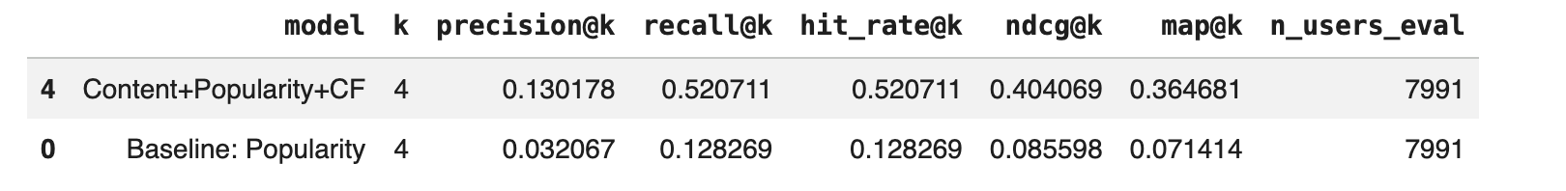
The hybrid model consistently outperformed the popularity baseline across all ranking metrics, demonstrating the value of combining collaborative, content-based, and popularity signals.

14.9 Error Analysis
To understand model behavior beyond aggregate metrics, recommendation outcomes were manually inspected.
Strong Cases
Strong cases occurred when the held-out city appeared within the Top-K recommendations. These cases were observed across users with varying interaction histories, suggesting that recommendation success depends not only on the amount of available history but also on the quality and consistency of the user's travel preferences.
Failure Cases
Users with only two training cities exhibited the lowest Hit Rate (41.2%), indicating that limited historical information may reduce recommendation accuracy. Nevertheless, the absence of a strictly increasing trend across larger history sizes suggests that city similarity, cluster structure, and collaborative signals also play important roles.
Structural Limitation
City commercial personalities form a continuous spectrum rather than sharply separated groups.
Consequently, some cities naturally sit between archetypes and are difficult to rank consistently.

14.10 Limitations and Future Work
Several limitations should be acknowledged.
Cold Start
Users with very few visited cities provide insufficient information for robust personalization.
Data Sparsity
Only a minority of Yelp users reviewed businesses across multiple cities.
Continuous City Space
Commercial city personalities do not form perfectly discrete clusters, limiting segmentation quality.

14.11 Conclusions
The Week 11 recommendation engine successfully transformed city embeddings and clustering outputs into a practical ranking system capable of recommending travel destinations.
The popularity baseline established a simple benchmark, while the hybrid model leveraged collaborative filtering, content similarity, and popularity signals to improve recommendation quality.
Offline evaluation demonstrated consistent gains over the baseline, and error analysis revealed both the strengths and limitations of the approach. The resulting system provides a personalized city-ranking mechanism that supports travel destination discovery using large-scale Yelp behavioral data.
GitHub link: https://github.com/andreatpr/recommendation_system.git

