

Computer Science Major

Teacher: Carlos Adrian Alarcon Delgado

Dataset Charter and Processed Dataset V1
Local Business Discovery Engine:
Travel-Oriented Recommendation System using the Yelp Academic Dataset

Members:

Code | Last name | First name | Semester
u201714492 | Peña Cardenas | Jhamil Brijan | 8th
u20221a963 | Sihuincha Schermuly | Mireya Nicole | 7th
U202323166 | Chavarria Barrios | Maria Ximena | 8th
U202120058 | Tapia Pescoran | Andrea Katherina | 10th

April 2026

Index

1. Project Proposal 3
1.1 Domain 3
1.2 Problem Statement 3
1.3 Expected Product Questions 3
1.4 Why This Dataset Supports the Full 3
Course 3
2. Source Inventory 4
2.1 Files Used 4
3. Schema Draft 5
3.1 Entity-Relationship Overview 5
3.2 Key Design Decisions for Nested Columns 5
4. Processed Dataset V1 6
5. Data Dictionary 6
5.1 business_clean (58 columns) 6
5.2 review_interactions 7
5.3 user_clean 7
5.4 checkin_clean 7
6. Scale Analysis 8
6.1 Key Observations 8
6.2 Geographic Distribution of Businesses 8
7. Ethics and Access Note 9
8. Representation and Dimensionality Report (Week 5) 9
8.1 City-Level Feature Matrix 9
8.2 Dimensionality Reduction (PCA) 10
8.3 Visualizations 10
A. Attribute Prevalence across Cities 10
B. 2D City Personality Projection 10
8.5 Technical Interpretation 10

1. Project Proposal

1.1 Domain
Intelligent Travel Destination. The system focuses on modeling the "latent personality" of cities by aggregating large-scale commercial data from Yelp with global tourism indices. It treats cities as structured entities with distinct socioeconomic and cultural profiles (safety, climate, and service density) to match travelers with urban environments that align with their preferred lifestyle.

1.2 Problem Statement
Travelers often struggle to choose a new destination because traditional recommendation engines rely on generic popularity or simple geographic filters. Our system addresses this by answering the core question: Which cities worldwide share a latent "commercial DNA" with the places a user has previously enjoyed? To solve this, we must transition from micro-data (individual businesses) to macro-representations (city vectors).

1.3 Expected Product Question
- Given a traveler's Yelp review history, which cities have the most similar commercial personality to the ones they already love?

This is a single city-level recommendation question. The system does not recommend individual businesses — it recommends destinations. The connection between a user's past behavior and a city recommendation is made through aggregated behavioral signals (which cities they've
rated businesses in, and how highly).

1.4 Why This Dataset Supports the Full

Course
Course Layer | Yelp Asset Used | Justification
Catalog | business_clean.parquet | 150,346 businesses · 58 columns · rich attributes, geo, categories
Interaction | review_interactions.parquet | 6,990,280 user-business ratings — sparse matrix for collaborative filtering
Feature engineering | city_features.parquet | 1416 cities x 162 aggregated features from all 4 parquet files
Clustering (W7) | city_embeddings_pca.parquet | PCA-reduced city vectors → K-Means city personality segments
Recommendation (W10) | user_city_interactions.parque | User-city rating matrix → collaborative filtering
Graph (W12) | city_features + embeddings | City-city similarity graph by cosine distance in embedding space
Pipeline | 4 Parquet files from 4 JSON sources | Real ETL: nested JSON, chunked reads, ~9 GB raw

2. Source Inventory

Item | Detail
Source name | Yelp Academic Dataset
URL | https://www.yelp.com/dataset
License | Yelp Dataset License — free for academic, non-commercial research
Registration | Required — email + academic affiliation
Format | JSON per-line (.tar compressed), one file per entity
Raw total size | ~9 GB uncompressed
Subset applied | None — full dataset used for all four tables

2.1 Files Used
File | Records | Key Fields
yelp_academic_dataset_business.json | 150,346 | business_id, name, city, state, lat, lon, stars, review_count, is_open, attributes{}, categories, hours{}
yelp_academic_dataset_review.json | 6,990,280 | review_id, user_id, business_id, stars, text, date, useful, funny, cool
yelp_academic_dataset_user.json | ~1,987,897 | user_id, review_count, average_stars, yelping_since, friends[], elite, fans, compliments
yelp_academic_dataset_checkin.json | 131,930 | business_id, date (comma-separated timestamps)

3. Schema Draft

3.1 Entity-Relationship Overview
Table (Processed) | Primary Key | Foreign Keys | Grain
business_clean | business_id | — | One row per business, 58 columns after flattening
business_categories | business_id + category | business_id → business_clean | One row per (business, category) pair — bridge table
review_interactions | (user_id, business_id) | business_id, user_id | Sparse interaction matrix: user_id, business_id, stars
user_clean | user_id | — | One row per user: review_count, avg_stars, yelping_since
checkin_clean | business_id | business_id → business_clean | One row per business: n_checkins (aggregated count)

3.2 Key Design Decisions for Nested Columns
Three columns in business.json required special handling. The decisions below are architectural choices for the modeling pipeline:

Column | Raw Structure | Decision | Rationale
attributes | Dict with values that are themselves dicts serialized as strings: {"BusinessParking": "{'garage': False, 'lot': True}"} | Two-level flatten → attr__ prefix for top-level, attr__Parent__child for sub-dicts. 88 raw columns → 51 dropped (>90% null), 37 retained. | ML models require numeric/boolean inputs. NaN kept as NaN (not filled with False) because absence-of-attribute ≠ attribute-is-False. A business without WiFi info is genuinely unknown.
hours | Dict {"Monday": "9:0-21:0", ...} or None | Converted to 9 integer columns: open_days count + has_weekend flag + one boolean per day. All default to 0 when hours is None. | hours=None means no registered hours, equivalent to 0 days open
categories | Comma-separated string: "Restaurants, Italian, Pizza" | Parsed to list → primary_category (first element) + n_categories count + bridge table for full membership. | Enables both fast filtering by primary_category and full category-based similarity in W7/W12 graph construction.

4. Processed Dataset V1

Six Parquet files produced from four raw JSON sources. All ingestion runs from the notebook pre.ipynb via Google Colab + Google Drive mount. Snappy compression used throughout.

File | Rows | Cols | Compression | Notes
business_clean.parquet | 150,346 | 58 | Snappy | Flat table; 37 attr__ cols, 9 hours__ cols, 3 derived category cols
business_categories.parquet | ~750K+ | 2 | Default | Bridge: business_id × category
review_interactions.parquet | 6,990,280 | 3 | Snappy | Lean interaction matrix: user_id, business_id, stars only
user_clean.parquet | ~1,987,896 | 4 | Snappy | user_id, review_count, average_stars, yelping_since — 1 bad line skipped
checkin_clean.parquet | 131,930 | 2 | Default | business_id + n_checkins (count of comma-separated timestamps)

5. Data Dictionary

5.1 business_clean (58 columns)
Column Group | Columns | Type | Missingness | Notes
Identity | business_id, name, city, state, postal_code | str | 0% | PK is 22-char hash
Geography | latitude, longitude | float64 | 0% | WGS84 decimal degrees
Performance | stars, review_count, is_open | float/int | 0% | stars 1.0–5.0; is_open 0/1
Categories | categories_list, primary_category, n_categories | object/str/int | 0% / 0.07% / 0% | List, first element, count
Attributes (boolean) | attr__ByAppointmentOnly through attr__GoodForMeal__breakfast (32 cols) | boolean (nullable) | 20%–84% | NaN = not reported by business
Attributes (categorical) | attr__RestaurantsPriceRange2, attr__WiFi, attr__Alcohol, attr__RestaurantsAttire, attr__NoiseLevel (5 cols) | category | 20%–75% | Low-cardinality string values encoded as category dtype
Hours | hours__open_days, hours__has_weekend, hours__open_{day} × 7 (9 cols) | int64 | 0% | 0 when hours dict is None; valid default

5.2 review_interactions
Column | Type | Missingness | Notes
user_id | object | 0% | FK → user_clean
business_id | object | 0% | FK → business_clean
stars | int64 | 0% | 1–5 rating — the interaction signal for collaborative filtering

5.3 user_clean
Column | Type | Missingness | Notes
user_id | object | 0% | Primary key — links to review_clean and review_interactions
review_count | int64 | 0% | Total reviews written
average_stars | float64 | 0% | User's historical average rating
yelping_since | datetime64[ns] | 0% | Account creation date — used for user seniority feature in W5

5.4 checkin_clean
Column | Type | Notes
business_id | object | FK → business_clean
n_checkins | int64 | Count of timestamps in raw date string — proxy for foot traffic

6. Scale Analysis

Table | Rows | Columns | Memory (RAM) | Missingness
business_clean | 150,346 | 58 | ~34 MB | 0% on base cols; 20–84% on attr__ cols; 0% on hours__ cols
business_categories (bridge) | ~750K+ | 2 | ~30 MB | 0%
review_interactions | 6,990,280 | 3 | ~160 MB | 0%
user_clean | ~1,987,896 | 4 | ~60 MB | 0%; 1 malformed line skipped
checkin_clean | 131,930 | 2 | ~3 MB | 0%

6.1 Key Observations
- The attr__ columns have 84.4% average missingness. This is structural, not a data quality problem: Yelp only collects attributes relevant to a business type (restaurants have WiFi/Alcohol; hair salons have HairSpecializesIn). Imputing False would introduce false information — NaN is the correct representation.
- 51 of 88 attribute columns were dropped (>90% null across the full dataset). The remaining 37 cover the most universally populated attributes and include the richest semantic signal for business similarity.
- The user-item matrix derived from review_interactions is extremely sparse: ~6.99M interactions / (1.99M users × 150K businesses) ≈ 0.0023% density. This is expected for a recommendation problem and validates the need for collaborative filtering + matrix factorization in W10.

6.2 Geographic Distribution of Businesses
The dataset spans multiple US states and Canadian provinces with no geographic filter. Top cities by business count: Philadelphia (14,569), Tucson (9,250), Tampa (9,050), Indianapolis (7,540), Nashville (6,971). This geographic breadth is essential, the system needs diverse cities to make meaningful personality comparisons.

7. Ethics and Access Note
Data source: Yelp Academic Dataset, obtained directly from yelp.com/dataset under the Yelp Dataset License for non-commercial academic use. No scraping was performed.

Question | Answer
Where did the data come from? | Direct download from yelp.com/dataset after completing the Yelp academic registration form. Data stored in private Google Drive.
Why is the team allowed to use it? | The Yelp Dataset License explicitly permits academic, non-commercial research and classroom use. The project does not redistribute raw data.
What personal data risks exist? | user.json contains display names (excluded from user_clean), friend graph adjacency lists (not processed in V1), and behavioral history. review.json contains opinionated free text that may identify individuals.
How are those risks reduced? | user_clean retains only user_id (hashed), behavioral counts, and dates — no names or friend lists. No raw files are shared. No attempt will be made to de-anonymize users. The processed artifacts use only anonymized IDs throughout.

8. Representation and Dimensionality Report (Week 5)

8.1 City-Level Feature Matrix
To achieve the goal of recommending destinations based on a city's "personality," the dataset granularity was scaled from individual business units to aggregated city entities. This transformation allows the system to model latent urban profiles rather than just specific locations.
Matrix Construction:
- Semantic Aggregation: Boolean and categorical business attributes were averaged per city to create percentage-based features (e.g., % of romantic venues, % of kid-friendly locations).
- Tourism Enrichment: The matrix was integrated with external tourism data, including a safety index, climate classifications, and peak travel seasons.
- Encoding Strategy: One-Hot Encoding was applied to categorical variables such as climate type and city vibe, while Ordinal Encoding was used for noise levels and price ranges.
- Final Scale: The resulting matrix consists of 1416 rows (unique cities) and 162 columns (features).

8.2 Dimensionality Reduction (PCA)
Due to high feature dimensionality and expected redundancy between business categories, Principal Component Analysis (PCA) was performed.
- Normalization: Prior to PCA, a StandardScaler was applied to ensure that high-magnitude features, like total_reviews, did not bias the model against percentage-based features.
- Explained Variance: The analysis determined that 59 components are required to capture 75% of the total variance.
Components | Variance Retained | Dimensionality Reduction
51 | 70% | 68.3%
59 | 75% | 63.4%
69 | 80% | 57.1%
94 | 90% | 41.6%
161 (full) | 100% | 0%
- Dimensionality Gain: The process achieved a 63.4% reduction in total features, significantly optimizing the dataset for upcoming clustering and graph analysis.

8.3 Visualizations

A. Attribute Prevalence across Cities
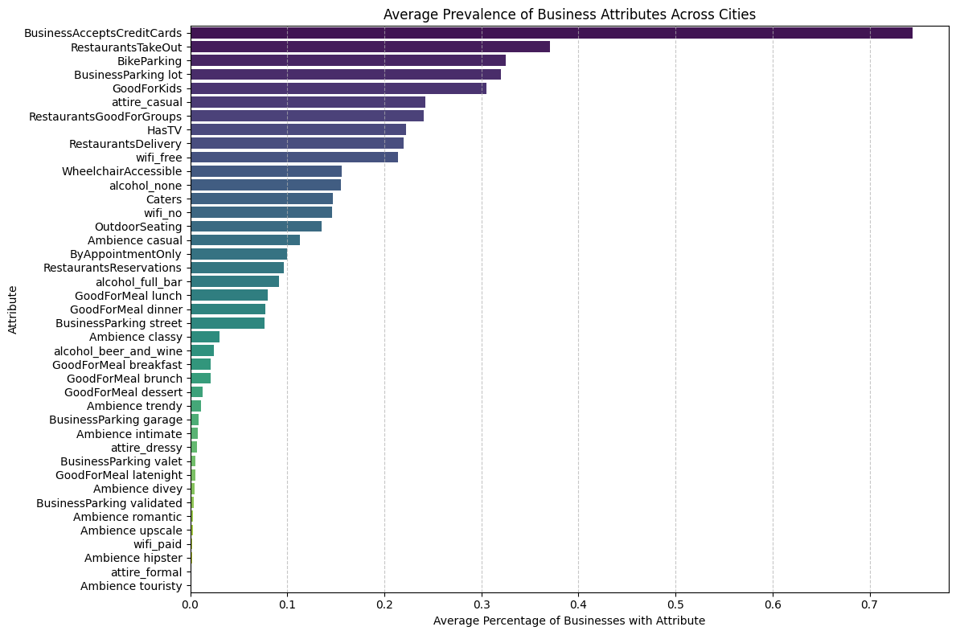
A bar chart of average attribute prevalence across all 1,416 cities shows that BusinessAcceptsCreditCards (~75%) is the most universal attribute, while attire_formal and Ambience__touristy are the least common. This confirms the ‘attributes profile’ section captures meaningful variation in city commercial profiles.

B. 2D City Personality Projection
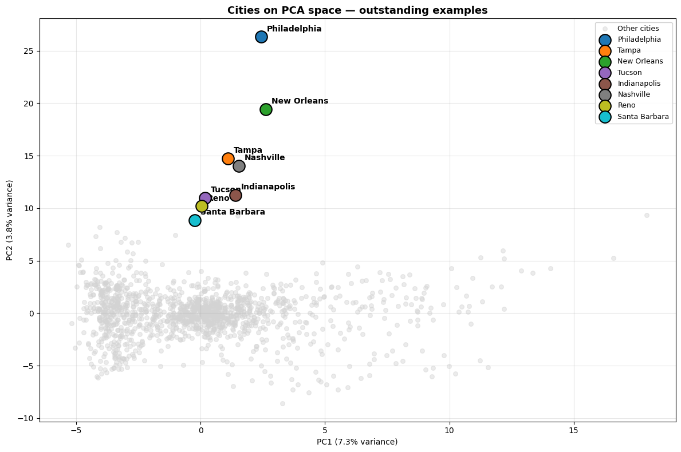
The 2D PCA projection shows most cities clustered tightly near the origin, while highlighted cities sit notably high on PC2. Philadelphia leads, followed by New Orleans, with Tampa, Nashville, Indianapolis, Tucson, Reno and Santa Barbara grouped lower. Their elevated PC2 values reflect richer, denser business ecosystems compared to the long-tail of smaller cities. PC1 explains only 7.3% of variance, confirming variance is distributed across many dimensions.

C. Correlation Heatmap of Key Features
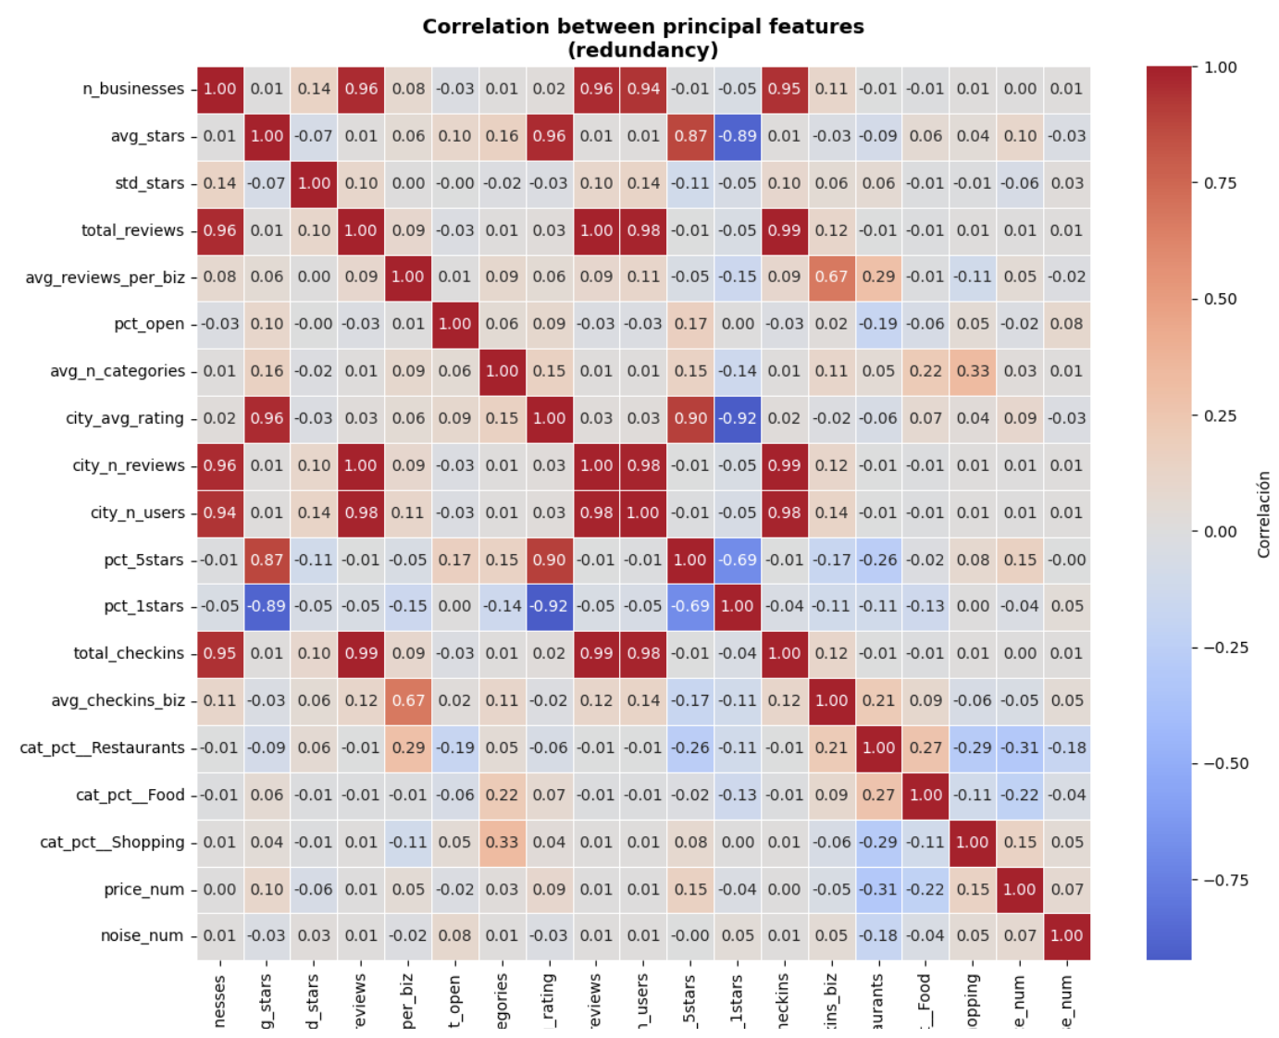
A correlation heatmap of 19 key features confirms expected relationships: n_businesses correlates strongly with total_reviews and total_checkins (all measure city size). avg_stars and city_avg_rating are nearly identical (both derived from the same underlying data). pct_5stars and pct_1stars are weakly negatively correlated. These redundancies justify dimensionality reduction, PCA collapses the size signal into one component rather than carrying 4 near-identical columns.

8.5 Technical Interpretation
This week’s analysis produced two key findings about the structure of the city feature space:
• Finding 1. Low redundancy, high complexity:
59 components are needed for 75% variance because the feature blocks capture genuinely independent aspects of city personality. Business attributes, category distribution, behavioral ratings, and checkin patterns are not interchangeable signals.

• Finding 2. Gastronomic features dominates PC1, ratings dominates PC2:
PC1 captures gastronomic density and casual culture, cities with many restaurants, casual attire, group-friendly venues, and HasTV dominate this axis. PC2 captures rating consistency, high pct_5stars vs low pct_1stars. PC4 is the most semantically rich component, separating nightlife-oriented cities (bars, alcohol, classy ambience) from food and family-oriented ones. PC5 identifies cities with high beauty service density. Notably, city scale (n_businesses, total_reviews) does not dominate any single component — it is distributed across several, confirming that city personality is genuinely multi-dimensional.
GitHub link: https://github.com/andreatpr/recommendation_system.git

