Benchmark of Explainability Techniques for Neural Networks in Banking Fraud Detection
Andrea Claudia Villanca Rosales
Abstract
This dissertation presents an in-depth benchmark of post-hoc explainability techniques for a neural network model applied to banking fraud detection. A TabNet classifier is trained on the Bank Account Fraud (BAF) dataset, a large-scale, privacy-preserving tabular benchmark derived from a real bank account opening fraud detection system. The study combines a thorough exploratory data analysis, a temporally-consistent preprocessing pipeline, class-imbalance treatment, and predictive evaluation, with a systematic explainability benchmark that compares SHAP KernelExplainer, SHAP GradientExplainer, LIME, Integrated Gradients, and TabNet's native attention mechanism. Beyond reporting global and local explanations, this memory documents the methodological corrections that were necessary to obtain trustworthy conclusions: an invalid SHAP background distribution was diagnosed and repaired, a one-hot-aware perturbation protocol was designed to avoid impossible categorical states, and a scale-normalized robustness metric was introduced after raw sensitivity values proved incomparable across methods. The final benchmark also reports calibration diagnostics, logit-based sensitivity checks, bootstrap confidence intervals, independent grouped-permutation validation, and a discussion of proxy-risk for dominant categorical variables. Results show that SHAP KernelExplainer is the most faithful post-hoc method on this model, Integrated Gradients is the best scalable neural alternative, LIME is the most stable but least faithful method, and TabNet's native attention should be treated as architectural introspection rather than as a faithful local explanation of individual predictions.
Index Terms
Explainable Artificial Intelligence, XAI, Banking Fraud Detection, TabNet, SHAP, LIME, Integrated Gradients, Fidelity, Robustness, Stability, Calibration, Bank Account Fraud Dataset, Proxy Risk.
I. INTRODUCTION
Banking fraud detection is a high-impact domain in which predictive performance alone is insufficient. When a model supports decisions about account opening, identity risk, or suspicious customer profiles, the institution must understand not only which applicants are classified as risky but also why the model reaches that conclusion. This requirement is technical, operational, and regulatory: the EU General Data Protection Regulation (GDPR) grants individuals a right to a meaningful explanation of automated decisions that significantly affect them (Article 22) [10], so analysts must be able to validate model behavior, compliance teams must audit automated decision processes, and data scientists must detect whether the model relies on unstable, spurious, or potentially discriminatory proxies.
The objective of this thesis is to build a bridge between predictive modeling and trustworthy interpretation in a realistic tabular financial setting. The selected use case is fraud detection in banking account opening, using the Bank Account Fraud (BAF) dataset [8]. The model is a TabNet neural network [6], chosen because it is purpose-built for tabular data and includes an internal, sparse attention mechanism that is often marketed as a source of native interpretability. A central methodological question of this work is whether that native attention is, in fact, equivalent to a faithful explanation of individual predictions. As will be shown in Section V, it is not: attention masks are informative about the architecture's internal feature-selection process, but they are only weakly correlated with the actual change in model output when the corresponding input variables are perturbed. External, post-hoc explanation methods are therefore evaluated independently and compared against both model behavior and TabNet's native signal.
The working hypothesis of this thesis is that different explainability methods provide systematically different views of the same neural model, and that these views must be evaluated quantitatively, with attention to the validity of the evaluation protocol itself, before being used for audit or decision support. In other words, explanations are treated as model outputs that themselves require validation, in the same way predictions require validation through held-out testing. This is not a purely theoretical concern: Section III documents two cases in which a naive implementation of an explanation background or a perturbation-based metric produced misleading results that were only caught through explicit diagnostic checks. The thesis therefore asks four practical questions: (i) which post-hoc method is most faithful to the trained TabNet model; (ii) which method is most robust and stable; (iii) how does TabNet's native attention compare to genuine post-hoc explanations; and (iv) what does the resulting explanation evidence imply for the responsible deployment of this model in a banking context.
The experimental workflow is implemented in two companion notebooks. The first notebook performs exploratory data analysis, preprocessing, temporal splitting, class-imbalance handling, TabNet training, and model export. The second notebook performs the full explainability benchmark: SHAP, LIME, Integrated Gradients, TabNet native masks, calibration diagnostics, logit-based validation, one-hot-aware perturbation metrics, bootstrap confidence intervals, grouped permutation importance, and reproducible CSV/figure exports. This memory documents both notebooks with the level of methodological detail expected of a benchmark whose conclusions may inform governance decisions in a regulated domain.
A. Objectives and Contributions
The general objective is to compare explainability techniques for neural networks in a fraud detection problem where the practical quality of the resulting explanations has operational relevance. The specific objectives are: to characterize the BAF dataset and its class imbalance and missingness structure; to train a reasonable TabNet model under a realistic, temporally-consistent evaluation protocol; to generate global and local explanations using several state-of-the-art post-hoc methods; to evaluate explanation fidelity, robustness and stability under a methodologically sound protocol; and to derive concrete, defensible recommendations for the banking domain.
- A complete preprocessing and modeling pipeline for BAF using temporal train/validation/test splits, sentinel-aware missing-value handling, and a TabNet classifier.
- A systematic comparison of SHAP KernelExplainer, SHAP GradientExplainer, LIME and Integrated Gradients on the same neural model, contrasted with TabNet's native attention.
- Diagnosis and correction of an invalid SHAP/Integrated-Gradients background distribution, replacing synthetic SMOTE-derived centroids with real training-row medoids.
- A one-hot-aware fidelity protocol that perturbs whole original categorical variables rather than isolated one-hot dummy columns, avoiding impossible "no-category" states.
- A scale-normalized robustness metric that makes max-sensitivity comparable across methods whose attribution magnitudes live on very different numeric scales.
- Calibration and logit-based checks that prevent overinterpreting an uncalibrated model score as a real-world probability when reporting attributions.
- Bootstrap confidence intervals for every final explanation metric, and an independent grouped permutation-importance validation that confirms categorical dominance is a genuine model-behavior pattern.
- A proxy-risk discussion connecting the dominant categorical variables to fairness and GDPR Article 22 governance considerations.
B. Scope and Structure
The thesis does not aim to maximize fraud-detection performance at all costs; a test AUC-ROC close to 0.85 is treated as sufficient to obtain a credible neural model on which to study explanation behavior. The scope of the work is instead the design, execution, and critical evaluation of an explainability benchmark, including the methodological pitfalls that arise specifically in tabular, one-hot encoded, class-imbalanced financial data. The memory follows the template structure required for this Master's thesis: state of the art, method, experiments, results, and conclusions. Section II reviews the relevant literature. Section III describes the dataset, the preprocessing pipeline, the TabNet model, and the design of the explainability benchmark, including the background-distribution and perturbation corrections. Section IV describes how these components were executed and configured. Section V reports and discusses the resulting evidence in depth, including global and local explanations, quantitative metrics, uncertainty estimates, and the proxy-risk discussion. Section VI concludes with limitations and future work, and the appendix summarizes the reproducibility artifacts generated by the notebooks.
II. STATE OF THE ART
A. Explainable Artificial Intelligence in High-Stakes Domains
Explainable Artificial Intelligence (XAI) studies methods that make model behavior more understandable to humans, from identifying which features drove a given prediction to characterizing global model behavior or sensitivity to controlled perturbations. In domains such as finance, healthcare and public services, XAI is a prerequisite for trust, auditability, and responsible deployment [1], [2].
The literature distinguishes intrinsically interpretable models (linear models, small decision trees, rule lists) from post-hoc methods such as SHAP, LIME and Integrated Gradients, which explain a trained black-box model after learning is complete. A central, frequently underestimated challenge is that post-hoc explanations are themselves approximations whose quality depends on design choices external to the model: the reference (background) distribution, the perturbation strategy, the baseline, the output scale, and how categorical variables are represented.
For tabular data these challenges are amplified by heterogeneous feature types. Perturbing one one-hot dummy independently, without adjusting the remaining dummies of the same variable, can silently create an impossible record (e.g., no operating-system flag active at all), and synthetic reference points such as cluster centroids can likewise move off the real data manifold into fractional "half-category" values no real applicant could have. This thesis treats explanation design, including background construction and perturbation validity, as a first-class part of the methodology; Section III documents two concrete cases where failing to do so produced misleading results.
Several recent frameworks address the evaluation side of this problem: Quantus groups quantitative XAI metrics by faithfulness, robustness, complexity and localization [7]; OpenXAI offers a transparent tabular benchmarking suite with reference stability and fidelity implementations [17]; xai_evals integrates SHAP, LIME, Grad-CAM and Integrated Gradients across tabular and image modalities [18]; and XAI Dataset (Saliency-Bench) contributes human-annotated ground truth, though focused on image rather than tabular data [19]. This thesis adopts the same evaluation axes as these frameworks (fidelity, robustness and stability), but after finding Quantus incompatible with flat, one-hot encoded tabular arrays in practice (Section III-H), implements these metrics manually, with explicit corrections documented for two of the three axes.
B. The Bank Account Fraud Dataset
The Bank Account Fraud (BAF) benchmark was introduced as a privacy-preserving, large-scale and realistic suite of tabular datasets for machine learning evaluation [8]. The associated NeurIPS 2022 paper emphasizes that tabular data remains central to high-stakes decision-making domains, and that realistic tabular benchmarks must capture severe class imbalance, temporal distribution shift, and controllable bias patterns, properties that are largely absent from older, smaller Fair-ML benchmarks such as UCI Adult, COMPAS or German Credit. The suite was generated by training a privacy-preserving CTGAN on an anonymized, real-world online bank account opening fraud dataset from a large consumer bank, after applying Laplacian noise and feature selection to the original data. The accompanying datasheet [9] documents field-level conventions, including which sentinel values represent missingness for each feature, information that is essential for correct preprocessing and that is used directly in Section III-A of this memory.
The variant used in this thesis is the BAF “Base” dataset, which contains approximately one million applications and 32 columns before preprocessing, spanning eight months of activity (encoded in the month column). The target, fraud_bool, is extremely imbalanced: fraud represents close to 1.1% of applications in the raw data, with prevalence and application volume both drifting across months. This imbalance mirrors real financial-crime problems, where false negatives are costly but false positives also generate operational burden, customer friction and reputational risk. As documented in Section III, several numerical columns encode missingness using column-specific sentinel values which must be handled explicitly.
C. Neural Networks for Tabular Fraud Detection
TabNet is an attentive, sequential architecture for tabular data [6]. At each decision step it uses a learned, sparse (entmax) mask to select input features, giving a natural form of architectural introspection: aggregated mask weights across steps and across a batch can be read as a native, model-intrinsic feature-importance signal without any external explanation method. This makes TabNet attractive for an XAI thesis, since the same model offers both a genuinely non-linear decision function and a built-in attention signal directly comparable, on equal footing, against external post-hoc explanations.
However, attention-based importance is not automatically a faithful local explanation, and conflating the two is a common source of overclaiming in the applied XAI literature: native attention reflects which features the architecture routed through a decision step during training, not that perturbing those features produces a correspondingly large output change for a specific instance. The results of this thesis (Section V-F) confirm this empirically: TabNet's native attention is comparatively stable at the vector level but shows very low fidelity to prediction changes under perturbation, motivating its treatment as a complementary, architectural diagnostic.
D. Post-Hoc Explanation Methods
SHAP is grounded in Shapley values from cooperative game theory [3], attributing a model's output to individual features relative to a background (reference) distribution that represents the absence of information. KernelExplainer is model-agnostic, applicable to any prediction function, but computationally expensive because it requires many evaluations of the model per explained instance. GradientExplainer is more scalable for differentiable models such as neural networks, but its behavior depends more directly on the shape of the loss surface around the baseline and on the sampling of background points. Extensions such as TreeExplainer illustrate how the same Shapley-value framework generalizes from local attributions to global structure for other model families [11]. In this thesis, SHAP is evaluated both on the model's probability-score output and on the raw pre-sigmoid fraud logit, in order to check whether the ranking of important features is an artifact of the output scale or of softmax saturation near the extremes of the score range.
LIME explains a single prediction by sampling perturbed neighbors around the instance in feature space and fitting an interpretable linear surrogate model to the perturbed predictions [4]. It is intuitive and comparatively fast to compute for a single local narrative, but its reliability depends strongly on the perturbation distribution and on the stability of the fitted surrogate. In one-hot encoded tabular settings, naive perturbation can generate combinations of dummy variables that never occur in real data unless the encoding structure is respected. This thesis therefore evaluates LIME not only through local visualizations but through the same quantitative fidelity, robustness and stability protocol applied to every other method.
Integrated Gradients (IG) is a path-based attribution method for differentiable models [5], implemented here through the Captum library [14]. It integrates gradients of the model's output with respect to the input along a straight-line path from a baseline input to the instance being explained. The choice of baseline is critical and frequently mishandled in practice: an all-zero baseline is often inappropriate for standardized numerical features (where zero is a specific, meaningful value) and is directly invalid for one-hot encoded categorical variables, where an all-zero vector corresponds to no category being active at all, a state that never occurs in the real data and that the model never saw during training. This thesis uses real training-row baselines for Integrated Gradients, consistent with the SHAP background correction described in Section III-F, and additionally evaluates a logit-target version of Integrated Gradients as a further robustness check on the output-scale question.
E. Evaluating Explanations: Fidelity, Robustness and Stability
The three evaluation axes used throughout this thesis are fidelity, robustness and stability, following the general framing adopted by Quantus [7] and OpenXAI [17]. Fidelity (also called faithfulness) measures whether the attributions assigned to a feature or feature group are consistent with the actual change in model output that results from perturbing that feature or group; a faithful explanation should show a strong positive correlation between the magnitude of attributed importance and the magnitude of the resulting output change. Robustness measures how much an explanation changes when the input is perturbed by a small amount that should not materially change the underlying prediction; an explanation that swings wildly for a nearly identical input is not trustworthy for case-by-case audit. Stability measures whether structurally similar inputs, identified as nearest neighbors in feature space, receive similar explanations; this is particularly relevant in banking, where two very similar applications receiving contradictory explanations would undermine confidence in the model's consistency.
Quantus [7] was evaluated for this purpose and found, in practice, to be incompatible with the flat, one-hot encoded numerical arrays produced by this thesis' preprocessing pipeline (Section III-H); the final metrics were therefore implemented manually, as fully transparent and reproducible functions, so that every design decision, including the two corrections documented in Section III-G and III-I, could be inspected and justified.
III. METHOD
A. Dataset Preparation and Exploratory Analysis
The exploratory data analysis (EDA) notebook begins by loading the BAF “Base” dataset and inspecting its structure directly. The raw dataset has exactly 1,000,000 rows and 32 columns, mixing numerical and categorical variables. There are no conventional NaN values anywhere in the file; missingness is instead represented using column-specific sentinel values, a convention confirmed against the official BAF datasheet [9]. Two conventions coexist in the data: for five columns (prev_address_months_count, current_address_months_count, bank_months_count, session_length_in_minutes and device_distinct_emails_8w), only the exact value −1 denotes a missing observation; for intended_balcon_amount, whose valid range is [−16, 114], any negative value denotes missingness. Critically, two other columns, credit_risk_score ([−191, 389]) and velocity_6h ([−175, 16818]), have negative values that are valid data and must not be touched by any missing-value rule.
Table I summarizes the missingness diagnosis performed on the raw data. prev_address_months_count is missing in 71.29% of rows and intended_balcon_amount in 74.25% of rows, both far too sparse to impute reliably, while bank_months_count is missing in 25.36% of rows, a level considered imputable. The remaining sentinel columns have negligible missingness (at most 0.43%). device_fraud_count was found to be constant across all one million rows (a single unique value, 0), and therefore carries no information for the model.
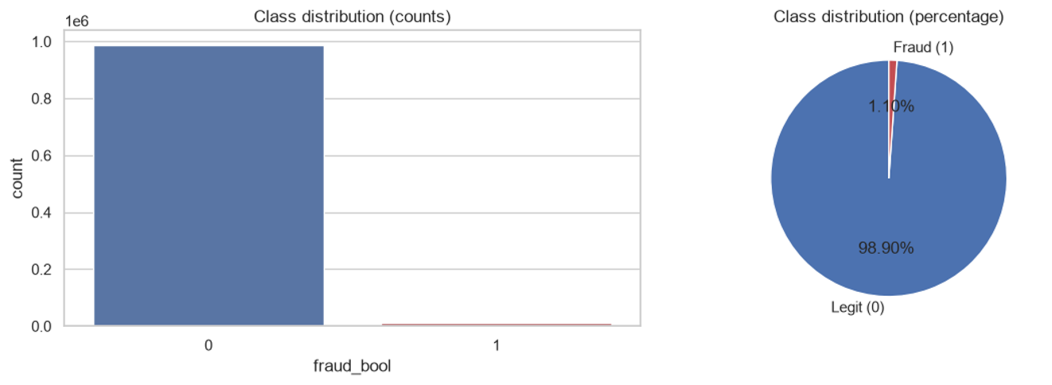
Fig. 1. Class distribution of fraud_bool in the raw data (98.90% legitimate vs. 1.10% fraudulent, a roughly 90:1 imbalance).
Column | Missingness rule | % missing | Action taken
prev_address_months_count | exact -1 sentinel | 71.29% | Dropped (excessive missingness)
intended_balcon_amount | any negative value | 74.25% | Dropped (excessive missingness)
bank_months_count | exact -1 sentinel | 25.36% | Imputed (median)
current_address_months_count | exact -1 sentinel | 0.43% | Imputed (median)
session_length_in_minutes | exact -1 sentinel | 0.20% | Imputed (median)
device_distinct_emails_8w | exact -1 sentinel | 0.04% | Imputed (median)
device_fraud_count | constant column (zero variance) | n/a | Dropped (no information)
Table I. Column-specific missingness diagnosis for the BAF dataset, following the BAF datasheet's documented sentinel conventions, and the action applied to each affected column.
Beyond missingness, the EDA characterizes the correlation structure of the numerical features (Fig. 2). Most pairwise Pearson correlations are weak, as expected for engineered, largely independent fraud-detection features; the clearest structural pattern is among the three velocity features (velocity_6h, velocity_24h and velocity_4w), which are moderately to strongly correlated with one another by construction, and a strong negative correlation between velocity_4w and month, since velocity is computed over a rolling window that interacts with the temporal encoding of the dataset. This latter correlation motivates excluding month from the model's input features (Section III-D) while retaining velocity_4w itself, so that its independent signal is not discarded merely because of a redundant temporal encoding.
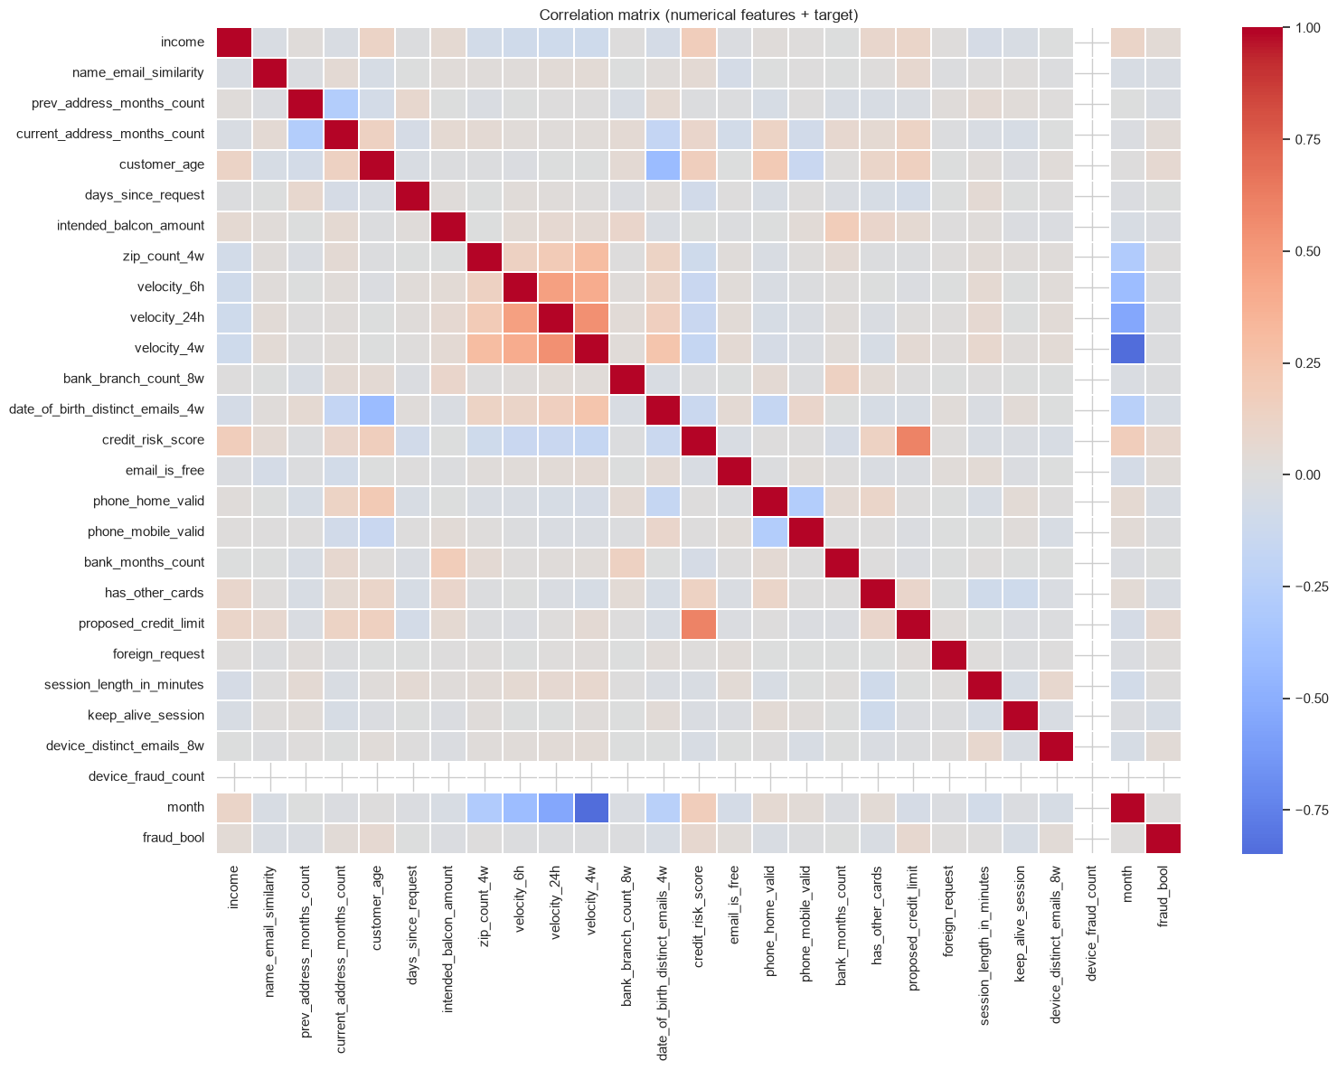
Fig. 2. Correlation matrix of numerical features and the target. Off-diagonal structure is generally weak; the clearest pattern is among the velocity_6h/24h/4w features and their negative correlation with month.
Feature-level distributions conditioned on the target (Fig. 3) show that several numerical variables shift moderately between fraud and legitimate applications: credit_risk_score and proposed_credit_limit skew higher for fraudulent applications, while name_email_similarity skews lower, consistent with the intuition that fraudulent applicants are less likely to have a name that matches their email address. None of these univariate shifts is large enough to separate the classes on its own, which is expected in a dataset engineered specifically to be realistically difficult, and it motivates the use of a non-linear model capable of combining many weak signals.
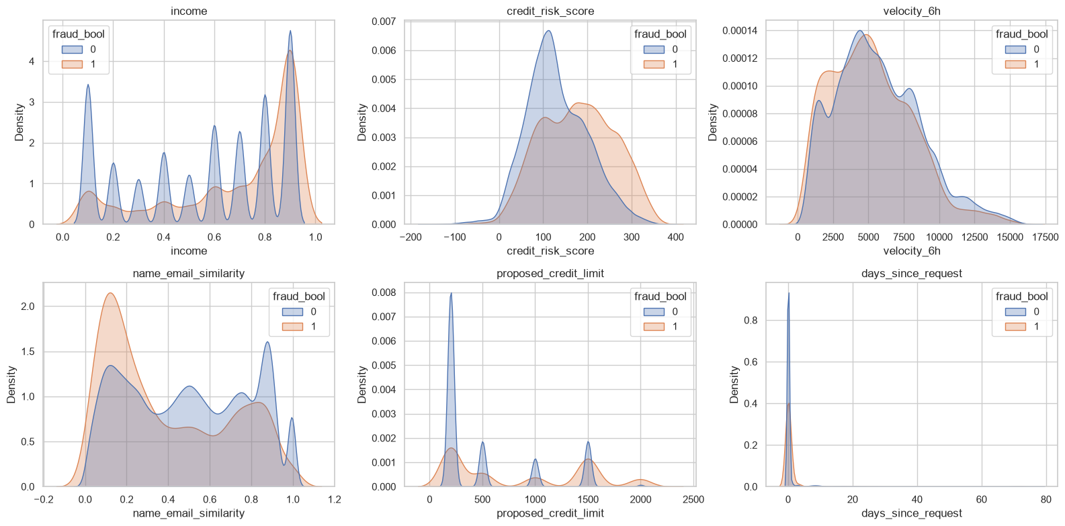
Fig. 3. Kernel density estimates of six representative numerical features, split by class (0 = legitimate, 1 = fraud). Distributional shifts are present but modest for any single variable, consistent with a dataset designed to resist simple univariate rules.
Finally, the EDA confirms the temporal dynamics reported in the original BAF paper [8]: both application volume and fraud prevalence drift across the eight months of data (Fig. 4). Application volume decreases gradually from month 0 to month 7, while fraud prevalence follows a U-shaped-then-rising pattern, dropping from around 1.13% in month 0 to a low of about 0.87% in month 2, then climbing steadily to approximately 1.47% by month 7. This confirms that a naive random train/test split would leak future distributional information into training and would materially overestimate deployment-like performance; Section III-D describes the temporal split adopted to avoid this.
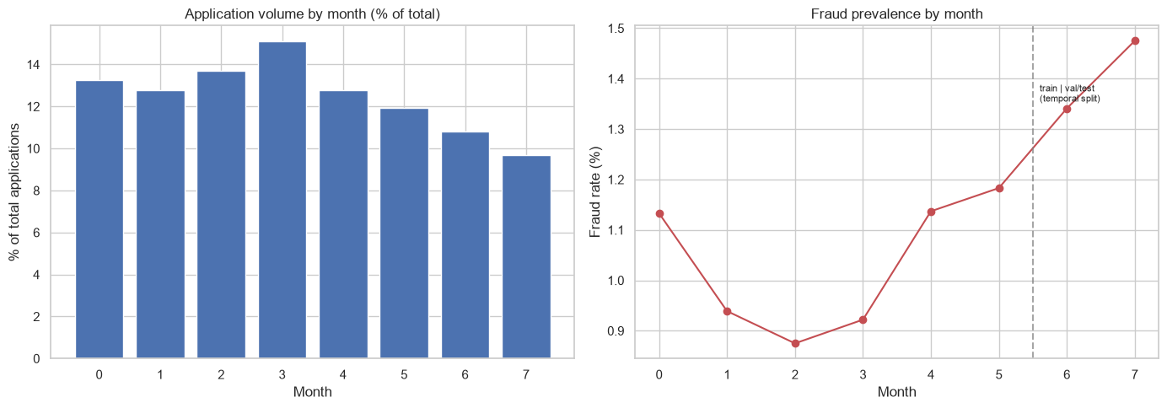
Fig. 4. Left: relative application volume by month. Right: fraud prevalence by month, with the training/validation-test boundary marked; prevalence is markedly higher in the months used for validation and testing than in the months used for training.
B. Preprocessing Pipeline
Based on the diagnosis above, prev_address_months_count, intended_balcon_amount and device_fraud_count are dropped prior to splitting or imputing, leaving 29 columns. The remaining sentinel-encoded columns are converted to genuine NaN values and imputed using column-appropriate rules: the median for numerical columns and the most frequent category for categorical columns, fitted exclusively on the training partition to avoid leakage from validation or test data into the imputation statistics. Five categorical variables are identified before encoding (payment_type, employment_status, housing_status, source and device_os) and are one-hot encoded; all remaining numerical variables are standardized (zero mean, unit variance) using statistics fitted on the training partition only. After preprocessing, the model input contains exactly 48 features, of which 27 original variables collapse into this final representation once the five categorical variables are expanded into their respective dummy columns (21 dummy columns in total across the five variables).
This one-hot representation is convenient for a neural classifier, but it creates a methodological complication for explainability that recurs throughout Section III and Section V: perturbing, masking, or averaging one dummy column independently of its siblings can construct a categorical state that has no real-world counterpart (for example, an application whose device_os is simultaneously “none of the above” for every available operating system). The final XAI protocol addresses this by explicitly tracking, for every one-hot dummy column, which single original variable it belongs to, and by performing perturbation, masking, and grouped-importance operations at the level of whole original variables (Section III-I).
C. Handling Class Imbalance
Two strategies for class imbalance were considered: SMOTE (Synthetic Minority Over-sampling Technique), applied only to the training partition, and class weighting, which instead penalizes minority-class errors more heavily inside the loss function without altering the training data. Only SMOTE was carried through to a trained model. Before resampling, the training partition contains 786,838 legitimate and 8,151 fraudulent applications, a ratio of about 1:96.5; after SMOTE, both classes contain 786,838 examples, a balanced 50/50 training set. Its beneficial effect is shown directly by the predictive results in Section V: the TabNet model trained on this balanced set reaches an AUC-ROC of 0.8500 on the untouched, realistically imbalanced test partition (fraud prevalence 1.47%), so exposing the network to a class-balanced training signal does not come at the cost of discrimination once the model is evaluated under real, deployment-like imbalance. Class weighting was explored analytically as an alternative: balanced class weights were computed directly from the training-set class frequencies (0.505 for the legitimate class and 48.77 for the fraudulent class, an implied penalty ratio on minority-class errors of about 1:96.5, matching the imbalance ratio itself), but training a second TabNet model under this configuration was not carried out in this thesis, chiefly for computational-budget reasons, since each training epoch took approximately three minutes and one full model had already been validated end-to-end for the explainability benchmark. Consequently, this thesis quantitatively reports and evaluates the beneficial effect of SMOTE, while class weighting remains a computed, ready-to-run alternative rather than an empirically compared one; a direct SMOTE-versus-class-weighting ablation, holding the rest of the pipeline fixed, is identified as a natural next step in future work (Section VI-B). Validation and test partitions are left untouched and retain their natural, realistic imbalance in both cases, so that all reported predictive metrics reflect deployment-like conditions rather than the artificially balanced training distribution.
A methodological consequence of this choice, discovered only during the explainability benchmark and documented in Section III-G, is that SMOTE-resampled data must never be used to construct reference distributions, backgrounds, or baselines for explanation methods: synthetic, interpolated minority-class points are not valid “neutral” reference applications, and using them silently degraded the first version of the SHAP background.
D. Temporal Splitting
The month column is used exclusively as the temporal split key and is excluded from the model's input features, precisely because of its correlation with velocity_4w (Section III-A) and because using it as a predictor would allow the model to learn spurious month-indexed shortcuts. Following the split strategy used in the original BAF paper, the first six months (0–5) are used for training, month 6 for validation, and month 7 for testing. Table II reports the resulting partition sizes and fraud rates, which increase monotonically from train to test, consistent with the rising fraud-prevalence trend documented in Fig. 4 and confirming that the test partition is, by construction, the most difficult and most realistic evaluation setting available in this dataset.
Partition | Months | Rows | Fraud rate
Train | 0 – 5 | 794,989 | 1.03%
Validation | 6 | 108,168 | 1.34%
Test | 7 | 96,843 | 1.47%
Table II. Temporal train/validation/test partitions. Fraud rate increases from train to test, reflecting the genuine temporal drift in the underlying data.
E. TabNet Architecture and Training Configuration
The model is a TabNet classifier [6] implemented with pytorch-tabnet [15] on top of PyTorch [12]. Table III reports the exact architecture and optimization configuration used for the reported model. The configuration follows commonly used starting values for TabNet on medium-sized tabular problems (five attentive decision steps with n_d = n_a = 16) rather than an exhaustive hyperparameter search, consistent with the thesis' stated scope of obtaining a reasonable, explainable model rather than a maximally optimized one.
Hyperparameter | Value
Decision steps (n_steps) | 5
Feature/attention width (n_d = n_a) | 16
Relaxation parameter (gamma) | 1.5
Sparsity regularization (lambda_sparse) | 0.001
Mask type | entmax
Optimizer | Adam (lr = 0.002)
LR scheduler | StepLR (step_size = 10, gamma = 0.9)
Batch size / virtual batch size | 1024 / 128
Max epochs / early-stopping patience | 100 / 15 (on validation AUC)
Class balancing | SMOTE-resampled training set (weights = 0)
Random seed | 42
Table III. TabNet architecture and training configuration used to produce the reported model.
Training uses TabNet's built-in .fit() procedure, which receives the SMOTE-balanced training set and the untouched, realistically imbalanced validation set directly, with AUC-ROC on the validation set as the early-stopping criterion. Early stopping halted training at epoch 27 out of a maximum of 100, consistent with a patience of 15 non-improving validation epochs. Training curves and the corresponding predictive evaluation are reported in Section V-A.
F. Explainability Benchmark Design
The final benchmark compares five explanation signals side by side: TabNet native attention, SHAP KernelExplainer, SHAP GradientExplainer, LIME, and Integrated Gradients. The first is an internal, architectural signal computed as a byproduct of a normal forward pass; the remaining four are genuine post-hoc explanation methods, each requiring its own reference distribution, sampling strategy, or baseline. The final summary tables deliberately separate TabNet attention from the post-hoc method ranking (Section V), because the fidelity results (Section V-E) show that attention should not be interpreted on equal footing with a faithful local explanation of individual predictions.
Two explanation subsets are used throughout, for different and complementary purposes. A balanced diagnostic subset of 200 observations (100 fraud, 100 legitimate, by construction) is used for qualitative visualizations, per-instance case studies, and most of the quantitative metrics; this guarantees that rare fraud cases, which would be underrepresented in a random sample of only 200 test rows, are adequately covered. A separate population subset of 1,000 observations, sampled from the real, imbalanced test distribution (with a fraud rate of approximately 1.3%, close to the deployment-like test rate of 1.47%), is used specifically to sanity-check that conclusions drawn on the balanced subset are not an artifact of the artificial 50/50 composition. This distinction is treated as a first-class methodological safeguard: global rankings computed only on the balanced subset are explicitly not presented as population-level conclusions without this cross-check.
G. Explanation Backgrounds, Baselines, and a Diagnosed Background Bug
SHAP KernelExplainer, SHAP GradientExplainer and Integrated Gradients all require a reference distribution: a background (for SHAP) or baseline (for Integrated Gradients) representing the absence of information, against which the marginal contribution of each feature is measured. Selecting this reference is not a minor implementation detail; it directly determines what “importance” means for the resulting attributions, and an invalid reference can silently invalidate every downstream number.
The first version of the exported SHAP background was constructed by running K-Means with 50 clusters directly on X_train_res, the SMOTE-resampled training set, and using the resulting cluster centroids as the background. A diagnostic check, printing the model's mean predicted P(fraud) on this background, revealed the problem: the mean predicted fraud probability on the background was exactly 1.0000, meaning the model predicted essentially certain fraud for every point meant to represent a neutral, uninformative reference. Since the real base fraud rate in the training data is only 1.03%, this is not a plausible neutral reference by a wide margin. The root cause was that averaging synthetic, GAN-free but SMOTE-interpolated minority-class points over a mixed standardized-numeric and one-hot feature space produces centroids that do not correspond to any real application; in effect, the background had drifted entirely into the synthetic minority-oversampling region of the input space.
This was corrected by rebuilding the background from the original, un-resampled training distribution, X_train_proc, and by additionally replacing raw K-Means centroids (which are themselves synthetic combinations of one-hot and standardized values) with the real training row nearest to each of the 50 centroids, a medoid-like background construction that guarantees every background point is an actual, valid application in the preprocessed feature space. After this correction, the medoid background's mean predicted P(fraud) fell to 0.2481: still somewhat elevated relative to the true base rate of 0.0103 (K-Means naturally favors denser regions of feature space, which are not perfectly representative of the marginal fraud rate), but no longer implausible, and a fallback to randomly sampled real training rows was implemented and would have triggered automatically had the medoid background still shown an implausible mean prediction. The corrected, real-row background is the one used for every reported SHAP and Integrated Gradients result in Section V; the same real-row philosophy is applied to Integrated Gradients baselines, which use multiple real training rows rather than an all-zero vector, for the reasons discussed in Section II-D.
This correction is reported here in detail because it exemplifies a general risk in applied XAI pipelines: a broken reference distribution can produce numbers that look plausible in isolation (a SHAP waterfall plot with a broken background still renders, and its bars still sum correctly to the model output) while being systematically misleading. Catching this kind of error requires an explicit sanity check: comparing the background's average predicted outcome to the known base rate, built into the pipeline as a first-class diagnostic step.
H. Calibration Methodology
TabNet, like most neural classifiers trained under class-imbalance correction (here, SMOTE), does not automatically produce a calibrated probability: the raw sigmoid output can systematically over- or under-estimate the true conditional fraud probability even when the model discriminates well between classes. Because SHAP and Integrated Gradients attributions are computed directly on this raw score unless the model is explicitly recalibrated, it is essential to establish whether that score can be interpreted as a real-world probability before reporting attribution values in those terms. Two standard calibration techniques are fitted on validation scores: Platt scaling (a monotonic logistic recalibration) and isotonic regression (a more flexible monotonic recalibration). Both are evaluated by comparing the mean predicted output to the true test-set fraud rate and by computing the Brier score, and both are additionally checked against a full calibration curve (predicted score vs. observed fraud rate, binned), since a model can have a reasonable mean prediction while still being poorly calibrated in specific score ranges. Crucially, calibration is used only as a diagnostic and reporting safeguard: the XAI benchmark itself continues to explain the original, uncalibrated TabNet score, and calibrated probabilities are reported separately in Section V-A specifically for risk-communication purposes, so that attribution values are never mislabeled as calibrated probability changes.
I. Quantitative Metrics: Definitions and Methodological Corrections
This subsection also gives the formal definition of every metric reported in Section V, so that reported numbers, including the explanation-quality metrics, can be reproduced exactly. AUC-ROC is the probability that a randomly drawn fraudulent case receives a higher score than a randomly drawn legitimate case, AUC-ROC = P(s(x+) > s(x−)) for independently sampled positive x+ and negative x− (Eq. 1). The Brier score is the mean squared error between predicted probability and outcome, Brier = (1/N)Σᵢ(pᵢ − yᵢ)², with yᵢ ∈ {0,1} the true label and pᵢ the predicted probability of fraud for instance i (Eq. 2). The Expected Calibration Error (ECE) partitions the predicted-probability range into B equal-width bins, and for each bin b compares its mean predicted probability conf(b) to its observed fraud rate acc(b), weighting by the bin's share of instances: ECE = Σᵇ₌₁ᴮ (nᵇ/N)·|acc(b) − conf(b)|, with B = 10 bins (Eq. 3), as reported for the three score variants in Table IV.
Fidelity (faithfulness correlation) is estimated per instance by repeatedly masking a random subset of features (replacing them with their standardized “neutral” value of zero) and testing whether the sum of the masked subset's attributions correlates, across many random masks, with the actual drop in predicted P(fraud) caused by that masking. A naive implementation of this test masks individual one-hot dummy columns independently, which (exactly as in Section III-B) can silently construct an impossible categorical state (e.g., every device_os_* dummy reading zero simultaneously), an input the model never encountered during training and on which its behavior is undefined. This corrupts the fidelity measurement in a way that is indistinguishable, at face value, from the explanation genuinely being unfaithful. The corrected, one-hot-aware protocol instead perturbs at the level of whole original variables: when a categorical variable is selected for masking, all of its one-hot dummies are replaced together, using the corresponding values from a real reference row, so that the resulting record always represents a valid, if hypothetical, application. Table VI (Section V-E) reports both the naive and the corrected fidelity for every method; the correction changes the ranking of no method but shifts every individual value, most notably TabNet native attention's fidelity, which falls from 0.0825 (naive) to 0.0369 (one-hot-aware) once the impossible perturbation states are removed, confirming that even the corrected, lower number for TabNet attention is not an artifact of invalid perturbations. Formally, for instance x with a random feature subset S masked at each of R repeats, fidelity is the correlation across repeats between the summed attribution mass Σj∈S φj(x) and the resulting output drop f(x) − f(x\S) (Eq. 4).
Robustness (max-sensitivity) is estimated by applying several small, independent Gaussian perturbations to an instance, recomputing the explanation after each perturbation, and recording the largest resulting change in the explanation vector, divided by the perturbation's magnitude. A raw implementation of this metric compares absolute explanation-vector distances across methods whose attributions live on entirely different numeric scales: TabNet's native explain_matrix aggregates attention across five decision steps and can exceed 1 in magnitude, while SHAP, LIME and Integrated Gradients attributions live in probability space and are typically an order of magnitude smaller. The raw metric, computed first, showed TabNet native attention with a mean max-sensitivity of approximately 77.4, roughly 15 to 300 times larger than every post-hoc method (which ranged from about 0.29 to 3.9), a gap large enough to warrant checking the metric itself before concluding that TabNet's attention is dramatically less robust. Table VII (Section V-F) reports both the raw and a scale-normalized (relative) version, obtained by dividing each sensitivity value by the norm of the corresponding explanation vector; under this correction, TabNet native attention's relative sensitivity falls to approximately 9.8, comparable to Integrated Gradients (10.6) and lower than SHAP Gradient (13.8), confirming that most of the raw gap was a scale artifact rather than a genuine 15-to-300-fold robustness difference. The relative version is the one used for every reported robustness ranking in Section V. Formally, raw max-sensitivity is R(x) = max‖δ‖≤ε ‖E(x+δ) − E(x)‖ / ‖δ‖ (Eq. 5), and the scale-normalized version used for ranking divides this by ‖E(x)‖, i.e. Rrel(x) = R(x) / ‖E(x)‖ (Eq. 6).
Stability is estimated, for each instance in a method's explained subset, by finding its nearest neighbor in the model's input feature space (Euclidean distance) and computing the cosine similarity between the two instances' explanation vectors; a higher cosine similarity indicates that structurally similar applications receive similar explanations. Because this metric reuses attribution matrices already computed for the fidelity and robustness experiments, it requires no additional model queries and is the least computationally expensive of the three axes. Formally, with NN(i) = argminj≠i ‖xi − xj‖ the nearest neighbor of instance i in input space, stability is Stab(xi) = cos(E(xi), E(xNN(i))) (Eq. 7), the cosine similarity between the two instances' explanation vectors.
Bootstrap confidence intervals are computed for every final fidelity, robustness and stability estimate, using 1,000 resamples with replacement over the evaluated instances and repeats, with the 2.5th and 97.5th percentiles of the resulting bootstrap distribution reported as a 95% confidence interval. This is treated as necessary: several methods, in particular SHAP KernelExplainer and LIME, are evaluated on smaller instance subsets than the gradient-based methods due to their substantially higher computational cost per instance, so point estimates alone could overstate the certainty of the resulting ranking.
Finally, grouped permutation importance is computed as an evaluation that is completely independent of any XAI attribution method, to check whether the categorical dominance pattern found by every explanation method (Section V-C) reflects genuine model behavior rather than a shared artifact of the explanation methods themselves. For each original variable, all of its corresponding one-hot dummy columns are shuffled together (preserving the joint structure within the group, unlike shuffling each dummy independently) across 10,000 randomly sampled test rows, and the resulting drop in test AUC-ROC is recorded. Because this procedure never touches any attribution method and depends only on the trained model and the held-out test labels, agreement between its ranking and the XAI-derived rankings is strong evidence that the model itself, not the explanation pipeline, relies on these variables. Formally, for original variable group g with one-hot columns permuted jointly by π, grouped permutation importance is ΔAUCg = AUC(f, D) − AUC(f, Dπ(g)) (Eq. 8), the drop in test AUC-ROC caused by that joint permutation.
IV. EXPERIMENTS
A. Experimental Environment
Both notebooks were executed in Python using pandas, NumPy, scikit-learn [13], PyTorch [12], pytorch-tabnet [15], SHAP [3], LIME [4], Captum [14], Matplotlib and Seaborn. The final XAI benchmark run used SHAP 0.52.0 and PyTorch 2.13.0+cpu. Reproducibility is controlled throughout with a fixed RANDOM_STATE of 42, applied consistently to NumPy, PyTorch, the train/validation/test split, SMOTE, K-Means, and every stochastic explanation or metric computation. The final benchmark was executed with QUICK_MODE=False, which selects the more thorough of two predefined configuration profiles built into the notebook: 100 instances explained with SHAP KernelExplainer and LIME (versus 30 in the fast/debug profile), 300 KernelExplainer perturbation samples and 2,000 LIME perturbation samples per instance (versus 100 and 500), 50 instances and 30 repeated runs for the fidelity metric (versus 20 and 15), and 100/25 instances with 10 repeats for the fast/slow robustness metric (versus 30/10 with 5 repeats). This dual-profile design allowed the full notebook to be validated end-to-end quickly during development before committing to the more computationally expensive, final thesis-grade run reported here.
B. Predictive Training Experiment
The TabNet classifier described in Table III is trained on the SMOTE-balanced training partition and monitored on the untouched, realistically imbalanced validation partition, using validation AUC-ROC as the early-stopping criterion with a patience of 15 epochs. Fig. 5 shows the resulting training dynamics. The training loss decreases smoothly and monotonically throughout optimization, while validation AUC is considerably noisier from epoch to epoch than training AUC, an expected consequence of monitoring a rare-event metric (fraud prevalence of only 1.34% in the validation month) on a comparatively small validation partition. Early stopping halted training at epoch 27, close to the point where validation AUC last reached its highest observed values (around epochs 9 and 15), before the metric began to drift downward again in later epochs; this behavior is consistent with a model that has learned genuine signal early and is at risk of overfitting to training-set idiosyncrasies if allowed to continue without regularization from early stopping.
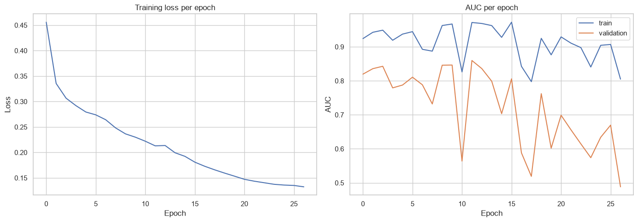
Fig. 5. Left: training loss per epoch. Right: training vs. validation AUC-ROC per epoch; validation AUC is noticeably noisier due to the low fraud prevalence in the validation month, but consistently remains in the 0.73–0.86 range from around epoch 8 onward.
C. Calibration Experiment
The calibration experiment compares the original TabNet score against Platt-scaled and isotonic-regression-calibrated probabilities, all fitted on validation scores and evaluated on the test partition. The goal is not to replace the original model for the XAI benchmark, but to quantify whether the original scores can be safely interpreted as real-world probabilities when reported to a risk or compliance stakeholder. Table IV and Fig. 6 report the results: the original TabNet score has a mean value of 0.1410 on the test set, nearly ten times higher than the true test fraud rate of 0.0147, while both calibration methods bring the mean predicted probability down to approximately 0.011–0.012, much closer to the true rate, and reduce the Brier score by roughly a factor of five (from 0.0667 to about 0.0136), all while preserving the model's discrimination (AUC-ROC changes by less than 0.002). The Expected Calibration Error (ECE, defined formally in Section III-I) tells the same story with a sharper contrast: it falls from 0.1263 for the original score to 0.0032 (Platt) and 0.0036 (isotonic), a roughly 35-fold reduction, confirming that the raw sigmoid output is not only offset in its mean but systematically miscalibrated bin by bin. The reliability diagram (Fig. 6, left) confirms this pattern in more detail: the original model ranks fraud cases well, in the sense that higher scores do correspond to higher observed fraud rates, but the model substantially overestimates the absolute probability of fraud across essentially the entire score range, while the Platt- and isotonic-calibrated curves track the diagonal closely across all deciles, consistent with training on an artificially balanced (50/50) SMOTE-resampled set while being evaluated against the true, highly imbalanced base rate. This motivates the explicit reporting rule adopted throughout Section V: attribution values are reported as contributions to the model's original fraud-class score, not as calibrated real-world probability changes, unless an explanation is explicitly recomputed on a calibrated wrapper.
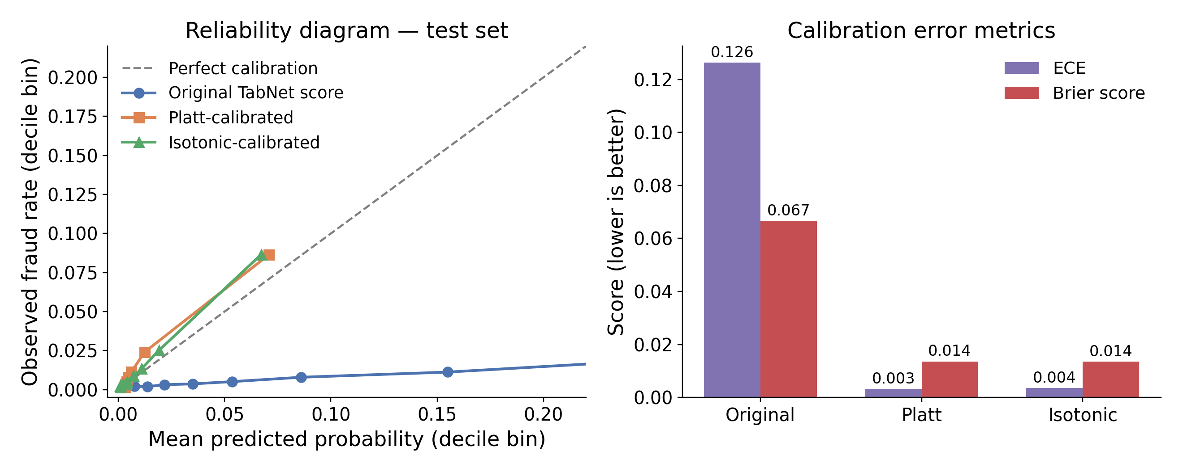
Fig. 6. Left: reliability diagram on the test set (deciles by quantile, for readability), comparing the original TabNet score against the Platt- and isotonic-calibrated probabilities; the original score ranks cases correctly but sits well below the diagonal, consistently overestimating absolute fraud probability, while both calibrated variants track perfect calibration (dashed diagonal) closely across the score range. Right: ECE and Brier score for the original score versus the two calibrated variants, both reduced by more than an order of magnitude after calibration.

Output | Mean score / probability | True fraud rate | AUC-ROC | Brier score | ECE
Original TabNet score | 0.1410 | 0.0147 | 0.8500 | 0.0667 | 0.1263
Platt-calibrated probability | 0.0115 | 0.0147 | 0.8500 | 0.0136 | 0.0032
Isotonic-calibrated probability | 0.0113 | 0.0147 | 0.8484 | 0.0135 | 0.0036
Table IV. Calibration comparison on the test set. Both calibration methods align the mean predicted probability with the true fraud rate, substantially reduce the Brier score, and cut the Expected Calibration Error (ECE, 10 equal-width bins; see Eq. 3 in Section III-I) by roughly a factor of 35, all while preserving discrimination (AUC-ROC).
D. Explanation Generation Experiment
SHAP KernelExplainer and SHAP GradientExplainer, LIME, and Integrated Gradients are each applied to the 200-instance balanced diagnostic subset, using the corrected real-row background described in Section III-G. LIME uses the real, non-SMOTE-resampled processed training distribution as its own internal reference data, consistent with the same real-row philosophy applied to SHAP and Integrated Gradients. In addition to the standard probability-target attributions, SHAP KernelExplainer and Integrated Gradients are separately recomputed with the raw, pre-sigmoid fraud logit as the explained target, specifically to check whether the global feature ranking is an artifact of the bounded, saturating probability scale rather than of the model's underlying decision function. The resulting probability-vs-logit ranking agreement is high for both methods: SHAP KernelExplainer obtains a Spearman rank correlation of 0.823 between its probability-target and logit-target global rankings, and Integrated Gradients obtains 0.924. These results support the robustness of the main feature-ranking conclusions reported in Section V-C to the choice of output scale, while also indicating that the exact ordering of the top few features can shift slightly depending on that choice.
E. Metric Computation Experiment
Fidelity, robustness and stability are computed on aligned, method-specific subsets so that no method is compared against another on a different set of explained instances than it was actually evaluated on. As described in Section III-I, the preferred fidelity metric is one-hot-aware, replacing all one-hot dummy columns of a selected original variable together, using values sampled from a real reference row; this is computed over 50 instances and 30 repeated random masking runs per instance under the final QUICK_MODE=False configuration. Robustness is computed as both a raw and a scale-normalized relative max-sensitivity under small Gaussian perturbations (epsilon = 0.05), using 100 instances with 10 repeats for the fast, gradient-based and native methods, and 25 instances with 10 repeats for the computationally expensive KernelExplainer and LIME. Stability is computed as nearest-neighbor explanation cosine similarity, reusing the attribution matrices already produced for the fidelity and robustness experiments. Bootstrap confidence intervals (1,000 resamples, 95% percentile interval) are computed for every final metric, and grouped permutation importance is computed independently on 10,000 randomly sampled test rows, exactly as specified in Section III-I.
V. RESULTS
A. Predictive Performance
The trained TabNet classifier reaches a test AUC-ROC of 0.8500 (Table V), a reasonable level of discrimination for a tabular fraud-detection benchmark under severe class imbalance and genuine temporal distribution shift, and broadly in line with the range of results reported by fairness-blind LightGBM baselines in the original BAF paper [8]. At the default 0.5 decision threshold, the model recalls 56.37% of fraud cases at a false positive rate of 8.33%, with a precision of 9.20% and an F1-score of 0.1582; the low precision is an expected and largely unavoidable consequence of the extreme rarity of fraud (1.47% prevalence in the test set) rather than a modeling failure, since even a highly discriminative model will generate many false positives in absolute terms when the positive class is this rare at any operating threshold near the default. The confusion matrix (Fig. 7, left) shows that of 1,428 true fraud cases in the test set, 805 are correctly flagged and 623 are missed, while of 95,415 legitimate applications, 87,469 are correctly cleared and 7,946 are incorrectly flagged; the row-normalized view shows a 56.4%/43.6% split between correctly and incorrectly classified fraud cases, underscoring that threshold selection in a deployed system would need to be tuned explicitly against the bank's specific cost trade-off between missed fraud and customer friction. The ROC curve (Fig. 7, right) confirms consistent discrimination across the full range of operating points, with no evidence of a degenerate or threshold-specific artifact.
Metric | Value
AUC-ROC | 0.8500
Recall (TPR) | 0.5637
False Positive Rate | 0.0833
Precision | 0.0920
F1-score | 0.1582
Table V. Predictive performance of the trained TabNet classifier on the test set (month 7), at the default 0.5 decision threshold.
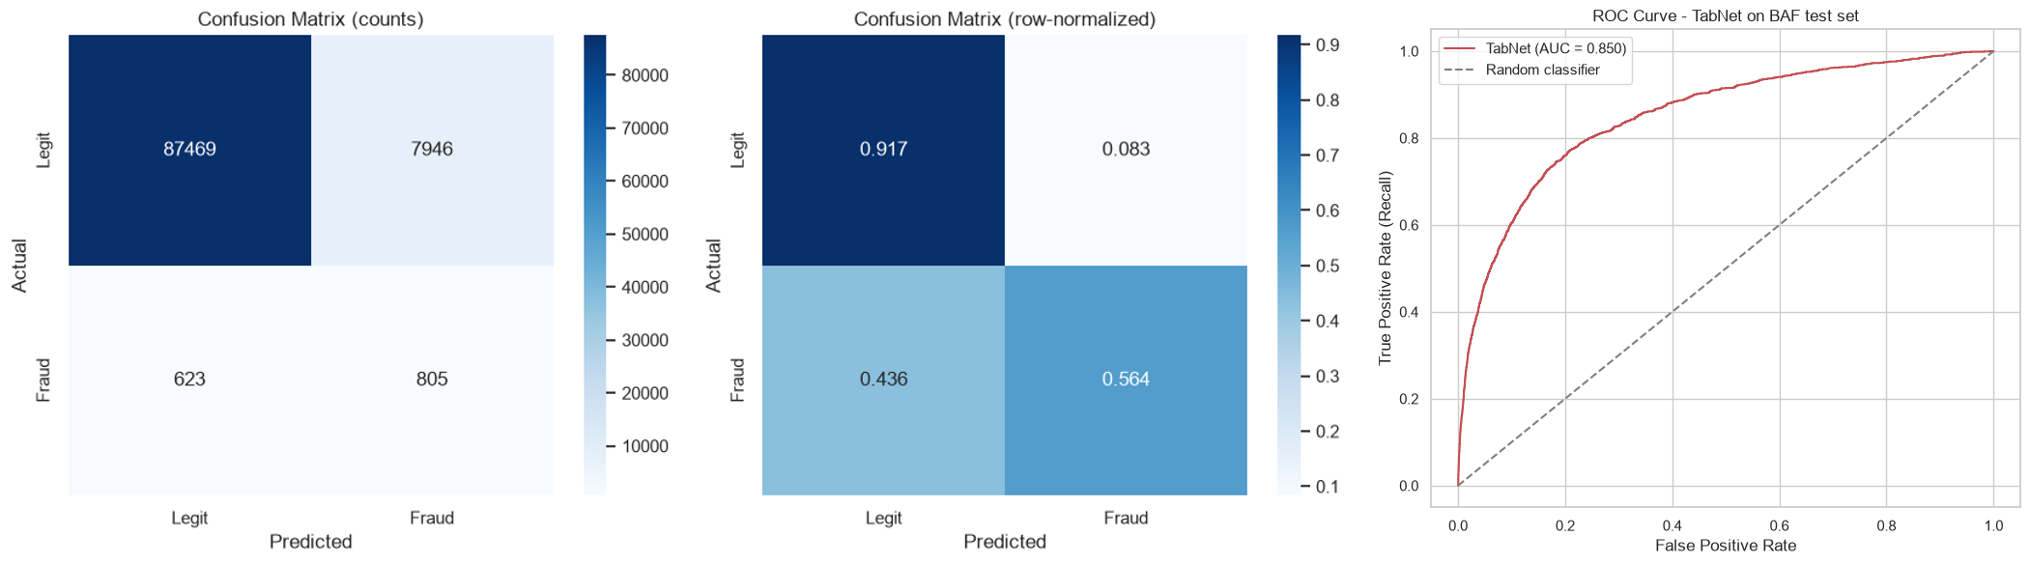
Fig. 7. Left: confusion matrix (counts and row-normalized) on the test set. Right: ROC curve, AUC = 0.850. The dashed diagonal represents a random classifier.
This model is treated throughout the remainder of this thesis not as a candidate for production deployment, but as a sufficiently expressive and sufficiently realistic black box on which to conduct a meaningful explainability benchmark; the following sections study how well different explanation methods characterize the decision function this model has actually learned.
B. TabNet Native Attention: Global Patterns
TabNet's native, attention-based global feature importance (Fig. 8) is dominated by categorical, profile-like variables rather than by numeric behavioral signals: device_os_windows is the single most important feature, followed by two employment_status categories, two housing_status categories, and a second device_os category. Only from around the seventh-ranked feature onward does a numeric variable, current_address_months_count, appear. Fig. 9 decomposes this aggregated signal by TabNet's five internal decision steps, revealing that the model does not spread its attention evenly: each step specializes strongly in a small number of features (e.g., step 1 concentrates almost exclusively on employment_status_CA and current_address_months_count; step 4 concentrates on device_os_windows and housing_status_BA), a pattern consistent with TabNet's design intent of sequential, sparse feature selection across steps rather than a single global weighting.
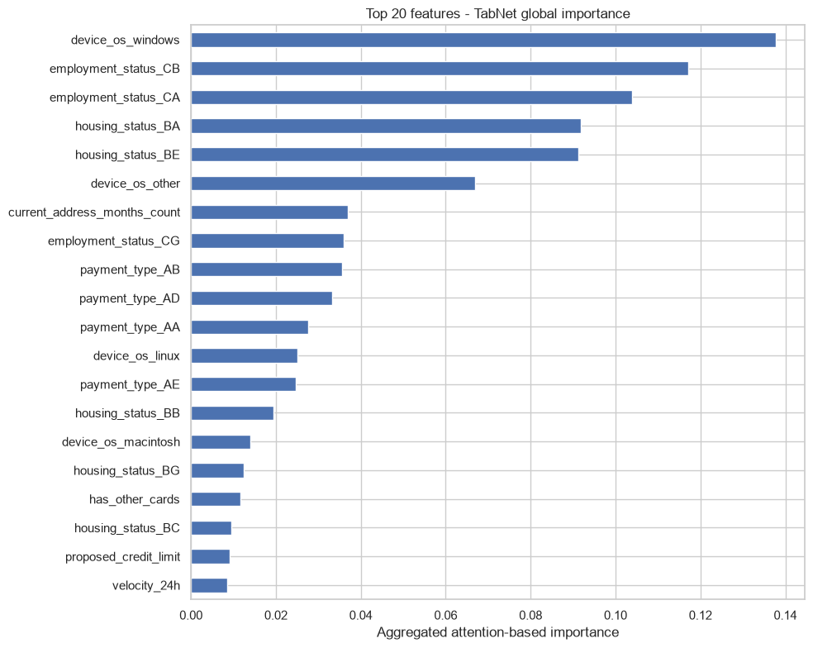
Fig. 8. TabNet native global feature importance (aggregated attention across all decision steps), top 20 features. Categorical variables (device_os, employment_status, housing_status, payment_type) dominate the ranking.
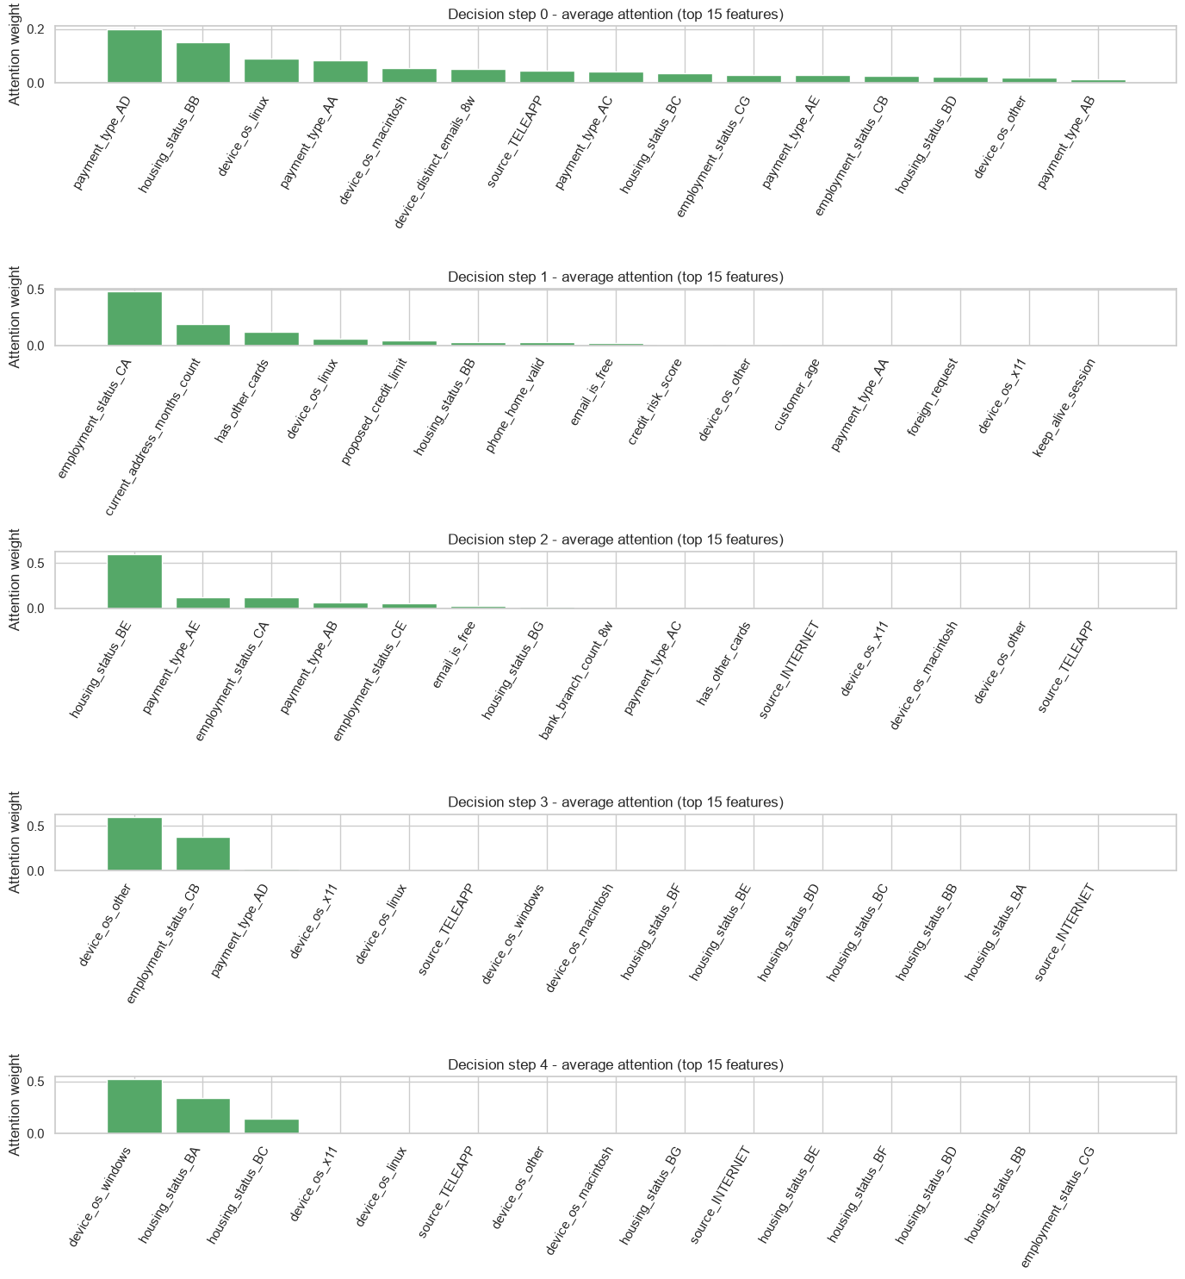

Fig. 9. Average attention weight by TabNet decision step (top 12 features per step). Each step specializes in a small, largely distinct subset of categorical features, consistent with TabNet's sequential sparse feature-selection design.
C. Global Post-Hoc Explanation Patterns
The four post-hoc methods largely corroborate TabNet's own native signal at the level of which original variables matter most, while disagreeing more on exact ranking and on the numeric feature current_address_months_count. SHAP KernelExplainer's beeswarm plot (Fig. 10) shows that device_os_windows = 1 (pink, high) pushes the prediction strongly toward fraud while device_os_windows = 0 pushes it toward legitimate, and the same directional pattern holds for housing_status_BA; interestingly, current_address_months_count shows a more complex, non-monotonic relationship with SHAP value, with both very low and very high values of the feature associated with elevated SHAP values in some instances, suggesting a non-linear or interaction-driven effect that a purely linear correlation would miss. SHAP GradientExplainer's beeswarm (Fig. 11) broadly agrees on the same top variables but ranks device_os_other more highly and de-emphasizes phone_home_valid and email_is_free relative to KernelExplainer, illustrating that even two variants of the same underlying Shapley-value framework can diverge once their respective approximation strategies (perturbation sampling vs. gradient-based estimation) are taken into account.
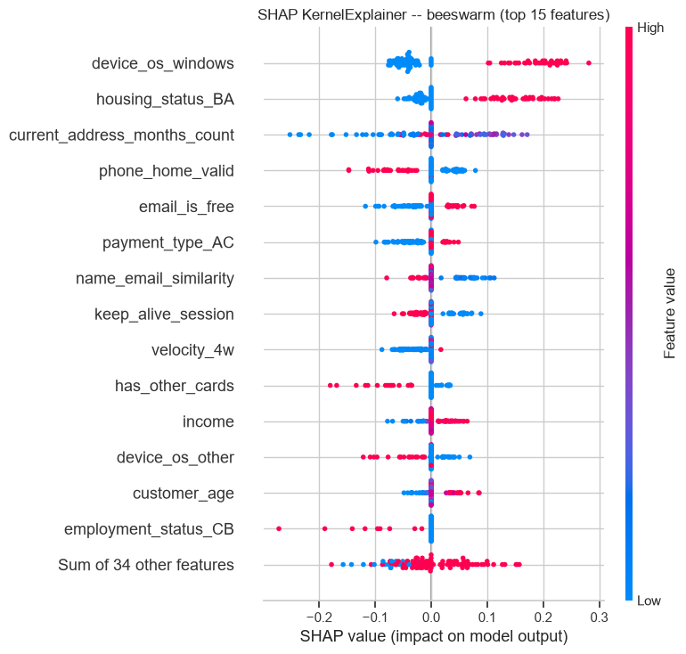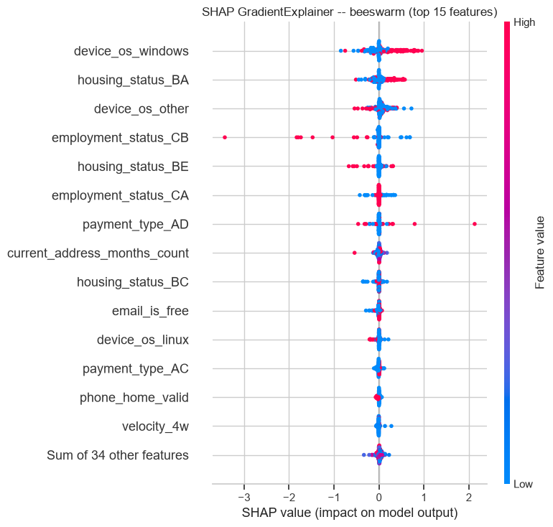
Fig. 10. Left: SHAP KernelExplainer beeswarm plot, top 15 features. Color encodes the feature's own value (pink = high, blue = low); horizontal position encodes the SHAP value (impact on model output). Right: SHAP GradientExplainer beeswarm plot, top 15 features. The overall categorical dominance pattern agrees with KernelExplainer, but the relative ranking of individual features differs.
LIME's global importance (Fig. 12, obtained by averaging the absolute local surrogate weights across the 200-instance subset) ranks housing_status_BA and device_os_windows even more dominantly than either SHAP variant, with a steep drop-off after the top two features; this concentration is consistent with LIME's high stability (Section V-E) but is also a symptom of a locally linear surrogate model collapsing a more complex, non-linear relationship onto a small number of dominant linear terms. Integrated Gradients (Fig. 13) shows a consistent top-3 (device_os_windows, housing_status_BA, device_os_other) across both output scales, with employment_status_CB/CA swapping order and current_address_months_count entering the top 10 mainly under the logit target, confirming the Spearman correlation of 0.924 reported in Section IV-D.
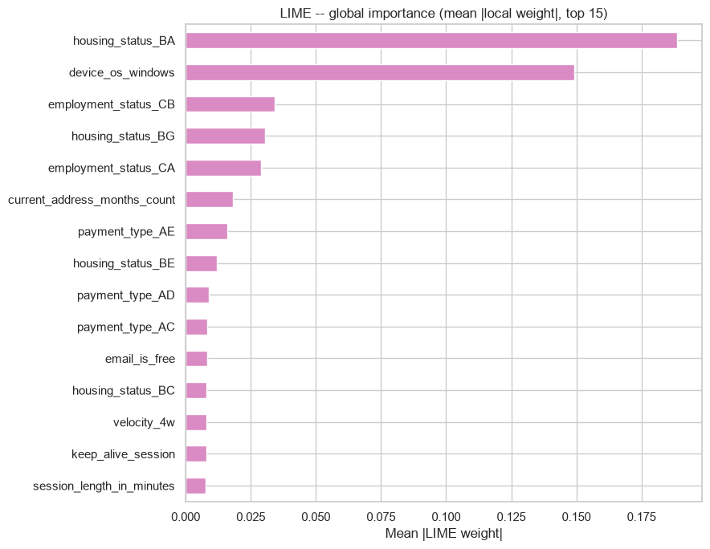
Fig. 12. LIME global feature importance (mean absolute local surrogate weight across the 200-instance subset), top 15 features.
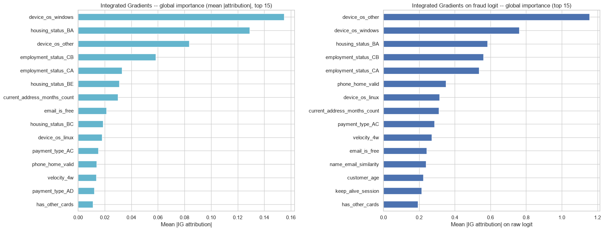
Fig. 13. Integrated Gradients global feature importance, top 15 features, computed on the probability target (left) and on the raw fraud logit (right). The top-ranked features are highly consistent across both output scales.
A cross-method agreement analysis (Fig. 14) quantifies these observations using Spearman rank correlation between every pair of the five global rankings. SHAP Gradient and Integrated Gradients show the highest pairwise agreement (0.98), unsurprising since both are gradient-based methods on the same differentiable model; SHAP Kernel agrees reasonably well with both (0.79–0.80); LIME is the clear outlier, agreeing only weakly with every other method (0.33–0.49); and TabNet native attention agrees only weakly with SHAP Kernel (0.26), the post-hoc method it is compared against most directly in Section V-E. This pattern (gradient-based methods clustering together, LIME and native attention each standing apart) recurs throughout the benchmark and is not merely a visual impression from the beeswarm plots.
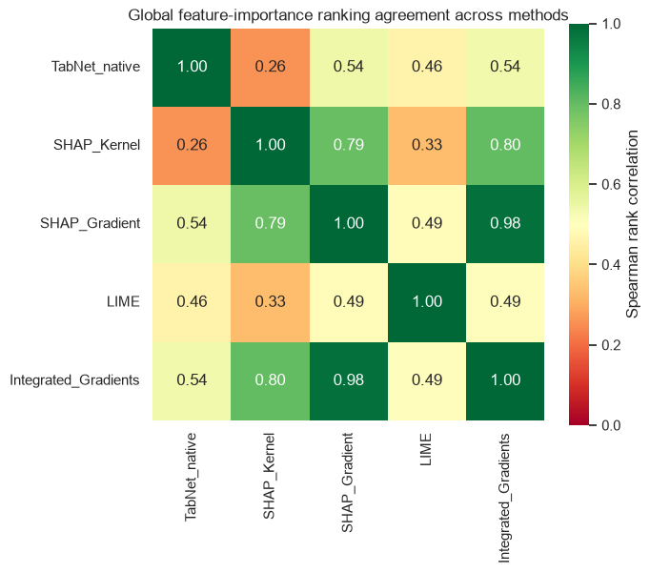
Fig. 14. Spearman rank correlation between the global feature-importance rankings of all five explanation sources. Gradient-based methods (SHAP Gradient, Integrated Gradients) agree most strongly with each other; LIME and TabNet native attention each diverge from the rest.
Finally, to control for the possibility that the categorical-dominance finding is merely an artifact of one-hot encoding granularity: categorical variables occupy more processed columns than single numeric variables, which could mechanically inflate their apparent importance: every method's importance is re-aggregated back to the level of original variables (summing or averaging across each variable's one-hot dummies) and re-normalized to each method's own maximum (Fig. 15). The categorical dominance survives this fairer, variable-level comparison: device_os, housing_status, employment_status and payment_type occupy the top four to five ranks for all five sources, including TabNet's own native attention, computed completely independently of any post-hoc method. Numeric behavioral features such as current_address_months_count, phone_home_valid and email_is_free only begin to appear from around rank five to nine onward. Because this pattern survives the fairer, variable-level aggregation and is independently corroborated by the model's own native attention mechanism, it is treated in this thesis as a genuine finding about model behavior, not a measurement artifact, a conclusion further reinforced, independently of any XAI method, by the grouped permutation-importance experiment in Section V-J.
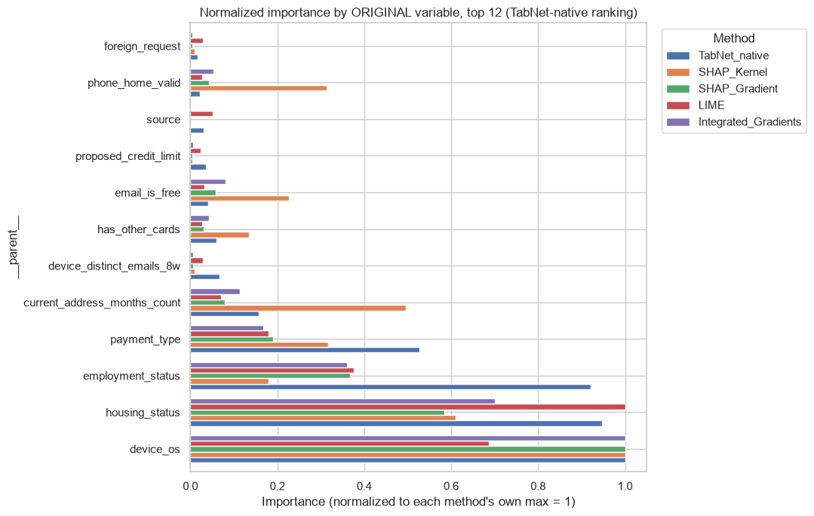
Fig. 15. Global feature importance re-aggregated to the level of original variables and normalized to each method's own maximum, ordered by TabNet's native ranking. Categorical variables (device_os, housing_status, employment_status, payment_type) dominate across all five sources.
D. Local Explanation Case Study
To illustrate how these global patterns manifest for a single decision, a specific true-fraud instance from the balanced subset (instance #0) is explained by all five methods and compared directly. SHAP KernelExplainer's waterfall chart (Fig. 16, top) decomposes this instance's prediction (f(x) = 0.817, against a background expectation of 0.248) feature by feature: device_os_windows = 1 contributes +0.24, housing_status_BA = 1 contributes +0.17, while phone_home_valid contributes −0.15, the single largest protective contribution for this instance. The corresponding force plot (Fig. 16, bottom) presents the same decomposition as a single push-pull visualization, which is a more compact format better suited to a one-line case summary for an analyst reviewing many applications in sequence.
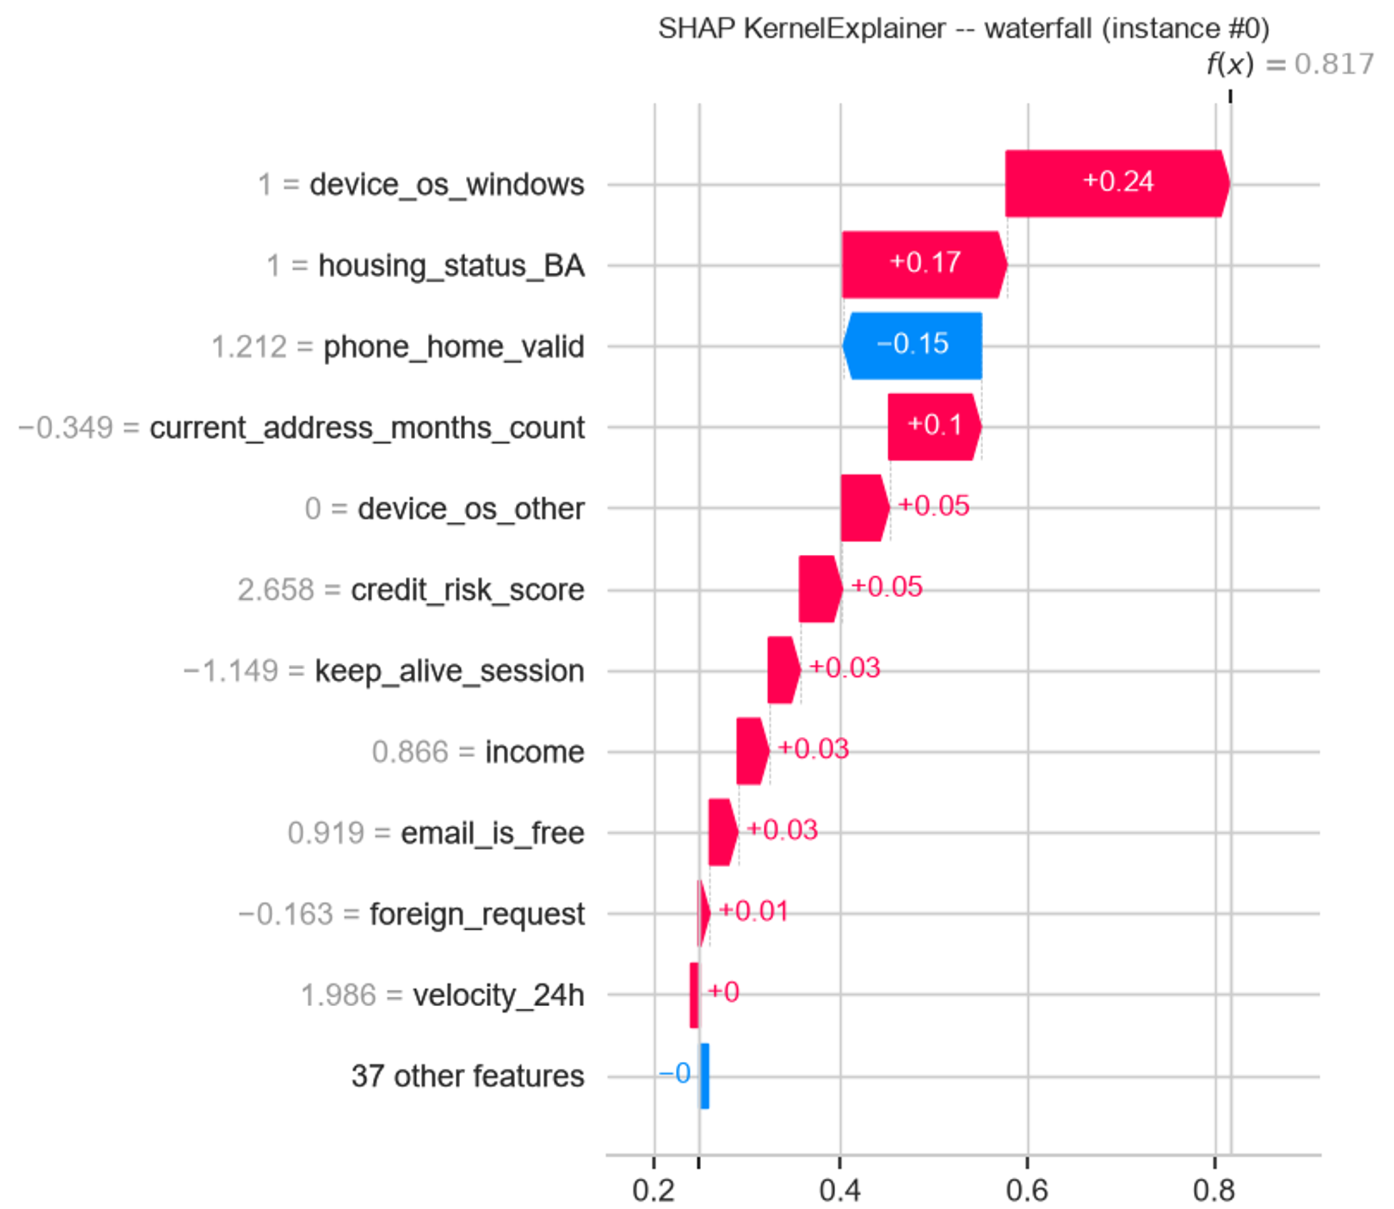
Fig. 16. SHAP KernelExplainer local explanation for a true-fraud test instance. Waterfall chart showing the ordered, additive feature contributions from the background expectation E[f(X)] = 0.248 to the final prediction f(x) = 0.817.
Fig. 17 places all five methods side by side for this same instance. All methods agree that device_os_windows and housing_status_BA are the two dominant drivers of this particular fraud prediction, but they disagree substantially on the remainder of the ranking and, in two cases, on direction: SHAP GradientExplainer ranks housing_status_BC above device_os_windows for this instance (a ranking not seen in any other method), and LIME assigns employment_status_CA a small negative (protective) contribution where SHAP KernelExplainer and Integrated Gradients assign the same variable a small positive one. A dedicated per-instance agreement matrix (not shown as a separate figure, computed as a Spearman correlation over absolute attribution ranks for this instance) confirms the global pattern from Fig. 14 at the local level: SHAP Gradient and Integrated Gradients again agree most strongly (0.70), while LIME is again the most divergent method, including a small negative correlation with Integrated Gradients (−0.06) for this specific instance, a reminder that even methods with reasonable global agreement can disagree sharply on any single case, which is precisely why case-level, not only aggregate, explanation quality matters for individual-decision audit under GDPR Article 22.
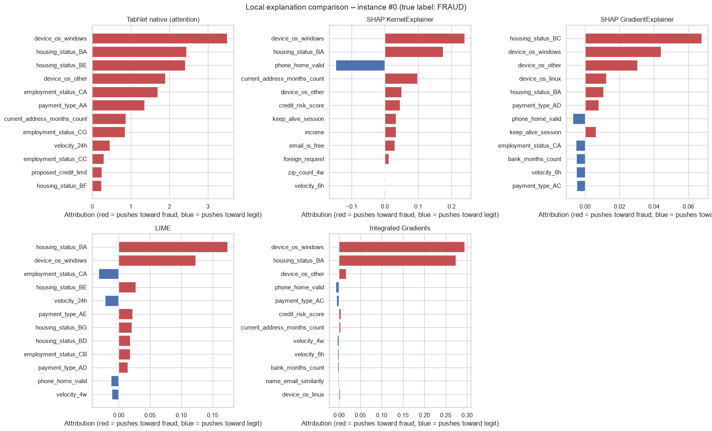
Fig. 17. Local explanation comparison across all five sources for the same true-fraud test instance. Red bars push the prediction toward fraud; blue bars push toward legitimate. The two dominant features (device_os_windows, housing_status_BA) are consistent across methods, but the remaining ranking and even the sign of some contributions differ.
E. Fidelity: From Naive to Corrected Estimates
As described in Section III-I, fidelity is first computed naively, perturbing individual one-hot dummy columns independently, and then recomputed using the one-hot-aware protocol that perturbs whole original variables together. Table VI reports both versions side by side for all five explanation sources. The correction changes every individual value, in most cases increasing the estimated fidelity (SHAP Kernel: 0.5098 → 0.5392; SHAP Gradient: 0.2021 → 0.2888; LIME: 0.1022 → 0.1557; Integrated Gradients: 0.3513 → 0.3955), consistent with the naive protocol's impossible perturbation states adding noise that depressed the naive scores. The one exception is TabNet native attention, whose fidelity decreases under the correction (0.0825 → 0.0369); because this is a decrease it cannot be explained by the correction simply removing invalid-state noise in TabNet's favor, and is treated as further evidence that the corrected, lower fidelity genuinely reflects TabNet attention's weak relationship to actual output change.
Method | Naive (per-dummy) fidelity | One-hot-aware (per-variable) fidelity
TabNet native attention | 0.0825 | 0.0369
SHAP KernelExplainer | 0.5098 | 0.5392
SHAP GradientExplainer | 0.2021 | 0.2888
LIME | 0.1022 | 0.1557
Integrated Gradients | 0.3513 | 0.3955
Table VI. Fidelity (mean Pearson correlation between summed attributions and the resulting output drop), naive per-dummy perturbation vs. the corrected one-hot-aware protocol. The one-hot-aware column is used for every downstream ranking and conclusion.
Under the corrected protocol, SHAP KernelExplainer achieves the highest fidelity among post-hoc methods (0.5392), followed by Integrated Gradients (0.3955), SHAP GradientExplainer (0.2888), and LIME (0.1557), the same relative ordering seen in the naive results, indicating that the correction refines the estimates without overturning the overall ranking. The logit-target results, computed with the same one-hot-aware protocol, reinforce this ordering: SHAP Kernel Logit reaches 0.5565 and Integrated Gradients Logit reaches 0.4514, both very close to their probability-target counterparts, again consistent with the high Spearman ranking agreement reported in Section IV-D.
F. Robustness: From Raw to Scale-Normalized Estimates
Table VII reports the same before/after pattern for robustness. The raw max-sensitivity metric places TabNet native attention as dramatically less robust than every other method (77.38 vs. 0.29–3.88), a gap large enough, as discussed in Section III-I, to warrant checking the metric's scale-dependence before drawing conclusions. Once each method's sensitivity is normalized by the norm of its own explanation vector, TabNet native attention's relative sensitivity falls to 9.81, placing it in the same broad range as Integrated Gradients (10.58) and below SHAP Gradient (13.81); LIME remains, by a wide margin, the most robust method under either version of the metric (0.29 raw / 1.15 relative), a direct consequence of its surrogate-fitting procedure smoothing over small input perturbations.

Method | Raw max-sensitivity | Relative (scale-normalized) max-sensitivity
TabNet native attention | 77.38 | 9.81
SHAP GradientExplainer | 3.88 | 13.81
Integrated Gradients | 2.54 | 10.58
SHAP KernelExplainer | 2.02 | 13.00
LIME | 0.29 | 1.15
Table VII. Robustness (max-sensitivity under small Gaussian input perturbations), raw vs. scale-normalized relative version. The relative version is used for every downstream ranking, since attribution magnitudes differ by an order of magnitude or more across methods.
G. Final Post-Hoc Explanation Benchmark
Table VIII consolidates the corrected fidelity and robustness metrics together with stability into a single benchmark of the four post-hoc methods, deliberately reported separately from TabNet native attention (Section V-I) since the two are not directly comparable on equal footing. SHAP KernelExplainer is the most faithful method (0.5392) but only moderately robust (relative sensitivity 13.00) and the least stable of the four (0.3414). Integrated Gradients offers the best balance among the three axes: second-highest fidelity (0.3955), mid-range robustness (10.58), and mid-range stability (0.2631). LIME is, by a wide margin, both the most robust (1.15) and the most stable (0.9480) method, but this comes at the cost of being the least faithful (0.1557). SHAP GradientExplainer is dominated on two of the three axes (lowest fidelity among the SHAP/IG group at 0.2888, and the worst raw and relative robustness), making it the least compelling of the four post-hoc methods on this particular model and dataset, despite its computational cheapness.
Method | Fidelity | Relative robustness | Stability
SHAP KernelExplainer | 0.5392 | 13.00 | 0.3414
SHAP GradientExplainer | 0.2888 | 13.81 | 0.1657
LIME | 0.1557 | 1.15 | 0.9480
Integrated Gradients | 0.3955 | 10.58 | 0.2631
Table VIII. Final post-hoc explanation benchmark: one-hot-aware fidelity, relative (scale-normalized) robustness, and stability, for the four post-hoc methods (TabNet native attention reported separately in Table X).
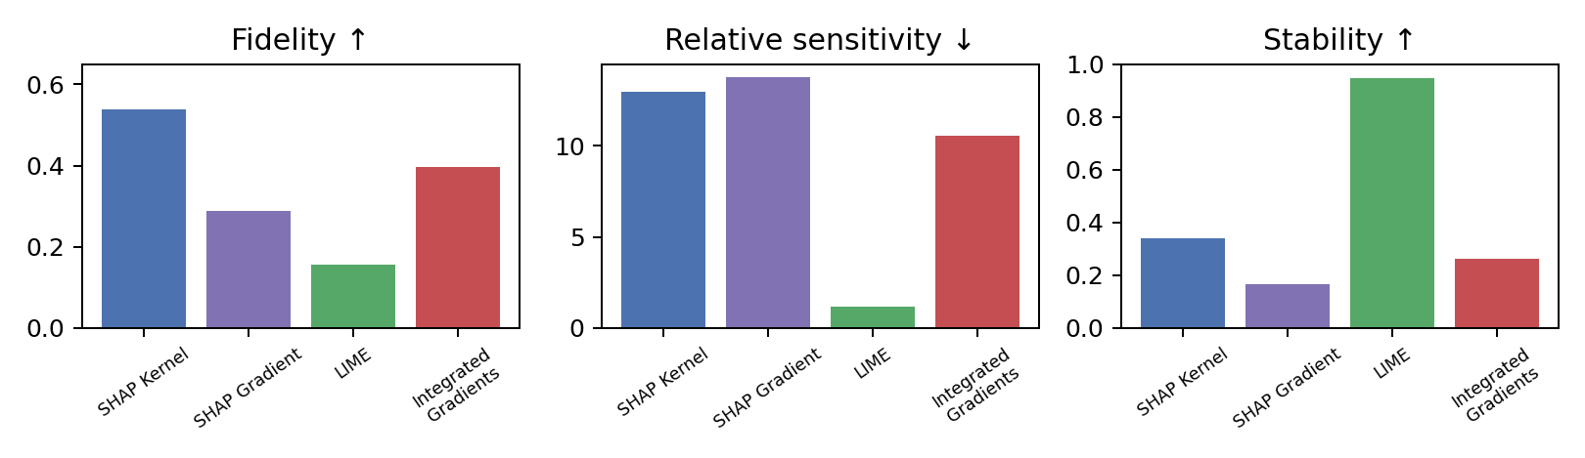
Fig. 18. Final post-hoc explanation benchmark across the three quality axes. Higher fidelity and stability are better; lower relative sensitivity is better.

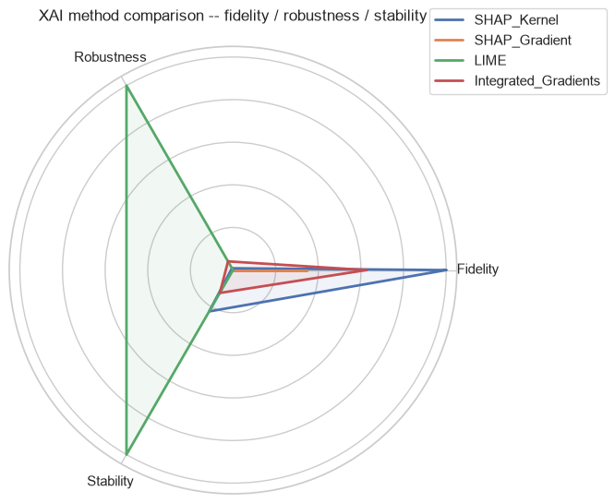
Fig. 19. Radar-chart summary of the same three axes. SHAP Kernel dominates on fidelity; LIME dominates on robustness and stability; Integrated Gradients occupies a balanced middle ground.
This fidelity/stability trade-off (SHAP Kernel and Integrated Gradients highest on fidelity but not on stability; LIME the reverse) is recognized tension in the XAI literature: smoother, locally-linear surrogate methods such as LIME average out local noise in the model's decision surface, which improves consistency across similar inputs but can wash out genuine local non-linearities, hurting fidelity; gradient-based and Shapley-value methods are more faithful to the model's exact local behavior, but that behavior can itself be locally noisy in a deep, non-linear model, which in turn hurts robustness and stability. This trade-off translates into a concrete, use-case-dependent recommendation, developed further in Section V-M: Integrated Gradients or SHAP KernelExplainer for a single, high-stakes case review where identifying the true underlying driver matters most; LIME where consistent, predictable explanations across similar applications matter more, such as batch reporting or dashboarding for a non-technical audience.
H. Bootstrap Confidence Intervals
Table IX reports 95% bootstrap confidence intervals (1,000 resamples) for the fidelity metrics discussed above. None of the reported intervals for the four post-hoc methods overlaps zero, and the intervals for SHAP KernelExplainer and Integrated Gradients (the two highest-fidelity methods) do not overlap each other, supporting the conclusion that the fidelity ranking is not an artifact of sampling noise over the evaluated instances. LIME's interval is the widest relative to its point estimate, consistent with it also being the method with the lowest absolute fidelity and therefore the most sensitive, in relative terms, to which specific instances happened to be sampled.
Metric | Method | Mean | 95% CI low | 95% CI high
Fidelity | SHAP Kernel | 0.5392 | 0.4873 | 0.5850
Fidelity | Integrated Gradients | 0.3955 | 0.3125 | 0.4745
Fidelity | SHAP Gradient | 0.2888 | 0.1975 | 0.3733
Fidelity | LIME | 0.1557 | 0.0659 | 0.2451
Logit fidelity | SHAP Kernel Logit | 0.5565 | 0.5055 | 0.6056
Logit fidelity | IG Logit | 0.4514 | 0.3703 | 0.5230
Table IX. Bootstrap 95% confidence intervals (1,000 resamples) for fidelity and logit-target fidelity. No interval overlaps zero.
I. Native TabNet Attention, Reported Separately
Table X reports TabNet native attention's own fidelity, robustness and stability, isolated from the post-hoc benchmark of Table VIII. Its one-hot-aware fidelity is only 0.0369, with a bootstrap interval that crosses zero, meaning its correlation with actual output change cannot be reliably distinguished from no relationship at all given the evaluated sample. This result means that attention masks should be interpreted as internal, architectural feature-selection introspection, a genuinely useful diagnostic of which features the model chose to route through each decision step during training, rather than as a faithful, perturbation-consistent local explanation of any individual prediction. This distinction matters in practice: a compliance team that used TabNet's attention masks directly as a GDPR Article 22 explanation for a rejected applicant would be presenting a signal with statistically indistinguishable-from-zero fidelity to the model's actual local decision boundary.
Signal | Fidelity | Relative sensitivity | Stability
TabNet native attention | 0.0369 | 9.81 | 0.6596
Table X. TabNet native attention, reported separately from the post-hoc benchmark. Its fidelity is not statistically distinguishable from zero (bootstrap CI crosses zero), despite reasonable stability.
J. Independent Validation: Grouped Permutation Importance
Table XI and Fig. 20 report grouped permutation importance, computed entirely independently of any explanation method (Section III-I), as a direct check on whether the categorical dominance pattern found by every XAI method (Section V-C) is a genuine property of the trained model. Permuting housing_status reduces test AUC by 0.0508, the largest drop of any variable, followed by device_os (−0.0446), current_address_months_count (−0.0298), employment_status (−0.0276) and email_is_free (−0.0201); this ordering is broadly consistent with, though not identical to, the XAI-derived rankings in Fig. 15, and critically, the same four to five variables occupy the top ranks under both approaches. Because grouped permutation importance depends only on the trained model's held-out predictive performance and the true test labels, never on any attribution method, this agreement is strong, model-behavior-level evidence that the categorical dominance finding is real: the model genuinely relies on an applicant's housing status, device operating system, employment status, and address tenure more than on numeric behavioral signals such as transaction velocity or income.
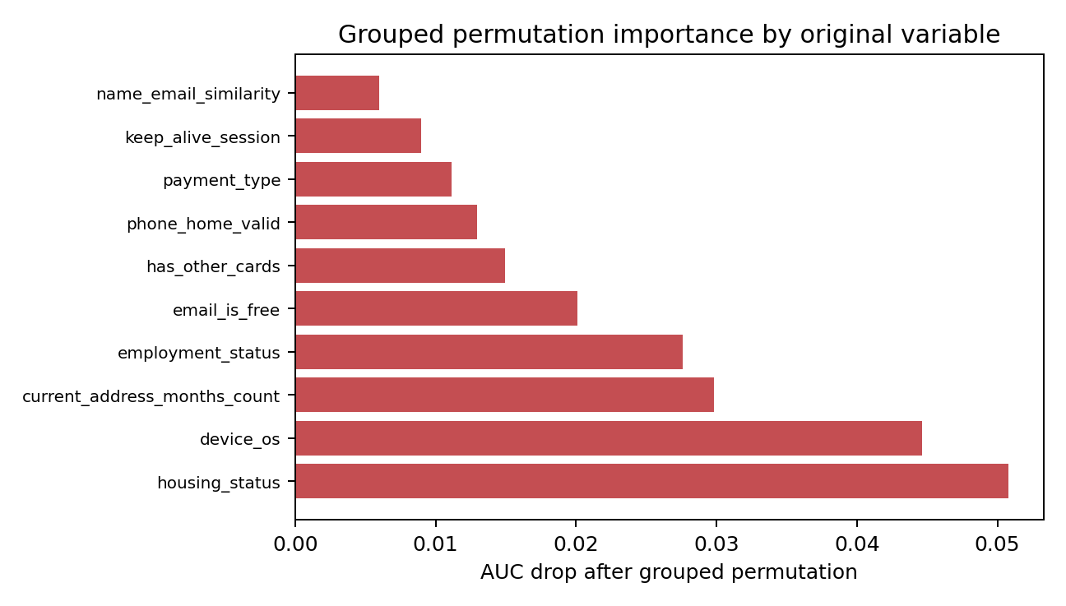
Fig. 20. Grouped permutation importance by original variable (test-set AUC drop after shuffling all one-hot dummies of a variable together, n = 10,000 rows). housing_status and device_os cause the largest performance drops, independently confirming the categorical-dominance pattern found by every XAI method.
Original variable | AUC after permutation | AUC drop | Model columns
housing_status | 0.7795 | 0.0508 | 7
device_os | 0.7856 | 0.0446 | 5
current_address_months_count | 0.8005 | 0.0298 | 1
employment_status | 0.8027 | 0.0276 | 7
email_is_free | 0.8102 | 0.0201 | 1
has_other_cards | 0.8153 | 0.0150 | 1
phone_home_valid | 0.8173 | 0.0130 | 1
payment_type | 0.8191 | 0.0111 | 5
Table XI. Grouped permutation importance by original variable (baseline test AUC = 0.8500, n = 10,000 sampled test rows). Categorical variables cause the largest performance drops despite each contributing only a handful of one-hot dummy columns.
K. Runtime and Practical Considerations
Explanation quality is not the only practical consideration for a real fraud-detection pipeline, where explanations are often needed close to real time for case triage. Table XII summarizes the relative computational cost of the five methods as a qualitative ordering (exact timings depend on hardware and the QUICK_MODE configuration, Section IV-A): TabNet native attention is effectively free, already computed as a byproduct of a normal forward pass; Integrated Gradients and SHAP GradientExplainer are both very fast, requiring only a handful of gradient evaluations per instance; LIME is slow, requiring hundreds of perturbed samples and a local surrogate fit per instance; and SHAP KernelExplainer is the slowest, requiring hundreds of predict_proba calls per instance. This feeds directly into the recommendation of Section V-M: a lower-fidelity, near-zero-cost method suits real-time triage of high volumes, while a slower, higher-fidelity method suits retrospective review or regulatory reporting, where GDPR Article 22 explanations are not real-time-constrained.
Method | Relative speed | Reason
TabNet native attention | Fastest (free) | Already computed as part of a normal forward pass
Integrated Gradients | Very fast | A handful of gradient evaluations per instance
SHAP GradientExplainer | Very fast | Gradient-based, similar cost to Integrated Gradients
LIME | Slow | Hundreds of perturbed samples plus a local model fit, per instance
SHAP KernelExplainer | Slowest | Hundreds of predict_proba calls, per instance
Table XII. Qualitative relative computational cost of the five explanation sources, per explained instance.
L. Proxy-Risk and Fairness Discussion
The dominance of housing_status, employment_status, device_os and email_is_free: confirmed jointly by every post-hoc method, by TabNet's own native attention, and by an attribution-independent grouped permutation-importance test, carries direct practical significance beyond model interpretability. These variables may be genuinely predictive of fraud here, but in a real banking context can plausibly also act as socioeconomic or digital-access proxies: device operating system may correlate with device cost and purchasing power, while housing and employment categories may correlate with social vulnerability or historically disadvantaged groups. The BAF paper itself discusses employment_status and income as protected-attribute-adjacent in its own fairness framing [8], independently supporting this as a fairness-relevant finding.
Consequently, the recommendation of this thesis is not simply to trust the highest-ranked features as legitimate risk indicators, but to audit them explicitly: monitor their marginal contribution to disparate outcomes across demographic or socioeconomic groups, consider fairness-aware training or post-processing interventions before deployment, and treat this finding as required input to the accountability and documentation processes anticipated by GDPR Article 22 [10]. This thesis does not perform a full fairness audit, since protected attributes analogous to the original BAF paper's own fairness study (e.g., a binarized customer_age group) are not re-derived here; proxy-risk is therefore identified as a limitation and a concrete direction for future work (Section VI-B). The value of the present analysis is in making the underlying pattern impossible to ignore: it is not an explanation artifact, and it is corroborated by three independent lines of evidence (post-hoc attributions, native attention, and permutation importance) that agree with each other far more than they agree with any assumption that the model relies primarily on behavioral, transaction-level signals.
M. Practical Recommendation
Combining the fidelity, robustness, stability, uncertainty, and runtime evidence above, this thesis' recommendation for this specific TabNet fraud-detection model is threefold. First, SHAP KernelExplainer is the preferred method whenever fidelity is the primary criterion and its runtime cost (Table XII) is acceptable, such as for retrospective case review, model validation, or regulatory documentation; its bootstrap confidence interval (Table IX) does not overlap that of any faster alternative, giving reasonable statistical confidence in its advantage. Second, Integrated Gradients is the recommended scalable alternative for any setting where near-real-time explanation is required, since it combines the second-highest fidelity with very low computational cost and very high probability-vs-logit ranking agreement (0.924), making its conclusions robust to the specific output scale chosen. Third, LIME's exceptional robustness and stability make it a reasonable choice specifically for aggregate or dashboard-level reporting where consistent, low-variance explanations across many similar applications are valued more than exact per-feature fidelity for any single case, but its low fidelity (0.1557) makes it a poor choice whenever an individual explanation must be defensible as an accurate account of what actually drove a specific decision. Finally, TabNet's native attention should be retained as a useful, free-of-cost architectural diagnostic, for instance to sanity-check that the model is not degenerately ignoring entire input groups, but must not be presented, on its own, as a faithful post-hoc explanation of any individual prediction, given its fidelity is statistically indistinguishable from zero (Table X).
VI. CONCLUSIONS
A. Summary of Findings
This thesis set out to benchmark explainability techniques for a neural network applied to banking fraud detection, with an explicit focus on the methodological validity of the benchmark itself. A TabNet classifier was trained on the Bank Account Fraud dataset under a temporally-consistent, sentinel-aware preprocessing pipeline, reaching a test AUC-ROC of 0.8500 under realistic, highly imbalanced conditions. Four post-hoc explanation methods (SHAP KernelExplainer, SHAP GradientExplainer, LIME and Integrated Gradients) were compared against each other and against TabNet's native attention mechanism, using global visualizations, a local case study, and a quantitative benchmark of fidelity, robustness and stability.
Two methodological corrections proved central to the credibility of the final results. First, an initial SHAP background built from K-Means centroids over SMOTE-resampled data was diagnosed as invalid (mean predicted P(fraud) of 1.0 against a true base rate of 0.0103) and replaced with real-row medoids from the un-resampled training distribution. Second, a naive perturbation-based fidelity metric that masked individual one-hot dummy columns independently was replaced with a one-hot-aware protocol that perturbs whole original categorical variables together, avoiding impossible input states; a parallel scale-normalization correction was applied to the robustness metric once raw sensitivity values proved incomparable across methods with different attribution magnitudes. Both corrections changed numeric results substantially without overturning the qualitative conclusions, which is itself evidence that the underlying findings are reasonably robust, but the exercise underscores that an XAI benchmark's own evaluation protocol requires the same scrutiny normally reserved for the model being explained.
The final results indicate that SHAP KernelExplainer is the most faithful post-hoc method for this model (fidelity 0.5392, 95% CI [0.4873, 0.5850]), Integrated Gradients is the best-balanced and most scalable alternative (fidelity 0.3955, near-identical ranking under a raw-logit target), LIME is by far the most robust and stable method but the least faithful (fidelity 0.1557), and TabNet's native attention, while reasonably stable, has fidelity that is statistically indistinguishable from zero and should be treated as an architectural diagnostic. Every method, together with an attribution-independent grouped permutation-importance test, agrees that the model relies predominantly on categorical, profile-like variables (device operating system, housing status, employment status and address tenure) rather than on numeric behavioral or transaction-velocity signals, a finding with direct relevance to fairness governance and GDPR Article 22 compliance in a real deployment.
B. Limitations and Future Work
Several limitations qualify these conclusions and motivate future work. The TabNet model was trained with a single, commonly used hyperparameter configuration rather than an exhaustive search, so the reported explanation patterns are specific to this particular model fit and could shift somewhat under a differently regularized or differently sized network; replicating the benchmark across several trained models would strengthen the generality of the conclusions. The quantitative metrics were evaluated on a diagnostic subset of 200 instances (with the largest, most expensive method, SHAP KernelExplainer, further restricted to subsets of 25–100 instances for the robustness metric), and although bootstrap confidence intervals partially address estimation uncertainty, a larger evaluation budget would tighten these intervals further, particularly for LIME. The proxy-risk discussion in Section V-L identifies fairness as a first-class concern raised by the explanation evidence but does not itself execute a full fairness audit against protected or protected-adjacent attributes; a natural extension of this work is to combine the explainability benchmark developed here with the group-fairness metrics (e.g., predictive equality across an age-based protected group, as used in the original BAF paper [8]) to jointly assess whether the categorical variables identified in Section V-C and V-J introduce disparate impact across groups. Finally, this thesis relied on manually implemented fidelity, robustness and stability metrics after finding the Quantus library incompatible with the flat, one-hot encoded tabular arrays used here; adapting Quantus or OpenXAI to this representation, or contributing a one-hot-aware perturbation mode upstream to one of these libraries, would improve reproducibility and comparability with other tabular XAI benchmarks in the wider research community.
A further direction, noted in Section III-C, is a controlled ablation training TabNet with class weighting instead of SMOTE, holding architecture, preprocessing and evaluation protocol fixed, to directly compare the two imbalance-handling strategies rather than relying on SMOTE's result alone. A related and more direct extension targets the model itself rather than the training-set distribution: at the default 0.5 threshold TabNet still recalls only 56.4% of fraud cases at a precision of 9.2% (Section V-A), showing that SMOTE alone does not fully compensate for the dataset's imbalance at the operating-point level, even though it yields a good ranking model (AUC-ROC 0.85). A preliminary exploration of this direction, reported in a companion notebook outside the main thesis pipeline, trained TabNet directly on the original, un-resampled data with three imbalance-aware losses proposed by Kanász et al. [20]: Focal Loss, Influence-Balanced (IB) Loss, and a boundary-vicinity-weighted loss inspired by their BVSLoss. Results were mixed rather than uniformly better: Focal Loss improved AUC-ROC, precision and F1 over the SMOTE baseline at a small recall cost; the BVSLoss-inspired variant raised recall to 75.8% and reached the best geometric mean of sensitivity and specificity, at a substantial precision cost; and IB Loss reached the highest AUC-ROC (0.8818) yet collapsed to 2% recall at the 0.5 threshold, an apparent threshold-calibration failure rather than a learning failure. None of the three is validated enough, single run, untuned hyperparameters, unverified BVSLoss formula, to replace the reported model; per-model threshold tuning, hyperparameter search, and, if a variant is adopted, a full re-run of the XAI benchmark on the resulting model remain future work.

APPENDIX A. REPRODUCIBILITY ARTIFACTS
Both companion notebooks export their intermediate and final artifacts to disk for reproducibility: the EDA/training notebook exports the fitted preprocessing pipeline, trained TabNet weights, processed train/validation/test arrays, and the predictive-performance figures of Section V-A; the XAI benchmark notebook exports, per method, the raw attribution matrices (200-instance and 1,000-instance subsets), the corrected real-row SHAP background and Integrated Gradients baseline, naive and one-hot-aware fidelity, raw and relative robustness, stability, bootstrap confidence intervals, the grouped permutation-importance table, and every Section V figure at publication resolution. All random seeds are fixed at 42, and the QUICK_MODE flag (Section IV-A) allows a fast debug re-run before the full thesis-grade configuration reported here.
ACKNOWLEDGMENT.
The author would like to thank Javier del Ser and José Manuel Nieto for their supervision and guidance throughout this thesis, and the Universidad de Málaga's Master's programme in Big Data, Artificial Intelligence and Data Engineering for the training that made this work possible.
REFERENCES
[1] A. B. Arrieta et al., "Explainable Artificial Intelligence (XAI): Concepts, taxonomies, opportunities and challenges toward responsible AI," Information Fusion, vol. 58, pp. 82–115, 2020.
[2] S. Ali et al., "Explainable Artificial Intelligence (XAI): What we know and what is left to attain Trustworthy Artificial Intelligence," Information Fusion, vol. 99, 101805, 2023.
[3] S. M. Lundberg and S. I. Lee, "A unified approach to interpreting model predictions," in Advances in Neural Information Processing Systems 30, 2017.
[4] M. T. Ribeiro, S. Singh, and C. Guestrin, "Why should I trust you? Explaining the predictions of any classifier," in Proc. KDD, 2016.
[5] M. Sundararajan, A. Taly, and Q. Yan, "Axiomatic attribution for deep networks," in Proc. ICML, 2017.
[6] S. O. Arik and T. Pfister, "TabNet: Attentive interpretable tabular learning," in Proc. AAAI, 2021.
[7] A. Hedström et al., "Quantus: An Explainable AI Toolkit for Responsible Evaluation of Neural Network Explanations and Beyond," Journal of Machine Learning Research, vol. 24, no. 34, pp. 1–11, 2023.
[8] S. Jesus et al., "Turning the Tables: Biased, Imbalanced, Dynamic Tabular Datasets for ML Evaluation," in Advances in Neural Information Processing Systems 35 (NeurIPS 2022), Datasets and Benchmarks Track. Dataset: https://www.kaggle.com/datasets/sgpjesus/bank-account-fraud-dataset-neurips-2022
[9] S. Jesus et al., "BAF Dataset Suite Datasheet," NeurIPS 2022 Datasets and Benchmarks Track (supplementary datasheet), Feedzai / Universidade do Porto, 2022.
[10] European Parliament and Council, Regulation (EU) 2016/679 (General Data Protection Regulation), Article 22: Automated individual decision-making, including profiling, 2016.
[11] S. M. Lundberg et al., "From local explanations to global understanding with explainable AI for trees," Nature Machine Intelligence, vol. 2, pp. 56–67, 2020.
[12] A. Paszke et al., "PyTorch: An imperative style, high-performance deep learning library," in Advances in Neural Information Processing Systems 32, 2019.
[13] F. Pedregosa et al., "Scikit-learn: Machine learning in Python," J. Mach. Learn. Res., vol. 12, pp. 2825–2830, 2011.
[14] N. Kokhlikyan et al., "Captum: A unified and generic model interpretability library for PyTorch," arXiv preprint arXiv:2009.07896, 2020.
[15] DreamQuark, "pytorch-tabnet: PyTorch implementation of TabNet," GitHub repository, https://github.com/dreamquark-ai/tabnet, 2020.
[16] N. V. Chawla, K. W. Bowyer, L. O. Hall, and W. P. Kegelmeyer, "SMOTE: Synthetic minority over-sampling technique," J. Artif. Intell. Res., vol. 16, pp. 321–357, 2002.
[17] C. Agarwal et al., "OpenXAI: Towards a transparent evaluation of model explanations," in Advances in Neural Information Processing Systems 35 (NeurIPS 2022), Datasets and Benchmarks Track.
[18] P. Seth, Y. Rathore, N. K. Singh, C. Chitroda, and V. K. Sankarapu, "xai_evals: A Framework for Evaluating Post-Hoc Local Explanation Methods," arXiv preprint arXiv:2502.03014, 2025.
[19] Y. Zhang, J. Song, S. Gu, T. Jiang, B. Pan, G. Bai, and L. Zhao, "Saliency-Bench: A Comprehensive Benchmark for Evaluating Visual Explanations," arXiv preprint arXiv:2310.08537, 2023.
[20] R. Kanász, P. Drotár, P. Gnip and M. Zoričák, "Clash of titans on imbalanced data: TabNet vs XGBoost," 2024 IEEE Conference on Artificial Intelligence (CAI), Singapore, Singapore, 2024, pp. 320-325, doi: 10.1109/CAI59869.2024.00068.

