Collective Seed Storage: Urban Citizens as Active Agents of Agricultural Resilience
Andrea Vitaletti ^{1*}, Ioannis Chatzigiannakis ²
^{1,2}Sapienza University of Rome
*vitaletti@diag.uniroma1.it
Abstract
More than 95% of the crop genetic erosion articles analyzed in (C. K. Khoury, 2022) reported changes in diversity, with nearly 80% providing evidence of loss. The lack of diversity presents a severe risk to the security of global food systems. Without seed diversity, it is difficult for plants to adapt to pests, diseases, and changing climate conditions. Genebanks, such as the Svalbard Global Seed Vault, are valuable initiatives to preserve seed diversity in a single secure and safe place. However, according to our analysis of the data available in the Seed Portal, the redundancy for some species might be limited, posing a potential threat to their future availability. Interestingly, the conditions to properly store seeds in genebanks, are the ones available in the freezers of our homes. This paper lays out a vision for Collective Seed Storage relying on a peer-to-peer infrastructure of domestic freezers to increase the overall availability of seeds transforming urban citizens into active agents of agricultural resilience.
Introduction

There are over 50,000 edible plants worldwide, but just 15 provide 90% of the world’s food energy intake and among these, rice, corn (maize), and wheat contribute up to two-thirds. We have to put all our efforts to preserve those fundamental energy assets.

The need for seed diversity. A key objective in preserving these plants is to protect seed diversity, that is, the wide range of plant species, cultivars and genetic materials found within a given crop. This genetic diversity is a vital resource on which the future of our food systems depends. As climate change intensifies, bringing extreme weather events along with emerging pests and diseases, the presence of specific genes becomes critical. These genes enable certain crop varieties to withstand heat, drought, pests, and pathogens, forming the foundation of agricultural resilience and adaptation.
A limited seed pool not only threatens our ability to cope with environmental stresses but also risks the loss of flavor, nutritional value, and the cultural heritage embedded in traditional cuisines. Genetic diversity improves agriculture’s ability to adapt to changing climates, regional growing conditions, and evolving consumer preferences.
Without broad access to diverse crop varieties, future generations will face serious constraints in shaping agriculture to meet their needs and respond to environmental challenges. Our preservation efforts should also extend to Crop Wild Relatives (CWRs), as they play an important role. They are wild plant species that are closely related to cultivated crops and can provide genetic diversity that may not be available in current cultivated varieties. This diversity may be used to improve the productivity, resilience, and quality of agricultural products. The Earth is losing plant genetic diversity at an unprecedented rate. More than 95% of the crop genetic erosion articles analyzed in (C. K. Khoury, 2022) reported changes in diversity, with nearly 80% providing evidence of loss. The extent of this loss varied depending on species, taxonomic and geographic scale, region, and analytical approach. In many countries, seed diversity has been irreversibly diminished, limiting farmers’ crop options.

Efforts to preserve seed diversity. Preservation of seed diversity is considered a common fundamental goal among the countries organized in the Multilateral System of Access and Benefit Sharing (MLS https://www.fao.org/plant-treaty/areas-of-work/the-multilateral-system/), part of the International Treaty on Plant Genetic Resources for Food and Agriculture (PGRFA). MLS allows member states to share and exchange plant genetic resources for research, breeding, conservation, and training. Recipients sign a Standard Material Transfer Agreement (SMTA https://mls.planttreaty.org/itt/) that specifies conditions for use and benefit sharing. MLS includes 64 of the world’s most important crops that together represent 80% of all human consumption derived from plants.
The main strategies to preserve seed diversity are summarised in Table 1
Table 1: In situ and ex situ conservation methods
Criteria | In Situ Conservation | Ex Situ Conservation
Location | Natural environment / farms | Seed banks, seed vaults, labs
Evolution | Plants continue to adapt naturally. | Static; no natural evolution
Risk of Loss | Higher (e.g., land-use change, climate) | Lower (secure and controlled conditions)
Cultural Link | Strong; maintains traditional knowledge | Weak or absent
Access & Sharing | Local and informal | Global access via formal mechanisms (e.g., SMTA)
Documentation | Often limited or informal | Detailed and standardized
Cost | Lower short-term cost | Higher cost (infrastructure and maintenance)
Best Use | Wild relatives, landraces | Major crops, backup, and global breeding

The Svalbard Global Seed Vault in Norway (SGSV) serves as a global backup facility for seed banks worldwide (Hopkin, 2008). Its purpose is to provide long-term backing for genebank collections to secure the foundation of our future food supply and it is unanimously considered the backup seed facility that provides the highest standards of safety and security. The SGSV now safeguards seeds of more than 250,000 types of wheat, 160,000 types of rice and 46,000 types of maize, the fundamental sources of food energy intake. However, analysing the data available through the SGSV Seed Portal , the vast majority of species have a single depositor. In other words, the data show that the samples are available at SGCV and at the depositor only.

Open Problem. The low level of redundancy in the availability of seeds samples backups for the majority of the species, might have serious consequences; even in the best genebanks, things can occasionally go disastrously wrong. The question we aim to investigate in this paper is whether it is possible to further increase the overall availability of seeds by a robust and resilient backup infrastructure capable of preserving seed diversity with limited investments.

Our Vision. The rise of smart cities introduces new opportunities for participatory, decentralized infrastructures in which citizens actively contribute to global challenges. Notably, the environmental conditions required for proper seed storage closely resemble those found in domestic freezers, making urban households a largely untapped resource for biodiversity preservation. This paper proposes a vision of Collective Seed Storage that leverages a peer-to-peer network of household freezers, transforming urban citizens into active agents of agricultural resilience.
Within this smart city framework, each household becomes a micro-node in a distributed seed conservation system, supported by IoT-based monitoring to ensure optimal storage conditions and data sharing across the network. By integrating urban participation with agricultural needs, this model redefines the role of cities as active contributors to food system resilience and biodiversity conservation.
Methodology

We recognize that a comprehensive strategy for seed preservation must address all components of the conservation pipeline (CGRFA, 2022) and should actively encourage citizen participation to raise awareness and engagement. Nonetheless, having a robust and resilient backup remains a fundamental element of such a strategy. In this paper, we focus specifically on this essential, though narrowly defined, objective.
Interestingly, the temperature conditions in domestic freezers can meet the international standard for long-term seed conservation. The main idea of this paper is to develop a system inspired by the principles of the shared economy, capable of safely storing the seeds in our home freezers, thus contributing to the development of a Collective Seed Storage (CSS) that can increase the availability of seeds and the overall resilience of the world’s crop diversity. In the following we sketch the main requirements for a CSS.
- R1 Storing conditions of seeds in domestic freezers must comply with (CGFRA, 2014), (Commission, 2014). We assume that orthodox samples meant for long-term storage are packaged under controlled conditions, in airtight containers (Standard 4.2.2 (CGFRA, 2014)) and then samples are ideally stored at -18◦C ± 3 percent and relative humidity of 15 ± 3 percent (Standard 4.2.3 (CGFRA, 2014)). Figure 4 of (CGRFA, 2022) is a summary diagram of the workflow and activities for drying and storage and clarifies that the use of subzero freezers is acceptable if ideal conditions are not available.
The success of this project relies on the active and numerous participation of users. To encourage the participation, the system should:
- R2 Simplify the installation without requiring any specific technical skill or infrastructure. The installation of the system should be user friendly and based on off-the-shelves equipment. We only assume users have a WiFi at home.
- R3 Not require unnecessary cables which complicates and limit the installation options.
- R4 Run for at least 1 year without the need of intervention by the user.
- R5 Support the implementation of suitable incentive mechanisms.

Results and Discussion

A sketch of the architecture of the CSS Proof-of-Concept is shown in Figure 1. The airtight container storing the seeds is equipped with a humidity and temperature sensor (the DHT22) connected to an IoT sensor node, in our case the Esp32 Devkit V1 (Esp32 in the following), which implements the logic to acquire the sensor readings and to deliver them to the smart contract in charge of dispensing the incentives to the participants (R5).
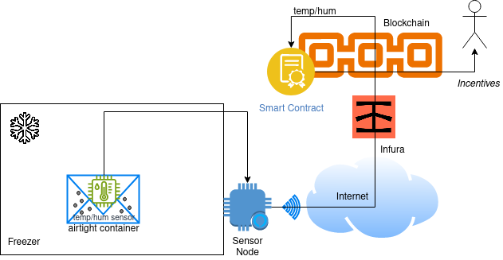Figure 1: The architecture of the Proof-of-Concept for the Collective Seed Storage

The code is available on https://github.com/andreavitaletti/PlatformIO/tree/main/Projects/web3E_SC. The Esp32 delivers the data to the smart contract by the onboard WiFi. WiFi access points are nowadays largely available in homes (see R2) making this technology appropriate for the project, furthermore, the nature of the phenomenon to be monitored does not require frequent data acquisition; temperature and humidity in the freezer do not suddenly change. For this reason, the node alternates long period of deep sleep with a short active period where two main tasks are performed, namely data acquisition and communication. In deep sleep mode, only the RTC Timer and RTC Memory are active, reducing the consumption to 10µA. The resulting low duty cycle prolongs the lifetime of the node, and allows us to meet the requirement R4. To satisfy R3, the Esp32 is powered by a 3.6V LiFePo4. This solution does not require any voltage regulator that would introduce losses. In the future, we plan to design a more efficient custom board without all unnecessary components. The ESP32 operating temperature range is from −40 to125 ◦C, so in principle it can also be placed into the freezer together with the DHT22 temperature and humidity sensor, however, the wifi connectivity could be severely hindered. In our experiments, when the ESP32 is placed into the freezer, more then 40% of the packets do not reach the server. Furthermore, it is well known the the efficiency of batteries decreases significantly in cold temperatures: at -20°C to -40°C, a LiFePo4 battery may only achieve about 60% to 40% of its rated capacity9. Finally, despite being small, the ESP32 steal some further space in the user’s freezer. For these reasons, the DHT22 is placed into the freezer and it is connected to the ESP32 placed outside, by three tiny wires. This solution is not fully consistent with R3, but it is acceptable and the arguments discussed above togheter with the simplicity of the installation, makes it compliant with R2
The temperature and humidity conditions at which seeds are stored in the freezer, are monitored by a DHT22 sensor (see R1). It features excellent technical specifications also in terms of power consumption. The sensor can be queried by a single wire protocol: when the sensor node sends the start signal, the DHT22 change from stand-by-mode (40 µA) to measuring-mode (1 mA). The DHT22 will get back to stand-by-mode again upon the completion of the data acquisition. Figure 2 shows the results of a monitoring activity on a domestic freezer (BOSCH KGN39X23) set at -18C°. Samples are taken every 5 minutes. After an initial transient period, the observed temperature oscillates significantly. These conditions do not fulfill the Standard 4.2.3 (CGFRA, 2014) but are consistent with the acceptable subzero conditions indicated in (CGRFA, 2022) when the ideal ones are not available. The implications of these conditions in seed conservation and the possibility to reach the ideal ones in domestic freezer are object of future studies.
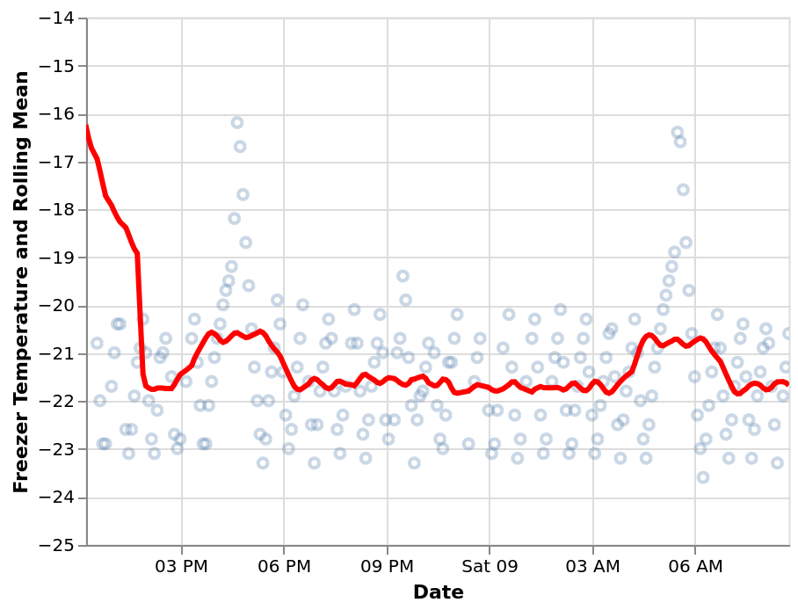Figure 2: The observed temperature drops immediately after the placement of the sensor into the freezer, then fluctuates noticeably.

Conclusion
The Collective Seed Storage (CSS) concept aims to support the preservation of seed diversity by transforming urban citizens into active agents of agricultural resilience. In this model, households become micro-nodes within a distributed seed conservation system, supported by IoT-based monitoring to ensure optimal storage conditions and enable data sharing across the network. Our Proof-of-Concept demonstrates the feasibility of the core technical components underlying this vision.
A modern approach to seed preservation should promote more active citizen participation (e.g., Seed Guardians) that extends beyond the mere act of storage. Although the preservation of seeds in domestic freezers is a novel and valuable practice, it may remain, to some extent, a passive activity. However, we argue that the network of IoT devices forming the CSS is not only a powerful tool for monitoring conservation conditions, but also a means to initiate structured knowledge sharing on effective seed preservation. In particular, the availability of quantitative, objective data can support evidence-based practices and serve as a foundation for more active citizen engagement.
Greater involvement, such as participation in seed regeneration and cultivation, would not only directly enhance conservation efforts but also equip participants with practical knowledge of seed growth and management. Although such activities lie beyond the scope of this work, we believe that the sharing-economy principles underlying our CSS concept represent a first step in this direction, laying the groundwork for deeper, hands-on participation in the long-term preservation of seed diversity.
References

Commission on Genetic Resources for Food and Agriculture (CGRFA). (2014). Genebank Standards for Plant Genetic Resources for Food and Agriculture. Food and Agriculture Organization of the United Nations (FAO). https://www.fao.org/4/i3704e/i3704e.pdf
Commission on Genetic Resources for Food and Agriculture (CGRFA). (2022). Practical guide for the application of the genebank standards for plant genetic resources for food and agriculture conservation of orthodox seeds in seed genebanks. Food and Agriculture Organization of the United Nations (FAO). https://doi.org/10.4060/cc0021en
C. K. Khoury et al. (2022). Crop genetic erosion: understanding and responding to loss of crop diversity. New Phytologist, vol. 233, no. 1, pp. 84–118.
Hopkin, M. (2008). Biodiversity: Frozen futures. Nature 452, 404–405 https://doi.org/10.1038/452404a

