**Gathering Requirement**

1. **Title:** Ask Username to end user

**Description:** The QuizApp application ask the username to end user on startup page is index.jsp

1. **Title:** Select category and difficulty by end user

**Description:** The QuizApp application ask to the user select category and difficulty for generate exam.

1. **Title:** Listing question to the end user

**Description:** The QuizApp application generates the 10 list of question based on selected category and difficulty. List of question contains 5 multiple choice and 5 True/False question.

1. **Title:** Display the result/score

**Description:** After user submits the exam application calculate grade based on correct exam.

1. **Title:** Display the previous result/score

**Description:** User may view the previous score card which is stored in the local file. This result store as a CSV format in the file.

**Use Case Diagram**

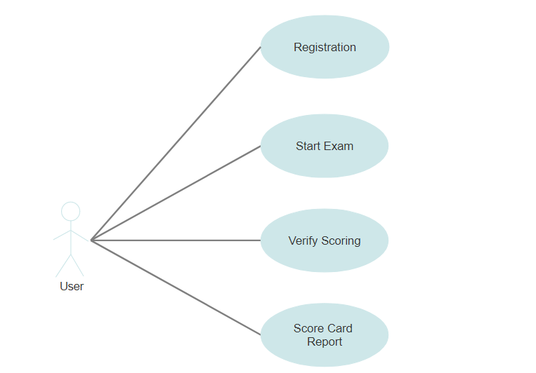

**UML Diagram**

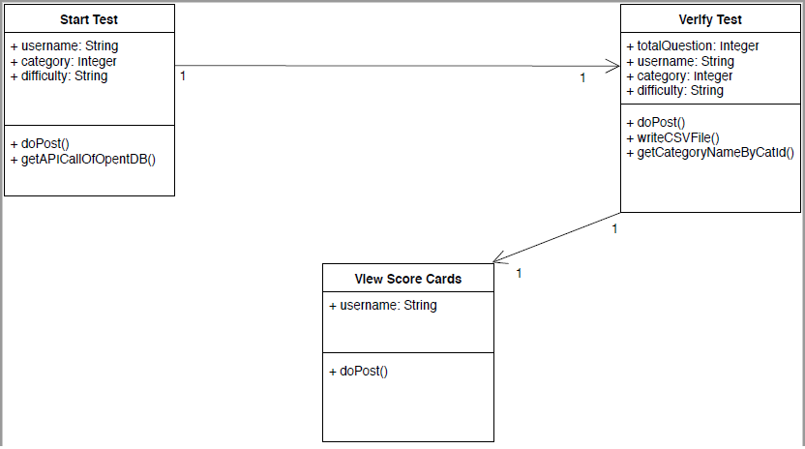

**Screenshot of Quiz Application**

1. **Home page**

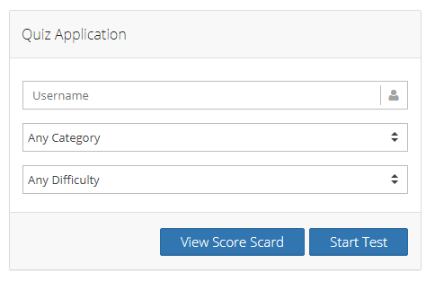

1. **Question page**

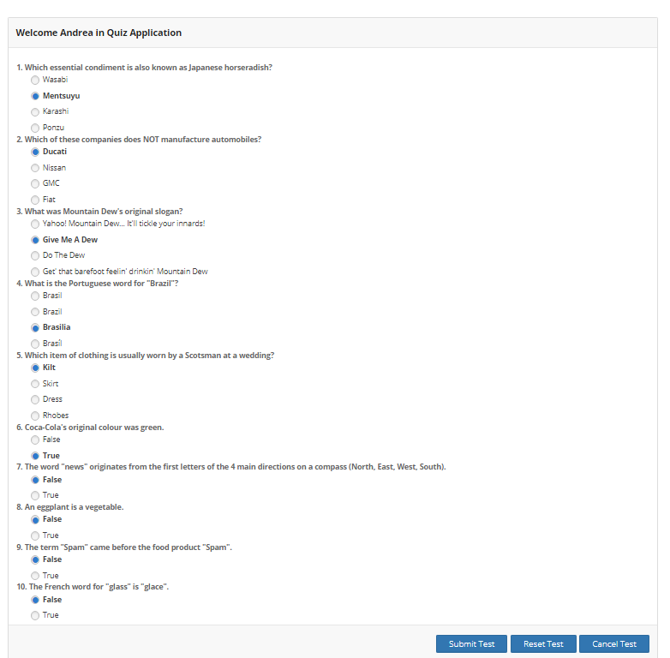

1. **Current Score Card page**

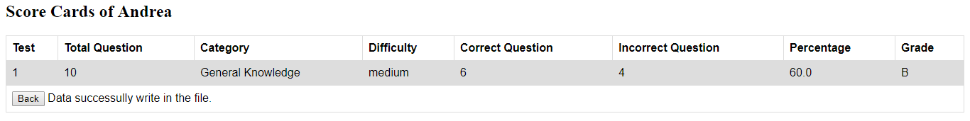

1. **Previous Score Card page**

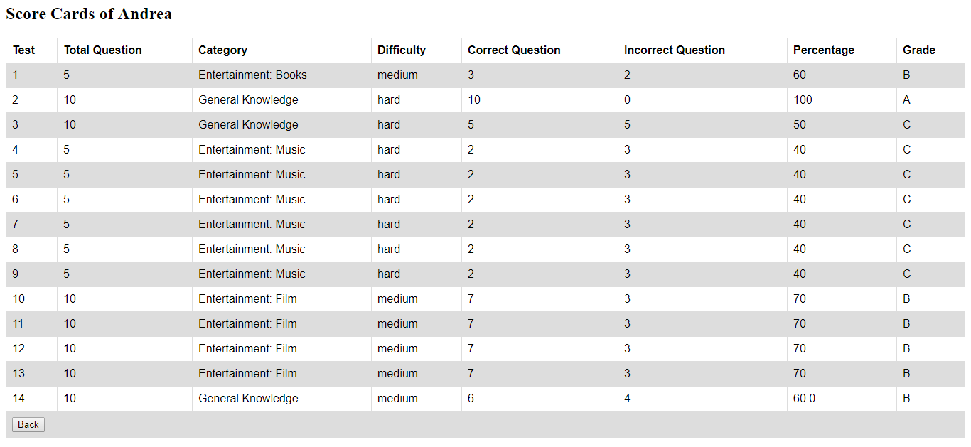

**MVC Design Pattern**

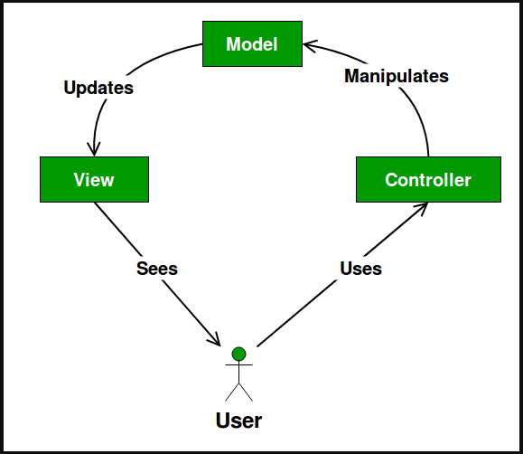

**Project Structure**

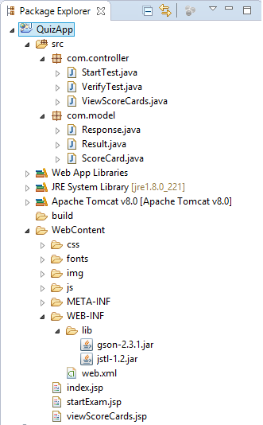

I have used MVC design pattern you can see in the above screenshot.

**M- Model:** Response.java, Result.java and ScoreCard.java

**V- View:** index.jsp, startExam.jsp and viewScoreCards.jsp

**C- Controller:** startTest.java, VerifyTest.java and ViewScoreCards.java