

Make Insurances great again!

Objective:

The App objective is to quote the any type of insurance and showing the customer not only the prices but also the rating and comments on that company, to enable the app user to choose the company using others attributes.

App Name: Easy Creadi



Figure . Login Page

Will be possible to login with facebook or standard login

After the login, the user needs to enter his profile, in this way the user avoids to fill everytime that he needs a quote for any type of insurance.

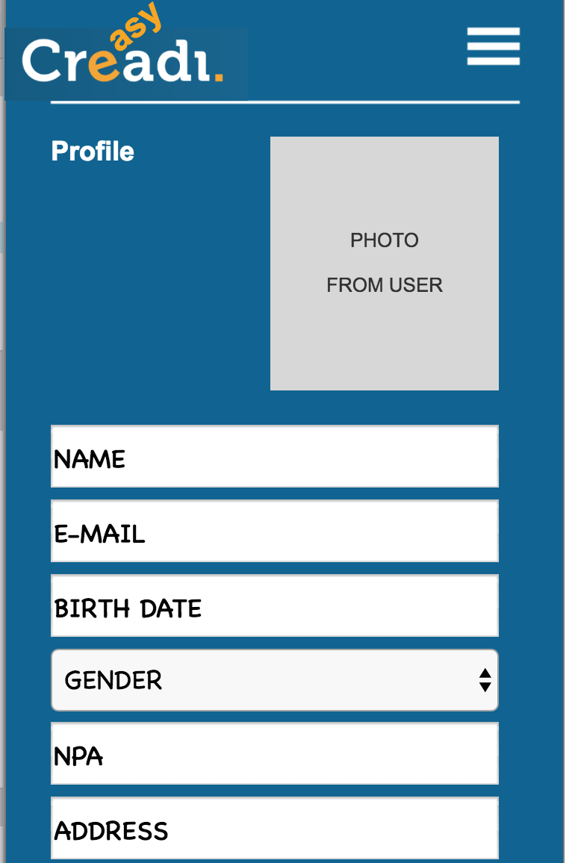

Figure . Profile screen

This also grants that all types of insurance has the same profile, avoiding frauds and always have the updated data (like address or phone number)

After fill the profile will be possible to choose what type of insurance you need to quote?

We divided the switherzland types of insurances in 5 categories:

**Assumptions:**

The user can quote as many times that he wants

The type of questions will change for each type of insurance

Some of the categories have more than one type of insurance

For this POC we are going to select only health:

In order to have the best accuracy on the quotation the user need to choose an option:

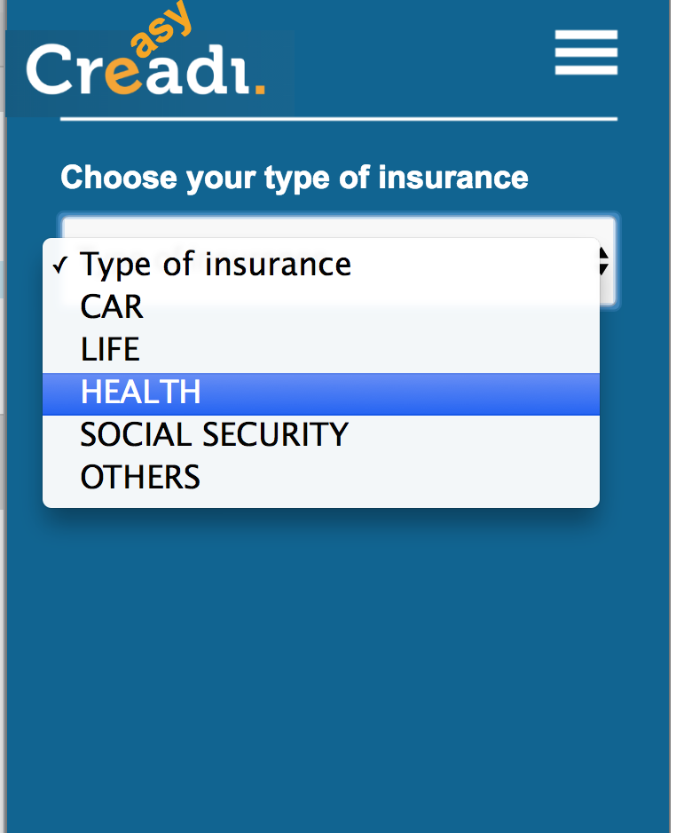

Figure . Choose option screen

In this way we only need to ask the questions for each type of insurance, avoiding the user to have to fill a huge form that we are only going to use part of it.

**Assumptions:**

For this POC we are going to select Standard in order to fill the mandatory questions to be able to calculate the insurance cost.

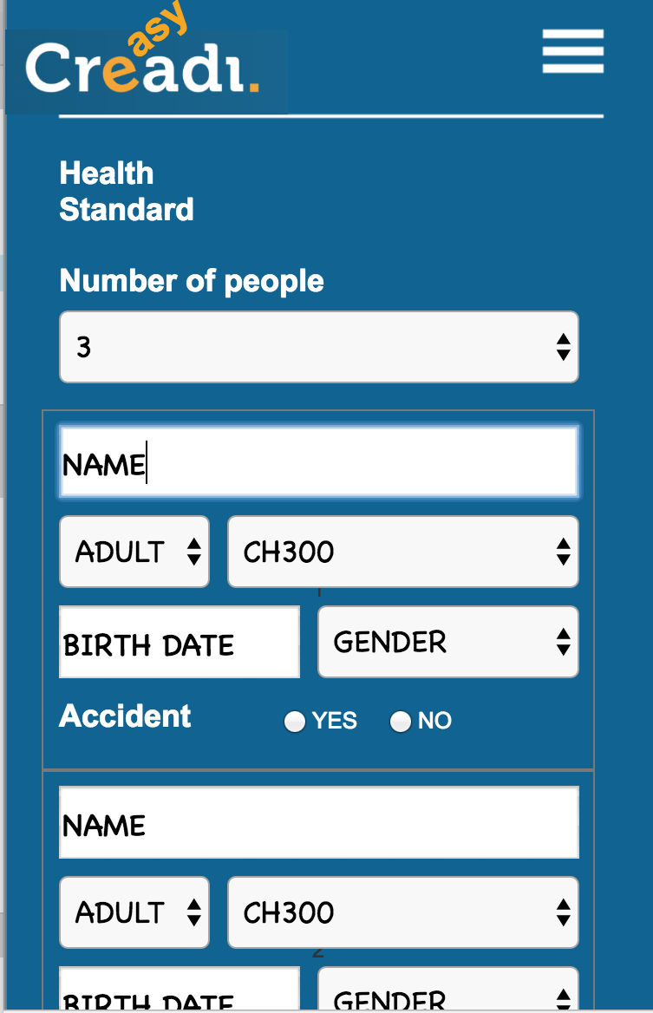

Figure . Required information screen

The person data will be retrieved from the profile with two more questions:

Qty of people?

This will open the quantity of box to fill Name, type (insurance plan) and if will cover accident.

The insurance plan needs to be converted to be able to compare between one company and the others.

We need to have categories in order to classify all the plans we have now a days and make that updated every time.

The last question is about the current insurance policy.

The calculate button will use this information in the company’s websites to bring the Premium calculation.

This also could be done more easy if the insurance companies has an API to calculate premium.

After we did the calculation and receive the answers from the companies we will show the result to the user:

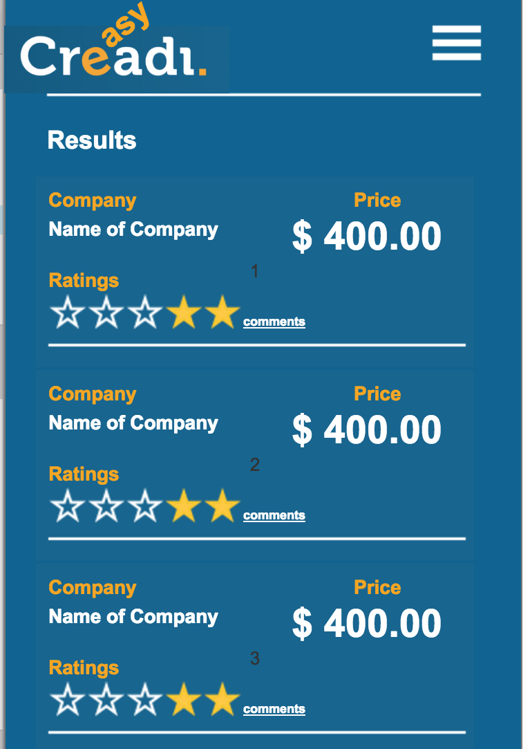

Figure 5. Results Screen

In this way we can compare between companies the models , the premiuns for month, potential savings and the rating.

You can choose one and click on buy now.

This triggers a request to the company with all informations provided by the user and the calculation to do the insurance.

We can upload the required documents also and deliver everything once, but that could depend on each insurance company.

For the MVP:

* Insurance Companies:
  + Contact the insurance companies in order to be able to use the API for the premium calculation.
  + Check with the insurance companies how the request will be handle, by email or system.
* Creadi:
  + Create the convergence between all available insurance plans to be able to classify in categories. Make sure that the insurance companies agrees with that
  + Use a firebase database in order to create the app.
  + Use APIs to connect with each company

How to open prototype:

* + Access the github in the link :
    - <https://github.com/andrebezz/creadiGIT>
  + In folder CREADI_HTML open start.html
    - Browser will ask you to download a extension of axure
    - Just download and install, and you are ready to view