Lower Caribbean Bible College

Administrative System

User Manual

Version 1.0

© Alpha Solutions Inc.

Table of Contents

Getting Started…………………………………………………………………………1

Application Features…………………………………………………………………...2
Application Tasks……………………………………………………………...4
Approval……………………………………………………………….6
Storage and Retrieval…………………………………………………..6
Student Tasks…………………………………………………………………..7
Registration…………………………………………………………….8
Transcripts (Grades)…………………………………………………....9
Class Grade Report…………………………………………….………10
Courses…………………………………………………….…………………..11
Addition………………………………………………………………..11
Deletion………………………………………………………………..11
Back Up………………………………………………………………………..12
Creating A Backup…………………………………………….………12
Reverting to a Backup…………………………………………………12
Receipts………………………………………………………………………..13
Generating a Receipt…………………………………………………..13
Grade Point……………………………………………………………………15
Searching the Database………………………………………………………..16
Printing………………….……………………………………………...……………..18

GETTING STARTED

This document describes the functionality present and provides examples of how to use the LCBCAdminSystem. LCBCAdminSystem is the name given to the specialized software package that Alpha Solutions Inc was contracted to create for Mr. Owen Crichlow the bursar at Lower Caribbean Bible College.

Application Features:
The LCBCAdminSystem is capable of performing the following tasks:
- Storing and retrieving data from Application Forms and Approving new applicants.
- Storing and retrieving student information including registration of classes, updating and retrieving grades and printing transcripts.
- Updating course information; adding, deleting and modifying courses.
- Creating local backups of the database and reverting to previous backups.
- Creating storing and printing receipts.
- Searching the entire database.

The user accesses each task in the program by clicking one of the functions corresponding to the desired function.

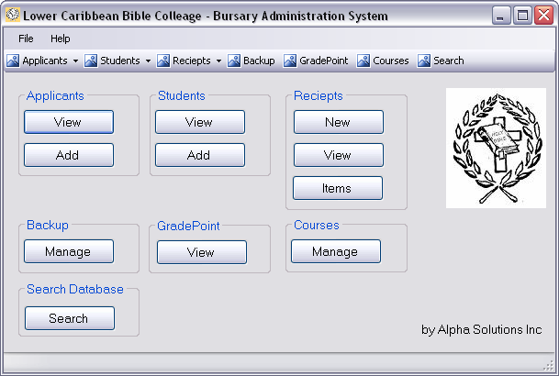
LCBCAdminSystem Main user interface
APPLICATION TASKS

Here an applicant refers to a person who has requested enrolment in the Lower Caribbean Bible College and has submitted completed an application form.
The LCBCAdminSystem is capable of handling the following application tasks:
- Electronic storage and retrieval of application information (read/write to a database)
- Modification of applicant information (editing field values)
- Approval of applicants (which converts an applicant to a student)

The application tasks can be accessed by clicking either the “View “or “Add” buttons on the main screen as shown below:
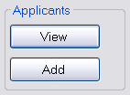

Editing applicant information and saving changes.
The dialog for accessing and modifying the applicant information can be accessed by clicking the “View” button as presented above.

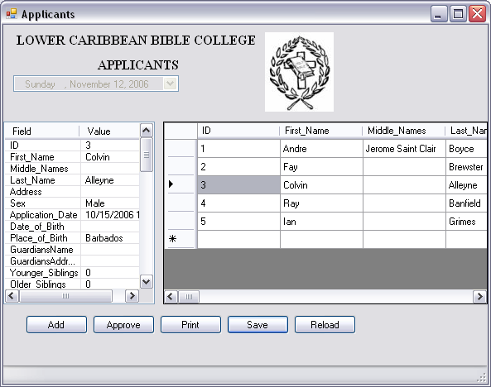
Applicants Dialog

The following list describes the functions of the buttons present in the Applicants dialog:

- Add: Allows you to add a new applicant via a form similar to the current printed application form.
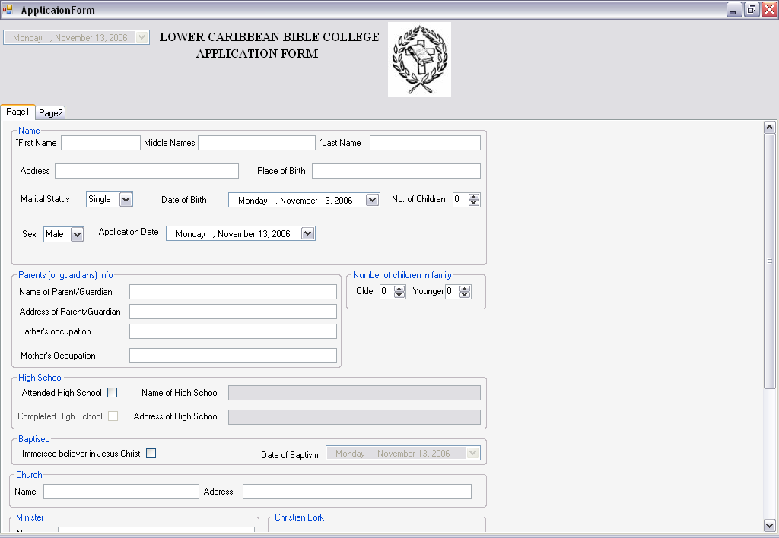
Application Form Dialog

- Approve: This approves the currently selected applicant. The
- Print: This allows you to print applicant information, (see printing section)
- Save: Save the changes you made to the database.
- Reload: Disregards any changes you made and reloads the information from the database.

STUDENT TASKS

The student tasks can be access by clicking the view or add buttons under the Students groupbox as shown below:
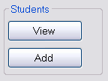
A student can be added to the system by clicking the add button in the screenshot above or by adding an applicant and then approving them.

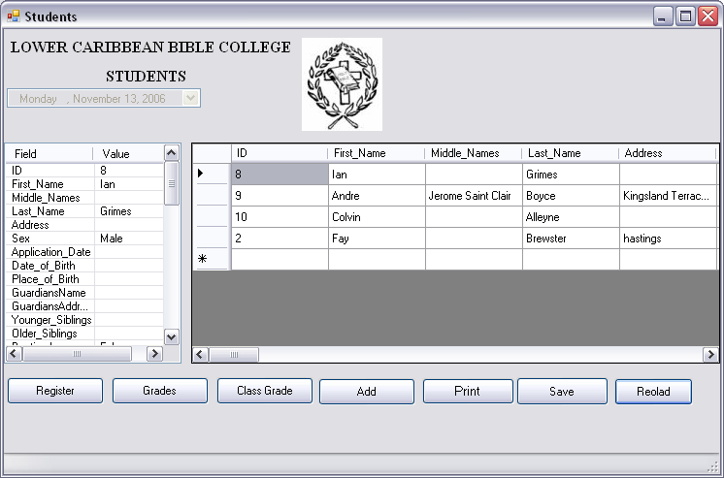
Students Dialog

- Register: Allows you to register student’s classes.
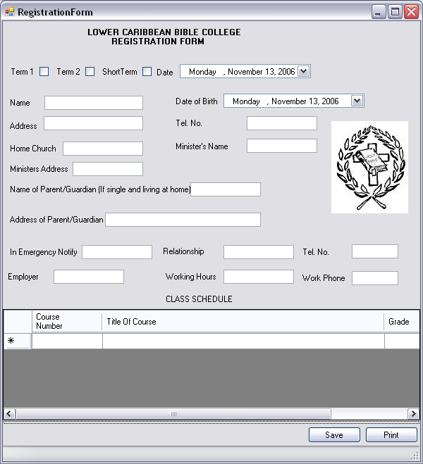
Registration Form Dialog

Fill in the required information and click the “Save” button and the student will be registered.
Grades: Update student’s grades.
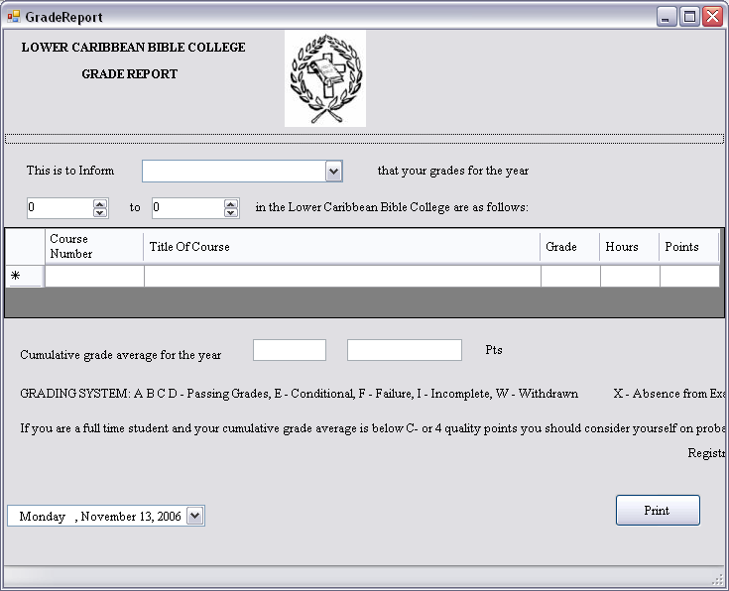
Class Grades: Create a class grade report.
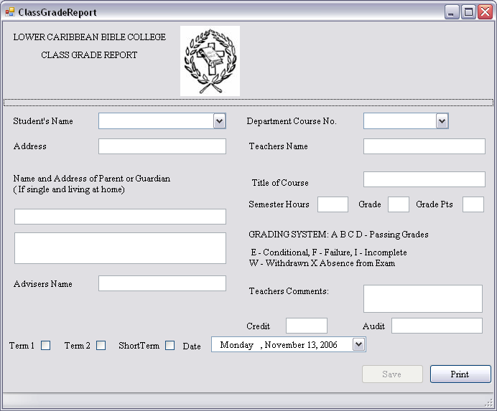
- Add: Displays the Add Student dialog.
- Print: Print the students in a database.
- Save: Save the changes made to the students table.
- Reload: Cancel changes made to the student table.
COURSES

The Courses tasks can be access by clicking the view or add buttons under the Courses groupbox as shown below:

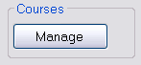
A course specifies an actual class that can be taken by a student at Lower Caribbean Bible College.

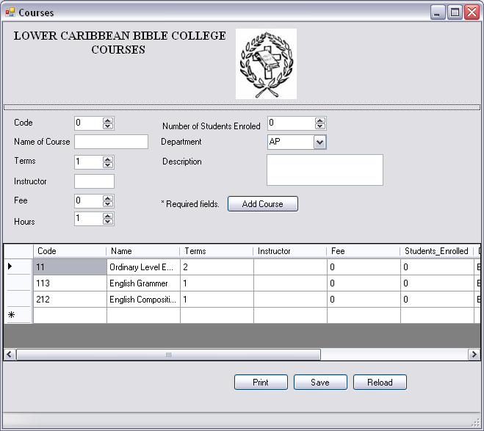
Courses Dialog

To add a course, fill in the required information and Click the “Add Course” button.

- Save: Saves the changes you made to the courses table.
- Reload: Cancels changes made to the courses table.
- Print: Allows you to print the courses available.
BACK UP

The backup dialog can be access by clicking the view or add buttons under the Courses groupbox as shown below:

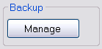

The database should be backed up every time a major change is made and every week.

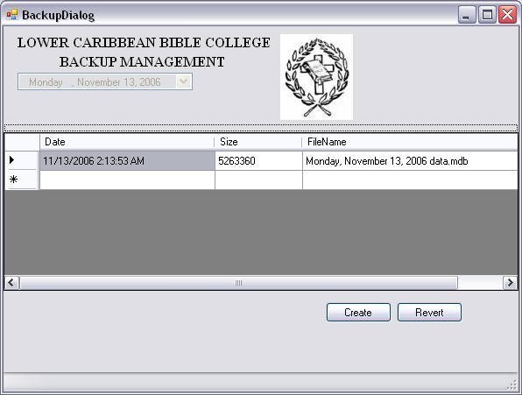

- Create: Create a backup of the database.
- Revert: Revert the system to the file specified.

RECEIPTS

Under the Receipts groupbox you can create edit and print receipts, as well as update items in an inventory.

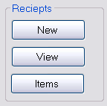

The receipts payment form can be access by clicking the “New” button, saved receipts can be viewed by clicking the “View” button and the inventory can be accessed by clicking the “Items” button.

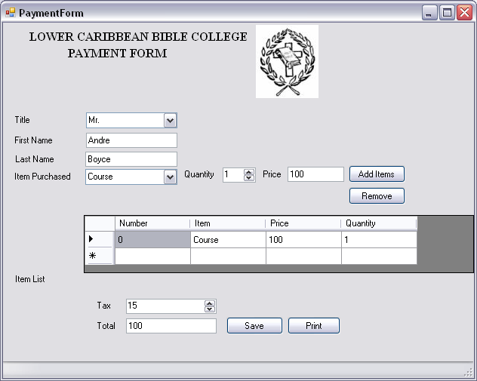

- Add Items: Adds an item to the list.
- Remove: Removes an Item from the list.
- Save: Saves the receipt.
- Print: Prints the receipt.

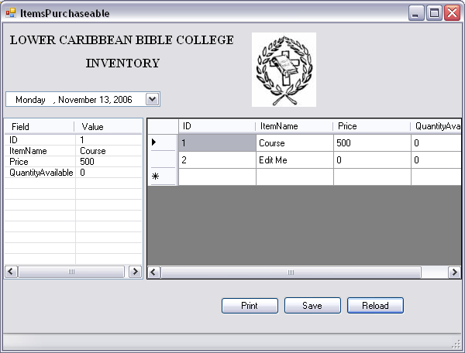

- Print: Allows you to print the inventory.
- Save: Allows you to print the items available.
- Reload: Cancels all changes made and reloads the information from the database.

GRADE POINT

You can access the Grade Point dialog by clicking the “View” button on the main screen as seen in the screen shot below.

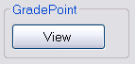
This dialog allows you to edit and print grade point scheme used by Lower Caribbean Bible College.

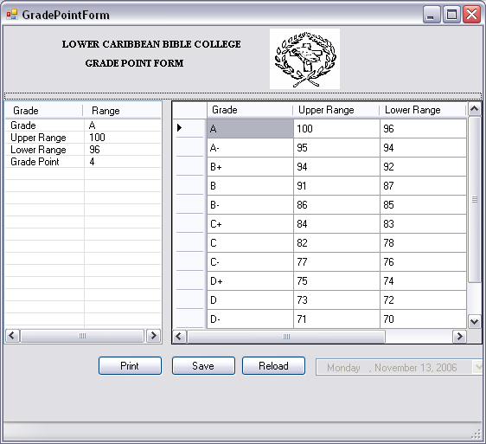
Description of functions:
- Print: Allows you to print the Grade Point Scheme.
- Save: Allows you to save any changes made.
- Reload: Cancels any changes made and reloads the information from the database.
SEARCHING THE DATABASE

You can access the Search dialog by clicking the “Search” button on the main screen as seen in the screen shot below.

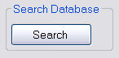

The search dialog allows you to search the entire database.

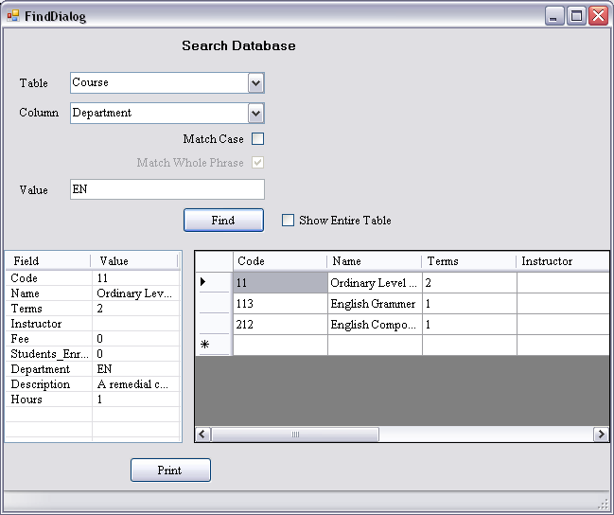

- Table: Specifies which Table in the database to search. In a database similar records are grouped into tables. Tables contain columns indicating the type of a particular field. In the screenshot above, the Courses table has been selected. The Courses table contains columns indicating Code, Name, Terms etc… Each course in the Course table is classified as a record. Other examples of Tables are Student and Applicant.
- Column: The field to search for. In the above screenshot example The department EN was specified.
- Match Case: Specifies case sensitive searching. If this is specified then “andre” and “Andre” are considered 2 different terms.
- Show Entire Table: This allows you to list all the records in the table ignoring the search phrase.
- Print: This allows printing of search results.

PRINTING

Currently the program has limited printing configuration options, in future versions the print options will be expanded upon.

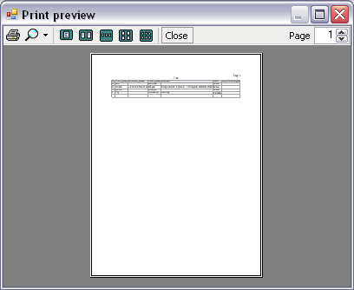

© Alpha Solutions Inc.

