Launch of MUSICOVERY.COM,
a Genuinelly Interactive WebRadio

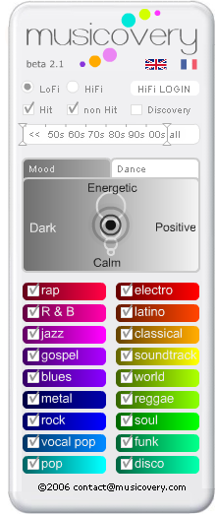
Paris – 14th november 2006
Vincent Castaignet (Emosound) and Frédéric Vavrille (Liveplasma) have combined their technologies to create Musicovery, an interactive webradio which helps searching, finding and playing music.
The interface offers the most natural and useful landmarks to start and drive a musical programme : moods entry (the interface enables to find intuitively the mood looked for), music for dancing (choices of tempo and groove), as well as options to select specific genres, chronological periods and songs fame (hits/discovery).
The interface’s design makes it possible to start your music listening experience in 1 or a couple of clicks, without the need to know, choose and type the name of artists or songs, or even built playlist.
At launch the webradio offers a catalogue of 8,000 tracks from all genres and times. It will evolve very rapidly in terms of functions and catalogue depth.

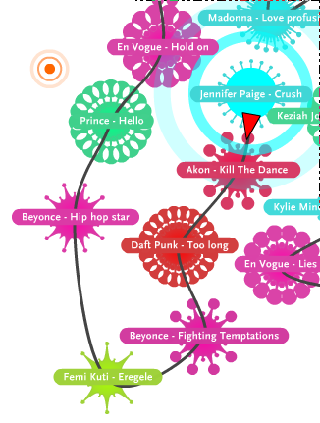

http://www.musicovery.com

Contacts

Vincent Castaignet
vincent.castaignet@musicovery.com

Frédéric Vavrille
frederic.vavrille@musicovery.com

About the technologies
Liveplasma is a graphic discovery engine that allows a dynamic navigation in a set of objects linked together by relationships of similarity or proximity. The engine is today applied to various types of objects: music, movies, news,…
http://www.liveplasma.com/

Emosound designs interfaces to allow an intuitive and straight access to music. Every song is described by a set of parameters which are used in a graphic animation intuitively understandable by the listener.

