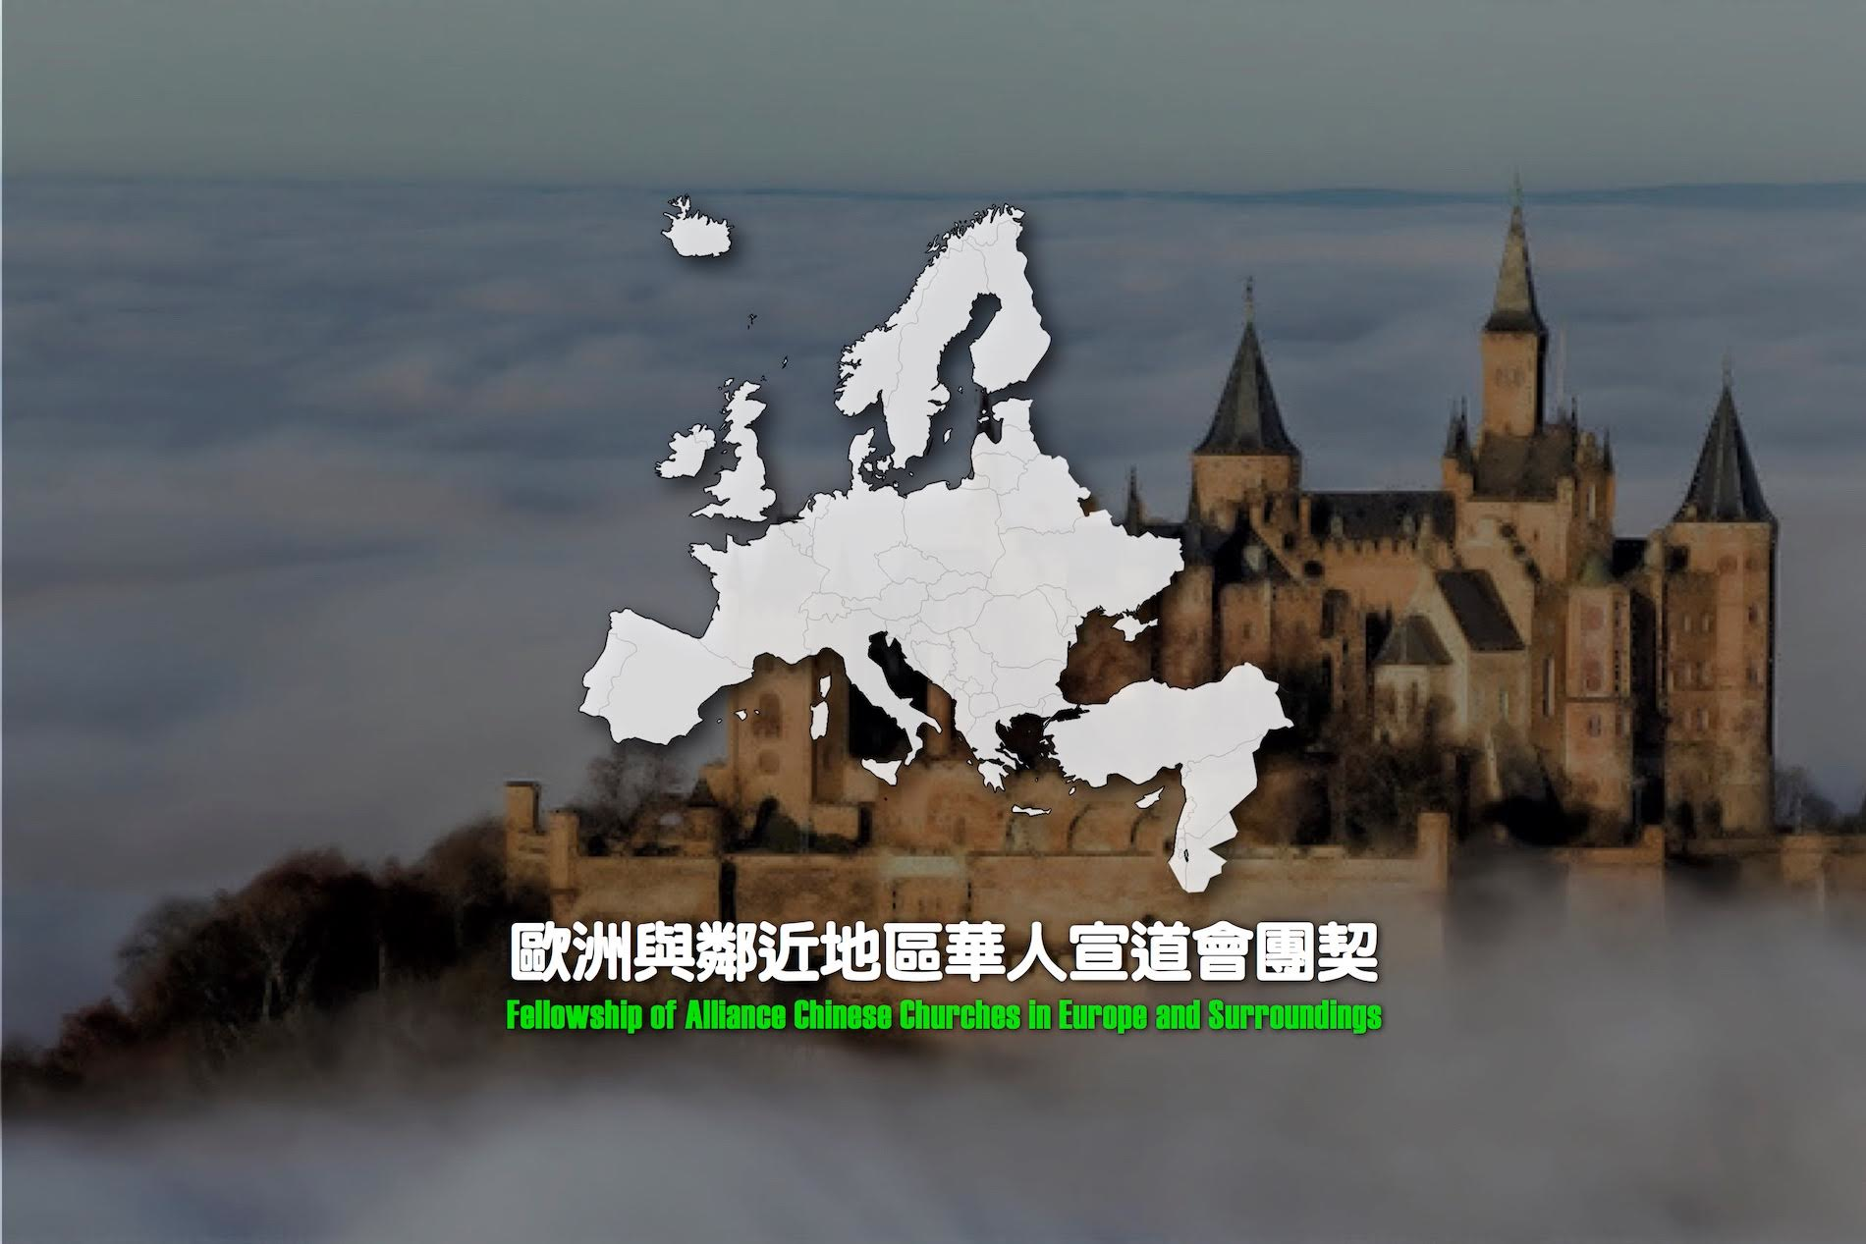

Dear Pastors / Partners in Christ,

The Fellowship of Chinese Alliance Churches in Europe & Surroundings (***FACCES***) praises God for His grace and guidance during this last biennial ***FACCES*** Round Table Symposium (for European co-workers). The Symposium was held in Berlin, from May 4-7, 2015, at the Faith Hope Love Alliance Church.

The Symposium’s main theme this year was, “Pastoring in the City”, and the schedule included speaker presentations, project updates, business, as well as planning sessions. Over 80 national church leaders and representatives from across Europe, U.K., and surrounding regions came together for a rich time of fellowship, discussion, and collaboration. Indeed, there was a deep sense of God’s Spirit and unity.

The following are just a few highlights of the Berlin 2015 ***FACCES*** Symposium:

During the opening ceremony, Rev. Benedict Kwok (professor, Alliance Bible Seminary, Hong Kong; currently on sabbatical leave and doing research in Germany), shared a proposal that promotes further theological training for pastoral leaders in Europe. Dr. Kwok introduced a model for continued education – to provide an opportunity for further equipping and learning Chinese ministry leaders.

The main speaker of the Symposium, Professor Dr. Paul Leung, is an experienced psychiatrist, currently teaching and practicing in the United States. Dr. Leung reminded ***FACCES*** delegates that, as pastors and leaders shepherding flocks in their respective metropolitan cities – we cannot neglect our own personal (and family members’) physical, emotional, and spiritual health. Dr. Leung encouraged us to be attentive, and to seek appropriate support for common concerns -- including symptoms of anxiety disorder, depression, and burn-out. We were also reminded to remain unrelenting in building a strong devotional life nourished by God’s word and prayer. Dr. Leung’s firm clinical and biblical teachings were very timely. ***FACCES*** delegates greatly appreciated Dr. Leung’s serious, wise, and gentle ‘doctor’s orders’.

Among the over 80 international ***FACCES*** delegates joining us from different countries (including French Guyana, U.K., Germany, Israel, Netherlands, Spain) – we were also blessed by other special guests and representatives -- who shared greetings, encouragement, support, ministry updates, etc. These included:

* Wallace Mang (representative, Chinese Churches Association of C&MA U.S.A.);
* Frank Fung (representative, Chinese Churches Association of C&MA U.S.A);
* Aaron Tang (representative, Canada Chinese Alliance Churches Association);
* Nick Tsang (representative, Canada Chinese Alliance Churches Association);
* D &Y (international worker, Creative Access Country);
* Kwong Choi Kan (Hong Kong Men’s Fellowship);
* Frank Wong (representative, accompanied by 11 Suriname church deacons and leaders) who shared about cross-cultural-mission work in Suriname and South America;
* Daniel Nguyen (pastor, France) who shared about short-term mission opportunities for French-speaking millennial in Senegal;
* Dick Kaan (international worker, France) who shared about church-planting and other mission opportunities in Italy.

To more effectively meet the ministry opportunities among the growing Diasporas across Europe, our church leaders recognized the need to establish a formal European Chinese network among our C&MA churches.

Therefore, in May 2013, during our biennial Round-Table Symposium conference held in Paris, national European Chinese C&MA church leaders shared overwhelming support and voted to officially establish ***FACCES*** and also nominated a Working Committee. This formally provided the added accountability that encourages ***FACCES*** to serve as a bridge -- to connect churches and facilitate ministry partnerships in Europe and surrounding areas.

This year in Berlin (May 2015), once again, unity was evident as leaders came together during Symposium scheduled business sessions. Following discussions, national leaders voted and affirmed their official support to adopt a Constitution. Consequently, ***FACCES*** will more effectively be positioned to collaborate and team with other ministry, including their European CMA national offices with which churches are already closely connected.

During the closing ceremony, we were further blessed by another special guest, William Leung (representative, Hong Kong Alliance Global Serve). Rev. Leung re-emphasized our continued responsibility to the God-opened mission opportunities at our doorsteps, and that we are to shine as the light of the world, as we strive to spread the gospel far and wide.

On behalf of ***FACCES***, may I offer praise to God and gratitude to you. Your continued faithfulness and support provide encouragement to us all. We look forward to partnering and serving, together, with you!

Additional information about ***FACCES*** (with a list of the 26 C&MA European Chinese churches, and their ministry descriptions, etc.)can be viewed on our website: <http://www.facces.eu>.

Servant of our Lord,

Daniel Nguyen (representative, ***FACCES*** Committee)

June 2015, France