THE HISTORY OF TELEPRESENCE

AUTOMATA, ILLUSION,
AND THE REJECTION OF THE BODY

by Oliver Grau

Simon Penny's work in progress Traces (fig. 1), which will be premiered in a few days at ars electronica, promises to mark an important step towards an art of telepresence. Traces is a project for three networked CAVEs in different cities. Users will see large virtual spaces, hear spacially distributed sound and experience the vibrations of the floor. Each CAVE will use camera stereo machine vision to construct real-time body maps of its participants. The user interacts with gossamer traces which have movements and volumes of bodies, but are translucent and ephemeral.
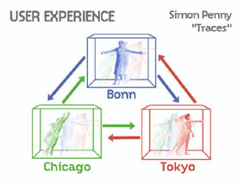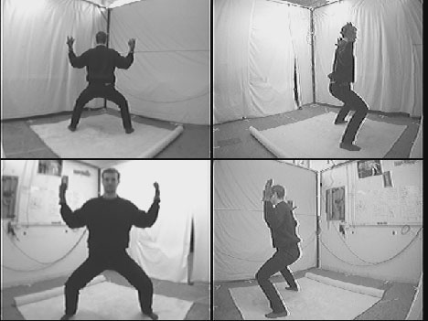

Fig. 1 Simon Penny, Traces, 1999

TELEPRESENCE unites three technological principles: robotics, telecommunications and virtual reality. Telecommunication enables a robot to reach out from a virtual environment into physical reality making it possible for even long distance users to experience this intervention. Thus, telepresence consolidates three persistent concepts in the history of ideas along with their manifest mythical, magical and utopian connotations: the legendary dream and search for artificial life and automation, the aesthetic traditions of virtual illusions and the rejection of the body occult precursors of telecommunications. In order to understand telepresence—its historical, psychological, and epistemological importance—we must understand how these three themes have been expressed throughout history in our technological myths and fantasies. That is what I propose to do here. I will examine the historical precursors of telepresence, focusing on technological manifestations of our notions about artificial life, the aesthetic traditions of virtual realities and the occult precursors of telecommunications. Traditionally diverse disciplines of thought are converging to produce a consolidated utopian projection. The history of technology has always included a history of its utopias and myths that reveal human desire and serve to express protorational points of reference. Myths do not loose their relevance by virtue of being ancient because they are about how we view the world and, as such, maybe outside of ordinary time. They drive history.

automata

The conception of human beings as machines reaches back to antiquity. As early as the second century, the famous physician Galen conceived his pneumatic model of the human body in terms of the hydraulic technology of his age. Art was already being automated in the mechanical theater of Heron of Alexandria (fig. 2). Using a system of cords, pulleys and levers bound to counterweights, as well as sound effects and changing scenery, Heron was able to create an illusion that brought the legend of Naplius to life. Indeed, one continually finds descriptions of technological wonders such as mechanical flying doves, dancing apes, and talking parrots in the literatures of lslamic nations, India, China and Greece. In fourteenth century Florence, it was none other than Filippo Brunelleschi who designed a mechanical stage that brought an imitation of paradise to life.
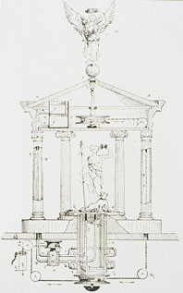

Fig. 2 Heron of Alexandria, Mechanical theatre, 129-199

Medieval evidence of the automaton is almost completely non-existent, since a mechanistic world-view was inconsistent with religious dogmas that proclaimed man, God's creation, the alter deus, the vessel of the eternal soul. By the 17th century, however, we find a return to mechanistic thinking with analogies between the body and the period’s most elaborate technology, the clock. In 1615, Salomon de Caus published his famous collection of plans for automata and gardens, Les Raisons des Forces Mouvantes, which was studied intensely by Descartes (fig. 3) in his effort to construct an android that would in no ascertainable way differ from a human being. Descartes interpreted biological processes as mechanical occurrences. His English contemporary, Thomas Hobbes (fig. 4), took the mechanistic Weltanschauung an important step further by understanding all organic phenomena – including mental phenomena – as physical bodies in motion. Whereas Descartes believed in a non-physical mind distinct from the body, Hobbes took mental phenomena to be nothing more than the movement of bodily substances in the head.
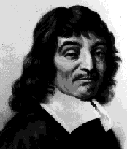

Fig. 3 René Descartes

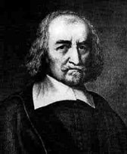

Fig. 4 Thomas Hobbes

The interaction between technology and artificial life is illustrated particularly well by a political event of the 17th century: During an interregnum, the dead English king was represented by movable puppets at his own funeral. This led to the further development of movable figures that, in case of a power vacuum, were used to artificially manifest the absent rulers. In this context we find the machine not as a counterpart, but rather as a continuation and improvement of the human being in the face of death.

In the eighteenth century, the android finally came of age: La Mettrie’s L'Homme Machine (fig. 5), Vaucanson's Mechanical Duck (fig. 6), Kleist's On the Marionette Theater, Hoffmann's Olimpia, Mary Shelly's feeling monster in Frankenstein, the Maschinenmensch in Fritz Lang's Metropolis (fig. 7), as well as the vast collection of robotics fantasies of our century are all branches of a development, stemming perhaps from the Jewish metaphor of the Golem, warning against self-deification. Even if today nobody knows exactly how consciousness functions, the android seems to reemerge in the attempt to produce artificial life and intelligence on the internet.
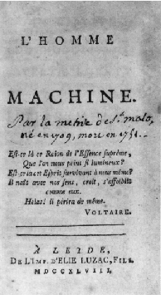

Fig. 5 La Mettrie, 1747
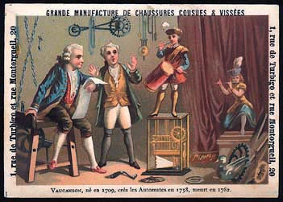

Fig. 6 Vaucanson, 1758
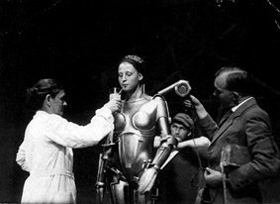

Fig. 7 Fritz Lang, Metropolis

The motivation for these large-scale attempts to combine technology and art and breathe life into them seems to stem from male uterine envy, as well as the demiurgic self-deification of the artist. At the core of artistic motivation, however, we also find the fantasy of overcoming the limitations of our own bodies. This manifests itself partly in a desire to achieve immortality through machines.

b. VIRTUAL ILLUSIONS

The seemingly unprecedented phenomenon of virtual reality, the third source of the vision of telepresence, actually rests on a deep tradition within the history of art. The tradition is often subjugated to the media of a given period and has also been employed with disparate subject matter. However, the core idea of this tradition reaches all the way back to antiquity and has been expansively revived in the VR-art of the current age. This kind of virtual reality hermetically excludes the sensation of being alienated by the image and integrates the observer 360 degrees into an illusory space where time and place are one (fig. 8). At the very least, it fills out the field of view of the onlooker. The immersive cult frescos of the Pompeiian Casa dei Misteri (fig. 9), Baldassare Peruzzi's Sala delle Prospettive in Rome or the Sacri Monti movement represent stages of this aesthetic conception.
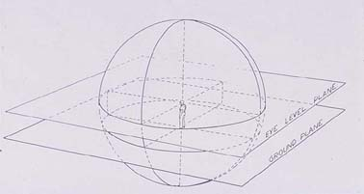

Fig. 8 John Boone, Spherical Field of Vision (Immersion)
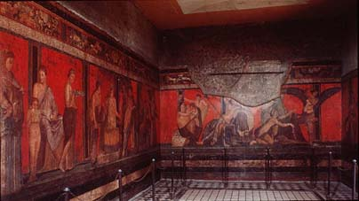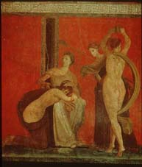

Fig. 9 Casa die Misteri, Pompeji, 60 B.C.

Parallel to how these historical forms of media repeatedly go beyond pure simulation in order to make the audience believe it's non existent content, it is the genuine core of the virtual to create an alternative dimension of reality. Therefore in the history of ideas, illusionary spaces are predessors, also of non cartesian environments like Char Davies Osmose (1995), Èphémére (1998) or Monika Fleischmanns and Wolfgang Strauss' Murmuring Fields (1999). From a historical perspective, the suggestive power of virtual reality is not only a visual arena for ritualistic acts or employed for the establishment of private artificial utopias but also to provide a forum for public and mass media spectacles in religious and political spheres – a visual history, the symptom of which is totality, that continually simulates presence over great distances.

An outstanding example appeared at the beginning of the sixteenth century near Varallo in northern Italy on the slopes of the Sacro Monte (fig. 10): An artificial installation exhibiting the stations of the life of Christ. The idea was to present the public not with a picture of the contemporary Jerusalem but rather to present a complete simulation of the sacred places as they are described in the Bible and in the Meditationes of Augustine. On the way up the mountain, the believers could begin to imagine themselves on a pilgrimage. Once they reached the top, they were surrounded by the virtual environment. Through 28 dioramatic stations the pilgrims experienced the life of Christ from the Anunciation to the Pietà. The success was overwhelming, visitors came in thousands, day by day, even from foreign countries. Prominent humanists and franciscans guaranteed the historical authenticity of the graphic arrangement and the accordance of the installation with the particulars of the Holy Land.
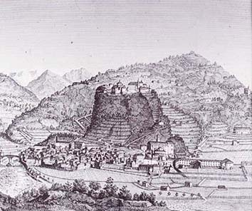

Fig. 10 Sacro Monte, Varallo, ca. 1500

The most famous virtual installation on the Sacro Monte, the Calvary (fig. 11), was created by Gaudenzio Ferrari. Ferrari was much admired by his contemporaries and placed in the company of Raffael, Michelangelo and Leonardo. He adhered to a strict naturalistic style. The creations were made in the service of techné conditioned by the ideal of mimesis, so that some of the life-size, color, terra-cotta figures wore real clothes and wigs and even had glass eyes (fig. 12). At the core of the exhibition method was the illusory fusion of the three-dimensional foreground with the two-dimensional fresco. This Gesamtkunstwerk came into direct contact with the observer and conveyed an immersive presence that involved the pilgrims physically and psychologically in the distant events. The chapels could be visited at night by torch light, hightening the illusion’s impact. Monks leading the pilgrims through the installations found it necessary to continually remind them that this was not the real Jerusalem. The persuasive success of this suggestively powerful image complex was so enduring that the coming years saw the appearance of a whole series of Sacri Monti. The project was propelled, not at least, by a desire to use the spectacle to counter the approaching Reformation. The sacrimonti installations were used as a sort of shield embracing the onlookers with powerful images and manipulating their inner visual memory.
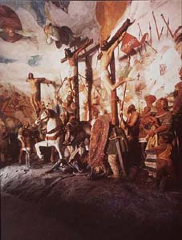

Fig. 11 Sacro Monte, Calvary, 1518-1522
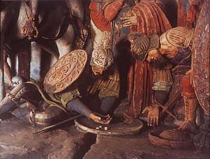

Fig. 12 Sacro Monte, Calvary, 1518-1522, detail

In Mannerism and the Baroque period, chambers of illusion were en vogue. Towering relms of fantasy and deception constructed with the traditional devices of the plastic arts found their fullest flourishing in the Panorama (fig. 13 and 14), patented in 1787. The Panorama was that medial dinosaur, tele-visor and mass entertainment sensation of the nineteenth century. These huge photo realistic canvasses – circular-hanging and often larger than 7000 square feet – hermetically enclosed onlookers. The image was not experienced as a self-contained object anymore, but perceived in its form of a totalized image therefore preventing its reception as a work of art. In reality though these highly suggestive, visual media were used repeatedly for the realisation of visual phantasies or propaganda. The representations of nature provided visual totality, produced an intense effect of immersion and allowed journeys through time and space – a complete universe of illusion. The effect was so intense that already around 1800, it was argued that the illusion could affect the ability to perceive reality.
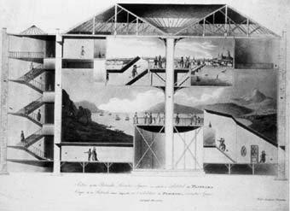

Fig. 13 cut through panorama rotunda
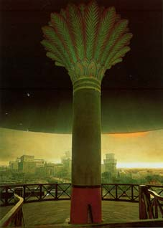

Fig. 14 Panorama Altötting

The budding age of tourism, an age preoccupied with a longing for distant places, found a perfect witness in the panorama. These rotundas brought the world to the metropoli of Europe and North America and, for many, became a cheap surrogate for physical presence abroad. Being telepresent with the eyes was compared with actual travel and many preferred the former to the latter. In Blackwood's Magazine from 1824, we find the following report:

"What cost a couple of hundred pounds and half a year, half a century ago, now costs a shilling and a quarter of an hour. Throwing out of the old account the innumerable miseries of travel, the insolence of public functionaries, the roguery of innkeepers, the visitations of banditti, (...) the indescribable disagreements of Italian cookery, and the insufferable annoyances of that epitome of abomination, an Italian bed."

Even the sober evaluations of Alexander von Humboldt assert that the panorama could almost "supplant a trek through diverse climates. The observers, as if trapped inside an enchanted circle and removed from all the interference of reality, envision themselves to actually be in the foreign environment."

Not only has western art always been bound to the media that carry it but it has also, over and over, favored, inspired, and initiated the inception of new media of illusion. The tendency toward illusionism has provided an essential motivating factor behind new developments in media of illusion. The development was marked by an exchange between large format immersion spaces that fully integrate the body, (frescoes, panoramas, stereopticons, Cineorama, Omnimax- and IMAX-Cinema and the CAVE, fig. 15), and devices held directly in front of the eyes (peepshow images, stereoscopes, Stereoscopic Televison, Sensorama and HMD, fig. 16). VR marks the search for an interface that ideally appeals to all senses and that is as immediate and as imperceptible as possible, as if the illusion were a real experience. Prominent artists in the virtual arts, like Char Davies, Monika Fleischmann and Wolfgang Strauss (GMD) or Christa Sommerer and Laurent Mignonneau (ATR), with their pioneering research installations, are once again combining art and the natural sciences, helping to reflect the most complex methods of polysensual illusion. With this development, we witness the historical return of that type of artist, who is both artist and scientist.
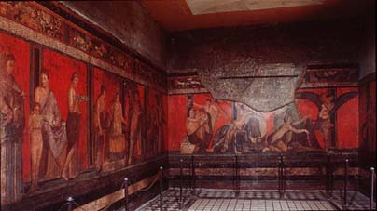

Fig. 15a 360° fresco
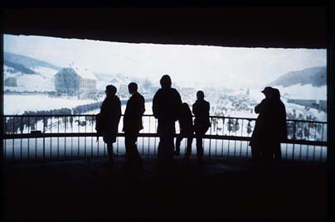

Fig. 15b panorama
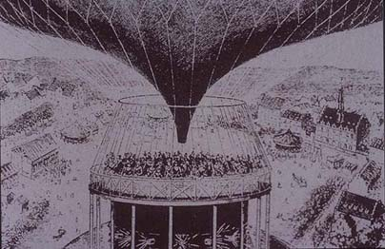

Fig. 15c Cinéorama
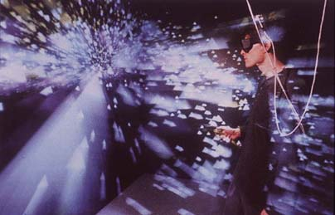

Fig. 15d CAVE
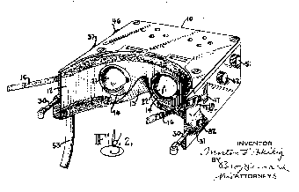

Fig. 16a Stereoscopic Television, 1960
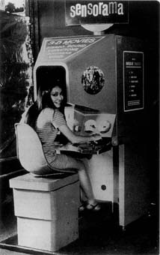

Fig. 16b Sensorama, 1962
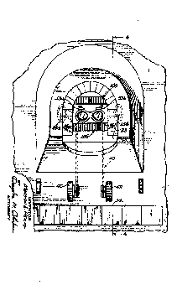

Fig. 16c Sensorama, 1962
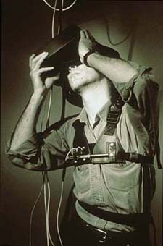

Fig. 16d HMD, 1995

c. REJECTING THE BODY

Communication through light is an old idea. Even the news of the fall of Troy is reported to have been disseminated throughout Greece by means of a chain of light signals. The separation of the code from its carrier allowed, for the first time, images to appear in various places and media independent of direct human agency. A pre-history of the idea to effect presence in distant places, telepresence, cannot avoid the image. In the longest period of its history, before the 'invention of art', the image was understood to be loaded with occult powers. We can see this in the German word for image, Bild, and its etymological germanic root bil. Bild represents less the consciousness of the visual image than the more lively and often over-looked sense of something that is permeated by an irrational, magical and spectral power which cannot be fully understood or controlled by the observer. It is as if it were an artifact that has freed itself from the body and now possesses a life of its own. In the middle ages, the idea that divine images could gain presence in aesthetic representations and express themselves was something that was in no way contradicted by the fact that these representations had been fashioned by human hands. The quality of telepresence found in cult images reveals itself in testimonies attributing lifelike blood, tears and actions, called miracles, to them. Various imaging technologies have similarly been viewed as able to traverse spatial, temporal, and even metaphysical boundaries. In belief systems that rely heavily on images – Voodoo for example – images and puppets are credited with the power to work miracles and magic over great distances. Images allow for direct interaction with the gods, and secure presence and power for that which is represented.

In regards to this function of the image, the idea that one could gain presence and travel through space by stepping through a mirror emerged in the middle ages and early modern period. Under certain conditions, one was supposed to be able to see his own free-floating image hovering about the room. In 1529, Agrippa von Nettesheim asserted that with the aid of a catoptrical mirror one could project any image in the air as far as one wished. According to legends and tales, magic mirrors reflect a reality, that is simultaneously, like in the Romance of the Rose (1265-80), distant and in the distant future. The observers, however, have, for the most part, no influence upon the events they regard.

Various imaging technologies have similarly been viewed as able to traverse spatial, temporal, and even metaphysical boundaries. In the medieval and early modern periods, the mirror was reputed to make possible extraordinary types of observation. In 1646, Athanasius Kircher described a cylindrical mirror that through an artificial alteration made it possible to show the Ascension of Christ hovering in open space. (fig. 17). According to legend, mirrors can destroy entire fleets by fire or make them visible beyond the horizon. A mirror belonging to Pythagoras was said to project everything written upon it in blood, onto the surface of the moon. The sick were advised to cover up their mirrors so that their souls could not fly away and escape to another sphere of existence. Mirrors have the power to bind light in a way that enables discovery. This is not only the case with the telescope.
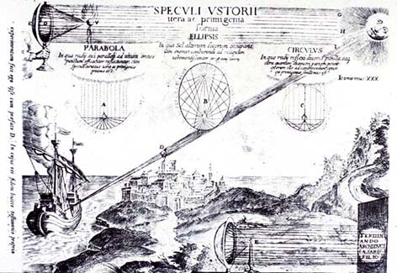

Fig. 17 Athanasius Kircher, Ars magna lucis et umbrae, Rom 1646

The Cinéma Telegraphique and the Telephonoscope of Thomas A. Edison (fig. 18) remained media-utopia. Even before the invention of movies, these projects envisioned the transmission of moving pictures. At the turn of the century, a British couple was said to be able to communicate with their daughter on the colonial British Island of Ceylon by means of a large format screen that they hung over their fireplace instead of a painting.
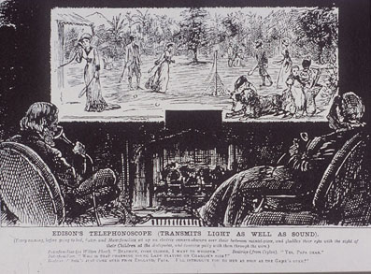

Fig. 18 Thomas A. Edison, Telephonoscope, 1879

The Seeing machine of Christian Riess (fig. 19) stands as a precursor of the webcam. Riess connected a camera to a machine that could send electric image signals over the telephone lines to be retranslated into an image at the other end. By the 1930s, the notion of telecommunication had been fused with the notion of artificial life to form a powerful new vision of a disembodied human self. Italian Futurists envisioned a metallic body that would gain vitality through mechanical impulses. Thus, Marinetti (fig. 20) did not only want to overcome death but also with the aid of radiophony – a form of cordless telegraphy – to massively expand the body's sensual perceptions. Taste, touch and the sense of smell were supposed to expand to the point of being capable of receiving stimuli over enormous distances. It is at this point that the concept of the automaton is combined with the mythological power and the utopian aura of electricity, the roots of which lie in the European Enlightenment. In the United States, it was believed that the integration of nature and mechanics would eradicate the evils of industrial society. Evidence for this is found in Mumford's early works as well as in McLuhan's electrical fusion fantasies. In his book God and Golem (1964) Nobert Wiener envisioned the possibility in principle of translating the very essence of man into code and transmitting it over telephone lines. Over and over again the image of humankind is projected into the most current technology, which is in its potential not fully understood. In search of the substance of man, one hopes to realize the essence of life in projections of utopian technologies.
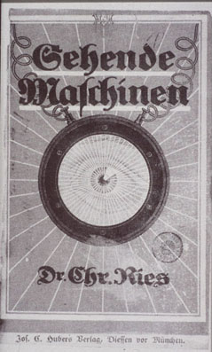

Fig. 19 Christian Riess, Seeing Machine, 1916
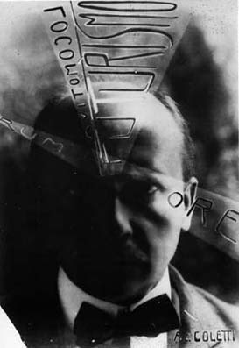

Fig. 20 Filippo Marinetti

Aside from sober considerations about the optimization of our control over space, the utopian notion of a global amalgamation of information that would evolve to form a community intelligence on a massive scale came onto the scene, at the very latest, after being inspired by McLuhan's comment on the extension of man. It is assumed that this infosphere would spread over the frail and increasingly ailing globe as a massive nirvana. This sphere becomes affiliation itself. The categorical imperative of the cyber-culture is universal communication and includes the notion that every piece of equipment, every airplane, every coffee machine will get an internet address in order to engage, as far as possible, in a cordless exchange of information with everything else. Some exponents of cyber-culture, as original as they might at first seem to be, fall, from a historical perspective, into well-worn historical tropes. Pierre Lévy envisions "a transcendental 'collective intelligence' as the future source of human consciousness" and a kind of meta-language springing from direct global communication. The Pope of VRML, Marc Pesce, and Bruce Damer go from conference to conference with their religious rhetoric. They preach of the phantasma of unification in a global internet congregation, the Cybergnosis, of deliverance in technology, or even of being disembodied as post-biological-eternal data scattered across the globe. This concept is most radically formulated by Hans Moravec.

Today, in the age of an advanced technological upheaval, the concept of omnipresence, an anxiously desired state of transcendence, a variation of the gnosis, is being unconsciously entreated. It is a sign of uncertainty that myths are once again appearing on the scene. They provide models of comprehension that stem undoubtedly from religion. The idea of the transcendental abandonment of the body follows from the primeval notion of the migration of souls, as expressed in Buddhism or in the Upanishads. These belief systems propound the involution of the spirit in the material, metempsychoses or reincarnation. Religions, esoteric faiths, parapsychology, and apocalyptic sects are all searching for ways to overcome the physical. They view human existence as a transitional stage on the path towards pure spirit. We find the notion of the immortality of the soul at least as early as Plato. Hermes Trismegistos asserts, "the innumerable bodies we must pass through [...] until we are united with the one and only god." Mystical theories propound the existence of another, transcendental reality in the light of which this material world sinks into meaninglessness. Furthermore, we can find corroborating evidence for these sentiments in apocryphal and canonical scriptures. Aquinas regarded it an essential ability of angels that they be independent of space and time to take on human bodies. The concept of the migration of souls permeates western thinking to various degrees from Giordano Bruno, to Swedenborg, to Lessing and others. It is an ideology that stands in opposition to the enlightenment. It should be made clear that many religions and occult teachings conceive of the immortal soul, or the enduring self, so to speak, as a wispy, untouchable, and, under certain circumstances, even visible apparition. In Gnosticism, a chosen one can experience a taste of the ascension of the soul in religious ecstasy. The highest goal of the mystic is to seek out the experience of the divine in its most comprehensive and absolute form. It could be the Ka of the ancient Egyptians, or the astral bodies of the theosophes. All speak of a being separate from the body.

d. TELEPISTEMOLOGICAL IMPLICATIONS

Media utopias are born in flux, in the aura of magic and the occult. It is no coincidence, that after the collapse of the prevailing utopias of the twentieth century that, along with a fortification of religious and ethnic categories, the modern media too has become a reliquary of utopian projections that are anti-world systems. Telepresence combines the contents of three archetypal areas of thought: the creation of artificial life, virtual illusion, and a non-physical view from the self. These notions collide within the concept of telepresence, which enables the user to be present in three different places at the same time: a) in the spatio-temporal location determined by the user’s body, b) by the means of teleperception in the simulated, virtual image space (the point to which attempts in art history have lead so far to obtain Virtual Reality), and c) by means of teleaction in the place where for example a robot is situated, directed by one's own movement and providing orientation through its sensors.

The media-induced epistemology of telepresence seems to be a paradoxon. Telepresence is indeed a mediated perspective that surmounts great distances, however, perception will soon be enriched in the virtual environment. The so-called lesser senses will be adressed ('active' touching, 'passive' feeling, smelling and even tasting) thereby reducing the abstracting and term-generating function of distance. The three-fold nature of telepresence raises fundamental questions in telepistemology, for example for our understanding of the way distance affects our capacity for knowledge and discovery. Aesthetic theories since the eighteenth century have interpreted distance as the precondition for reflection and self discovery and for the experiance of art and nature. However, this is a distance primarily defined epistemologicly as the accrual of overview and is not, as in the case of telepresence and telecommunications, understood as the surmounting of physical distance. Neither does distance reject the compulsive or passionate, nor religion and myth, it focusses, however, on its qualifying integration into the experience of human entirety. The inner distance were to be matched carefully in order to allow the total view as much as the detailled perception. In his intellectual collaboration with Ernst Cassirer, Aby Warburg stressed the intellectually productive awareness raising power of distance in his Mnemosyne Atlas. The result of this physical and psychological distancing from the phenomenon is Warburg's conceptual space (Denkraum) – the precondition for the constitution of the subject and the development of consciousness. It seemed to him that this was already threatened at the beginning of our century through the sudden proximity created by the telegraph.This idea was inherited and expanded in the theories of aesthetic distance offered by Adorno, Jonas, and Serres.

In contrast stands Paul Valéry (fig. 21), whose "Conquest of Ubiquity," predicted electrical transmitted longdistance transmission of sense experiments. Valéry envisioned, in a certain sense as a spiritual father of McLuhan, an art-media that, like electricity or tap water, could be available everywhere and mediate polysensual stimuli:

"Works will attain a kind of ubiquity. Reacting to our call, works of art will obediently present themselves everywhere and at any time. They will cease to exist only in themselves, but be present anywhere, wherever there is someone and a suitable set of equipment. ... We (will) find it completely natural ... to receive these extremely swift mutable images and oscillations out of which our sensual organs ... will make up all that we know. I do not know if there has ever been a philosopher who has dreamed up a company specializing in the free home delivery of sensually perceptible reality."
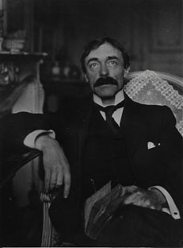

Fig. 21 Paul Valéry

If we did not know that these comments were written in 1928, they could be describing netbased telepresence. It seems as though soon a fusion of all the senses with a virtual image machine will produce a compelling impression of intimate bodily closeness for the spatially distant observer. In the animated image, the observer is electronically present at light-speed, via Robot, possibly at several locations simultaneously. Telepresence is transforming the classical perception of space, that had been primarily linked to physical location. Distance as Cassirer described it is giving way to visual and tactile experiance provided on demand anywhere, anytime (Valéry).

Today we are on the threshold of change in our location-oriented concept of persons. Telepresence has far-reaching consequences for work, culture, jurisprudence and politics. However, there is hope for a global shift in consciousness. Impetus for this was formulated a few years ago with the Gaia-perspective. The telepresence installation T-Vision by ART+COM (fig. 22) attempted to visualize this with aesthetic means: the entire face of the earth was generated out of topographical data and satellite images using a level of detail to manage scene complexity, the work presents a model of the earth as seen from a million kilometers above its surface, or at the level of desktop in Berlin. It's a bit like Nicholas of Cusa 1453 described an all-seeing God: "[...] the absolute vision of God [...] surpasses all of the precision, swiftness and power of all other real observers [...]" "Your field of view [...] is not of any size but rather infinite, like a circle because your view is the eye of spherical perfection and infinite completeness."
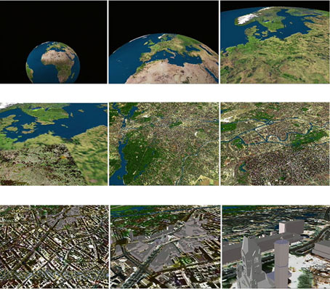

Fig. 22 ART+COM, T-Vision, 1995-1999

Following Simon Pennys concept for Traces (fig. 1), the interaction will take "[...] the form of real-time collaborative sculpturing with light, created through dancing with telematic partners." Consequently Traces will give users the opportunity to catch a glimpse of the feeling of having a dispersed body and the experience of interaction with traces of other remote bodies. The division of body and mind is not only easily traced back to the dualistic conception of human beings, but also to the gnostic tradition of devaluating corporality. According to this conception the spirit is simulated to an increasing extent, whereas the body is restrained in its function of getting sensual knowledge of the world – most intensivly by experiences through the skin. The exchangeable experience conveyed by machines and saved in its elements on computer is taking up the position of the real body and of physical experience. Through networking between a variable number of technobodies telepresence unfolds a multiplicity of experiences, spaces and bodies. These might even be set up in entirely contradictory recognitions. The ability to move with and through different bodies even intensifies this paradox.

Reality – as stated by quantum physics – is always a product of perception. Distance and proximity will coincide through a technical set up in real-time and create the paradox of I am where I am not and I experience sensual certainty against my better judgement. This way we might reach the most remote parts of our planet. Conscious tele-experience is not during the period of technological self-relinquishment, but at the moment of return; a return which relies on the realisation of the technological basis and its actual relation with the body.

Media utopias are born in flux, often in the aura of magic and the occult. It is no coincidence, that after the collapse of the prevailing utopias of the twentieth century, along with a fortification of religious and ethnic categories, the modern media too has become a reliquary for utopian projections. The desire to overcome physical distance, to project ourselves outside the constraints of our own physical bodies, has always been a powerful motivation for both art and technology. It has inspired art that strove to bring about what the technology itself could not realize. Telepresence and the Internet mark the latest stage in this development, a union of fact and fiction that is not just technological and not just artistic.

ANNOTATIONS

Horst Bredekamp discovered monastic automata from the sixteenth century that mechanically prayed the rosary. H. Bredekamp, Antikensehnsucht und Maschinenglauben: Die Geschichte der Kunstkammer und die Zukunft der Kunstgeschichte, (Berlin: Wagenbach, 1993), 72, fig. 31. Legends of automation from the middle ages can be found in Reinhold Hammerstein, Macht und Klang, (Bern, 1986.).
John Amos Kominstky (Comenius), Orbis Sensualium Pietus, (Nürnberg,1657).
René Descartes,Traité de l'homme, 1662. According to legend, Descartes himself constructed an android, ma fille Francine that could do somersaults on a tightrope—a substite for his own illegitimate daughter of the same name? The excellence of his artistry proved to be the undoing of this feminine miracle machine: A terrified captain threw the machine overboard out at sea.
Thomas Hobbes, De homine, 1658.
Ernst H. Kantorowicz, The King's two Bodies (Priceton: University Press, 1957)
Aram Vartanian (Ed.), La Mettries L'Homme Machine (1747): A Study in the origins of an idea, (Princeton: University Press 1960).
John R. Searle, "Das Rätsel des Bewußtseins: Biologie des Geistes – Mathematik der Seele", Lettre International 32, 1996, 34-43.
See Luc Steels, ed., The Artificial Life Route to Artificial Intelligence: Building Embodied, Situated Agents, (Hillsdale, New Jersey, 1995); Thomas S. Ray, An Approach to the Synthesis of Life in: Margaret A. Boden, ed.: The Philosophy of Artificial Life, (Oxford: University Press, 1996): 111-145. Also dealing with the hope for cultrally meanigful digital transmissions, Richard Dawkins, Mind Viruses, Ars Electronica 1996, Memesis: The Future of the Evolution, (Vienna: Springer, 1996), 40-47 as well as Kevin Kelly, Out of Control, (London: Forth Estate, 1994).
O. Grau, "In das lebendige Bild: Die Virtuelle Realität setzt der Kunst neue Spielregeln", neue bildende kunst, 6. (1997), 28-35.
O.Grau, "Zur Kunstgeschichte der Virtuellen Realität: Eine Forschungsnotiz", Kunstchronik, 7 (1998), 354-355.
Anonimo, Tractato de li capituli de passione: Questi sono li misteri che sono sopra el Monte di Varale, Milan, march 29, 1514.
The contemprary aesthetic theory demanded along with the life-like representation of proportions, colors and perspective, especially the conveyance of passion (moto). See G. Paolo Lomazzo, Trattato dell'arte della pittura, scultura ed architettura, (Rome 1844) (1584). It was Gaudenzio Ferrari, who represented the category moto in Lomazzos Tempio della Pittura. Lomazzo, Idea del Tempio della Pittura, Bologna 1785 (Milan 1590), 40.
Imparticularly after the Council of Trient, they followed a stategic iconographic program against the Reformation: Orta (1576), Crea (1589), Varese (1589), Canavese (1602), Graglia (1616), Oropa (1620), and Domodossola (1656). The movement of the Sacrimonti spread throughout Italy and was eventually exported to France, Portugal, Spain, Mexico, and even Brazil.
Silvia Bordini, "Paesaggi e Panorami: immagine e immaginazione del viaggio nella cultura visiva dell'Ottocento", Ricerche di Storia dell'Arte, 15 (1982), 27ff.
Blackwood's Magazine 15, (1824), 472f.
Alexander von Humboldt, Kosmos: Entwurf einer physischen Weltbeschreibung, Vol. 7., Hanno Beck, ed. (Darmstadt: Wissenschaftliche Buchgesellschaft 1993), 79.
Recent art history of virtual reality spand ultimately from Wagner's concept of the Gesamtkunstwerk to Monet's impressionistic panorama Nymphéas, to Prampolini's plans for a futurist polydimensional chamber stage, to Eisenstein's theory of the multisensory Chamber-Film, to Youngblood's Expanded Cinema, to Heilig and Sutherland's Mediautopias and the hype of the Californian Dream. See: Oliver Grau: "An historical Approach to Virtual Reality", Centre for Advanced Inquiry in the Interactive Arts (CAiiA), Newport/Wales, Consciousness Reframed, art and consciousness in the post-biological era (5.-6.7.1997), Proceedings published by the University of Wales College Newport, Roy Ascott ed., (1997) 159-163.
M. Slater et. al., "Depth of Presence in Virtual Environments", Presence: Teleoperators and virtual Environments, 3. 2, (1994), 130-144; D. W. Schloerb, "A Quantitative Measure of Telepresence", Presence: 4.1, (1995), 64-80.
C. Sommerer und L. Mignonneau, eds., Art@Science (New York: Springer 1998).
Telecommunications and military history: Friedrich Kittler, Gramophon, Film, Typewriter, (Berlin: Brinkmann & Bose, 1988).
Alfred Wolf, Die germanische Sippe bil: Eine Entsprechnug zu Mana, (Uppsala: Universitets Årsskrift, 1930), 18-56.
Hans Belting, Bild und Kult, (München: Beck 1991).
In pre-comlumbian Mexico, they would kill the image of the God that they were trying to influence in the human sacrifice, i.e., just like the concept behind Voodoo a being that is not directly approachable is addressed through the medium of the image (the human sacrifice) and through the manipulation of the image the being addressed is persuaded to fulfill the wishes of the worshipers.
H.C. Agrippa, De occulta philosophia, (Colone, 1529) I.6, II.1.
Occult beliefs attribute the crystal ball with the power of providing one a privelleged glance into the future. Their sublime form and exceptional substance symbolize the abstract, the hermeneutical technique of the atemporal or tele-vison.
Athanasius Kircher, Ars magna lucis et umbrae, (Rome 1646) X.3.3, 896-900. Like Agrippa, Kircher was obsessed by the art of telegraphics: his projections utilized solar equipment and he was able to project over a distance of five hundred feet. He hoped to reach distances of up to twelve thousand feet with larger equipment.
Jurgis Baltrusaitis, Der Spiegel: Entdeckungen, Täuschungen, Phantasien (Giessen: Anabas, 1996) 328.
Georg Andreas Boeckler, Theatrum Machinarium Novum, (Nürnberg 1661).
C. Riess, Sehende Maschinen, (München: Hubers Verlag, 1916).
"La Radia, Futuristisches Manifest vom Oktober 1933", Vom Verschwinden der Ferne: Telekommunikation und Kunst, Peter Weibel and Edith Decker, ed. (Köln, 1991) 224-228.
James W. Carey et al, "The Mythos of the Electronic Revolution", American Scholar 39 (1969-70): 219-241, 395-424. R. Smith, "Technological Determinism in American Culture", Merritt Roe Smith (Ed a.o.): Does Technology drive History? (Cambridge: MIT Press, 1994) 1-35.
Pierre Lévy, L'intelligence collective. Pour une anthropologie du cyberspace (Paris: Éditions La Découverte, 1995).
Marc Pesce, www.hyperreal.org/~mpesce/caiia.html "The deterritorialization of the self is the essential feature that marks human entry into cyberspace. In the universe of infinite connection and possibility the only possible ontology is magical; [...] The techniques of magical will, quintessentially linguistic, require a conscious mastery of the relationship between word and world. At the end of history comes the Word."
Bruce Damer, www.damer.com/
Hans Moravec, "Körper, Roboter, Geist", Kunstforum International, 133, (1996) 98-112.
On this recently published: the slightly unsystematic esoteric cosmos of ideas of Eric Davis: Techgnosis: Myth, Magic + mysticism in the age of information, (New York: Harmony Books, 1998).
Krishna proclaims, "Only the body is transient, within it dwells the eternal soul.", Krishna, Bhagavadgita: Des Erhabenen Sang, (Jena: Diederichs, 1922) 2, 18. The term Avatar, the mental traveler, comes from Sanskrit. Geoffrey Parrinder, Avatar and Incarnation, (London: Faber and Faber, 1970).
It seems that the oldest passage with the judaic corpus that mentions the idea of a heavenly asscension is the so-called ethiopian book of Henoch. In Greece, ideas regarding the astral natur of man appear, for the first time, in the second half of the fifth cetury B.C.
Along with telepathy, we should mention the notion of personal duplication that is indigenous to the esoteric millieu.
Plato, Phaidon, (Zürich: Rascher 1947) 257, Meno, 81b.
Die XVII Bücher des Hermes Trismegistos, (Icking: Akasa, 1964). See also Dionysos Areopagita (ed. and transl. by Walter Trietsch) Mystische Theologie und andere Schriften, (München-Planegg: Barth, 1956).
"According to the nature of my unborn self, I always was, am, and always will be." Meister Eckhart, Deutsche Predigten und Traktate, Josef Quint (ed.), (München: Hanser, 1977), 308.
"Cum igitur angeli neque corpora sint, neque habeant corpora naturaliter sibi unita, ut ex dictis patet, reliquitur quot interdum corpora assumant." T. Aquinas, Summa Theologia, I, 50, 2.
Initially a pioneer of the sciences, Emanuel Swedenborg (1688-1772), according to Kant, gradually became more of a clarivoyant, who perceived the great fire of stockholm from a distance of five hundred kilometres.
Thus Chris Griscom writes "We leave our physical vessel, move, however, only one sequence further toward in the astral frequency. Griscom, Die Frequenz der Ekstase, (München: Goldmann, 1988) 232.
Cassirer, Individuum und Kosmos, (Darmstadt: Wissenschaftliche Buchgesellschaft, 1963) (1927) 179.
Warburg, "Einleitung zum Mnemosyne-Atlas", Ilsebill Barta Fliedl und Christoph Geissmar eds. (Vienna: 1991) 171-173. Erwin Panofsky emphasized the deciding function of perspective for the construction of the ego and personal space. "Die Perspektive als Symbolische Form", Veröffentlichungen der Bibliothek Warburg. (Berlin: Teubner, 1927) 287.
Warburg, Images from the Region of the Pueblo Indians of North America, (Ithaca: Cornell University Press, 1995 (1923).
Adorno wrote: [...] Distance is what nearness to a work's substance requires first. In the Kantian term of indifference, which demands an aesthetic behaviour that does not seize the object, does not devour it, this is noted. [...] Distance, concerning the phenomenon, transcends the mere existence of a work of art; its total nearness would be its total integration. (transl. O.G.)] Adorno: Ästhetische Theorie, (Frankfurt: Suhrkamp, 1973) 460.
H. Jonas, "Der Adel des Sehens: Eine Untersuchung zur Phänomenologie der Sinne" (1954), in Organismus und Freiheit: Ansätze zu einer philosophischen Biologie (Göttingen 1973) 198-219.
Michel Serres points out, that only in the fixed artwork of which elements the onlooker 'sets into motion' the spacial configuration becomes vivid sensuous event. Serres: Carpaccio: Ästhetische Zugänge, (Reinbek: Rowohlt, 1981) 152.
Valéry, "Die Eroberung der Allgegenwärtigkeit", Über Kunst, Frankfurt/Main, 1973) 47 (transl. O.G.).
Valéry, "Die Eroberung der Allgegenwärtigkeit", Über Kunst, Frankfurt/Main, 1973) 47 (transl. O.G.).
www.artcom.de/projects/t_vision/welcome.en
Nicholas of Cusa, Vom Sehen Gottes, Philosophisch-Theologische Schriften, vol. 3, Leo Gabriel, (Vienna, 1967) 93-219.
Nicholas of Cusa, 93-219.
http://imk.gmd.de/docs/ww/mars/proj1_4.mhtml
Regarding a cultural history of the skin. Claudia Benthien, Haut. Literaturgeschichte – Körperbilder - Grenzdiskurse, (Reinbek: Rowohlt, 1999).

