

Pre-Dispatch Decision Intelligence:
Risk-Profit Integration for Operational Prioritization

Group 2
Andre de Breyne - NF1002704
Bruno Sassi - NF1008627
Luciana Popa - NF1005554
Tiago Ceolato - NF1006634

Professor Dr. William Pourmajidi
Master of Data Analytics
DAMO 699-3 - Capstone Project Final Report
June 14, 2026

Table of Contents
List of Tables 4
List of Figures 4
Abstract 5
Introduction and Business Problem 5
Problem Statement 6
Solution Statement 7
Objectives and Analytical Milestones 7
Research Question 8
Hypotheses 9
Literature Review 9
Methodology 11
Data Source and Data Governance 11
Data Engineering and Cloud Implementation 13
Exploratory Data Analysis 15
Leakage-Control and Chronological Split Methodology 17
Analytical Methods 19
Results 20
AO1 Results: Late-Delivery Risk Prediction 20
AO2 Results: Profitability Estimation 21
AO3 Results: Risk-Margin Prioritization Framework 23
Power BI Dashboard and Visualization Layer 26
Strategic and Operational Recommendations 28
Limitations, Ethics, and Responsible Use 29
Future Research 31
Conclusion 32
References 33
Appendices 35
Appendix A. Artifact Navigation 35
Appendix B. Validation Summary 36
Appendix C. Data Dictionary and Schema 37
Appendix D. Code Repository and Script Index 38
Appendix E. Model Metadata and Analytical Evidence 39
E.1 AO1 Validation and Interpretation 40
E.2 AO2 Validation and Interpretation 42
E.3 AO3 Benchmark Evidence 44
Appendix F. Power BI Dashboard Evidence 45
Appendix G. AI / Tooling Usage Note 47
Appendix H. Full AO3 Operational Recommendation Framework 48

List of Tables
Table 1. Analytical Objectives Summary 8
Table 2. DataCo Dataset Summary 11
Table 3. Chronological Split Summary 16
Table 4. AO1 Model Validation Comparison 19
Table 5. AO2 Model Validation Comparison 21
Table 6. AO3 Held-Out Scored Segment Summary 24
Table 7. AO3 Operational Recommendation Matrix - Concise View 27
Table A1. Primary Project Artifact Index …………………………………………………………………………..35
Table B1. Validation Scope and Evidence Boundaries ……………………………………………………………36
Table C1. Representative Silver Data Dictionary …………………………………………………………………..37
Table D1. Repository Structure ……………………………………………………………………………………….38
Table E1. Model and Analytical Metadata Summary ……………………………………………………………..39
Table F1. Power BI Evidence Package ……………………………………………………………………………...45
Table H1. AO3 Segment Interpretation and Primary Recommendation ………………………………………..48
Table H2. AO3 Operational Attention, Monitoring, and Dashboard Use ……………………………………....48
Table H3. AO3 Evidence Basis and Limitations …………………………………………………………………..49

List of Figures
Figure 1. Medallion and Project Workflow Architecture 13
Figure 2. Late-Delivery Rate by Shipping Mode 16
Figure 3. AO2 Order-Profit Distribution 16
Figure 4. AO3 Risk–Margin Prioritization Matrix for Held-Out Scored Orders 24
Figure 5. Power BI Executive View for DataCo Supply-Chain Decision Intelligence 27
Figure E1. AO1 Validation ROC Curve Comparison …………………………………………………………….40
Figure E2. AO1 Global Mean Absolute SHAP Values ……..…………………………………………………….41
Figure E3. AO2 Predicted Versus Actual Profit on the Validation Slice ……………………………………….42
Figure E4. AO2 Global Mean Absolute SHAP Values …………………………………………………………….43
Figure E5. AO3 Segmentation Compared with Risk-Only and Margin-Only Views ……………………………44
Figure F1. Power BI Command Center for Operational Review and Allocation ………………………………46

Abstract
This capstone develops a pre-shipment decision-support framework for global e-commerce supply chain operations using the DataCo Smart Supply Chain dataset. The project addresses a practical decision problem: before dispatch, managers need to identify which orders deserve operational attention, but late-delivery risk alone is not enough because the value of intervention also depends on expected profitability. To support this decision, the project combines late-delivery risk prediction, expected profitability estimation, and risk–margin prioritization in one analytical workflow.
The analysis is organized around three analytical objectives. AO1 predicts late-delivery risk using pre-shipment and order-time attributes. AO2 estimates expected order-level profitability before dispatch. AO3 integrates the AO1 and AO2 outputs into a risk–margin segmentation framework that supports differentiated operational review. The final visualization layer is a Power BI dashboard connected to governed Azure Databricks serving-layer tables.
The evidence supports the project hypotheses with appropriate caveats. AO1’s XGBoost classifier outperformed Logistic Regression on chronological validation evidence, supporting H1. AO2’s XGBoost regressor improved RMSE and MAE relative to Ridge Regression, supporting H2, although the improvement was modest and the target-reconstruction audit accepted the model with caution. AO3 supported H3 by showing that the combined risk–margin framework identified operational priority groups that were not fully visible from risk-only or margin-only views.
The report does not claim causal intervention impact, production deployment, or unsupported final-test confirmation. The results should be interpreted as an academic decision-support prototype with documented leakage controls, chronological validation discipline, model-explanation caveats, and final dashboard evidence through the Power BI export package.

Introduction and Business Problem
Global e-commerce supply chains coordinate large volumes of transactions across products, regions, customer segments, and logistics networks. In this environment, reliable fulfillment and sustainable profitability are both central to operational performance. However, many order-level decisions are still made reactively. Delivery problems are often addressed after service expectations have already been missed, while profitability issues are frequently evaluated only after discounts, product mix, or fulfillment choices have already affected financial outcomes. This limits the value that managers can extract from transactional data and reduces their ability to intervene while intervention is still possible.
The central challenge is not simply that late deliveries and low-margin orders exist as separate problems. Supply chain managers often need to decide how to prioritize orders before dispatch without an integrated view of two uncertainties: whether an order is likely to miss delivery expectations and whether its expected profitability justifies operational attention. When these dimensions are evaluated separately, orders with different service and financial implications may receive the same fulfillment treatment. This can lead to avoidable service failures, inefficient use of intervention capacity, and weak pricing or margin oversight.
This capstone addresses that decision problem using the DataCo Smart Supply Chain dataset. The project develops a leakage-aware pre-shipment decision-support framework in which late-delivery risk prediction and expected profitability estimation are treated as complementary analytical inputs. These inputs are then combined into a risk–margin prioritization layer that supports differentiated operational review before dispatch. The final workflow connects data engineering, supervised learning, explainability, segmentation, and Power BI dashboard communication into a practical analytics prototype for pre-dispatch order prioritization.

Problem Statement
Supply chain managers need to prioritize orders before dispatch, but they often lack an integrated view of delivery risk and expected profitability at the moment when operational decisions can still be made. A risk-only view may identify orders likely to be late, but it does not show whether intervention is economically meaningful. A profitability-only view may highlight high-value or margin-sensitive orders, but it does not show whether those orders face service risk. The managerial problem is therefore not only to predict delivery delays or estimate profitability in isolation, but to combine both signals into a decision-support framework that helps managers identify which orders require differentiated logistics attention, pricing or margin review, and monitoring before shipment.

Solution Statement
This project developed a pre-shipment decision-support framework using the DataCo Smart Supply Chain dataset. The framework combines three analytical layers. First, AO1 predicts late-delivery risk using attributes available before or at order creation. Second, AO2 estimates expected order-level profitability before dispatch while excluding target-like and post-outcome variables. Third, AO3 integrates the AO1 and AO2 outputs into a governed risk–margin segmentation framework that identifies operational priority groups.
The solution is designed as an academic analytics prototype rather than a production deployment. Its purpose is to demonstrate how leakage-controlled data engineering, predictive modeling, explainability, and dashboard visualization can support earlier and more differentiated pre-dispatch decisions. The final communication layer is a Power BI dashboard connected to governed Azure Databricks serving-layer tables, allowing users to review delivery risk, expected profitability, and risk–margin priorities in one decision-support view.

Objectives and Analytical Milestones
The objective of this capstone is to develop a practical and academically grounded decision-support framework for pre-shipment order prioritization. Using the DataCo Smart Supply Chain dataset, the project combines estimated late-delivery risk and expected order profitability into a unified risk–margin framework. This framework supports differentiated review of orders that may require logistics attention, profitability oversight, or operational monitoring before dispatch.
To achieve this objective, the project completed the following analytical milestones:
- Develop a reproducible data pipeline. The project structured, cleaned, and transformed the DataCo dataset using a Databricks-compatible Medallion workflow with Bronze, Silver, and Gold analytical layers.
- Construct leakage-safe analytical datasets. The modeling datasets were designed to reflect decision-time conditions by excluding post-shipment, target-like, and outcome-derived fields that would not be available before dispatch.
- Develop a late-delivery risk model for AO1. AO1 compared an interpretable Logistic Regression baseline with an XGBoost classifier to predict late-delivery risk using pre-shipment and order-time attributes.
- Develop a profitability estimation model for AO2. AO2 compared a Ridge Regression baseline with a Gradient Boosting/XGBoost Regressor to estimate expected order-level profitability before dispatch, with target-reconstruction risk documented through an audit process.
- Integrate AO1 and AO2 outputs into AO3. AO3 combined predicted delivery risk and expected profitability into a governed risk–margin segmentation framework for operational prioritization.
- Translate analytical results into decision-support outputs. The final results were communicated through report tables, operational recommendations, validation artifacts, and a Power BI dashboard connected to Azure Databricks serving-layer tables.

Research Question
The capstone research question is:
- How can pre-shipment attributes available at order creation be used to build a practical pre-dispatch order-prioritization framework that combines late-delivery risk and expected order profitability in a global e-commerce supply chain?
The research question is both operational and methodological. Operationally, it asks how managers can prioritize orders before dispatch, when intervention is still possible. Methodologically, it asks how to create that prioritization using only decision-time information, while excluding variables that would not be available before shipment.

Hypotheses
The project tested the following hypotheses:
H1. For late-delivery prediction, an XGBoost classifier will outperform logistic regression on chronological held-out data, particularly in AUC-ROC and recall.
H2. For order-profitability estimation, a gradient boosting regressor will outperform linear or ridge regression on chronological held-out data, particularly in RMSE and MAE.
H3. Combining predicted late-delivery risk and expected order profitability in a risk-margin framework will identify pre-dispatch priority groups that are not evident from either signal alone and therefore support differentiated operational actions.
The hypotheses are integrated across the project workflow. AO1 and AO2 produce the two predictive signals required for AO3: late-delivery risk and expected profitability. AO3 then combines those signals into operational priority segments. Power BI serves as the final communication layer for reviewing model evidence, segment outputs, decision support and governance context.
Table 1.
Analytical Objectives Summary
Objective | Primary question | Main output | Role in framework
AO1 | Which orders are likely to arrive late? | Predicted late-delivery probability and high-risk flag | Risk signal for AO3
AO2 | Which orders are expected to be profitable or loss-making? | Predicted order profit and derived predicted margin | Margin signal for AO3
AO3 | Which orders deserve differentiated pre-dispatch review? | Risk-margin priority segment | Decision-support layer
Power BI | How can reviewers inspect and use the results? | Dashboard connected to Databricks serving tables | Communication layer
Note. AO1 and AO2 provide the predictive inputs used by AO3. Power BI is not a modeling objective; it is the visualization and communication layer used to inspect the framework outputs.

Literature Review
Supply-chain analytics research provides the broader context for this project because the practical value of prediction depends on its connection to operational decision-making. Reviews of artificial intelligence and machine learning in supply-chain management identify prediction, risk detection, logistics planning, and performance improvement as recurring analytics use cases (Ni, Xiao, & Lim, 2020; Toorajipour, Sohrabpour, Nazarpour, Oghazi, & Fischl, 2021). This capstone narrows that broader literature context to a specific pre-dispatch prioritization problem: identifying which orders deserve operational attention before shipment by combining delivery-risk and profitability signals.
Delivery-risk prediction is the first analytical requirement. Supply-chain risk-prediction literature supports the use of machine learning to identify operational risk patterns, while also recognizing the trade-off between predictive performance and interpretability (Baryannis, Dani, & Antoniou, 2019). Applied supply-chain forecasting research also provides context for combining predictive modeling with explainability techniques such as SHAP (Ahmed, et al., 2025). In this report, however, the empirical evidence for AO1 comes from the project’s checked validation artifacts rather than from external studies.
Profitability estimation is treated as a supervised regression task. General statistical learning literature supports the use of linear baselines, regularized regression, and nonlinear boosting methods for prediction problems (Hastie, Tibshirani, & Friedman, 2009). In this project, Ridge Regression provides the AO2 baseline (Hoerl & Kennard, 1970), while Gradient Boosting/XGBoost regression provides the primary nonlinear profitability model. Profitability modeling also introduces a methodological risk because commercial fields may approximate accounting formulas. For that reason, the report treats AO2 as expected profitability estimation rather than as direct profit reconstruction.
Leakage-safe modeling is central to the validity of the project. Prior work on data leakage shows that future information, target-derived information, or improper validation design can lead to overstated model performance (Liu, Chen, Zheng, & Feng, 2022). Because that source is time-series-focused rather than supply-chain-specific, it is used here only to support the general temporal-leakage principle. The project’s specific leakage controls are documented through the feature availability policy, leakage-control plan, chronological split policy, and AO2 target-reconstruction audit.
Explainability is included because the project must support both academic review and managerial interpretation. SHAP summaries are used to describe model-driver patterns for AO1 and AO2. These summaries are interpreted as model explanations rather than causal evidence, consistent with the use of SHAP as a model-interpretation method rather than an intervention-impact method (Lundberg & Lee, 2017).
AO3 uses segmentation to translate prediction outputs into operational groups. The project uses a governed 2x2 risk–margin framework rather than adopting unsupervised clustering as the main decision layer. The optional K-means extension was evaluated but not adopted because the project artifacts showed that the clusters largely duplicated the clearer and more interpretable risk–margin matrix.
The dashboard layer functions as a business-intelligence communication layer. Microsoft Learn documents Power BI with Azure Databricks as the connector source for the selected Power BI-to-Azure-Databricks architecture (Microsoft, 2026a). In this project, Power BI is used to communicate model evidence, risk–margin segments, and operational recommendations through governed Databricks serving-layer tables.

Methodology
This project used a reproducible analytics workflow to develop a leakage-aware pre-shipment decision-support framework from the DataCo Smart Supply Chain dataset. The methodology included data preparation, decision-time feature selection, chronological validation, predictive modeling, explainability, AO3 risk–margin segmentation, and Power BI dashboard development. Together, these steps translated order-time data into a practical framework for pre-dispatch prioritization.

Data Source and Data Governance
The primary data source for this capstone is the DataCo Smart Supply Chain for Big Data Analysis dataset from Mendeley Data, version 5 (Constante, Silva, & Pereira, 2019). Source verification confirmed that the dataset is associated with DOI 10.17632/8gx2fvg2k6.5, was published on March 12, 2019, and is distributed under a CC BY 4.0 license. The structured dataset contains 180,519 rows and 53 columns, while the companion metadata file contains 52 metadata rows. The raw structured file was parsed using latin-1 encoding and comma delimiters.
The dataset includes order, customer, product, shipping, logistics, geography, and financial fields. These fields support the three analytical objectives of the project: late-delivery risk prediction, expected profitability estimation, and AO3 risk–margin prioritization. However, not all fields are valid predictors. Some fields represent targets, target proxies, post-shipment outcomes, duplicate outcomes, identifiers, or fields unavailable at decision time. For that reason, feature governance was treated as a central part of the methodology rather than as a routine preprocessing step.
Table 2.
DataCo Dataset Summary
Field | Value | Methodological Relevance
Dataset name | DataCo SMART SUPPLY CHAIN FOR BIG DATA ANALYSIS | Primary structured dataset for the capstone
Source | Mendeley Data, Version 5 | Official source used for dataset verification
DOI | 10.17632/8gx2fvg2k6.5 | Persistent dataset identifier
Published date | 2019-03-12 | Dataset source date
Contributors | Fabian Constante; Fernando Silva; Antonio Pereira | Contributor names from source verification
Main structured file | DataCoSupplyChainDataset.csv | Structured transactional supply-chain dataset
Companion metadata file | DescriptionDataCoSupplyChain.csv | Used for metadata and data dictionary review
Data rows | 180,519 | Verified parsed row count
Dataset columns | 53 | Verified parsed column count
Companion metadata rows | 52 | Metadata row count from companion file
Data domain | Order, customer, product, shipping, logistics, geography, and financial fields | Supports AO1, AO2, and AO3
Project use | Pre-shipment late-delivery risk prediction, profitability estimation, and AO3 risk–margin prioritization | Structured clickstream file remains out of scope
Governance notes | Raw source files are preserved without manual changes; cleaning and modeling controls are handled through Silver, Gold, and documented policies | Supports reproducible Bronze–Silver–Gold workflow
Known limitations | Public academic dataset; final report treats the project as an academic decision-support prototype | Limits generalization to live enterprise operations
Important modeling fields included `Late_delivery_risk`, `Order_Profit_Per_Order`, planned shipping variables, order-date variables, market, region, country, category, discount rate, quantity, and price-related fields. These fields were reviewed against the project’s feature-availability and leakage-control rules before being assigned to AO1, AO2, AO3, dashboard reporting, or documentation-only use.
Source verification identified several data-quality considerations. The companion metadata file matched 51 of the 53 dataset columns exactly after trimming, while `Order Zipcode` and the shipping-date column labelled `shipping date (DateOrders)` did not match exactly. Blank-value checks found complete blankness in `Product Description`, substantial missingness in `Order Zipcode`, and a small number of blanks in customer-name and customer-zipcode fields. These issues did not block ingestion but supported the need for documented schema handling and cleaning rules.
The DataCo dataset is suitable for academic analysis because it provides a large structured supply-chain transaction sample, but its public academic nature limits direct generalization to live enterprise operations. Governance followed a Medallion architecture so that raw source data remained unchanged while cleaned, model-ready, and dashboard-serving outputs were produced in controlled downstream layers. This supported reproducible and decision-time-aligned analysis.

Data Engineering and Cloud Implementation
The project used a Bronze–Silver–Gold architecture to move from raw DataCo source files to analytical and dashboard-ready outputs. The Bronze layer preserved the original source data and metadata. The Silver layer applied cleaning, type standardization, lineage fields, and feature-availability controls. The Gold layer produced model-ready analytical tables, validation outputs, held-out scoring outputs, AO3 segment assignments, and Power BI serving-layer artifacts.
Figure 1.
Medallion and Project Workflow Architecture
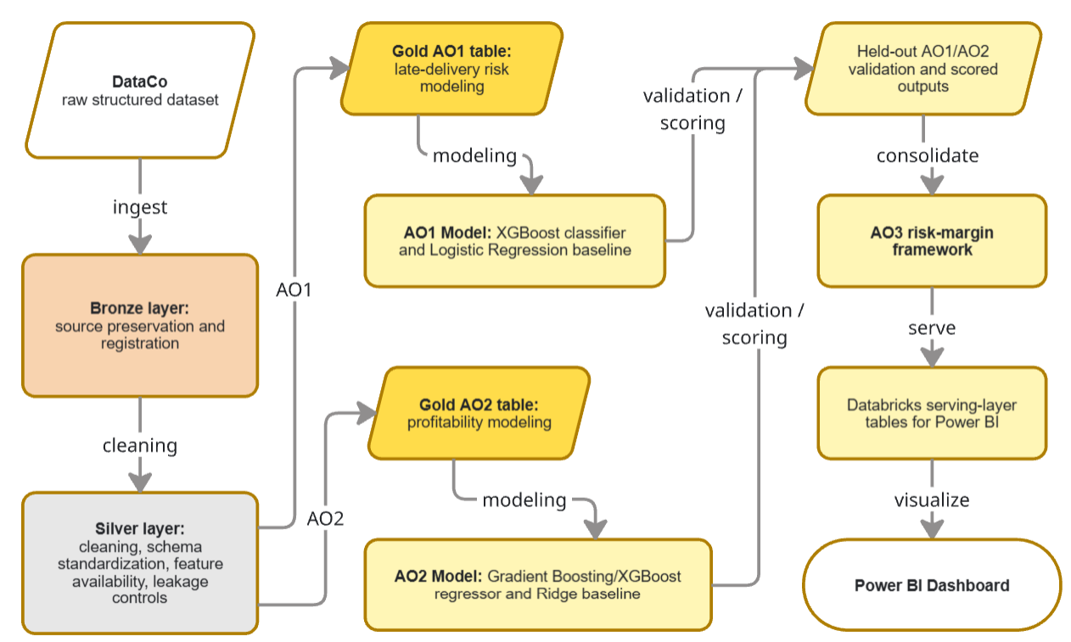
Note. Figure 1 summarizes the workflow from the raw DataCo source through Bronze, Silver, and Gold layers; AO1 and AO2 modeling; held-out scoring; AO3 risk–margin prioritization; and Power BI. The figure was developed from the project workflow documentation in docs/medallion_structure.md, docs/project_orchestrator.md, and report/final_report_assets/figures/figure_1_medallion_project_workflow.md.
The standard academic execution environment for the project was Databricks Community Edition. The preferred documented runtime was Databricks Runtime 14.3 LTS with Spark 3.5.0, with 13.3 LTS as a fallback. Spark and Delta Lake supported the data-processing and table-management pattern used in the workflow (Armbrust, et al., 2020; Zaharia, et al., 2016). Azure Databricks supported the project’s data-processing and serving-layer architecture, while Power BI consumed the governed serving outputs for visualization and decision-support communication (Microsoft, 2026b).
Reusable logic was maintained in repository source modules, while notebooks and workflow scripts were used for orchestration and review. The workflow covered source validation, Bronze ingestion, Silver cleaning, feature governance, Gold table creation, chronological partitioning, model training, validation, explainability, held-out scoring, AO3 segmentation, and Power BI serving-layer registration.
To protect reproducibility, the final report relied on validated project artifacts rather than regenerating models, evaluation outputs, or dashboard assets during submission preparation. This reduced the risk of introducing inconsistencies after the analytical results had been checked.

Exploratory Data Analysis
Exploratory data analysis was used to assess data quality, examine target distributions, identify descriptive patterns, and support feature-governance and modeling decisions for AO1, AO2, and AO3. It served as a validation and design-support step rather than as a separate analytical objective.
Most reviewed fields were usable, but several required exclusion or additional controls. `Order Zipcode` had 86.24% missingness, while raw identifiers, timestamps, and granular geographic fields presented high-cardinality concerns. Commercial variables also showed outliers and potential duplication or target-reconstruction risks, requiring additional review before AO2 modeling.
For AO1, `Late_delivery_risk` was a complete binary target. Late deliveries represented 98,977 rows, or 54.83% of the dataset, indicating mild class imbalance rather than a rare-event problem. This supported evaluating the classifier with recall, precision, F1, ROC-AUC, and PR-AUC rather than accuracy alone. Descriptive analysis also showed substantial variation across planned service fields. For example, First Class shipping and one scheduled shipping day each had a 95.32% late-delivery rate, compared with 38.07% for Standard Class shipping and four scheduled days. These relationships supported retaining planned-service variables for leakage-screened modeling review but were not interpreted as causal effects.
Figure 2.
Late-Delivery Rate by Shipping Mode
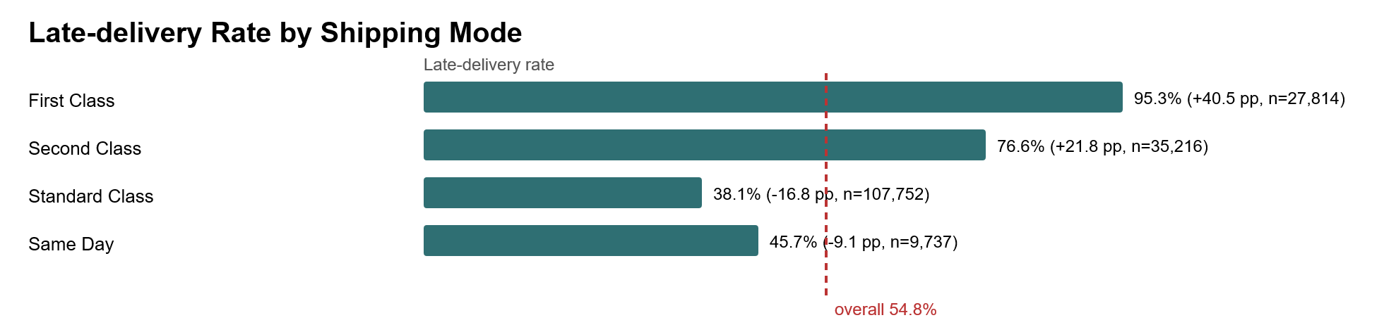
Note. The figure shows the historical late-delivery rate for each shipping mode in the AO1 Gold table, with the deviation in percentage points from the overall 54.8% rate and the row count per group. First Class orders show the highest late-delivery rate (95.3%, +40.5 pp), consistent with the strong First Class shipping-mode effect observed in the AO1 SHAP analysis. Source artifact: report/figures/eda/late_delivery_rate_by_shipping_mode.svg.
For AO2, `Order_Profit_Per_Order` was strongly skewed and sensitive to outliers. The target had a mean of 21.97, a median of 31.52, a standard deviation of 104.43, skewness of -4.742, and 18,942 IQR outliers. These characteristics supported the use of both RMSE and MAE and reinforced the need for target-reconstruction controls around commercial predictors.
Figure 3.
AO2 Order-Profit Distribution
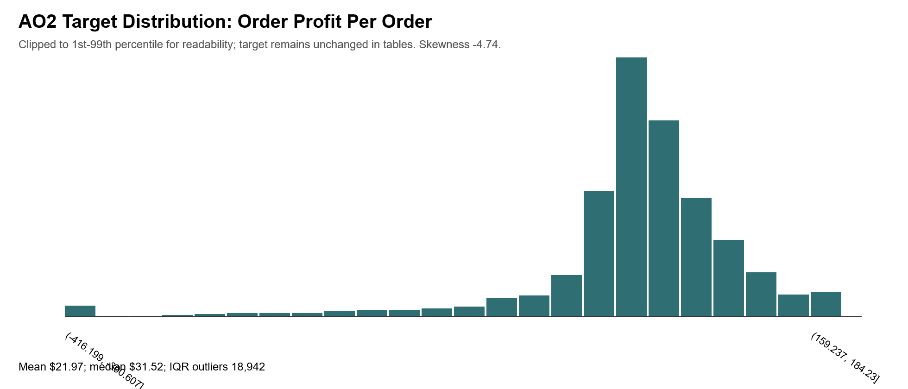
Note. The figure shows the distribution of Order_Profit_Per_Order in the AO2 Gold table, clipped to the 1st–99th percentile for readability while the modeling target remains unchanged. The distribution is strongly left-skewed (skewness -4.74), with a mean of $21.97 and a median of $31.52. This high target variability is consistent with the limited R², substantial residual errors, and prediction compression toward the mean reported for AO2. Source artifact: report/figures/eda/ao2_profit_distribution.svg.
Overall, EDA supported the project’s preprocessing, metric selection, feature governance, and chronological evaluation design. It also provided descriptive context for combining delivery risk and expected profitability in the later AO3 framework without serving as direct evidence for H3.

Leakage-Control and Chronological Split Methodology
The project followed a decision-time integrity rule: a feature could be used for modeling only if it was known at order creation or could be derived from information available before shipment. This rule protected the pre-shipment framing of the project and prevented models from using fulfillment or delivery information that would not be available at the time of operational decision-making.
For AO1, forbidden predictors included `Late_delivery_risk `, delivery status, actual shipping duration, shipping completion timestamps, order status, and other post-outcome or target-proxy fields. For AO2, forbidden predictors included `Order Profit Per Order`, duplicate profit fields, profit ratios, realized margin-like fields, and direct transformations of profit. Non-operational identifiers and empty fields were also excluded from modeling.
The split strategy was chronological rather than random (Kaufman, Rosset, & Perlich, 2012). The split anchor was `order_date_DateOrders`, representing order creation time. Rows were sorted by order date, order identifier, and order-item identifier. The earliest 80% formed the development partition, and the most recent 20% formed the reserved final test partition (Bergmeir & Benítez, 2012). This rule was applied separately to each objective-specific Gold table after its population policy was applied.
Table 3.
Chronological Split Summary
Objective | Partition | Row count | Share | Date range | Role in modeling | Held-out usage caveat
AO1 late-delivery risk | Overall | 172,765 | 100% | 2015-01-01 to 2018-01-31 | Full AO1 Gold population after population policy | Overall row set only; not a model-selection slice
AO1 late-delivery risk | Development | 138,212 | 80% | 2015-01-01 to 2017-04-22 | Development partition; inner validation evidence is drawn from development artifacts | Final test remains untouched for AO1 model selection and H1 wording
AO1 late-delivery risk | Test | 34,553 | 20% | 2017-04-22 to 2018-01-31 | Reserved final held-out partition | Reserved; not used for model selection or H1 inference in the current analysis.
AO2 profitability estimation | Overall | 180,519 | 100% | 2015-01-01 to 2018-01-31 | Full AO2 Gold population after population policy | Overall row set only; not a model-selection slice
AO2 profitability estimation | Development | 144,415 | 80% | 2015-01-01 to 2017-04-22 | Development partition; H2 validation evidence is drawn from development artifacts | Final test remains untouched for AO2 model selection and H2 wording
AO2 profitability estimation | Test | 36,104 | 20% | 2017-04-22 to 2018-01-31 | Reserved final held-out partition | Reserved; not used for model selection or H2 inference in the current analysis.
Note. Rows were ordered chronologically by `order_date_DateOrders`, `Order_Id`, and `Order_Item_Id` before partitioning. Source artifacts include docs/chronological_split_policy.md, data/references/ao1_chronological_partition_summary.csv, and data/references/ao2_chronological_partition_summary.csv.
AO1 contained 172,765 Gold rows after its population policy, with 138,212 development rows and 34,553 reserved test rows. AO2 contained 180,519 Gold rows, with 144,415 development rows and 36,104 reserved test rows. AO1 and AO2 validation claims in this report are based on chronological validation evidence from the development workflow. The final test partitions were preserved and were not used to support the checked model-selection conclusions.
All learned preprocessing was fit only on training data and then applied unchanged to validation or test data. This included imputers, encoders, scalers, feature selectors, threshold selection, and hyperparameter tuning where applicable. This design reduced the risk that validation or future-period information would influence training-time decisions.
AO2 received an additional target-reconstruction audit because financial predictors can be close to accounting formulas. The audit found zero forbidden features, confirmed that `ao3_order_value` was not detected as an AO2 predictor or dominant driver, and issued the final decision `accepted_with_caution`. This supports reporting AO2 as expected-profitability estimation while preserving caution around approved commercial predictors.

Analytical Methods
This project combined supervised learning, model explanation, and rule-based decision support. AO1 used Logistic Regression as the baseline classifier (Hosmer, Lemeshow, & Sturdivant, 2013) and XGBoost as the primary nonlinear classifier to estimate late-delivery probability. AO2 used Ridge Regression as the regularized linear baseline and XGBoost regressor as the primary nonlinear model to estimate expected order-level profitability (Chen & Guestrin, 2016). SHAP was used to examine model-driver patterns for AO1 and AO2, while AO3 translated the scored model outputs into operational priority groups through a governed risk–margin segmentation policy. K-means was reviewed as an optional extension but was not adopted because it did not improve interpretability over the clearer risk–margin matrix.
For AO1, the target variable was `Late_delivery_risk`, where `1` indicates a historical late-delivery event. The selected XGBoost model was chosen from a validation-only candidate set using ROC-AUC as the primary metric and recall as the secondary metric. This design aligned the model-selection process with the project’s operational goal: identifying orders that may require pre-dispatch attention because of elevated delivery risk.
For AO2, the target variable was `Order_Profit_Per_Order`. Ridge Regression served as the baseline model, while XGBoost regressor served as the primary nonlinear model for expected profitability estimation. Because some financial predictors may approximate accounting relationships, AO2 was also reviewed through a target-reconstruction audit. For this reason, AO2 is interpreted as expected-profitability estimation rather than direct profit reconstruction.
SHAP was used to support model interpretation and methodological review. The AO1 SHAP artifacts highlighted planned shipping service, scheduled service windows, order timing, and geography as important model-driver patterns. The AO2 SHAP artifacts highlighted commercial, geographic, product, discount, and quantity signals, with caution because of the financial target-policy risks described above. These patterns are interpreted as model associations rather than causal effects.
AO3 applied fixed thresholds to held-out AO1 and AO2 scored outputs. Orders with predicted late-delivery probability greater than or equal to 0.35 were classified as high risk, while orders with predicted margin greater than or equal to 0.0 were classified as high margin. These thresholds produced the risk–margin segments used for operational interpretation. AO3 was therefore a decision-support layer built from scored model outputs, not an additional predictive model.

Results
The results are organized around AO1, AO2, and AO3. AO1 reports late-delivery risk prediction performance, AO2 reports expected-profitability estimation results, and AO3 shows how both outputs were combined into risk–margin priority groups. The findings are interpreted as decision-support evidence, not as causal intervention results or production deployment outcomes.

AO1 Results: Late-Delivery Risk Prediction
AO1 evaluated whether late-delivery risk could be predicted before dispatch using decision-time features. The validation evidence came from the chronological validation slice inside the AO1 development partition. The final test partition remained reserved and was not used for AO1 model selection, threshold selection, SHAP explainability, or H1 validation in the current analysis.
The AO1 inner training slice contained 110,569 rows, the validation slice contained 27,643 rows, and the reserved final test partition contained 34,553 rows.
Table 4.
AO1 Model Validation Comparison
Model | ROC-AUC | PR-AUC | Accuracy | Precision | Recall | F1 | Log loss | Conclusion
XGBoost classifier | 0.7753 | 0.8489 | 0.7212 | 0.889 | 0.584 | 0.7049 | 0.5133 | Primary model
Logistic Regression baseline | 0.7426 | 0.8307 | 0.6856 | 0.8296 | 0.5645 | 0.6718 | 0.5723 | Baseline comparator
Note. Source artifacts: report/tables/ao1_model_validation_comparison.csv and docs/ao1_results_h1_validation.md. This table reports chronological validation evidence from the development workflow and does not claim final-test confirmation.
The XGBoost classifier outperformed the Logistic Regression baseline on the shared chronological validation slice. It improved ROC-AUC by 0.0327 and recall by 0.0195 at the default 0.50 threshold, while also achieving stronger PR-AUC, accuracy, precision, F1, and log-loss results. H1 is therefore supported on chronological validation evidence.
The AO1 operating threshold used for AO3 was 0.35 rather than the default 0.50. This threshold was selected to prioritize recall while keeping the predicted positive rate operationally manageable. At threshold 0.35, validation precision was 0.8469, recall was 0.6171, the predicted positive rate was 0.4154, false negatives were 6,035, and false positives were 1,758.
AO1 SHAP results supported interpretation and leakage review. The strongest model-driver patterns involved First Class shipping mode, scheduled service-window features, order timing, and geography. These patterns are operationally plausible because they relate to planned service promises and order context, but they should be interpreted as model associations rather than causal effects. The post-model leakage audit found no reviewed driver resembling the AO1 target, actual shipping duration, delivery status, shipping completion status, realized profit, final-test labels, or another direct post-outcome proxy.

AO2 Results: Profitability Estimation
AO2 estimated expected order-level profitability before dispatch. The target variable was `Order_Profit_Per_Order`. Because profitability can be closely related to commercial fields and accounting-style calculations, the AO2 output is interpreted as expected profitability, not as guaranteed realized profit at dispatch time or direct accounting reconstruction.
The AO2 inner training slice contained 115,532 rows, the validation slice contained 28,883 rows, and the reserved final test partition contained 36,104 rows. H2 statements are based on the chronological validation slice only.
Table 5.
AO2 Model Validation Comparison
Model | Model Type | RMSE | MAE | R² | Median Absolute Error | Mean Error | Conclusion
Gradient Boosting / XGBoost Regressor | xgboost.XGB  Regressor | 95.6203 | 52.6463 | 0.0118 | 31.3954 | 0.9627 | Primary nonlinear model improved RMSE and MAE over Ridge
Ridge Regression baseline | sklearn.linear_  model.Ridge | 96.8276 | 54.2191 | -0.0133 | 32.5591 | 0.6453 | Baseline comparator
Note. Source artifacts: report/tables/ao2_model_validation_comparison.csv, report/tables/ao2_results_h2_summary.csv, and docs/ao2_results_h2.md. This table reports chronological validation evidence from the development workflow and does not claim final-test confirmation.
The XGBoost Regressor improved the primary AO2 validation metrics relative to Ridge Regression, with RMSE lower by 1.2073 and MAE lower by 1.5729. R² also improved by 0.0251, moving from negative baseline performance to a small positive value. These results support H2 on chronological validation evidence, but the strength of support is modest.
R² remained low, residual errors were substantial, and both models compressed predictions toward the mean. The validation target standard deviation was 96.1905, compared with prediction standard deviations of 19.5479 for Ridge and 11.9159 for the XGBoost regressor. However, the profit-sign error rate decreased from 0.2536 to 0.1974, which is relevant because sign errors can affect AO3 margin-band assignment.
AO2 SHAP results identified commercial, geographic, product, discount, and quantity signals as model-driver patterns. These patterns remain subject to target-policy caution because approved commercial predictors may still be close to profitability calculation context. The target-reconstruction audit identified no forbidden features and issued the final decision `accepted with caution`.
H2 is therefore supported with caution. AO2 provides a useful expected-profitability signal for AO3 prioritization, but it should not be interpreted as a precise financial accounting model.

AO3 Results: Risk-Margin Prioritization Framework
AO3 integrated the AO1 and AO2 outputs into an operational prioritization framework rather than training an additional predictive model. It used `ao1_predicted_late_delivery_probability` from AO1 and `ao2_predicted_order_profit` from AO2, then derived predicted margin as:
$$ao3_predicted_margin = ao2_predicted_order_profit / ao3_order_value$$
The denominator, `ao3_order_value`, was reserved for AO3 support and was not used as an AO2 predictor. This preserved the distinction between expected-profit modeling and operational margin segmentation.
AO3 used 34,467 matched orders from the common AO1/AO2 held-out scoring population after aligning valid prediction outputs and required margin inputs. These scored outputs were used for segmentation and benchmark analysis, not for AO1 or AO2 model selection.
AO3 classified each scored order along two dimensions. Orders with predicted late-delivery probability greater than or equal to 0.35 were classified as high risk, while orders with predicted margin greater than or equal to 0.0 were classified as positive-margin orders. Combining these thresholds produced the four operational segments shown in Figure 2.
Figure 4.
AO3 Risk–Margin Prioritization Matrix for Held-Out Scored Orders
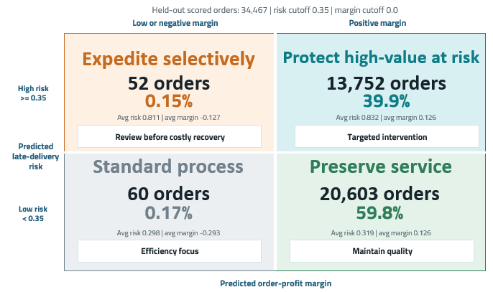
Note. The matrix summarizes 34,467 held-out AO1/AO2 scored orders. Risk is classified using ao1_predicted_late_delivery_probability >= 0.35, and margin is classified using ao3_predicted_margin >= 0.0. Counts, shares, average risk, and average margin are based on predicted outputs rather than realized intervention outcomes.
Most scored orders belonged to the two positive-margin segments. The largest group, `preserve_service`, contained 20,603 orders with lower predicted delivery risk and positive expected margin. A further 13,752 orders were assigned to `protect_high_value_at_risk`, combining elevated delivery risk with positive expected margin and forming the primary pre-dispatch protection queue. Only 112 orders fell into the two negative-margin segments, where selective intervention or standard processing was recommended.
Two additional governance categories, `requires_score_review` and `requires_margin_review`, were defined for missing or invalid scoring inputs. No orders in the held-out scored population were assigned to either exception category.
Table 6.
AO3 Held-Out Scored Segment Summary
Segment | Row Count | Share | Avg. Predicted Risk | Avg. Predicted Profit | Avg. Predicted Margin
protect_high_value_at_risk | 13,752 | 39.90% | 0.832 | 21.61 | 0.126
preserve_service | 20,603 | 59.80% | 0.319 | 21.60 | 0.126
expedite_selectively | 52 | 0.15% | 0.811 | -14.64 | -0.127
standard_process | 60 | 0.17% | 0.298 | -20.61 | -0.293
Note. The two governance exception categories contained zero orders. Percentages may not total exactly 100% because of rounding. Source artifacts: data/references/ao3_risk_margin_benchmark_segment_summary.csv, docs/ao3_segment_assignment.md, docs/ao3_risk_margin_benchmark.md, and docs/ao3_methodology_and_results.md.
The AO3 benchmark supports H3 because the combined framework separated groups that risk-only or margin-only views would not fully distinguish. Margin-only prioritization would group `protect_high_value_at_risk` and `preserve_service` together because both segments had positive predicted margins and nearly identical average predicted profit. AO3 separated them because their average predicted late-delivery risk differed substantially: 0.832 versus 0.319. This was the clearest decision-layer value observed in the benchmark population.
Risk-only prioritization would group `protect_high_value_at_risk` and `expedite_selectively` together because both were high-risk segments. AO3 separated them because their predicted economics differed sharply: average predicted profit was 21.61 for `protect_high_value_at_risk` and -14.64 for `expedite_selectively`. This distinction matters because scarce intervention capacity should not be allocated only by delivery risk when predicted profitability differs.
The optional K-means extension was evaluated but not adopted. Although the selected k = 3 solution produced a silhouette score of 0.6859, the resulting clusters largely duplicated the governed AO3 risk–margin matrix and did not provide clearer operational interpretation. The final decision was therefore not to adopt K-means as the primary segmentation method.
H3 is supported by held-out scored prediction outputs and benchmark segmentation with caveats. AO3 identified operational groups not fully evident from risk-only or margin-only views, but it should be interpreted as a decision-support framework rather than evidence of realized intervention impact.

Power BI Dashboard and Visualization Layer
Power BI was selected as the project’s final visualization and decision-support layer. The dashboard connects to governed Azure Databricks serving-layer tables and translates AO1 delivery-risk scores, AO2 expected-profitability estimates, and AO3 priority segments into executive summaries, operational review queues, geographic comparisons, and logistics KPI exposure views. Power BI presents frozen upstream outputs through a semantic model, DAX measures, filters, and interactive navigation; it does not retrain models, modify thresholds, recalculate AO3 margins, or redefine segment assignments.
The dashboard is organized as a guided decision path rather than as a collection of isolated visuals. The Executive Overview introduces the governed portfolio and explains how AO1 delivery-risk exposure, AO2 expected profitability, and AO3 prioritization combine into a management action view. The Command Center then translates the same outputs into operating pressure, recent movement, and management action agendas. Focused analytical pages allow users to drill into AO1 delivery risk, AO2 profitability exposure, AO3 prioritization, geographic hotspots, and logistics KPI risk exposure, moving from portfolio-level interpretation to operational investigation.
The integrated Executive View provides the main summary of the project results. The governed held-out scoring population contains 34,467 order items, of which 13,804, or 40.0%, form the active delivery-risk review queue. The dashboard also reports aggregate expected profit of $740,319, expected margin of 10.4%, and approximately $2.82 million in order value associated with the protect_high_value_at_risk segment. These indicators bring the AO1, AO2, and AO3 outputs together in a single decision-oriented view.
Figure 5.
Power BI Executive View for DataCo Supply-Chain Decision Intelligence
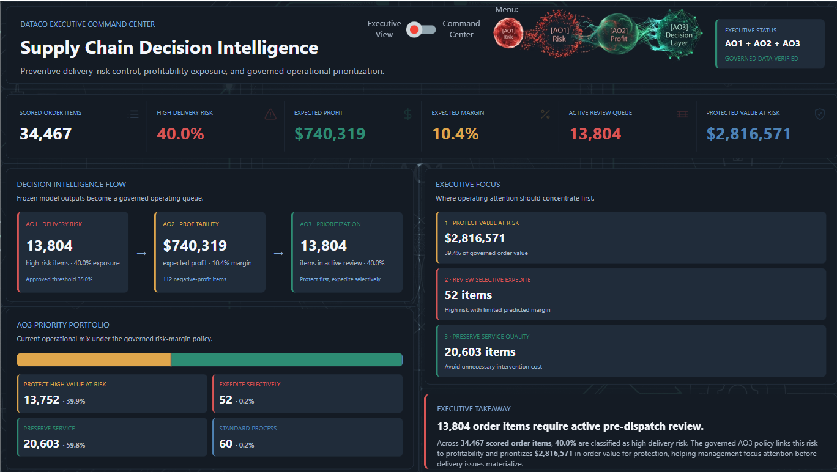
Note. The Executive View integrates AO1 delivery-risk exposure, AO2 expected profitability, and AO3 operational prioritization for the governed held-out scored population. Source: DataCo Power BI dashboard, Executive View, Page 2.
The remaining analytical pages provide progressively more focused interpretation. The AO1 pages explain where delivery risk is concentrated, how the approved 35.0% operating threshold creates the high-risk queue, and which orders require pre-dispatch attention. The AO2 pages separate profitability exposure from precise accounting, showing where modeled losses and margin-protection review are concentrated. The AO3 page converts delivery-risk and profitability outputs into protect-first, selective-expedite, preserve-service, and standard-process operating groups. The geographic page separates high-volume workload from disproportionate regional severity, while the logistics KPI page links historical fulfillment performance with expected pre-dispatch exposure through indicators such as historical OTD, expected OTD, late-delivery capture, and high-risk precision.
The dashboard functions as an insight and communication layer rather than an automated decision engine. Expected profitability represents modeled expected profit, not realized accounting profit; protected value represents order-value exposure requiring managerial attention, not realized savings. Historical delivery comparisons and expected KPI exposure should be interpreted as pre-dispatch risk signals, not as causal evidence that intervention will improve outcomes. Executive views support portfolio-level interpretation, while command-center and drill-down views support detailed queue review, selective intervention, and operational exploration using the same governed analytical source of truth.
The Power BI project source, semantic-model definitions, DAX measures, page documentation, dashboard exports, and page inventory are included in the accompanying project package. The .pbix file is submitted separately through the academic submission system. A companion Command Center screenshot and detailed page inventory are provided in the appendices.

Strategic and Operational Recommendations
The central strategic recommendation is to use AO3 as a pre-dispatch triage framework rather than relying on delivery risk or expected profitability alone. By combining both signals, AO3 distinguishes orders that may require service protection from those where costly intervention should be reviewed more selectively. The segments should guide managerial attention and exception review, not trigger fully automated operational actions.
Table 7.
AO3 Operational Recommendation Matrix - Concise View
AO3 Segment | Interpretation | Recommended Action | Limitation or Caution
protect_high_value_at_risk | High predicted late-delivery risk and nonnegative predicted margin | Prioritize pre-dispatch protection, monitoring, and exception review before lower-risk work | Predicted risk and margin do not establish that intervention will improve realized delivery or profit
expedite_selectively | High predicted late-delivery risk and negative predicted margin | Review selectively before committing scarce expedited capacity | The segment is small, so decisions should remain case specific
preserve_service | Lower predicted delivery risk and nonnegative predicted margin | Maintain service quality and protect customer experience without unnecessary escalation | Lower predicted risk does not eliminate the need for routine monitoring
standard_process | Lower predicted delivery risk and negative predicted margin | Use standard operating procedures and avoid special-cost intervention unless new information emerges | The segment is small and does not support broad operating conclusions
requires_score_review | Missing AO1 or AO2 score inputs | Hold automated AO3 assignment and review scoring-pipeline completeness | Indicates a data or scoring issue rather than a business recommendation
requires_margin_review | Missing or invalid order-value or margin inputs | Hold margin-based prioritization and review the denominator or margin calculation | Requires data-quality review before operational use
Note. The wording is derived from data/references/ao3_operational_recommendation_matrix.csv. The full source-faithful recommendation matrix, including logistics, pricing or margin, monitoring, dashboard-use, and evidence-basis fields, is maintained in the final report assets.
The `protect_high_value_at_risk` segment should form the primary protection queue, but membership should not automatically trigger costly expedited shipping. Managers should consider operational capacity, customer importance, service commitments, and the cost of intervention. The `expedite_selectively` segment requires even greater discretion because service risk is high while predicted economics are weak. The remaining segments generally support service preservation or standard processing unless new operational information changes the order context.
Power BI supports this process by presenting segment volumes, predicted-risk distributions, expected-profitability patterns, threshold implications, and data-quality exceptions as a coherent source of insight for decision-makers. Executive views support prioritization and resource allocation, while more detailed command-center views support queue review and exception handling. The dashboard should remain an insight and governance layer rather than an automated decision engine.
Thresholds and operating rules should be reassessed before operational use if service policies, order patterns, customer priorities, margin structures, intervention costs, or available capacity change.

Limitations, Ethics, and Responsible Use
The DataCo dataset is public and anonymized and supports academic analysis, but it does not fully represent the complexity of a live enterprise supply chain. Important operational factors such as carrier contracts, fulfillment-center workload, weather disruptions, holiday constraints, customs delays, labor availability, customer lifetime value, and intervention cost are not included. These omissions limit the generalizability of the findings to real operational settings.
The project does not establish causality. AO1 predicts late-delivery risk, AO2 estimates expected profitability, and AO3 converts these outputs into operational segments, but none of these analyses demonstrates that a specific intervention would reduce late deliveries or improve realized profit. Evaluating intervention impact would require a controlled pilot, A/B test, or quasi-experimental design.
The project also does not claim production deployment. Databricks, Spark, Delta Lake, and Power BI supported a reproducible academic workflow and decision-support prototype. Production use would require additional access controls, refresh governance, security review, drift monitoring, fairness assessment, incident handling, and integration with operational systems.
Each analytical component has specific limitations. AO1 achieved useful but incomplete recall and should be treated as a prioritization tool rather than a comprehensive late-delivery detector. Its SHAP patterns, including shipping-mode and geographic signals, represent model associations rather than causal relationships. AO2 showed limited explanatory power: although the XGBoost regressor improved RMSE and MAE relative to Ridge Regression, R² remained low and predictions were compressed toward the mean. The target-reconstruction audit therefore accepted AO2 with caution, and its outputs should support prioritization rather than replace financial review.
AO3 inherits uncertainty from both upstream models. Errors, instability, or changes in AO1 or AO2 can affect segment assignments, while the current thresholds depend on the project’s validation policy and business assumptions. Future operational use would require monitoring segment stability and recalibrating thresholds as data patterns and operating conditions change.
Responsible use requires human oversight. The framework should not be used to penalize customers, geographic regions, products, or teams solely on the basis of predicted risk or margin. Geographic and customer-related variables may reflect historical service patterns or structural inequalities rather than controllable behavior. The project’s safeguards therefore include leakage controls, chronological validation, target-reconstruction review, transparent caveats, human review, and limits on the interpretation of SHAP explanations.

Future Research
Future research should incorporate additional variables available before shipment, such as weather conditions, carrier capacity, route constraints, holiday peaks, fulfillment-center workload, customs indicators, and regional service limitations. Any new variables should preserve the project’s decision-time integrity rule and be evaluated for leakage risk before modeling.
A major next step is to evaluate realized intervention outcomes. AO3 identifies orders that may deserve differentiated treatment, but it does not measure whether recommended actions improve delivery performance or profitability. A controlled pilot or quasi-experimental design could compare protected high-value at-risk orders with similar orders that did not receive intervention.
The AO1 operating threshold and AO3 risk–margin cutoffs should also be reassessed over time. The current risk threshold of 0.35 and margin threshold of 0.0 are defensible within this project, but future implementation may require thresholds that reflect intervention capacity, service-level commitments, customer value, and explicit cost-sensitive trade-offs.
AO2 could be strengthened by extending the financial analysis beyond immediate order profitability. Future data could include cost-to-serve, carrier cost, inventory availability, returns, promotion strategy, fulfillment-center assignment, customer lifetime value, purchase frequency, retention risk, historical margin contribution, and account importance. This would allow the framework to distinguish low-margin orders that should remain low priority from those where intervention may protect a strategically important customer relationship. A future AO3 design could therefore combine delivery risk, expected order profitability, and customer value while preserving target-reconstruction controls, decision-time integrity, and human oversight.
Future dashboard development should prioritize decision usefulness rather than additional visual complexity. Role-specific views, drill-through analysis, refresh and data-quality monitoring, outcome tracking, and segment-stability indicators could strengthen Power BI as a source of operational insight. Linking recommended actions to realized outcomes would also support future evaluation of whether the framework improves service or profitability in practice.

Conclusion
This capstone developed a reproducible pre-shipment decision-support framework that combines late-delivery risk prediction, expected profitability estimation, risk–margin prioritization, and Power BI visualization. The project addressed the research question by demonstrating how attributes available at order creation and before dispatch can support differentiated order prioritization when governed by decision-time feature controls, leakage prevention, and chronological validation.
The analytical evidence supported all three hypotheses with appropriate qualifications. For AO1, the XGBoost classifier outperformed Logistic Regression on chronological validation evidence, including ROC-AUC and recall, supporting H1. For AO2, the XGBoost regressor improved RMSE and MAE relative to Ridge Regression, supporting H2 with modest strength because explanatory power remained limited and the target-reconstruction audit accepted the model with caution. For AO3, the combined risk–margin framework separated operational groups that were not fully visible from either risk-only or profitability-only views, supporting H3 through held-out scored prediction outputs and benchmark segmentation.
The project’s main contribution is the integration of a governed data pipeline, leakage-aware modeling, chronological evaluation, explainability, profitability caution, and segment-based decision support. Power BI translates these outputs into an accessible source of insight for decision-makers, supporting executive interpretation, operational review, and exception handling while preserving the distinction between model evidence, predicted segment assignments, and realized outcomes.
The framework should therefore be interpreted as an academic decision-support prototype rather than a production operating system. It does not establish causal intervention impact, claim production deployment, or present unsupported final-test confirmation. Within those boundaries, the project demonstrates a practical and reproducible approach to combining service risk and expected economics for pre-dispatch supply-chain prioritization.

References

Ahmed, K. R., Ansari, M. E., Ahsan, M. N., Rohan, A., Uddin, M. B., & Rivin, M. A. (2025). Deep learning framework for interpretable supply chain forecasting using SOM, ANN, and SHAP. Scientific Reports, 15, Article 26355. doi:10.1038/s41598-025-11510-z
Armbrust, M., Das, T., Sun, L., Yavuz, B., Zhu, S., Murthy, M., . . . Zaharia, M. (2020). Delta Lake: High-performance ACID table storage over cloud object stores. Proceedings of the VLDB Endowment, 13(12), 3411-3424. doi:10.14778/3415478.3415560
Baryannis, G., Dani, S., & Antoniou, G. (2019). Predicting supply chain risks using machine learning: The trade-off between performance and interpretability. Future Generation Computer Systems, 101, 993-1004. doi:10.1016/j.future.2019.07.059
Bergmeir, C., & Benítez, J. M. (2012, May). On the use of cross-validation for time series predictor evaluation. Information Sciences, pp. 192–213. doi:https://doi.org/10.1016/j.ins.2011.12.028
Chen, T., & Guestrin, C. (2016). XGBoost: A Scalable Tree Boosting System. Proceedings of the 22nd ACM SIGKDD International Conference on Knowledge Discovery and Data Mining (pp. 785–794). San Francisco, CA: Association for Computing Machinery. doi:https://doi.org/10.1145/2939672.2939785
Constante, F., Silva, F., & Pereira, A. (2019). DataCo Smart Supply Chain for Big Data Analysis. Mendeley Data. doi:10.17632/8gx2fvg2k6.5
Hastie, T., Tibshirani, R., & Friedman, J. (2009). The elements of statistical learning: Data mining, inference, and prediction (2nd ed.). Springer. doi:10.1007/978-0-387-84858-7
Hoerl, A. E., & Kennard, R. W. (1970, February). Ridge Regression: Biased Estimation for Nonorthogonal Problems. Technometrics, pp. 55–67. doi:https://doi.org/10.1080/00401706.1970.10488634
Hosmer, D. W., Lemeshow, S., & Sturdivant, R. X. (2013). Applied Logistic Regression (3rd ed.). Hoboken, NJ: John Wiley & Sons. doi:https://doi.org/10.1002/9781118548387
Kaufman, S., Rosset, S., & Perlich, C. (2012, December). Leakage in Data Mining: Formulation, Detection, and Avoidance. ACM Transactions on Knowledge Discovery from Data, pp. 1–21. doi:https://doi.org/10.1145/2382577.2382579
Liu, F., Chen, L., Zheng, Y., & Feng, Y. (2022). A prediction method with data leakage suppression for time series. Electronics, 11(22), Article 3701. doi:10.3390/electronics11223701
Lundberg, S. M., & Lee, S.-I. (2017). A unified approach to interpreting model predictions. Advances in Neural Information Processing Systems, 30. Retrieved from https://proceedings.neurips.cc/paper_files/paper/2017/hash/8a20a8621978632d76c43dfd28b67767-Abstract.html
Microsoft. (2026a, May 19). Power BI with Azure Databricks. Microsoft Learn. Retrieved June 2, 2026, from https://learn.microsoft.com/en-us/azure/databricks/partners/bi/power-bi
Microsoft. (2026b, May 15). What is Azure Databricks? Microsoft Learn. Retrieved June 2, 2026, from https://learn.microsoft.com/en-us/azure/databricks/introduction/
Ni, D., Xiao, Z., & Lim, M. K. (2020). A systematic review of the research trends of machine learning in supply chain management. International Journal of Machine Learning and Cybernetics, 11, 1463-1482. doi:10.1007/s13042-019-01050-0
Toorajipour, R., Sohrabpour, V., Nazarpour, A., Oghazi, P., & Fischl, M. (2021). Artificial intelligence in supply chain management: A systematic literature review. Journal of Business Research, 122, 502-517. doi:10.1016/j.jbusres.2020.09.009
Zaharia, M., Xin, R. S., Wendell, P., Das, T., Armbrust, M., Dave, A., . . . Stoica, I. (2016). Apache Spark: A unified engine for big data processing. Communications of the ACM, 59(11), 56-65. doi:10.1145/2934664

Appendices

Appendix A. Artifact Navigation
The project artifact index provides the primary navigation guide to the supporting technical and analytical materials. It connects the report to the data-engineering workflow, governance policies, model evidence, validation records, dashboard documentation, and final report assets.
Table A1.
Primary Project Artifact Index
Area | Main Supporting Artifacts | Purpose
Project overview | README.md; report/final_artifact_index.md | Project orientation and master artifact navigation
Data engineering | docs/project_orchestrator.md; docs/medallion_structure.md; src/data_engineering/ | Bronze–Silver–Gold implementation and workflow documentation
Feature governance | docs/leakage_control_plan.md; docs/chronological_split_policy.md; data/references/feature_availability_map.csv | Decision-time availability, leakage controls, and chronological partition policy
Silver schema | docs/silver_schema_data_dictionary.md; data/references/silver_schema_data_dictionary.csv | Standardized fields, data types, lineage, and policy classifications
AO1 evidence | docs/ao1_results_h1_validation.md; models/ao1_late_delivery/ | Late-delivery model selection, evaluation, threshold, explainability, and leakage review
AO2 evidence | docs/ao2_results_h2.md; models/ao2_profitability/ | Profitability model comparison, explainability, and target-reconstruction audit
AO3 evidence | docs/ao3_methodology_and_results.md; models/ao3_integration/; data/references/ao3_risk_margin_matrix_policy.csv | Held-out scoring, segment assignment, benchmark evidence, and operational policy
Dashboard evidence | dashboard/; docs/powerbi_databricks_serving_layer.md; final dashboard exports and page inventory | Power BI semantic model, DAX measures, page definitions, exports, and serving-layer architecture
Validation | report/final_validation_summary.md; docs/TESTING.md; tests/data_validation/ | Validation status, evidence boundaries, and executable checks
Final report assets | report/final_report_assets/ | Final tables, figures, manifests, and dashboard evidence
Note. The complete artifact inventory is maintained in report/final_artifact_index.md.

Appendix B. Validation Summary
The project used a combination of lightweight local validation and workspace-dependent checks. Local validators reviewed policies, metadata, report artifacts, and analytical summaries. Other checks required generated Databricks, PySpark, or Delta Lake outputs.
Table B1.
Validation Scope and Evidence Boundaries
Validation Area | Local Validation | Workspace-Dependent Validation | Evidence Boundary
Governance and schema | Silver dictionary, feature availability, leakage policy, and chronological split checks | Silver and Gold table quality checks using generated Delta outputs | Governance policies are documented and locally reviewable; final table execution depends on the Databricks environment
AO1 | Model metadata, evaluation pack, threshold policy, SHAP artifacts, leakage audit, and H1 summary | Chronological partition and held-out scoring checks using Databricks outputs | H1 is supported by chronological validation evidence; reserved final-test performance is not claimed
AO2 | Ridge and XGBoost metadata, evaluation pack, SHAP artifacts, target-reconstruction audit, and H2 summary | Chronological partition checks using Databricks outputs | H2 is supported with modest improvement; the target-reconstruction decision is accepted with caution
AO3 | Matrix policy, operational recommendations, and optional K-means evidence | Held-out score alignment, segment assignment, and benchmark checks using generated outputs | H3 is supported as decision-layer evidence, not as evidence of realized intervention impact
Dashboard serving layer | Static serving-layer definitions, semantic model, DAX measures, and dashboard-support files | Direct serving-table and export validation using Databricks and Power BI outputs | Dashboard evidence represents governed predictions, segments, and validation summaries rather than realized outcomes
Note. The detailed validation record is available in report/final_validation_summary.md, with execution guidance in docs/TESTING.md.

Appendix C. Data Dictionary and Schema
The Silver-layer data dictionary documents standardized analytical fields, source mappings, data types, decision-time availability, and modeling policy. Table C1 provides a representative sample of fields central to AO1, AO2, AO3, and dashboard reporting.
Table C1.
Representative Silver Data Dictionary
Source Field | Standardized Field | Data Type | Availability and Modeling Policy | Primary Purpose
Late_delivery_risk | Late_delivery_risk | Integer | AO1 target only; prohibited as a predictor | Binary late-delivery target
Order Profit Per Order | Order_Profit_  Per_Order | Double | AO2 target only; prohibited as a predictor | Order-level profit target
Days for shipping (real) | Days_for_  shipping_real | Integer | Available after delivery; prohibited for AO1/AO2 prediction | Historical outcome and dashboard/audit field
Days for shipment (scheduled) | Days_for_shipment  _scheduled | Integer | Available before dispatch; eligible subject to Gold selection | Planned service-window feature
Shipping Mode | Shipping_Mode | String | Available before dispatch; eligible with train-only encoding | Planned shipping-service feature
Order Item Total | Order_Item_Total | Double | Available at order creation; conditional because of AO2 reconstruction risk | Commercial order-value field
Customer Segment | Customer_Segment | String | Available at order creation; eligible with train-only encoding | Customer-profile field
Category Name | Category_Name | String | Available at order creation; eligible with train-only encoding | Product-category field
Note. The complete machine-readable dictionary is available at data/references/silver_schema_data_dictionary.csv. Supporting documentation is maintained in docs/silver_schema_data_dictionary.md, and the complete feature policy is recorded in data/references/feature_availability_map.csv.

Appendix D. Code Repository and Script Index
The project repository contains the source code, validation scripts, documentation, analytical artifacts, report assets, and dashboard-support materials used in this capstone.
Project repository: Repository Url.
Table D1.
Repository Structure
Repository Area | Location | Contents
Pipeline orchestration | notebooks/pipeline/run_  project_workflow.py | Databricks-compatible project workflow entry point
Data engineering | src/data_engineering/ | Bronze ingestion, Silver cleaning, feature engineering, Gold table creation, and reference registration
Modeling and AO3 | src/modeling/ | Partitioning, preprocessing, AO1/AO2 training, evaluation, SHAP, AO2 audit, scoring, AO3 assignment, and benchmarking
Dashboard support | src/dashboard/; dashboard/ | Databricks serving-layer registration, Power BI project source, semantic model, DAX measures, themes, and page definitions
Validation | tests/data_validation/ | Local and Databricks-dependent validation scripts
Documentation | docs/ | Governance, implementation, modeling, testing, and dashboard documentation
Report evidence | report/final_report_assets/ | Final tables, figures, manifests, dashboard exports, and report-support artifacts
The Power BI .pbix source file is submitted separately through the academic submission system.

Appendix E. Model Metadata and Analytical Evidence
The project metadata provides traceability between the methods described in the report and the selected analytical artifacts.
Table E1.
Model and Analytical Metadata Summary
Analytical Component | Supporting Metadata or Evidence | Summary
AO1 selected classifier | models/ao1_late_delivery/xgboost_classifier/  ao1_xgboost_classifier_metadata.json | Documents the selected XGBoost classifier and validation-based H1 evidence
AO1 operating threshold | models/ao1_late_delivery/threshold/  ao1_decision_threshold_metadata.json;  data/references/ao1_decision_threshold_policy.csv | Records the selected 0.35 risk threshold used by AO3 and the dashboard
AO1 explainability | models/ao1_late_delivery/explainability/  ao1_shap_explainability_metadata.json;  report/figures/ao1_shap_top_features.png | Documents SHAP interpretation of validation-slice model behavior
AO2 selected regressor | models/ao2_profitability/gradient_boosting/  ao2_gradient_boosting_metadata.json | Documents the selected XGBoost regressor and validation-based H2 evidence
AO2 explainability | models/ao2_profitability/explainability/  ao2_shap_explainability_metadata.json;  report/figures/modeling/ao2_shap_top_features.png | Documents AO2 model-driver patterns and target-policy caution
AO2 target-reconstruction audit | models/ao2_profitability/target_reconstruction_audit/  ao2_target_reconstruction_audit_metadata.json; report/tables/ao2_target_reconstruction_audit_findings.md | Records the accepted-with-caution audit decision and supporting findings
Held-out AO1/AO2 scoring | models/ao3_integration/ao1_ao2_test_scores/  ao1_ao2_test_score_metadata.json;  data/references/ao1_ao2_test_score_summary.csv | Documents the common held-out scored population used for AO3
AO3 segment assignment | models/ao3_integration/risk_margin_segments/  ao3_segment_assignment_metadata.json;  data/references/ao3_segment_summary.csv | Records application of the 0.35 risk cutoff and 0.0 margin cutoff
AO3 benchmark | models/ao3_integration/risk_margin_benchmark/  ao3_risk_margin_benchmark_metadata.json; data/references/ao3_risk_margin_benchmark_insights.csv | Compares AO3 with risk-only and margin-only prioritization as H3 evidence
Note. SHAP outputs describe model associations rather than causal relationships. Held-out scores support AO3 segmentation but are not presented as final-test confirmation of AO1 or AO2 performance.
The following figures supplement the model metadata with validation, diagnostic, explainability, and benchmark evidence for AO1, AO2, and AO3. They support the results presented in the main report but do not replace the reported validation tables, establish causal relationships, or provide unsupported final-test confirmation.

E.1 AO1 Validation and Interpretation
Figure E1.
AO1 Validation ROC Curve Comparison 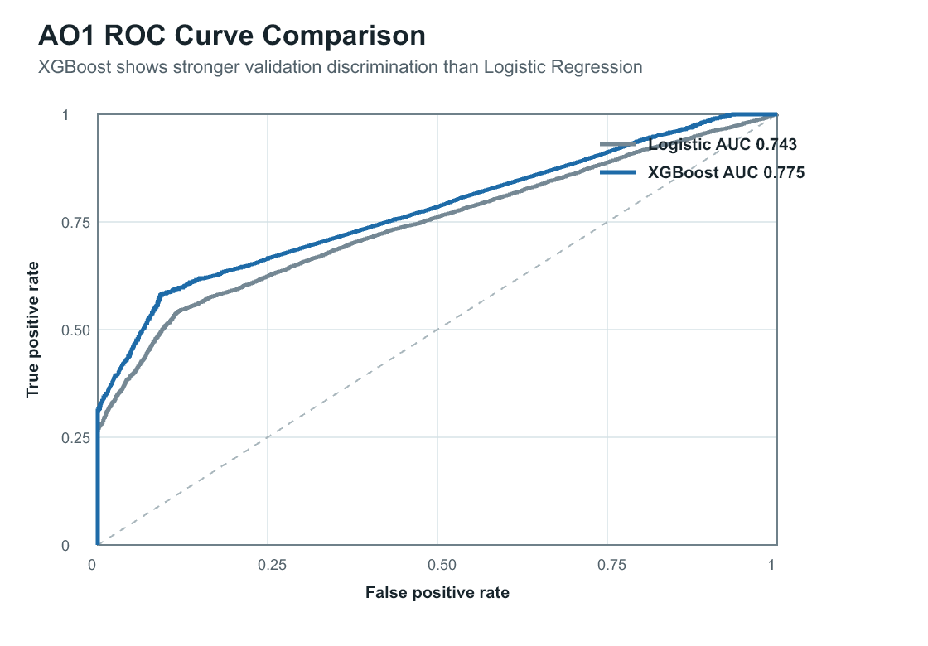
Note. The curves compare the XGBoost classifier and Logistic Regression baseline on the shared chronological validation slice. XGBoost achieved ROC-AUC of 0.7753, compared with 0.7426 for Logistic Regression, supporting the AO1 model-selection conclusion. The diagonal line represents random discrimination. This figure reports validation evidence and does not represent reserved final-test performance.

Figure E2.
AO1 Global Mean Absolute SHAP Values 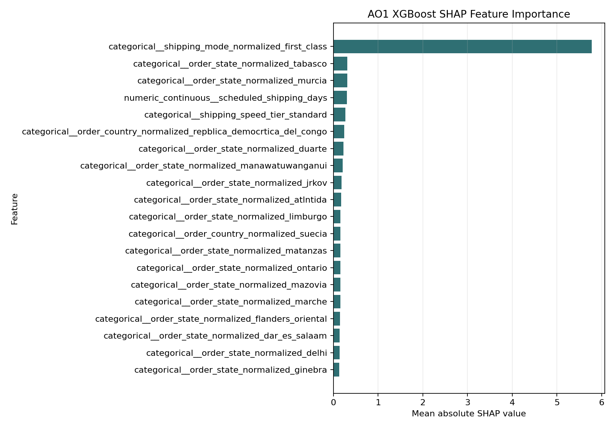Note. The figure presents global mean absolute SHAP values for the selected AO1 XGBoost classifier. Larger values indicate greater average influence on the model’s predictions but do not indicate the direction of that influence. The dominance of First Class shipping mode and the presence of service-window and geographic features should be interpreted as model associations rather than causal effects. The results were also reviewed through the project’s post-model leakage audit.

E.2 AO2 Validation and Interpretation
Figure E3.
AO2 Predicted Versus Actual Profit on the Validation Slice 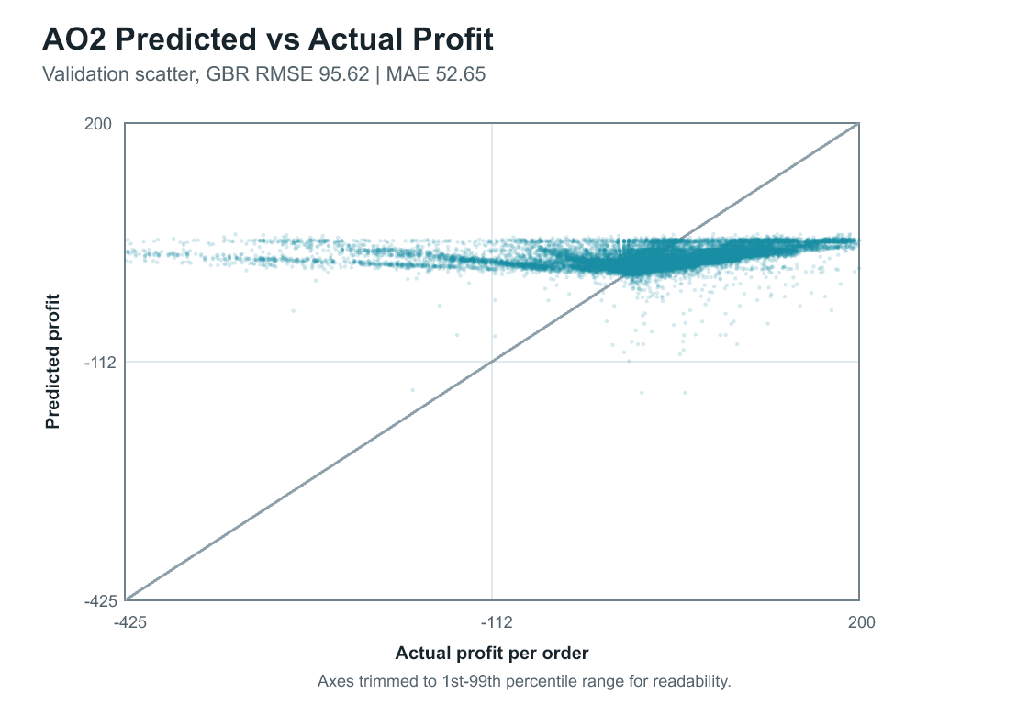
Note. The scatterplot compares actual order profit with predictions from the selected AO2 XGBoost regressor on the chronological validation slice. The diagonal line represents perfect prediction. The concentration of predictions within a narrower range than the observed target illustrates compression toward the mean and supports the report’s cautious interpretation of AO2. Axes are limited to the first through ninety-ninth percentile range for readability; the reported RMSE and MAE were calculated from the complete validation evidence.

Figure E4.
AO2 Global Mean Absolute SHAP Values 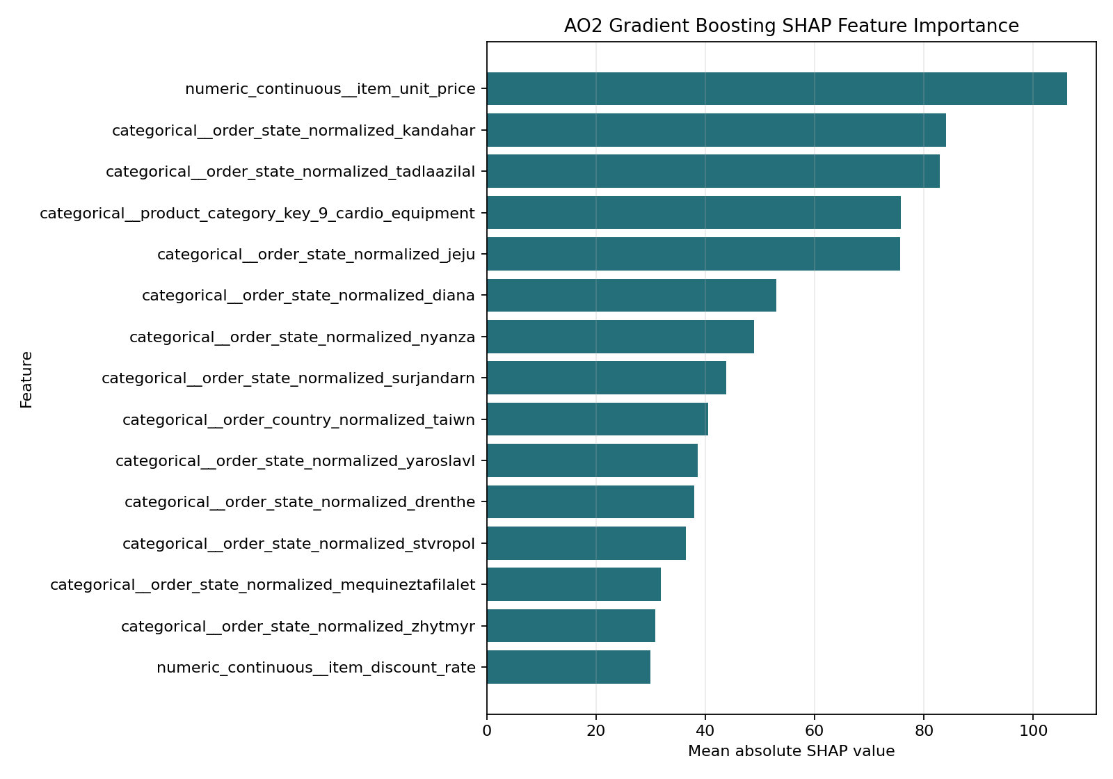
Note. The figure presents global mean absolute SHAP values for the selected AO2 XGBoost regressor. The values describe average model influence, not causal effects or the direction of each relationship. Commercial, product, discount, and geographic signals remain subject to the target-reconstruction caution described in the main report. The figure should therefore be interpreted as model-behavior evidence rather than as a financial decision rule.

E.3 AO3 Benchmark Evidence
Figure E5.
AO3 Segmentation Compared with Risk-Only and Margin-Only Views 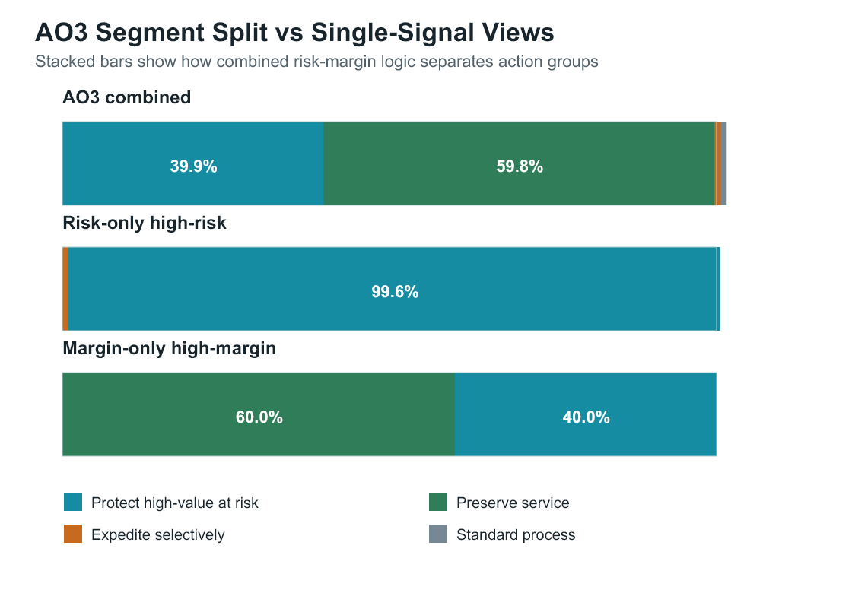
Note. The figure compares the governed AO3 risk–margin segmentation with conditional risk-only and margin-only views for 34,467 matched held-out scored orders. The AO3 combined bar represents the full scoring population. The risk-only bar shows how high-risk orders divide between positive- and negative-margin segments, while the margin-only bar shows how nonnegative-margin orders divide between high- and lower-risk segments. The comparison illustrates that combining predicted delivery risk and predicted margin separates action groups that either signal alone would conceal. The values are prediction-based segment outputs, not realized intervention outcomes.

Appendix F. Power BI Dashboard Evidence
The Power BI evidence package documents how the governed AO1, AO2, and AO3 outputs were translated into an interactive decision-support interface. The dashboard contains a common cover page and five analytical subjects covering the integrated executive overview, AO1 delivery risk, AO2 profitability, geographic exposure, and logistics KPI risk exposure. Each analytical subject provides an Executive View and a Command Center view using the same governed semantic model and filter context.
Executive View emphasizes headline measures, trends, management implications, and concise decision briefs. Command Center provides detailed review queues, distributions, segment breakdowns, geographic comparisons, and diagnostic records. The view toggle changes the presentation and level of detail rather than the underlying scores, thresholds, or segment assignments.
Table F1.
Power BI Evidence Package
Evidence Item | Final Location
Executive View PDF export | report/final_report_assets/figures/
Command Center PDF export | report/final_report_assets/figures/
Dashboard page inventory | report/final_report_assets/tables/
Power BI project source | dashboard/Dashboard.pbip; dashboard/Dashboard.Report/; dashboard/Dashboard.SemanticModel/
Semantic-model documentation | dashboard/powerbi_semantic_model.md
DAX measures | dashboard/powerbi_measures.dax
Databricks serving-layer documentation | docs/powerbi_databricks_serving_layer.md
Serving-layer registration | src/dashboard/register_powerbi_databricks_tables.py
Power BI .pbix | Submitted separately through the academic submission system
Figure F1.
Power BI Command Center for Operational Review and Allocation
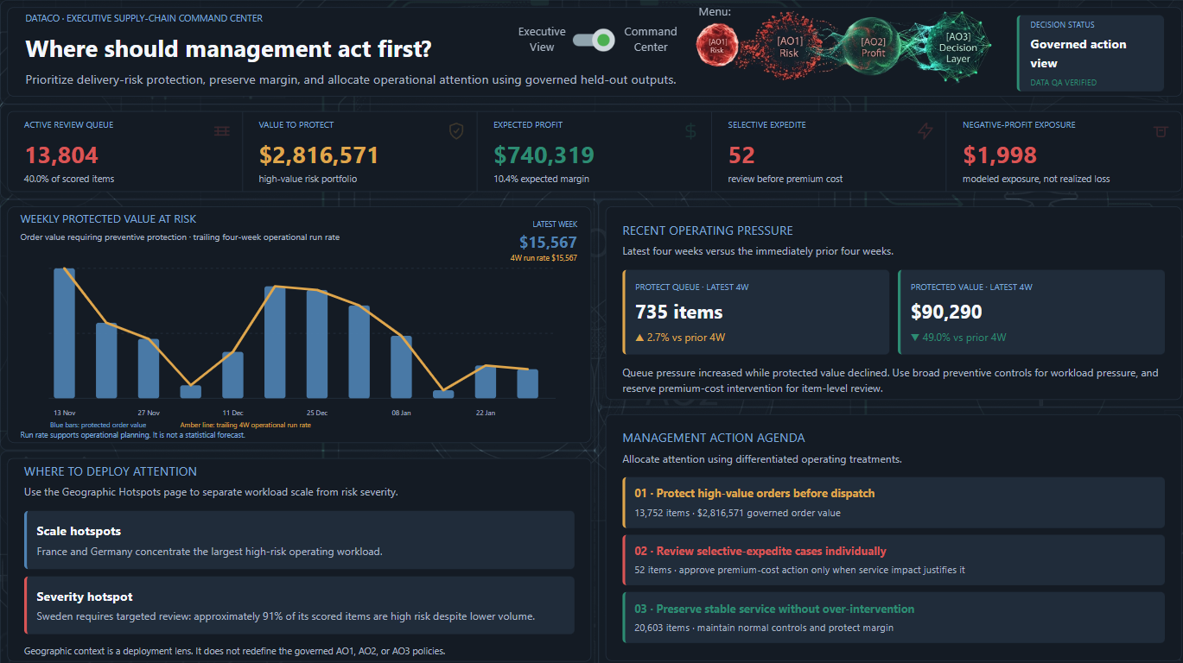
Note. The Command Center provides detailed review queues, trends, geographic guidance, and operational actions using the same governed outputs presented in the Executive View.
Power BI functions as a visualization, communication, and governance layer. It does not recreate AO1 or AO2 scores, recalculate AO3 margins, retune thresholds, or reassign operational segments. Dashboard values should therefore be interpreted according to the same evidence boundaries described in the main report: predicted profitability is not realized accounting profit, protected value is not realized savings, and historical comparisons do not establish causal intervention impact.

Appendix G. AI / Tooling Usage Note
Generative AI tools, including OpenAI ChatGPT and Codex, were used to support selected project activities such as code review, documentation drafting, language refinement, repository organization, and validation planning. AI tools were not treated as independent sources of evidence and did not replace the project’s analytical workflow, model evaluation, or human judgment.
All analytical claims, metrics, tables, figures, and conclusions were reviewed against project datasets, scripts, validation artifacts, and documented outputs before inclusion in the report. The authors remained responsible for methodological decisions, interpretation, citation accuracy, and the final submission content.
Azure Databricks, Apache Spark, Delta Lake, GitHub, Python, and Power BI were used as the primary data-engineering, modeling-support, version-control, and visualization tools.

Appendix H. Full AO3 Operational Recommendation Framework
The main report presents a concise summary of the AO3 recommendations. Appendix H expands that summary across three complementary tables. Table H1 defines each segment and its primary recommended action. Table H2 describes the corresponding logistics, pricing or margin, monitoring, and dashboard guidance. Table H3 presents the quantitative evidence and limitations supporting each recommendation.
The tables should be interpreted together as decision-support guidance rather than automated operating rules.
Table H1.
AO3 Segment Interpretation and Primary Recommendation
AO3 Segment | Segment Interpretation | Recommended Action
protect_high_value_at_risk | High late-delivery risk and high predicted margin; these orders combine service risk with meaningful expected value. | Prioritize pre-dispatch protection and exception handling before lower-risk work.
expedite_selectively | High late-delivery risk and low predicted margin; these orders have service risk but limited expected economic upside. | Review selectively before committing scarce expedited capacity.
preserve_service | Low late-delivery risk and high predicted margin; these orders have expected value but do not require urgent risk intervention. | Maintain standard service quality and protect customer experience without unnecessary escalation.
standard_process | Low late-delivery risk and low predicted margin; these orders do not show strong risk or margin reasons for special handling. | Use normal operating procedures and avoid special-cost interventions unless new information appears.
requires_score_review | Missing AO1 or AO2 score inputs; the order cannot be assigned to a reliable operational segment. | Hold automated AO3 prioritization and review score-pipeline completeness before acting on the matrix.
requires_margin_review | Missing or invalid AO3 order value or predicted margin; the order cannot be placed reliably on the margin axis. | Hold automated margin-based prioritization and review denominator or margin construction before acting.
Note. AO3 segments are based on a predicted late-delivery risk cutoff of 0.35 and a predicted margin cutoff of 0.0. The two review categories are governance safeguards for missing or invalid analytical inputs.
Table H2.
AO3 Operational Attention, Monitoring, and Dashboard Use
AO3 Segment | Logistics Attention | Pricing or Margin Attention | Monitoring Focus | Dashboard Use
protect_high  _value_at_risk | High: review carrier or service capacity early, confirm dispatch readiness, and escalate preventable delay risks. | Medium: preserve expected margin by avoiding blanket expediting; use targeted intervention when risk is actionable. | Track segment volume, average risk, expected profit, predicted margin, and intervention capacity. | Primary AO3 action queue for high-value orders requiring risk protection.
expedite_  selectively | Medium: investigate root causes and intervene only when customer impact or service commitments justify the cost. | High: avoid automatic premium-cost expediting because average predicted profit and margin are negative. | Track as a small exception queue and compare intervention costs with expected value. | Caution queue where delivery risk is high but margin support is weak.
preserve_  service | Medium: maintain normal dispatch controls and monitor emerging delay indicators. | Low: protect margin by avoiding unnecessary intervention costs. | Track high-margin volume, service consistency, and movement toward higher risk. | Preserve-service view for economically valuable orders without urgent escalation.
standard_  process | Low: maintain routine handling and exception management only when operational alerts arise. | Medium: monitor pricing or cost drivers because predicted profit and margin are negative. | Track negative-margin exposure and operational drift. | Default-process segment and margin-monitoring reference group.
requires_  score_review | Review only when an independent operational alert exists; do not infer risk from missing scores. | Confirm data and scoring availability before margin-related action. | Track missing-score volume and investigate upstream scoring failures. | Data-quality exception category rather than an operational priority group.
requires_  margin_review | Review only when independent operational risk evidence exists; do not use the AO3 margin axis until corrected. | Resolve missing or nonpositive order value and margin inputs before action. | Track invalid-margin volume and investigate upstream AO2 or order-value issues. | Data-quality exception category for dashboard quality assurance and refresh monitoring.
Note. Attention levels indicate relative review emphasis within the AO3 framework. They do not mandate a specific intervention or expenditure. Managers should also consider operational capacity, customer importance, service commitments, and intervention cost.
Table H3.
AO3 Evidence Basis and Limitations
AO3 Segment | Evidence Basis | Limitation or Caution
protect_high_value_at_risk | 13,752 orders, representing 39.9% of the held-out scored population; average predicted late-delivery probability was 0.832 and average predicted margin was 0.126. | Predicted risk and margin do not establish that intervention will improve realized delivery or profit.
expedite_selectively | 52 orders, representing 0.15%; average predicted late-delivery probability was 0.811 and average predicted margin was -0.127. | The small segment size requires case-by-case use and does not support a broad operating policy.
preserve_service | 20,603 orders, representing 59.8%; average predicted late-delivery probability was 0.319 and average predicted margin was 0.126. | Lower predicted risk does not remove the need for routine monitoring and only argues against urgent intervention by default.
standard_process | 60 orders, representing 0.17%; average predicted late-delivery probability was 0.298 and average predicted margin was -0.293. | The small segment size limits broad conclusions; recommendations should remain conservative.
requires_score_review | Zero held-out orders were assigned to this fallback segment, indicating complete score coverage in the reviewed run. | If this category appears in future refreshes, it indicates a data or scoring issue rather than a direct business recommendation.
requires_margin_review | Zero held-out orders were assigned to this fallback segment, indicating complete margin coverage in the reviewed run. | If this category appears in future refreshes, it indicates a data-quality issue requiring manual review.
Note. Evidence is based on 34,467 matched held-out AO1/AO2 scored orders used for AO3 segmentation and benchmark analysis. These are predicted outputs rather than realized intervention outcomes. Source: data/references/ao3_operational_recommendation_matrix.csv.

