Results

Table 1
Table 1. Characteristics of avoidable deaths, ATS Milano residents aged 0-74 years, 2022-2024. Columns are mutually exclusive, age is median (IQR), all other cells are n (column %).
Characteristic | Preventable only N = 5,494 | Treatable only N = 3,645 | Preventable and treatable N = 2,875 | Overall N = 12,014
Age at death (years) | 67 (60–71) | 65 (57–71) | 67 (59–71) | 67 (59–71)
Sex
Male | 3,604 (65.6%) | 1,617 (44.4%) | 2,016 (70.1%) | 7,237 (60.2%)
Female | 1,890 (34.4%) | 2,028 (55.6%) | 859 (29.9%) | 4,777 (39.8%)
Cause group
Cancer | 3,866 (70.4%) | 2,041 (56.0%) | 50 (1.7%) | 5,957 (49.6%)
Diseases of the circulatory system | 0 (0.0%) | 118 (3.2%) | 2,820 (98.1%) | 2,938 (24.5%)
Diseases of the respiratory system | 464 (8.4%) | 310 (8.5%) | 0 (0.0%) | 774 (6.4%)
Infectious diseases | 210 (3.8%) | 414 (11.4%) | 5 (0.2%) | 629 (5.2%)
Provisional assignment of new diseases | 507 (9.2%) | 0 (0.0%) | 0 (0.0%) | 507 (4.2%)
Endocrine and metabolic diseases | 86 (1.6%) | 373 (10.2%) | 0 (0.0%) | 459 (3.8%)
Alcohol-related and drug-related deaths | 360 (6.6%) | 0 (0.0%) | 0 (0.0%) | 360 (3.0%)
Diseases of the genitourinary system | 0 (0.0%) | 132 (3.6%) | 0 (0.0%) | 132 (1.1%)
Diseases of the digestive system | 0 (0.0%) | 119 (3.3%) | 0 (0.0%) | 119 (1.0%)
Diseases of the nervous system | 0 (0.0%) | 91 (2.5%) | 0 (0.0%) | 91 (0.8%)
Congenital malformations | 1 (0.0%) | 25 (0.7%) | 0 (0.0%) | 26 (0.2%)
Pregnancy, childbirth and perinatal period | 0 (0.0%) | 22 (0.6%) | 0 (0.0%) | 22 (0.2%)
Service function that could have avoided the death
Environment and Safety | 228 (4.1%) | 0 (0.0%) | 0 (0.0%) | 228 (1.9%)
Gender and Reproductive Health | 133 (2.4%) | 0 (0.0%) | 0 (0.0%) | 133 (1.1%)
Immunisation and Prophylaxis | 567 (10.3%) | 0 (0.0%) | 0 (0.0%) | 567 (4.7%)
Lifestyle and NCDs | 4,206 (76.6%) | 0 (0.0%) | 0 (0.0%) | 4,206 (35.0%)
Mental Health Services | 360 (6.6%) | 0 (0.0%) | 0 (0.0%) | 360 (3.0%)
Screening | 0 (0.0%) | 0 (0.0%) | 0 (0.0%) | 0 (0.0%)
Tertiary prevention | 0 (0.0%) | 1,873 (51.4%) | 0 (0.0%) | 1,873 (15.6%)
Environment and Safety + Tertiary prevention | 0 (0.0%) | 0 (0.0%) | 5 (0.2%) | 5 (0.0%)
Immunisation and Prophylaxis + Screening | 0 (0.0%) | 0 (0.0%) | 50 (1.7%) | 50 (0.4%)
Lifestyle and NCDs + Tertiary prevention | 0 (0.0%) | 0 (0.0%) | 2,820 (98.1%) | 2,820 (23.5%)
Screening + Tertiary prevention | 0 (0.0%) | 1,772 (48.6%) | 0 (0.0%) | 1,772 (14.7%)

Table 2
Table 2. Avoidable deaths by the service function that could have averted them. Weighted counts: a death from a cause split equally between two mechanisms contributes 0.5 to each.
Service function | Deaths (weighted) | %
Lifestyle and NCDs | 5,616.0 | 46.7%
Tertiary prevention | 4,171.5 | 34.7%
Screening | 911.0 | 7.6%
Immunisation and Prophylaxis | 592.0 | 4.9%
Mental Health Services | 360.0 | 3.0%
Environment and Safety | 230.5 | 1.9%
Gender and Reproductive Health | 133.0 | 1.1%

Table 2b (optional)
Table 3: Table 2b. Twenty leading individual causes of avoidable death. Include only if the Results text keeps the list of leading causes; otherwise move to an appendix. (Source: desc_numbers$by_cause.)
Cause | Deaths | %
Lung cancer | 2151 | 17.9%
Ischaemic heart diseases | 1428 | 11.9%
Breast cancer (female only) | 893 | 7.4%
Colorectal cancer | 879 | 7.3%
Cerebrovascular diseases | 851 | 7.1%
COVID-19 | 507 | 4.2%
Liver cancer | 507 | 4.2%
Stomach cancer | 423 | 3.5%
Sepsis | 399 | 3.3%
Diabetes mellitus - Type 1 / other / unspecified | 355 | 3.0%
Chronic lower respiratory diseases | 349 | 2.9%
Hypertensive diseases | 321 | 2.7%
Other alcohol-related disorders | 232 | 1.9%
Pneumonia, not elsewhere classified or organism unspecified | 212 | 1.8%
Bladder cancer | 191 | 1.6%
Lip, oral cavity and pharynx cancer | 191 | 1.6%
Aortic aneurysm | 174 | 1.4%
Skin (melanoma) cancer | 172 | 1.4%
Uterus cancer | 148 | 1.2%
Oesophageal cancer | 136 | 1.1%

Figure 1
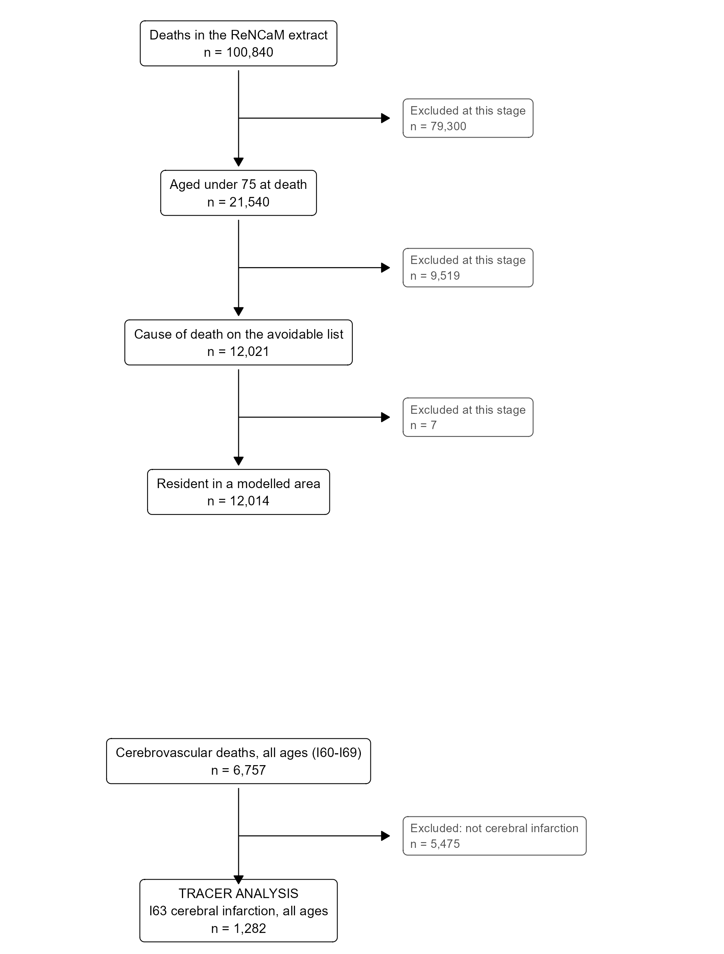
Figure 1.
Derivation of the analysis dataset, main analysis and stroke sub-analysis. The stroke arm branches from the full extract rather than from the age-restricted population, because the tracer outcome is defined for all ages. Source: flow and stroke_subtypes; drawn by plot_flow_diagram().

Figure 2
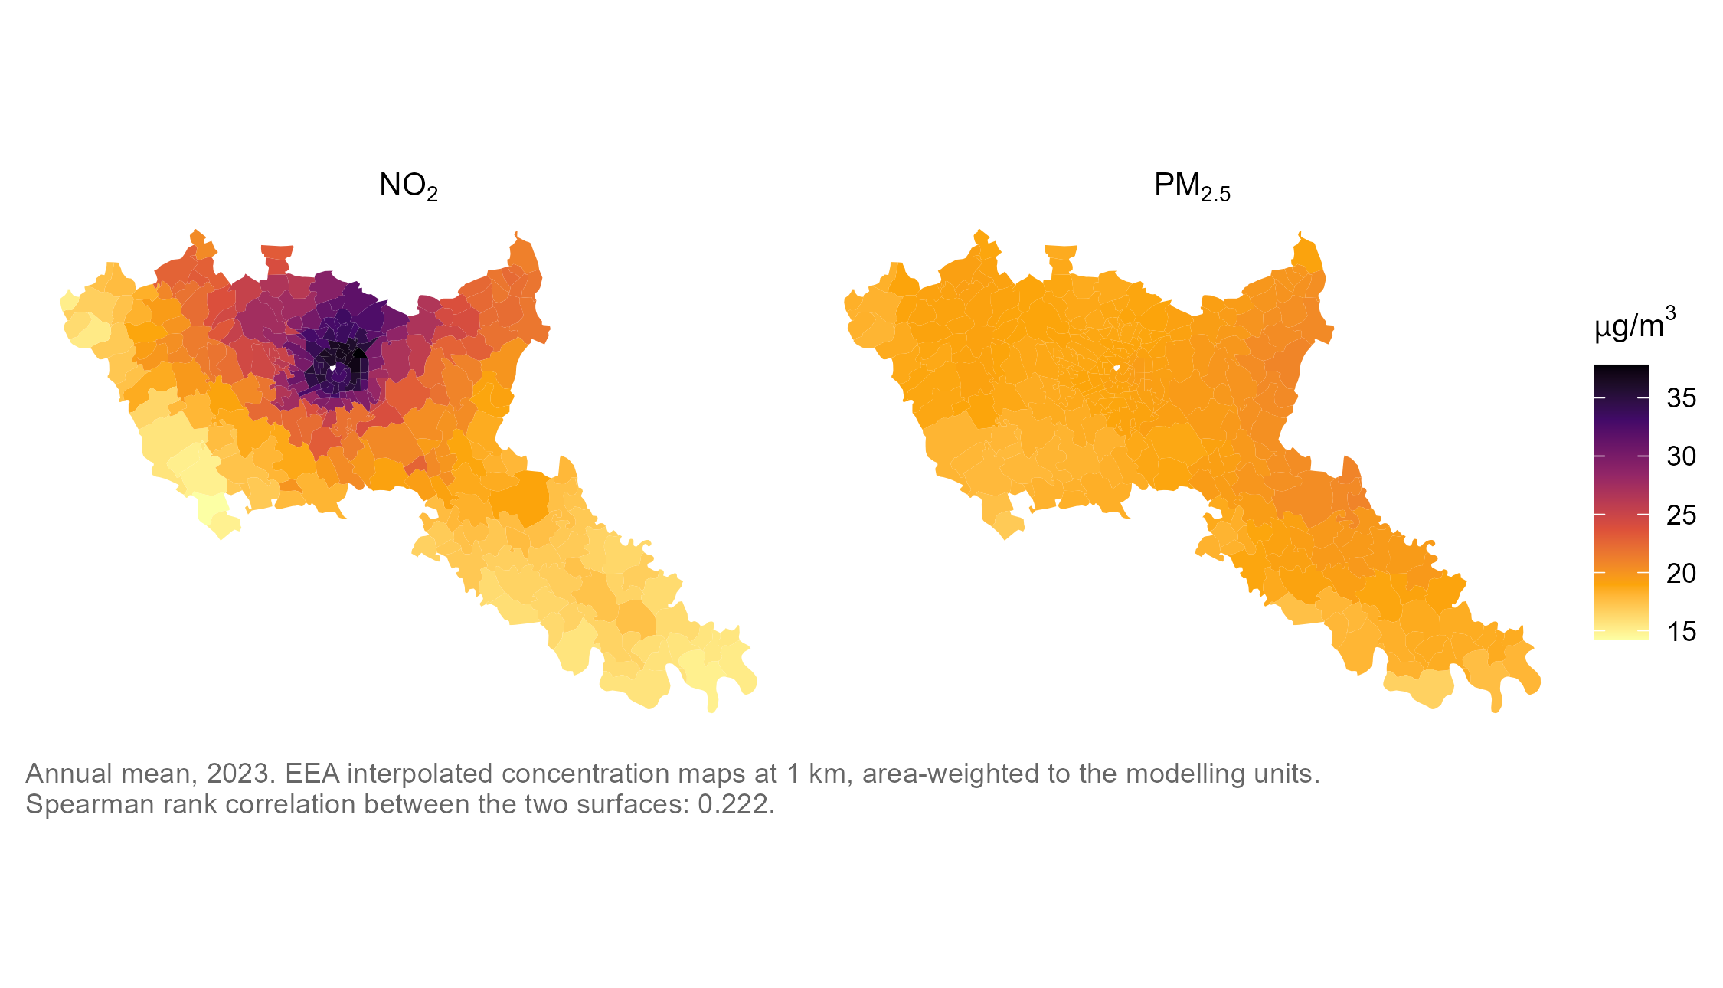
Figure 2
NO2 and PM2.5 across the study area, on a shared scale.

Figure 3
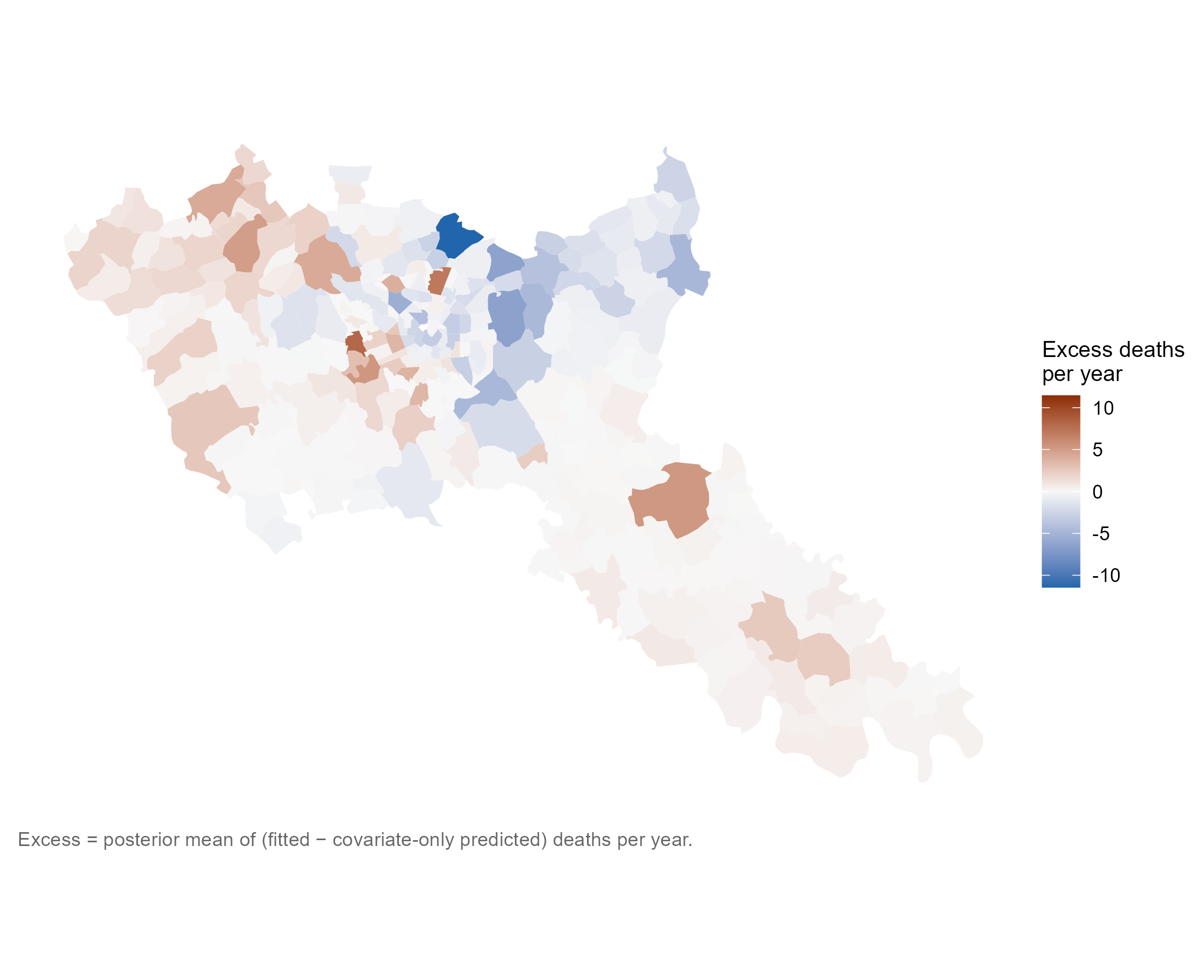
Figure 3
Panel A — all areal units
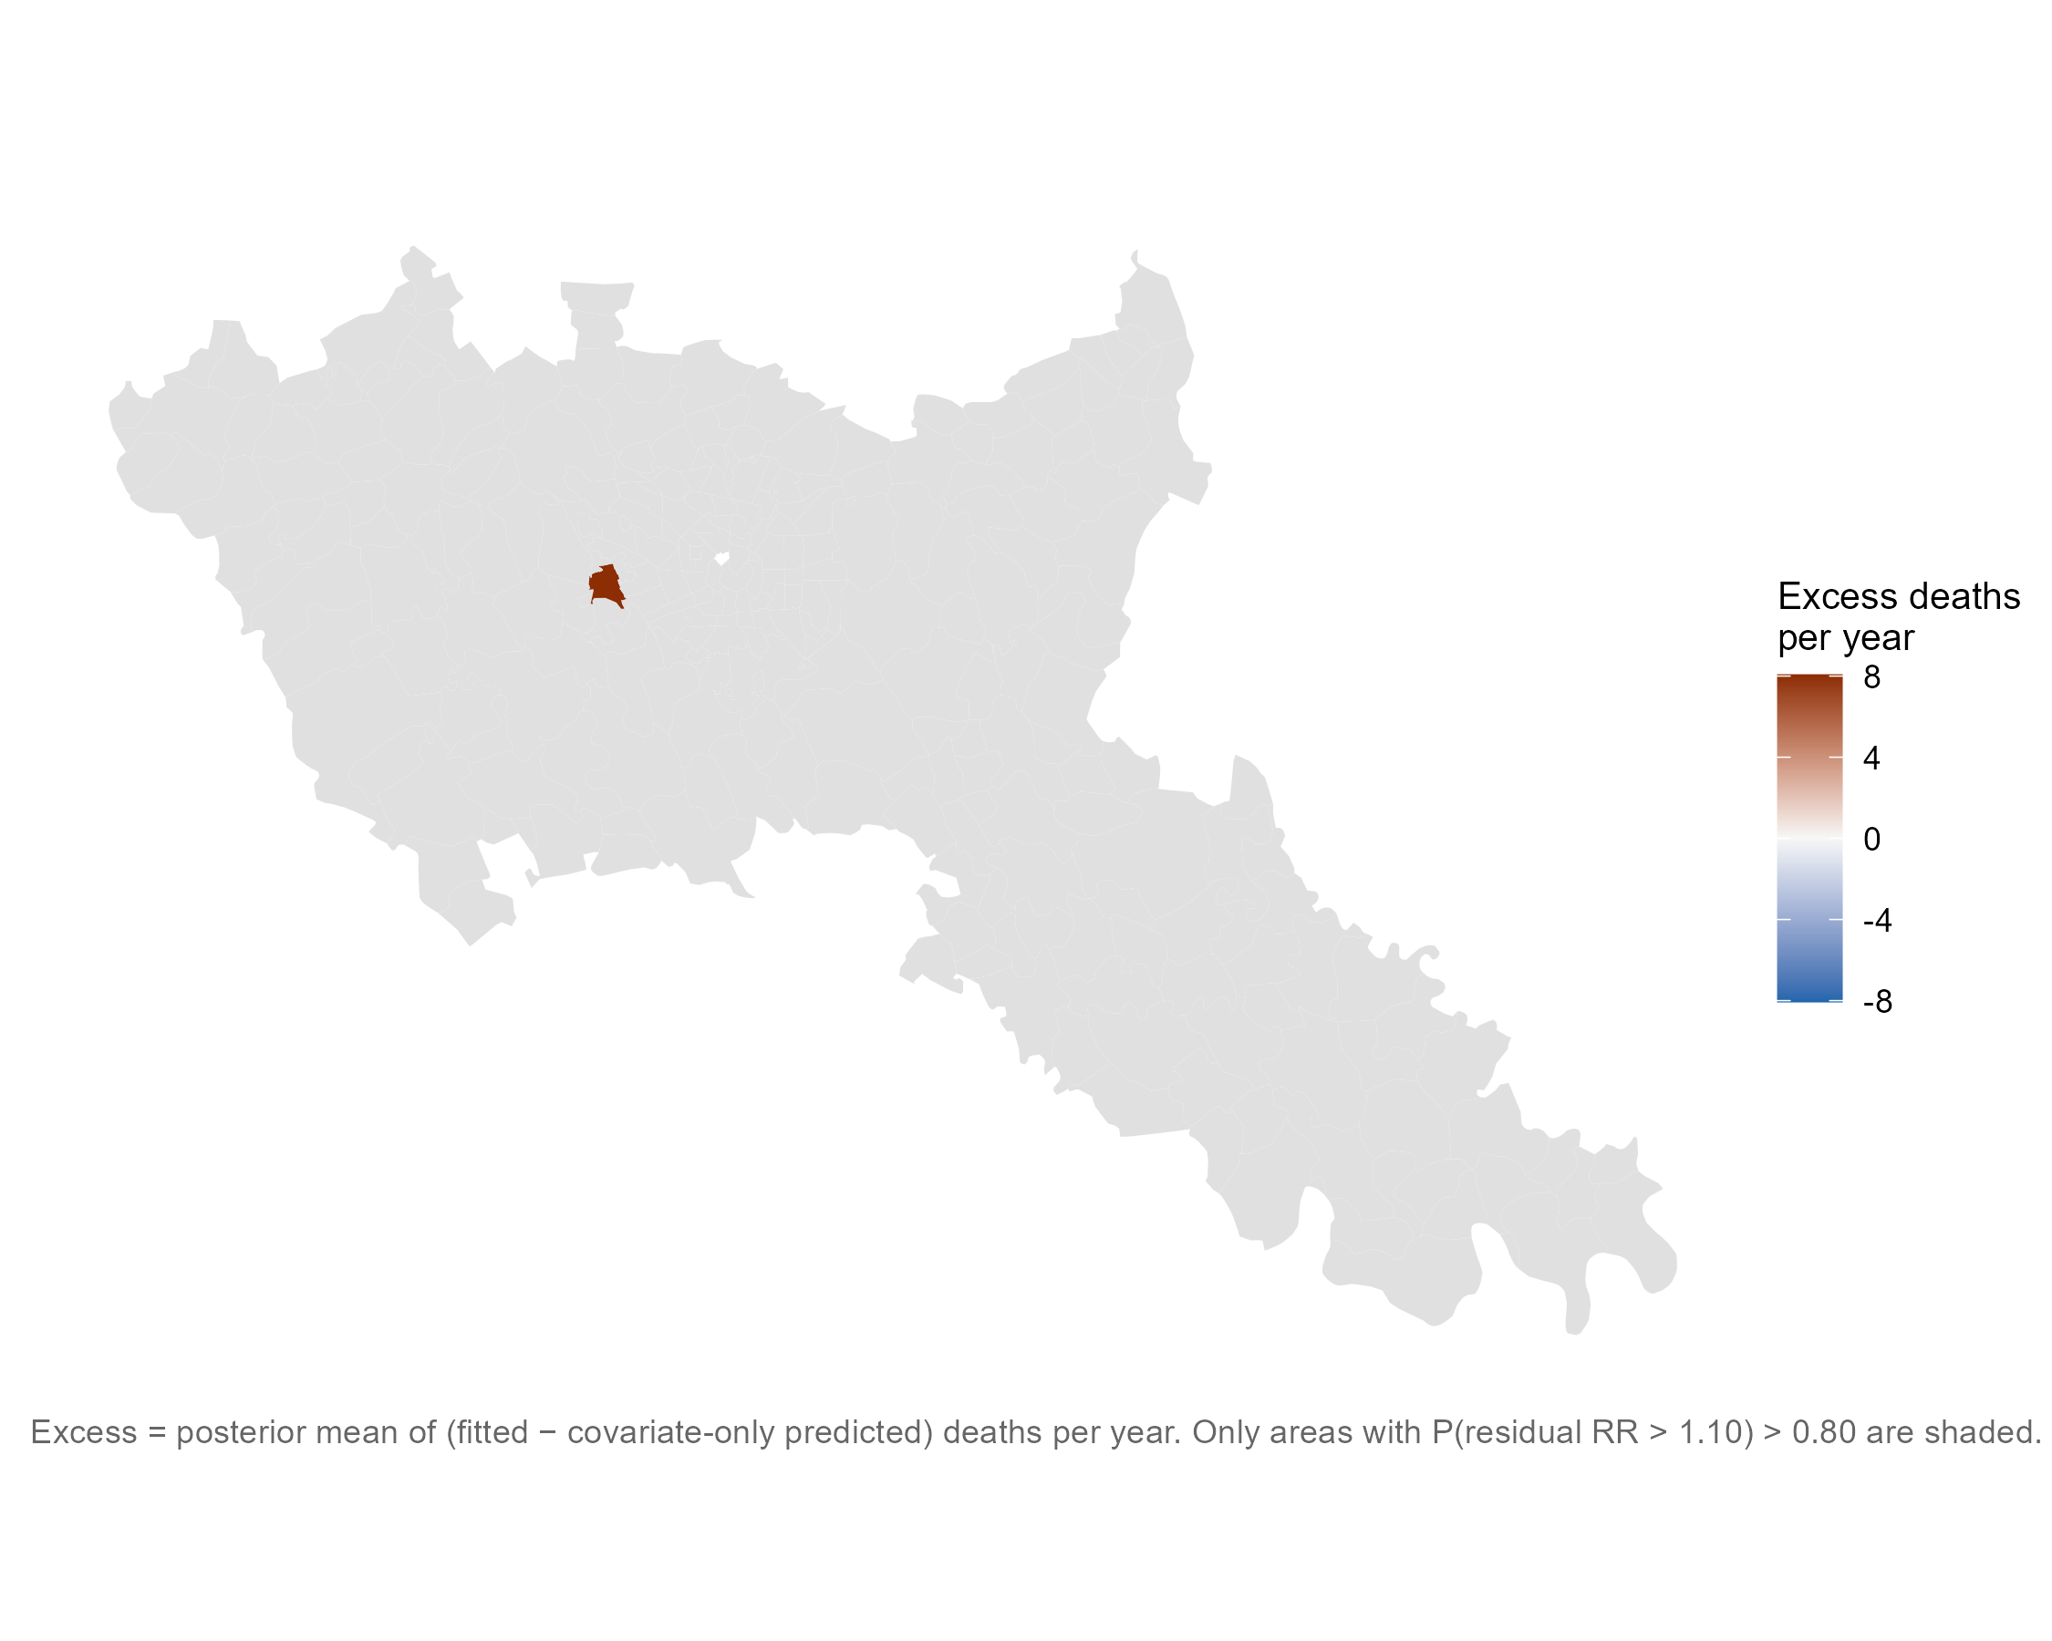
Figure 4
Panel B — areas above the 0.80 cutoff
Residual excess avoidable deaths per year under M5. Panel A shows all 279 areal units; panel B restricts to areas exceeding the 0.80 posterior probability cutoff. Source: fig_excess_map, fig_excess_flagged.

Figure 4
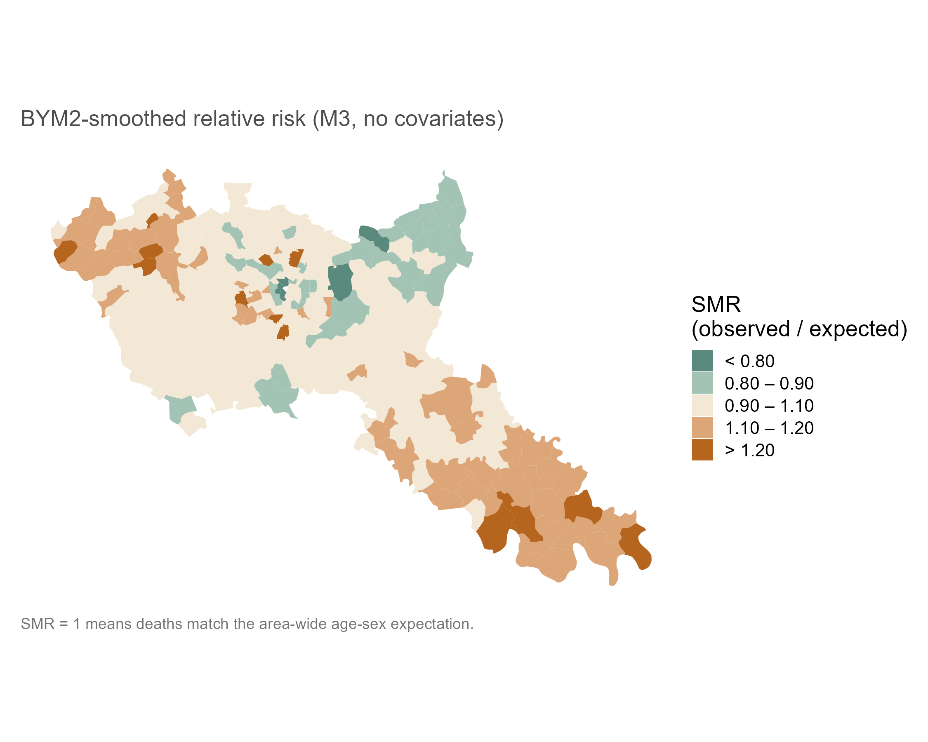
Figure 5
Panel A — smoothed relative risk
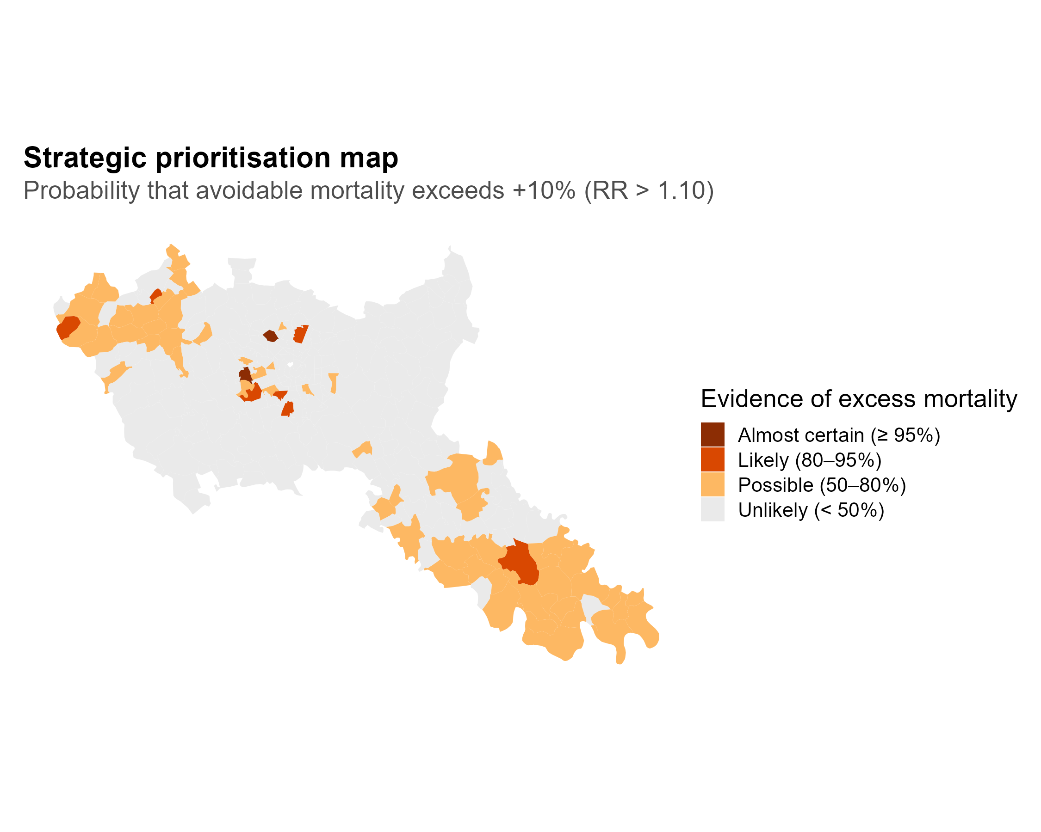
Figure 6
Panel B — exceedance probability (RR > 1.10)
Smoothed relative risk and exceedance probability, M3 (no covariates). Panel A is the BYM2-smoothed relative risk surface; panel B is the posterior probability that an area’s relative risk exceeds 1.10. Source: fig_rr_map, fig_exceedance.

Table 3
Table 4: Table 3. Model comparison by approximate leave-one-out cross-validation, ordered best first. Higher expected log predictive density is better. The difference and its standard error are computed on paired pointwise differences. (Source: tbl_loo.)
Model | ELPD LOO | ELPD SE | P(LOO) | ELPD difference
M4 | -884.1 | 18.5 | 73.5 | 0.0
M5 | -884.9 | 18.5 | 73.8 | -0.8
M7 | -885.4 | 18.6 | 74.1 | -1.3
M3 | -893.7 | 18.0 | 91.6 | -9.6
M6 | -904.7 | 22.7 | 45.8 | -20.6
M2 | -919.9 | 25.0 | 9.4 | -35.9
M1 | -964.0 | 29.6 | 2.6 | -79.9

Table 3b (optional, or appendix)
Table 5: Table 3b. Convergence and sampler diagnostics, M1-M7.
Model | Max R-hat | Min ESS | Divergent | Min E-BFMI
M1 | 1.0013 | 2220.0016 | 0 | 1.0321
M2 | 1.0007 | 3344.9430 | 0 | 0.9620
M3 | 1.0026 | 839.4244 | 0 | 0.8346
M4 | 1.0023 | 803.1822 | 0 | 0.8537
M5 | 1.0037 | 786.2560 | 0 | 0.8251
M6 | 1.0027 | 2149.1428 | 0 | 0.7616
M7 | 1.0032 | 1074.5830 | 0 | 0.8170

Table 3c (optional, or appendix)
Table 6: Table 3c. Moran’s I on Pearson residuals, M1-M7. This is the table behind the residual autocorrelation sequence quoted in the Results, which is the argument for the spatial specification. (Source: moran_residual.)
Model | Moran’s I | p | Posterior mean I | 2.5% | 97.5%
M1 | 0.127 | p < 0.001 | 0.127 | 0.119 | 0.137
M2 | 0.077 | p = 0.018 | 0.080 | 0.071 | 0.091
M3 | -0.045 | p = 0.868 | 0.001 | -0.064 | 0.061
M4 | -0.051 | p = 0.900 | -0.007 | -0.062 | 0.052
M5 | -0.049 | p = 0.884 | -0.006 | -0.066 | 0.053
M6 | -0.086 | p = 0.987 | -0.031 | -0.071 | 0.008
M7 | -0.043 | p = 0.852 | -0.002 | -0.056 | 0.055

Table 4
Table 7: Table 4. Covariate associations across model specifications. Relative risks per standard deviation of the covariate, with 95% credible intervals. (Source: model_coefficients.)
Model | Term | RR per SD |  | 2.5% | 97.5%
M2 | Deprivation Index (per SD) | 1.110 | 1.083 |  | 1.138
M2 | NO2 (per SD) | 0.970 | 0.951 |  | 0.989
M2 | Primary care density (per SD) | 0.955 | 0.933 |  | 0.978
M4 | Deprivation Index (per SD) | 1.102 | 1.066 |  | 1.136
M5 | Deprivation Index (per SD) | 1.103 | 1.067 |  | 1.139
M5 | NO2 (per SD) | 1.000 | 0.953 |  | 1.055
M5 | Primary care density (per SD) | 0.977 | 0.947 |  | 1.008
M6 | Deprivation Index (per SD) | 1.110 | 1.079 |  | 1.141
M6 | NO2 (per SD) | 0.974 | 0.945 |  | 1.003
M6 | Primary care density (per SD) | 0.964 | 0.939 |  | 0.991
M7 | Deprivation Index (per SD) | 1.103 | 1.066 |  | 1.138
M7 | PM2.5 (per SD) | 0.985 | 0.945 |  | 1.027
M7 | Primary care density (per SD) | 0.977 | 0.948 |  | 1.007

Figure 5
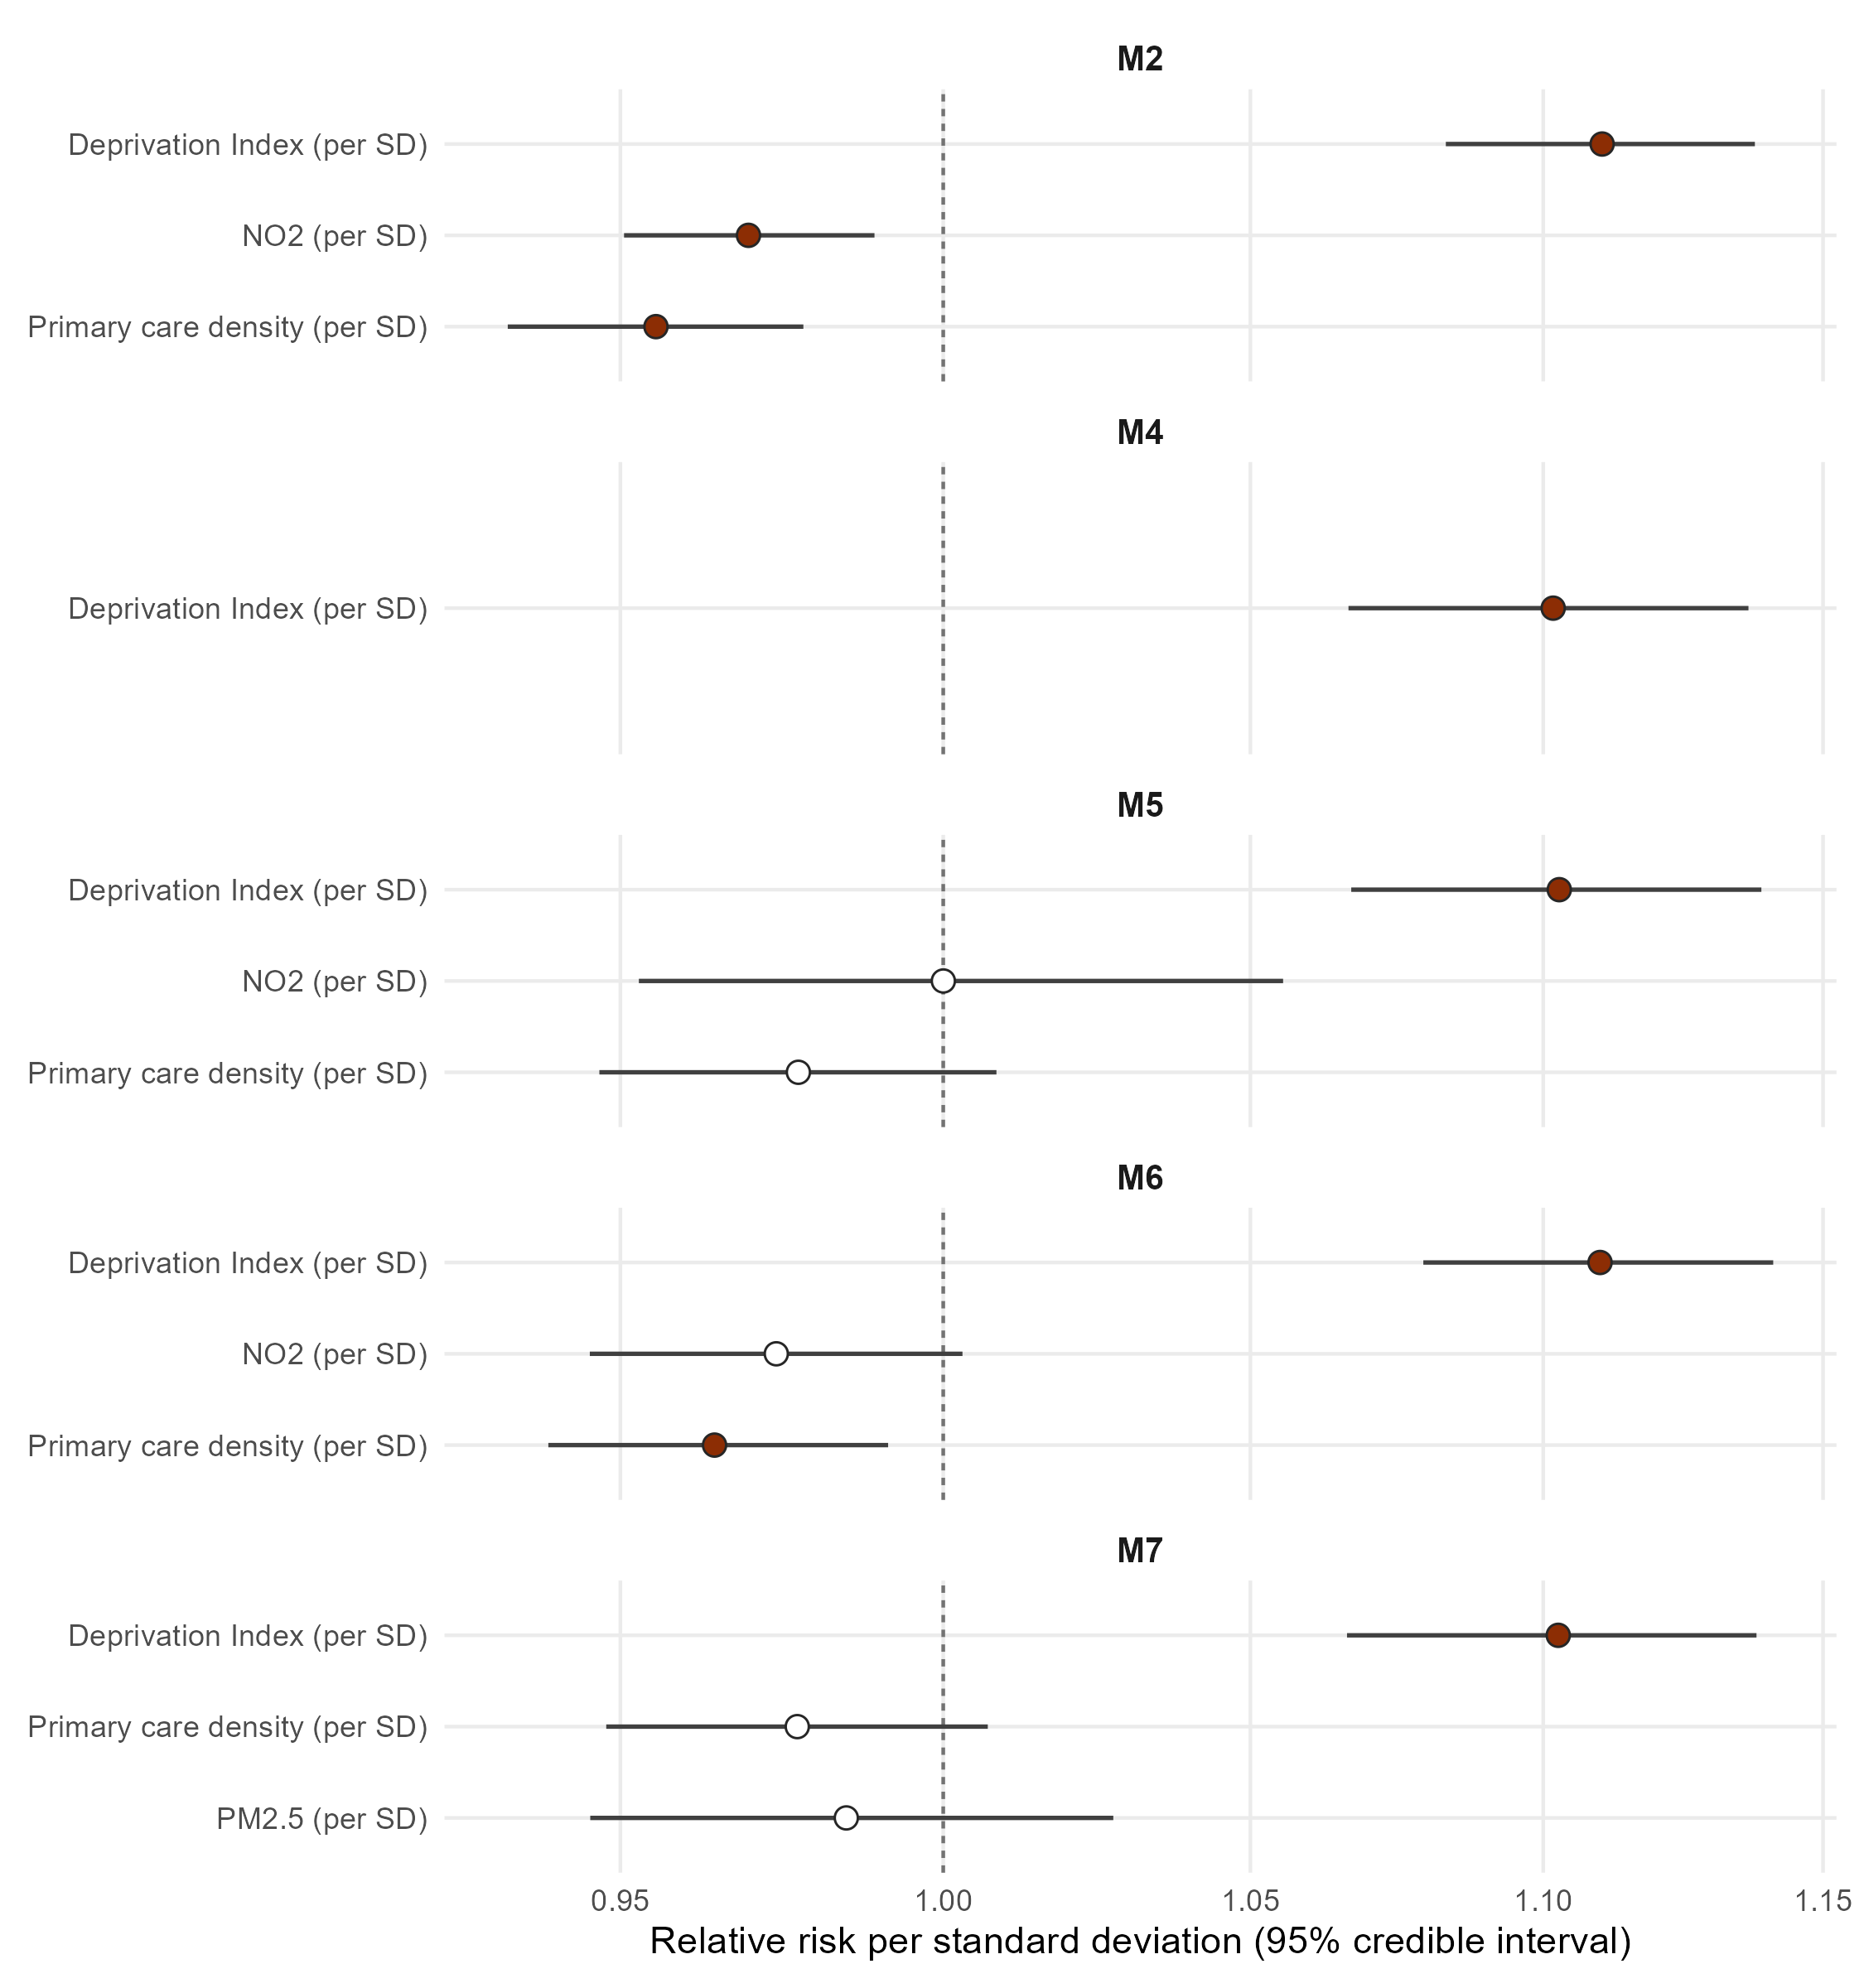
Figure 7
Covariate associations across specifications, relative risk per standard deviation. Source: fig_forest.

Table 5
Table 8: Table 5. Per-mechanism BYM2 models, all seven service-function strata. Deaths are weighted counts. Rho is the share of residual variation that is spatially structured; its intervals overlap across every pair of strata, so the spread of point estimates should not be read as a difference between service functions. (Source: mechanism_table.)
Service function | Deaths | rho | 2.5% | 97.5% | Min RR | Max RR | Areas exceeding
Lifestyle and NCDs | 5,616.00 | 0.60 | 0.19 | 0.97 | 0.82 | 1.35 | 12
Tertiary prevention | 4,171.50 | 0.74 | 0.34 | 0.99 | 0.85 | 1.33 | 21
Screening | 911.00 | 0.64 | 0.06 | 0.99 | 1.01 | 1.15 | 0
Immunisation and Prophylaxis | 592.00 | 0.54 | 0.04 | 0.97 | 0.84 | 1.46 | 0
Mental Health Services | 360.00 | 0.47 | 0.02 | 0.97 | 0.81 | 1.34 | 0
Environment and Safety | 230.50 | 0.60 | 0.06 | 0.99 | 0.89 | 1.35 | 0
Gender and Reproductive Health | 133.00 | 0.50 | 0.03 | 0.97 | 0.72 | 1.37 | 0

Figure 6
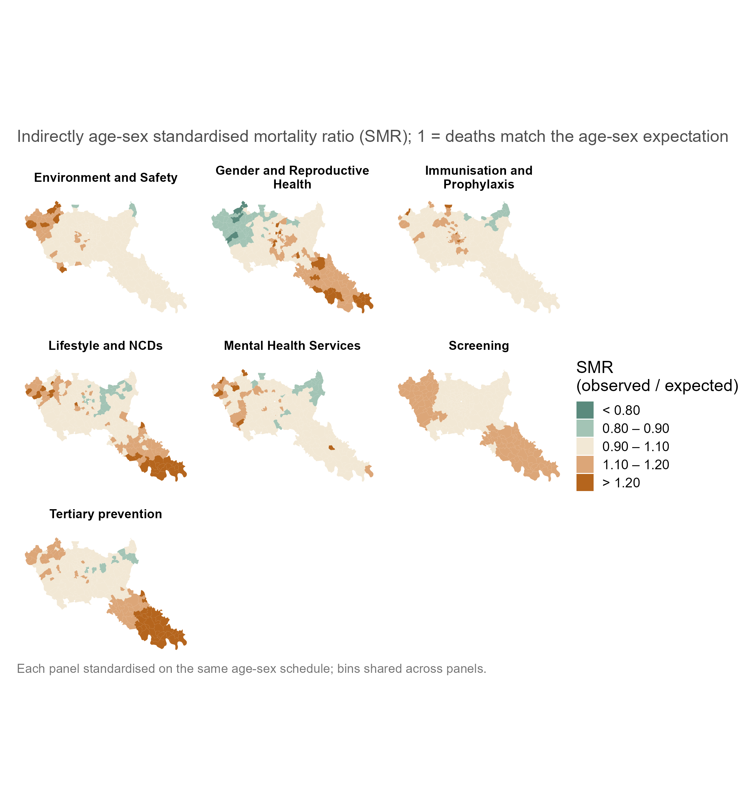
Figure 8
BYM2-smoothed relative risk by service function. Source: fig_mech_facets.

Figure 7
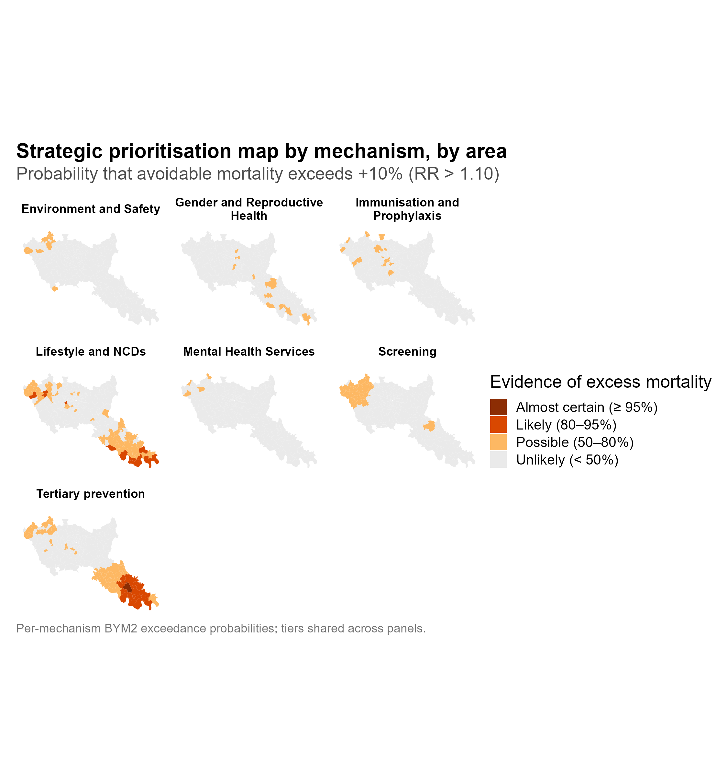
Figure 9
Posterior probability that relative risk exceeds 1.10, by service function. Source: fig_mech_exceedance.

Figure 8
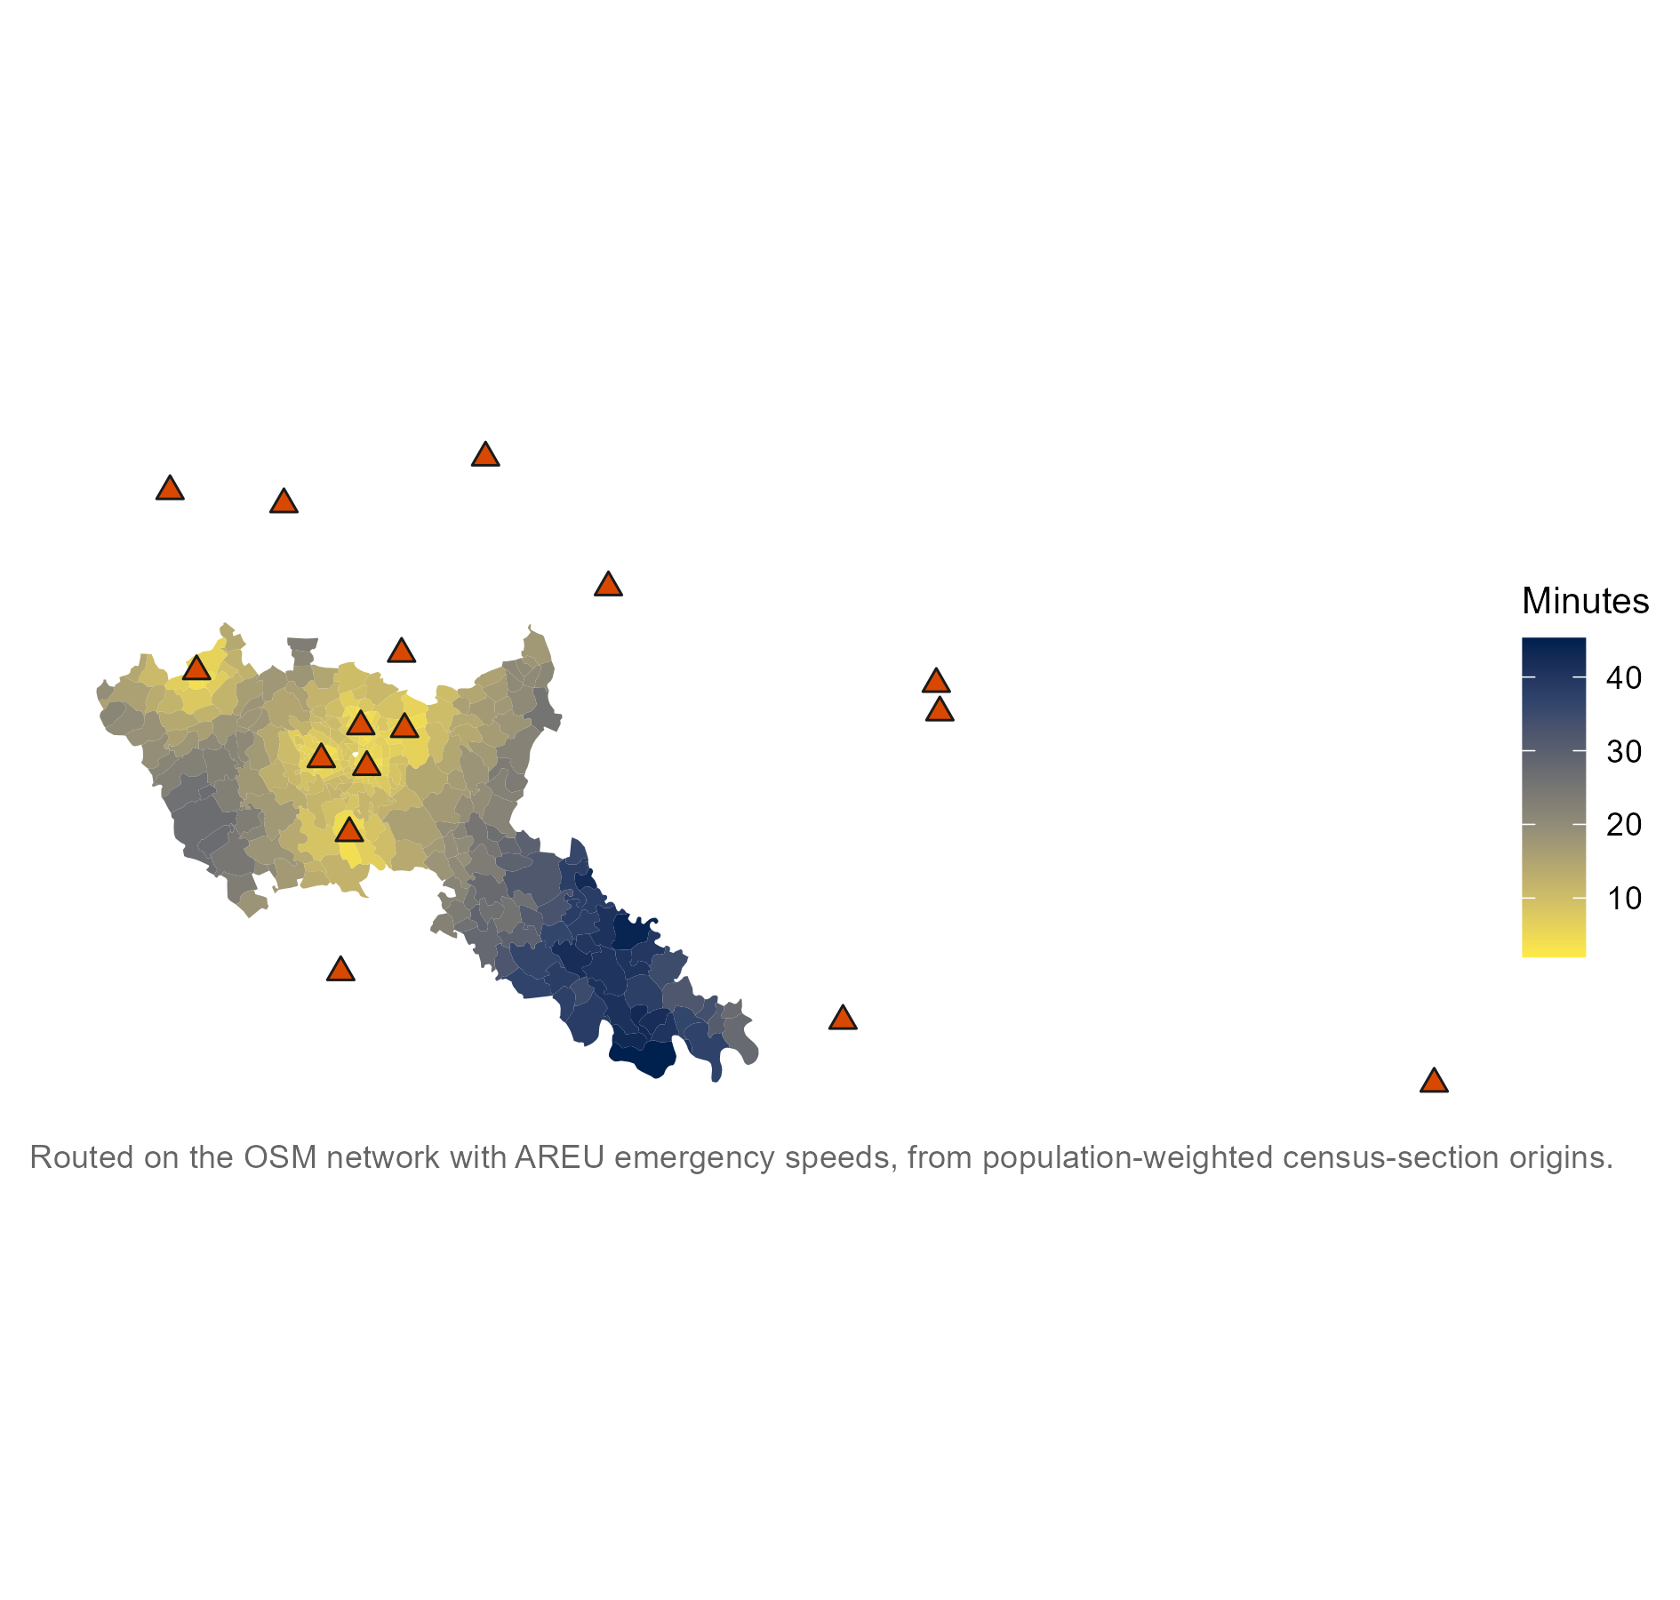
Figure 10
Population-weighted travel time to the nearest level-II thrombectomy hub. Source: fig_hub_time.

Table 6
Table 9: Table 6. Specification ladder: all-age I63 cerebral infarction against travel time to the nearest thrombectomy hub. Row two is the reference model. The BYM2 and ESF rows remove the exposure’s spatial contrast along with the confounding, and are reported as a bound rather than as a correction. (Source: i63_engine_table.)
Specification | Term | RR per SD | 2.5% | 97.5% | ESS | R-hat
GLM, exposure only | Travel time to thrombectomy hub (per SD) | 1.175 | 1.094 | 1.258 | 3825.4460 | 1.0005912
BYM2 + adjustment set | Travel time to thrombectomy hub (per SD) | 1.097 | 0.941 | 1.263 | 775.4109 | 1.0061848
BYM2 + adjustment set | Deprivation Index (per SD) | 1.172 | 1.069 | 1.283 | 11353.6415 | 0.9999870
BYM2 + adjustment set | NO2 (per SD) | 0.995 | 0.881 | 1.125 | 2061.3767 | 1.0005670
BYM2 + adjustment set | Primary care density (per SD) | 1.038 | 0.960 | 1.123 | 8050.9929 | 1.0007260
ESF + adjustment set | Travel time to thrombectomy hub (per SD) | 1.118 | 0.988 | 1.260 | 6805.9407 | 0.9999542
ESF + adjustment set | Deprivation Index (per SD) | 1.169 | 1.070 | 1.273 | 8427.6348 | 0.9999056
ESF + adjustment set | NO2 (per SD) | 0.987 | 0.871 | 1.105 | 3915.3109 | 1.0010023
ESF + adjustment set | Primary care density (per SD) | 1.040 | 0.962 | 1.123 | 8423.7485 | 0.9997537

Table 7
Table 10: Table 7. Tracer and control panel. Every arm is fitted on the reference specification with the same adjustment set. The expectation column was written before the estimates were seen. (Source: control_table.)
Role | Outcome | Exposure | RR per SD | 2.5% | 97.5%
Tracer | I63 cerebral infarction, all ages | Travel time to thrombectomy hub | 1.114 | 1.003 | 1.235
Tracer | I63 cerebral infarction, all ages | Deprivation Index | 1.170 | 1.076 | 1.267
Tracer | I63 cerebral infarction, all ages | NO2 | 0.990 | 0.906 | 1.079
Tracer | I63 cerebral infarction, all ages | Primary care density (per SD) | 1.044 | 0.972 | 1.125
Negative control outcome | All-cancer mortality | Travel time to thrombectomy hub (per SD) | 0.993 | 0.947 | 1.042
Negative control outcome | All-cancer mortality | Deprivation Index (per SD) | 1.096 | 1.056 | 1.136
Negative control outcome | All-cancer mortality | NO2 (per SD) | 0.933 | 0.897 | 0.971
Negative control outcome | All-cancer mortality | Primary care density (per SD) | 0.954 | 0.923 | 0.985
Positive control | Lifestyle/NCD-preventable mortality | Deprivation Index (per SD) | 1.095 | 1.055 | 1.136
Positive control | Lifestyle/NCD-preventable mortality | NO2 (per SD) | 0.963 | 0.935 | 0.991
Positive control | Lifestyle/NCD-preventable mortality | Primary care density (per SD) | 0.955 | 0.923 | 0.988

Figure 9
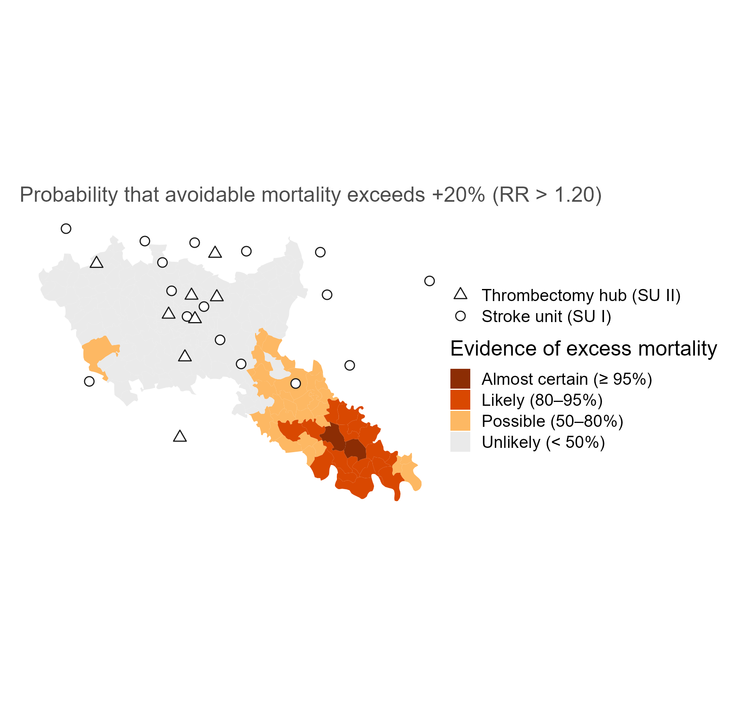
Figure 11
Posterior probability that all-age I63 relative risk exceeds 1.20. Source: fig_i63_exceedance.

Figure 10
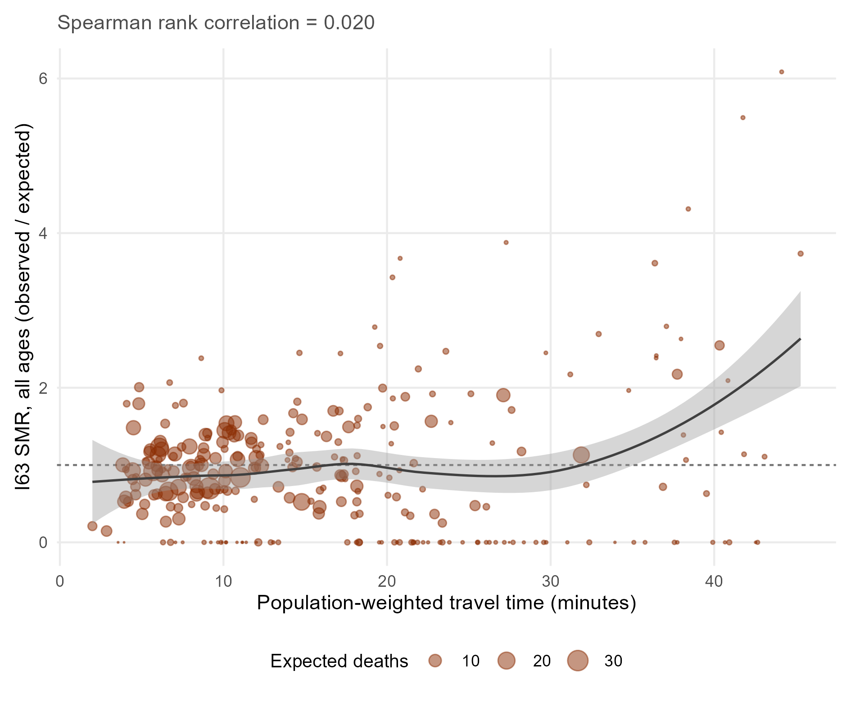
Figure 12
All-age I63 standardised mortality ratio against travel time to the nearest thrombectomy hub. Point size is the expected count, so the large points are the areas the model learns from. Source: fig_i63_raw. See note N5.

Strongly suggested additions
Three pipeline objects support claims the thesis already makes in prose but does not illustrate. Each is a single insertion.

Figure 11 (suggested)
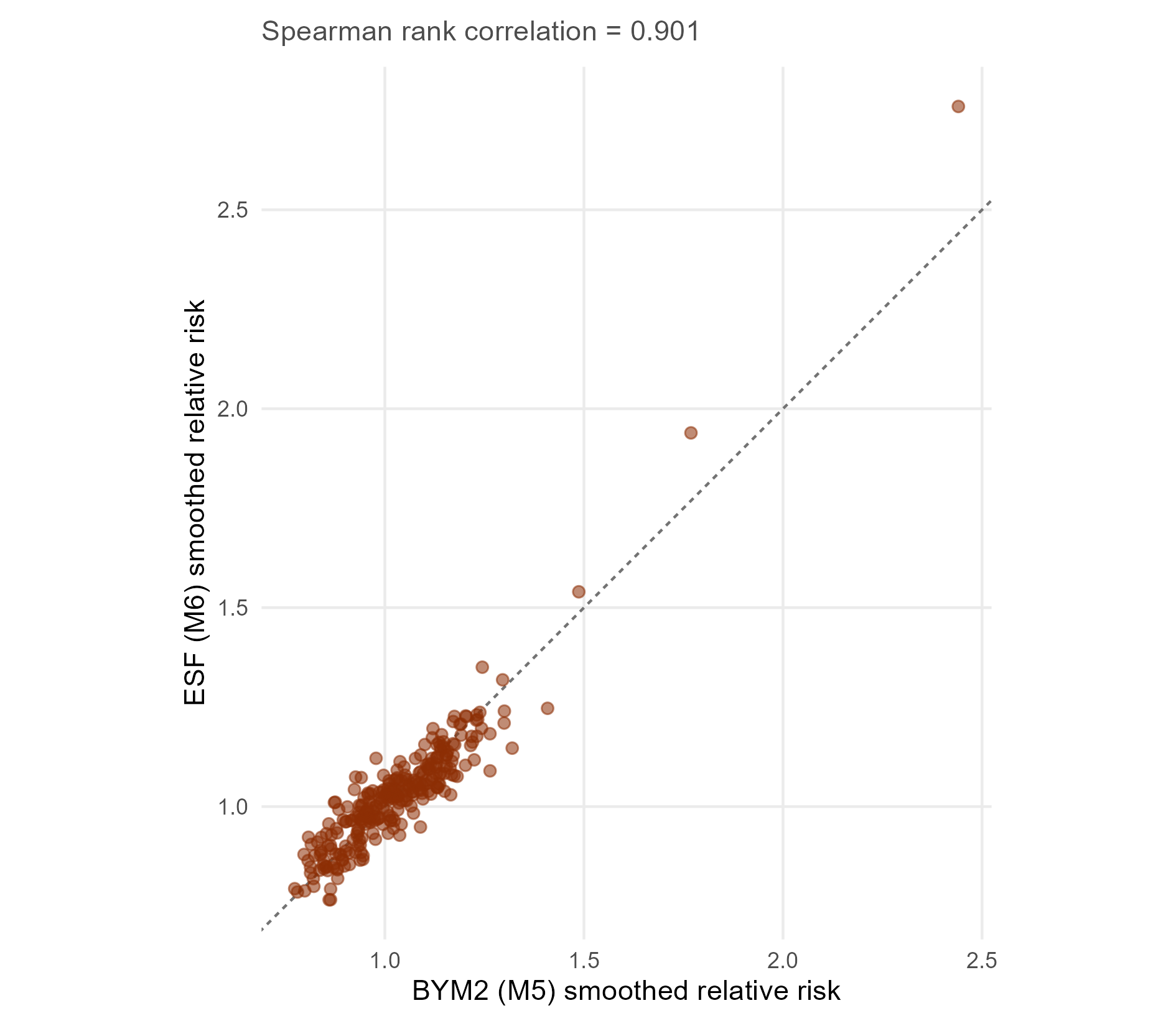
Figure 13
BYM2 (M5) against ESF (M6) smoothed relative risk. Supports the Spearman rank correlation quoted in Sensitivity to model specifications, which currently has no figure. Source: fig_rr_compare.

Figure 12 (suggested)
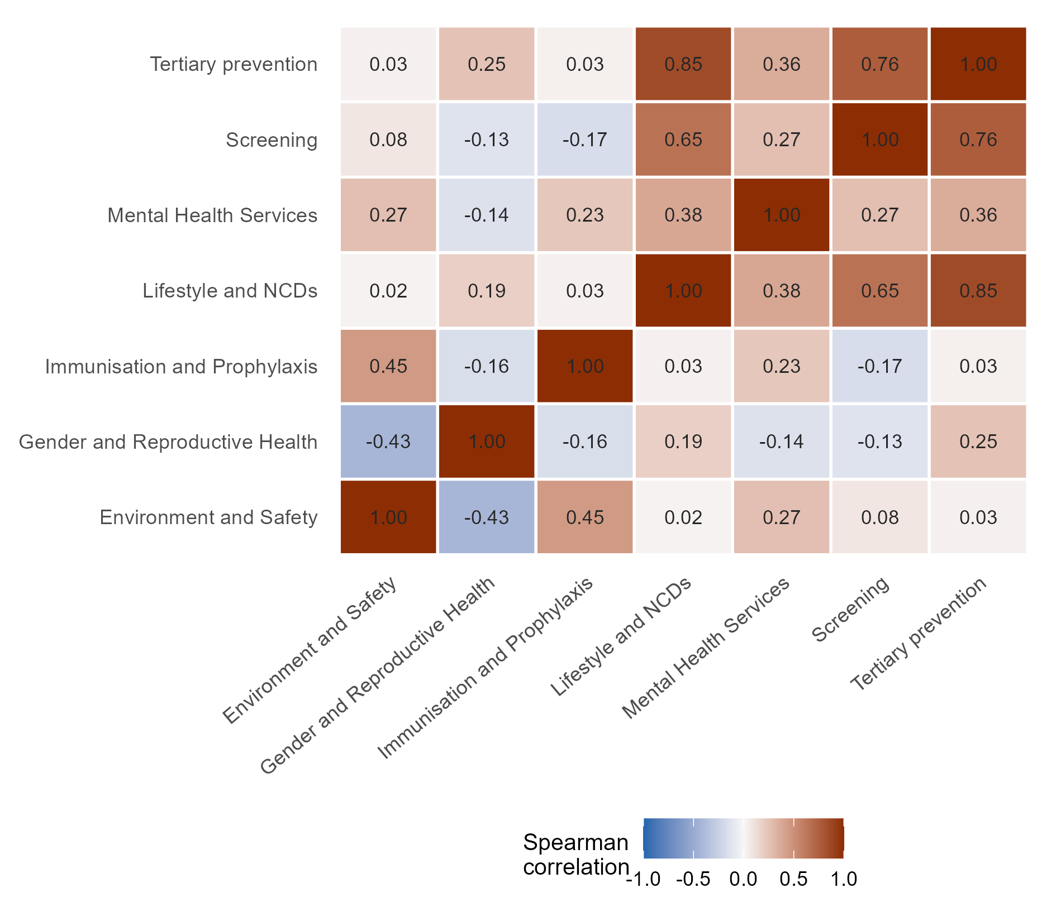
Figure 14
Rank concordance among the seven mechanism risk surfaces. Supports the correlation between the lifestyle/NCD and tertiary prevention surfaces that the Discussion turns on. Source: fig_concordance.

Table 8 (suggested) — the tabular version of Figure 12
Table 11: Table 8. Most and least concordant pairs of mechanism risk surfaces. Use this or Figure 12, not both. (Source: mechanism_concordance$long.)
Service function A | Service function B | Spearman rho
Lifestyle and NCDs | Tertiary prevention | 0.854
Screening | Tertiary prevention | 0.761
Lifestyle and NCDs | Screening | 0.652
Environment and Safety | Immunisation and Prophylaxis | 0.453
Lifestyle and NCDs | Mental Health Services | 0.384
Mental Health Services | Tertiary prevention | 0.359
Mental Health Services | Screening | 0.270
Environment and Safety | Mental Health Services | 0.267
Gender and Reproductive Health | Tertiary prevention | 0.251
Immunisation and Prophylaxis | Mental Health Services | 0.231
Gender and Reproductive Health | Lifestyle and NCDs | 0.189
Environment and Safety | Screening | 0.080
Immunisation and Prophylaxis | Tertiary prevention | 0.033
Environment and Safety | Tertiary prevention | 0.032
Immunisation and Prophylaxis | Lifestyle and NCDs | 0.032

Figure 13 (suggested)
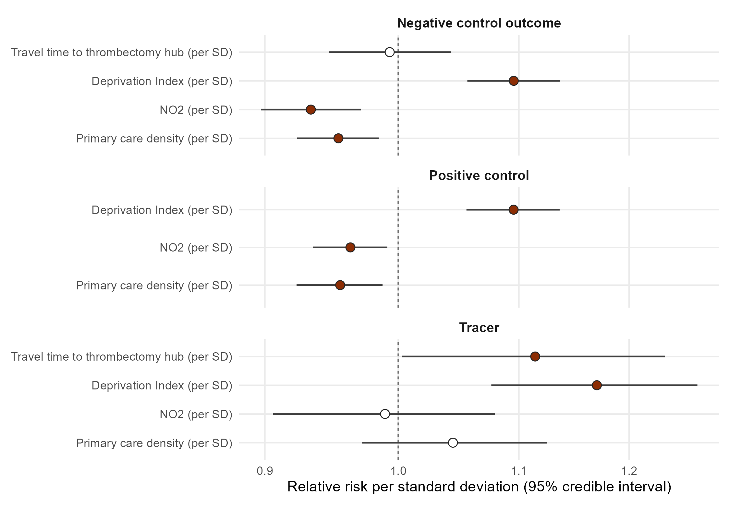
Figure 15
Tracer and control coefficients, relative risk per standard deviation. Makes the control panel legible at a glance. Source: fig_controls.

Annex and appendix material
Referenced by name in the Methods, but with no content attached in the draft.

Annex A — pollutant selection
Table 12: Table A1. Pre-specified pollutant selection criteria. Every criterion is computed on the exposure alone, before any outcome model was fitted. (Source: pollutant_selection.)
pollutant | column | n_missing | mean | sd | min | max | range | cv | sd_milan | cor_z_low | cor_di | rho
no2 | no2_2023 | 0 | 23.76171 | 6.5823252 | 14.22490 | 37.82233 | 23.597428 | 0.2770139 | 4.1521363 | NA | -0.1951133 | 0.9694659
pm25 | pm25_2023 | 0 | 19.02768 | 0.6155666 | 16.63512 | 20.88258 | 4.247466 | 0.0323511 | 0.1936362 | NA | -0.0143371 | 0.3084253

Table 13: Table A2. Rank stability of the pollutant surfaces, 2013 to 2023. This is the table behind the NO2 and PM2.5 rank correlations quoted in Methods, Air pollution. (Source: aq_ranks.)
pollutant | col_old | col_new | mean_old | mean_new | sd_old | sd_new | rho
no2 | no2_2013 | no2_2023 | 37.43541 | 23.76171 | 9.037230 | 6.5823252 | 0.9694659
pm25 | pm25_2013 | pm25_2023 | 27.01023 | 19.02768 | 2.974414 | 0.6155666 | 0.3084253

Table 14: Table A3. Deprivation measure sensitivity: the Deprivation Index against the ISTAT index of social and material vulnerability. Promised in the Annex by Methods, Sensitivity analysis. (Source: sensitivity_coefficients.)
Model | Term | RR per SD | 2.5% | 97.5%
M4 | Deprivation Index (per SD) | 1.102 | 1.066 | 1.136
SIVSM | IVSM (per SD) | 1.047 | 1.005 | 1.089

