a) Cereri de adresa (A)

andreea@andreea-ubuntu:~/Desktop/PROTOCOALE/laburi/lab9$ dig single-v4.protocoale.xyz

; <<>> DiG 9.11.3-1ubuntu1.11-Ubuntu <<>> single-v4.protocoale.xyz
;; global options: +cmd
;; Got answer:
;; ->>HEADER<<- opcode: QUERY, status: NOERROR, id: 30363
;; flags: qr rd ra; QUERY: 1, ANSWER: 1, AUTHORITY: 0, ADDITIONAL: 1

;; OPT PSEUDOSECTION:
; EDNS: version: 0, flags:; udp: 65494
;; QUESTION SECTION:
;single-v4.protocoale.xyz. IN A

;; ANSWER SECTION:
single-v4.protocoale.xyz. 300 IN A 127.0.0.1

;; Query time: 39 msec
;; SERVER: 127.0.0.53#53(127.0.0.53)
;; WHEN: Tue Apr 14 13:33:03 EEST 2020
;; MSG SIZE rcvd: 69

andreea@andreea-ubuntu:~/Desktop/PROTOCOALE/laburi/lab9$ dig A single.protocoale.xyz

; <<>> DiG 9.11.3-1ubuntu1.11-Ubuntu <<>> A single.protocoale.xyz
;; global options: +cmd
;; Got answer:
;; ->>HEADER<<- opcode: QUERY, status: NOERROR, id: 64805
;; flags: qr rd ra; QUERY: 1, ANSWER: 1, AUTHORITY: 0, ADDITIONAL: 1

;; OPT PSEUDOSECTION:
; EDNS: version: 0, flags:; udp: 65494
;; QUESTION SECTION:
;single.protocoale.xyz. IN A

;; ANSWER SECTION:
single.protocoale.xyz. 300 IN A 127.0.0.1

;; Query time: 68 msec
;; SERVER: 127.0.0.53#53(127.0.0.53)
;; WHEN: Tue Apr 14 14:16:56 EEST 2020
;; MSG SIZE rcvd: 66

andreea@andreea-ubuntu:~/Desktop/PROTOCOALE/laburi/lab9$ dig A multi-v4.protocoale.xyz

; <<>> DiG 9.11.3-1ubuntu1.11-Ubuntu <<>> A multi-v4.protocoale.xyz
;; global options: +cmd
;; Got answer:
;; ->>HEADER<<- opcode: QUERY, status: NOERROR, id: 21122
;; flags: qr rd ra; QUERY: 1, ANSWER: 4, AUTHORITY: 0, ADDITIONAL: 1

;; OPT PSEUDOSECTION:
; EDNS: version: 0, flags:; udp: 65494
;; QUESTION SECTION:
;multi-v4.protocoale.xyz. IN A

;; ANSWER SECTION:
multi-v4.protocoale.xyz. 300 IN A 127.4.4.4
multi-v4.protocoale.xyz. 300 IN A 127.2.2.2
multi-v4.protocoale.xyz. 300 IN A 127.3.3.3
multi-v4.protocoale.xyz. 300 IN A 127.1.1.1

;; Query time: 52 msec
;; SERVER: 127.0.0.53#53(127.0.0.53)
;; WHEN: Tue Apr 14 14:17:29 EEST 2020
;; MSG SIZE rcvd: 116

andreea@andreea-ubuntu:~/Desktop/PROTOCOALE/laburi/lab9$ dig multi.protocoale.xyz

; <<>> DiG 9.11.3-1ubuntu1.11-Ubuntu <<>> multi.protocoale.xyz
;; global options: +cmd
;; Got answer:
;; ->>HEADER<<- opcode: QUERY, status: NOERROR, id: 43290
;; flags: qr rd ra; QUERY: 1, ANSWER: 4, AUTHORITY: 0, ADDITIONAL: 1

;; OPT PSEUDOSECTION:
; EDNS: version: 0, flags:; udp: 65494
;; QUESTION SECTION:
;multi.protocoale.xyz. IN A

;; ANSWER SECTION:
multi.protocoale.xyz. 300 IN A 127.2.2.2
multi.protocoale.xyz. 300 IN A 127.1.1.1
multi.protocoale.xyz. 300 IN A 127.4.4.4
multi.protocoale.xyz. 300 IN A 127.3.3.3

;; Query time: 47 msec
;; SERVER: 127.0.0.53#53(127.0.0.53)
;; WHEN: Tue Apr 14 14:18:31 EEST 2020
;; MSG SIZE rcvd: 113

b) Cereri de adresa (AAAA)

andreea@andreea-ubuntu:~/Desktop/PROTOCOALE/laburi/lab9$ dig AAAA single-v6.protocoale.xyz

; <<>> DiG 9.11.3-1ubuntu1.11-Ubuntu <<>> AAAA single-v6.protocoale.xyz
;; global options: +cmd
;; Got answer:
;; ->>HEADER<<- opcode: QUERY, status: NOERROR, id: 62620
;; flags: qr rd ra; QUERY: 1, ANSWER: 1, AUTHORITY: 0, ADDITIONAL: 1

;; OPT PSEUDOSECTION:
; EDNS: version: 0, flags:; udp: 65494
;; QUESTION SECTION:
;single-v6.protocoale.xyz. IN AAAA

;; ANSWER SECTION:
single-v6.protocoale.xyz. 58 IN AAAA ::1

;; Query time: 0 msec
;; SERVER: 127.0.0.53#53(127.0.0.53)
;; WHEN: Tue Apr 14 13:33:32 EEST 2020
;; MSG SIZE rcvd: 81

andreea@andreea-ubuntu:~/Desktop/PROTOCOALE/laburi/lab9$ dig AAAA single.protocoale.xyz

; <<>> DiG 9.11.3-1ubuntu1.11-Ubuntu <<>> AAAA single.protocoale.xyz
;; global options: +cmd
;; Got answer:
;; ->>HEADER<<- opcode: QUERY, status: NOERROR, id: 58070
;; flags: qr rd ra; QUERY: 1, ANSWER: 1, AUTHORITY: 0, ADDITIONAL: 1

;; OPT PSEUDOSECTION:
; EDNS: version: 0, flags:; udp: 65494
;; QUESTION SECTION:
;single.protocoale.xyz. IN AAAA

;; ANSWER SECTION:
single.protocoale.xyz. 300 IN AAAA ::1

;; Query time: 58 msec
;; SERVER: 127.0.0.53#53(127.0.0.53)
;; WHEN: Tue Apr 14 14:20:22 EEST 2020
;; MSG SIZE rcvd: 78

andreea@andreea-ubuntu:~/Desktop/PROTOCOALE/laburi/lab9$ dig AAAA multi.protocoale.xyz

; <<>> DiG 9.11.3-1ubuntu1.11-Ubuntu <<>> AAAA multi.protocoale.xyz
;; global options: +cmd
;; Got answer:
;; ->>HEADER<<- opcode: QUERY, status: NOERROR, id: 58341
;; flags: qr rd ra; QUERY: 1, ANSWER: 4, AUTHORITY: 0, ADDITIONAL: 1

;; OPT PSEUDOSECTION:
; EDNS: version: 0, flags:; udp: 65494
;; QUESTION SECTION:
;multi.protocoale.xyz. IN AAAA

;; ANSWER SECTION:
multi.protocoale.xyz. 300 IN AAAA ::4
multi.protocoale.xyz. 300 IN AAAA ::3
multi.protocoale.xyz. 300 IN AAAA ::2
multi.protocoale.xyz. 300 IN AAAA ::1

;; Query time: 60 msec
;; SERVER: 127.0.0.53#53(127.0.0.53)
;; WHEN: Tue Apr 14 14:21:19 EEST 2020
;; MSG SIZE rcvd: 161

c) Cerere de tip MX, pentru serverul de mail

andreea@andreea-ubuntu:~/Desktop/PROTOCOALE/laburi/lab9$ dig MX protocoale.xyz

; <<>> DiG 9.11.3-1ubuntu1.11-Ubuntu <<>> MX protocoale.xyz
;; global options: +cmd
;; Got answer:
;; ->>HEADER<<- opcode: QUERY, status: NOERROR, id: 37902
;; flags: qr rd ra; QUERY: 1, ANSWER: 3, AUTHORITY: 0, ADDITIONAL: 1

;; OPT PSEUDOSECTION:
; EDNS: version: 0, flags:; udp: 65494
;; QUESTION SECTION:
;protocoale.xyz. IN MX

;; ANSWER SECTION:
protocoale.xyz. 81 IN MX 20 alt2.gmail-smtp-in.l.google.com.
protocoale.xyz. 81 IN MX 30 alt3.gmail-smtp-in.l.google.com.
protocoale.xyz. 81 IN MX 10 alt1.gmail-smtp-in.l.google.com.

;; Query time: 15 msec
;; SERVER: 127.0.0.53#53(127.0.0.53)
;; WHEN: Tue Apr 14 14:22:17 EEST 2020
;; MSG SIZE rcvd: 132

d) (?) Cerere in care se afiseaza doar RR-urile autoritare

andreea@andreea-ubuntu:~/Desktop/PROTOCOALE/laburi/lab9$ dig google.com +noall +authority

; <<>> DiG 9.11.3-1ubuntu1.11-Ubuntu <<>> google.com +noall +authority
;; global options: +cmd

andreea@andreea-ubuntu:~/Desktop/PROTOCOALE/laburi/lab9$ dig SOA google.com

; <<>> DiG 9.11.3-1ubuntu1.11-Ubuntu <<>> SOA google.com
;; global options: +cmd
;; Got answer:
;; ->>HEADER<<- opcode: QUERY, status: NOERROR, id: 18093
;; flags: qr rd ra; QUERY: 1, ANSWER: 1, AUTHORITY: 0, ADDITIONAL: 1

;; OPT PSEUDOSECTION:
; EDNS: version: 0, flags:; udp: 65494
;; QUESTION SECTION:
;google.com. IN SOA

;; ANSWER SECTION:
google.com. 15 IN SOA ns1.google.com. dns-admin.google.com. 306204018 900 900 1800 60

;; Query time: 14 msec
;; SERVER: 127.0.0.53#53(127.0.0.53)
;; WHEN: Tue Apr 14 15:58:32 EEST 2020
;; MSG SIZE rcvd: 89

e) Folosirea mai multor servere de nume pentru a interoga adresa IP a google.com

andreea@andreea-ubuntu:~/Desktop/PROTOCOALE/laburi/lab9$ dig google.com @86.120.141.140

; <<>> DiG 9.11.3-1ubuntu1.11-Ubuntu <<>> google.com @86.120.141.140
;; global options: +cmd
;; Got answer:
;; ->>HEADER<<- opcode: QUERY, status: NOERROR, id: 40874
;; flags: qr rd ra; QUERY: 1, ANSWER: 1, AUTHORITY: 13, ADDITIONAL: 1

;; QUESTION SECTION:
;google.com. IN A

;; ANSWER SECTION:
google.com. 141 IN A 172.217.16.110

;; AUTHORITY SECTION:
. 4860 IN NS m.root-servers.net.
. 4860 IN NS d.root-servers.net.
. 4860 IN NS k.root-servers.net.
. 4860 IN NS e.root-servers.net.
. 4860 IN NS a.root-servers.net.
. 4860 IN NS g.root-servers.net.
. 4860 IN NS i.root-servers.net.
. 4860 IN NS h.root-servers.net.
. 4860 IN NS c.root-servers.net.
. 4860 IN NS b.root-servers.net.
. 4860 IN NS j.root-servers.net.
. 4860 IN NS f.root-servers.net.
. 4860 IN NS l.root-servers.net.

;; ADDITIONAL SECTION:
a.root-servers.net. 169421 IN A 198.41.0.4

;; Query time: 154 msec
;; SERVER: 86.120.141.140#53(86.120.141.140)
;; WHEN: Tue Apr 14 14:34:23 EEST 2020
;; MSG SIZE rcvd: 271

andreea@andreea-ubuntu:~/Desktop/PROTOCOALE/laburi/lab9$ dig google.com @8.8.8.8

; <<>> DiG 9.11.3-1ubuntu1.11-Ubuntu <<>> google.com @8.8.8.8
;; global options: +cmd
;; Got answer:
;; ->>HEADER<<- opcode: QUERY, status: NOERROR, id: 60126
;; flags: qr rd ra; QUERY: 1, ANSWER: 1, AUTHORITY: 0, ADDITIONAL: 1

;; OPT PSEUDOSECTION:
; EDNS: version: 0, flags:; udp: 512
;; QUESTION SECTION:
;google.com. IN A

;; ANSWER SECTION:
google.com. 201 IN A 172.217.20.14

;; Query time: 26 msec
;; SERVER: 8.8.8.8#53(8.8.8.8)
;; WHEN: Tue Apr 14 14:33:20 EEST 2020
;; MSG SIZE rcvd: 55

andreea@andreea-ubuntu:~/Desktop/PROTOCOALE/laburi/lab9$ dig google.com @81.180.124.165

; <<>> DiG 9.11.3-1ubuntu1.11-Ubuntu <<>> google.com @81.180.124.165
;; global options: +cmd
;; Got answer:
;; ->>HEADER<<- opcode: QUERY, status: NOERROR, id: 47680
;; flags: qr rd ra; QUERY: 1, ANSWER: 1, AUTHORITY: 4, ADDITIONAL: 1

;; OPT PSEUDOSECTION:
; EDNS: version: 0, flags:; udp: 4096
;; QUESTION SECTION:
;google.com. IN A

;; ANSWER SECTION:
google.com. 300 IN A 172.217.165.14

;; AUTHORITY SECTION:
google.com. 138536 IN NS ns2.google.com.
google.com. 138536 IN NS ns3.google.com.
google.com. 138536 IN NS ns4.google.com.
google.com. 138536 IN NS ns1.google.com.

;; Query time: 50 msec
;; SERVER: 81.180.124.165#53(81.180.124.165)
;; WHEN: Tue Apr 14 14:37:30 EEST 2020
;; MSG SIZE rcvd: 127

f) Interogare bulk
andreea@andreea-ubuntu:~/Desktop/PROTOCOALE/laburi/lab9$ dig -f queries.txt +noall +answer
google.com. 17 IN A 172.217.20.14
facebook.com. 71 IN A 185.60.218.35
twitter.com. 735 IN A 104.244.42.129
twitter.com. 735 IN A 104.244.42.193

g) Folosirea optiunii de tracing

andreea@andreea-ubuntu:~/Desktop/PROTOCOALE/laburi/lab9$ dig test.dorinel.protocoale.xy +noall +answer +trace

; <<>> DiG 9.11.3-1ubuntu1.11-Ubuntu <<>> test.dorinel.protocoale.xy +noall +answer +trace
;; global options: +cmd
;; Received 51 bytes from 127.0.0.53#53(127.0.0.53) in 0 ms

andreea@andreea-ubuntu:~/Desktop/PROTOCOALE/laburi/lab9$ dig protocoale.xyz +noall +answer +trace

; <<>> DiG 9.11.3-1ubuntu1.11-Ubuntu <<>> protocoale.xyz +noall +answer +trace
;; global options: +cmd
;; Received 51 bytes from 127.0.0.53#53(127.0.0.53) in 0 ms

andreea@andreea-ubuntu:~/Desktop/PROTOCOALE/laburi/lab9$ dig dorinel.protocoale.xyz +noall +answer +trace

; <<>> DiG 9.11.3-1ubuntu1.11-Ubuntu <<>> dorinel.protocoale.xyz +noall +answer +trace
;; global options: +cmd
;; Received 51 bytes from 127.0.0.53#53(127.0.0.53) in 0 ms

h) Cautare inversa (PTR) pentru o adresa IP

andreea@andreea-ubuntu:~/Desktop/PROTOCOALE/laburi/lab9$ dig -x 172.217.20.14 +noall +answer

; <<>> DiG 9.11.3-1ubuntu1.11-Ubuntu <<>> -x 172.217.20.14 +noall +answer
;; global options: +cmd
14.20.217.172.in-addr.arpa. 11569 IN PTR bud02s28-in-f14.1e100.net.
14.20.217.172.in-addr.arpa. 11569 IN PTR ham02s13-in-f14.1e100.net.

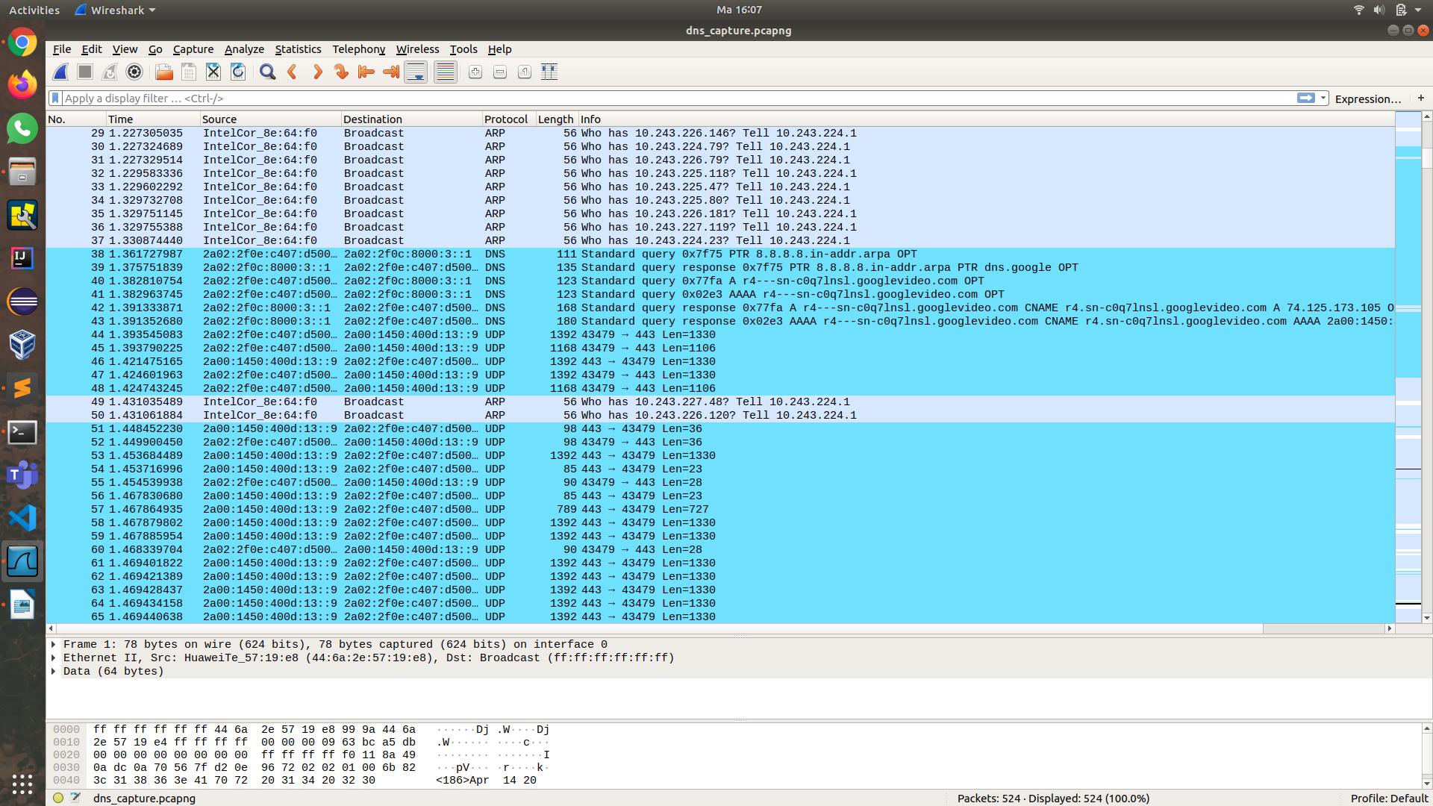
I) Vizualizare cerere si raspuns DNS din Wireshark

