Animal-Based Therapy for Children with Disabilities

Professor: Delia Mitrea, Ph. D
Author: Andreea-Cristiana Popa
Group: 30323

- Purpose
An everyday issue refers to the difficulties children with mental disorders go through. Life for children with an Autism Spectrum Disorder (ASD) or other developmental disabilities can be challenging. ASD causes developmental impairment that often leads to other issues like rigid behavior, narrow range of interests, social withdrawal, and anxiety. Children with ASD often have short attention spans and difficulties with social communication.
There are various therapies and behavioral management programs available to offer support to children living with this neurological and developmental disorder. While some therapists focus on developing communication skills of ASD patients, others stress reducing the problematic behaviors associated with autism. In addition to this, there is something else that is helping people with autism: spending time with animals like dogs and horses.
Considering the great importance of the problematic, the present thesis explores a solution in order to increase the quality of the life of the previously mentioned children and their families. The impact on the long-term is going to be highlighted, due to the site I invite you to visit. There are the necessary pieces of information that helps people understand the matter in depth. Videos are inserted for a better understanding capacity. Symbolic images are inserted.
At the same time, the user has the ability to insert the data of the child proposed to benefit from either dog-based or horse-based therapy. During a therapy session, the kid is supported by a special trainer, specialized in dog / horse training, and a psychologist. The two persons would introduce the child with either ASD or Down syndrome in the reign of animals, where a communication bridge is being consolidated.

- Obtained Results
An authentication page is created. The user can choose between logging up and signing up.
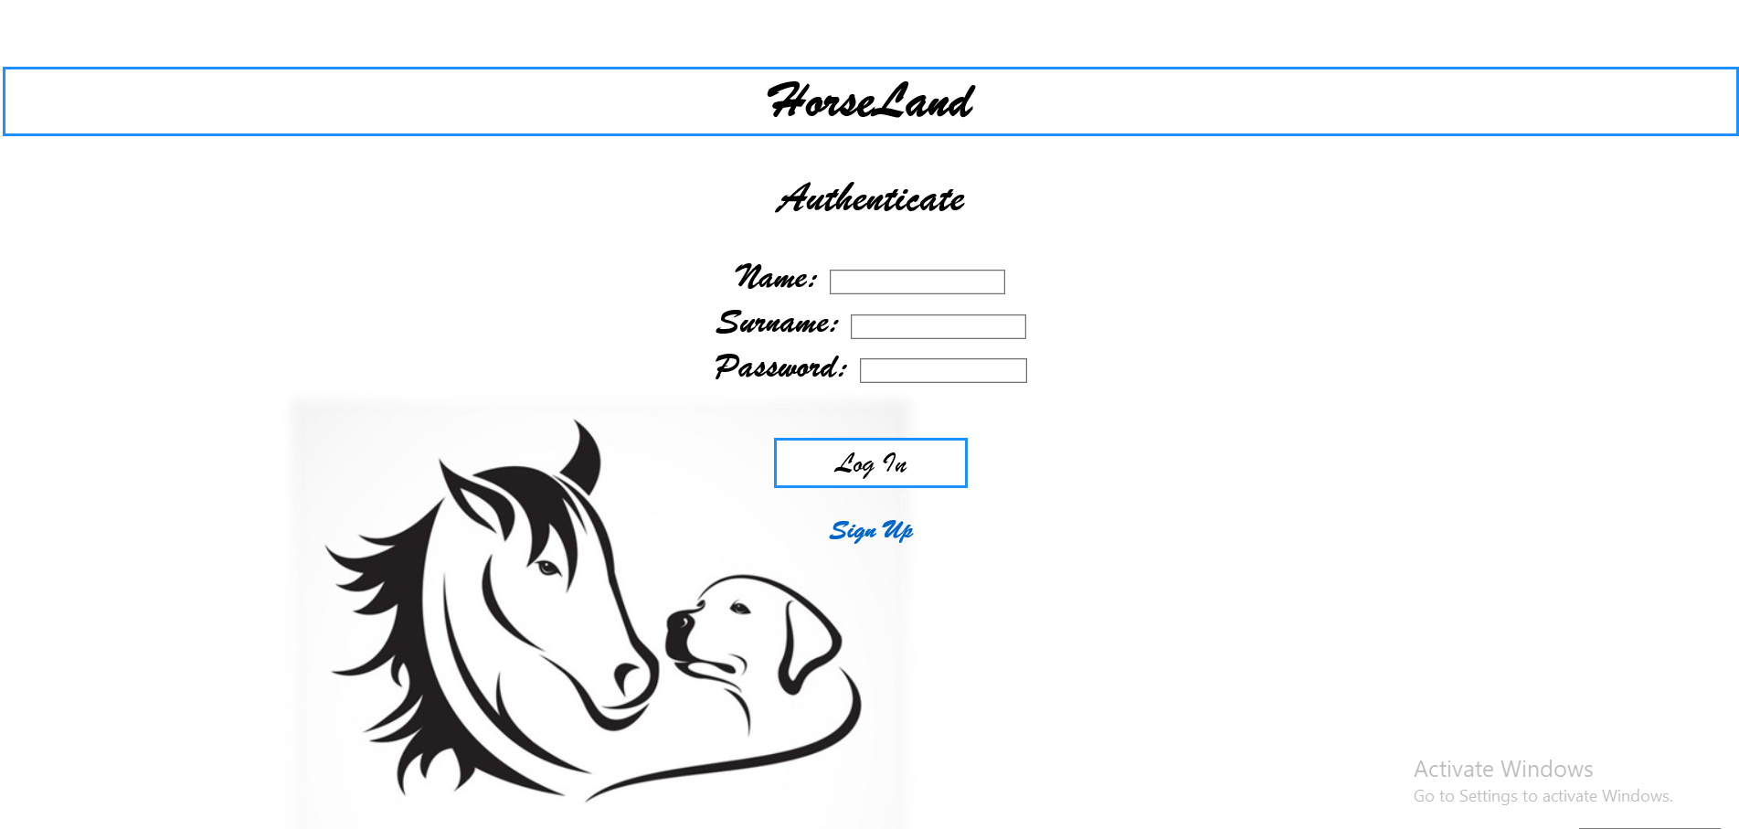
After submitting the data, the user is redirected to the main page:
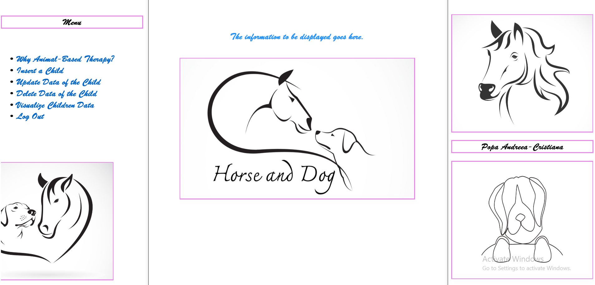
By pressing “Why Animal-Based Therapy?”, the user is brought up to date with Autism Spectrum Disorder-based problematic. In the bottom of the page are two buttons.
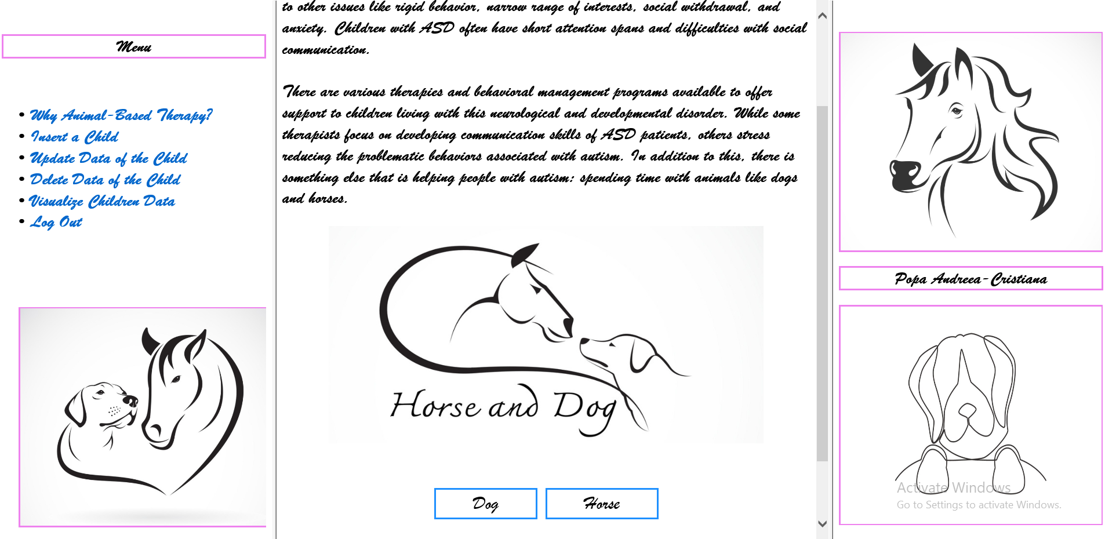
There are two buttons (created using hover) in the bottom of the page. The first one attracts attention on the dog-based therapy type. The second one reflects upon the bond between humans and horses.
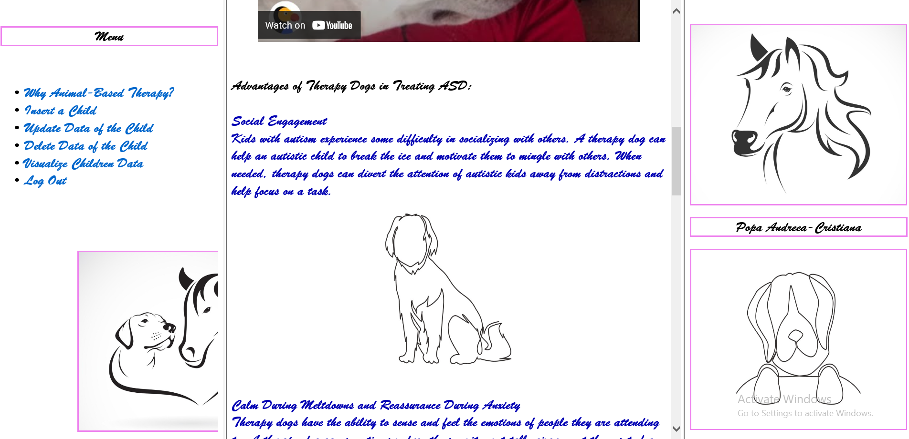

Whether we were to create a reference to the backend part, I start by displaying the diagram used in order to create the data-basis, using Microsoft SQL Server Management Studio:
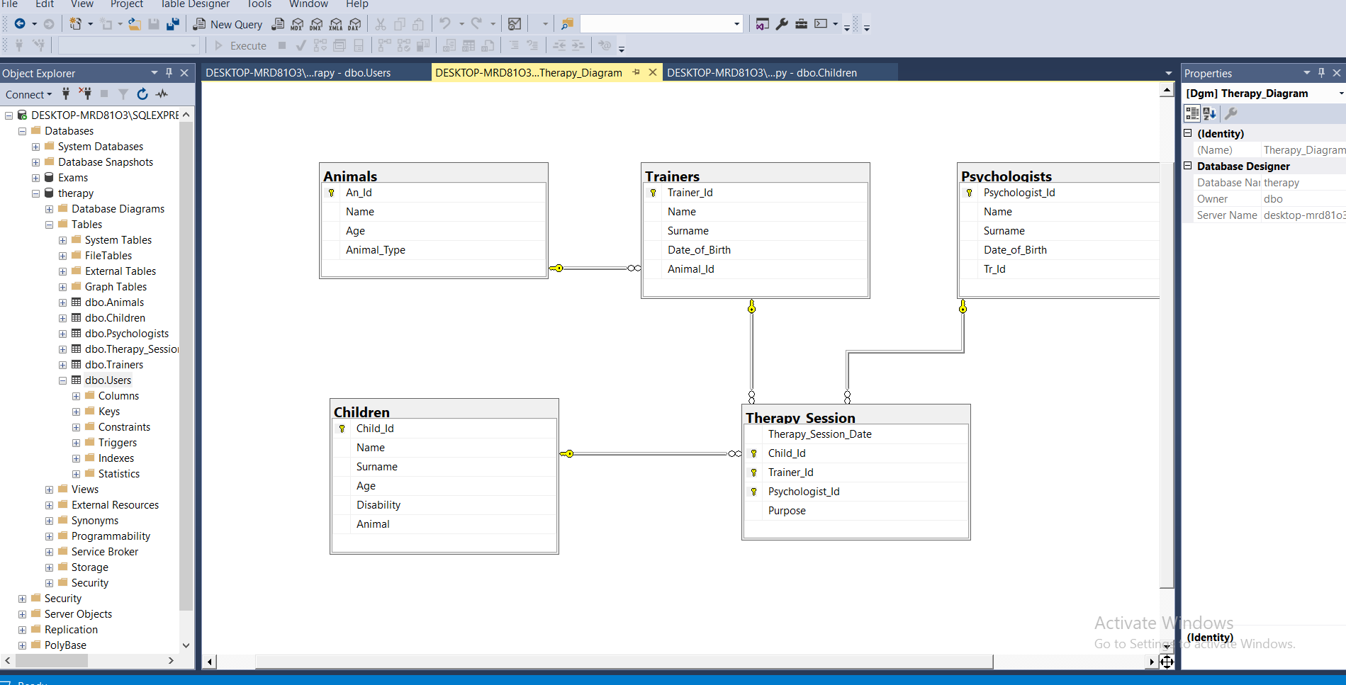
I populated the tables.
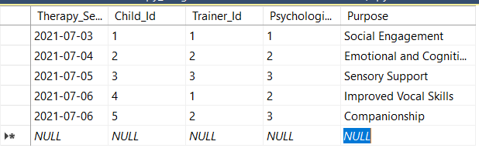
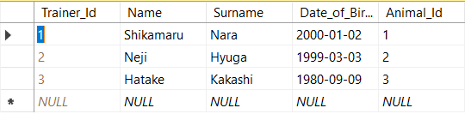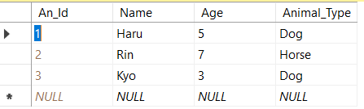
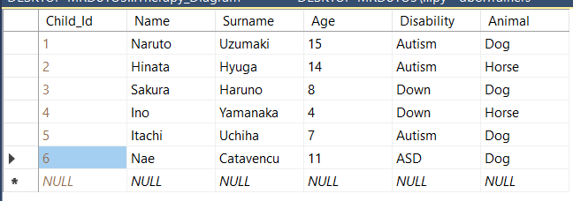
The user is able to insert, update, delete and visualize the data of the children. He / she can also log out.
