SECURITY ALERT

Author: Andreea-Cristiana POPA

- Theme Requirements
An everyday issue refers to security, as a general factor. The safest place to go to is considered to be a person’s own home. An aspect often not taken into consideration refers to the situation in which an intruder enters a certain house. The burglar is unpredictable. Such an intrusion might endanger all the inhabitants’ lives, from adults’ to children’s.
Considering the great importance of the problematic, the present thesis explores a solution in order to increase the home security. An alarm system, consisting of PIR sensors, buzzers, LCD (on which is displayed if there is or not a possible threat in that certain area) and lights (with colors depending on the security state) is going to be highlighted.

- Chosen Solutions
In order to make a step on the path of solving the previously disposed problem, a general culture considering the compounding elements is needed. Next, I am going to present the main pylons of the app, the functioning principles which make the implementation possible.
A key point to make refers to the main components which can be found in the program. First of all, we have a PIR sensor. PIR stands for Passive Infra Red. It allows us to sense motion. More specifically, it is used to detect whether a burglar has moved in the house, both in or out of its range. Whether the PIR sensor detects heat, it would engage.
The LCD is implied in the current process in order to display certain messages. If there is no intruder in the range of the sensor, this component lets the user know that there is no threat to his or her safety. To the LCD, a potentiometer is connected in order to adjust the bias level of the component, to provide the contrast necessary for people to see the message on the screen.
Another significant element is the buzzer. It is the one which, in case of danger caused by an intruder, starts making loud noises. The noise starts at the moment when the PIR sensor detects heat within the certain range where disposed. The sounds stop only when the burglar exits the covered area.
There is the risk for the user not to hear the buzzer, due to the fact that he listens to music with his / her headphones on, at a significantly high volume. Also, another possibility implies a deaf user. He / she would not be able to hear the alarm.
This is the reason why lights are implemented. The blue LEDs assure people that there is no burglar nearby. The red, intermittent one suggests that there might be a threat nearby.
The previously described components are interconnected, due to the pins of an Arduino UNO R3 board and a breadboard. There are, also, resistances, in order to avoid the case of a short circuit.

- Obtained Results
The application entitled “Security Alert” is divided into 5 main parts. The first one consists in including libraries (LiquidCrystal.h), alongside defining a connecting bridge between the PIR sensor and pin 2 of the Arduino UNO R3 board, respectively between the buzzer and pin 3 of the same board.
Still in this phase, I add the fact that, making use of the previously mentioned library, the LCD is connected to Arduino board through the next pins: 13, 12, 11, 10, 9 and 8.
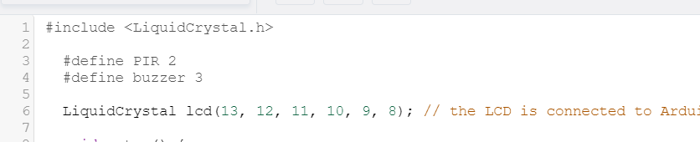
The second part implies the setup phase. Here, the Arduino is told to get ready to exchange messages with the Serial Monitor at a data rate of 9600 bits per second. Also, the LCD type is presented, 16X2. It has 16 columns and 2 rows. Next, the pins for the buzzer, PIR sensor and LEDs are declared and their type (input / output) is specified.
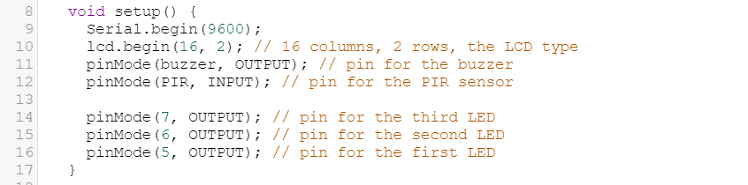
The third main part consists of the loop that assures the continuity of the program. Firstly, the message on the LCD is set to be displayed starting from the third column and the first row of the 2X16 matrix. The initial text to be printed is “No threat”, meaning that there are no burglars in the house where the Security Alert is implemented. Further, the functions for threat and lights checking are called.
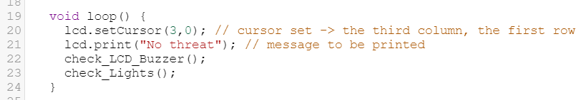
The fourth main part explores the based on the PIR sensor and buzzer functionality. At this point, we have a threat check. A Boolean variable is initialized for the state of the PIR sensor to be stored in. It is checked whether the sensor detects an intruder. The value “1” correlated to the “sensor” variable implies a burglar in the covered area.
As a result of this case, the buzzer is turned on and the message on the LCD is changed to “Threat encountered”. The two aspects would be trained until the intruder exits the part of the house where he / she got caught. Before each actualization, the LCD gets cleared, in order to avoid overwriting.
If the previously described “if” block is not called, the buzzer maintains the off state.
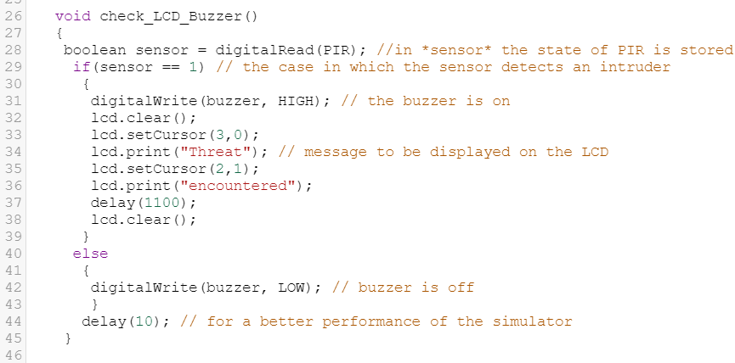
The last part, just like the previous one, refers to the PIR sensor and buzzer functionality. As the distinction has it, we talk about a light check, at this stage. A Boolean variable is initialized for the state of the PIR sensor to be stored in. The foregoing indicated LEDs are included within an array.
From the starting point, the two blue LEDs are turned on. Further, it is checked whether the sensor detects an intruder. The value “1” correlated to the “sensor” variable implies a burglar in the covered area. Therefore, the red, intermittent LED is turned on. The other two would automatically turn off. They would turn on, followed by turning the red one off, if the PIR sensor does not detect any movement.
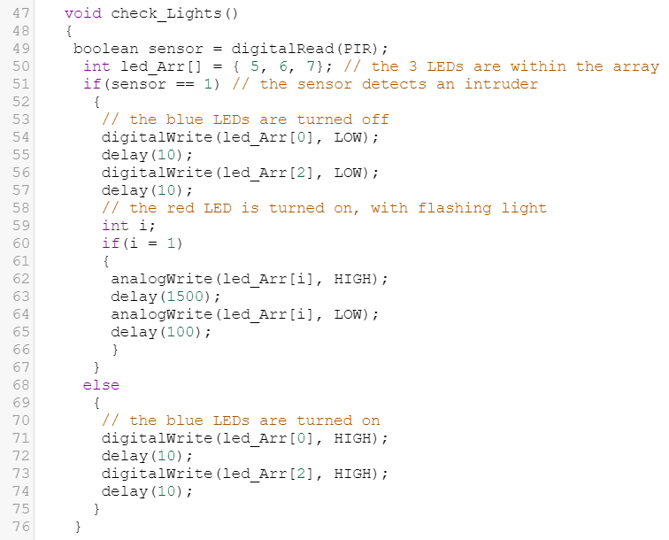

“check_LCD_Buzzer” and “check_Lights” functions have the produce changes simultaneously because of the fact that the buzzer, respectively, the red LED, is activated by the same issue: the change of state of the PIR sensor, comprehended in the “sensor” variable. It is privately initialized in both functions.
Next, I am going to attach a screenshot of the “no burglar in” state, when no moving heat was detected by the PIR sensor:
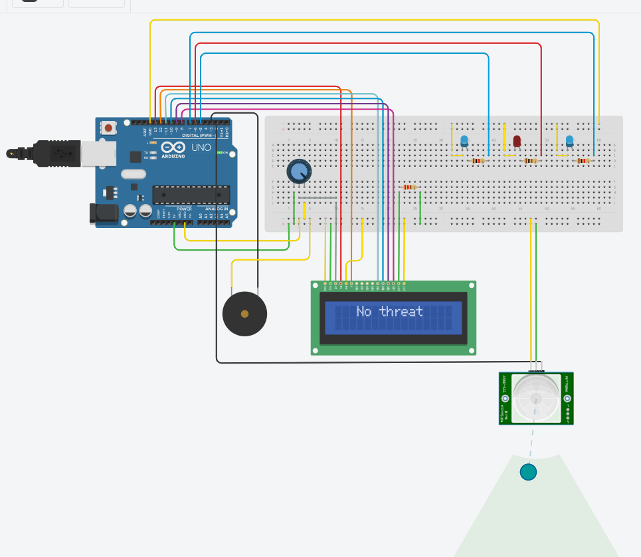
In order to make a comparison, here is displayed the situation in which the PIR sensor detects a human moving:
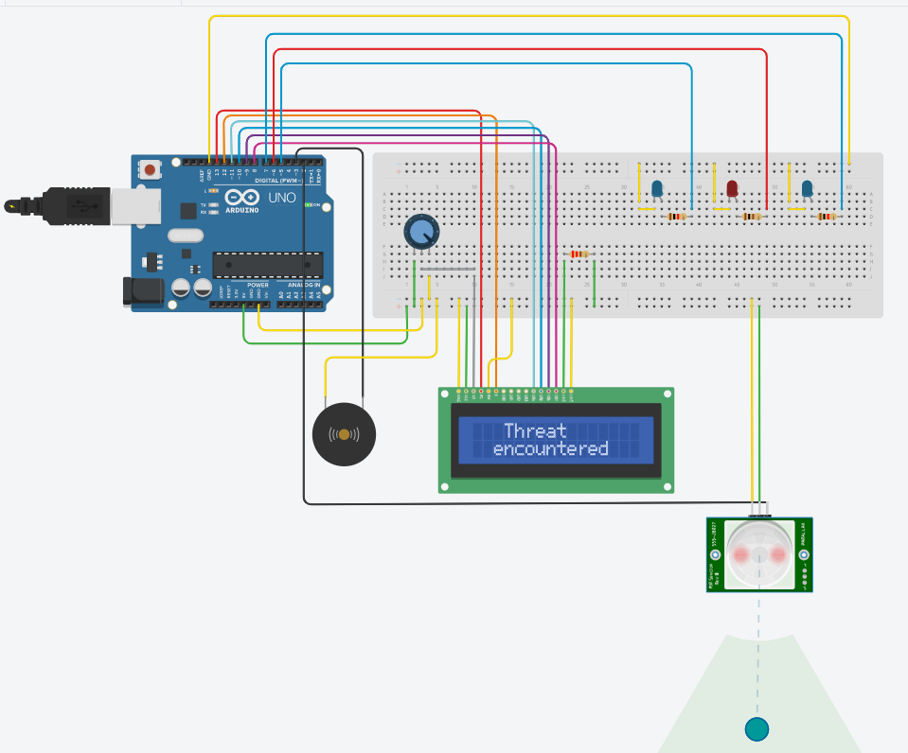
The yellow wires are used in order to connect certain elements to the ground. The green ones are used to connect the potentiometer, the buzzer, the LCD and the PIR sensor to 5V. All the previously described components, in terms of both functionality and connection, are originally displayed in the following figure:
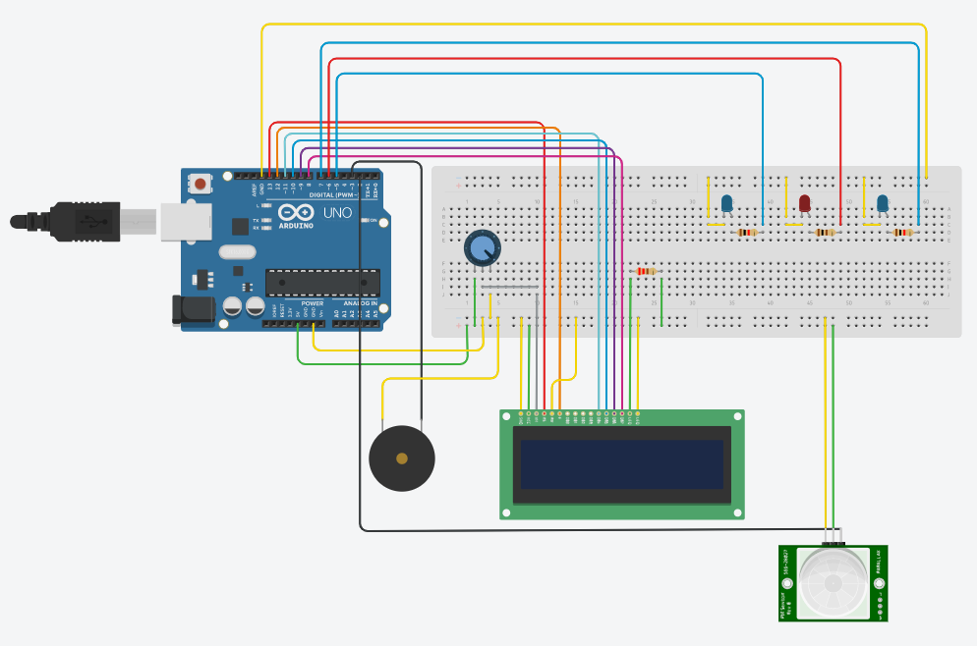

- Tests and Inspection
First of all, the app is conceived to increase the persons’ security at home. An alert system is implemented, in order to let the user know that there might be a burglar in his / her home.
The main using recommendation is to have the PIR (Passive Infra Red) sensor mounted near the door or in the immediate vicinity of a window. A burglar is most probably to enter a house through these two elements.
There must not be other objects in front of the PIR sensor, in order to avoid reducing the action range.
In normal conditions, with no burglar in the range of the sensor, there are 2 blue lights and on the LCD is displayed the message “No threat”.
In the scenario where a possible thief enters the house, the PIR sensor placed near the door or window, detects that human’s movements. As a result, the buzzer starts emitting noise and, the 2 blue lights turn off, they being replaced with one red, intermittent light and the message on the LCD is changed to “Threat encountered”.
When the burglar exits the covered area, the 2 blue lights turn on and on the LCD is displayed the message “No threat” again. The red light and the buzzer are turned off.
The link to access the circuit in Tinkercad:
https://www.tinkercad.com/things/2Lve9Qu6XcI-pirsystem/editel?sharecode=WyW8l7t-zJCPZbcF0qA46dV32V-y7Of92U0OKcBEcdE

Date:
21.05.2021

