30 de inputuri, relu, 1 outptut, STANDARDIZARE

fac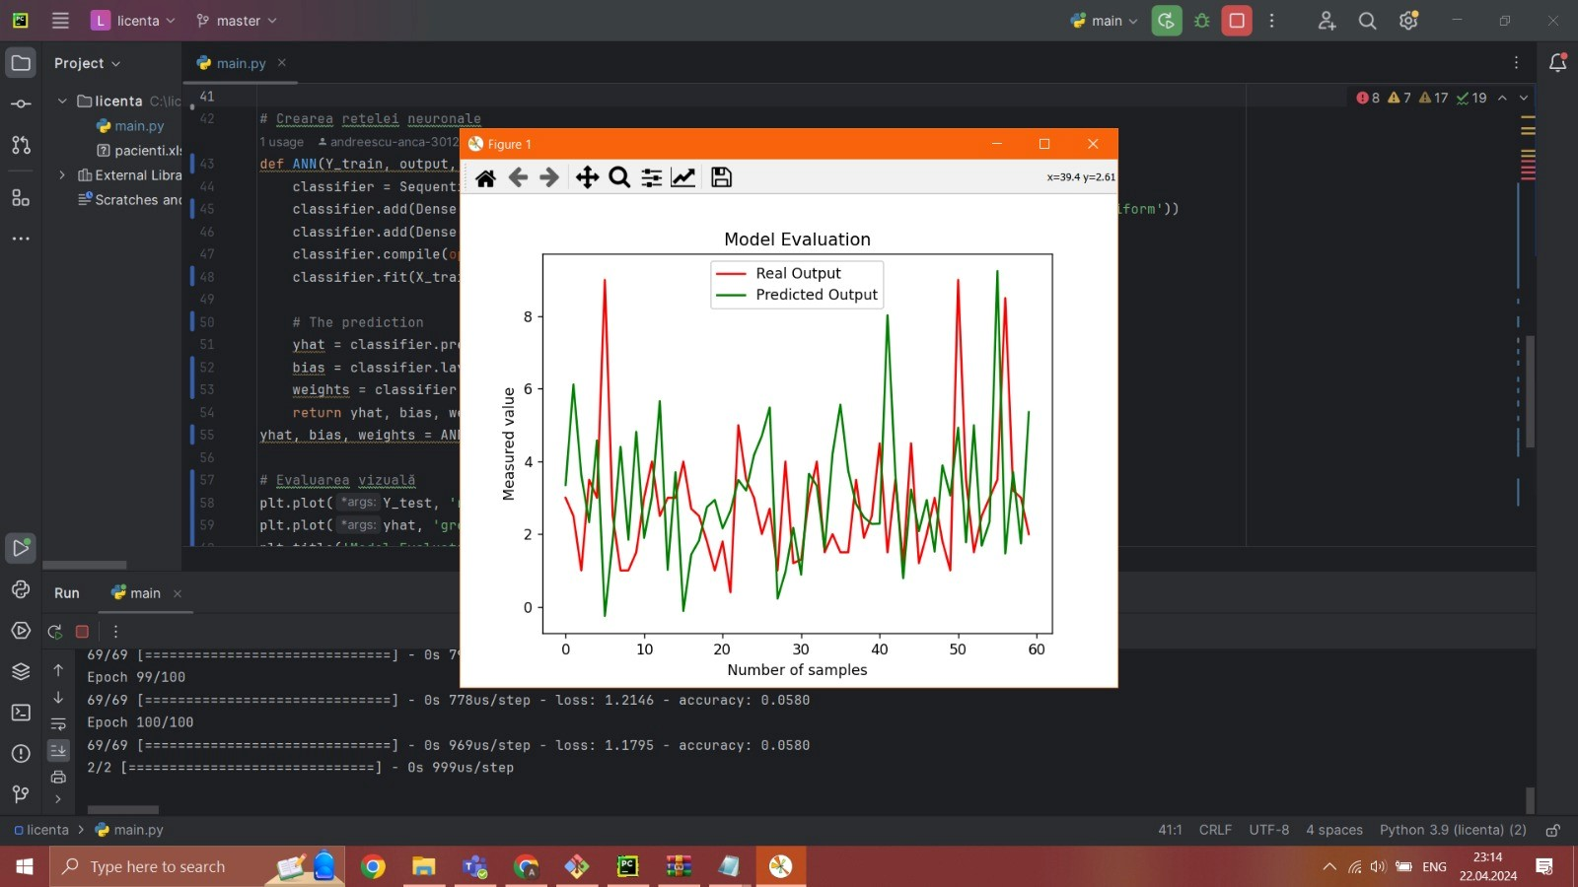

30 de inputuri , 1 output, NORMALIZARE

1. Prima incercare pe datele de la cancer cu 33 de feature. Mse de 0.3. functie de activare : relu. 30 inputuri

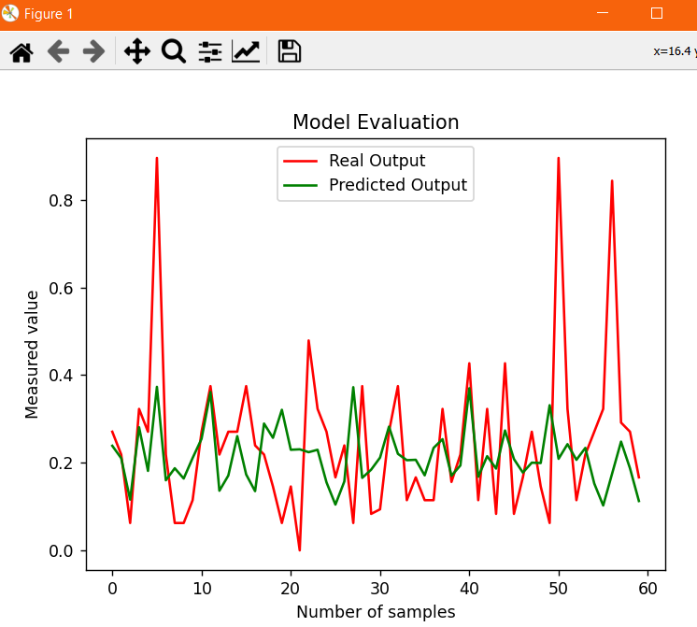

Mean Squared Error (MSE) relu: 0.03603802814030511

Minimal Error (MAE) relu: 4.520950385414052e-05

2.

Leaky relu comparare cu relu -epoci 100, batch 5, 23 de neuroni, 1 strat, 30 INPUTURI

Mean Squared Error (MSE) leaky: 0.036540547246418684

Minimal Error (MAE) leaky: 6.953239240776141e-06

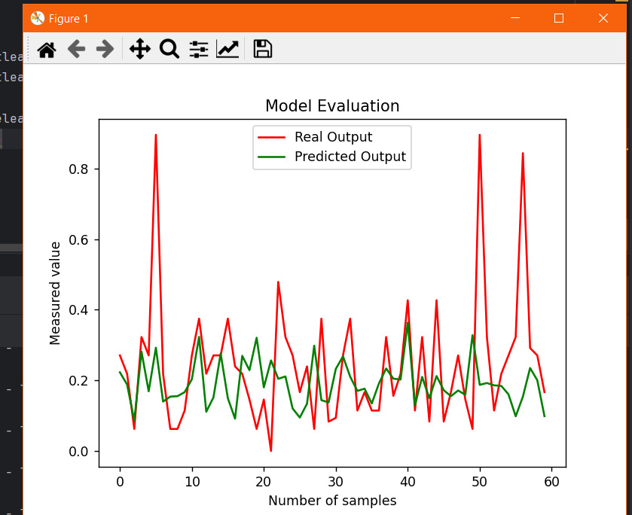

1. Elu -100 de epoci, batch 5, 23 de neuroni, 1 strat de neuroni, 30 INPUTURI-NU E PENTRU CE NE TREBUIE NOUA

Mean Squared Error (MSE) ELU: 0.03603802814030511

Minimal Error (MAE) ELU: 4.520950385414052e-05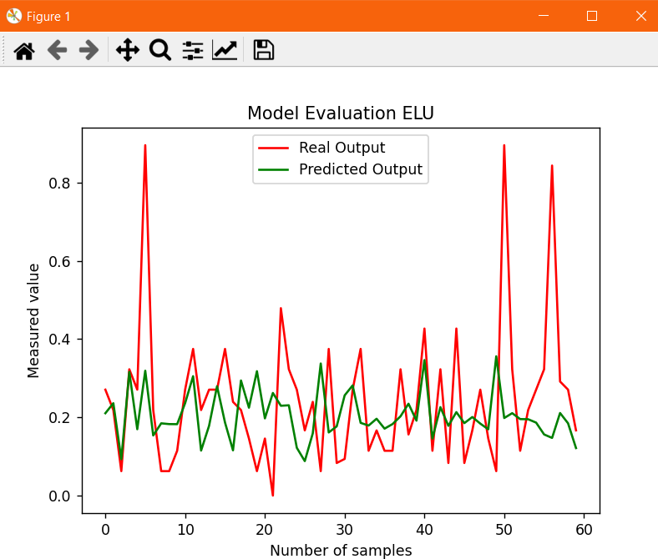

Mai putine inputuri-4

a)relu-200 de epoci 5 bacth, 4 neuroni, layer

Mean Squared Error (MSE) relu: 0.04255698021625775

Minimal Error (MAE) relu: 6.834613588659892e-08

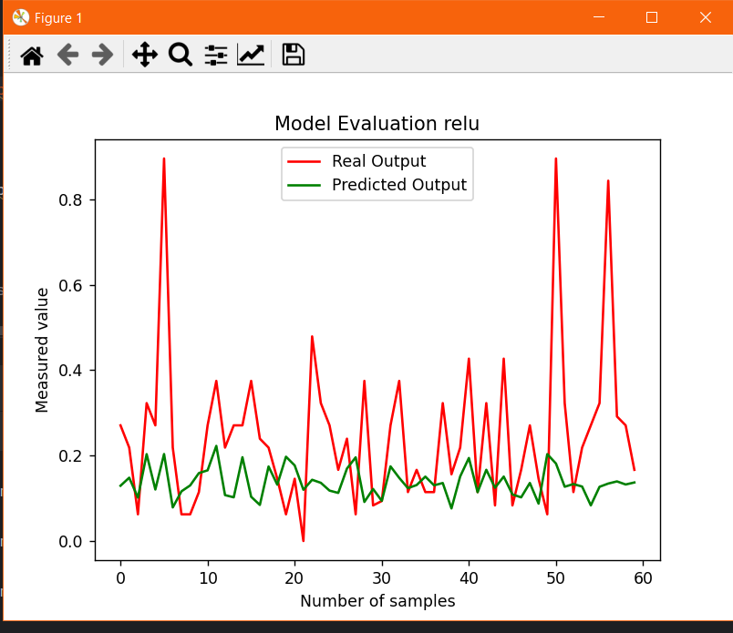

b) leaky 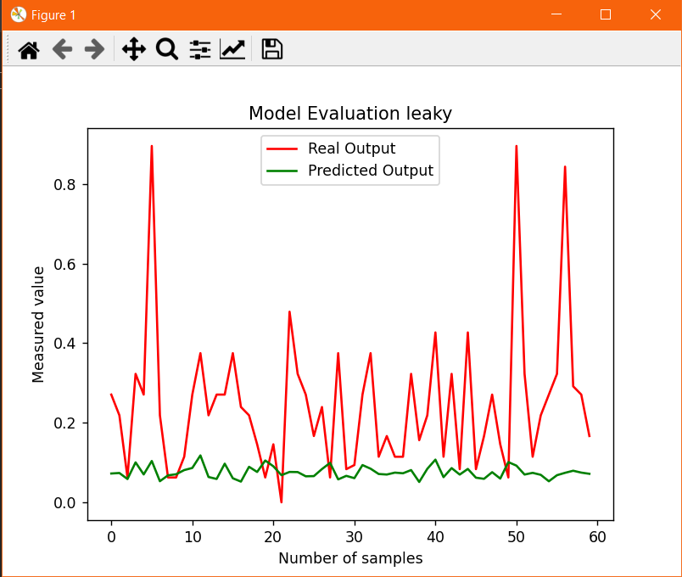 -200 same ca sus

Mean Squared Error (MSE) leaky: 0.06100610529421301

Minimal Error (MAE) leaky: 1.5709806810981775e-05

Input 4 , 300 de epoci

1. Relu

Mean Squared Error (MSE) relu: 0.04108075797172138

Minimal Error (MAE) relu: 1.5116127263705986e-05

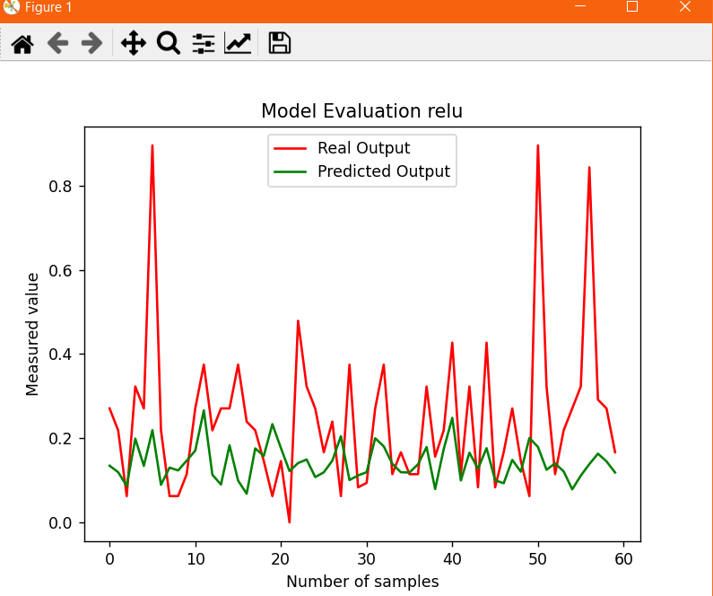

1. Leaky

Mean Squared Error (MSE) leaky: 0.04843549614323168

Minimal Error (MAE) leaky: 2.231599257391296e-06

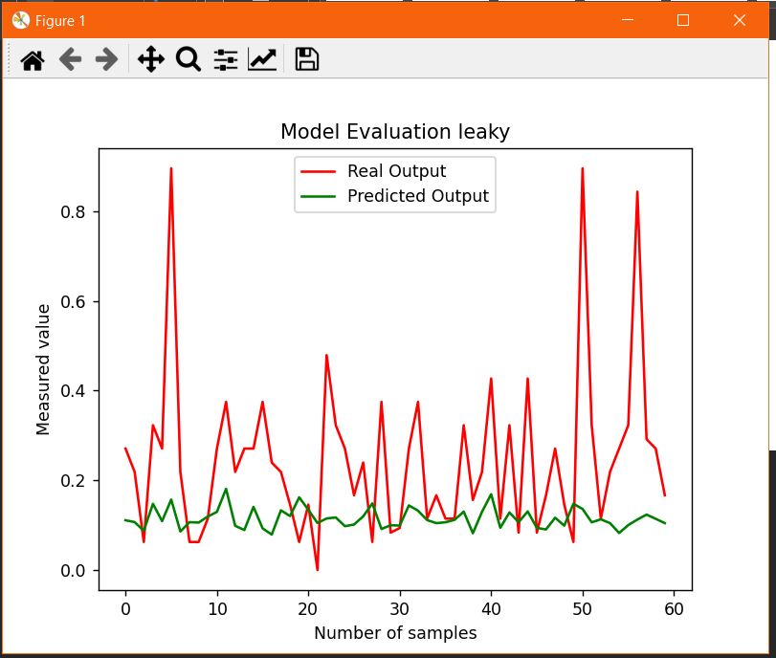

Rezultate rulare cod pentru gasirea parametriilor cei mai buni =>learning_rate=0.05e-4 si epsilon de 1e-8

Variabilele cu care s-au realizat combinatiile

num_neurons_values = [21,22,23,24,26] # Number of neurons for the first hidden layer  
num_neurons_per_layer_values = [[21], [22], [23],[21,23],[21,22], [21,22,23], [21, 23, 26], [22,24]] # Number of neurons per hidden layer  
batch_size_values = [3, 5, 8, 16, 32] # Batch size  
epochs_values = [50, 100, 150, 200, 300, 500, 700] # Number of epochs  
num_layers_values = [1, 2, 3] # Number of hidden layers

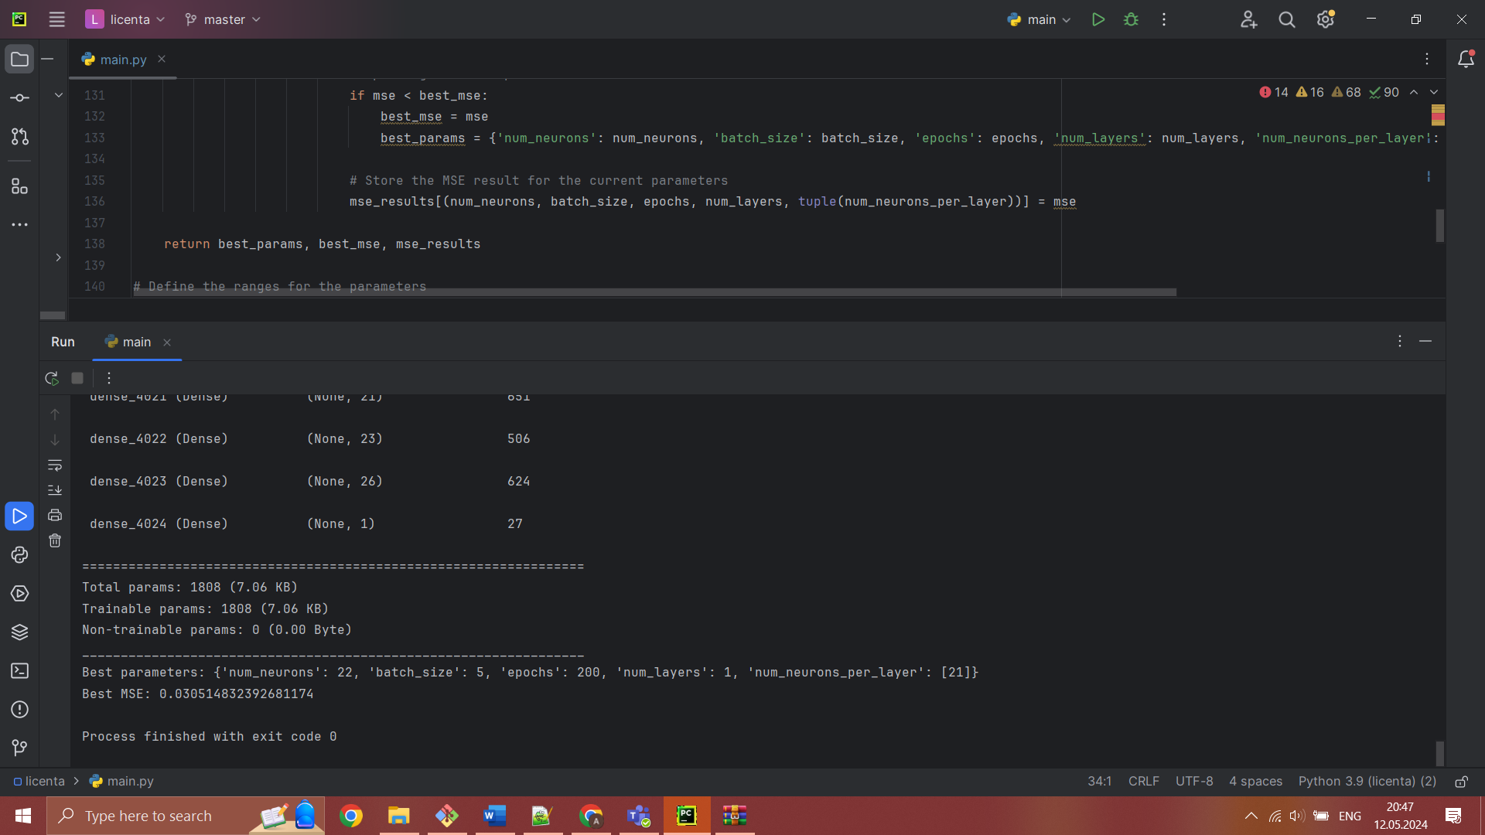

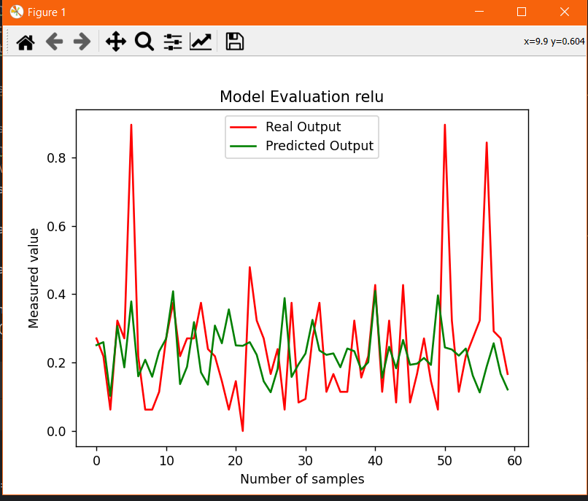

Rezultat cu numar mare de neruoni pe straturi si 3 straturi – se observa o modificare foarte mica

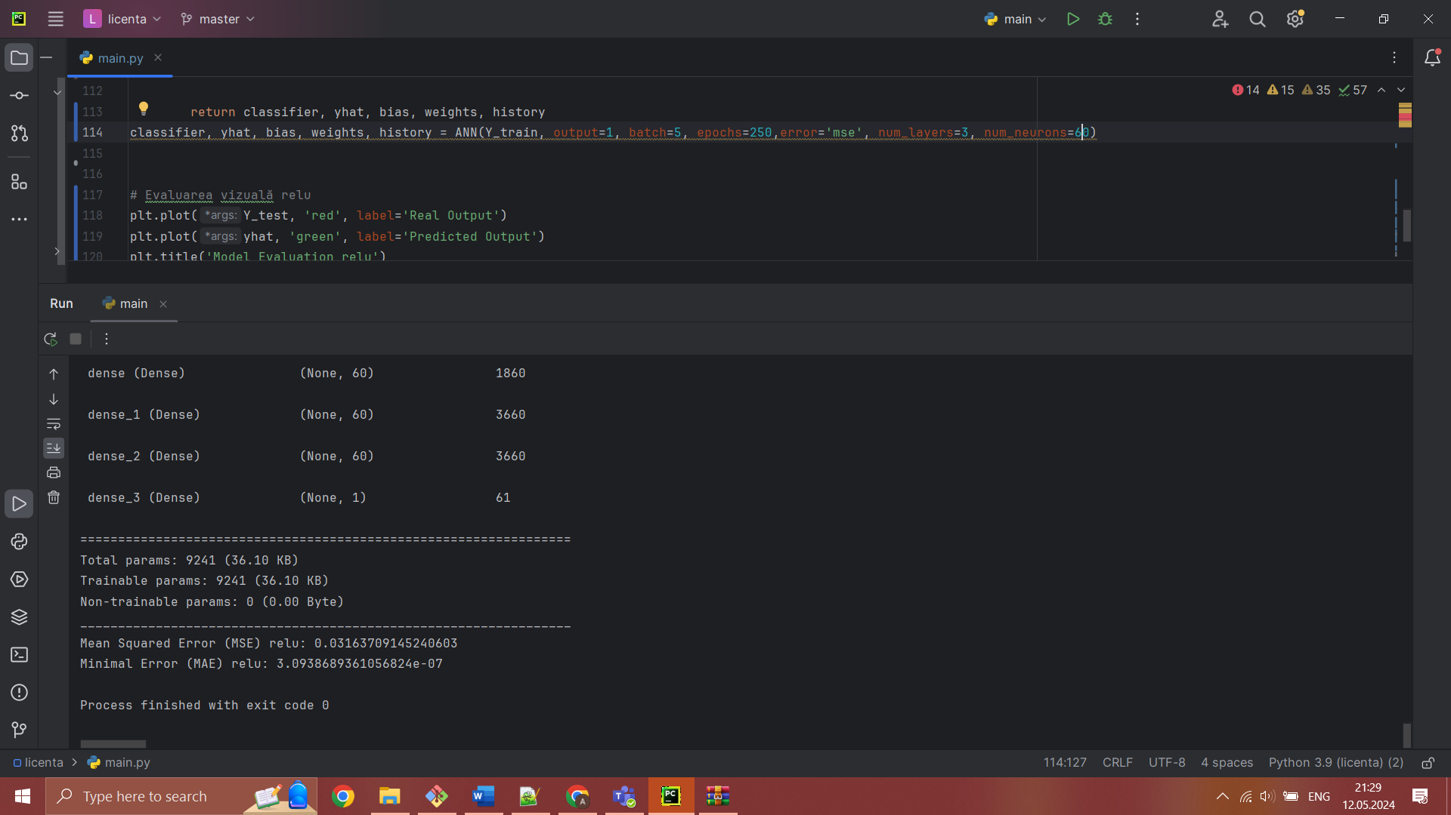

Poza cu parametrii gasiti si cu leanring rate de 0.01

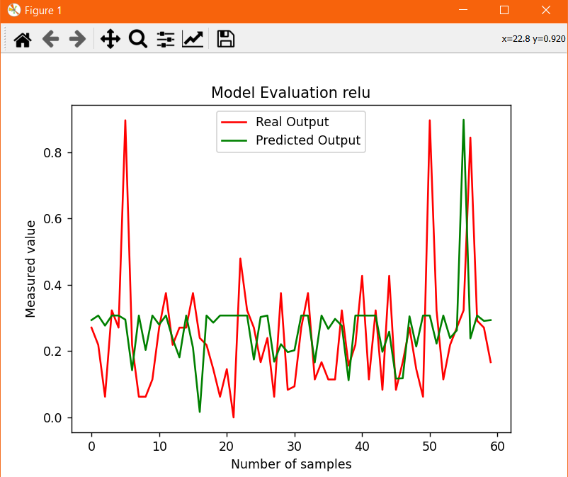

Mean Squared Error (MSE) relu: 0.03878216827936636

Minimal Error (MAE) relu: 6.425689612409149e-05

POZA CU ACEEASI PARAMETRII DAR CU LEARNING RATE DE 0.001 => A CRESCUT ACURATETEA dar a crescut si mse ul

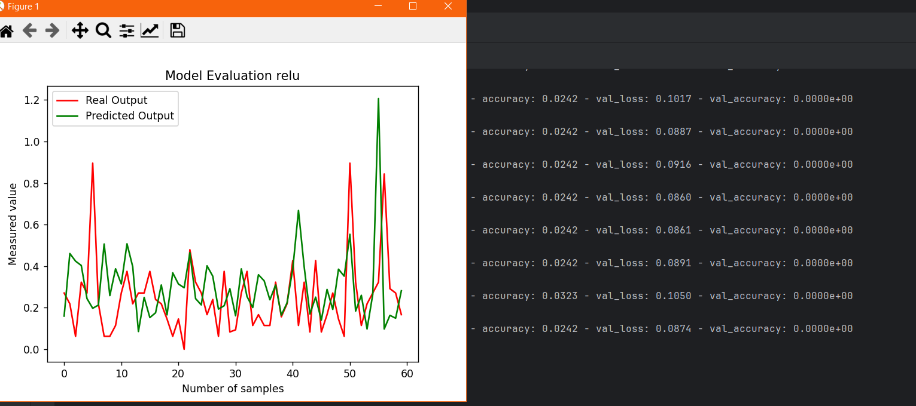

Mean Squared Error (MSE) relu: 0.06236084715651833

Minimal Error (MAE) relu: 1.891400195663806e-05

C) Deci mie la 0.0001 m-am intors la o acuratete de 0.016

Mean Squared Error (MSE) relu: 0.034255390438865566

Minimal Error (MAE) relu: 3.6288516962714277e-06

D) Mean Squared Error (MSE) relu: 0.033755041421916814

Minimal Error (MAE) relu: 1.3654795874253999e-05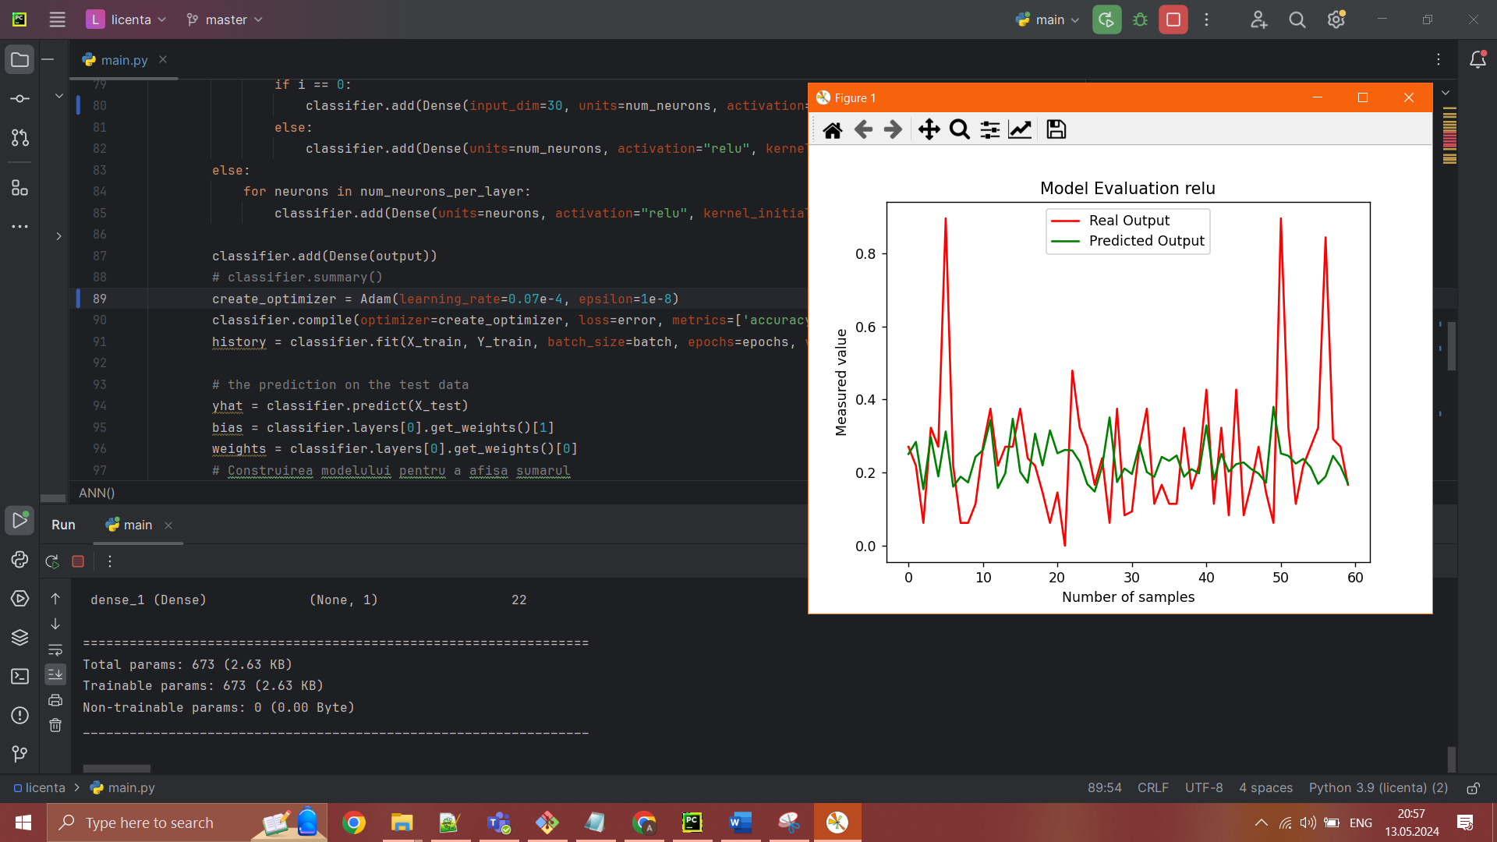

E)Robust Scaler -metoda de scalare a date

F)regularizare pe parametrii gasiti

Mean Squared Error (MSE) relu: 0.03384584816638271

Minimal Error (MAE) relu: 3.948880856480807e-06 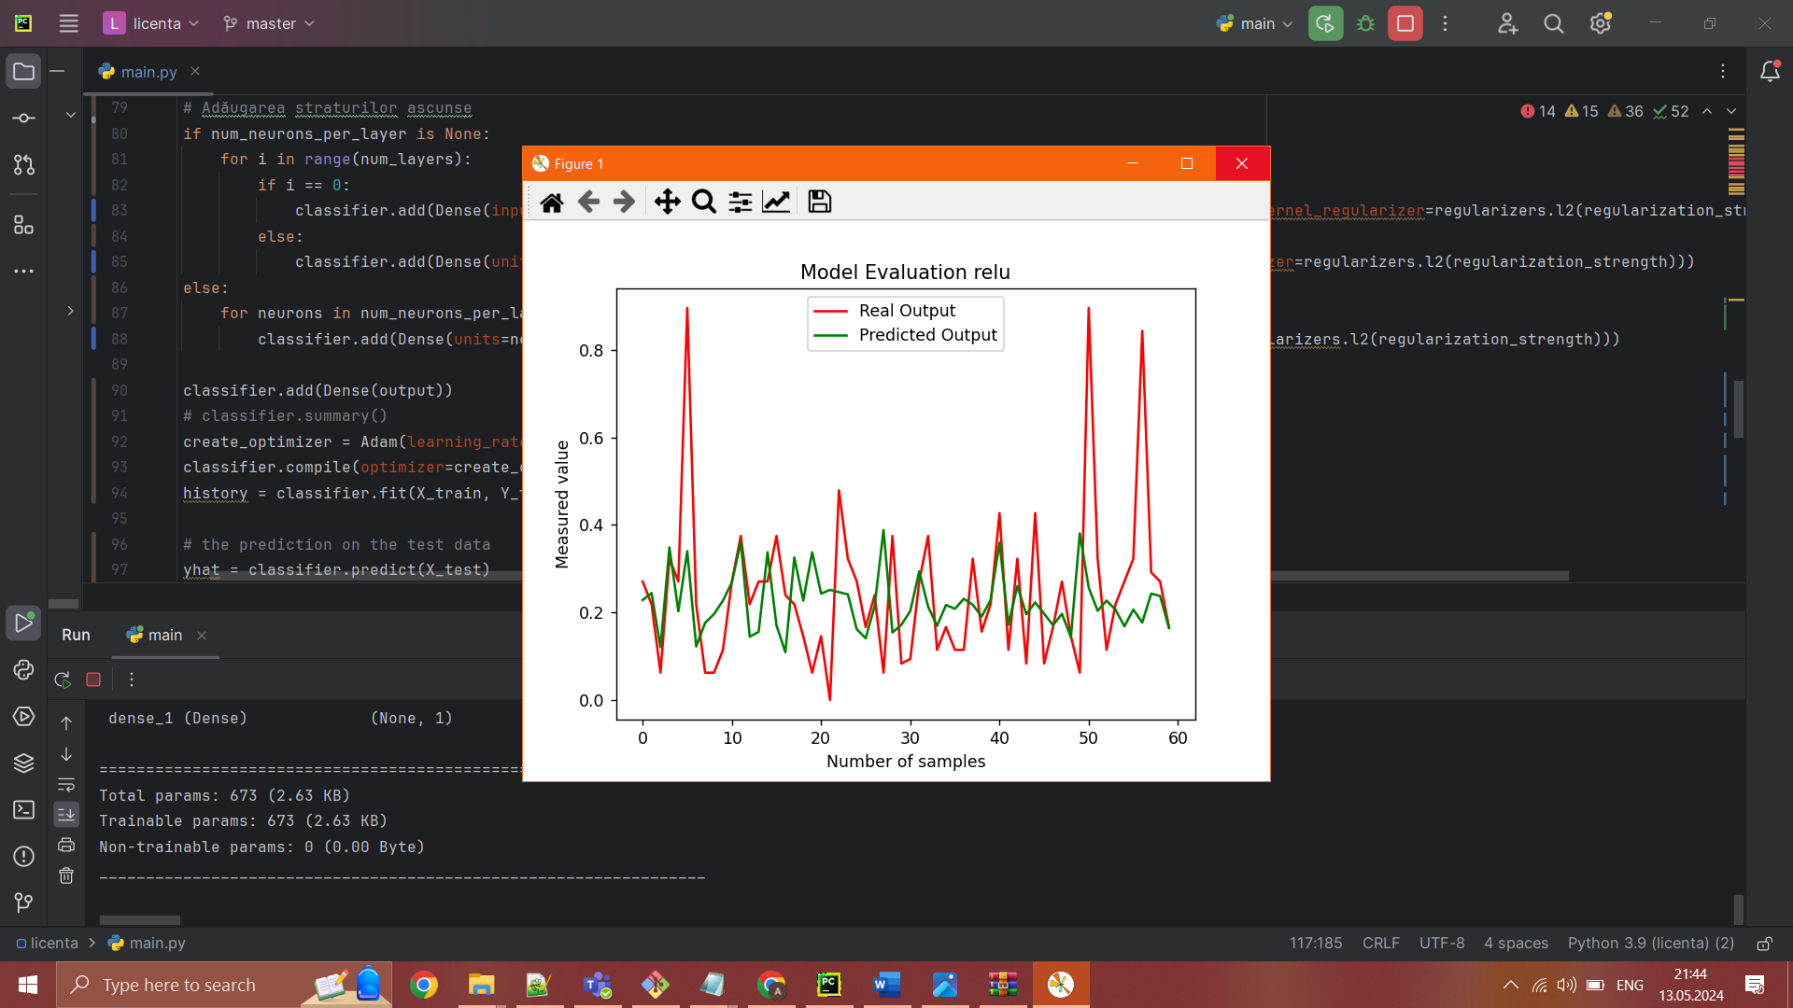

G) pentru un testsize=0.2 si parametrii gasiti am un grafic , leanring rate 0.05e-04

Mean Squared Error (MSE) relu: 0.0223225431365262

Minimal Error (MAE) relu: 2.952054527977685e-05

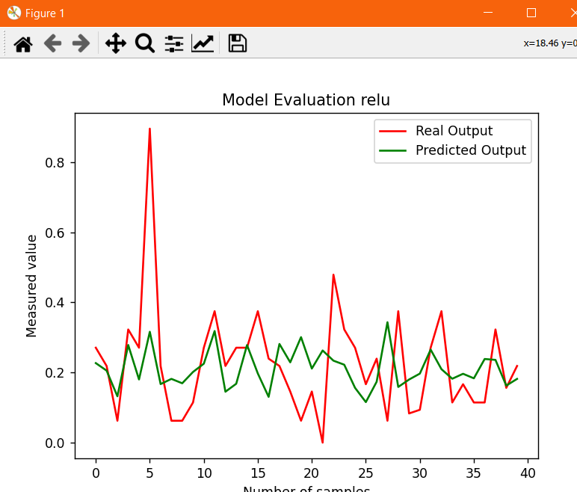

H) parametrii gasiti , testsize=0.2, RMSprop ace;asi learningrate learning_rate=0.05e-4

Mean Squared Error (MSE) relu: 0.02273371684186014

Minimal Error (MAE) relu: 9.433665937308433e-06

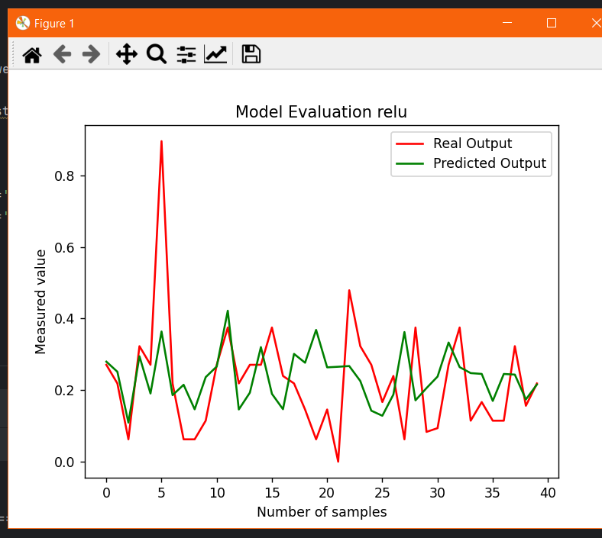

K) aceeasi parametrii gasiti cu adam si cu testsize=0.2

Mean Squared Error (MSE) relu: 0.022191358247153653

Minimal Error (MAE) relu: 5.983575876358383e-06

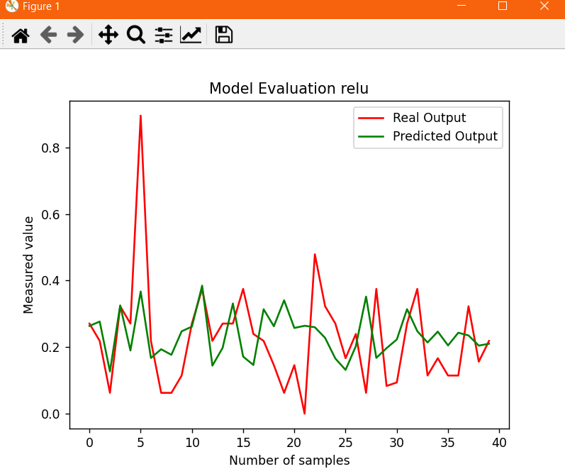

L) sigmoid learning rate de 0.05e-04

400 de epoci, sigmoid

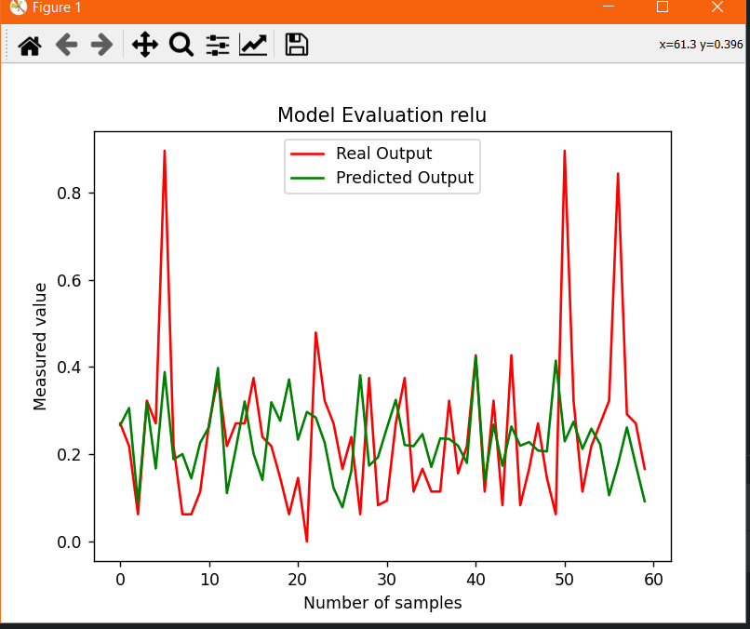

Mean Squared Error (MSE) relu: 0.034844932925267275

Minimal Error (MAE) relu: 1.4240880659994103e-05

K) rezultate cross validation

Average Mean Squared Error (MSE) across folds: 0.04215242627603537

Average Mean Absolute Error (MAE) across folds: 0.14563569134753993