jUCMNav Report

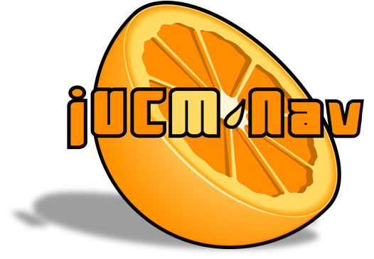

http://softwareengineering.ca/jucmnav

Title: | SimplePhoneSystem-WithFI
URN Model Name: | URNspec
Description:
Author: | damyot
Creation Date: | October 30, 2007 08:59:49 AM EDT
Modification Date: | October 30, 2007 08:59:49 AM EDT
Report Generation Date: | November 16, 2012 10:26:52 PM EST
Specification Version: | 43

UCM Scenario Groups documentation
- BasicCall:
- BCsuccess: Normal scenario, no feature, successful ringing
- BCbusy
- OCS:
- OCSsuccess
- OCSbusy
- OCSdenied
- CND:
- CNDdisplay
- CNDbusy
- TeenLine:
- TLnotActiveSuccess
- TLActiveSuccess
- TLActiveTimeOut
- TLActiveInvalidPIN
- TLActiveBusy
- TLnotActiveBusy
- FI_OCS_CND:
- OCS_CND_display
- OCS_CND_busy
- OCS_CND_OnList
- FI_TL_CND:
- BasicDefinitions: Initial start point, initial values, no end point. Do not run.
- TL_CND_NotActiveDisplay
- TL_CND_ActiveDisplay
- TL_CND_TimeOut
- TL_CND_InvalidPIN
- TL_CND_NotActiveBusy
- TL_CND_ActiveBusy
- FI_OCS_TL:
- Scenario2732

Variables
- Busy (boolean): The terminating party is busy
- OnOCSlist (boolean): The terminating party is on the OCS filtering list
- PINvalid (boolean): The TeenLine PIN provided is valid
- TLactive (boolean): TeenLine is active at this time
- SubCND (boolean): The terminator is subscribed to CND
- SubOCS (boolean): The originator is subscribed to OCS
- SubTL (boolean): The originator is subscribed to TeenLine

CND

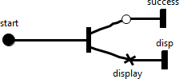

Figure 2 - CND

Description
Call Name Delivery feature. Displays the originator's info on the terminator's device.
Responsibilities
display: Displays the originator's number.

TerminatingFeatures

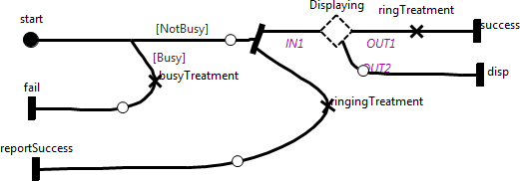

Figure 3 - TerminatingFeatures

Description
Handles the terminating features, including the basing rigning of the device.
Responsibilities
ringingTreatment: This user is available. Prepares the ringback signal.

busyTreatment: This user is busy and cannot answer. Prepares busy signal.

ringTreatment: Prepares the ring signal

Stubs
Dynamic Stub - Displaying

Plugin Map - Default
Input Bindings:
IN 1 <-> start
Output Bindings:
OUT 1 <-> continue
Precondition:
Expression: !SubCND
Transaction: false
Probability: 1.0

Plugin Map - CND
Input Bindings:
IN 1 <-> start
Output Bindings:
OUT 1 <-> success
OUT 2 <-> disp
Precondition:
Expression: SubCND
Transaction: false
Probability: 1.0

Or Fork Description
[NotBusy] ==> !Busy (probability: 1.0)
[Busy] ==> Busy (probability: 1.0)

OriginatingFeatures

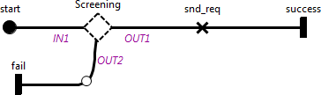

Figure 4 - OriginatingFeatures

Description
Handles the originating features. Sends the request to the terminating agent, if allowed to
Responsibilities
snd_req: Send the connection request to the terminating agent.

Stubs
Dynamic Stub - Screening: Screening function stub

Plugin Map - Default
Input Bindings:
IN 1 <-> start
Output Bindings:
OUT 1 <-> continue
Precondition:
Expression: !(SubOCS || SubTL)
Transaction: false
Probability: 1.0

Plugin Map - OCS
Input Bindings:
IN 1 <-> start
Output Bindings:
OUT 1 <-> success
OUT 2 <-> fail
Precondition:
Expression: SubOCS
Transaction: false
Probability: 1.0

Plugin Map - TeenLine
Input Bindings:
IN 1 <-> start
Output Bindings:
OUT 1 <-> success
OUT 2 <-> fail
Precondition:
Expression: SubTL
Transaction: false
Probability: 1.0

OCS

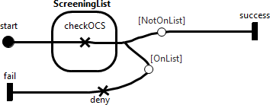

Figure 5 - OCS

Description
Originating Call Screening. Checks a filtering list to determine whether the connection should be denied.
Responsibilities
checkOCS: Checks whether the terminator is on the originator's screening list

deny: Denies the connection

Or Fork Description
[NotOnList] ==> !OnOCSlist (probability: 1.0)
[OnList] ==> OnOCSlist (probability: 1.0)

TeenLine

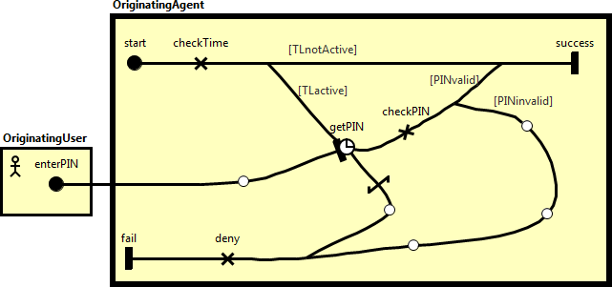

Figure 6 - TeenLine

Description
TeenLine denies a connection when attempted during a predefined time range (ex. between 7pm and 6am), unless a valid PIN is provided in a timely fashion
Responsibilities
checkTime: Checks that TeenLine is active, i.e. that the connection is in the pre-defined time range

checkPIN: Checks whether the PIN is valid

deny: Denies the connection

Or Fork Description
[TLnotActive] ==> !TLactive (probability: 1.0)
[TLactive] ==> TLactive (probability: 1.0)

[PINvalid] ==> PINvalid (probability: 1.0)
[PINinvalid] ==> !PINvalid (probability: 1.0)

Default

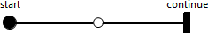

Figure 7 - Default

Description
Default behaviour that can be overriden

SimpleConnection

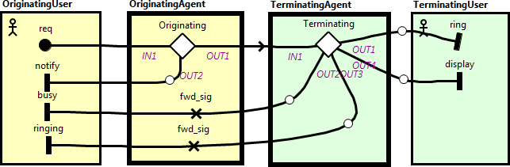

Figure 8 - SimpleConnection

Description
Call connection model. An originating user attempts a connection to a terminating user. Both users have their own agent, which handles their features.
Responsibilities
fwd_sig: Forwards any signal received from other agents

fwd_sig: Forwards any signal received from other agents

Stubs
Static Stub - Originating: Originating Features Stub

Plugin Map - OriginatingFeatures
Input Bindings:
IN 1 <-> start
Output Bindings:
OUT 1 <-> success
OUT 2 <-> fail
Precondition:
Expression: true
Transaction: false
Probability: 1.0

Static Stub - Terminating: Terminating Features Stub

Plugin Map - TerminatingFeatures
Input Bindings:
IN 1 <-> start
Output Bindings:
OUT 1 <-> success
OUT 2 <-> fail
OUT 3 <-> reportSuccess
OUT 4 <-> disp
Precondition:
Expression: true
Transaction: false
Probability: 1.0

Start Point
req: A call request to a terminating party is done

End Points
ring: A call request is announced

display: The originator's information is displayed

Scenario Documentation

Scenario Execution Summary

Group BasicCall (ID:5)
Scenario | Result | Message(s)
BCsuccess (ID: 6) | PASSED
BCbusy (ID: 2416) | PASSED

Group OCS (ID:2418)
Scenario | Result | Message(s)
OCSsuccess (ID: 2419) | PASSED
OCSbusy (ID: 2420) | PASSED
OCSdenied (ID: 2421) | PASSED

Group CND (ID:2423)
Scenario | Result | Message(s)
CNDdisplay (ID: 2424) | PASSED
CNDbusy (ID: 2425) | PASSED

Group TeenLine (ID:2426)
Scenario | Result | Message(s)
TLnotActiveSuccess (ID: 2427) | PASSED
TLActiveSuccess (ID: 2428) | PASSED
TLActiveTimeOut (ID: 2429) | PASSED
TLActiveInvalidPIN (ID: 2430) | PASSED
TLActiveBusy (ID: 2431) | PASSED
TLnotActiveBusy (ID: 2432) | PASSED

Group FI_OCS_CND (ID:2433)
Scenario | Result | Message(s)
OCS_CND_display (ID: 2434) | PASSED
OCS_CND_busy (ID: 2435) | PASSED
OCS_CND_OnList (ID: 2436) | PASSED

Group FI_TL_CND (ID:2437)
Scenario | Result | Message(s)
BasicDefinitions (ID: 2438) | PASSED
TL_CND_NotActiveDisplay (ID: 2439) | PASSED
TL_CND_ActiveDisplay (ID: 2440) | PASSED
TL_CND_TimeOut (ID: 2441) | PASSED
TL_CND_InvalidPIN (ID: 2442) | PASSED
TL_CND_NotActiveBusy (ID: 2443) | PASSED
TL_CND_ActiveBusy (ID: 2444) | PASSED

Group FI_OCS_TL (ID:2445)
Scenario | Result | Message(s)
Scenario2732 (ID: 2732) | FAILED | Traversal has multiple alternatives at Stub "Screening (1049)". Taking first option to remain deterministic.
 |  | Race condition symptom: connected path arrived at a non-blocked path.

Scenario Information

Group BasicCall (ID: 5)

Scenario BCsuccess (ID: 6)

Scenario Start Point(s):
req (ID: 30): A call request to a terminating party is done

Initialization(s):

Variable Name | ID | Description | Type | Initial Value
Busy | 2054 | The terminating party is busy | boolean | false
SubOCS | 2059 | The originator is subscribed to OCS | boolean | false
SubTL | 2060 | The originator is subscribed to TeenLine | boolean | false
SubCND | 2058 | The terminator is subscribed to CND | boolean | false

Scenario End Point(s):
ring (ID: 32): A call request is announced
ringing (ID: 953)

Scenario BCbusy (ID: 2416)

Scenario Start Point(s):
req (ID: 30): A call request to a terminating party is done

Initialization(s):

Variable Name | ID | Description | Type | Initial Value
SubCND | 2058 | The terminator is subscribed to CND | boolean | false
SubOCS | 2059 | The originator is subscribed to OCS | boolean | false
SubTL | 2060 | The originator is subscribed to TeenLine | boolean | false
Busy | 2054 | The terminating party is busy | boolean | true

Scenario End Point(s):
busy (ID: 933)

Group OCS (ID: 2418)

Scenario OCSsuccess (ID: 2419)

Scenario Start Point(s):
req (ID: 30): A call request to a terminating party is done

Initialization(s):

Variable Name | ID | Description | Type | Initial Value
SubOCS | 2059 | The originator is subscribed to OCS | boolean | true
SubTL | 2060 | The originator is subscribed to TeenLine | boolean | false
SubCND | 2058 | The terminator is subscribed to CND | boolean | false
Busy | 2054 | The terminating party is busy | boolean | false
OnOCSlist | 2055 | The terminating party is on the OCS filtering list | boolean | false

Scenario OCSbusy (ID: 2420)

Included UCM Scenario(s):
Scenario OCSsuccess (ID: 2419)

Initialization(s):

Variable Name | ID | Description | Type | Initial Value
Busy | 2054 | The terminating party is busy | boolean | true

Scenario OCSdenied (ID: 2421)

Included UCM Scenario(s):
Scenario OCSsuccess (ID: 2419)

Initialization(s):

Variable Name | ID | Description | Type | Initial Value
OnOCSlist | 2055 | The terminating party is on the OCS filtering list | boolean | true

Group CND (ID: 2423)

Scenario CNDdisplay (ID: 2424)

Scenario Start Point(s):
req (ID: 30): A call request to a terminating party is done

Initialization(s):

Variable Name | ID | Description | Type | Initial Value
SubCND | 2058 | The terminator is subscribed to CND | boolean | true
SubOCS | 2059 | The originator is subscribed to OCS | boolean | false
SubTL | 2060 | The originator is subscribed to TeenLine | boolean | false
Busy | 2054 | The terminating party is busy | boolean | false

Scenario End Point(s):
display (ID: 978): The originator's information is displayed
ring (ID: 32): A call request is announced
ringing (ID: 953)

Scenario CNDbusy (ID: 2425)

Scenario Start Point(s):
req (ID: 30): A call request to a terminating party is done

Initialization(s):

Variable Name | ID | Description | Type | Initial Value
SubCND | 2058 | The terminator is subscribed to CND | boolean | true
SubOCS | 2059 | The originator is subscribed to OCS | boolean | false
SubTL | 2060 | The originator is subscribed to TeenLine | boolean | false
Busy | 2054 | The terminating party is busy | boolean | true

Scenario End Point(s):
busy (ID: 933)

Group TeenLine (ID: 2426)

Scenario TLnotActiveSuccess (ID: 2427)

Scenario Start Point(s):
req (ID: 30): A call request to a terminating party is done

Initialization(s):

Variable Name | ID | Description | Type | Initial Value
TLactive | 2057 | TeenLine is active at this time | boolean | false
SubCND | 2058 | The terminator is subscribed to CND | boolean | false
SubOCS | 2059 | The originator is subscribed to OCS | boolean | false
SubTL | 2060 | The originator is subscribed to TeenLine | boolean | true
Busy | 2054 | The terminating party is busy | boolean | false

Scenario End Point(s):
ring (ID: 32): A call request is announced
ringing (ID: 953)

Scenario TLActiveSuccess (ID: 2428)

Scenario Start Point(s):
req (ID: 30): A call request to a terminating party is done
enterPIN (ID: 1478)

Initialization(s):

Variable Name | ID | Description | Type | Initial Value
Busy | 2054 | The terminating party is busy | boolean | false
SubCND | 2058 | The terminator is subscribed to CND | boolean | false
SubTL | 2060 | The originator is subscribed to TeenLine | boolean | true
SubOCS | 2059 | The originator is subscribed to OCS | boolean | false
TLactive | 2057 | TeenLine is active at this time | boolean | true
PINvalid | 2056 | The TeenLine PIN provided is valid | boolean | true

Scenario End Point(s):
ring (ID: 32): A call request is announced
ringing (ID: 953)

Scenario TLActiveTimeOut (ID: 2429)

Scenario Start Point(s):
req (ID: 30): A call request to a terminating party is done

Initialization(s):

Variable Name | ID | Description | Type | Initial Value
Busy | 2054 | The terminating party is busy | boolean | false
SubCND | 2058 | The terminator is subscribed to CND | boolean | false
SubOCS | 2059 | The originator is subscribed to OCS | boolean | false
SubTL | 2060 | The originator is subscribed to TeenLine | boolean | true
TLactive | 2057 | TeenLine is active at this time | boolean | true
PINvalid | 2056 | The TeenLine PIN provided is valid | boolean | true

Scenario End Point(s):
notify (ID: 750)

Scenario TLActiveInvalidPIN (ID: 2430)

Scenario Start Point(s):
req (ID: 30): A call request to a terminating party is done
enterPIN (ID: 1478)

Initialization(s):

Variable Name | ID | Description | Type | Initial Value
Busy | 2054 | The terminating party is busy | boolean | false
PINvalid | 2056 | The TeenLine PIN provided is valid | boolean | false
TLactive | 2057 | TeenLine is active at this time | boolean | true
SubCND | 2058 | The terminator is subscribed to CND | boolean | false
SubOCS | 2059 | The originator is subscribed to OCS | boolean | false
SubTL | 2060 | The originator is subscribed to TeenLine | boolean | true

Scenario End Point(s):
notify (ID: 750)

Scenario TLActiveBusy (ID: 2431)

Scenario Start Point(s):
req (ID: 30): A call request to a terminating party is done
enterPIN (ID: 1478)

Initialization(s):

Variable Name | ID | Description | Type | Initial Value
Busy | 2054 | The terminating party is busy | boolean | true
PINvalid | 2056 | The TeenLine PIN provided is valid | boolean | true
TLactive | 2057 | TeenLine is active at this time | boolean | true
SubCND | 2058 | The terminator is subscribed to CND | boolean | false
SubOCS | 2059 | The originator is subscribed to OCS | boolean | false
SubTL | 2060 | The originator is subscribed to TeenLine | boolean | true

Scenario End Point(s):
busy (ID: 933)

Scenario TLnotActiveBusy (ID: 2432)

Scenario Start Point(s):
req (ID: 30): A call request to a terminating party is done

Initialization(s):

Variable Name | ID | Description | Type | Initial Value
Busy | 2054 | The terminating party is busy | boolean | true
TLactive | 2057 | TeenLine is active at this time | boolean | false
SubCND | 2058 | The terminator is subscribed to CND | boolean | false
SubOCS | 2059 | The originator is subscribed to OCS | boolean | false
SubTL | 2060 | The originator is subscribed to TeenLine | boolean | true

Scenario End Point(s):
busy (ID: 933)

Group FI_OCS_CND (ID: 2433)

Scenario OCS_CND_display (ID: 2434)

Scenario Start Point(s):
req (ID: 30): A call request to a terminating party is done

Initialization(s):

Variable Name | ID | Description | Type | Initial Value
OnOCSlist | 2055 | The terminating party is on the OCS filtering list | boolean | false
SubCND | 2058 | The terminator is subscribed to CND | boolean | true
SubOCS | 2059 | The originator is subscribed to OCS | boolean | true
Busy | 2054 | The terminating party is busy | boolean | false
SubTL | 2060 | The originator is subscribed to TeenLine | boolean | false

Scenario End Point(s):
ring (ID: 32): A call request is announced
ringing (ID: 953)
display (ID: 978): The originator's information is displayed

Scenario OCS_CND_busy (ID: 2435)

Scenario Start Point(s):
req (ID: 30): A call request to a terminating party is done

Initialization(s):

Variable Name | ID | Description | Type | Initial Value
Busy | 2054 | The terminating party is busy | boolean | true
OnOCSlist | 2055 | The terminating party is on the OCS filtering list | boolean | false
SubCND | 2058 | The terminator is subscribed to CND | boolean | true
SubTL | 2060 | The originator is subscribed to TeenLine | boolean | false
SubOCS | 2059 | The originator is subscribed to OCS | boolean | true

Scenario End Point(s):
busy (ID: 933)

Scenario OCS_CND_OnList (ID: 2436)

Scenario Start Point(s):
req (ID: 30): A call request to a terminating party is done

Initialization(s):

Variable Name | ID | Description | Type | Initial Value
OnOCSlist | 2055 | The terminating party is on the OCS filtering list | boolean | true
SubCND | 2058 | The terminator is subscribed to CND | boolean | true
SubOCS | 2059 | The originator is subscribed to OCS | boolean | true
SubTL | 2060 | The originator is subscribed to TeenLine | boolean | false

Scenario End Point(s):
notify (ID: 750)

Group FI_TL_CND (ID: 2437)

Scenario BasicDefinitions (ID: 2438)

Scenario Start Point(s):
req (ID: 30): A call request to a terminating party is done

Initialization(s):

Variable Name | ID | Description | Type | Initial Value
SubTL | 2060 | The originator is subscribed to TeenLine | boolean | true
SubOCS | 2059 | The originator is subscribed to OCS | boolean | false
SubCND | 2058 | The terminator is subscribed to CND | boolean | true
TLactive | 2057 | TeenLine is active at this time | boolean | false
PINvalid | 2056 | The TeenLine PIN provided is valid | boolean | false
Busy | 2054 | The terminating party is busy | boolean | false

Scenario TL_CND_NotActiveDisplay (ID: 2439)

Included UCM Scenario(s):
Scenario BasicDefinitions (ID: 2438): Initial start point, initial values, no end point. Do not run.

Scenario End Point(s):
ring (ID: 32): A call request is announced
ringing (ID: 953)
display (ID: 978): The originator's information is displayed

Scenario TL_CND_ActiveDisplay (ID: 2440)

Included UCM Scenario(s):
Scenario BasicDefinitions (ID: 2438): Initial start point, initial values, no end point. Do not run.

Scenario Start Point(s):
enterPIN (ID: 1478)

Initialization(s):

Variable Name | ID | Description | Type | Initial Value
TLactive | 2057 | TeenLine is active at this time | boolean | true
PINvalid | 2056 | The TeenLine PIN provided is valid | boolean | true

Scenario End Point(s):
ring (ID: 32): A call request is announced
ringing (ID: 953)
display (ID: 978): The originator's information is displayed

Scenario TL_CND_TimeOut (ID: 2441)

Included UCM Scenario(s):
Scenario BasicDefinitions (ID: 2438): Initial start point, initial values, no end point. Do not run.

Initialization(s):

Variable Name | ID | Description | Type | Initial Value
TLactive | 2057 | TeenLine is active at this time | boolean | true

Scenario End Point(s):
notify (ID: 750)

Scenario TL_CND_InvalidPIN (ID: 2442)

Included UCM Scenario(s):
Scenario BasicDefinitions (ID: 2438): Initial start point, initial values, no end point. Do not run.

Scenario Start Point(s):
enterPIN (ID: 1478)

Initialization(s):

Variable Name | ID | Description | Type | Initial Value
TLactive | 2057 | TeenLine is active at this time | boolean | true

Scenario End Point(s):
notify (ID: 750)

Scenario TL_CND_NotActiveBusy (ID: 2443)

Included UCM Scenario(s):
Scenario BasicDefinitions (ID: 2438): Initial start point, initial values, no end point. Do not run.

Initialization(s):

Variable Name | ID | Description | Type | Initial Value
Busy | 2054 | The terminating party is busy | boolean | true

Scenario End Point(s):
busy (ID: 933)

Scenario TL_CND_ActiveBusy (ID: 2444)

Included UCM Scenario(s):
Scenario BasicDefinitions (ID: 2438): Initial start point, initial values, no end point. Do not run.

Scenario Start Point(s):
enterPIN (ID: 1478)

Initialization(s):

Variable Name | ID | Description | Type | Initial Value
Busy | 2054 | The terminating party is busy | boolean | true
TLactive | 2057 | TeenLine is active at this time | boolean | true
PINvalid | 2056 | The TeenLine PIN provided is valid | boolean | true

Scenario End Point(s):
busy (ID: 933)

Group FI_OCS_TL (ID: 2445)

Scenario Scenario2732 (ID: 2732)

Scenario Start Point(s):
req (ID: 30): A call request to a terminating party is done
enterPIN (ID: 1478)

Initialization(s):

Variable Name | ID | Description | Type | Initial Value
SubOCS | 2059 | The originator is subscribed to OCS | boolean | true
SubTL | 2060 | The originator is subscribed to TeenLine | boolean | true
Busy | 2054 | The terminating party is busy | boolean | false
SubCND | 2058 | The terminator is subscribed to CND | boolean | false
OnOCSlist | 2055 | The terminating party is on the OCS filtering list | boolean | false
TLactive | 2057 | TeenLine is active at this time | boolean | true
PINvalid | 2056 | The TeenLine PIN provided is valid | boolean | true

Scenario End Point(s):
ring (ID: 32): A call request is announced
ringing (ID: 953)

