jUCMNav Report



http://softwareengineering.ca/jucmnav

Title: | WirelessIN-Integrated
URN Model Name: | WirelessIN
Description: | Example model for separate GRL and UCM analysis of (3) architectural alternatives for the location of service logic and data in a simple wireless system.
Author: | damyot
Creation Date: | July 6, 2009 02:35:39 PM EDT
Modification Date: | February 22, 2010 11:20:36 AM EST
Report Generation Date: | November 16, 2012 10:26:26 PM EST
Specification Version: | 68

UCM Scenario Groups documentation
- UCMarchAlternatives:
- ConnectionAccepted
- ConnectionRejected

Variables
- authorized (boolean)

Intentional Elements
- Low Cost
- High Performance: High performance of the system as seen by the service provider
- Minimum Changes to Infrastructure
- Maximum Hardware Utilisation
- High Throughput
- Minimum Message Exchange
- Minimum Switch Load
- Determine Data Location
- Data in Service Control Point
- Data in New Service Node
- Service in Mobile Switch
- Service in Service Control Point
- Determine Service Location
- Service Node
- Service Nodes Ready For Sale
- Install Service Node
- Service Works

Actors
- Vendor
- Service Provider
- System
- User

Strategy Legend for Group "ArchAlternatives"
1:1-ServiceInSwitchDataInSCP
2:2-ServiceInSwitchDataInSNready
3:3-ServiceInSwitchDataInSNnotReady - Note: The UCM scenario will block here because none of the two option for Determine Data Location is satisfied.
4:4-ServiceAndDataInSCP
5:5-ServiceInSCPDataInSNnotReady - Note: the UCM does not have an architectural alternative for this option!
6:6-ServiceInSCPDataInSNready - Note: the UCM does not have an architectural alternative for this option!
Note: Trend calculated based on last 3 strategies

 | Strategy Evaluations
 | 1 | 2 | 3 | 4 | 5 | 6 | Trend
Vendor (A) | 0 | 100 | -100 | 0 | -100 | 100 | 
Service Provider (A) | 46 | 31 | 48 | -14 | -12 | -29
System (A) | 100 | 100 | 50 | 100 | 50 | 100
User (A) | 0 | 0 | 0 | 0 | 0 | 0 | 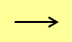
Low Cost | 37 | -25 | 45 | 37 | 45 | -25
High Performance | 50 | 50 | 50 | -31 | -31 | -31
Minimum Changes to Infrastructure | 75 | -50 | 90 | 75 | 90 | -50
Maximum Hardware Utilisation | 50 | 50 | 50 | 50 | 50 | 50
High Throughput | 50 | 50 | 50 | -31 | -31 | -31
Minimum Message Exchange | 100 | 100 | 100 | -75 | -75 | -75
Minimum Switch Load | -100 | -100 | -100 | 100 | 100 | 100
Determine Data Location | 100 | 100 | 0 | 100 | 0 | 100
Data in Service Control Point | 100 | 0 | 0 | 100 | 0 | 0 | 
Data in New Service Node | 0 | 100 | -100 | 0 | -100 | 100
Service in Mobile Switch | 100 | 100 | 100 | 0 | 0 | 0
Service in Service Control Point | 0 | 0 | 0 | 100 | 100 | 100
Determine Service Location | 100 | 100 | 100 | 100 | 100 | 100
Service Node | 0 | 100 | -100 | 0 | -100 | 100
Service Nodes Ready For Sale | 0 | 100 | -100 | 0 | -100 | 100
Install Service Node | 0 | 100 | 100 | 0 | 100 | 100 | 
Service Works | 0 | 0 | 0 | 0 | 0 | 0

ServiceProvider

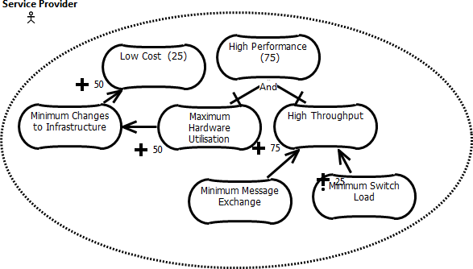

Figure 2 - ServiceProvider

Intentional Elements
High Performance: High performance of the system as seen by the service provider

RootScenario

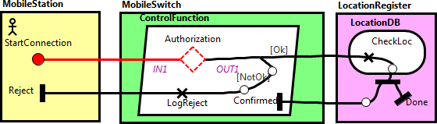

Figure 3 - RootScenario

Description
This is a connection request scenario, which can be rejected.
Responsibilities
LogReject
Expression: _GRL_Service_Works = -100;

CheckLoc: Location Registration Function (LHR)
Expression: _GRL_Service_Works = 100;

Stubs
Dynamic Stub - Authorization
Metadata: "_hits" = "1"

Plugin Map - SvcInSwitchDataInSCP
Input Bindings:
IN 1 <-> StartPoint
Output Bindings:
OUT 1 <-> EndPoint
Precondition:
Expression: _GRL_Service_in_Mobile_Switch = 100 ?
&&?
_GRL_Data_in_Service_Control_Point = 100
Transaction: false
Probability: 1.0

Plugin Map - SvcAndDataInSCP
Input Bindings:
IN 1 <-> StartPoint
Output Bindings:
OUT 1 <-> EndPoint
Precondition:
Expression: _GRL_Service_in_Service_Control_Point = 100?
&&?
_GRL_Data_in_Service_Control_Point = 100
Transaction: false
Probability: 1.0

Plugin Map - SvcInSwitchDataInSN
Input Bindings:
IN 1 <-> StartPoint
Output Bindings:
OUT 1 <-> EndPoint
Precondition:
Expression: _GRL_Service_in_Mobile_Switch = 100?
&&?
_GRL_Data_in_New_Service_Node = 100
Transaction: false
Probability: 1.0

Or Fork Description
[Ok] ==> authorized (probability: 1.0)
[NotOk] ==> !authorized (probability: 1.0)
Metadata: "_hits" = "0"

Start Point
StartConnection
Metadata: "_hits" = "1"

End Points
Reject
Metadata: "_hits" = "0"

Done
Metadata: "_hits" = "0"

Confirmed
Metadata: "_hits" = "0"

SvcInSwitchDataInSN

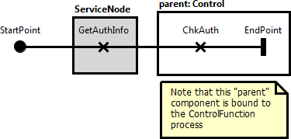

Figure 4 - SvcInSwitchDataInSN

Responsibilities
GetAuthInfo: Gets the authorization information

ChkAuth: Checks (determines) the user location

Start Point
StartPoint
Metadata: "_hits" = "0"

End Points
EndPoint
Metadata: "_hits" = "0"

SvcInSwitchDataInSCP

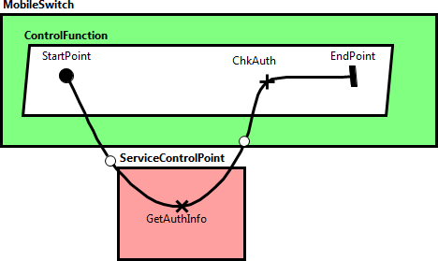

Figure 5 - SvcInSwitchDataInSCP

Responsibilities
GetAuthInfo: Gets the authorization information

ChkAuth: Checks (determines) the user location

Start Point
StartPoint
Metadata: "_hits" = "0"

End Points
EndPoint
Metadata: "_hits" = "0"

GlobalView

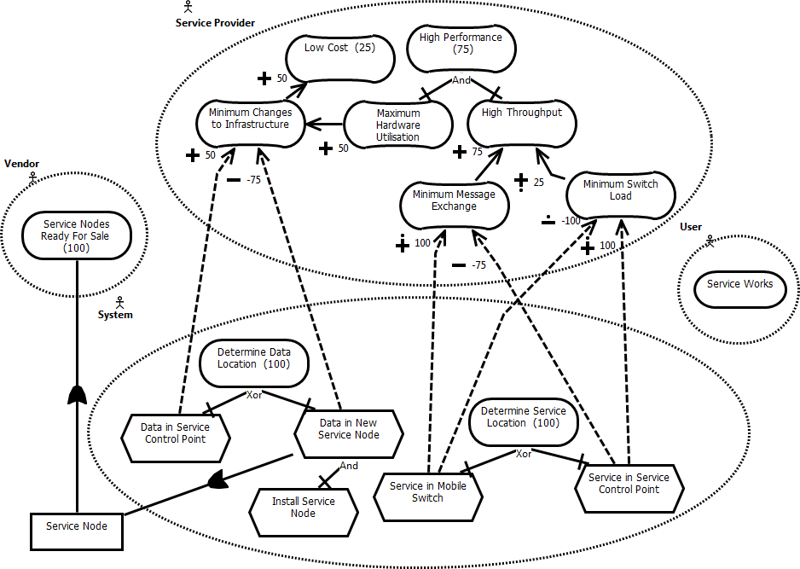

Figure 6 - GlobalView

Intentional Elements
High Performance: High performance of the system as seen by the service provider

SvcAndDataInSCP

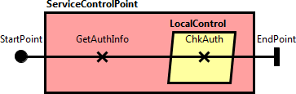

Figure 7 - SvcAndDataInSCP

Responsibilities
GetAuthInfo: Gets the authorization information

ChkAuth: Checks (determines) the user location

Start Point
StartPoint
Metadata: "_hits" = "0"

End Points
EndPoint
Metadata: "_hits" = "0"

System

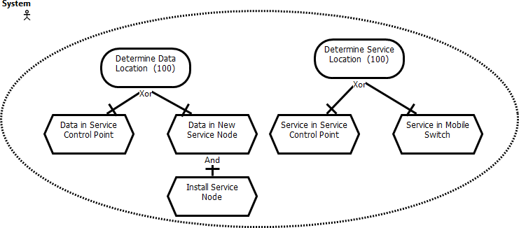

Figure 8 - System

Scenario Documentation

Scenario Execution Summary

Group UCMarchAlternatives (ID:5)
Scenario | Result | Message(s)
ConnectionAccepted (ID: 703) | FAILED | Type checker error occurred. Variable _grl_service_in_mobile_switch is not defined.
 |  | Type checker error occurred. Variable _grl_service_in_service_control_point is not defined.
 |  | Type checker error occurred. Variable _grl_service_in_mobile_switch is not defined.
 |  | Unable to navigate to a plugin from Stub "Authorization (185)"
ConnectionRejected (ID: 704) | FAILED | Type checker error occurred. Variable _grl_service_in_mobile_switch is not defined.
 |  | Type checker error occurred. Variable _grl_service_in_service_control_point is not defined.
 |  | Type checker error occurred. Variable _grl_service_in_mobile_switch is not defined.
 |  | Unable to navigate to a plugin from Stub "Authorization (185)"

Scenario Information

Group UCMarchAlternatives (ID: 5)

Scenario ConnectionAccepted (ID: 703)

Scenario Start Point(s):
StartConnection (ID: 100)

Initialization(s):

Variable Name | ID | Description | Type | Initial Value
authorized | 299 |  | boolean | true

Scenario ConnectionRejected (ID: 704)

Included UCM Scenario(s):
Scenario ConnectionAccepted (ID: 703)

Initialization(s):

Variable Name | ID | Description | Type | Initial Value
authorized | 299 |  | boolean | false

