Atividade Pratica 4 - Estatistica Aplicada

André Filipe Queiroz de Melo e Soares

26 de Setembro de 2018

# QUESTÃO 1

## Letra A

# questao 1  
# A  
k = 10000  
n = 10  
s = 0  
soma = 0  
variancia = 0  
  
for (i in 1:k) {  
 distance = rnorm(n,500,10)  
 media = mean(distance)  
 soma = 0  
 for (j in 1:n) {  
 soma = soma + (distance[j] - media)**2  
 }  
 s[i] = soma/(n-1)  
 variancia[i] = soma/n  
}  
hist(s,col = "dark red",border = "white")

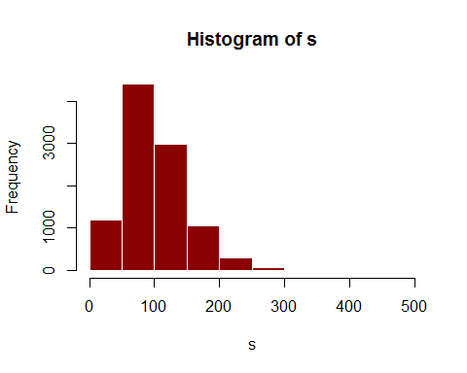

hist(variancia,col = "dark blue",border = "white")

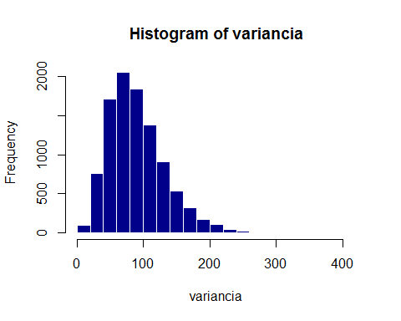

## Letra B

#B  
  
k = 10000  
n = 20  
s = 0  
soma = 0  
variancia = 0  
#vetor = vector()  
  
for (i in 1:k) {  
 distance = rnorm(n,500,10)  
 media = mean(distance)  
 soma = 0  
 for (j in 1:n) {  
 soma = soma + (distance[j] - media)**2  
 }  
 s[i] = soma/(n-1)  
 variancia[i] = soma/n  
}  
hist(s,col = "brown",border = "white")

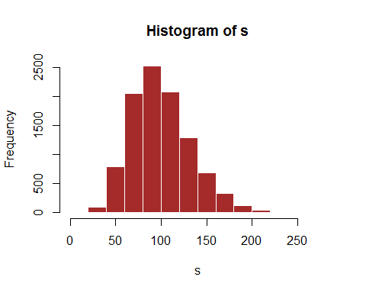

hist(variancia,col = "red",border = "white")

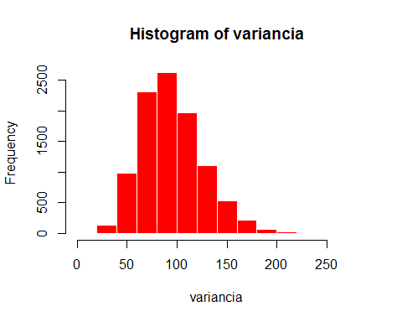

## Letra c

#C  
k = 10000  
n = 30  
s = 0  
soma = 0  
variancia = 0  
  
for (i in 1:k) {  
 distance = rnorm(n,500,10)  
 media = mean(distance)  
 soma = 0  
 for (j in 1:n) {  
 soma = soma + (distance[j] - media)**2  
 }  
 s[i] = soma/(n-1)  
 variancia[i] = soma/n  
}  
hist(s,col = "black",border = "white")

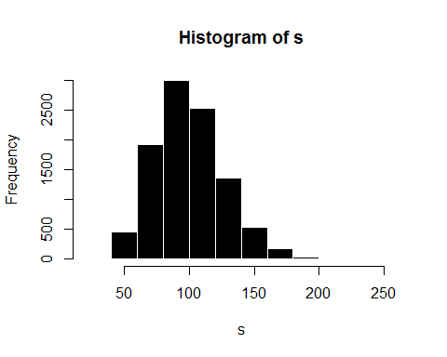

hist(variancia,col = "orange",border = "white")

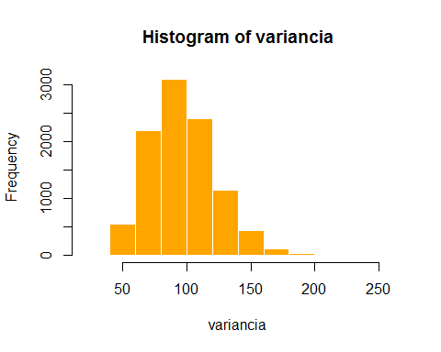

## Letra D

#D  
k = 10000  
n = 50  
s = 0  
soma = 0  
variancia = 0  
  
for (i in 1:k) {  
 distance = rnorm(n,500,10)  
 media = mean(distance)  
 soma = 0  
 for (j in 1:n) {  
 soma = soma + (distance[j] - media)**2  
 }  
 s[i] = soma/(n-1)  
 variancia[i] = soma/n  
}  
hist(s,col = "gray",border = "white")

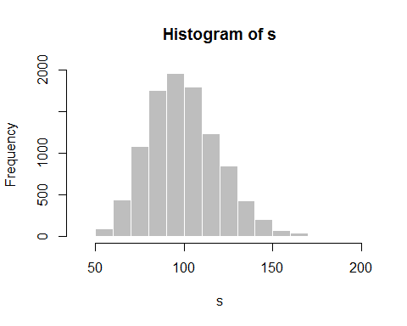

hist(variancia,col = "brown",border = "white")

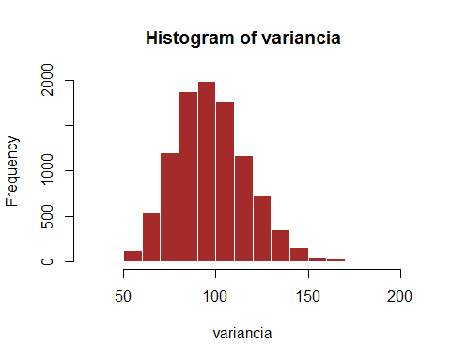

## Letra E

#E  
k = 10000  
n = 100  
s = 0  
soma = 0  
variancia = 0  
  
for (i in 1:k) {  
 distance = rnorm(n,500,10)  
 media = mean(distance)  
 soma = 0  
 for (j in 1:n) {  
 soma = soma + (distance[j] - media)**2  
 }  
 s[i] = soma/(n-1)  
 variancia[i] = soma/n  
}  
hist(s,col = "dark red",border = "white")

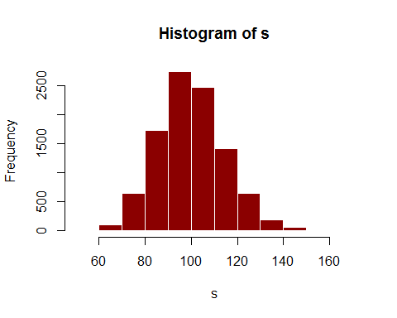

hist(variancia,col = "light blue",border = "white")

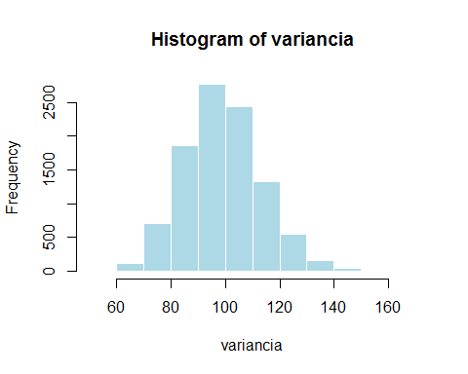

# QUESTÃO 2

# QUESTAO 2  
  
n = 100   
k = 10000   
erro1 = 0   
erro2 = 0   
medias = 0   
variancias = 0   
t1 = 0  
t2 = 0   
for(i in 1:k){  
 uniforme = runif(n, 0, 500)  
 mediaUniforme = mean(uniforme)  
 medias[i] = mediaUniforme  
 soma = 0  
 for(j in 1:n){  
 soma = soma + (uniforme[j] - mediaUniforme  
 )** 2  
 }  
 variancias[i] <- soma/n  
 t1[i] = 2*mediaUniforme  
   
 t2[i] = ((n+1)/n)*max(uniforme)  
   
}  
erro1 = (t1-medias)** 2  
var1 = erro1 - variancias  
erro2 = (t2-medias)** 2  
var2 = erro2 - variancias  
  
hist(t2, border = "white",xlab = "T2",col="red", main="Histograma do T2")

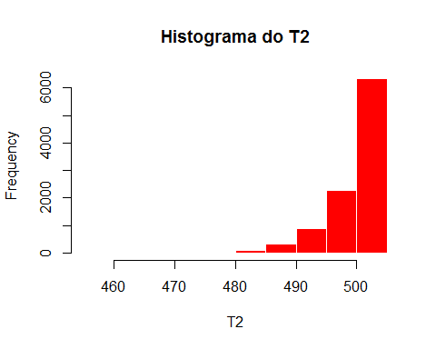

hist(t1,main="Histograma do T1",border = "white", col="dark blue", xlab = "T1")

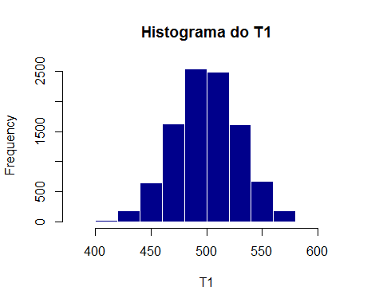

hist(erro1,border = "white", col="dark orange", main="Histograma do erro medio quadratico - T1")

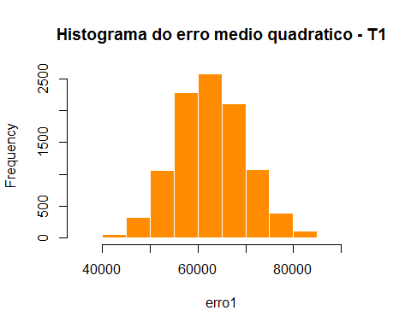

hist(erro2,border = "white", col="light blue", main="Histograma do erro medio quadratico - T2")

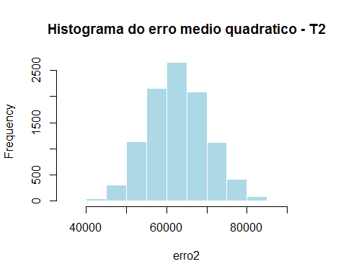

hist(var1,border = "white", col="purple", main="Histograma do vies - T1",xlab = "Variância do T1")

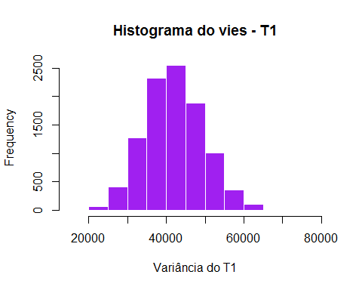

hist(var2,border = "white",main="Histograma do vies - T2", col="dark green", xlab = "Variância do T2")

