# Implementing an *Izzi 2* Puzzle Solver with Constraint Logic Programming in Prolog

André Freitas, Rui Gonçalves

FEUP-PLOG, Class 3MIEIC4, Group 35

**Abstract.** In the context of PLOG course, this document describes an implementation of a puzzle solver with constraint logic programming in Prolog, using Sicstus. This paradigm of programming is very powerful since we just write the rules of the puzzle and the program tries to solve it. Izzi2 is the best example to practice this subject since is a kind of problem that we have some complex constraints to describe how a piece A can connect to piece B and how the solution is valid considering the geometry of the tiles.

## Introduction

This project was developed in the Logic Programming course, to apply Constraint Logic Programming using the *clpfd* module in Sicstus Prolog. So, we choose the Izzi2 puzzle because although is simple, is very challenging since the pieces geometry is a diamond. This game is similar to Tangram, so the box come with the rhombuses and with a list of shapes. So, we must connect all the pieces with the same color in the connecting side, fitting a shape we have chosen from the list.

In this article is described the implementation and the steps we did, showing some analysis aspects that are the key of the success and that took a lot of hours to achieve, because this puzzle is very tricky in the implementation.

## Problem Description

The Puzzle comes with 12 pieces and a list of possible shapes. The pieces are all rhombuses and each rhombus have 4 colors that are Red, Green, Blue and Yellow, so the pieces are all the possible combinations that are 4! divided by 2, because of the symmetry.

Izzi 2, tile set

Then how to represent a piece in Prolog? It’s very easy, is just a list of colors. So for example, for the first diamond, the code is: p1([y,b,g,r])

The puzzle have 34 shapes to solve and summing all the possibilities, there are 24!·224 = 10,409,396,852,733,332,453,861,621,760,000 solutions. Some of the 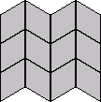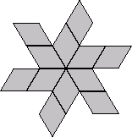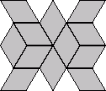34 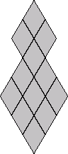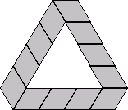shapes are the following:

When a person what to solve a puzzle, must choose one shape first and then solve 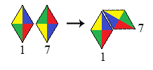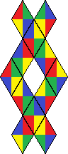it. For the first shape, a solution can be the following.

Now we must choose a way to represent a connection between two pieces, like the previous illustration in the right. Since the pieces are 1 and 7 the connection is represented by [1,7,2,4] following the syntax [piece1,piece2,piece1colorindex,piece2colorindex] but this representation isn’t enough because we will see later that the orientation is necessary. So, if the piece is turned upside down, then the orientation is 1, otherwise if is the default position, is 0. Considering this, a more complete representation is connect([1,7,2,4,0,1]) because the piece 7 is upside down.

So far we have seen how to represent a piece and how to represent a connection between two pieces. Now, we need to define how a puzzle solution is represented. For example, the solution of the following shape, that doesn’t belong to the list of Izzi2 and is just an example, have the representation:

[[2,4,3,2,0,0],[2,6,4,4,0,1],[6,9,2,3,1,1],[4,9,4,4,0,1]]



# Decision Variables

The variables that will appear in the final solution are the number of the pieces from 1 to 12, the color index from 1 to 4 and the orientation that can be 0 or 1. The following is an example of a solution with 4 connections, that is using any four pieces from the diamonds set.

(...)

createPieces(Pieces),

Connections=[C1,C2,C3,C4],

C1=[P1,P2,C1I1,C1I2,O1,O2],

C2=[P1,P3,C2I1,C2I2,O1,O3],

C3=[P3,P4,C3I1,C3I2,O3,O4],

C4=[P2,P4,C4I1,C4I2,O2,O4],

(...)

domain([P1,P2,P3,P4],1,12),

domain([C1I1,C1I2,C2I1,C2I2,C3I1,C3I2,C4I1,C4I2],1,4),

domain([O1,O2,O3,O4],0,1),

(...)

## Constraints

The constraints that were build are for checking if a connection is valid, if the solution of a shape is valid and if the pieces fit in a certain way. For checking a connection we created the predicate connect(Pieces,Connection) that can receives the list of pieces and the connection and by comparing the color of the indexes given, evaluate if true.

To check if a complete solution is valid regarding that they are unique, there is a predicate unique(Connections), that receives the list of connections. For example, if the piece 2 is linked to another with the index 4, that index is no more available to another piece and, if there is a connection 1,2 doesn’t make sense a connection 2,1 to appear later.

The last constraints and the most important are the constraint to check if the solution respect a certain shape. For example, to describe a shape, like the following we need to say how the pieces fit in each other. Please give a lot of attention to this