**Andre Vargas Galvez**

**Homework 1: Mixed-Models course 2016**

#2

#lm tutorial

pitch = c(233,204,242,130,112,142)

sex = c(rep("female",3),rep("male",3))

my.df = data.frame(sex,pitch)

xmdl = lm(pitch ~ sex, my.df)

summary(xmdl)

#was significant (F(1,4)=46.61, p<0.01). (.)"

Coefficients:

Estimate Std. Error t value Pr(>|t|)

(Intercept) 226.33 10.18 22.224 2.43e-05 ***

sexmale -98.33 14.40 -6.827 0.00241 **

##############################################################

mean(my.df[my.df$sex=="female",]$pitch)

#this (up) or by

#######################

age = c(14,23,35,48,52,67)

pitch = c(252,244,240,233,212,204)

my.df = data.frame(age,pitch)

xmdl = lm(pitch ~ age, my.df)

summary(xmdl)

Coefficients:

Estimate Std. Error t value Pr(>|t|)

(Intercept) 267.0765 6.8522 38.98 2.59e-06 ***

age -0.9099 0.1569 -5.80 0.00439 **

#center for average age in intercept instead of 0

my.df$age.c = my.df$age - mean(my.df$age)

xmdl = lm(pitch ~ age.c, my.df)

summary(xmdl)

Coefficients:

Estimate Std. Error t value Pr(>|t|)

(Intercept) 230.8333 2.8113 82.11 1.32e-07 ***

age.c -0.9099 0.1569 -5.80 0.00439 **

######################################

#plot linearity assumption

plot(fitted(xmdl),residuals(xmdl))

#heteroscedasticity assumption in plot

plot(rnorm(100),rnorm(100))

#normality in residuals plots

hist(residuals(xmdl))

qqnorm(residuals(xmdl))

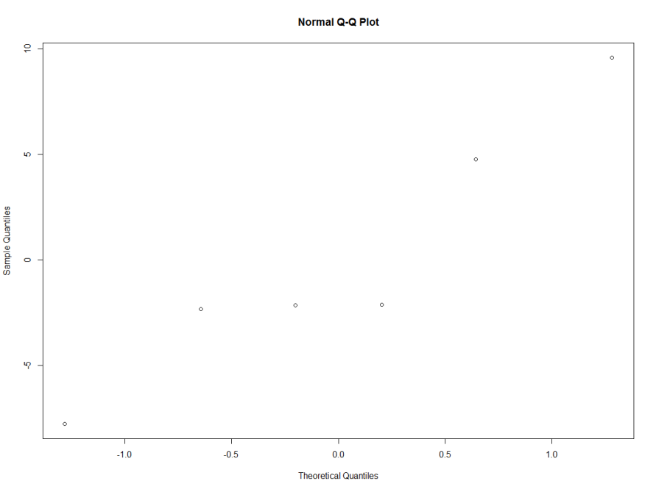

#dfbetas

dfbeta(xmdl)

# DFbetas and look for values that are different by

#at least half of the absolute value of the slope

#independence of observations

##############################

#4

# recreate plots

install.packages("lattice")

library(lattice)

install.packages("ggplot2")

library(ggplot2)

cherry <- read.csv("C:\\Users\\s4600479\\Desktop\\CherryPit_small_N5.csv", sep = ",")

#dotplot

plot_1 <- qplot(pid, distance, data = cherry, geom=c("point"))

plot_1

#density plot

densityplot(~distance|pid,data=cherry,

xlab="distance (meters)",

main="distance of cherry by participant")

#xyplot

xyplot(distance ~ trial | pid, cherry, grid = TRUE)

