**Homework 3: Mixed-Models course 2016**

**The homework consists of doing two mixed-effects models analyses, including all the steps we discussed in the classes.**

**What you have to hand in:**

Hand in your R code and the output and figures you created with it: Copy/paste the code and the output/figures into a word document, print it out, and bring it to the class/lab session on **Feb 29, 2016**.

**(1) Analyze the *N*=30 Cherry Pit Spitting data file to answer the research questions below.**

**(Note: This is the same data file as in the last homework: The file is called** CherryPit_large_N30Gender.csv **and can be found on BlackBoard --> Course Documents --> Week 2 --> Homework)**

**Make sure you have set your contrast setting sum-to-zero contrasts.**

**The research questions you want to investigate are:**

1. Is there a significant trial effect? If so, in which direction does it go (i.e., do participants reach better or worse distances over the course of the 5 trials)? **Not significant at 95% but marginally (90%), they would reach worse distances.**
2. Is there a significant gender difference in the reached distances? (I know that you already answered that question in the last homework, but I want you to investigate it again in this analysis.) **It is significant at 95 and 90%.**
3. Is there a significant interaction between gender and the trial effect? If so, what is the difference and how does the trial effect look for female and for male participants (you can use plots to answer that last question)? **It is significant and the effect is shown in the last xyplot from the first part. In average, females improve their distance while males become worse at spitting.**
4. Are there significant individual differences in the reached distances? **Yes at 90 and 95%**
5. Are there significance individual differences in the trial effect? **No, the effect is not significant.**

***Report the results in full sentences including the relevant estimate (and Std Error in case of regression coefficients), p value, and CI, like I did in my example when I reported the result of the days effect for the sleep study data (slide 69 of my classes).***

**Hints**

* For non-significant effects, you can report *p* > .10 and the corresponding CI (once you learn how to obtain *p* values directly, we will be reporting the actual *p* values, but for now, this approach with *p* > .10 will do fine).
* Questions 4 and 5 are answered by looking at CIs of random (not fixed) effects (in contrast to the fixed effects, you don't get an estimate of the regression coefficient and its standard error, but you get a variance (or SD) estimate, without an associated error term. Thus, for the random effects, you can report the variance (or the SD, whichever you prefer), plus the relevant CI (as the CI is reported for the SD, it's better to report also the SD instead of the variance for the point estimate).

In addition to answering the above questions, do the following things in the following order:

**(a) Write down the lmer syntax for the model you want to use to test your hypothesis. Do not yet run the model.**

**HINTS:**

* You first need to create a new variable for trial that is numeric and has the value 1 for the first trial, 2 for the second trial etc (you'll be needing that variable for some plots in part (b) of this assignment). There are different ways to create this variable; one way is to use the function recode() from the package car. Make sure to check whether the new variable you created is truly a numerical variable!
* Now when you have this variable, think about your trial predictor in the context of the lmer model: Does it make sense to create a centered predictor? Or a scaled predictor? **I don’t see any advantage to do this.** Or change it in some other way (currently, it has the values 1-5; would a different range make more sense)? *For this homework, I want you to create and use a trial predictor so that the model intercept represents trial number 3 and that a one-unit increase in the predictor corresponds to an increase of one trial to the next trial.*
* Only within-subject effects can be (and should be) modeled as random slopes.

**(b) Create some plots to understand the data, before you are going to test this hypothesis statistically:**

* A densityplot showing distance as a function of trial and gender, with each trial being shown in a separate panel, and each gender being represented in a different color. HINTS:
  + The general syntax looks like this: densityplot(~ DV | IV1, group = IV2, auto.key = TRUE, data = MyData)
  + For this plot, use the original trial variable (with the values cp1, cp2, etc), as this will lead to an easier-to-read graph

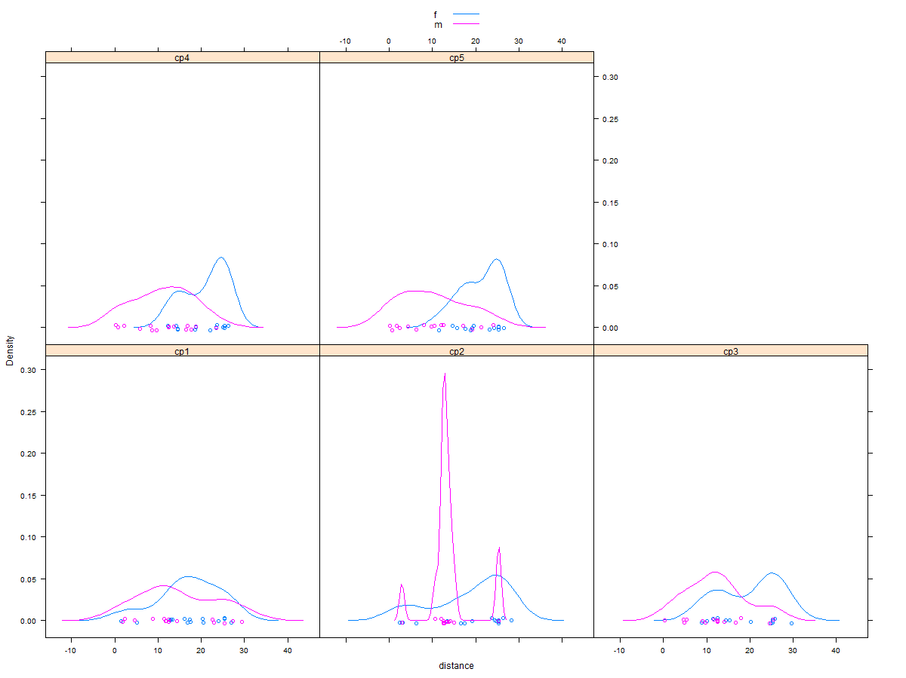

* Create the following 5 xyplots. NOTE: For these 5 plots use either the trial variable that uses values ranging from 1 to 5, indicating trial 1, 2, 3, 4, 5):
  + One panel per participant, ordered by participant code and showing trial on the x axis and distance on the y axis.

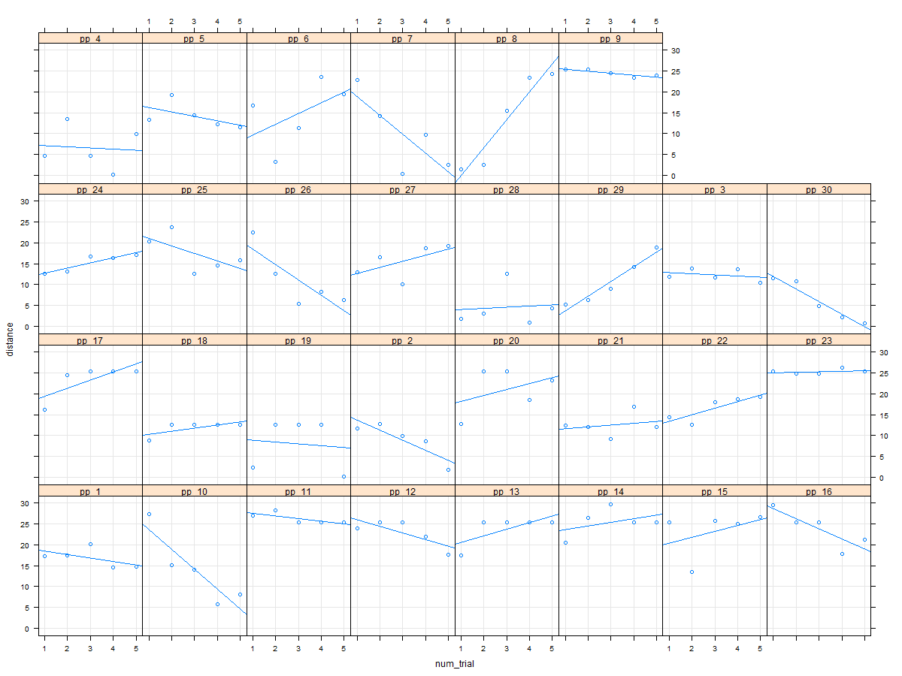

* + The same as the previous one, but ordered by intercept in **descending** order. [Hint: To get a descending order, all you need to do is to add a minus sign in the right place in the code to create the figure.]
  + 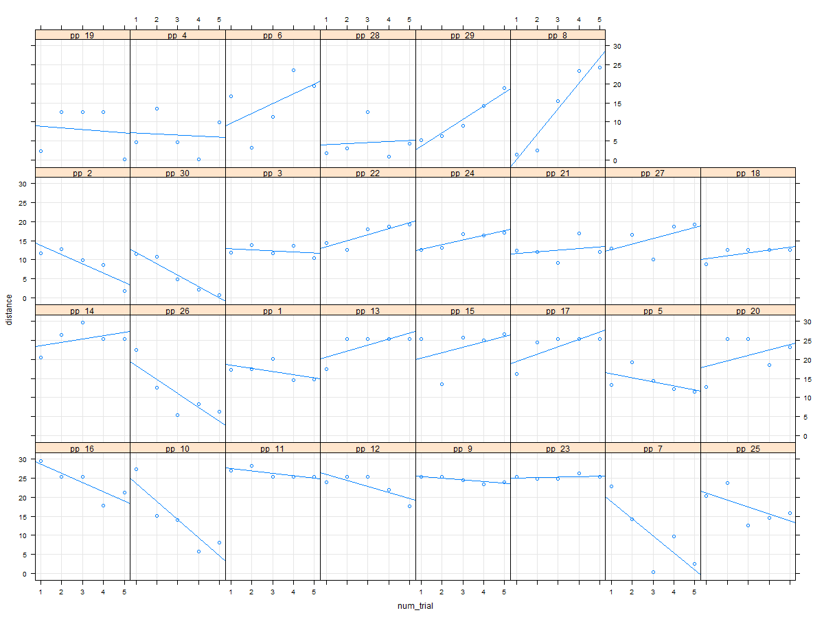
  + The same as the previous one, but ordered by trial slope in **ascending** order.
  + 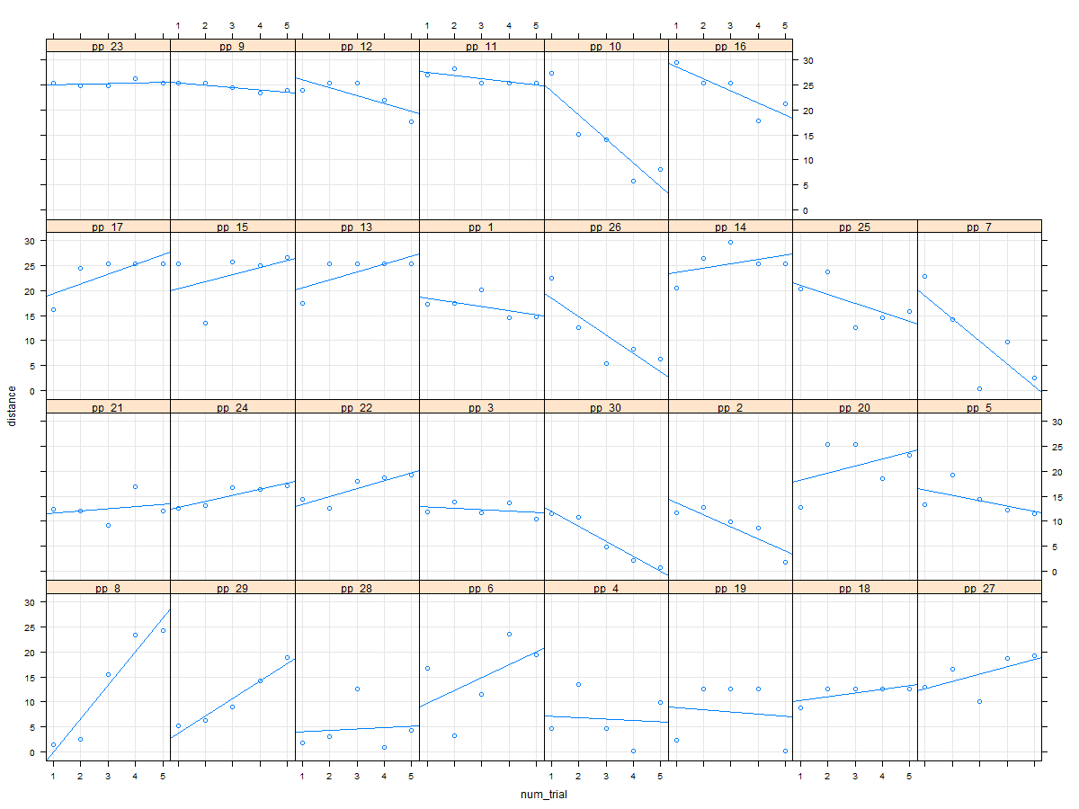
  + An xyplot with 1 panel for females and one panel for males, showing each one regression line: Trial is on the x axis and distance on the y axis; show also the points and a grid.
  + 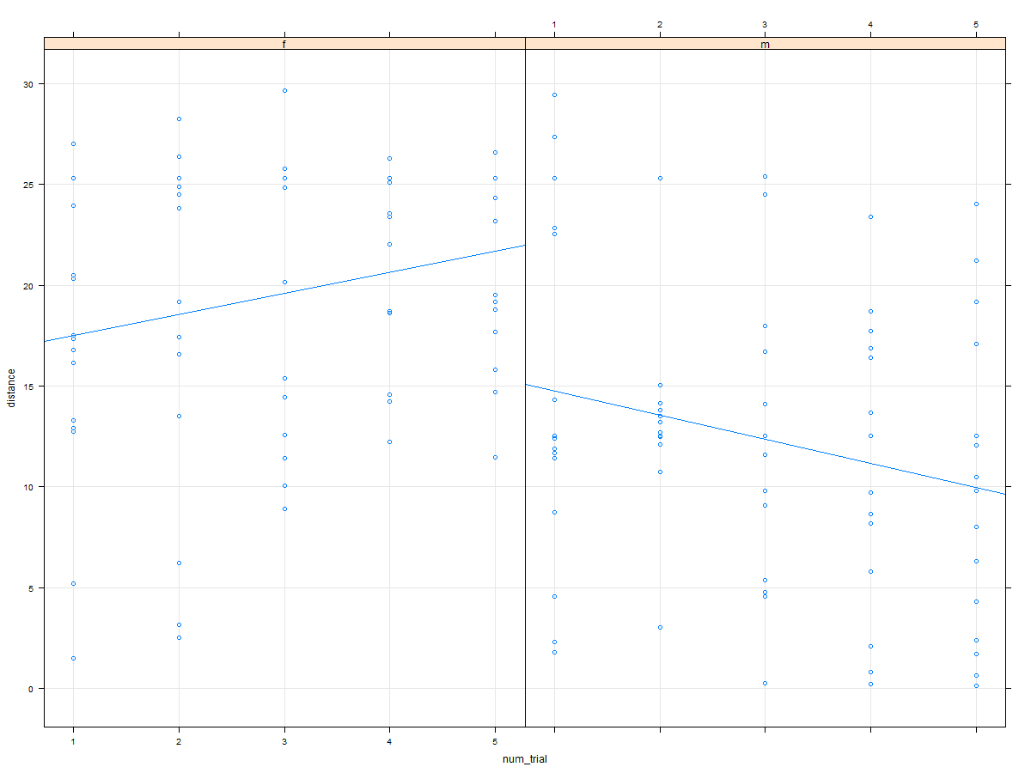
  + A similar xyplot as the previous one, with 1 panel for females and one panel for males. However, a separate regression line per participant is shown (and participants are shown in different colors). **Hints**: (a) Do not show the data points of each participant (as this will look messy); (b) use the group argument to get differently colored lines per participant; (c) no need to show a legend explaining the different colors.

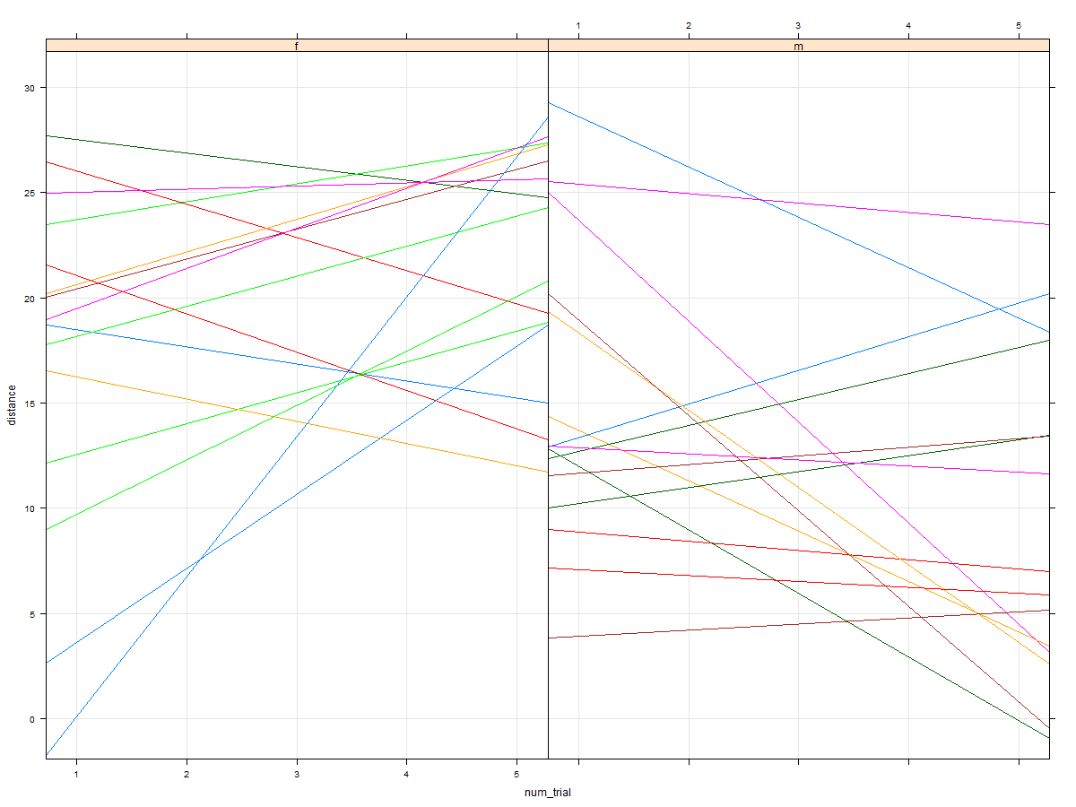

**(c) Run your lmer model and do the following things:**

* Thoroughly inspect your summary() for the model:
* What is the variance associated with the participant intercepts? **27.374**
* What is the variance associated with the random slopes? **3.127**
* What is the random correlation? What does that mean? **-.18, it is the covariance between random intercept (participant) and random slope (trial), wich has a negative relation.**
* What is the residual variance? **15.095**
* What is the estimate for the intercept? **15.98083** What does that number mean? **It means that the average distance of this sample is 15.098 distance.**
* What is the estimate for the Gender effect? **3.62148** What does that number mean? **It means that females spit 3.62 distance further than the average, and men spit 3.62 distance less than the average. Females spit further than most males.**
* What is the estimate for the trial effect? **-0.07861**What does that number mean? **It means that in average participants got worst (less distance) as the trials advance from the third trial**
* What is the estimate for the interaction effect? **1.12061** What does that number mean? **It means that females spit a longer distance every new trial.**
* So, based on these numbers, what do you think is the average distance of female participants on trial 2? (Plug in the relevant numbers into the regression equations; for such computations, you can ignore the random effects and use only the fixed effect estimates.) **18.4 (15.98+3.62+.078-1.12)**
* What do you think is the average distance of male participants on trial 4? **11.14 (15.98 + 2*-.078-3.62 - 1.12)**
* Verify these numbers by using describeBy from the library psych to get the respective raw means.

f

: 2

vars n mean sd median trimmed mad min max range skew kurtosis se

1 1 15 18.82 8.75 23.83 19.35 6.58 2.51 28.27 25.76 -0.77 -0.99 2.26

: m

: 4

vars n mean sd median trimmed mad min max range skew kurtosis se

1 1 15 11.15 6.95 12.51 11.05 6.5 0.2 23.39 23.19 -0.09 -1.2 1.79

* Were your guesses based on the intercepts and slope correct or not? If not, why not? **Yes, they where almost precisely correct.**

**(d) Model diagnostics: Create the following plots**

* A densityplot of the scaled model residuals
* 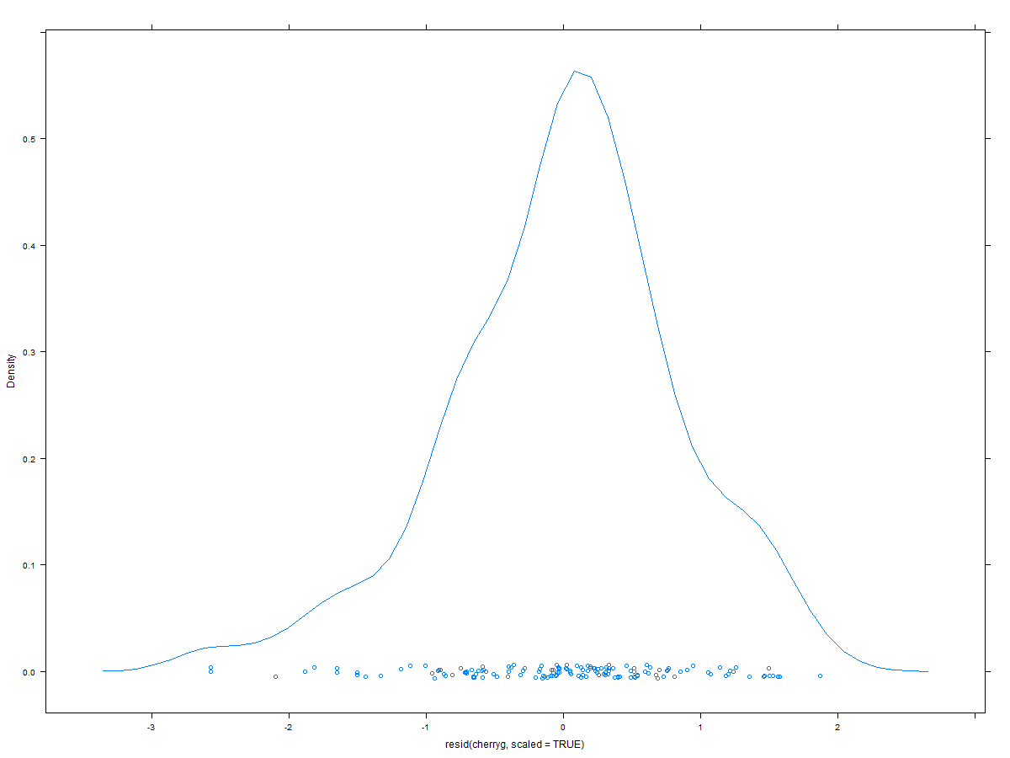
* A q-q plot of the scaled residuals; use qqPlot() from the package car
* 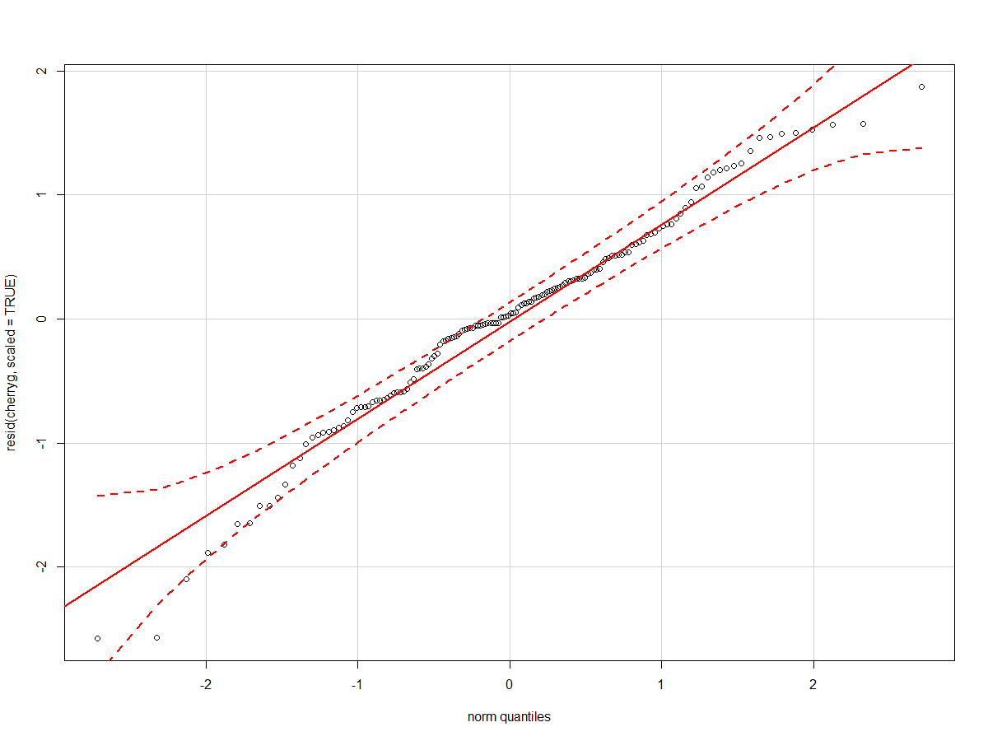
* Compute the proportion of residuals larger than +/- 2, 2.5, 3. Are any of these numbers problematic? **in order=.02** , **.013, 0 it doesn’t represent a problem.**
* A boxplot showing for each participant the distribution of the scaled residuals. Are there any participants with problematic data points? If so, what are these participants' participant IDs?
* 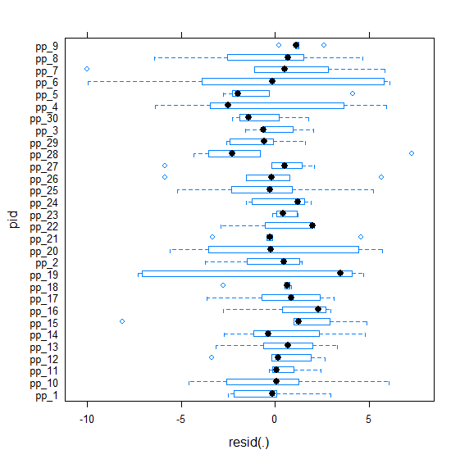
* A scatterplot showing the fitted vs. the residuals to check for homo/heteroskedasticity; add a smoothed line.
* 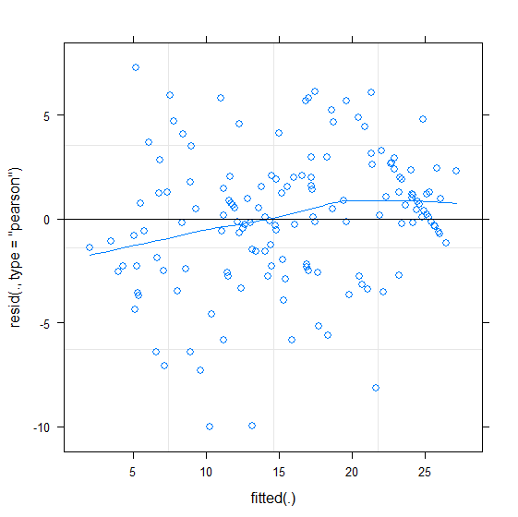
* A scatter plot showing the observed vs. the fitted values; use the relevant function from the package car
* 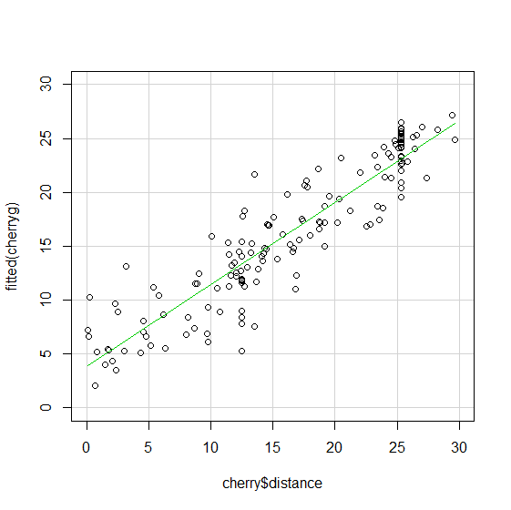
* Two caterpillar plots showing the random effects: One caterpillar plot should show on the y axis each participant with equal spacing; the other should show them spaced according to standard normal quantiles.

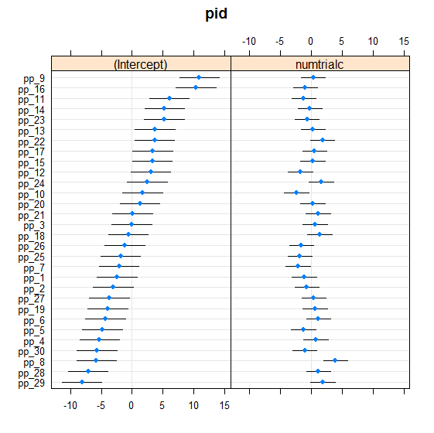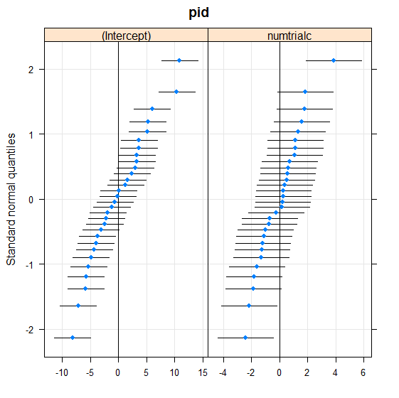

* Compute the correlation between the observed and fitted values and the pseudo-R2 based on that correlation. Are these numbers different from the model you ran in your last homework? If it has changed, why do you think it has changed the way it has changed? Previous Pseudo R2 = .66, **current Pseudo R2 = .84 yes they are different it has increased because know we have another source of variance (slopes) that explains the dependent variable.**

Based on these model diagnostics, do you have any concerns (and if so, what could you do to address them) or are things fine? Maybe there are some influential points; I think this because of the boxplot per participant has a very large variance between subjects, but in general it seems OK.

**(e) Confidence intervals**

Compute 95% confidence intervals to answer the research questions above. For a non-significant effect, it's nice to also compute the 90% CI to be able to write something like "[...] was non-significant with *p* > .10 [...]."

BOOTSTRAP

At 95%

.sig01 3.7361460 6.8723704

.sig02 -0.6468271 0.3051626

.sig03 0.9651739 2.4628113

.sigma 3.2938310 4.4760655

(Intercept) 14.0539352 17.8170179

numtrialc -0.8950662 0.6972044

gender1 1.4822176 5.4769950

numtrialc:gender1 0.3941591 1.9007880

at 90%

.sig01 3.9325915 6.5646374

.sig02 -0.5693759 0.2284515

.sig03 1.1090894 2.3425590

.sigma 3.3936543 4.3347181

(Intercept) 14.2004420 17.5864907

numtrialc -0.7037538 0.5416689

gender1 1.9441361 5.2616192

numtrialc:gender1 0.4494452 1.7833428

PROFILE

> confint(cherryprof1, level = 0.90)

5 % 95 %

sd_(Intercept)|pid 4.0024711 6.4648838

cor_numtrialc.(Intercept)|pid -0.5346410 0.2030037

sd_numtrialc|pid 1.1544119 2.3117125

sigma 3.4535725 4.4150516

(Intercept) 14.3446161 17.6170386

numtrialc -0.7176508 0.5604270

gender1 1.9852737 5.2576962

numtrialc:gender1 0.4815721 1.7596498

Warning message:

> confint(cherryprof1, level = 0.95)

2.5 % 97.5 %

sd_(Intercept)|pid 3.8360563 6.8035858

cor_numtrialc.(Intercept)|pid -0.5920813 0.2747804

sd_numtrialc|pid 1.0547348 2.4556937

sigma 3.3800538 4.5301652

(Intercept) 14.0122846 17.9493701

numtrialc -0.8474462 0.6902224

gender1 1.6529422 5.5900277

numtrialc:gender1 0.3517767 1.8894452

Compute both the **profile-based** and the **bootstrapped CIs** (which exact profile-based or bootstrapped CIs you use doesn't matter).

Do you notice anything unusual? **Yes several things, first 50 warnings in the profile CI calculation…**

**(2) Analyze the sleep study data.**

**You want to investigate the following research questions:**

* **Are there significant individual differences in reaction times in the middle of the experiment? Yes there are at 95%**
* **Is there a significant effect of increasing sleep deprivation on reaction times? Yes the effect is significant at 95%**

To not overburden you with homework and since I presented already several of the usual data analysis steps in my class slides (e.g., plots of the raw data, model diagnostics), we skip some of these steps here (but feel free to do them anyway, as it is very good practice to do these things often). Do the following things in the following order and try NOT to look at my slides!

*Also: The model that you are asked to run is different from the model that I presented on my class slides! And that also changes some of the results, so be aware of these differences and think about why there are these differences.*

**(a) Write down the lmer syntax for the model you want to use to test your hypothesis. Do not yet run the model.**

HINT: The first research question asks about individual differences in reaction times in the middle of the experiment. Thus, I want you to create a model in which the intercept represents the middle of the observation period of 10 days and a one-unit change in the predictor corresponds to a one-day change.

**(c) Run your lmer model and do the following things:**

* Thoroughly inspect your summary() for the model:
* What is the variance associated with the participant intercepts? Is it different from the result I presented in my slides? If so, why? **1408.73, yes because of the centered variable the intercept is located in the 5th day.**
* What is the variance associated with the random slopes? Is it different from the result I presented in my slides? If so, why? **35.07, no it is not different.**
* What is the random correlation? What does that mean? Is it different from the result I presented in my slides? If so, why? **.75, it is different because the intercept changed… (but I don’t fully understand why, it may be the nature of the numbers)**
* What is the residual variance? Is it different from the result I presented in my slides? If so, why? **654.94, no its not different**
* What is the estimate for the intercept? What does that number mean? Is it different from the result I presented in my slides? If so, why? **298.508, it means that the average reaction time in the 5th day of the experiment is 298.5. Yes it is different because the variable is centered.**
* What is the estimate for the Days effect? What does that number mean? Is it different from the result I presented in my slides? If so, why? **10.467, it means that for one day increase of sleep deprivation the reaction times get longer for 10.46, so people become slower.**
* So, based on these numbers, what do you think is the average response time on day 3 (with day 3, I'm referring to the counting in the original Days variable: 0, 1, 2, \***3\***)? **(trial 4)** HINT: To make sure you get the correct mapping (which value in the newly created days predictor in the model corresponds to the original Day 3? You can use some code like this to look this up (NewDaysPredictor should be the name of the predictor you used in your lmer model of course): unique(cbind(MyDataFrame$Days, MyDataFrame$NewDaysPredictor)) **(298.508-10.467)= 288**
* Verify this by using describeBy from the library psych to get the raw means for each day. **#mean 282.99**
* Was your guess based on the intercept and slope correct or not? If not, why not? **It is similar but not exactly the same, I’m not sure why not it may be because 0 is not 5 but .5…**

(We skip the model diagnostics part, as you can see those things on my slides; but if you want to exercise your skills, then feel free to create the following graphs: densityplot of the model residuals; q-q plot of the residuals using qqPlot() from the package car; boxplot showing for each participant the distribution of the residuals; scatterplot showing the fitted vs. the residuals to check for homo/heteroskedasticity with a smoothed line; scatter plot showing the observed vs. the fitted values (use the relevant function from the package car; two caterpillar plots showing the random effects: One caterpillar plot should show on the y axis each participant with equal spacing; the other should show them spaced according to standard normal quantiles)

**(d) Confidence intervals**

Compute profile-based 95% confidence intervals to answer the research questions above.

> confint(sleepprofci, level = 0.95)

2.5 % 97.5 %

sd_(Intercept)|pidf 26.5815999 53.2177409

cor_daysc.(Intercept)|pidf 0.3714824 0.9396059

sd_daysc|pidf 3.8011641 8.7533831

sigma 22.8982669 28.8579965

(Intercept) 280.3081703 316.7076135

daysc 7.3586533 13.5759188