Influence Statistics, Outliers, and Collinearity Diagnostics

- Studentized Residuals – Residuals divided by their estimated standard errors (like t-statistics). Observations with values larger than 3 in absolute value are considered outliers.
- Leverage Values (Hat Diag) – Measure of how far an observation is from the others in terms of the levels of the independent variables (not the dependent variable). Observations with values larger than 2(k+1)/n are considered to be potentially highly influential, where k is the number of predictors and n is the sample size.
- DFFITS – Measure of how much an observation has effected its fitted value from the regression model. Values larger than 2*sqrt((k+1)/n) in absolute value are considered highly influential. Use standardized DFFITS in SPSS.
- DFBETAS – Measure of how much an observation has effected the estimate of a regression coefficient (there is one DFBETA for each regression coefficient, including the intercept). Values larger than 2/sqrt(n) in absolute value are considered highly influential.
- Cook’s D – Measure of aggregate impact of each observation on the group of regression coefficients, as well as the group of fitted values. Values larger than 4/n are considered highly influential.
- COVRATIO – Measure of the impact of each observation on the variances (and standard errors) of the regression coefficients and their covariances. Values outside the interval 1 +/- 3(k+1)/n are considered highly influential.
- Variance Inflation Factor (VIF) – Measure of how highly correlated each independent variable is with the other predictors in the model. Values larger than 10 for a predictor imply large inflation of standard errors of regression coefficients due to this variable being in model.

Residulas vs fitted plot

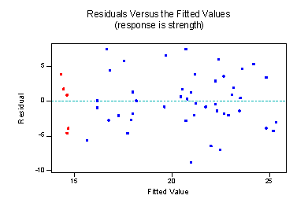
- The residuals "bounce randomly" around the 0 line. This suggests that the assumption that the relationship is linear is reasonable.
- The residuals roughly form a "horizontal band" around the 0 line. This suggests that the variances of the error terms are equal.
- No one residual "stands out" from the basic random pattern of residuals. This suggests that there are no outliers.

- Examine standardized residuals
  - 5% of cases should have residuals > 2, 1% should have residuals > 2.5, and none > 3.
- Examine absolute values of DFBetas
  - effect on coefficients after deleting observation
  - No values should be above 1
- Calculate leverage
  - (# predictors + 1) / sample size
  - Are any values larger than 2x or 3x this value?
- Independence of errors (Durbin-Watson)
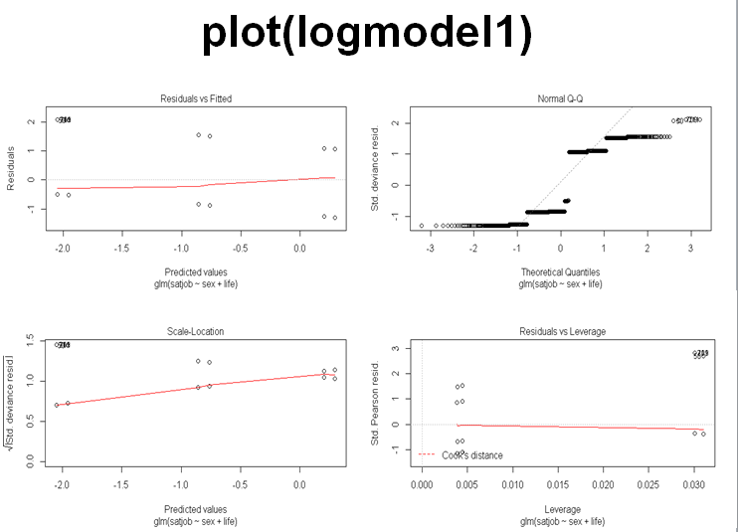
…in the car() package

- #Compute odds ratios and 95% confidence intervals
- exp(logmodel1$coefficients)
- exp(confint(logmodel1))

- relevel changes the level of the reference variable to the second level in this case
logex$life <- relevel(logex$life, ref = 2)

install.packages("mlogit")
# necessary for multinomial logistic regression

install.packages("gmodels")
install.packages("MASS")

Pearson’s Chi-Square Test
- Calculated for each of the cells in the contingency table.
  - The test distribution is approximate so in small samples use Fisher’s exact test.
Likelihood Ratio Statistic
  - based on maximum-likelihood theory.
  - Creates an “optimal” model (probability of obtaining the observed set of data is maximized), and this model is compared to the probability of obtaining those data under the null hypothesis
  - Preferred to the Pearson’s chi-square when samples are small.
- Statistical Assumptions
  - Independence of observations:
  - All cases contribute equally (once): N = # of cases
  - Same as MLinR and MLogR
    - Ratio of cases to variables
  - 5x the # of cases to cells in the design
    - Adequacy of expected values
  - All expected values are >1 & 20% >5

- Hierarchical loglinear analysis
- Start with saturated model, and eliminate nonsignificant parameters until the most parsimonious model is identified.
    - Requires contingency table
  - xtabs()
  - Requires model comparisons
  - anova()
      - Requires subsequent post-hoc analyses
  - CrossTable()

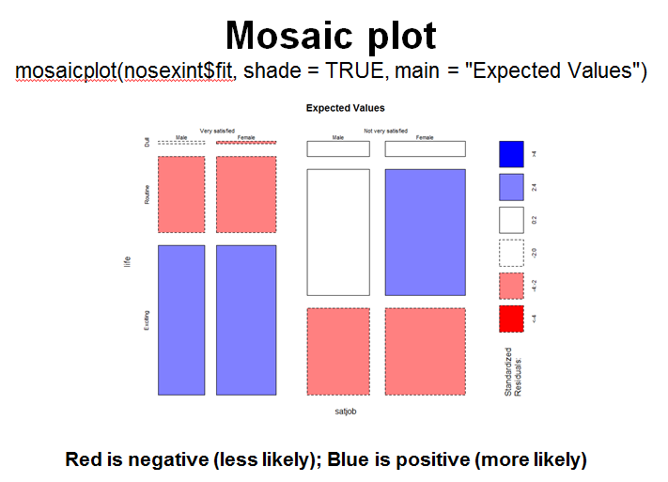

ANOVA
- When you have categorical predictors (IVs) and continuous outcome (DV)
  - Can be used when you have two or more groups.
  - Can be used when you have manipulated more than one independent variable.
- Homogeneity of variance between groups
  - Levene’s test and Hartley’s F-max
- install.packages("car") #Levene’s test
- If Levene’s test is significant then it is reasonable to assume that population variances differ across groups. oneway.test(libido ~ dose, data = viagraData)
- Independence of observations
- Normal distributions within groups
  - When group sizes are equal, then F-statistic is quite robust to violations
    - It indicates that the group means are different, but doesn’t tell us exactly which means differ.
- Planned contrasts
  - Hypothesis driven (a priori)
  - Post hoc comparisons
  - Not planned (no hypothesis)
    - Compare all pairs of means
Bonferroni method

Rules of Contrasts
- Independent (orthogonal)
  - Contrasts must not interfere with each other (they must test unique hypotheses).
  - Dichotomous
  - Each contrast should compare only two chunks of variation.
  - K–1
You should always end up with one less contrast than the number of groups.

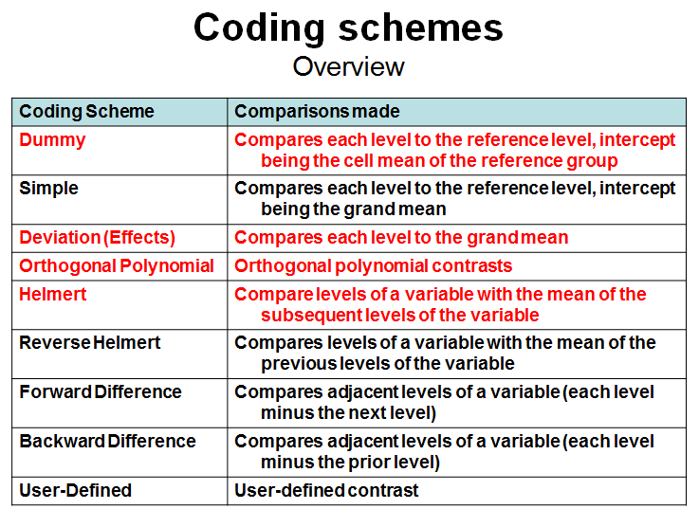

  - Dummy (default): contr.treatment()
    - Contr.SAS()
  - Deviation/zero sum: contr.sum()
  - Helmert: contr.helmert()
  - Polynomial: contr.poly()Here too, different contrasts result in different values, which require different interpretation
- contr.treatment: contrasts each level with the baseline level (specified by base): the baseline level is omitted.
Post Hoc Tests
- Bonferroni and related methods using the pairwise.t.test()
- Tukey and Dunnett’s test can be done using the glht() function in the multcomp package.
    - Wilcox (2005) has some robust methods implemented in his functions lincon() and mcpp20().
Robust ANOVA
- An alternative when assumptions aren’t met
- Require the data to be in wide format rather than the long format.
- Reformat the data using unstack():
- For an ANOVA of the Viagra data based on 20% trimmed means:
t1way(viagraWide)
- To compare medians rather than means:
med1way(viagraWide)
- To add a bootstrap to the trimmed mean method:
t1waybt(viagraWide)

ANCOVA
- Used to control for known extraneous variables
- Reduces error variance
- Provides greater experimental control
- For a one-way ANCOVA we can use the aov() or lm() functions.
- Anova(viagraModel, type="III")
Assumptions
Anova+
- Independence of covariate and IV
  - When covariates and IVs are not independent, then the effect of IV is obscured. We can test this by running an ANOVA with covariate as the outcome and IV as the predictor.

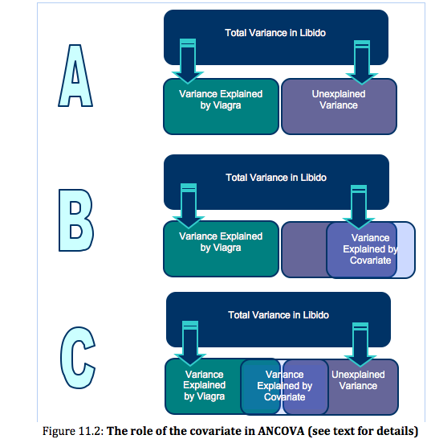
  - Homogeneity of regression slopes
  - The relationship between the covariate and IV should be similar for all groups
  - Perform ANCOVA with the DV and the main effects and interaction between IV and the covariate as IVs
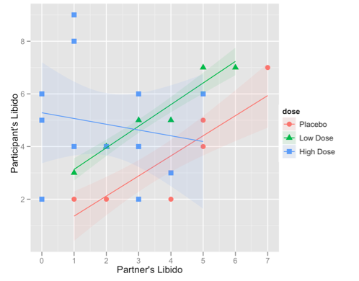

TYPES OF ERRORS
- There are four types: I, II, and III, IV
  - Each partitions variance in slightly different ways
Type I
Sequential
- The reason is that when R computes the fit of the model it uses Type I sums of squares by default.
This means that any predictor entered into the model is evaluated after predictors before it in the model (order matters!).
- There are few situations in which Type I is advantageous (e.g., hierarchical?)

Pros:
(1) SS for all the effects add up to the total SS, which is not generally true for any other types.
(2) Preferable when effects of some factors (e.g., control measures) should be considered before others.
Cons:
(1) Hypotheses depend on the order in which effects are specified. Lack of invariance is a problem for certain designs.
(2) Not appropriate for factorial designs

Type II
Partially sequential
- Type II is the most powerful in detecting main effects of multiple predictors.
A and B main effects will both be adjusted for each other (since neither contains the other), but will NOT be adjusted for A*B (since it contains both A and B). A*B will be adjusted for both main effects.
Pros:
(1) appropriate for model building.
(2) most powerful type when there is no interaction
(3) invariant to the order in which main effects are entered into the model.
Cons:
(1) Not appropriate for models with multiple interactions
(2) Not appropriate for factorial designs

Type III
Weighted
- If interactions are of interest, then Type III
SS for a given effect is adjusted for all other effects listed in the MODEL statement, regardless of whether they contain the given effect or not. In particular A and B main effects WILL be adjusted for the A*B interaction.
Pros:
- Not sample size dependent, so better for unbalanced data,
- Interactions have equal priority for explaining variance

Cons:
(1) testing main effects in the presence of interactions
(2) Not appropriate for designs with missing cells

Type IV
Balanced
- Goodnight’s method for missing cell layouts
  - similar to Type III in spirit, with a different strategy for compensating for missing cells when estimating the model parameters.

Post hoc tests
- Because we want to test differences between the adjusted means, we can only use the glht() function.
- As such, we are limited to using Tukey or Dunnett’s post hoc tests:
Obtain adjusted means
effect()

Factorial ANOVA
- We can look at how variables interact (e.g., test the conditional effects of one IV on another (i.e. moderation)
  - Interactions between groups, and/or within individuals
  - Interactions are often more interesting than main effects.

- Independent ANOVA (Ch. 12)
  - Same as one-way ANOVA, but…
  - (Between-participant) interactions!
  - 2+ between-participant factors
  - 2+ IVs both measured with different participants
  - between-participant effects can also be described in terms of the regression equation.
Assumptions
- Homogeneity of variance for each effect
  - Levene’s test and Hartley’s F-max
    - Independence of observations
  - Note: This is violated in RM ANOVA
    - Normal distributions within groups
  - When group sizes are equal, then F-statistic is quite robust to violations when due to skew, but…less robust to outliers and kurtosis.
- Homogeneity of Variance
  - ANOVA & RM ANOVA (between participants)
- Homogeneity of Covariance (“sphericity”)
  - RM ANOVA (within participants)
- Homogeneity of Variance-Covariance Matrices
  - MANOVA (foreshadowing)
- Post hoc comparisons of the interaction require a single variable that distinguishes all groups

- Repeated measures ANOVA (Ch. 13)
  - Within-participant effects
  - Utilizes difference score approach…
  - So, lm() won’t work here
  - 1+ between- and 1+ within-participant factors
1+ IVs both measured with same participants
  - aov() and lm() are equivalent…when zero-sum coding is used.
- Some (non-) experimental situations require within-participant effects…
  - Account for individual differences
- Experimental
  - All participants complete all conditions
- Correlational
  - All participants complete all identical baseline and follow-up measures
- Tests whether a member of one group is expected to change more than a member of another group, given that they have the same initial value.
  - Unsystematic variance is reduced.
    - More sensitive to experimental effects.
Longitudinal studies able to predict changes in individual behaviors.
- Statistical Power (Economy)
  - Fewer participants are needed.
  - But be careful of fatigue and practice effects.
Assumptions
- Homogeneity of variance
- Normal distributions within groups
- Same participants in all conditions
  - Scores across conditions correlate, which violates assumption of independence.
- Assumption of sphericity
  - Crudely put: the correlation across conditions should be the same.
  - Only an issue with 3+ conditions (or measures)
  - Use Mauchly’s test

MANOVA
- To test for differences between groups when there are several moderately correlated DVs.
- In principle, better than multiple ANOVAs
  - Controls familywise error (protection against Type I error)
  - Account for relationships between DVs (smaller residuals)
  - Multiple DVs increase chances of finding an effect.
    - However, MANOVAs require use of matrices and have more assumptions
  - Homogeneity of variances AND covariances, as well as all other ANOVA assumptions.
  - MANOVA usually have less power than ANOVAs
Assumptions
- Multivariate normality of distributions within groups
  - Linearity: MANOVA assumes that there are linear relationships among all pairs of dependent variables, all pairs of covariates, and all dependent variable-covariate pairs in each cell.
  - Homogeneity of variances
  - Homogeneity of variance-covariance matrices: intercorrelations (covariances) among DVs are homogeneous across the cells of the design.
- MANOVA works best with highly negatively correlated DVs
  - e.g., reaction time and error rate
  - also works well with moderate + or – correlations
- When DVs are highly positively correlated:
  - MANOVA has same ambiguity as multiple ANOVAs
  - Could simply average the DVs and do a single ANOVA
- With low correlations among DVs:
  - MANOVA controls overall α, but offers no extra power and has one less df.
- Use both univariate ANOVAs and DFA as follow-up tests

Package | Function | What does it do?
foreign | read.xls(), read.sav() | import data
pastecs | stat.desc() | Descriptives, including skew.2SE
psych | describe(), describeBy() | Descriptives (no significance of skew & kurtosis), descriptives by group
lattice | densityplot() | Densityplots
reshape | melt()/cast(), reshape() | Reshape data from wide to long and vice versa
ltm | rcor.test() | Correlation including significance
ggplot2 | qplot() | Create qplot, quick basic plot. qplot will attempt to guess what geom you want depending on the input
 | ggplot() | Create ggplot, can be used to declare the input data frame for a graphic and to specify aesthetics throughout all subsequent layers
 | aes():colour,fill,alpha | Define aesthetics: colour,fill and alpha
 | geom():bar,boxplot,density,histogram | Add bars,boxes,smooth density,histograms
 | stat_summary() | Add means/medians/confidence intervals etc.
Hmisc | rcorr() | Correlations
ggm | Pcor(), pcor.test() | Partial correlations
QuantPsyc | lm.beta(myModel) | Get standardized beta’s
effects | plot(effect()) | Plot effects of predictor in lm
car | dwt() | Durbin-Watson test
 | leveneTest() | Levene’s test
 | Anova() | ANOVA
mlogit | m.logit.data() | Multinomial logistic regression
gmodels | CrossTable():chisq=true | Chi-square tests
MASS | Ida() | Discriminant Function Analysis, Chi-square tests
multcomp | ghlt() | Tukey posthoc
compute.es | mes() | Effect sizes. (M₁,M₂,SD₁,SD₂,n₁,n₂)
ez | ezAnova() | Repeated-measures Anova
mvnormtest | mshapiro.test() | Multivariate normality test
mvoutlier | aq.plot() | Multivariate outlier test, adjusted quantile plot
stats | rstandard(), hatvalues() | Standardized residuals
 | contr.treatment() | contrasts
 | lm(),aov() | Linear model, Analysis of variance
 | Summary.lm(),summary.aov() | Summary for model
 | pairwise.t.test | Pairwise comparisons
 | cor(), cor.test() | correlations
polycor | polyserial() | Polyserial correlation

