Homework 2
Does fearfulness and anxiety predict distress, and does distress and anger predict sociability?
due in class April 18, 2016 (13:45 pm)

This assignment involves the specification, estimation, and testing of structural path models. Specifically, this assignment requires you to (a) identify prevalence and patterns of missing data; (b) describe similarities/differences between models using different specifications, estimators, and imputation strategies; and (c) evaluate structural path models using the chi-square test statistic. The assignment has a total of 10 equally weighted items. The data set for this assignment is EASn500.csv and contains these variables:

ID participant id number
GENDER participant sex (males = 0; females =1)
SOCIAL sociability (1 = asocial to 5 = very social)
ANXIETY anxiety (1 = not anxious to 5 = very anxious)
DISTRESS distress (1 = low distress to 5 = high distress)
FEAR fear (1 = no fear to 5 = very fearful)
ANGER anger (1 = not at all angry to 5 = very angry)

Part A: Remember the three steps!
This data file includes 500 participants. The 219 additional individuals were initially removed from the previous data file because they were missing at least one of the study measures. Technically, you should re-examine the univariate distributions, but there is no need because all measures, including sociability and anger are not significantly skewed …and there are no univariate outliers☺ So, you can begin with examining the prevalence and patterns of the missing values.

1. Are there any discernible patterns that are more prevalent than others (aside from the complete data group)? Do males and females differ in the prevalence of missing values?
The males are missing sociability socres and females are missing anger scores, but as a proportion against other variables it doesn-t seem like a regular pattern.
Also females seem to have more missiing values than males.
2. Are the data missing completely at random (MCAR)? How should the Little’s MCAR test be interpreted?
The p value = 0, so this should be interpreted as the probability of the missing values not having a pattern.

3. Are the correlations between the four continuous measures similar when using listwise and pairwise deletion?
Note: rcor.test does not “like” missing values…corr.test?
The values do differ, they are kind of similar but not very similar in some cases.

Part B: Model specification(s), estimation(s), and missingness
There are two primary research questions: Does fearfulness and anxiety predict distress? Does distress and anger predict sociability? These questions could be addressed with two separate regression equations, or one structural path model. The lavaan package can be used to perform linear and logistic regression analyses (as well as much more), but it uses Maximum Likelihood (ML) estimation instead of Ordinary Least Squares (OLS) that is used by the lm() function. So, results will differ between the default options used by the lm() function and the functions used by lavaan.

4. Perform the two regression analyses using the lm() function. That is, use anxiety and fearfulness as predictors of distress, and use distress and anger as predictors of sociability. Now, perform the two regression models using the sem() function in lavaan (using listwise deletion, which is the default, like the lm() function does). What values differ when using ML or OLS? What values are the same?
The estimates and standard errros, observations used, also the p-values and R-squared, but they lead to similar conclusions.

5. Perform the two regression analyses using the sem() function in lavaan using Full-Information Maximum Likelihood (FIML) estimation to include all participants in the analyses. Do the results meaningfully differ for those using listwise deletion?
No, they are identical.

6.Provide the R script that performs one structural path model that tests both research questions using the lavaan() function, that’s right, the lavaan() function…get used to it! Include the model, fit and summary commands. Use FIML for this analysis. Remember to include all variances and intercepts. You can double check the “correct” specification by also using either sem() or cfa()!
modelmax <- "DISTRESS ~ ANXIETY + FEAR
SOCIAL ~ ANGER + DISTRESS"
fit <- sem(modelmax, data = job, missing="FIML")
summary(fit, standardized = T, rsquare=T)

semPaths(fit)
semPaths(fit, residuals = F)
semPaths(fit, what="std", residuals = F)

7. Briefly describe any meaningful differences that might be attributed to: specification (i.e., differences between separate regressions and single path model), estimation (differences between ML and OLS), and missing values strategy (differences between listwise deletion and FIML).
In this case I don’t see any big difference between all the models, maybe some coefficients are smaller in the complete model, but this is because of the shared variance and correlation between the dependent variables. Futhermore in this case the way to deal with missing values doesn-s affect much.. also the different methods to obtain the best estimator.

8. Present a path diagram of the model using the semPlot package.
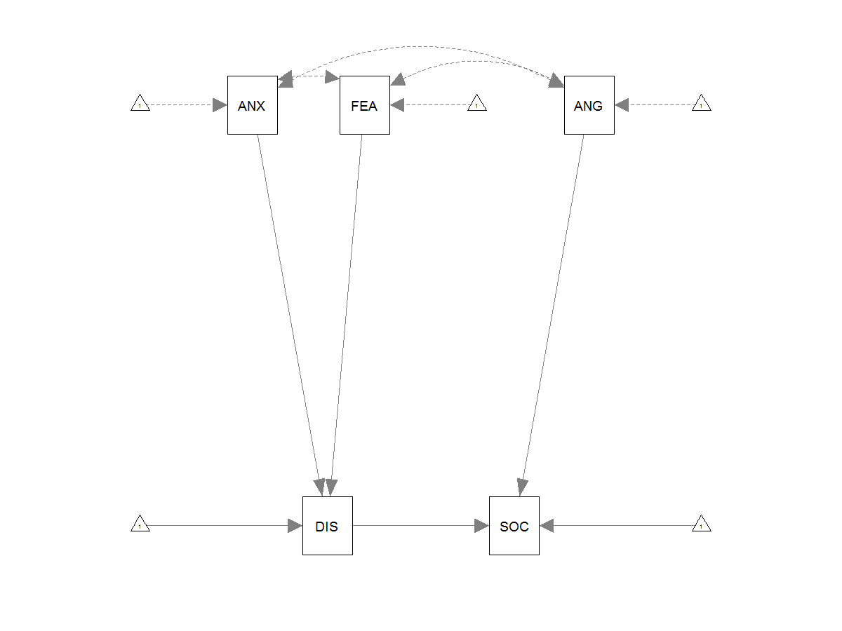
PART C : Model evaluation
The multiple linear regression analyses are saturated models (i.e., they have zero df), so model fit is always perfect (i.e., a chi-square test statistic is always zero). However, the structural path model has three degrees of freedom, so the “fit” of the model can be assessed. Chi-square is a typical means of assessing model fit.

9. Does the estimated model fit” the observed data? What is the chi-square test statistic?
Estimator ML
Minimum Function Test Statistic 66.995
Degrees of freedom 3
P-value (Chi-square) 0.000

No, the p-value of the chi-square is lower than .05 for the model, which means that the data “behaves” different from the model where we fitted the data. The statistic is the ML = 66.99

10. What values on the chi-square distribution (with one degree of freedom) indicate statistically significance at p = .05 and p = .01?
For p = .05 with 1 df, chi-square = 3.841
For p = .01 with 1 df, chi-square = 6.635

#PART A
job <- read.csv2("C:\\Users\\s4600479\\Desktop\\EAS_n500(2).csv", sep = ";")

install.packages("lavaan")
library(lavaan)

install.packages("semPlot")
library(semPlot)

install.packages("VIM")
library(VIM)

install.packages("mvnmle")
library(mvnmle)

install.packages("BaylorEdPsych")
library(BaylorEdPsych)

install.packages("psych")
library(psych)

#missing values
job$gender <- factor(job$gender, levels = c("0","1"), labels = c("male", "female"))

jobf <- subset(job, gender == "female")
jobm <- subset(job, gender == "male")

miss1<- aggr(job)
miss1

missmales<- aggr(jobf)
missfemales<- aggr(jobm)

#identify missing values between continuous and categorical measures
d<- job[ ,c("gender","SOCIAL")]
barMiss(d)
d<- job[ ,c("gender","ANXIETY")]
histMiss(d)
d<- job[ ,c("gender","DISTRESS")]
histMiss(d)
d<- job[ ,c("gender","FEAR")]
histMiss(d)
d<- job[ ,c("gender","ANGER")]
histMiss(d)

###Little's MCAR test

LittleMCAR(job)
#this does not work very well with large data files like this, so use the alternative

MCAR<-LittleMCAR(job)

MCAR$chi.square
MCAR$df
MCAR$p.value
MCAR$missing.patterns
MCAR$amount.missing

#pairwise VS LISTWISE deletion

corr.test(job[,2:7], use = "complete")
corr.test(job[,2:7], use = "pairwise")

#PART B

#two regressions (OLS)
lm1 <- lm(DISTRESS ~ ANXIETY + FEAR, job)
summary(lm1)
lm2 <- lm(SOCIAL ~ ANGER + DISTRESS, job)
summary(lm2)

#TWO REGRESSION IN SEM (ML)
#LISTWISE DELETION IS DEFAULT

model1 <- "DISTRESS ~ ANXIETY + FEAR"
model2 <- "SOCIAL ~ ANGER + DISTRESS"

fit1 <- sem(model1, data = job, missing="ML")
summary(fit1, standardized = T, rsquare=T)

fit2 <- sem(model2, data = job, missing="ML")
summary(fit2, standardized = T, rsquare=T)

#some plots
semPaths(fit1)
semPaths(fit1, residuals = F)
semPaths(fit1, what="std", residuals = F)

semPaths(fit2)
semPaths(fit2, residuals = F)
semPaths(fit2, what="std", residuals = F)

#same but with Full-Information Maximum Likelihood (FIML) estimation to include all participants in the analyses

model1.1 <- "DISTRESS ~ ANXIETY + FEAR"
model2.1 <- "SOCIAL ~ ANGER + DISTRESS"

fit1.1 <- sem(model1.1, data = job, missing="FIML")
summary(fit1.1, standardized = T, rsquare=T)

fit2.1 <- sem(model2.1, data = job, missing="FIML")
summary(fit2.1, standardized = T, rsquare=T)

####now testing both questions in one

modelmax <- "DISTRESS ~ ANXIETY + FEAR
SOCIAL ~ ANGER + DISTRESS"
fit <- sem(modelmax, data = job, missing="FIML")
summary(fit, standardized = T, rsquare=T)

semPaths(fit)
semPaths(fit, residuals = F)
semPaths(fit, what="std", residuals = F)

#Part C

