ANDRE VARGAS
Assignment 3
CFA: Is it better to burnout than fade away?
Due in class May 9, 2016 (13:45pm)

This assignment involves the use of confirmatory factor analysis (CFA), which is used to identify more global constructs from numerous specific measures. This technique is particularly useful when validating instruments that contain multiple subscales which consist of several items each. CFA primarily differs from exploratory factor analyses (EFA) in that indicators of constructs are specified in an “a priori” manner in CFA and in a “post-hoc” manner in EFA. The assignment consists of ten equally weighted items. The data set for this homework is cfa.csv. The theoretical background and assignment is described below.

The dimensional structure of burnout

Introduction
Burnout is a common phenomenon among working people; about 13% of the Dutch labor force is presumed to suffer from it (CBS, 2011). The burnout concept is thought to consist of at least three dimensions: emotional exhaustion (EE), depersonalization/cynicism (CY, i.e., distancing oneself from one's job), and reduced personal accomplishment (RPA, i.e., feeling like you are not doing anything worthwhile at work). In an abbreviated version of the Maslach Burnout Inventory has been developed with three items measuring each of the three dimensions. This inventory was administered to 500 primary school teachers in the Netherlands. The question formulations are not available, which is a pity since we are evaluating measurement instrument(s). However, this will not interfere with the didactical purpose of this assignment: learning how to specify and evaluate confirmatory factor models.

Overview
In this assignment you will learn to specify and test factor models (i.e., latent variable models). You will start by testing a single factor model, proceed to testing a three factor model, and finally to testing a second-order factor model. You will learn how to evaluate and improve (re-specify) the factor solution in order to obtain a satisfactory factor solution. In a second order factor model the first order factors act as the indicators of the second order factor. Finally, a note is provided on validity assessment of the factors (i.e., does the latent variable represent burnout).

A. Model specification: Single factor model
The correlations in table 1 are positive and rather high, which begs the question whether it is really possible to distinguish empirically between the two key concepts of EE, CY, and RPA. This is the issue we will investigate first. Specify and test a single factor model for these items, i.e., all items should load on the same underlying factor.

1. Create a R script to estimate this model using the cfa() function in the lavaan package.
#its similar to pca but we kinda already know the theory and what the items represent... so you create the factor burnout
#as a fn of the items
model1 <- ' burnout =~ x1 + x2 + x3 + x4 + x5 + x6 + x7 + x8 + x9'
# fit the model
fit <- cfa(model1, data=cfadata)
# summarize output
summary(fit, standardized = T, fit.measures=T)

2. Draw the path diagram for this model using semPaths().
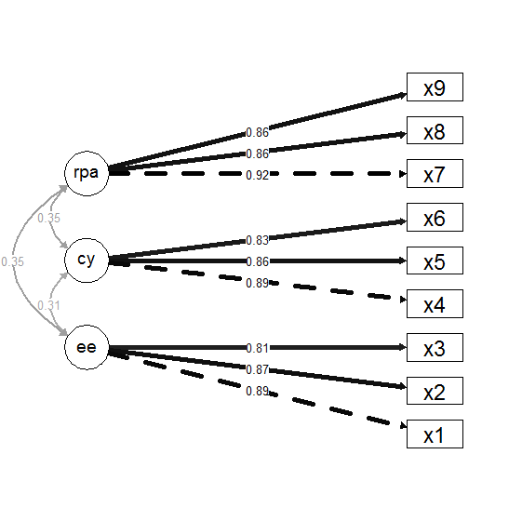

As discussed in class the scale of any latent variable is not defined, which makes sense because it is an unobserved variable. On the other hand, the scale of any observed variable is deduced from the response scale, for example ‘0 = never to 5 = always’. In order to identify the scale for the factor, one could either (a) fix the variance of the factor to one or (b) fix one factor loading to 1. In the first case the factor is standardized so that the variance is 1 and the mean is 0. In the second case, the scale of the factor becomes equal to the response scale of the item for which the factor loading was fixed to 1.

3. Which of these two options is done by default in the cfa() function?
It fixes the variance of the first indicator to one, thereby fixing the scale of the latent variable. he factor is standardized so that the variance is 1 and the mean is 0.

4. Inspect the fit of the model and provide reasons why you consider the fit to be (un)satisfactory. Be sure to mention the important statistics and indices used in your decision.
ML
P-value (Chi-square) 0.000 not bigger than .05

Comparative models
Comparative Fit Index (CFI) 0.456 not near.9 or .95
Tucker-Lewis Index (TLI) 0.274 not near.9 or .95

Root mean square
RMSEA 0.345 should be low (.05)
90 Percent Confidence Interval 0.331 0.360
P-value RMSEA <= 0.05 0.000
SRMR 0.228

All the model fits above are indicating a “bad” model fit. We use all of them because chi square can be biased by the n sample size (bigger sample sizes increase the chance of inflating estimates and therefore p values) .

B. Test of a 3‐factor model

Your next task is to specify a factor model in line with the structure suggested in the introduction (i.e., a three factor model). The factor describing exhaustion (EE) is described by items x1, x2, and x3. The factor describing cynism (CY) is described by items x4, x5, and x6. The factor describing reduced personal accomplishment (RPA) is described by items x7, x8, and x9.

5. Create a R script to estimate this model using the cfa() function in the lavaan package.
#next model with specific factors and items
model2 <- ' ee =~ x1 + x2 + x3
cy=~ x4 + x5 + x6
rpa=~ x7 + x8 + x9'
# fit the model
fit2 <- cfa(model2, data=cfadata)
# summarize output
summary(fit2, standardized = T, fit.measures=T)

6. Draw the path diagram for this model using semPaths().
#draw it
semPaths(fit2, what= "std", layout = "tree", rotation = 2, intercepts = F, residuals = F, curve = 2, nCharNodes = 0, edge.label.cex = 1, edge.color = "black", sizeMan = 10, sizeMan2 = 5)

7. Create a R script to estimate this model using the lavaan() function.
In case you forgot, in the path diagram and model specification should include correlations between the factors. It would make no theoretical sense if the three dimensions of burnout were not correlated. These covariances are included by default in the cfa() function.

model3 <- ' ee =~ 1*x1 + x2 + x3
cy=~ 1*x4 + x5 + x6
rpa=~ 1*x7 + x8 + x9
ee~~cy
ee~~rpa
cy~~rpa
x1~~x1
x2~~x2
x3~~x3
x4~~x4
x5~~x5
x6~~x6
x7~~x7
x8~~x8
x9~~x9'

fit3 <- sem(model3, data = cfadata, missing="FIML")
summary(fit3, standardized = T, rsquare=T)

8. Inspect the fit of the models specified in items #5 and #7 (they should produce identical results) and provide reasons why you consider the fit to be (un)satisfactory. Be sure to mention the important statistics and indices used in your decision.

FROM CFA

Estimator ML
Minimum Function Test Statistic 30.972
Degrees of freedom 24
P-value (Chi-square) 0.155 bigger than .05

User model versus baseline model:

Comparative Fit Index (CFI) 0.998 near.9 or .95
Tucker-Lewis Index (TLI) 0.996 near.9 or .95

Root Mean Square Error of Approximation:

RMSEA 0.024 should be low (.05)
90 Percent Confidence Interval 0.000 0.046
P-value RMSEA <= 0.05 0.977

Standardized Root Mean Square Residual:

SRMR 0.018 should be low (.05)

FROM LAVAAN

Estimator ML
Minimum Function Test Statistic 30.972
Degrees of freedom 24
P-value (Chi-square) 0.155 bigger than .05

User model versus baseline model:

Comparative Fit Index (CFI) 0.998 near.9 or .95
Tucker-Lewis Index (TLI) 0.996 near.9 or .95

Root Mean Square Error of Approximation:

RMSEA 0.024 should be low (.05)
90 Percent Confidence Interval 0.000 0.046
P-value RMSEA <= 0.05 0.977

Standardized Root Mean Square Residual:

SRMR 0.016 should be low (.05)

We can conclude that we can accept the model based on all of the fits indices above, which comply with their criteria

The one and three factor models represent nested models and can be compared using a chi-square difference test. If that difference is significant it is decided that the model with the fewer dfs is the better model. In this example the three factor model is obviously preferred because of its overall fit, but the anova() function can be used to test the difference between models. However, just because a model is better than another model doesn’t necessarily mean it is an acceptable model.

***In the event that you would consider the model fit as insufficient then re-specify the model until you have reached an acceptable fit. The modification indices may be used to identify where improvements should be made. Any modification index (mi) greater than 3.84 indicates substantial improvement. William provided a set of rules to follow for model improvement. The logic behind this set of rules is that it generally will result a factor structure with items that have no or little overlap with items of other factors. This is important because we strive for a unidimensional scale; and cross-loadings and correlated errors between items of different factors undermine unidimensionality. The set of rules on the slides suggest that we should always first look at the largest modification index for a correlated error within a factor. If the modification indices for the within factor correlated errors are smaller than 10, then one should start inspecting the modification indices for the correlated errors between the items of different factors. Once a modification is made, the model should be re-estimated and evaluated.

In factor analysis we often strive for ‘simple structure’. Simple structure means that there are no correlated errors and no cross‐loadings in the model. The reason for that the latter is that cross‐loadings threaten the construct validity. A cross‐loading implies that the item measures two factors at the same time. Correlated error terms threaten the construct validity in the same way.

A last important note on this is related to content validity. Scales sometimes consist of items which cover a set of important aspects for the construct. Together these aspects assure the content validity of the measure. Deleting an item to enhance construct validity, might at the same time weaken the content validity of the scale. It is therefore important to also consider the role of the item in the scale as a whole. Did the developers (or you if you made the scale) intend to cover a set of aspects? If so, how would deletion affect the validity of the scale as a whole? These questions are not simple to answer, but one should at least give it a thought.

C. Second order factor analysis

In the introduction it is mentioned that burnout consists of three dimensions: fatigue/exhaustion, depersonalization/cynicism, and reduced personal accomplishment. However, the single factor model didn’t fit, and the three ‐factor model does not contain a variable called burnout. So, how do we know whether the three factors are dimensions of a more global construct (burnout)? This requires validity tests. For example, people with a burnout should on average score higher on all three dimensions compared to ‘healthy’ people. This type of validity is called predictive validity. Another type of validity is construct validity; a measure shows construct validity if it correlates with other constructs in a theoretical expected way (see below). In this case all three dimensions should correlate negatively with ‘general life satisfaction’, and positively with depression, stress, and anxiety. Even if all these validity tests are confirmative, we can still question whether we are measuring burnout, since the dimensions are not called burnout.

In the next model we will add a latent variable to the model called burnout. The three latent variables EE, CY, and RPA will be the indicators of the factor burnout. In this model burnout is called a second order factor. In principle it is not very difficult to specify a second order factor model. One should not estimate correlations between the first order factors and then it is a kind of repetition of the specification of the first order factors.

9. Create a R script to estimate this higher-order factor model using the lavaan() function.
model4 <- ' ee =~ 1*x1 + x2 + x3
cy=~ 1*x4 + x5 + x6
rpa=~ 1*x7 + x8 + x9
burnout=~ ee + cy + rpa
x1~~x1
x2~~x2
x3~~x3
x4~~x4
x5~~x5
x6~~x6
x7~~x7
x8~~x8
x9~~x9'

fit4 <- sem(model4, data = cfadata, missing="FIML")
summary(fit4, standardized = T, rsquare=T, fit.measures=T)

10. Provide a figure describing this higher-order factor model using semPaths(). Be sure to include (a) the standardized factor loadings and (b) a figure caption that describes the overall fit of the model to the observed data using GOF indices.

Figure 1
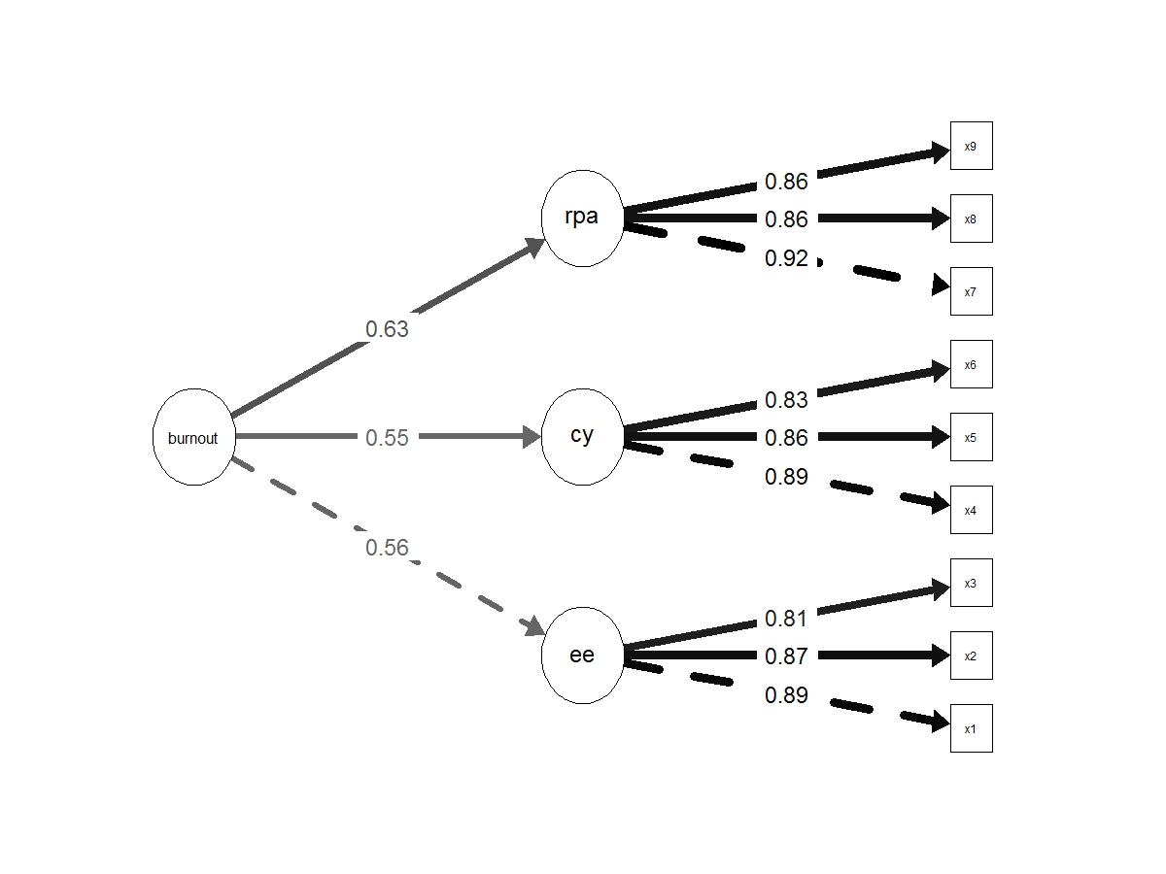
Figure 1. We can observe the the model that consists of the items x1 to x9 that measure specific latent variables (factors) emotional exhaustion (EE), depersonalization/cynicism (CY), and reduced personal accomplishment (RPA), that form part of a bigger concept (burnout). The complete model does fit the observed data and describes the concepts and it-s relationships. To test this several goodness of fit indices were analyzed: P-value (Chi-square) = 0.155, CFI = .998, TLI = .996, RMSEA = .024, SRMR = .016. They all indicate a good fit.

#R SCRIPT
cfadata <- read.csv2("C:\\Users\\s4600479\\Desktop\\cfa(2).csv", sep = ";")

install.packages("lavaan")
library(lavaan)

install.packages("semPlot")
library(semPlot)

install.packages("VIM")
library(VIM)

install.packages("mvnmle")
library(mvnmle)

install.packages("BaylorEdPsych")
library(BaylorEdPsych)

install.packages("psych")
library(psych)

#PART A
# specify the model
#its similar to pca but we kinda already know the theory and what the items represent... so you create the factor burnout
#as a fn of the items
model1 <- ' burnout =~ x1 + x2 + x3 + x4 + x5 + x6 + x7 + x8 + x9'
# fit the model
fit <- cfa(model1, data=cfadata)
# summarize output
summary(fit, standardized = T, fit.measures=T)

#draw it
#the dotted line is the fixed variable to the factor which is the default (always the first one)
semPaths(fit, what= "std", layout = "tree", rotation = 2, intercepts = F, residuals = F, curve = 2, nCharNodes = 0, edge.label.cex = 1, edge.color = "black", sizeMan = 10, sizeMan2 = 5)

#PART B
#next model with specific factors and items
model2 <- ' ee =~ x1 + x2 + x3
cy=~ x4 + x5 + x6
rpa=~ x7 + x8 + x9'
# fit the model
fit2 <- cfa(model2, data=cfadata)
# summarize output
summary(fit2, standardized = T, fit.measures=T)
#draw it
semPaths(fit2, what= "std", layout = "tree", rotation = 2, intercepts = F, residuals = F, curve = 2, nCharNodes = 0, edge.label.cex = 1, edge.color = "black", sizeMan = 10, sizeMan2 = 5)

#do the same but with lavaan compute covariances
#the rpa~~ee for example just tells the model to make a relationship between factors
model3 <- ' ee =~ 1*x1 + x2 + x3
cy=~ 1*x4 + x5 + x6
rpa=~ 1*x7 + x8 + x9
ee~~cy
ee~~rpa
cy~~rpa
x1~~x1
x2~~x2
x3~~x3
x4~~x4
x5~~x5
x6~~x6
x7~~x7
x8~~x8
x9~~x9'

fit3 <- sem(model3, data = cfadata, missing="FIML")
summary(fit3, standardized = T, rsquare=T, fit.measures=T)

#some plots
semPaths(fit3)
semPaths(fit3, residuals = F)
semPaths(fit3, what="std", residuals = F)
semPaths(fit3, what= "std", layout = "tree", rotation = 2, intercepts = F, residuals = F, curve = 2, nCharNodes = 0, edge.label.cex = 1, edge.color = "black", sizeMan = 10, sizeMan2 = 5)

#Part C

#so here we want to create an underlying concept "burnout" that is going to be correlated to the 3 factors
#we shouldn't add correlations between the factors because they will be "consindered"in the relationship with
#the big concept burnout

model2 <- ' ee =~ x1 + x2 + x3
cy=~ x4 + x5 + x6
rpa=~ x7 + x8 + x9'
# fit the model
fit2 <- cfa(model2, data=cfadata)
# summarize output
summary(fit2, standardized = T, fit.measures=T)
#draw it
semPaths(fit2, what= "std", layout = "tree", rotation = 2, intercepts = F, residuals = F, curve = 2, nCharNodes = 0, edge.label.cex = 1, edge.color = "black", sizeMan = 10, sizeMan2 = 5)

#do the same but with lavaan compute covariances
#the rpa~~ee for example just tells the model to make a relationship between factors
model4 <- ' ee =~ 1*x1 + x2 + x3
cy=~ 1*x4 + x5 + x6
rpa=~ 1*x7 + x8 + x9
burnout=~ ee + cy + rpa
x1~~x1
x2~~x2
x3~~x3
x4~~x4
x5~~x5
x6~~x6
x7~~x7
x8~~x8
x9~~x9'

fit4 <- sem(model4, data = cfadata, missing="FIML")
summary(fit4, standardized = T, rsquare=T, fit.measures=T)

#some plots
semPaths(fit4)
semPaths(fit4, residuals = F)
semPaths(fit4, what="std", residuals = F)
semPaths(fit4, what= "std", layout = "tree2", rotation = 2, intercepts = F, residuals = F, curve = 2, nCharNodes = 0, edge.label.cex = 1, edge.color = "black", sizeMan = 3, sizeMan2 = 3, sizeLat = 6)

