Andre Vargas (s4600479)
Assignment 4
Mediation: How do exercise and hardiness predict health?
due in class June 6, 2016 (13:45pm)

This assignment involves the use of structural path analyses to test mediation hypotheses. This is useful for determining direct and indirect effects of predictors and for testing the process by which a predictor impacts an outcome measure. The assignment requires the specification of a structural path model based on a set of hypotheses and consists of 8 items that are each worth one point. The data and background for these hypotheses are provided below.

Introduction
One of the important and traditional uses of SEM is causal analysis in non-experimental research. This assignment is about the causal mechanism of self-‐perceived health in which exercise participation, self-‐perceived fitness, stressful life experiences, and hardiness promotes stress resistance (Kline, 1998; Roth, Wiebe, Fillingim, & Shay, 1989).

Theoretical background
Past research suggests that personality hardiness and physical exercise are significant predictors of health in a variety of occupational groups (e.g. Roth et. al, 1989; Wiebe, 1991). Conceptually, hardiness is a variable that develops early in life and is reasonably stable over time, though amenable to change under certain conditions (Maddi & Kobasa, 1984). Hardy persons have a high sense of life and work commitment, greater sense of control, and are more open to change and challenges in life. Physical exercise is a concept which indicates a person’s objective physical condition. Both exercise and hardiness have been found to effect health directly as well as indirectly. To be more specific the relation between exercise and health is thought to be mediated by physical fitness and stressful life events, a concept indicating a person’s subjective physical condition. The relation between hardiness and health is also thought to be mediated by the occurrence of stressful life events and physical fitness.

Materials
Sampling and interview procedure
Data were collected among 406 university students from a psychology department. Students were asked to fill in a self-completion questionnaire that took at average 20 minutes to complete. A total 170 men and 236 women participated, and the mean age was 21.4 years (SD = 5.5).

Measures
Health. Seriousness of Illness Rating Scale (Wyler, Masuda, & Holmes, 1968) is a self‐report checklist of commonly recognized physical symptoms and diseases and provides a measure of current and recent physical health problems. Each item is associated with a severity level. A total health score is obtained by adding the severity ratings of endorsed items (symptoms experienced within the last month).
Stress. Life Experience Survey (Sarason, Johnson, & Segal, 1978) is a measure used to assess the occurrence and impact of stressful life experiences. Subjects indicate which events have occurred within the last month and rate the degree of impact on a 7-‐point scale (--‐3 extremely negative impact, 0 = no impact, 3 = extremely positive impact). In the study, the total negative event score was used as an index of negative life stress (the absolute value of the sum of negative items).
Fitness. Fitness Questionnaire (Roth & Fillingim, 1988) is a measure of self-‐perceived physical fitness. Respondents rate themselves on 12 items related to fitness and exercise capacity. The items are on an 11-‐point scale of 0 = very poor fitness to 5 = average fitness to 10 = excellent fitness. A total fitness score is calculated by summing the 12 ratings. Items include questions about strength, endurance, and general perceived fitness.
Exercise. Exercise Participation Questionnaire (Roth & Fillingim, 1988) assessed current exercise activities, frequency, duration, and intensity. An aerobic exercise participation score was calculated using responses to 15 common exercise activities and providing blank spaces to write in additional activities.
Hardiness. In the study, hardiness included components of commitment, challenge, and control. A composite hardiness score was obtained by summing Z scores from scales on each component. Commitment was assessed with the Alienation From Self and Alienation From Work scales of the Alienation Test (Maddi, Kobasa, & Hoover, 1979). Challenge was measured with the Security Scale of the California Life Goals Evaluation. Self and Alienation From Work scales of the Alienation Test (Maddi, Kobasa, & Hoover, 1979). Challenge was also measured with the Security Scale of the California Life Goals Evaluation Schedule (Hahn, 1966). Control was assessed with the External Locus of Control Scale (Rotter, Seaman, & Liverant, 1962) and the Powerlessness Scale of the Alienation Test (Maddi, Kobasa, & Hoover, 1979).
Data
Correlation matrix of the observed variables.

 | fitness Stress health exercise
fitness stress  health exercise hardiness | ---0.13  -‐0.29 0.34  0.39 -‐0.05 -‐0.08  -‐0.03 -‐0.23 -‐0.16 -‐0.03
Data Source: Kline(2005).

References
Kline, R. (2004). Principles and Practice of Structural Equation Modeling, 2nd Edition. The Guilford Press.
pp. 123‐131.
Maddi, S.R. & Kobasa, S.C. (1984). The Hardy Executive. Homewood, IL: Dow Jones‐Irwin.
Maddi, S. R., Kobasa, S. C., & Hoover, M. (1979). An alienation test. Journal of Humanistic Psychology, 19,
73-76.
Sarason, I. G., Johnson, J. H., & Siegel, J. M. (1978). Assessing the impact of life changes: Development of
the Life Experiences Survey. Journal of Consulting and ClinicaI Psychology, 46, 932‐946.
Roth, D. L., & Fillingim, R. B. (1988). Assessment of self‐reported exercise participation and self-perceived
fitness levels. Unpublished manuscript.
Roth, D. L., Wiebe, D. J., Fillingim, R. B., & Shay, K. A. (1989). Life Events, fitness, hardiness, and health:
A simultaneous analysis of proposed stress‐resistance effects. Journal of Personality and Social Psychology, 57, 136‐142.
Rotter, J. B., Seeman, M., & Liverant, S. (1962). Internal vs. External locus of control: A major variable in
behavior theory. In N. E Washburne (Ed.), Decisions, values, and groups (pp. 473‐516). Oxford, England: Pergamon Press.
Wiebe, D. J. (1991). Hardiness and stress moderation: A test of proposed mechanisms. Journal of Personality
and Social Psychology, 60, 89‐99.
Wyler, A. R., Masuda, M., & Holmes, T. H. (1968). Seriousness of Illness Rating Scale. Journal of
Psychosomatic Research, 11, 363-374.

Your task is to test alternative mechanisms explaining how exercise and hardiness predict physical health.

- Create a set of hypotheses based on the information in the text. Indicate the direction of the effects, e.g. positive or negative.

Direct effects
Hardiness will affect positively health.
Exercise will be positively related to health.
Exercise will affect positively fitness
Exercise will affect negatively stress
Hardiness will affect positively fitness
Hardiness will affect negatively stress
Fitness will not affect health
Stress will affect negatively health
Indirect effects
Self perceived fitness will mediate exercise to health
Stressful life events will mediate exercise to health
Self perceived fitness will mediate hardiness to health
Stressful life events will mediate hardiness to health

2. Create the path diagram based on the hypotheses you just wrote. You can try to do this using semPaths(), but I (WB) was not able to produce a coherent diagram, so please feel free to draw the diagram by hand. Notice that there should be a single arrow in the model for each hypothesis about a direct effect. However, you don’t have to add any arrows to the model for hypotheses about indirect (mediating) effects.

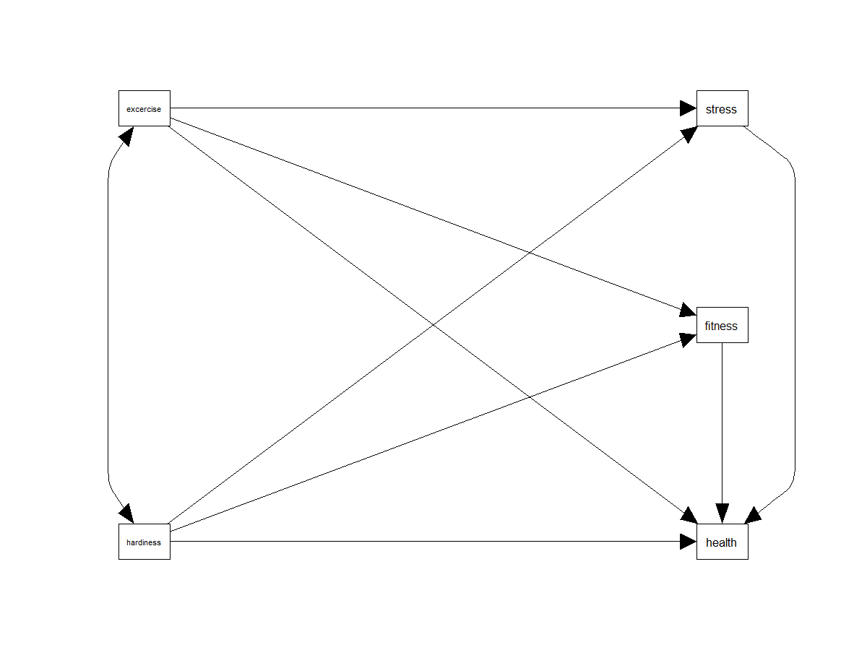
3. Express the path diagram as a set of three equation(s).

Health ~ hardiness + exercise + stress + fitness
Fitness ~ exercise + hardiness
Stress exercise + hardiness

Up to this point we have analyzed raw data, however, in SEM we can also analyze other types of data, such as correlation or covariance matrices. In this assignment we use correlations because we don’t have access to the original data; we only have access to the correlation matrix (and SDs) that was printed in the original publication in which this model was presented. The correlations are just numbers, representing the standardized relations between the observed variables. Unfortunately, lavaan() requires either raw data or covariances. To convert the correlations into covariances we also need to know the standard deviations of the variables. These are:
Fitness = 36.80
Stress = 67.00
Health = 62.48
Exercise = 66.50
Hardiness = 37.95

4. Enter the correlation matrix and use the getCov() function to convert the correlation matrix into a
covariance matrix (R script).

matrix <- '
1.00
-0.13 1.00
-0.29 0.34 1.00
0.39 -0.05 -0.08 1.0
-0.03 -0.23 -0.16 -0.03 1.0'

mcov <- getCov(matrix, lower = T, diagonal=T, sds = c(36.80, 67.00, 62.48, 66.50, 37.95), names = c("fitness", "stress" , "health", "exercise", "hardiness"))

5. Model specification. Create the R script to estimate the direct, indirect, and total effects using the lavaan() function. Note: to include the correlation between exercise and hardiness you need to include the command fixed.x = FALSE when fitting the model because lavaan assumes exogenous variables are not correlated. The inclusion of this correlation does not impact the regression paths.

model1 <- "health ~ c1*hardiness
health ~ c2*exercise

#indirect mediator path a
fitness ~ a12*exercise
stress ~ a11*exercise
fitness ~ a21*hardiness
stress ~ a22*hardiness

#mediator path b
health ~ b1*fitness
health ~ b2*stress

#covariance
exercise ~~ hardiness

#intercept
exercise ~1
hardiness ~1
health ~1
fitness ~1
stress ~1

#variances
health ~~ health
stress~~ stress
fitness~~fitness
hardiness~~hardiness
exercise~~exercise

#multiplying effects
a11b2 := a11*b2
a12b1 := a12*b1
a22b2 := a22*b2
a21b1 := a21*b1
totala21b1 := c1 + (a21*b1)
totala22b2 := c1 + (a22*b2)
totala12b1 := c2 + (a12*b1)
totala11b2 := c2 + (a11*b2)"

fit2 <- lavaan(model1, sample.cov = mcov, sample.nobs = 406, missing="FIML", estimator = "ML", fixed.x = F)

6. Model estimation and evaluation. Estimate the model using the lavaan() function and evaluate the fit of the estimated model to the observed data. Report and interpret the chi-square test statistic amount of variance explained by the predictors (i.e., R-square).
The chi suqare for this model indicates that it is not a good fit to the data, (chisq = 6.73(1), p = .009)
The R square of health was .174, for stress it was .056, for fitness it was .152

Enter the standardized estimates and p-values for the direct and indirect effects in the tables below.

Estimated direct effects (Dependent=health)
 | Estimate | p‐value
fitness | -.459 | < .001
exercise | .034 | .451
stress | .264 | < .001
hardiness | -0.168 | .027

Estimated direct effects (Dependent=stress)
 | Estimate | p‐value
hardiness | -.409 | < .001
exercise | -.057 | .238

Estimated direct effects (Dependent=fitness)
 | Estimate | pvalue
hardiness | -.018 | .689
exercise | 0.216 | .216

Estimated indirect effects
 | Estimate | p‐value
Fitness mediates hardiness to health (m1) | .008 | .689
Stress mediates hardiness to health (m2) | -0.108 | < .001
Fitness mediates exercise to health (m3) | -0.099 | < .001
Stress mediates exercise to health (m4) | -0.015 | 0.246

DOUBLE-CHECK: It follows from path analysis that the total effect is the sum of the direct and indirect effects. Check whether this is true. If not, then check the model specification.

The model can also be described in terms of the ability of the predictors to explain the outcome. Use the inspect() function to determine the R‐square of each dependent variable in the table below.

 | R²
fitness | 0.174
stress | 0.056
health | 0.152

7. Write down your conclusions from this analysis, e.g. which hypotheses are confirmed and which ones are rejected given the data.

 | Direct effects
 | Hardiness will affect positively health. | Not confirmed
 | Exercise will be positively related to health. | Not confirmed
 | Exercise will affect positively fitness | Not confirmed
 | Exercise will affect negatively stress | Not confirmed
 | Hardiness will affect positively fitness | Not confirmed
 | Hardiness will affect negatively stress | Confirmed
 | Fitness (perception) will not affect health | Not confirmed
 | Stress will affect negatively health | Not confirmed
 | Indirect effects
 | Self perceived fitness will mediate exercise to health | Confirmed
 | Stressful life events will mediate exercise to health | Not confirmed
 | Self perceived fitness will mediate hardiness to health | Not confirmed
 | Stressful life events will mediate hardiness to health | Confirmed

The final part of the assignment is to make you realize where the problems are in mediation analysis when concurrent measures are used. We focus on three variables: health, exercise and fitness. These variables are related with each other (see the correlation matrix). Thinking in terms of mediation and causation, we could hypothesize that healthy people exercise more (not being healthy hampers exercise), and healthy people are fitter and fitter people exercise more. This sounds plausible, but just as plausible as people who exercise more are healthier and fitter, and fitter people are healthier. I think you can probably think of several other plausible causal mechanisms. I have added all six causal mechanisms that can be created with three variables below (although many other possibilities exist if reciprocal effects or correlations are also allowed).

8. Estimate all these models using the sem() function, and decide which model(s) is the correct model. Copy the estimates in the tables below and indicate statistically significant parameters.

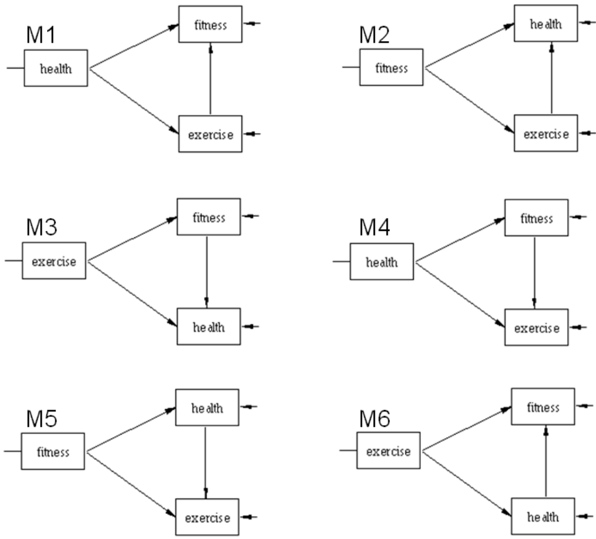

M1
health → fitness | -0.153*
health → exercise | -0.085
exercise → fitness | 0.204*
health → exercise → fitness | -0.017
* p<0.05.

M2
fitness → health | -0.518*
fitness → exercise | 0.705*
exercise → health | 0.037
fitness → exercise →health | 0.026
* p<0.05.

M3
exercise → health | -0.075
exercise → fitness | 0.204*
fitness → health | -0.153*
exercise → fitness → health | -0.031*
*p < 0.05.

M4
health → exercise | 0.038
health → fitness | -0.171*
fitness → exercise | 0.724*
health → fitness → exercise | -0.124*
* p<0.05.

M6
fitness → exercise | 0.204*
fitness → health | -0.153*
health → exercise | -0.075
fitness → health → exercise | 0.012
* p<0.05.

M5
exercise → fitness | 0.724*
exercise → health | 0.038
health → fitness | -0.492*
exercise → health → fitness | -0.019
* p<0.05.

