1.SELECT * FROM `obat` ORDER BY stok_obat DESC

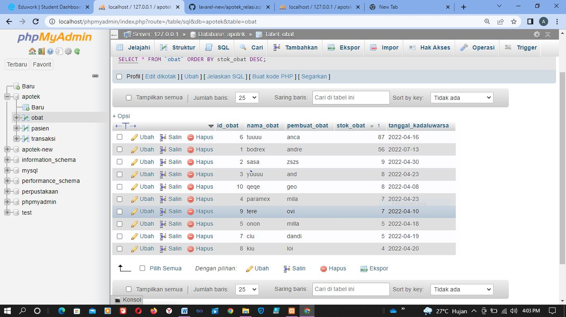

2. SELECT * FROM `obat` ORDER BY nama_obat ASC

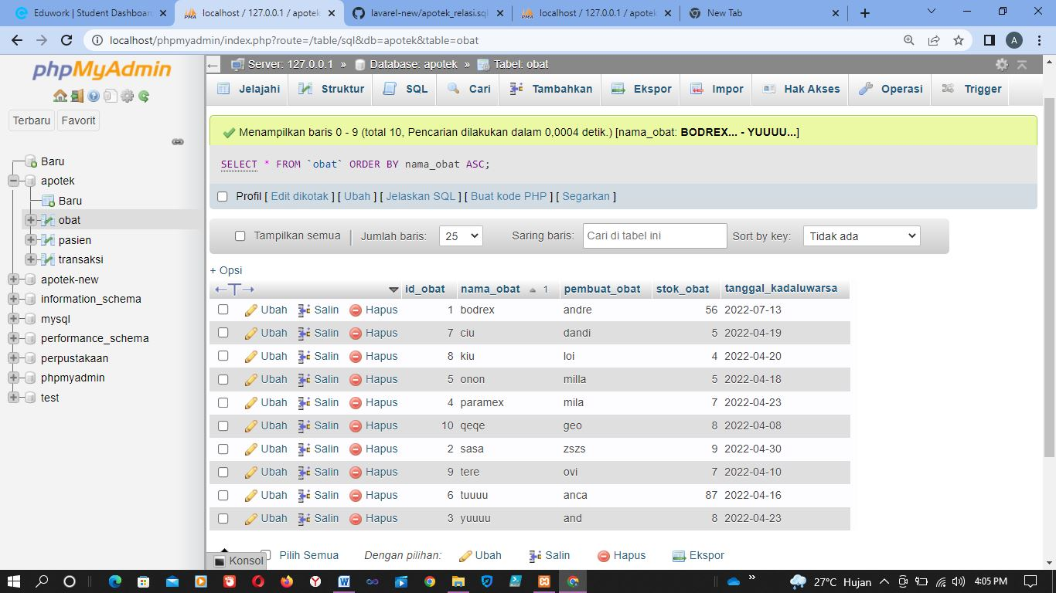

3. SELECT * FROM `obat` WHERE pembuat_obat LIKE '%and%'

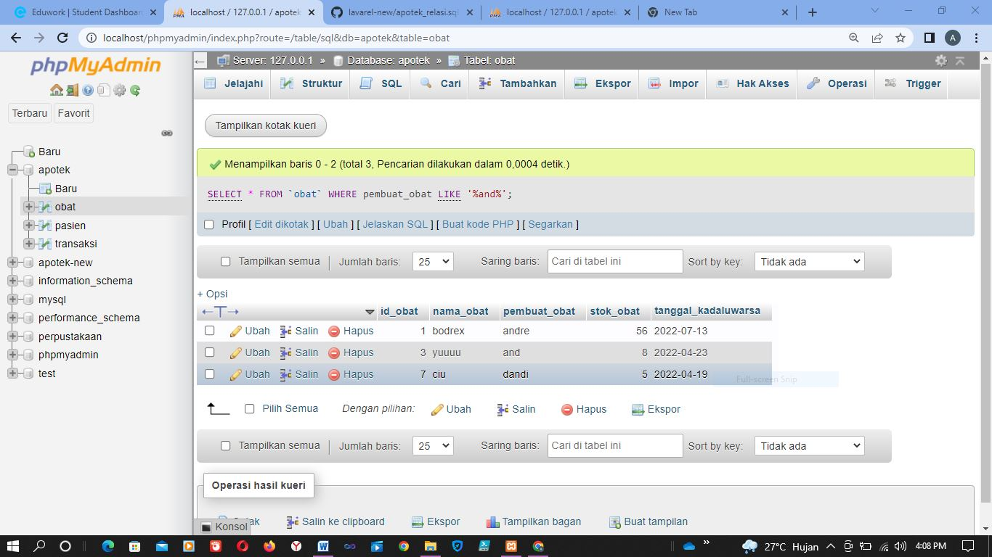

4. SELECT * FROM `pasien` WHERE nama_pasien LIKE '%a%'

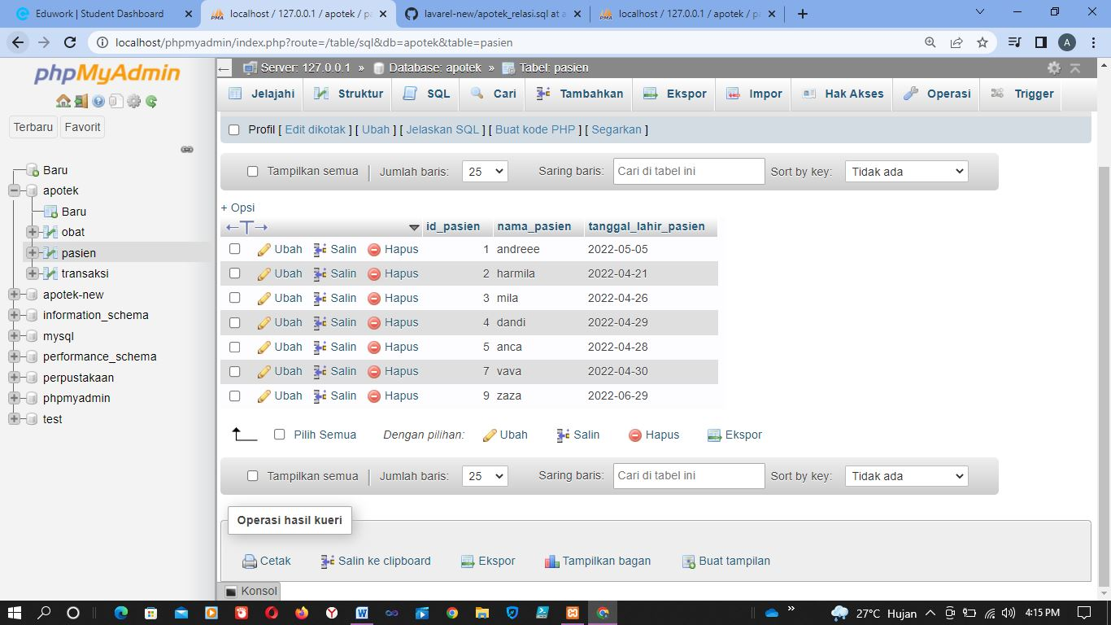

5. SELECT id_obat, SUM(stok_obat)AS total FROM `obat` GROUP BY id_obat;

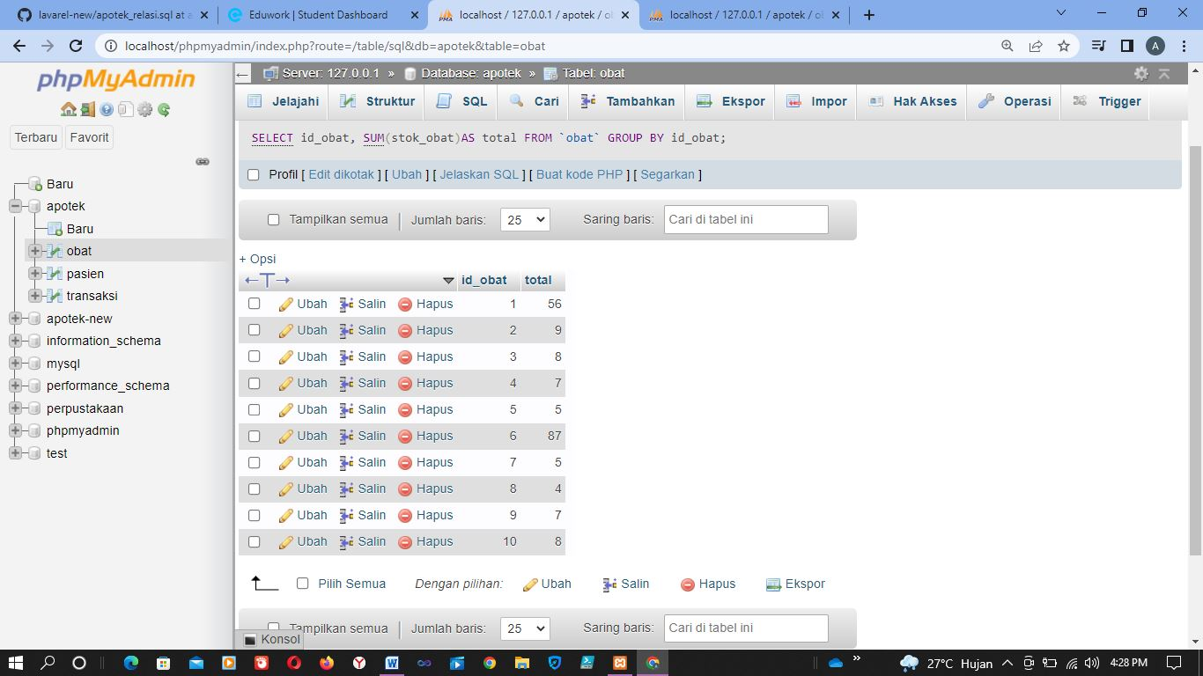

6. SELECT id_obat, SUM(stok_obat)AS total FROM `obat` GROUP BY id_obat;

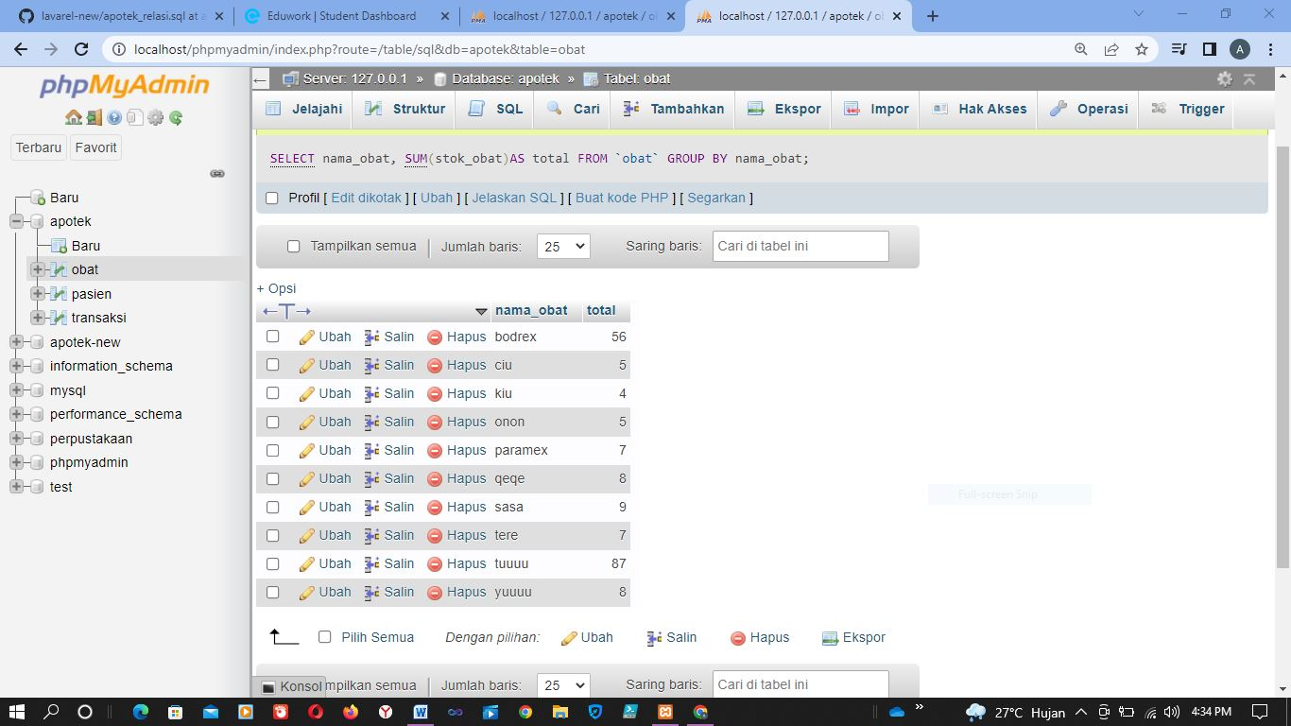

7 SELECT tgl_lahir, SUM(nama_pasien)AS total FROM `pasien` GROUP BY tgl_lahir;

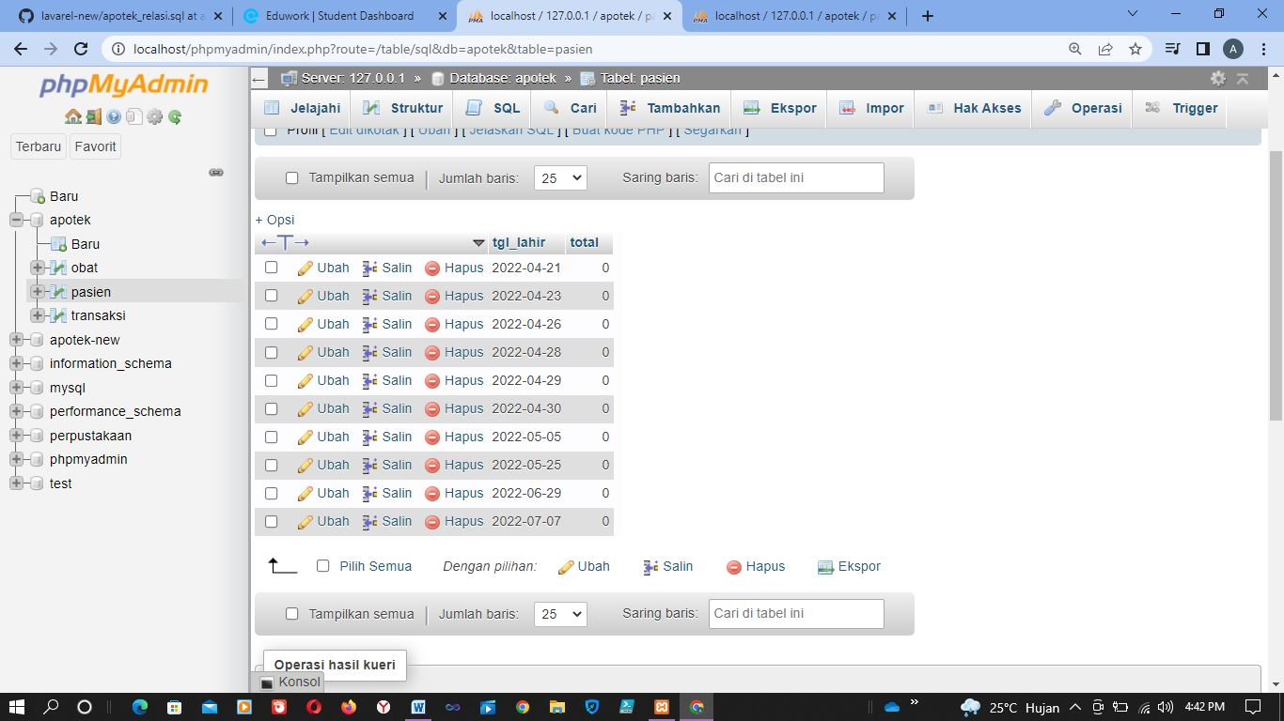

8.[SELECT](http://localhost/phpmyadmin/url.php?url=https://dev.mysql.com/doc/refman/8.0/en/select.html) tanggal_kadaluwarsa, [SUM](http://localhost/phpmyadmin/url.php?url=https://dev.mysql.com/doc/refman/8.0/en/aggregate-functions.html%23function_sum)(stok_obat) AS total FROM `obat` WHERE tanggal_kadaluwarsa >=2022;

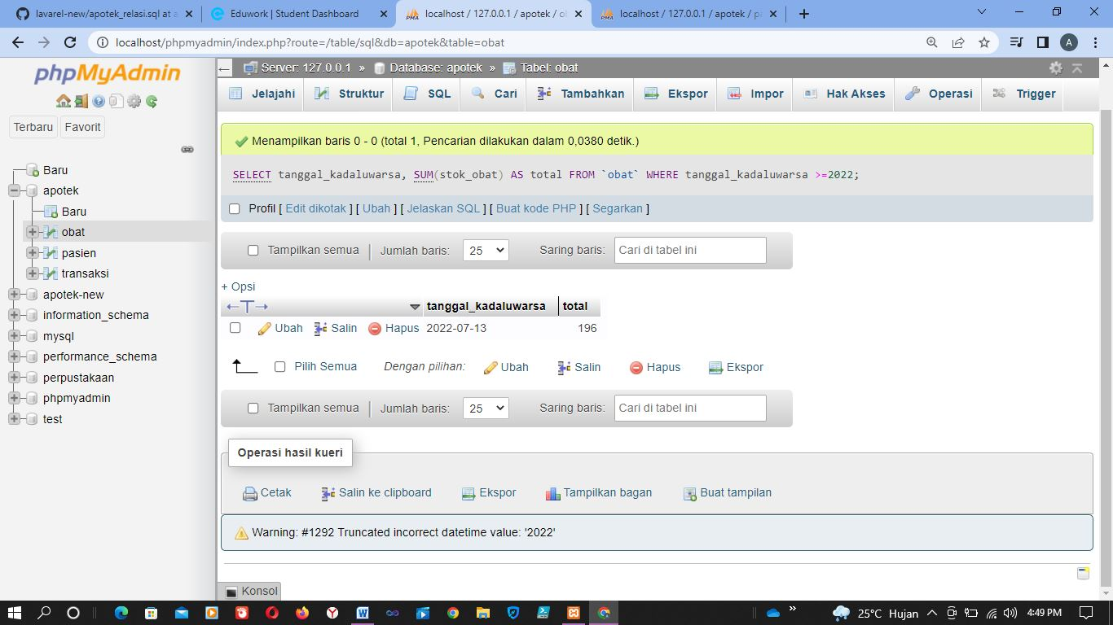

9. [SELECT](http://localhost/phpmyadmin/url.php?url=https://dev.mysql.com/doc/refman/8.0/en/select.html) * FROM `transaksi` ORDER BY id_transaksi DESC;

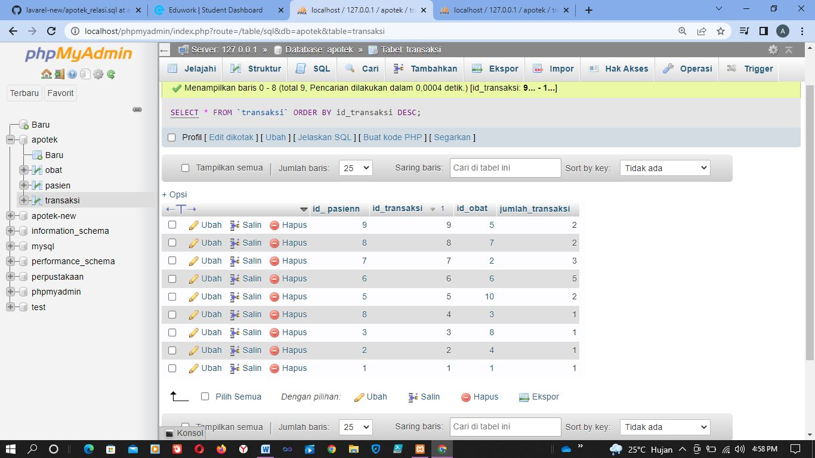

10. [SELECT](http://localhost/phpmyadmin/url.php?url=https://dev.mysql.com/doc/refman/8.0/en/select.html) * FROM `transaksi` ORDER BY id_transaksi ASC;

