Class Work – COMP397 – April 04th

Andre Batista Valentim Oliveira - 300909648

Contents

Setup 1

Go to chapter 8 2

MyGame class declaration 2

Output 3

New class declaration format 3

Output 3

# Setup

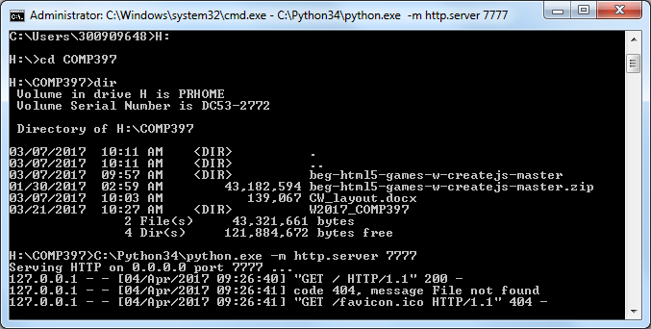

# Go to chapter 8

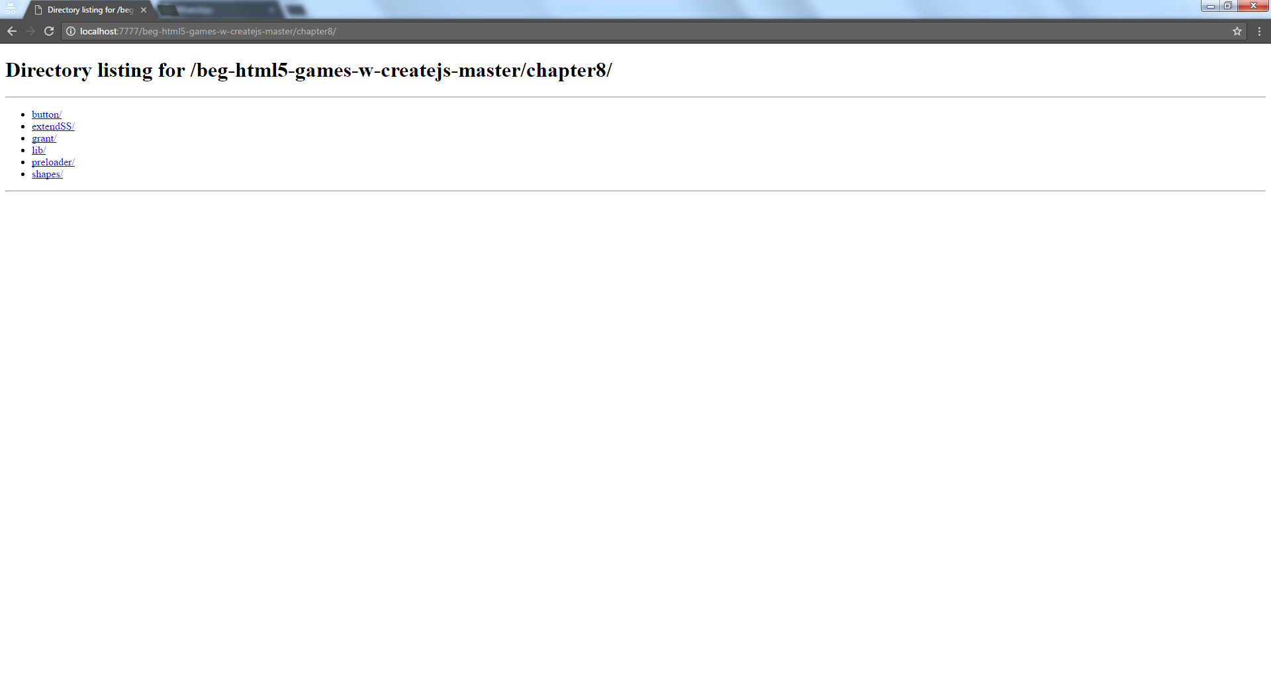

# MyGame class declaration

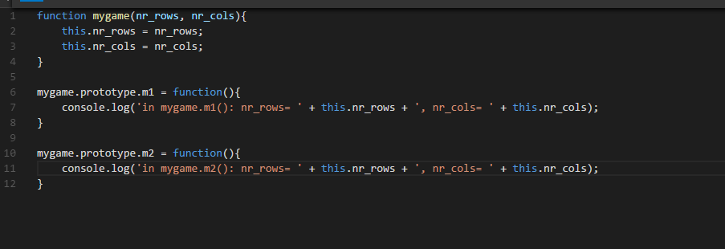

## Output

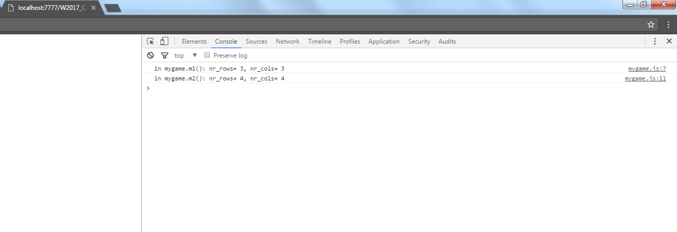

# New class declaration format

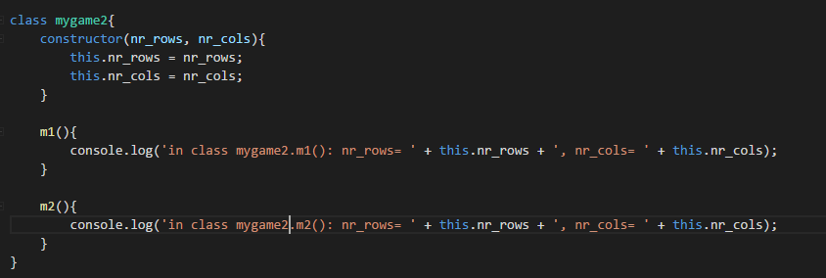

## Output

