Class Work – COMP397 – Feb. 21th

Andre Batista Valentim Oliveira - 300909648

Contents

Setup 1

Task 1 2

# Setup

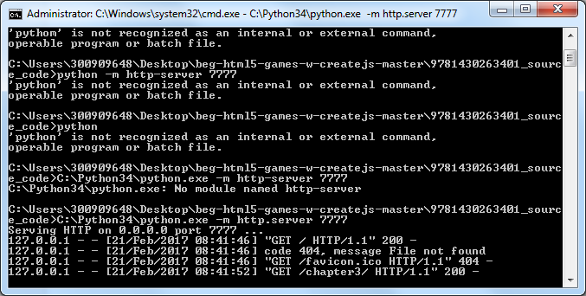

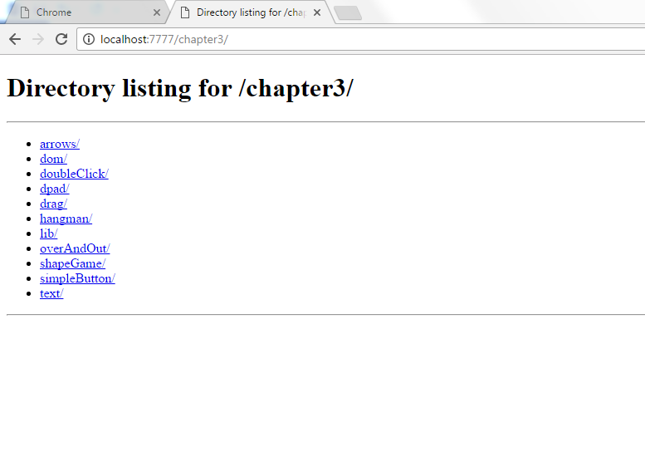

# Task 1

