Class Work – COMP397 – March 07th

Andre Batista Valentim Oliveira - 300909648

Contents

Setup 1

Go to chapter 5 2

# Setup

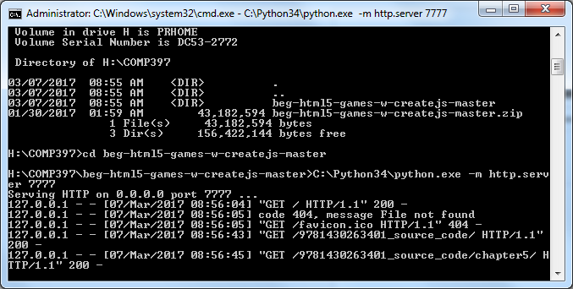

# Go to chapter 5

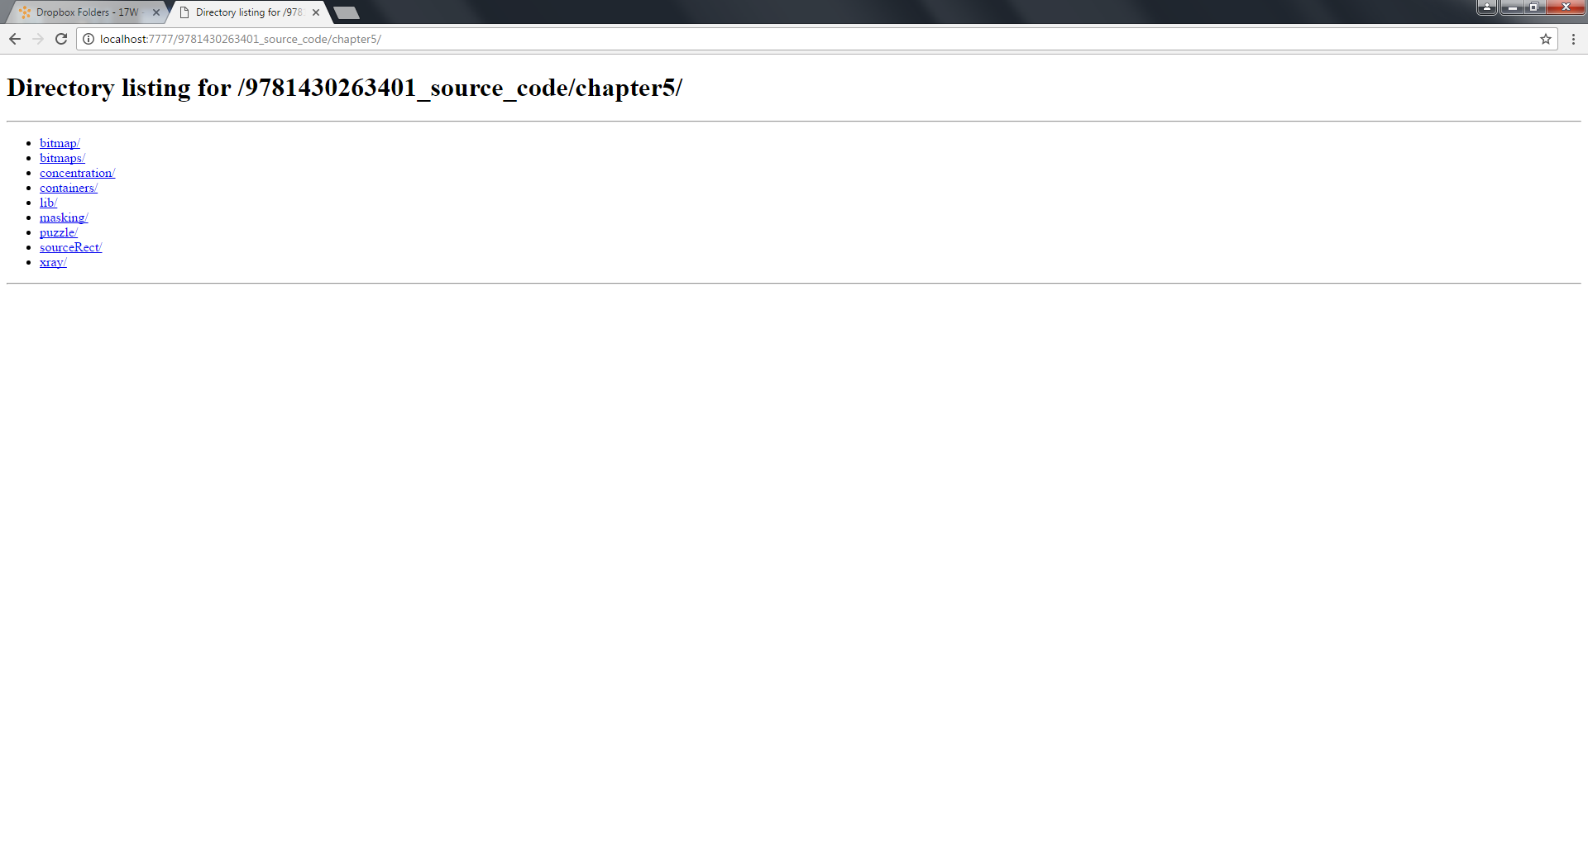

# Testing the order of filters:

## Before

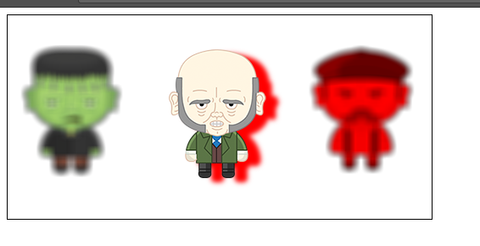

## After

