Class Work – COMP397 – March 14th

Andre Batista Valentim Oliveira - 300909648

Contents

Setup 1

Go to chapter 5 XRAY 2

# Setup

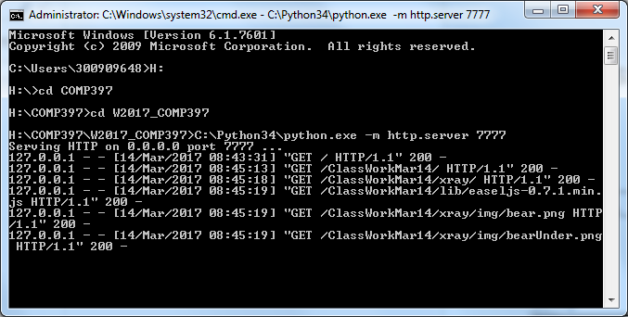

# Go to chapter 5 XRAY

